How to engage and keep people for the duration of their employment

Module Title: Personnel Resourcing and Development

Module Code:BMIH5005

Student Name:Luciana Maria Dobra

Student ID:2019290

Lecturer’s Name: Helen Evans

Contents
Introduction 3
Main Body 3
Human Resources' Function in Employee Engagement 3
Worker Lifecycle 4
Model for Employee Engagement 7
Conclusion 8
Reference 9

Introduction
Giving one's all to one's task increases the likelihood that one will produce extraordinary outcomes and go above expectations. Because employee engagement affects efficiency, organizational culture, staff turnover, output, connections to customers, and future earnings, well-thought-out tactics to boost engagement are essential for all businesses (Ogohi Daniel, 2019). When this occurs, productivity and the number of tasks done both increases as a result. In its broadest meaning, employee engagement refers to a workplace technique used to boost employees' passion for and dedication to their jobs, teams, coworkers, and the business as a whole (Hanaysha, 2016). Using a model of the employee's lifespan, this essay will delve deeper into the concept of employee engagement. The importance of human resources in fostering employee motivation will also be explored in this essay. The essay proposes a model with instructions on how to encourage workers to actively participate in their tasks, and it provides guidance on how to do so. The article illustrates its thesis with a wide range of examples all having something to do with hotels. The research paper wraps off with a summary of its primary arguments.

Main Body

Human Resources' Function in Employee Engagement
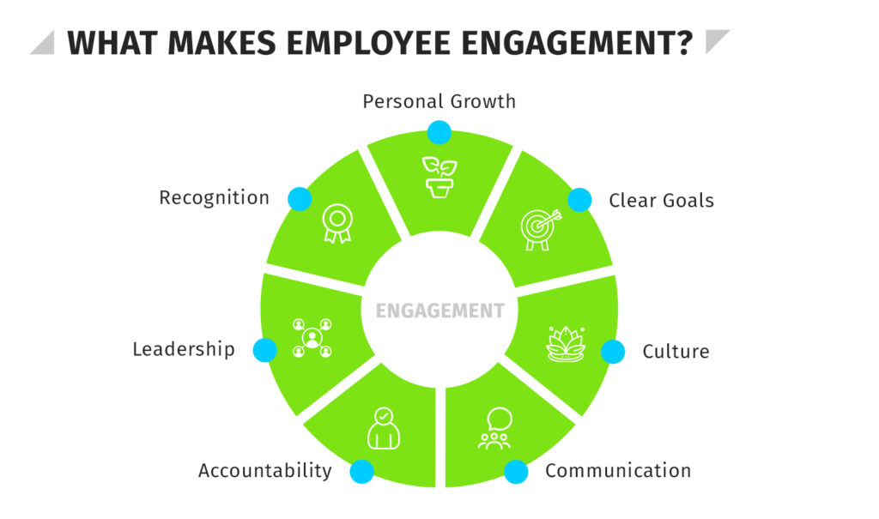
Source: https://hr.university/shrm/employee-engagement/
Since it affects every aspect of human resources management, employee engagement is more complicated than it first appears. According to Schmitt et al., (2016), An engaged workforce consists of people who are invested in their work, feel valued by their employers and peers, and are optimistic about the future of their careers. Human resources must have a thorough understanding of the employment agreement to successfully engage personnel. For employees to carry out their responsibilities effectively, HR must ensure that they have access to the proper tools, training, and working environments (Newman & Ford, 2021). HR must also keep up with staff training and development if it wants to retain employees motivated to come to work. Make sure that the paths for the employees' professional development are apparent. People that take pride in their work are conscious of their obligations. Everyone is pursuing a goal, whether it be personal or professional.
A diverse group of people are employed in the hotel industry. The responsibilities placed on wait staff, secretaries, and distributors are significantly dissimilar from those of housekeepers and supervisors. However, you must train every staff because they all reflect the hotel's hospitality culture (Sobering, 2019). Many people in the service sector start at the bottom and rise through the ranks. Therefore, the hotel business must invest in training and growth. It is advantageous to maintain a consistent demeanor and way of doing things. The hotel sector offers a variety of educational possibilities. In the workplace, effective communicators are very advantageous to both firms and individuals. Every hotel staff must be fluent in English to accomplish this. The history of the visitor might not be known to your personnel. Therefore, learning how to communicate effectively with people from different cultural backgrounds is essential. The workforce is often viewed as a unified whole by those outside of it. Collaboration and diversity education must be prioritized if this goal is to be achieved. The human resources department may improve teamwork by encouraging a sense of oneness. Two strategies to improve teamwork and communication at work include hosting friendly tournaments and giving out free cookies and cool drinks to coworkers.

Worker Lifecycle
The length of time a worker spends working for your business will never be unlimited. Employment is seen as a cyclical phase in the employee engagement lifecycle (Gerards et al., 2020). Former workers continue to influence those who could hire them in the future. Attraction, recruiting, onboarding, development, retention, and separation are the six phases of the employee engagement lifecycle route (Cattermole, 2019). Throughout the entire lifecycle, you cannot afford to cease communicating with your team. The success of the company and its employees depends on the completion of each of these phases. Following are the six stages of an employee's career:
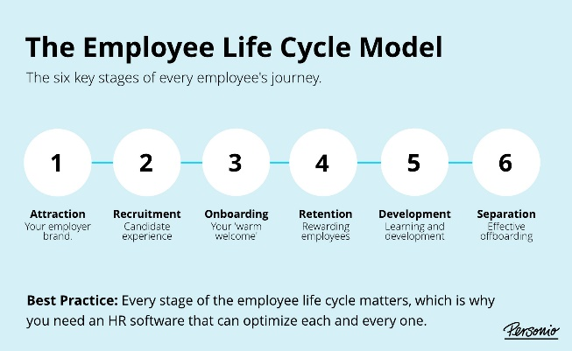
Fig: Employee LifeCycle
Source: https://www.personio.com/hr-lexicon/employee-life-cycle-model-uk/
- Attraction: Attraction frequently occurs before recruiting when a candidate is still only a potential possibility. Presumably, they are inquiring about the company's reputation and whether they have ever worked with, partnered with, or purchased from them from their friends, family members, and coworkers. Candidates' interest can be piqued during the Attraction stage if you use employer and consumer branding strategies that speak to their deepest motivations and interests (ALFANO et al., 2018). To do this, you need to be familiar with not only their own goals, but also their expectations from their time spent working for your organization. Maintain coherence in your approach across all platforms, from social media and live events to your website and word of mouth.
- Recruitment: Recruitment is the process of finding and persuading qualified candidates to join your company. The second stage of a worker's life cycle is recruitment. When a post becomes available or is established, that's when recruitment takes place. As stated by Villeda & McCamey, (2019), When recruiting is done well, it improves the candidate experience, fosters teamwork in the hiring process based on set standards, and yields useful data for future personnel decisions. Referrals from current employees are a great source of new hires. Working professionals have networks of friends and colleagues who might be qualified for the open post (Cloutier et al., 2015). Your chances of attracting the best candidates will definitely be reduced by vague job advertisements. In order to attract a larger pool of candidates, it is preferable to be general; but, in order to make the most of both of your time, it is essential to be specific about the traits you are looking for in a candidate.
- Onboarding: The next phase of the employee life cycle model involves integrating new hires. This stage is taken after choosing the best applicants to make sure they are competent and familiar with the workplace's culture. This is the new employee orientation. New employees receive training in their specific jobs, as well as in the company's values and the attitudes, knowledge, skills, and behaviors they'll need to thrive in their new positions, throughout the onboarding process (Cascio & Graham, 2016). The new hire must be given a clear explanation of the company's beliefs and goals during the onboarding process, and any queries they may have must be addressed. You may make sure that their point of view is consistent with success by answering any questions they may have and finding out more about what the values mean to them. Leaving a new hire on their own after the first week of training has been shown to significantly reduce output. Schedule follow-up meetings with each new hire after a few weeks to discuss their progress and any challenges they may have had while integrating into the team.
- Retention: At stage five of the lifecycle model, employee retention is introduced. By making sure that your best employees feel appreciated and challenged in their current positions, you can concentrate your time and effort on maintaining them (Barr, 2022). The company's culture may suddenly have a greater impact than ever. If your company culture is toxic, you should prepare for a high turnover rate, which will force you to consistently invest in hiring new staff. You can lower this risk and improve employee longevity and job satisfaction by focusing on retention (Boamah et al., 2022). As a first step to a higher percentage of staff retention, make sure that everyone on your team is aware of the goals and objectives of the organization. You need to keep people informed about their role in the business and how each person's actions support the enterprise's overarching goals.
- Development: Employee development is the stage at which an employee is in the employee life cycle concept. You should start actively assisting your staff's professional development at this time. This will support them in honing their skills and clearing the way for potential internal promotion in the future. The benefits of sending team members to relevant conferences and seminars for skill development cannot be overstated. To determine staff members' areas of specialty, supervisors must collaborate closely with them (Schuchmann & Seufert, 2015). Using their own perception of how they are doing, they may decide what needs to be improved and how. The majority of your staff members probably engage in informal development activities outside of the office on a regular basis (Gerken et al., 2015). Make it a point to look into the details after hearing about a staff person who went above and above, and when you do, be sure to express your gratitude and appreciation.
- Separation: When an employee quits their job, their life cycle comes to an end. Whether it's for retirement, advancement in their careers, or other personal reasons, most workers quit their positions at some point during their lives. It's critical to employ the same strategic thinking while leaving a job as when being hired. If one of the team members leaves, it will affect the rest of you. To minimize disruption to the organization, the departing employee should receive assistance from the management team and the human resources department (Sivathanu & Pillai, 2018). After an employee's departure from the organization, an interview should be held to get their honest feedback on their time there.

Model for Employee Engagement
Making employees feel valued, engaged, and appreciated is at the heart of employee engagement models, which aim to motivate workers to give their best work (Byrne & MacDonagh, 2017). It serves as the foundation for the entire company culture. Effective policy implementation necessitates sufficient managerial and senior leadership actions.
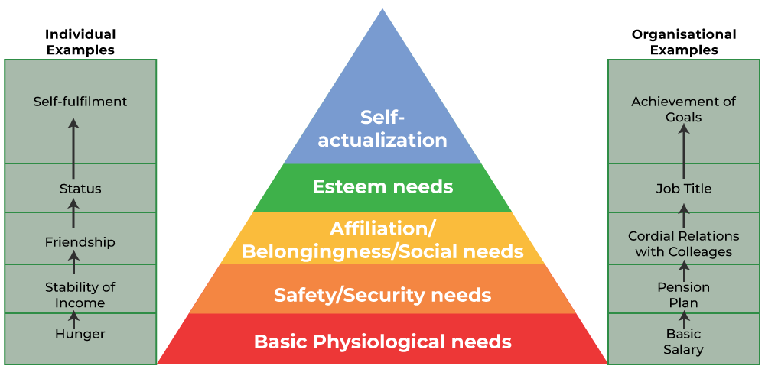
Fig: Maslow’s Hierarchy of Needs
Source: https://www.geeksforgeeks.org/maslows-hierarchy-of-needs-theory/
According to Maslow's hierarchy of needs theory, people may be motivated to act in a way that satisfies their physiological, safety, social, self-esteem, and self-actualization needs (Alex Acquah et al., 2021). The extent to which these prerequisites are met directly correlates with an individual's level of intrinsic motivation. According to the concept, a person's interest and satisfaction in their job are directly related to how well they are able to achieve these expectations. When workers are guaranteed a stable income and a risk-free workplace, their most basic requirements are met (Kullmann, 2018). The workplace should also foster feelings of belonging and gratitude among workers. Additionally, workers desire the opportunity to improve professionally, be creative, and be free to pursue their interests.
Everyone working in the hotel industry must work together, from the front desk to the cleaning crew and everyone in between. To get all the many cogs to turn smoothly, communication must be encouraged to be open and honest (Aitken et al., 2020). Asking for problems or suggestions for improvement in an anonymous manner is a crucial part of a successful engagement programs. Then you can identify problems quickly and get advice from front-line employees about potential repairs. Quarterly surveys provide clear insight into which upkeep, improvement, and repair needs are having the biggest financial impacts on a substantial property (and should be taken care of as soon as possible). This might be brought on by anything from sluggish lobby software to outdated vacuums that merely shift the dust around rather than truly cleansing the air. You'll be able to evaluate the situation accurately and quickly. Employees frequently provide useful information, such as the best type of training, if asked for thoughts on how they might be helped in their work. Additionally, by continually demonstrating your dedication to advancement, you can encourage a growth-oriented culture within your organization.

Conclusion
We might infer that employee engagement is a more intricate and challenging subject than it would first appear to be. Human Resources must have a complete understanding of the employment contract. Human resources are in charge of making sure that employees have the right tools, training, and working circumstances. People who enjoy their jobs are aware of the expectations. One of the most helpful tools for organizing an employee's interactions with your firm is the employee life cycle model, which gives you a clear picture of what to expect at each stage and the information you need to make that period as effective as possible. Finding and sustaining a great team can be difficult, but you'll have a far greater chance if you put up your best effort in every project.

Reference
Aitken, G. et al. (2020) ‘Participatory alignment: A positive relationship between educators and students during online masters dissertation supervision’, Teaching in Higher Education, 27(6), pp. 772–786. doi:10.1080/13562517.2020.1744129.
Alex Acquah et al. (2021) ‘Literature review on theories motivation’, EPRA International Journal of Economic and Business Review, pp. 25–29. doi:10.36713/epra6848.
ALFANO, M., CARTER, J.A. and CHEONG, M. (2018) ‘Technological seduction and self-radicalization’, Journal of the American Philosophical Association, 4(3), pp. 298–322. doi:10.1017/apa.2018.27.
Barr, E. (2022) The 6 stages of the employee life cycle • sprigghr, SpriggHR. Available at: https://sprigghr.com/blog/360-degree-continuous-feedback/the-6-stages-of-the-employee-life-cycle/ (Accessed: 25 May 2023).
Boamah, S.A. et al. (2022) ‘Striking a balance between work and play: The effects of work–life interference and burnout on faculty turnover intentions and career satisfaction’, International Journal of Environmental Research and Public Health, 19(2), p. 809. doi:10.3390/ijerph19020809.
Byrne, O. and MacDonagh, J. (2017) ‘What’s love got to do with it? employee engagement amongst higher education workers’, The Irish Journal of Management, 36(3), pp. 189–205. doi:10.1515/ijm-2017-0019.
Cascio, W.F. and Graham, B.Z. (2016) ‘New strategic role for HR: Leading the employer-branding process’, Organization Management Journal, 13(4), pp. 182–192. doi:10.1080/15416518.2016.1244640.
Cattermole, G. (2019) ‘Developing the employee lifecycle to keep top talent’, Strategic HR Review, 18(6), pp. 258–262. doi:10.1108/shr-05-2019-0042.
Gerards, R., van Wetten, S. and van Sambeek, C. (2020) ‘New ways of working and intrapreneurial behaviour: The mediating role of transformational leadership and social interaction’, Review of Managerial Science, 15(7), pp. 2075–2110. doi:10.1007/s11846-020-00412-1.
Gerken, M., Beausaert, S. and Segers, M. (2015) ‘Working on professional development of faculty staff in Higher Education: Investigating the relationship between social informal learning activities and employability’, Human Resource Development International, 19(2), pp. 135–151. doi:10.1080/13678868.2015.1116241.
Hanaysha, J. (2016) ‘Testing the effects of employee engagement, work environment, and organizational learning on Organizational Commitment’, Procedia - Social and Behavioral Sciences, 229, pp. 289–297. doi:10.1016/j.sbspro.2016.07.139.
Kullmann, M. (2018) ‘Work-related securities: An alternative approach to protect the workforce?’, International Journal of Comparative Labour Law and Industrial Relations, 34(Issue 4), pp. 395–412. doi:10.54648/ijcl2018018.
Newman, S.A. and Ford, R.C. (2021) ‘Five steps to leading your team in the virtual COVID-19 workplace’, Organizational Dynamics, 50(1), p. 100802. doi:10.1016/j.orgdyn.2020.100802.
Ogohi Daniel, Dr.C. (2019) ‘Effects of change management on the performance of firms in Nigeria’, International Journal of Advances in Scientific Research and Engineering, 5(1), pp. 59–64. doi:10.31695/ijasre.2019.33065.
Schmitt, A., Den Hartog, D.N. and Belschak, F.D. (2016) ‘Transformational leadership and proactive work behaviour: A moderated mediation model including work engagement and job strain’, Journal of Occupational and Organizational Psychology, 89(3), pp. 588–610. doi:10.1111/joop.12143.
Schuchmann, D. and Seufert, S. (2015) ‘Corporate learning in times of&nbsp; digital transformation: A conceptual framework and service portfolio for the learning function in banking organisations’, International Journal of Advanced Corporate Learning (iJAC), 8(1), p. 31. doi:10.3991/ijac.v8i1.4440.
Sivathanu, B. and Pillai, R. (2018) ‘Smart HR 4.0 – how industry 4.0 is disrupting HR’, Human Resource Management International Digest, 26(4), pp. 7–11. doi:10.1108/hrmid-04-2018-0059.
Sobering, K. (2019) ‘The relational production of Workplace Equality: The case of worker-recuperated businesses in Argentina’, Qualitative Sociology, 42(4), pp. 543–565. doi:10.1007/s11133-019-09434-y.
Villeda, M. and McCamey, R. (2019) ‘Use of social networking sites for recruiting and selecting in the hiring process’, International Business Research, 12(3), p. 66. doi:10.5539/ibr.v12n3p66.

