

Student name: ANDERSON SOGLO
Student ID 2523957

Module name: Introduction to Health and Social Care
Module code: LCHS4003_LON
Lecturer name Ping Wu

Two Challenges Faced by the NHS Ambulance Service
Challenge 1: Rising Demand
One of the biggest challenges facing the NHS Ambulance Service is the increasing demand for emergency care. England's growing and ageing population means more people require
urgent medical treatment. Long-term conditions such as heart disease, diabetes, and respiratory illnesses have also increased the number of emergency calls (National Audit Office, 2023). In addition, many patients contact ambulance services because they cannot easily access GP appointments or other healthcare services. As a result, ambulance crews receive millions of emergencies calls each year, placing considerable pressure on staff, vehicles, and emergency control centres. High demand can increase response times and make it more difficult to reach the most critically ill patients quickly (Care Quality Commission, 2024).
Challenge 2: Hospital Handover Delays and Staff Pressure
Another major challenge delays outside hospital emergency departments. Ambulances sometimes must wait for long periods before patients can be handed over because hospitals are overcrowded and there are insufficient available beds (National Audit Office, 2023). During these delays, ambulance crews and vehicles cannot respond to new emergencies. Staff shortages and increasing workloads have also affected the service. Paramedics often work long shifts in stressful situations, responding to traumatic incidents while making rapid clinical decisions (College of Paramedics, 2024). This can lead to physical exhaustion, stress, burnout, and difficulties recruiting and retaining experienced staff. Supporting staff wellbeing has therefore become a major priority for the NHS (College of Paramedics, 2024).

Brief History of the NHS Ambulance Service
Before the creation of the NHS in 1948, ambulance services were managed by local authorities, charities, and voluntary organisations. The quality of services varied depending on where people lived, meaning access to emergency healthcare was not equal across the country (Association of Ambulance Chief Executives (AACE), 2025). When the National Health Service was established in 1948, ambulance services became part of the NHS. This ensured that emergency ambulance care was free at the point of use and available to everyone, regardless of income (NHS England, 2025). Today, ambulance services use modern technology including computer-aided dispatch systems, GPS vehicle tracking, electronic patient records, specialist response teams, and advanced life-support equipment. The role of paramedics has also expanded, allowing them to deliver more treatment without needing to transport every patient to hospital (College of Paramedics, 2024).

Current Functioning of the NHS Ambulance Service
The NHS Ambulance Service receives millions of emergencies calls every year through the 999 system (NHS England, 2025). When someone calls, trained emergency call handlers gather important information about the patient's condition and location (NHS England, 2025). The call is then prioritised according to its urgency. Patients with life-threatening conditions, such as cardiac arrest, stroke, severe breathing difficulties, or major trauma, receive the highest priority. Modern ambulance services also provide specialist support through critical care teams, hazardous area response teams (HART), air ambulances, mental health response teams, and patient transport services for people who require non-emergency medical transport (Association of Ambulance Chief Executives (AACE), 2025). Technology plays a major role in improving patient care. Ambulances carry advanced medical equipment, including cardiac monitors, oxygen therapy devices, defibrillators, and digital communication systems that allow crews to share patient information directly with hospitals before arrival.

Explanation of the NHS Ambulance Service

The NHS Ambulance Service is one of the most important healthcare services in the United Kingdom. It provides emergency medical care to people who are seriously ill or injured and need immediate help (NHS, 2025).. Ambulance services operate 24 hours a day, 7 days a week, responding to emergency calls made through the 999 system (NHS England, 2025). The service aims to reach patients quickly, provide life-saving treatment, and transport them safely to hospital when required (NHS, 2025). Ambulance crews include paramedics, emergency medical technicians (EMTs), ambulance care assistants, call handlers, and emergency dispatch staff. Paramedics are highly trained healthcare professionals who can assess patients, diagnose medical conditions, provide emergency treatment, administer medicines, perform cardiopulmonary resuscitation (CPR), and use equipment such as defibrillators to restart the heart if necessary. The NHS Ambulance Service also works closely with NHS 111, hospitals, GPs, fire and rescue services, and the police. Not every patient needs to be taken to hospital. In many cases, paramedics can treat patients at home or refer them to another healthcare service, helping reduce pressure on emergency departments.

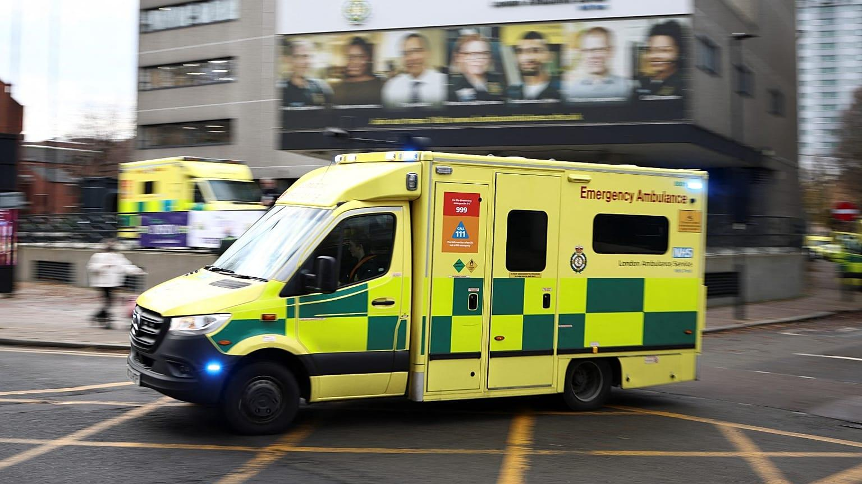
NHS Ambulance services
Anderson Soglo, introduction to public health, 2523957@student.uwtsd.ac.uk
Element 2

Residential care home
1. Origins of Residential Care Homes
Residential care homes have evolved over time in response to changing social attitudes and the growing need to support older and vulnerable people. Before the 20th century, most older adults depended on family members, charities, or religious organisations for care. Those without family or financial support often lived in workhouses, established under the Poor Law Amendment Act 1834. Although workhouses provided basic food and shelter, they were associated with overcrowding, poor living conditions, and limited personal freedom. Their primary purpose was to discourage reliance on public assistance rather than provide high-quality care.
A significant change occurred with the National Assistance Act 1948, which abolished workhouses and introduced residential care services managed by local authorities. This marked a shift towards providing care based on dignity, safety, and individual needs rather than poverty. The creation of the welfare state also ensured that vulnerable older people had greater access to organised support.
During the second half of the 20th century, increasing life expectancy and rising numbers of people living with long-term conditions, such as dementia, arthritis, and physical disabilities, led to a greater demand for residential care. As a result, the number of residential care homes expanded, with services being provided by local authorities, private companies, and voluntary organisations.
2. How Residential Care Homes Function Today
Residential care homes provide accommodation, personal care, and support for individuals who can no longer live independently due to age, disability, or illness but do not require continuous nursing care. Their main aim is to help residents maintain their independence while ensuring they receive the assistance needed to live safely and comfortably. Residents usually have their own private bedrooms and share communal facilities such as lounges, dining rooms, gardens, and activity areas, encouraging both privacy and social interaction.

Care staff are available 24 hours a day, seven days a week to provide support with daily living activities. This includes assistance with personal hygiene, dressing, eating and drinking, mobility, medication management, housekeeping, and emotional wellbeing. Staff also monitor residents' health and work closely with GPs, community nurses, pharmacists, and other healthcare professionals to ensure residents receive appropriate medical care when needed.
In England, residential care homes are regulated by the Care Quality Commission (CQC), which is responsible for monitoring the quality and safety of health and social care services. The CQC carries out regular inspections and assesses whether care homes are safe, effective, caring, responsive, and well-led. Following inspections, services are rated as Outstanding, Good, Requires Improvement, or Inadequate, helping residents and their families make informed decisions and encouraging care providers to maintain high standards of care.
3. Significance in Enhancing Quality of Life
Residential care homes play a vital role in improving the quality of life of older adults and vulnerable individuals. One of their greatest benefits is providing a safe environment where residents receive professional support while maintaining as much independence as possible. Staff encourage residents to make choices about their daily routines, helping them retain dignity and confidence. Care homes also reduce social isolation, which is a common problem among older people. Organised activities and shared living spaces encourage residents to build friendships and remain socially active, improving emotional wellbeing and reducing feelings of loneliness. Health outcomes may also improve because residents receive regular meals, medication support, and prompt access to healthcare professionals such as GPs, physiotherapists, and occupational therapists. Families often gain reassurance knowing that trained staff are always available to respond to emergencies or changes in a resident's health.

Conclusion
Residential care homes are a vital part of the UK's health and social care system, providing safe accommodation, personal care, and emotional support for people who are unable to live independently. They have evolved from basic institutional care into person-centred services that focus on dignity, independence, and quality of life. Although they face challenges such as increasing demand, staff shortages, and rising costs, residential care homes continue to play an essential role in supporting an ageing population and ensuring residents receive safe, compassionate, and high-quality care (Care Quality Commission (CQC), 2024; Age UK, 2024).

References

National Health Service (NHS) (2025) When to call 999. Available at: https://www.nhs.uk/nhs-services/urgent-and-emergency-care-services/when-to-call-999/ (Accessed: 17 July 2026).

NHS England (2025) Ambulance services. Available at: https://www.england.nhs.uk/urgent-emergency-care/ambulance-services/ (Accessed: 17 July 2026).

Association of Ambulance Chief Executives (AACE) (2025) About UK ambulance services. Available at: https://aace.org.uk (Accessed: 17 July 2026).

National Audit Office (2023) Progress in improving emergency care in England. London: National Audit Office. Available at: https://www.nao.org.uk (Accessed: 17 July 2026).

College of Paramedics (2024) About paramedics. Available at: https://collegeofparamedics.co.uk (Accessed: 17 July 2026).

National Health Service (NHS) (2025) NHS image library. Available at: https://www.nhs.uk (Accessed: 17 July 2026). OR Wikimedia Commons (2025) Category: Ambulances. Available at: https://commons.wikimedia.org/wiki/Category:Ambulances (Accessed: 17 July 2026).

