

LEVEL 7 ASSESSMENT SPECIFICATION

Student name: | Sejal Choudhary | Student ID number: | 2538991
Programme: | Master of Business Administration
Module: | Marketing Management
Module code: | LCMB7024 | Contribution to Overall Module Assessment (%): | 50%
Lecturer: | Laila Maazouz (London)  Taonga Kaonga Sobere-Snithers (Birmingham) | Internal Verifier: | Vasilios Tavlaridis  Hoang Nguyen
Assignment Title: | Marketing Environment Analysis | Word count (or equivalent): | 2,500 Words (± 10%)
Submission deadline: | Friday 26th June 2026 by 2pm | Return date of provisional marks & written feedback: | 24th July 2026

Table of Contents
1. Introduction 3
2. Task 1: Marketing Environment Analysis 3
2.1 Marketing Environment Overview 3
2.2 External Actor 1: Natural Environment 3
2.3 External Actor 2: Political and Regulatory Environment 5
2.4 Marketing Implications for Rio Tinto 6
3. Task 2: Strategic Growth and Competitive Positioning 6
3.1 Ansoff Matrix Overview 6
3.2 Growth Strategy Recommended: Product Development. 7
3.3 Competitive Advantage Strategy: Differentiation Strategy 8
3.4 Role of Technology in Future Marketing Development 9
3.5 Strategic Recommendation 9
4. Task 3: Critical Reflection on AI Usage 10
4.1 Tool Disclosure 10
4.2 Critical Evaluation of AI Output 10
4.3 Contribution Analysis 10
4.4 Ethical and Professional Reflection 11
5. Conclusion 11
Reference List 12

1. Introduction
Rio Tinto is one of the major mining companies in the world that is under pressure to implement sustainable and low-carbon operations (Rio Tinto, 2026). This report examines its marketing environment, suggests a suitable growth strategy to gain a competitive advantage, and critically examines how artificial intelligence was used in the development of the report. In 2025, Rio Tinto reported strong performance with a 9% increase in EBITDA, stable earnings of $10.9 billion, record copper and bauxite production, $7.4 billion copper EBITDA, 20% aluminium EBITDA growth, $11 billion capital expenditure, and net debt rising to $14.4 billion following the Arcadium acquisition (Fatima, 2026).

2. Task 1: Marketing Environment Analysis

2.1 Marketing Environment Overview
External marketing environment comprises of macro-level forces that impact business strategic decisions and long-term sustainability of organisations. As per Principles of Marketing, organisations should continuously review external factors since they influence competitive positioning and operation strategies. Khan et al. (2023) also posit that business sustainability, adoption of innovations, and strategic decision-making process are heavily dependent on macro-environmental conditions.

2.2 External Actor 1: Natural Environment
The natural environment is the greatest external factor affecting Rio Tinto in its shift towards lower-carbon operations since mining operations impact directly on the climate systems, natural resources, and ecological sustainability.
Climate Change Pressure
Mining is also known to be a major source of greenhouse gases in the world due to extraction, transportation, and mining of the mineral products. The rising global concern over climate change has mounted pressure on mining firms to cut down on carbon footprints and be in tandem with the global goals of sustainability. In the case of Rio Tinto, the need to cut down on emissions has gained importance since the stakeholders are demanding more and more of an environmentally friendly operation and the governments are adopting more stringent carbon reduction targets on high emission industries.
Resource Scarcity and Sustainable Extraction
Mining firms are very much reliant on natural resources which are finite and therefore long-term sustainability of resources is among the primary strategic issues. According to Hassler et al. (2022), the lack of resources is becoming more and more a pressure to make organisations more efficient and resort to other technologies. Rio Tinto is thus under pressure to come up with responsible extraction strategies that reduce environmental degradation, but at the same time guarantee sustainability of resources and operations in the long-term.
Transition Toward Low-Carbon Production
In line with decarbonisation goals, Rio Tinto has been proactive in developing renewable energy infrastructure and lower carbon production technologies. Fernandez-Landero et al. (2023) report that the company entered into a fifteen-year renewable wind power contract to help it operate Kenneth in the United States. By 2030, the organisation has made a target of 50% reduction in Scope 1 and Scope 2 emissions and net-zero emissions by 2050, which is a significant commitment to sustainable production systems.
Environmental Stakeholder Pressure
The pressure of stakeholders plays a significant role in environmental decision making of large organisations. The author claims that under the high pressure of stakeholders, innovation performance is better when there is environmental collaboration (Adomako and Tran, 2022). Customers who demand sustainable raw materials, governments that impose environmental requirements, environmental organisations that demand responsibility, and investors who are placing an increasing emphasis on ESG-based investment decisions are putting pressure on Rio Tinto to hasten the transformation towards sustainable operational practices.
The transition to sustainability by Rio Tinto enhances corporate image and promotes sustainable leadership over the long term. According to Sajjad et al. (2023), sustainability leadership increases long-term competitiveness of organisations and trust of stakeholders. Nominal investments and technological changes in the process of transition contribute to the financial risk associated with the adoption of low-carbon technologies, as well as more complexity in the operations.
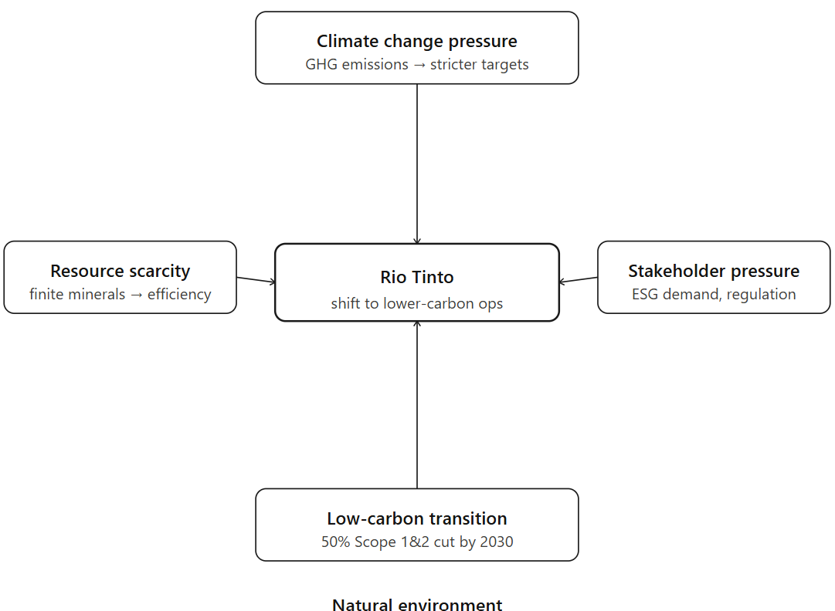
Figure 1: External actor 1 analysis
(Self-developed)

2.3 External Actor 2: Political and Regulatory Environment
The political and regulatory environment is another issue that affects the sustainability of Rio Tinto transition since the governments are stricter in the performance of the environmental context in the carbon-intensive sectors.
Government Regulations
The world governments are enacting more stringent environmental laws, carbon taxation policies, and waste management policies on mining activities. As Cacciuttolo and Cano (2022) point out, mining operations pose significant environmental hazards such as soil pollution, tailings pollution, and water pollution. As a result, mining organisations are likely to encounter greater legal requirements that stipulate the need to have better environmental management systems and cleaner production processes.
International Climate Policies
International treaties like the Paris Climate Agreement are still contributing to corporate sustainability policies. Yang et al. (2024) maintain that the shift to renewable energy has become a primary part of climate regulation all over the world, and organisations must focus on the fact that they need to decrease the use of fossil fuel-based production schemes and enhance the quality of ESG reporting.
Impact on Rio Tinto Operations
The growing environmental regulations impose more compliance burdens on Rio Tinto. Trebbi et al. (2026) demonstrate that compliance with regulations can greatly raise the operational costs of organisations, especially in those sectors which are highly regulated. Rio Tinto is therefore obliged to invest continuously in the environmental compliance systems, reporting structure, and technological improvements.
The pressure by regulations stimulates technological advancement and cleaner systems of operation. The compliance requirements, however, are stricter and add to the cost of operations and result in a decrease in the short-term profitability although they improve the performance of long terms sustainability.
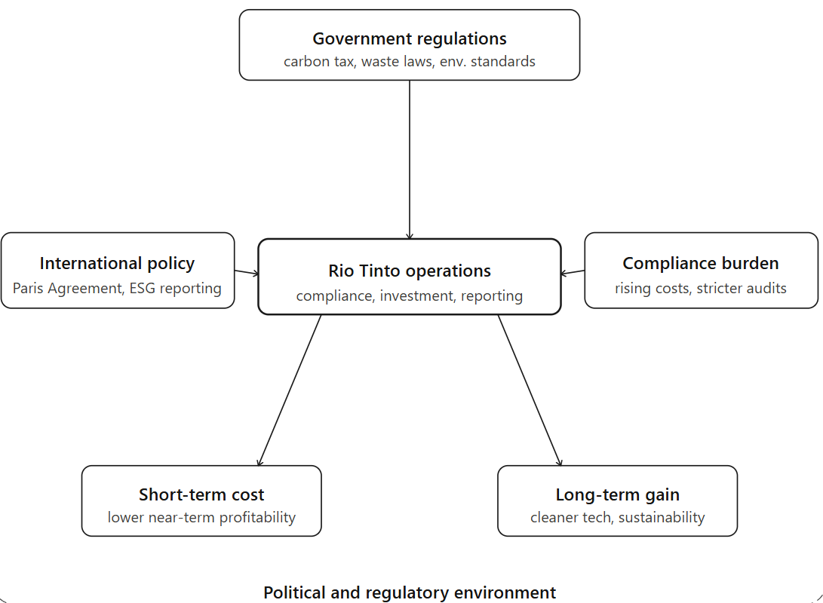
Figure 2: External actor 2 analysis
(Self-developed)

2.4 Marketing Implications for Rio Tinto
These are the environmental forces that have a considerable impact on the marketing strategy and the general competitiveness of Rio Tinto. To begin with, sustainability initiatives enhance brand positioning in the sense that they enable the company to position itself as a responsible mining organisation that takes the issue of environmental stewardship seriously. This will enhance corporate reputation among governments, customers and institutional investors. Second, customer demand is shifting towards sustainable industrial materials, especially low-carbon aluminium and conscientiously sourced minerals utilised in industries of renewable energy and electric vehicles. Third, the ESG performance becomes an ever more important factor in investor confidence due to the interest of institutional investors in environmentally responsible organisations that have long-term sustainability obligations (Fernández-Landero et al., 2023). Lastly, Rio Tinto will be under intense competition with its industry competitors like BHP Group, Tata Steel, and Codelco, all of which are investing in less-carbon production systems. This has led to the necessity of effective sustainability marketing in order to sustain long-term competitive advantage and relevance in the market. Such environmental pressures introduce opportunities and threats to Rio Tinto because sustainability efforts enhance long-term brand value and stakeholder confidence. But at the same time demand a lot of financial resources, adjusting operations, and constant innovation, which in turn can hurt short-term profitability and create strategic uncertainty. Rio Tinto is under the same sustainability pressure as competitors like BHP Group, Tata Steel, and Codelco, but its inability to adapt quicker can undermine its competitiveness, as effective low-carbon transition can reinforce its position in the market, brand reputation, and investor trust.

3. Task 2: Strategic Growth and Competitive Positioning

3.1 Ansoff Matrix Overview
Ansoff Matrix is a strategic analysis tool that is applied in organisational developments. EBSCO, (2023) describes four strategies of growth: market penetration, product development, market development and diversification. The framework assists organisations to weigh growth opportunities and strike a balance between risk levels related to expansion strategies.

3.2 Growth Strategy Recommended: Product Development.
Out of the four Ansoff strategies, product development is the most appropriate growth strategy that Rio Tinto can pursue since the company already has a presence in the already developed industrial markets and can be able to consolidate the competitive position through addition of lower-carbon mineral products in line with sustainability requirement. The product development is more appropriate than markets development or diversification since Rio Tinto can leverage its current capabilities and customers and minimise risk and react directly to the increasing demand of sustainable mineral products.
Low Carbon Aluminium
Rio Tinto can enhance growth by increasing the cleaner production of aluminium, which is now a major concern in decarbonisation-oriented industries. According to Yee et al. (2022), cleaner forms of aluminium production are much less damaging to the environment and more efficient in production. With the current increase in aluminium demand in the automotive, aerospace and renewable energy sectors, manufacturing low-carbon aluminium will enable Rio Tinto to present itself as an industrial material supplier that responds to global sustainability transformation.
Copper for Renewable Energy Industry
The use of copper is still vital in electric cars, solar systems, and renewable energy systems. According to Guj and Schodde (2024), global net-zero targets will create a high demand of copper even though future supply would be problematic. This allows Rio Tinto to increase sustainable copper production to supply renewable energy industries and consolidate its market within emerging clean energy supply chains.
Lithium Expansion
The growth in demand of lithium is expected to grow since battery technology will remain the core of electric cars and massive energy storage systems. Thomas et al. (2024) reveal that the further development of battery technology will push the quantity of lithium demanded in the future to a greater height. Rio Tinto can increase its lithium production activity to seize emerging opportunities in battery manufacturing markets and enable the rapid shift toward renewable energy and low-carbon transportation systems around the globe.
Strategic Justification
Product development presents Rio Tinto with a good strategic opportunity since the company is able to exploit available relationship with its current customers as it also reacts to the growing demands of sustainability. According to Pavloudakis et al. (2024), sustainable mining is becoming a driving factor in future competitiveness in the mineral extraction industries. Nevertheless, this approach entails significant research and development expenditure, technological innovation capacity, and proper handling of market uncertainty related to changing low-carbon technologies.
Risk Assessment
Despite the fact that product development helps to achieve long-term growth, the strategy implies a number of risks. A lot of capital investment is needed to create cleaner production systems, sustainable technologies of extraction and low-emission infrastructure. Moreover, the speed at which technology is transforming can lead to confusion of how the production will be in the future and the rate of its uptake by customers. Thus, Rio Tinto needs to establish a delicate equilibrium between investment in innovation and financial sustainability and efficiency in operations as it shifts to the development of low-carbon products.

3.3 Competitive Advantage Strategy: Differentiation Strategy
Rio Tinto needs to implement a differentiation strategy that is founded on the Porters Generic Strategies in order to enhance its competitiveness in the long run. Ali and Anwar (2022) argue that the generic strategies developed by Porter play a major role in organisational competitive advantage by enabling firms to differentiate themselves in a highly competitive industry.
Rio Tinto has an opportunity to distinguish themselves through creating sustainable mining activities, low-carbon industrial products, and sustainable supply chain systems. Instead of being a price leader, the organisation can position itself as a sustainability-based mining leader that provides green products that customer expectations are changing. According to Fan et al. (2025), the sustainability of a green supply chain and zero-carbon production system are becoming key aspects of value creation by mining organisations, and thus, sustainability is becoming a central competitive differentiator.
This differentiation strategy also develops a number of benefits. First, sustainable production capacities enhance brand reputation through environmental responsibility. Second, it is the case that customers are paying more attention to sustainable sourcing practices, which can enable Rio Tinto to potentially charge a premium price in the specialised industrial markets. Third, sustainability leadership enhances customer loyalty in the long-term and better relationship with socially responsible investors.
Nevertheless, differentiation is not easy to maintain since sustainability initiatives can be imitated by the competitors in the long run. The ongoing investment in innovation thus becomes critical towards sustaining competitive edge in the fast growing low-carbon industrial markets.

3.4 Role of Technology in Future Marketing Development
In the future Rio Tinto competitive positioning and sustainability marketing strategy, technological development will feature heavily. Artificial intelligence is making predictive maintenance systems more advanced, predicting equipment issues before they disrupt operations. Rojas et al. (2025) demonstrate that AI-based predictive maintenance enhances operational efficiency and minimizes downtime and maintenance expenses in mining activities.
The blockchain technology can enhance transparency of the supply chain by enabling customers and investors to check on the sustainable sourcing of mining activities. Moreover, data analytics can be used in demand forecasting to determine the future customer needs in renewable energy sectors. Digital sustainability reporting systems also enable real-time monitoring of ESG performance and enhance stakeholder trust. According to Cacciuttolo et al. (2023), technological advancements are crucial to future competitive advantage because smart mining technologies, sensors, and digital monitoring systems are increasingly facilitating sustainability performance.

3.5 Strategic Recommendation
Rio Tinto must focus on product development by increasing sustainable mineral products such as low-carbon aluminium, copper and lithium products. At the same time, the company can enhance low-carbon brand positioning, invest in superior digital technologies, and differentiate using sustainability innovation. Rio Tinto needs to also incorporate the use of artificial intelligence, predictive analytics, and digital sustainability monitoring tools to streamline operations and enhance environmental performance and develop innovation-based competitive advantages to reinforce sustainable market leadership in the long term.

4. Task 3: Critical Reflection on AI Usage

4.1 Tool Disclosure
There was minimum use of artificial intelligence in preparation of this report. The consultation with ChatGPT was limited to acquiring a general idea of how academic reports are traditionally structured and how information can be presented in an effective way. Nonetheless, it was not applied to report writing, content generation, academic research, and direct structure creation. The collection of all the academic sources was done independently with the help of journal databases, company reports, and textbooks. The last section, written work, analysis and general report writing were fully achieved by independent academic work in order to meet assessment requirements.

4.2 Critical Evaluation of AI Output
Due to the fact that only general guidance was obtained using artificial intelligence but not content generation, very little verification was needed. Any recommendations made on how to organise the report were done in a way that assignments guidelines were looked at to make sure that the requirements of the university are met. In this regard, specific focus was placed on the prevention of direct reliance on AI-generated recommendations since the evaluation particularly limited the usage of artificial intelligence in writing and in structure development. All scholarly data, sustainability data of the company, and evidence were gathered by hand using peer-reviewed journal articles and official Rio Tinto corporate reports. This self-verification procedure meant that there was no false information, misleading advice or unsubstantiated content that could have affected the final submission of the report.

4.3 Contribution Analysis
The level of artificial intelligence assistance versus independent academic contribution during the preparation of this report was evident. Artificial intelligence only helped with general ideas on how academic reports are typically presented and how they could be structured. Nevertheless, any substantial academic work was done autonomously. Personal contribution was to choose Rio Tinto as the case study organisation, do independent research, find relevant journal articles, critically analyse external environmental factors, use strategic frameworks such as Ansoff Matrix and Porters Generic Strategies, develop arguments, analyse evidence and write the final written report. Thus, the general submission is more of independent academic work than AI-based contribution.

4.4 Ethical and Professional Reflection
AI has a lot of benefits in academic and professional life as it can help access information much faster and even give helpful advice in the process of learning. Nevertheless, there are also significant ethical issues of over-reliance on such technologies. Artificial intelligence systems can generate false results, false recommendations, or biased interpretations that can adversely impact academic quality when unquestioningly accepted. Another aspect of academic misconduct is when students use the AI to write or develop assignments outside of school policies. In this report, restricting the use of artificial intelligence strengthened the value of independent academic accountability and the use of technology with care. Making professional decisions in the business world involves critical thinking, contextualization and independent decision-making that cannot be substituted entirely by automated systems. So, artificial intelligence is not supposed to replace human reasoning, moral accountability, and critical analysis but be a supportive tool in the idea generation.

5. Conclusion
The pressure of the environment is a major factor at Rio Tinto and is speeding up the transition to sustainability. The best lower-carbon growth strategy is product development, and the best long-term competitive advantage is technological innovation. Artificial intelligence may assist in academic research endeavors, although it should be applied ethically, responsibly, and with critical human minds.

Reference List
Adomako, S. and Tran, M.D. (2022). Environmental collaboration, responsible innovation, and firm performance: The moderating role of stakeholder pressure. Business Strategy and the Environment, 31(4), pp.1695–1704. doi:https://doi.org/10.1002/bse.2977.
Ali, B.J. and Anwar, G. (2022). Porter’s Generic Competitive Strategies and Its Influence on the Competitive Advantage. International Journal of Advanced Engineering, Management and Science, 7(6), pp.42–51. doi:https://doi.org/10.22161/ijaems.76.5.
Cacciuttolo, C. and Cano, D. (2022). Environmental Impact Assessment of Mine Tailings Spill Considering Metallurgical Processes of Gold and Copper Mining: Case Studies in the Andean Countries of Chile and Peru. Water, 14(19), p.3057. doi:https://doi.org/10.3390/w14193057.
Cacciuttolo, C., Guzmán, V., Catriñir, P., Atencio, E., Komarizadehasl, S. and Lozano-Galant, J.A. (2023). Low-Cost Sensors Technologies for Monitoring Sustainability and Safety Issues in Mining Activities: Advances, Gaps, and Future Directions in the Digitalization for Smart Mining. Sensors, 23(15), p.6846. doi:https://doi.org/10.3390/s23156846.
EBSCO (2023). Ansoff Matrix | EBSCO. [online] EBSCO Information Services, Inc. | www.ebsco.com. Available at: https://www.ebsco.com/research-starters/business-and-management/ansoff-matrix [Accessed 19 Jun. 2026].
Fan, C., Li, G., Chen, M., Hou, J., Wei, Q., Wang, P. and Guo, G. (2025). The green value chain model of mining company based on zero carbon emissions. Scientific reports, 15(1), p.35175. doi:https://doi.org/10.1038/s41598-025-19094-4.
Fatima, M. (2026). Rio Tinto (RIO) Reports Full Year 2025 Earnings, Highlights Record Copper and Bauxite Production. [online] Yahoo Finance. Available at: https://finance.yahoo.com/news/rio-tinto-rio-reports-full-071135943.html [Accessed 20 Jun. 2026].
Fernández-Landero, S., Fernández-Caliani, J.C., Giráldez, M.I., Morales, E., Barba-Brioso, C. and González, I. (2023). Soil Contaminated with Hazardous Waste Materials at Rio Tinto Mine (Spain) Is a Persistent Secondary Source of Acid and Heavy Metals to the Environment. Minerals, 13(4), p.456. doi:https://doi.org/10.3390/min13040456.
Guj, P. and Schodde, R. (2024). Will future copper resources and supply be adequate to meet the net zero emission goal? Geosystems and Geoenvironment, pp.100320–100320. doi:https://doi.org/10.1016/j.geogeo.2024.100320.
Hassler, J., Krusell, P. and Olovsson, C. (2022). Finite resources and the world economy. Journal of International Economics, 136, p.103592. doi:https://doi.org/10.1016/j.jinteco.2022.103592.
Khan, U., Ali, Y., Petrillo, A. and Felice, F.D. (2023). Macro-environmental factors and their impact on startups from the perspective of developing countries. International Journal of Sustainable Engineering, [online] 16(1), pp.166–183. Available at: https://www.tandfonline.com/doi/full/10.1080/19397038.2023.2238754.
Pavloudakis, F., Roumpos, C. and Spanidis, P.-M. (2024). Sustainable Mining and Processing of Mineral Resources. Sustainability, 16(19), pp.8393–8393. doi:https://doi.org/10.3390/su16198393.
Rio Tinto (2025). Rio Tinto signs new wind power deal for Kennecott. [online] Riotinto.com. Available at: https://www.riotinto.com/en/news/releases/2025/rio-tinto-signs-new-wind-power-deal-for-kennecott [Accessed 19 Jun. 2026].
Rio Tinto (2026). About. [online] Rio Tinto. Available at: https://www.riotinto.com/en/about [Accessed 19 Jun. 2026].
Rojas, L., Peña, Á. and Garcia, J. (2025). AI-Driven Predictive Maintenance in Mining: A Systematic Literature Review on Fault Detection, Digital Twins, and Intelligent Asset Management. Applied Sciences, 15(6), p.3337. doi:https://doi.org/10.3390/app15063337.
Sajjad, A., Eweje, G. and Raziq, M.M. (2023). Sustainability leadership: An integrative review and conceptual synthesis. Business Strategy and the Environment, 33(4), pp.2849–2867. doi:https://doi.org/10.1002/bse.3631.
Thomas, F., Mahdi, L., Lemaire, J. and Santos, D.M.F. (2024). Technological Advances and Market Developments of Solid-State Batteries: A Review. Materials, 17(1), p.239. doi:https://doi.org/10.3390/ma17010239.
Trebbi, F., Zhang, M.B. and Simkovic, M. (2026). The Cost of Regulatory Compliance in the United States*. The Review of Financial Studies. doi:https://doi.org/10.1093/rfs/hhag046.
Yang, G., Zha, D., Cao, D. and Zhang, G. (2024). Time for a change: Rethinking the global renewable energy transition from the Sustainable Development Goals and the Paris Climate Agreement. The Innovation, 5(2), pp.100582–100582. doi:https://doi.org/10.1016/j.xinn.2024.100582.
Yee, S.L., Wan, H., Chen, M., Li, L., Li, J. and Ma, X. (2022). Development of a cleaner route for Aluminum–Vanadium alloy production. Journal of Materials Research and Technology, 16, pp.187–193. doi:https://doi.org/10.1016/j.jmrt.2021.11.125.

