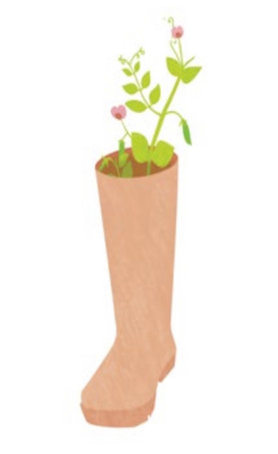


Wellbeing Therapeutic Garden
Placement Report Lena Amir

Section 1

A therapeutic garden comes in all shapes and guises, and is set up for many reasons in very varied settings. At the most general level, they supply cost effective and sustainable way of helping individuals improve their physical and mental well-being. Furthermore, a therapeutic garden can provide people enormous joy by allowing them to interact with the soil and plants, engage in calming activities, find moments of quiet, and serve as a catalyst for various forms of social interaction. To illustrate this further, in 2016, Trellis celebrated its 10th anniversary and the organisation now supports a network of over 300 therapeutic gardening projects. It is now commonly acknowledged how crucial adaptive gardening is to maintaining wellbeing and promoting healing. Some use it to build social networks that boost their self-confidence, while others use it to learn horticultural and life skills that can open up job chances (Trellis, 2016). Similar to this, gardening is incredibly flexible and can be adapted to fit different ages, abilities, interests, and requirements; however, the focus of this article will be on young children.


Coupled with this, there are many benefits of carrying out this report especially according to children’s mental health and wellbeing. For instance, the physical, psychological, social and personal aspect of an individual. Spending only 90 minutes a day in a wooded area reduces depression, and spending one day in nature in a recurring way improves the immune system. Moreover, experts have recorded great benefits in the use of gardens, parks and green spaces, both inside and outside health environments, such as: stress reduction, sleep improvement, anxiety and depression reduction, associated with increased happiness (Frumkin, 2017).

Similarly, there were a few studies that did show that a well being therapeutic garden is beneficial towards an individual's mental health. Firstly, according to a study by (Coyoca et al., 2022) the study aimed to determine the impact of gardening on an individual's mental health and wellbeing. The survey questionnaire was used to collect data for the study, which used a descriptive design. Additionally, statistical tools like mean, frequency, and percentage were used to process the collected data. The research revealed a grand mean of 4.10 for the effect of gardening on mental health. Furthermore, it is determined from the results that gardening has a significant positive effect on one's mental health. In conclusion, the experts strongly advise people to engage in gardening to prevent anxiety and despair. They are also motivated to engage themselves in gardening to boost their mental as well as physical health (Coyoca et al., 2022).

Secondly, a survey conducted by (Sia et al., 2022) was administered on 8,786 participants of a “Gardening with Edibles” programme in Singapore which measured their mental resilience status, engagement in gardening activities and socio-demographic information. In result of this, the mental resilience scores of participants who regularly gardened were compared with the results of a survey that was conducted online during the COVID pandemic among respondents who were demographically representative and interested in Covid-19-related community care.

The findings indicated that those who gardened had much higher mental toughness than the online community. In the gardening group, those who spent less than an hour gardening each week scored significantly lower on five out of the seven resilience factors—emotional regulation, relationship, confidence, positive thinking, and spirituality—than those who spent more time gardening each week. This suggests that the one to four hours of gardening each week may be the magic number for the mediating effects to be most effective. Finally, gardening may be a useful activity for urban residents to engage with nature and develop mental toughness (Sia et al., 2022).

Finally the researcher (Thompson R, 2018) carried out a one group of holistic therapies that aim to treat the whole individual and has been well researched through surveys and randomised trials is so-called green care, or therapy by exposure to plants and gardening. Linking to this, several trials have revealed the beneficial effects on mood and mental health of simply observing nature as well as gardening, maybe even pictures of scenes from nature. According to a Japanese study, seeing plants lowered stress, fear, anger, and melancholy as well as blood pressure, heart rate, and muscular tension in addition to altering EEG recordings (Thompson R, 2018). Overall, this information implies that therapeutic approaches such as gardening can be a very positive and helpful aspect towards an individual's overall mental health and wellbeing.

This project for this placement is a well-being garden for children in the nursery. This garden includes growing different types of flowers and plants and they could watch them grow. The children could also paint the pots as they please. This wellbeing garden could be therapeutic and could link to how gardening and nature could be therapeutic for young children and their mental health. Moreover, for this project I have been volunteering at a nearby nursery close to my home called Buttons and Bows Nursery.

Throughout this project I am trying to achieve a wellbeing therapeutic garden which can be very handy and beneficial towards young children. As well as this, the project is important to achieve as it can help reduce any signs that cause a mental health issue for young children. The aim for this project is to achieve a suitable and safe wellbeing therapeutic indoor garden for the children. The objectives are to ask the manager of the nursery to choose a suitable group of children that could carry out this project. Continuously, it was very important to inform the parents before taking a few photographs of them to confirm their approval. Another objective is to buy all the necessary equipment such as flowers and pots to carry out the project successfully. And finally, carrying out the project which includes guiding the children to place the seeds as well as watering them afterwards. To conclude this information, a thorough summary of the progress done will be shown in this report, which will outline all the aspects and progress into how it became possible and the achievements made throughout.


Section 2

My project was fully completed and I have achieved the required three objectives which was to ask the manager of the nursery to choose a suitable group of children that could carry out this project. Another objective was to buy all the necessary equipment such as flowers and pots to carry out the project successfully. And finally, carrying out the project which includes guiding the children to place the seeds as well as watering them afterwards. Additionally to this, having the opportunity to develop and produce what has become a therapeutic approach to improve children’s mental health and wellbeing presented several other opportunities for me to develop professional skills and drive. From an organisational perspective, the project demanded a certain level of professional competence in fields I had little prior experience in beforehand.


Having to manage excellent time management skills is not easy, however it was very important for me to gain further knowledge about these skills which I did throughout this project. I have gained and improved on this skill by taking the time to analyse and fully arrange a suitable timetable for me to be able to fully complete the 60 hour project. As I had other assignments and tasks to achieve at the same time as this report it was a challenge to fix everything in an organisational manner. According to my project the skill of time management played a huge aspect as a whole, this is because this skill allowed me as a professional to use my time wisely to complete the project. As a professional it was very important and helpful to have the skill of time management. This is because time management is essential to achieve goals and objectives in professional settings. Effective time management helped me make the most of my time, enabling me to fully prioritise tasks, focus on what is important, and achieve my desired outcomes.

Throughout this project I have noticed a few beneficial changes as I have gained my time management skills little by little. For instance, the increase of my productivity. By managing time efficiently, I could maximise my productivity, allowing me to complete tasks quicker and achieve more in a shorter period. As well as this, it reduced unnecessary stress. Gaining these kills reduced my stress levels and helped me avoid the feeling of being too overwhelmed. Similarly, when I plan what needs to be done and when it needs to be done, I am less likely to feel anxious or stressed. Thirdly, time management increased and improved my decision making which was one of my weakest aspects before this project. Time management skills helped me prioritise tasks, allowing me to make informed decisions about what to do first and what to postpone or delegate. Continuously, I have also noticed a boost in motivation and focus within my lifestyle. When I have a clear plan for how to use my time, I am more motivated and focused on my goals, increasing my chances of success during this project.

Another important skill that I have slowly developed is effective communication manners and skill. As a worker in any organisation it’s very beneficial and important to gain effective communication skills. Being an introvert it was not easy to step out of my zone and do something different. However, with this project I decided to try and surprisingly it turned out successfully. As I volunteered in a nursery setting the key aspect was to communicate with the staff as well as the children. This project has helped and improved my communication skills as I had to attend a one to one discussion with the manager of the nursery to fully confirm this project. Identically, by stepping in and entertaining the children during my shift by reading them stories or even helping them with their pots and seeds when it was needed to.

During and after this project I have noticed a few changes in my communication skills that were not there before. To illustrate, enhancement of different problem solving. This helped me understand the problem at hand, brainstorm possible solutions as well as reach a consensus on the best course of action. Clear communication helps avoid misunderstandings, reduces conflicts and increases the likelihood of finding successful solutions with the staff and children. Gaining communication skills has also increased my innovation in many different ways. For example, by sharing the needed ideas and perspectives of my project to the staff members, which they also mentioned new opportunities and exploring innovative solutions during the exchange of email and phone calls to make it suitable for both myself and the children. Moreover, by doing this has improved my productivity. Effective communication is essential for achieving productivity in the workplace setting. Clear communication helped me understand my role, responsibilities, and deadlines, ensuring that everyone is on the same page in the nursery as well as working towards the same goals together as a team.
Professional manners and adaptation was also another skill that I have learned and gained during this project. In a nursery setting it’s needed and essential to gain professional manners whether that’s with the staff or even the children. This skill was very interesting to master as it’s not my best strength to adapt to the actions of children but it was a great challenge for me as I gained this skill. I’ve gained this skill by learning how children act and behaviour during all my shifts in the nursery. For example, I needed to adapt my language and action to balance and level up the children’s action for me to understand what they need if any issues do occur. Coupled with this, this skill helped my professional growth. This was vital for my learning as it created a positive reputation. When I am courteous, respectful, and adaptable, I create a positive impression with the children and staff members, increasing the likelihood of success rate for this project.

In comparison to professional skills I have also gained a few personal skills throughout this project and one of them is confidence and stepping out of my comfort zone when needed to. Like I mentioned above I am a very closed off and introverted individual with people I have never worked with before. Nevertheless I have noticed my confident skills improve while volunteering for the nursery. This occurred when I have spent my time with both staff and children by getting to know them little by little, whether that’s asking the staff for a discussion even if I am nervous to do so. This has most certainly increased my confidence around them during my time in the nursery. Likewise, confidence improved my performance by reducing anxiety, stress, and self-doubt. When I am confident, I can easily focus on my strengths and abilities, leading to improved performance and better results.


Another personal skill I have achieved is active listening skills. I have achieved this skill by attending several shifts which have included listening to the children’s needs when asked to. For instance, when children ask for help to create their flowers or even when they just need a person to sit down and talk to while they create their flower. In addition to this, I have noticed an advantage to this skill, which is the built and maintenance of trust between myself, the staff and children. The skill of listening helps to build trust and rapport with others. When I listened attentively, I showed that I value and respect the speaker's opinions and perspectives which creates a bond between myself and them.
Patience and conflict resolution are great skills that I have benefited throughout this project. As I volunteered with young children it was not easy to work with. This is because at a young age they tend to obtain great amounts of energy which can sometimes lead to loss of control and that did make me feel a bit uneasy and lose patience. Whether that’s calming them down it was a challenge to maintain patience with young children as it’s very important. The benefits of gaining this specific skill is forming better relationships with the individual around me. Patience is a key ingredient in building and maintaining positive relationships. When I am patient, I show respect and consideration towards others, which can strengthen the bonds of trust and respect.

Conflict resolution was the final personal skill I have developed. Usually young children do tend to become very emotional and lash out which I have experienced a couple of times during my shifts and it was quite difficult to calm them down. On the other hand, as time went by I picked up on how to resolve the issues whether that’s between myself and a child or between two children fighting or having a disagreement. This skill was important for me personally to achieve as it can also contribute to my own personal growth. By resolving conflicts within the nursery. I have learned valuable lessons about myself and the children, which can help me to become more self-aware of how to tackle issues with the children as an individual and develop stronger emotional intelligence.

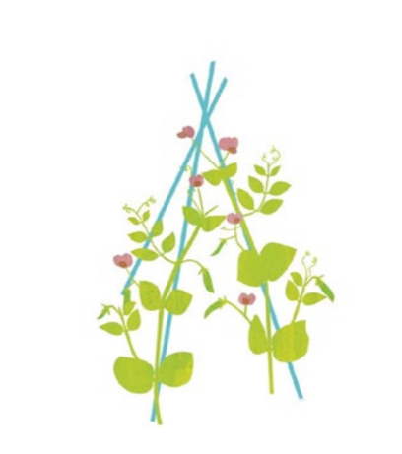
Right through this project I have gained a couple of professional and personal skills which was an excellent experience for my own development. However, there were also some problems along the way that I did not expect to happen. For instance, finding suitable equipment to complete the project. I had to visit more than one florist close to my area and finally decided to travel to B and Q which was a lot bigger and had great access to all the gardening equipment. As this was something I didn’t expect, it took a few hours to complete. Another issue that did occur during the project was finding a suitable time frame to carry out the project. The manager informed me during one the phone call that the nursery was quite busy that season however they did manage to squeeze me in with a lot of planning and that was quite challenging as I needed to use my confidence and effective communication skills which I am prior to this project not very used to.
From completing this project I have learned, achieved and experienced a handful of hours in a nursery, which allowed me to gain the knowledge and understanding of the overall child development and mental health. By volunteering in a nursery setting it created an opportunity to observe and interact with children of different ages, which can help me gain a deeper understanding of child development. I also learnt about different stages of development and what is typical behaviour for each age group. As well as this, a nursery setting may use a variety of teaching strategies and techniques to help children learn and develop. By volunteering in this setting, I carefully observed and learned from these strategies, which may be useful in my own future work with children. Furthermore, by completing this project it provided me with the opportunity to build relationships with children, parents as well as staff members. I have learned how to communicate with children effectively and how to form meaningful connections with them which lies under my professional and personal skills that I have experienced and achieved which is mentioned above. In conclusion, this project was important to achieve not only for the completion of this module but to carry out a therapeutic wellbeing garden to improve the children's mental health whether that's during or after my project has completed. Distracting them from the normal setting of the nursery and allowing them to try out a different calming and therapeutic approach of play and fun was an important aspect of my project.



Reference list

Coyoca, M. B. P., Del Rosario, M. A. B., Lazo, J. R. L., Calixtro Jr, V. L., & Edaño, L. B. (2022). Impact of gardening on physical and mental health in the midst of Covid-19 pandemic. Indonesian Journal of Community and Special Needs Education, 2(2), 99-102.

Early Learning Furniture (2017) Benefits Of Gardening With Kids. Available at:
https://www.earlylearningfurniture.co.uk/blog/benefits-of-gardening-with-kids.aspx (Accessed at 7 July 2017).

Moya, V. The therapeutic garden.

Sia, A., Tan, P. Y., Wong, J. C. M., Araib, S., Ang, W. F., & Er, K. B. H. (2022). The impact of gardening on mental resilience in times of stress: A case study during the COVID-19 pandemic in Singapore. Urban Forestry & Urban Greening, 68, 127448.

Trellis (2016) How To Set Up A Therapeutic Garden Project. Available at: https://trellisscotland.org.uk/sites/default/files/u29/trellis_start-up_guide.pdf (Accessed at 14 July 29016).

Thompson, R. (2018). Gardening for health: a regular dose of gardening. Clinical medicine, 18(3), 201.

Appendices

Appendix 1 – Wellbeing Therapeutic Garden

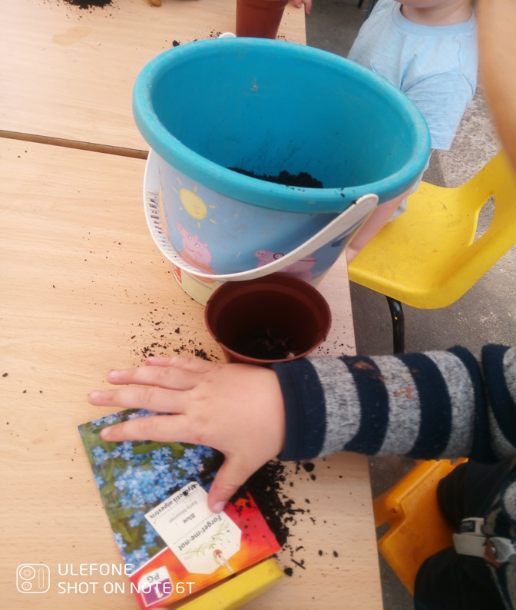
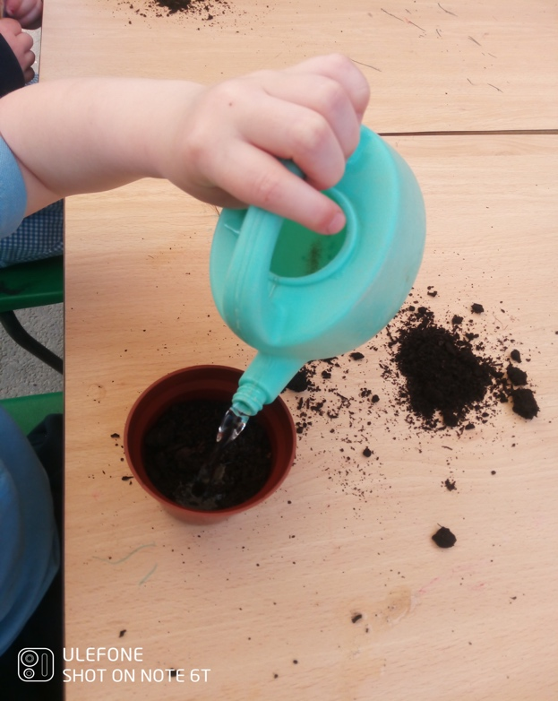
Appendix 2 – Wellbeing Therapeutic Garden

Appendix 3 – Wellbeing Therapeutic Garden
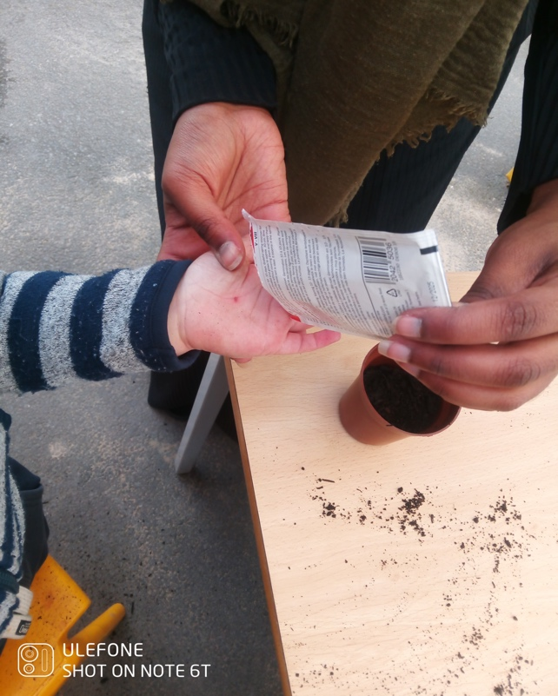

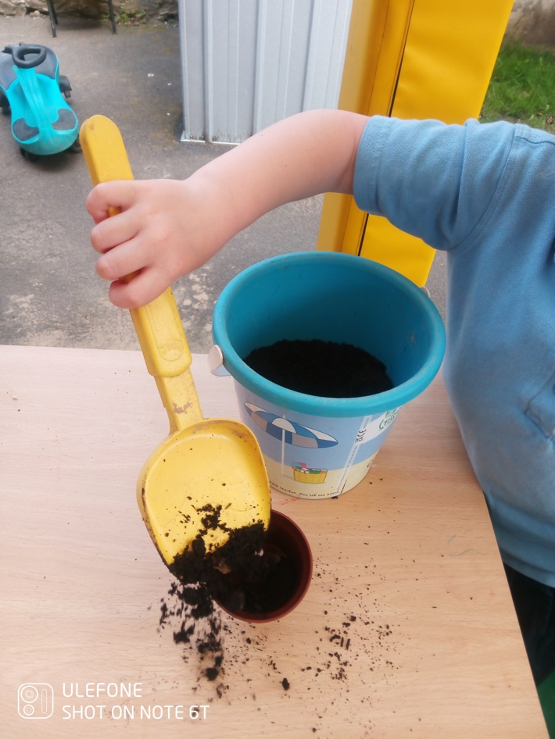
Appendix 4 – Wellbeing Therapeutic Garden

Appendix 5- Wellbeing Therapeutic Garden

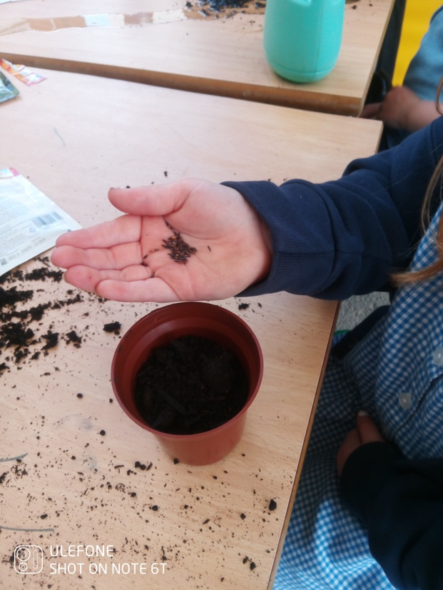

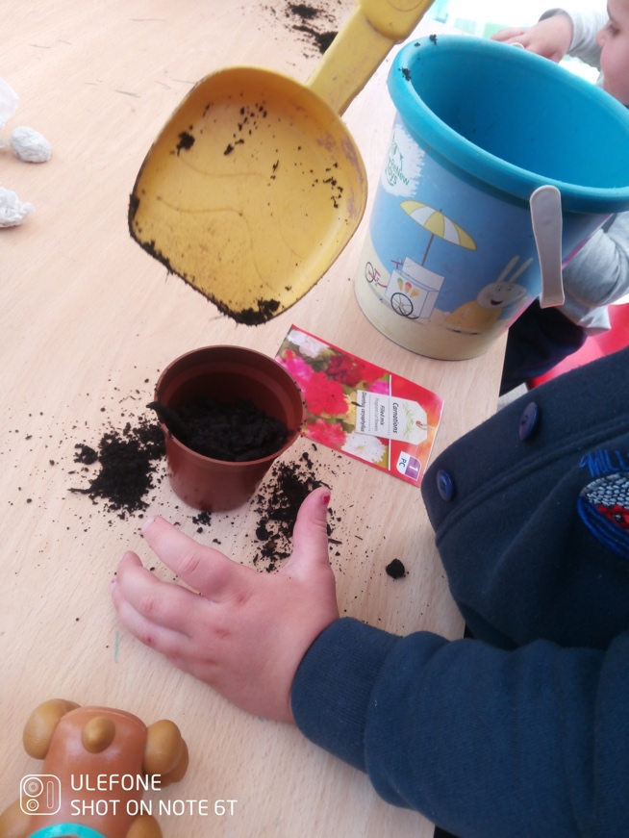
Appendix 6 – Wellbeing Therapeutic Garden

Appendix 7 – Log Book

Student Name: | Lena Amir (1901848)
Name of Host  Employer: | Wellbeing Therapeutic Garden

Record of project work carried out
Date: | 27 October 2022  6 hours
Task completed: | • Volunteering and assisting the children at the nursery.
Reflection: | As the nursery is very close to my home an opportunity opened for me to complete this task fully. As at the time the season was winter it was perfect timing for me to present my idea linking to mental health and well being, which it named a well being therapeutic garden for the children in the nursery.  - Consistent time management as well as communication skills increased and helped come to the conclusion to carry out this idea in the nursery.

Date: | 31 October 2022  3 hours
Task completed: | - Shift at nursery
Reflection: | I completed a shift at he nursery in order to get fully comfortable around the new setting which involved communicating and engaging with the children as well as the staff in the nursery. Those hours included helping staff with necessary daily tasks such as helping the children wit their coats, washing their hands before and after they eat as well as keeping them busy and entertained through the day.

Date: | 4 November 2022  3 hours
Task completed: | - Research on gardening and mental health.
Reflection: | This topic is very new to me and I didn’t have any background information about the benefits and other aspects. This is why I’ve decided to spend a few hours exploring and learning about the topic area. I’ve completed this by reading a few different journals discussing the effectiveness of a therapeutic garden towards young children. This allowed me to fully understand and grasp my topic area before beginning the project.

Date: | 10 November 2022  3 hours
Task completed: | - Shift a nursery
Reflection: | This was my third shift in the nursery so far and confidentially I could say that I am getting better at the skills that I’ve lacked perviously. For example spending a few hours a month with the same individual made it a lot easier to communicate and engage with them. This allowed me to know each any very individual. For instance, how they act or because according to certain things.

Date: | 14 November 2022  3 hours
Task completed | - Research behind gardening and well being
Reflection | I managed to explore different research evidence as well as empirical evidence that suggests therapeutic gardening can be effective and therapeutic towards young children.

Date: | 20 November 2022  4 hours
Task completed: | - Research different types of flowers
Reflection | I’ve spent a couple of hours to discover all the different types of flowers that could be grown. As well as this, I’ve research what the flowers contain within them making sure the children are not heavily allergic to any of the flowers that I could possible buy to complete this project. Furthermore, I have also researched and explored all the possible advantages and disadvantages of each any every flower that I have came across and finally decided four different flowers.

Date: | 29 January 2023  10 minutes
Task completed: | - Email exchanged with the manager
Reflection | Getting a hold of the manager through via email discussing if I could carry this activity out. After getting a green light me and the manager discussed about how many children would take a part of this project allowing me to grasp an idea of how many pots and seeds is needed.

Date: | 3 February 2023  6 hours
Task completed | - Shift in nursery
Reflection | For these hours I have decided to communicate with some of the children trying to get a bit of information about their likes and dislikes. Whether they like the idea of building, creating or growing flowers. The majority of the children were thrilled which was a positive response.

Date: | 15 February 2023  6 hours
Task completed: | - Shift at nursery
Reflection: | This day the children were allowed to spent a couple of hours outside in the playground. Along with their daily activities I have managed observe how the children act with the nature of playing outside inside of stating indoors. According to my observation I did pick up on an increase of energy and laughter when the children are outside compared to when they are indoors with not much space to run and have some sort of movement or exercise.

Date: | 20 February 2023  4 hours
Task completed | - Designed chosen flowers
Reflection: | After exploring the possible flier choices for my project I have decided to personally design and sketch the four chosen flowers. Personally, I am a very visual learner and I have always been so sketching or designing things down on a piece of paper makes a huge different for my learning. So I have created something similar to a mind map to carefully set everything straight for the project.

Date: | 22 February 2023  3 hours
Task completed: | - Visited florist for needed equipment
Reflection: | Throughout these hours I visited a few local stores and florist to observe the possible kind of flowers to grow. As well as this, I’ve also checked the possible prices and talked to the shopkeepers getting their advise on which type of fliers are great for young children in a nursery setting. However, as this search didn’t go according to plan I’ve decided to try against another day by visiting other possible shop as well as exploring other greater options. .

Date: | 25 February 2023  4 hours
Task completed: | - Visited B&Q, searched and brought all the needed equipment.
Reflection: | During this day I have encouraged myself to drive to the big B&Q culver house as it is bigger and contains different ranges and types of flowers as well as flower pots. Tue shop also contained other needed equipment. Additionally, this trip has been a success as I have a managed to finally buy the four different types of flowers as well as pots and mud.

Date: | 8 March 2023  30 minutes
Task completed: | - On call with the manager to confirm information
Reflection: | I have called the manager to inform them that I have brought all the needed supplies as well as discussing a suitable time for both myself and the nursery to carry out this project successfully.

Date: | 20 March 2023  6 hours
Task completed: : | - Shift in nursery
Reflection: | This day I have spent a few hours with the children. As well as this, those hours also included the usual daily activities with the children. Continuing with these hours allowed me to have a better relationship with the skill of communication between strangers which I was lacking before starting this project.

Date: | 23 March 2023  3 hours
Task completed: | - Shift at nursery
Reflection | I’ve spent another shift at the nursery which included a conversation with the manager as well as other staff to make sure everything is ready to go for this project to succeed. We have also discussed how we would take the documented photographs for the documents evidence. .

Date: | April 2023  6 hours
Task completed: | - Carried out the final project in the nursery
Reflection: | This was my final day in the nursery. The staff and myself managed to sit the children and start with the creation of the growing their flowers. It was quite challenging to get them to create their flower as it did get quite messy but luckily with the help of the staff and myself everything went smoothly.

