Please see the attached Presentation slides here in word file,

Slide 1
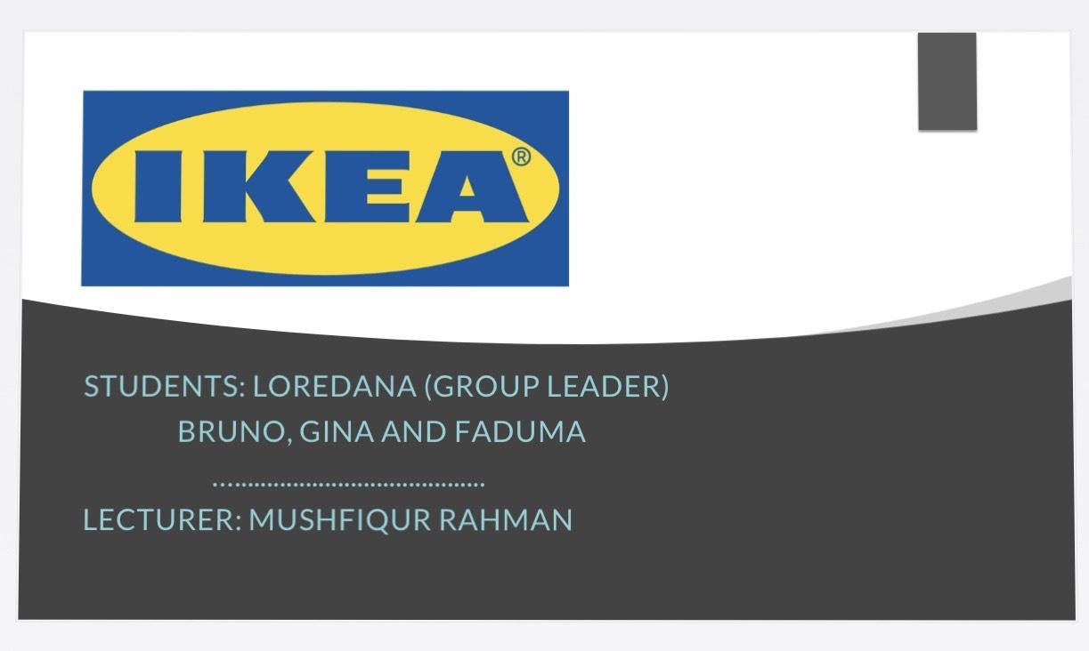
Slide 2

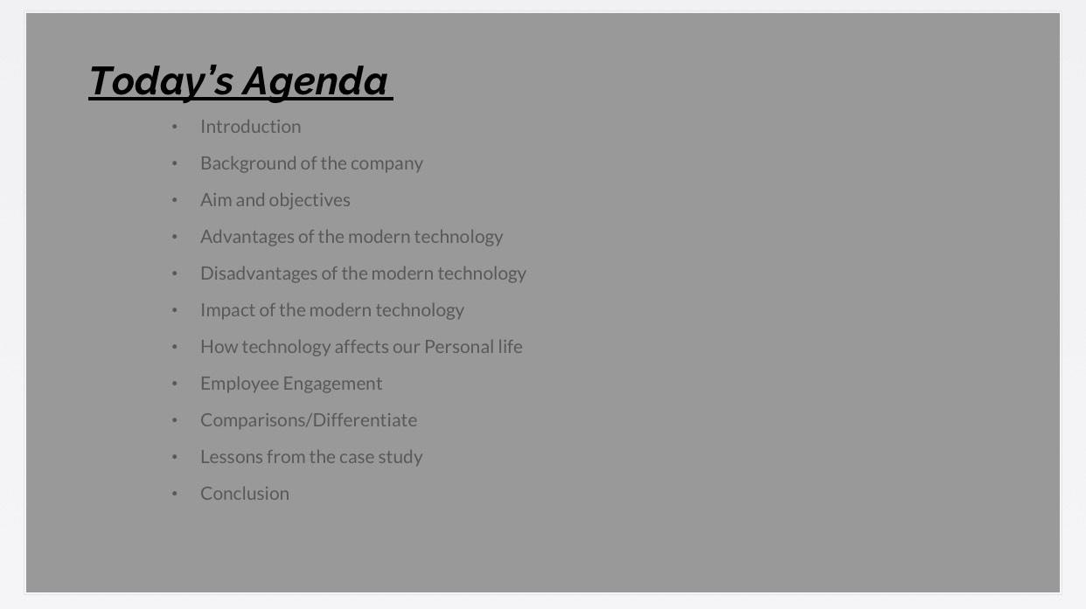

Slide 3
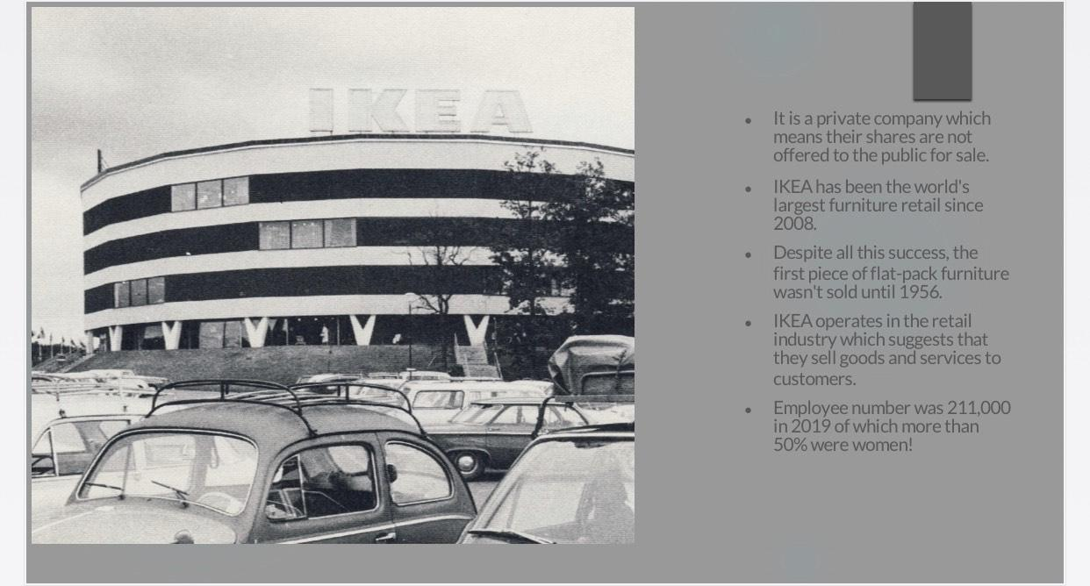

Slide 4
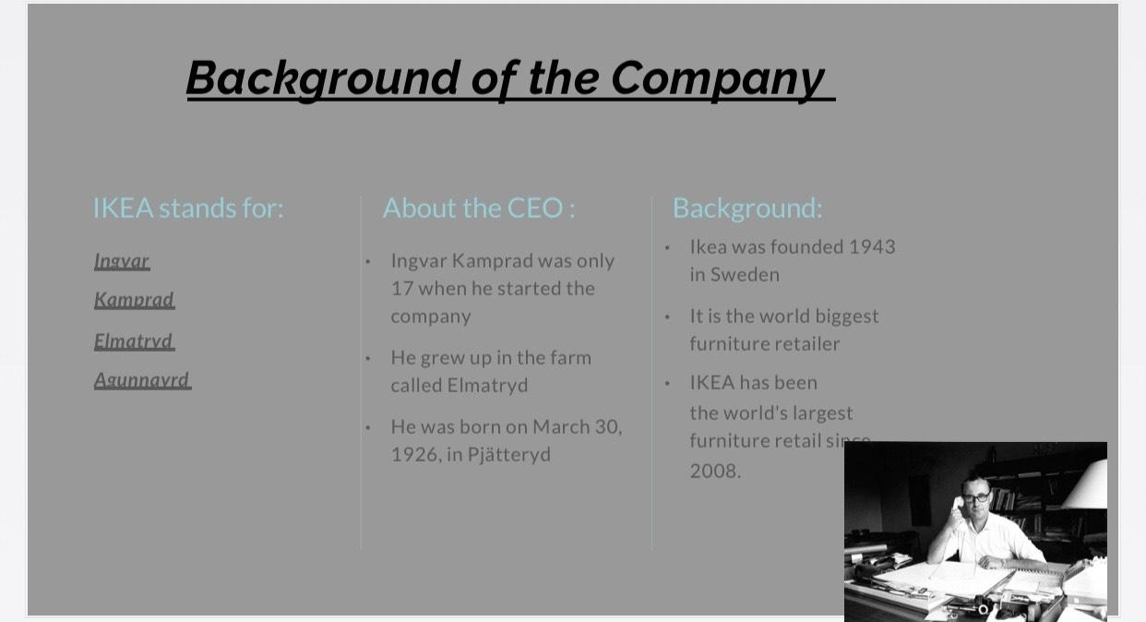

Slide 5
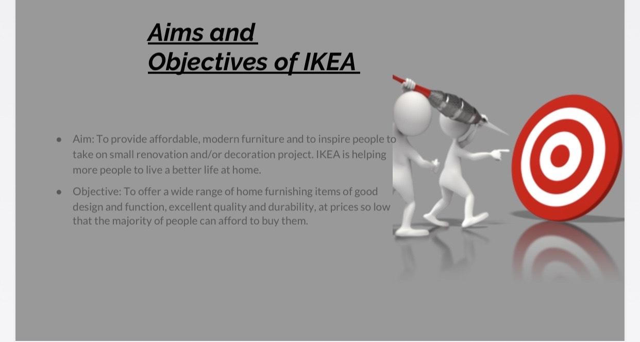

Slide 6
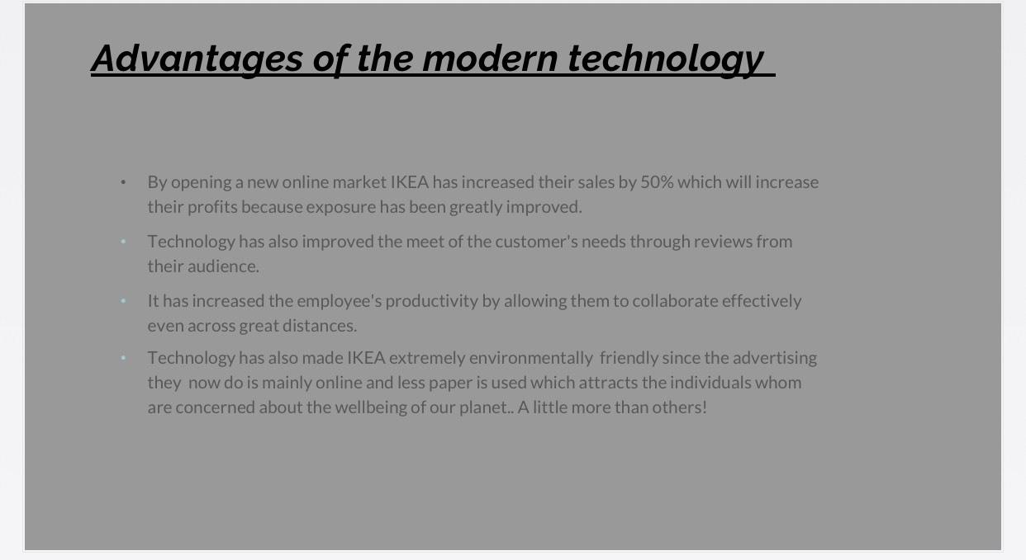

Slide 7
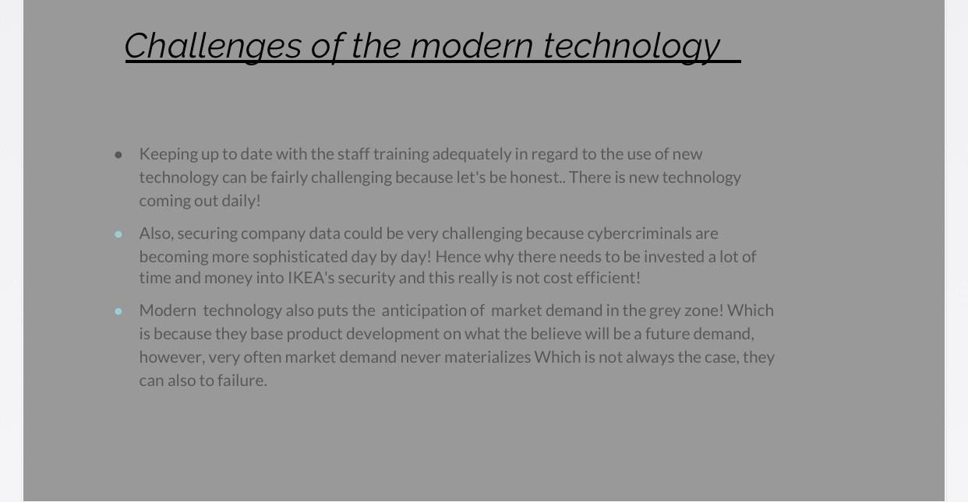

Slide 8
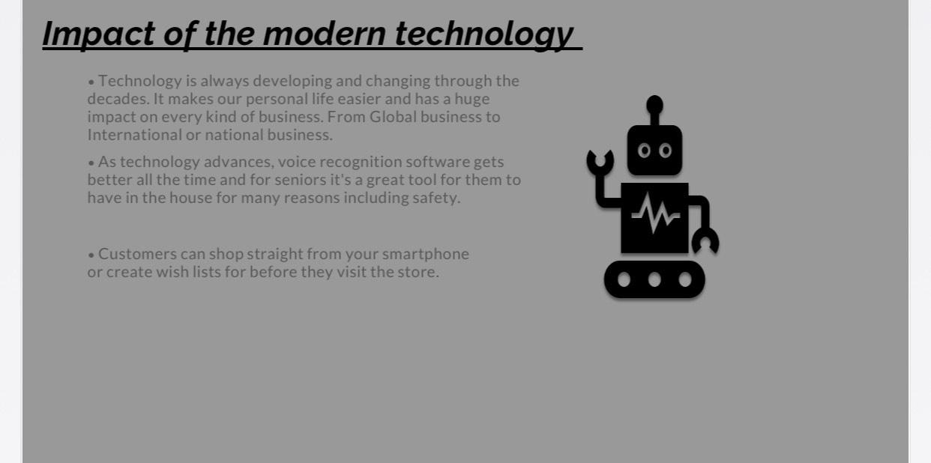

Slide 9
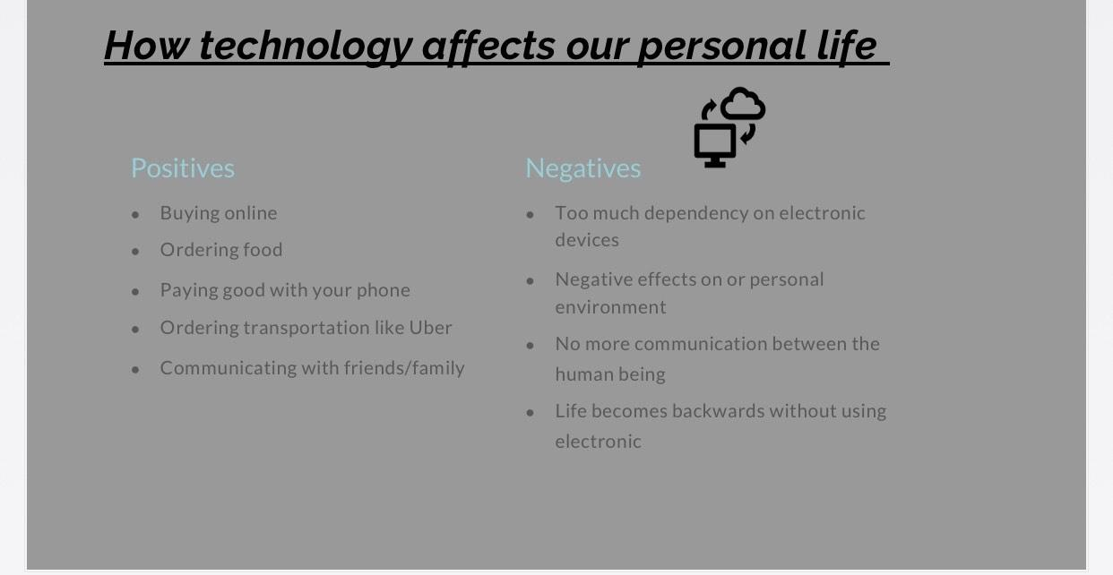

Slide 10
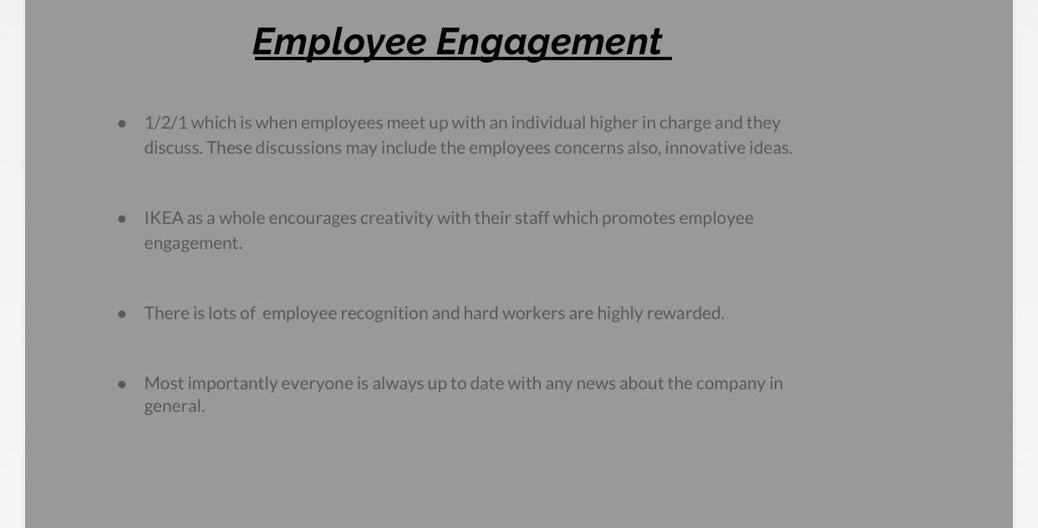

Slide 11
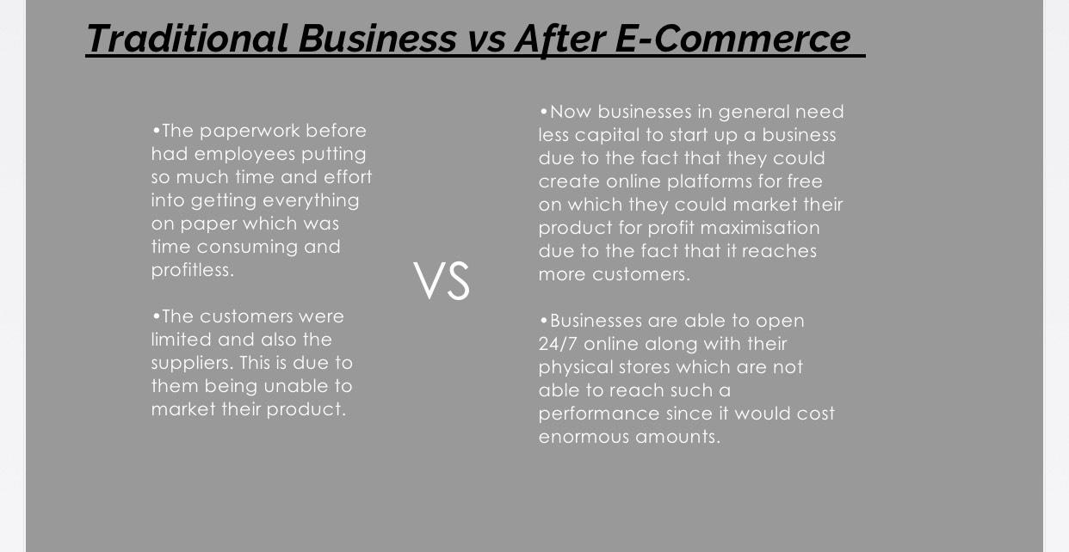

Slide 12
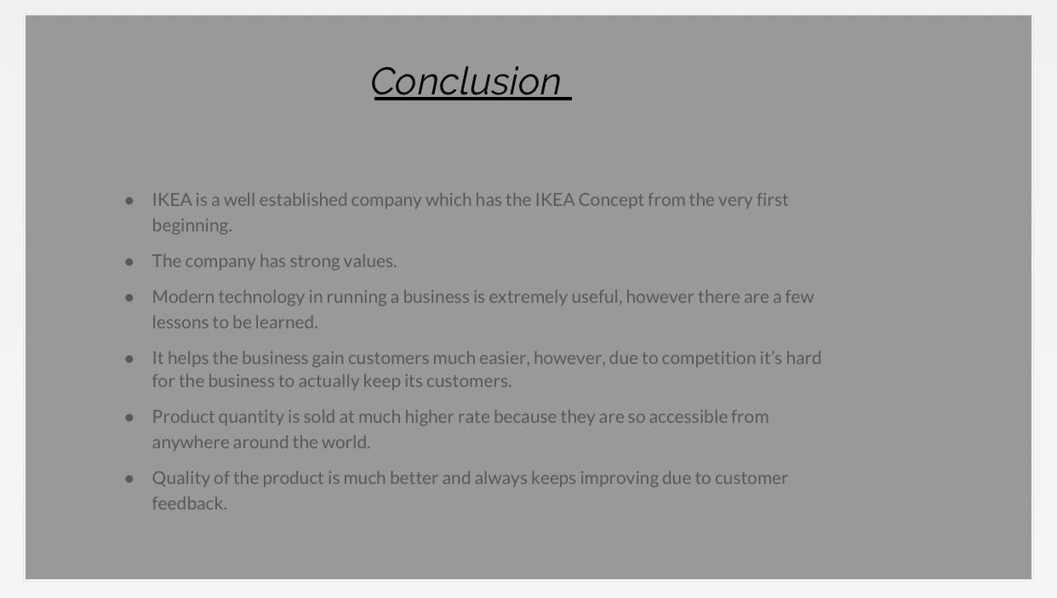

Slide 13
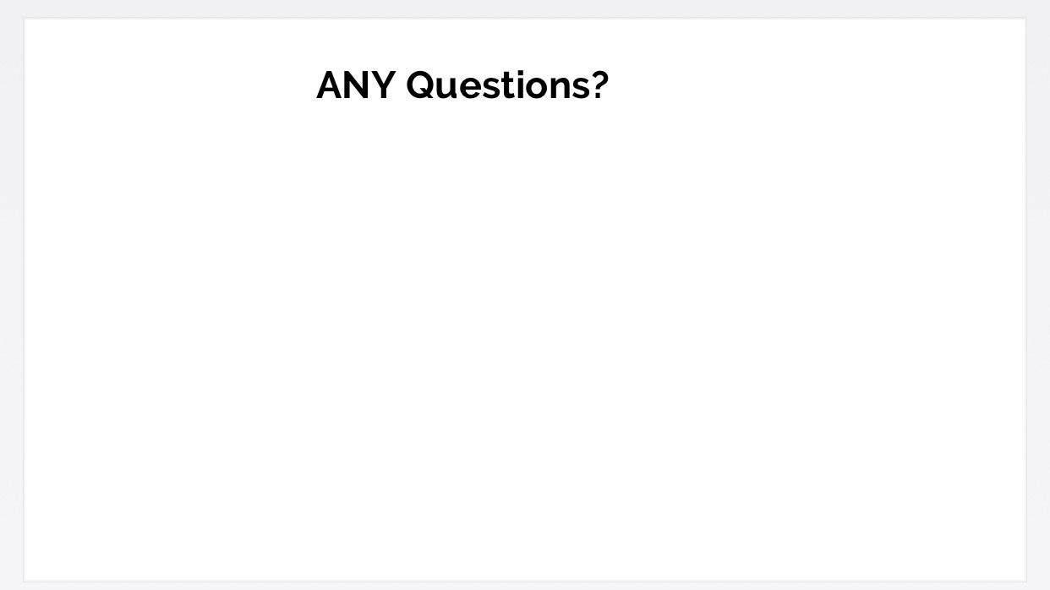

Also attached on this word file is the group report that we had to do according to the slides above.

Digital Skills and Research Methods
Group report
Students Names: Loredana, Gina, Faduma, Bruno
Lecturer: Dr Mushfiqur Rahman

ORGANISATION NAME- IKEA.
INDIVIDUAL CONTRIBUTION: GINA
SLIDE 3 & 4- (Who is IKEA & Background)
As a group, all of us four have decided to do a presentation on IKEA. In our presentation we explained why IKEA is and what IKEA is actually known for. IKEA is Swedish multinational group that designs and sells ready-to-assemble furniture. It was founded by Ingvar Kamprad who was born on March 30th, 1926. He was born on a small farm called Elmtaryd. Mr. Kamprad actually started his career at the age of six by selling matches then as he started growing up he started selling Christmas decorations at the age of ten which actually showed that he has great potential of being a very successful businessman and that is what happened in the end.
IKEA’s idea was and still is, that they do not actually have a target audience and that anyone should be able to afford stylish, fashionable and in vogue furniture. Based on this idea IKEA has now expanded all over the world and they now own over 300 stores in 38 countries. They not only cut down costs and have low costs, they serve the ordinary people to create comfort and coziness wherever they may migrate they are able to make a house an actual home because IKEA is literally everywhere.
Starting with the fact that he called them his ‘co-workers’ which suggests that he did not consider himself superior to them. As well as the fact that he encouraged everyone to dress informally this is most likely because he did not believe in the correlation between suit and tie and quality and productivity. Dressing informally also has other benefits such as improving employee morale because it breaks those communication barriers created between employees who are paid more and others who are paid less to even improve customer relations as customers feel more comfortable with approaching an individual wearing the same attire as them.
INDIVIDUAL CONTRIBUTION: BRUNO
SLIDE 5 & 6 - (Aim & Objective, Advantages of Modern techonology)
IKEA’s aim is to offer a wide range of well-designed, functional home furnishing products at prices so low, as many people as possible will be able to afford them. As a whole, IKEA’s idea is great. This is because we all buy furniture and then we get
used to it and we might want something new but that could be so expensive hence why this is such an amazing company to me and millions of others.
Technology has a huge impact on our daily lives. It’s almost impossible to live in this world without devices such as mobile phones, television or computers. Modern technology helped us in many ways such as in the medical branches from treatments to computers who assists the doctors. Things like planning and having a structure in life became easier and even the way we get information through the internet has become a click away. Moreover, from technology we can learn a few things too. Technology is created and developed for the greater good. To make our lives easier, it changes the way we communicate, pay bills, date, watch TV and take care of our safety and health. The way we use technology has a direct impact on our lives. We need to use responsibility and share for the good of all. We should not use the technologies to embrace negative causes. This is what IKEA teaches us overall by how simple their ideology is.
One might consider that technology has made it easy for us to do anything. You can order food on the phones, we can order transportation online and communicate with our friends and family. Due to the corona virus outbreak modern technology has helped us socialise more by going online to stay in contact and communicate with our loved ones who are not living with us.
INDIVIDUAL CONTRIBUTION: FADUMA
SLIDE 8, 9 & 10 – (Impact of Modern Techonology, How Technology Affects Our Personal Life & Employee Engagement)
On top of this, there are advantages and disadvantages that influence a business not just our personal life. Some advantages are that it is now extremely easy to collaborate in teams due to all the new softwares and apps that individuals could use. They can email their colleagues documents for example of a piece of work they have done and they could straight away get feedback on it even if the colleague is not at work on the day for example. Teams can always communicate through messages to announce lateness, any important messages that they have maybe forgotten to communicate at work and so on. Technology has also improved how businesses meet customer needs. This is because there are chats created on the business online platform which helps customers make up an idea about their purchase sooner or they are able to ask any enquiries that they have about assembling a product, in our case with IKEA.
It is also much easier to captivate customers online because other customers before them have left reviews of the product that they have used which was obviously encouraged by the business itself. Teams can always communicate through
messages to announce lateness, any important messages that they have maybe forgotten to communicate at work and so on. Technology has also improved how businesses meet customer needs. With this comes the risk of getting bad reviews also, however, a business which encourages reviews is sure that their product is great which means that the bad reviews will not be many. This is a great impact of Modern Technology.
Furthermore, going into a bit of depth about how Mr. Kamprad engaged his employees. He was actually an extremely humble man, although he was affluent he was still flying using economy class which showed how modest he was which reflected in the way he treated his employees.
INDIVIDUAL CONTRIBUTION: LOREDANA
SLIDE 7, 11 & 12 – (Challenges of Modern technology, Traditional Business VS E-Commerce & Conclusion)
On the other hand, technology could have great disadvantages for a business beginning with the most important one which is that technology could also be a distraction. This is because along with all these research platforms and so on. The employees could be tempted to check their phones for personal reasons. To go check Facebook or anything like that this is not great because it decreases employee productivity. Presumably, technology has increased the security risks which means that files can be stolen by hackers or just any individual that walks in your business. Maybe an USB can get infected by a virus and when they come to when and they plug the certain USB this can infect the device used which definitely is not convenient because these devices might have customer information which could lead to serious problems.
By traditional business we mean individuals going to a store to pick up a product or to get a service where as with E-Commerce this is done from the comfort zone of their home or wherever they are. Within a traditional business you have to hire employees to be at the store physically and as an employer you are always choosing the best of the best for your business which could definitely be time consuming, however, it is in my opinion better than E-Commerce because it is more trustworthy you get to see the material in real life rather than ordering it on the internet and then having to go through the hassle of returns.
In brief, we believe IKEA has amazing values which should be appreciated and followed by other businesses. They could be old or new start-ups because we admire their such unadorned way of running the whole business. When it comes to
technology as a whole, we believe that it is great however, it is advancing at such an alarming rate that the people have lost their fundamental communication skills and too much technology is not great for businesses either because it ma

