

Programme: MSc Public Health and Social Care in Practice
Student Name: Dhwani Yogeshbhai Patel
Student ID: 2431311
Lecturer’s Name: Shepherd Ziko
Module: Health Care System, Organisation and Leadership

Module code: LCHS7002

Assignment Title: Case Study Analysis

Report: Comparative report on COVID-19 leadership responses

Table of Contents
1. Introduction 3
2. Comparative Overview of National Health System Designs 3
2.1 Analytical Framework 3
2.2 Spain’s Health System Architecture 4
2.3 South Korea’s Health System Architecture 4
2.4 Canada’s Health System Architecture 5
2.5 Cross-Country Structural Comparison 6
3. Leadership Approaches During COVID-19 6
3.1 Leadership of Salvador Illa (Spain) - A Behavioural and Situational Analysis 6
3.2 Leadership of Chung Sye-kyun (South Korea) - A Transformational and Systems-Aligned Leader 9
3.3 Leadership of Justin Trudeau (Canada) - Consensus-Building Under Decentralisation 10
3.4 Comparative Leadership Synthesis 12
4. Centralisation vs Decentralisation as Determinants of COVID-19 Outcomes 12
4.1 Spain: Hybrid Centralisation with Delayed Activation 12
4.2 South Korea: High Centralisation Enabling Agility 13
4.3 Canada: Extreme Decentralisation & Fragmented Responses 14
4.4 What This Comparison Shows 14
5. Systems Thinking Evaluation of the Three Pandemic Responses 15
5.1 Systems Thinking Concepts Applied to COVID-19 Governance 15
5.2 Country-Specific Systems Analysis 15
5.3 Lessons Learned for Future Global Health Crises 16
6. Integrated Discussion: How Leadership and System Design Interacted 17
7. Conclusion 17
8. Reference List 19

1. Introduction
The COVID-19 pandemic was the first threat to the global systems on the scale of the problem, and it showcased vulnerabilities in the health infrastructure of countries and the significance of qualified leadership in the management of the crisis. Since pandemics are complicated dynamic systems, whose clinical, social, economic, and governance components depend on each other, the capacity of countries to respond was predetermined not only by their epidemiological capacity but also by the organisation of their health systems and the behaviour of leaders in an uncertain situation. The realisation of these relationships would be critical in the assessment of why certain jurisdictions responded quickly and efficiently as compared to others that had delays, disintegration or low public trust.
The three countries that are high-income countries with very different governance structures are compared in this report in terms of the pandemic response. As an example of a partially centralised health system, Spain has been facing early coordination difficulties; South Korea exemplifies a highly centralised command system of the public health under which quick mobilisation was observed; and Canada is representative of a highly decentralised federation with a great degree of autonomy within the provinces. These changes provide a substantial analytical framework, which gives a way of investigating the engagement between system design and the leadership behaviour in times of crisis.
Theories of leadership that were studied during this module, such as behavioural, situational, transformational, democratic, and relational perspectives, provide a systematic decisional tool with which to assess the influences which major decision-makers had in the course of every national response. The report uses these theories to determine how leadership style, communication, and decision-making intersect or do not intersect with health system structures through application to the actions of the leaders in the three jurisdictions.
The report has six sections, namely: comparative health system analysis, leadership evaluation, systems thinking evaluation, centralisation dynamics, integrated discussion and concluding insights to future pandemic preparedness.

2. Comparative Overview of National Health System Designs

2.1 Analytical Framework
The World Health Organisation defines a health system as any organisation, institution, resources, and the individuals whose main agency is to enhance health outcomes by ensuring coordination of services provided, funding, governance and the overall provision of health-related programs (World Health Organization, 2025). On this basis, this report will take a comparative analysis of four intersectional domains, including the structure of governance, financial arrangement, centralisation and decentralisation, and the capacity of the public health. These standards make it possible to conduct a systematic evaluation of the role of institutional design in determining the capacity of each country to react to COVID-19. It uses a systems thinking lens at all stages, and acknowledges the idea that pandemic response requires dynamic interaction between various components, which can include decision-making hierarchies, communication pathways, the capacity of the workforce, and surveillance systems. This methodology will aid in shedding light on the well-being of the structural capabilities and limitations that affected the agility, coherence, and permanence of each jurisdiction in the face of the crisis.

2.2 Spain’s Health System Architecture
The Spanish health system (SNS) is a nationwide health system that is both centralised and at the same time highly decentralised. As the national government has the general policy, funds, and controls the emergencies of the health of the population, 17 autonomous regions are in charge of healthcare, resource distribution, and local health actions (Bernal-Delgado et al. 2024). Such a hybrid model is flexible and responsive to the region, but at a cost of creating discrepancies in planning, coordination and reporting of data.
Before COVID-19, the system in Spain was advantageous, considering general coverage, good primary care, and moderately high levels of social trust. Structural bottlenecks, however, encompassed the disjointed governance, fluctuating regional capacity, as well as prolonged security in the sphere of surveillance, diagnostic amenities, and intensive care beds. The initial COVID wave revealed these restrictions clearly, as a slow response at the national level and the imbalanced readiness in the different regions of the country became the contributing factors to the sharp rise in cases and hospital overpressure.
The mode of governance later changed to be more central and coordinated in later stages, especially in the rollout of vaccination programs (Navarro and Velasco, 20222). Co-ordinated procurement, national communication plans and standardised procedures were more successful and helped make Spain among the European countries that led in the field of vaccinations. Altogether, the experience of Spain signifies that partial decentralisation may create obstacles to a timely response to the crisis, but empower successful performance under the condition of the establishment of the national level.

2.3 South Korea’s Health System Architecture
The health system of South Korea is characterised by the most centralised governance of public health and by universal health insurance and a high technological level. The Korea Disease Control and Prevention Agency (KDCA) has a great deal of power in surveillance, testing guidelines, and coordination of emergency responses, and policy execution (Hong, 2024). The pandemic was entering COVID-19 pandemic entered with well-developed legal frameworks and rapid decision-making channels, as well as with mature public health institutions, which were made possible through this centralised system of command, enhanced following the Middle East Respiratory Syndrome (MERS) outbreak in 2015.
One of the characteristics of the system in South Korea is its large-scale system of digital infrastructure. Integrated contact tracing, real-time data sharing, and automatic alerts were facilitated by the law, which authorised having temporary access to mobile, transaction, and location data in the case of a public health emergency (Yang, 2022). These tools allowed for finding and containing the cases quickly without lockdowns on a national scale.
There was a pre-existing high diagnostic capacity, an agile network of private and public labs, and a high level of societal approval in taking digital precautionary steps in health. Consequently, South Korea implemented rapid border control, mass testing, and selected isolation measures within several days after COVID-19 was discovered (Lee and Lee, 2020). Its performance during the pandemic that had been internationally recognised was directly contributed to by a highly centralised and technologically enabled structure.

2.4 Canada’s Health System Architecture
The Canadian health system is not a single unified national health system but a federation of 13 health systems, which are managed at the provincial level. Although the federal government aids in funding, creating general standards, and supporting national guidance in health policy, provinces and territories set their own healthcare policies, emergency response, testing, and immunisation policies individually. This degree of high decentralisation leads to a high rate of variation in the policy delivery and system capacity nationally.
Before COVID-19, the Canadian system was characterised by high universal coverage and a reliable primary care system, but with long-standing issues such as a lack of sufficient capacity in the workforce in the field of public health, sluggish integration of data, and differences in the access of Indigenous and rural populations to healthcare (Rabeneck et al. 2023). The heterogeneity of responses in decentralisation became clearly visible in the pandemic: some regions responded first and used a strict policy, whereas others responded later, or in a less coherent way. The testing criteria in testing, surveillance reporting, and other restrictions of public health differences by the provinces complicated national coherence.
The process of vaccine implementation also demonstrated structural fragmentation, with the federal-provincial consultation process and the implementation of the allocation procedure slowing down the implementation. Although eventually Canada recorded high levels of vaccination, some initial encounters showed that delays can be a nightmare when it comes to coordination problems associated with the concept of decentralised governance (MacDonald et al. 2020). Comprehensively, the Canadian system shows that autonomy may favour national customising but lead to a slow level of nationwide congruity in crises that need to have an accelerated movement.

2.5 Cross-Country Structural Comparison
The spectrum of governance forms that could influence the pandemic reaction is depicted by the three countries. The centralised national body of public health in South Korea was facilitating a quick and coordinated response with the aid of digitally linked systems and legally secured organisations (Ricci, 2022). This organisation encouraged agility, consistency of message and compliance levels. By contrast, Spain has had its weaknesses exposed in its hybrid model at the outset of the crisis: the regional difference and the divided ability to detect and contain the situation at an early stage. However, when national coordination was enforced again, the system was found to be able to provide an extremely effective vaccination programme, indicating that, in case it is triggered on a regular basis, centralisation can substantially enhance performance. Decentralisation in Canada was an embodiment of the other extreme in terms of structure. Although local autonomy has led to the creation of targeted interventions, it has also resulted in the creation of disjointed communication, uneven limitations, and slower correspondence with federal directions. This disintegration impacted testing rollout, data reporting and vaccine distribution, proving that decentralisation could frustrate consistent national crisis management (Phillips et al. 2023). Systems that were more centrally organised, in their actual sense, South Korea, and subsequently Spain responded far better. The strongest structures were the ones that could be coordinated quickly, communicate effectively, and have in place integrated functionalities in public health. The difference between nations highlights the role of governance design in the development of pandemic preparedness and response capacity.

3. Leadership Approaches During COVID-19

3.1 Leadership of Salvador Illa (Spain) - A Behavioural and Situational Analysis
The early response of the leadership of a person, Salvador Illa, to the COVID-19 pandemic indicated some of the features of the behavioural and situational leadership theories. The behavioural theory is focused on observable behaviours as opposed to some things inherent, and the early orientation of Illa inclines towards relationship-oriented behaviours instead of task-oriented command (Surdu et al. 2021). The perceived risk involved in the early communication was minimised, and his communication style was more democratic-oriented because it was a collaborative and reassurance-seeking style. Nevertheless, in an exploding crisis, such behaviour slowed down decision-making and led to the delayed triggering of national emergency procedures.
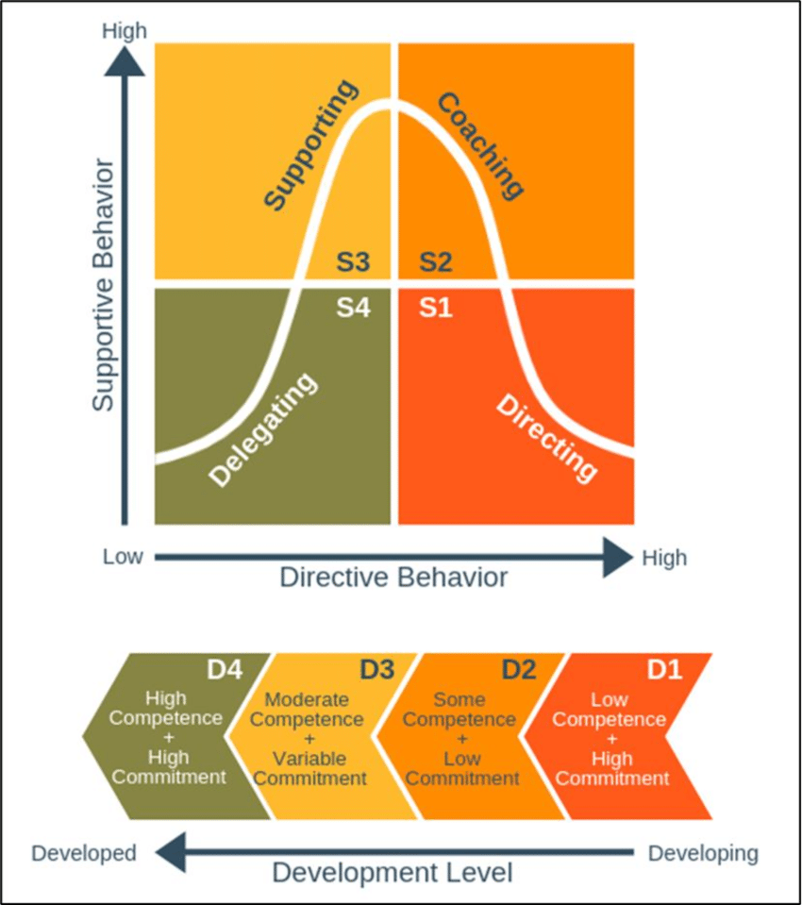
Figure 1: Situational Leadership Model
(Source: Sbeih and Jones, 2021)
Situational leadership theory suggests that a leader should be flexible depending on the situation. An early adjustment to Illa was hard because he continued with a balance and consensus-oriented style when the situation needed decisive leadership. The decision-making style changed to a more centralised and task-based one later when the severity of the pandemic changed and became more severe (Campbell and Chung, 2022). The adaptation of Illa became manifest in the move towards strict national lockdowns, combined purchase, and coordinated vaccine plan in Spain. This change is in line with what directive style of situational leadership dictates in the cases of high-threat, low-certainty situations.
Trait theory, which puts interest on traits like confidence, emotional stability and decisiveness, is also insightful. Illa was calm and open with her communication, but was criticised as being soft-spoken in the early risk assessment and border control actions. His advantageous features were a level-headedness, consistency and an ability to instigate cross-ministerial cooperation when the alarming situation was perceived in all its seriousness. Nevertheless, Spain was already weak in terms of proactive qualities, i.e., strong foresight or aggressive crisis anticipation (‌Bermejo-Casado, 2024).
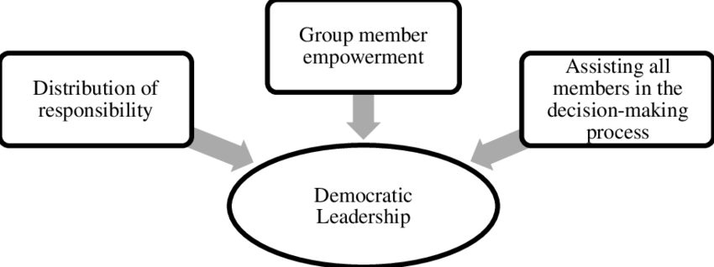
Figure 2: Democratic Leadership Indicators
(Source: Tobing and Aristama, 2023)
There are also differences between autocratic and democratic leadership. Illa had started by assuming a democratic, consultative policy, which gave much freedom to regional governments. As the national case counts grew, his approach became more autocratic, centralised to lockdowns and vaccinating processes. This shift also led to a better organisational response and ultimately high vaccination rates, which argues that the later autocratic practices employed by Illa were more efficient in crises.
Altogether, the leadership path of Illa presents a reflection of the difficulty of the change of leadership behaviour in the context of the fast-changing crisis (Al Jazeera Center for Studies, 2020). There were weak democratic insidious tendencies that prevented decisive action, and the later directive approach led to a stronger national performance.

3.2 Leadership of Chung Sye-kyun (South Korea) - A Transformational and Systems-Aligned Leader
The leadership by Chung Sye-kyun in the face of COVID-19 showed that he was very much aligned with the ideas of transformational leadership, especially the four essential elements, which include idealised influence, inspirational motivation, intellectual stimulation and individualised consideration. Chung, as Prime Minister, was at the centre stage of organising the South Korean national response to the nation, which was a structured national response which personifies idealised influence through constant visibility, impartial command and a selfless moral focus on collective duty (Penn Today, 2022). His open and regular communication style, which was also data-based, helped him to make people trust him more and build a national sense.
Chung did the same with inspirational motivation in her description of the crisis as a collective challenge in society that demanded concerted effort. An additional online slogan of solidarity, resilience, and shared responsibility has played a role in ensuring the mass following of government-controlled preventive actions. The intellectual stimulation was reflected in its encouraging innovative solutions, including drive-through testing, a digital tracing system, and integration of a laboratory with the government, etc (Agarwal et al. 2020). Such efforts were associated with the desire to break the traditional model and take advantage of technological development - fundamental themes of transformational leadership.
Relationship theory also goes further to justify the effectiveness of Chung, as trust, collaboration, and leader-follower rapport are important. Chung gave the authority to the agency of Korea Disease Control and Prevention (KDCA), and enabled the agency to make operational decisions, and he specialised in high-level coordination. This model of power sharing enhanced the flexibility of institutions and trust.
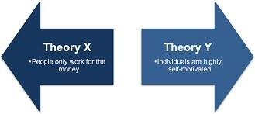
Figure 3: McGregor Theory X and Y
(Source: HINMIKAIYE et al. 2024)
This can also apply to Theory Y by McGregor because the leadership of Chung was based on the assumption that citizens and public employees are intrinsically motivated and can be capable of acting responsibly. This was the basis of the trust that the South Koreans had in voluntary obedience, an open line of communication, and the least coercion of the law (‌‌Na and Lee, 2023). The governance was good through trust, which facilitated quick adaptations in behaviour among all the people.
According to Mintzberg, the managerial functions are observed in the role of the negotiator, disseminator, and disturbance handler performed by Chung. He facilitated intersectoral partnership, relayed central information and absorbed in time when obstacles arose. He had a method of coordinating the efforts of his ministries, which enhanced the cohesiveness of the national response.
Altogether, the leadership approach of Chung combined transformational vision, relationship-based acquisition of trust, and coordination on systems levels. His management style also suited well with the centralised, technologically superior, government-subsidised system of South Korean public healthcare, and made his contributions to the internationally recognised response to the pandemic in South Korea.

3.3 Leadership of Justin Trudeau (Canada) - Consensus-Building Under Decentralisation
The politics of leadership of Justin Trudeau during COVID-19 was informed by the fact that Canada has a highly decentralised manner of governing its people, and thus demands a lot of negotiation, consensus-forming, and intergovernmental efforts. His style is close to the idea of democratic leadership, and it is characterised by involvement in decision-making, free communication and joint problem-solving (Lalancette and Small, 2020). Trudeau also met with provincial chiefs, indigenous leadership, and the health leaders and stressed transparency and common accountability. Although this method of inclusiveness developed trust and cohesiveness, it also retarded national coherence, as provincial control of health policy.
Theory Z, where the importance is placed on long-term relationships, trust, and collective dedication, can be seen in the focus of Trudeau on social cohesion, empathy, and supportive policies, which include federal financial assistance. His regular briefings with people were presented in a calming, understanding manner and supported through community-focused values and encouraging people to be voluntarily adherent to health behaviours.
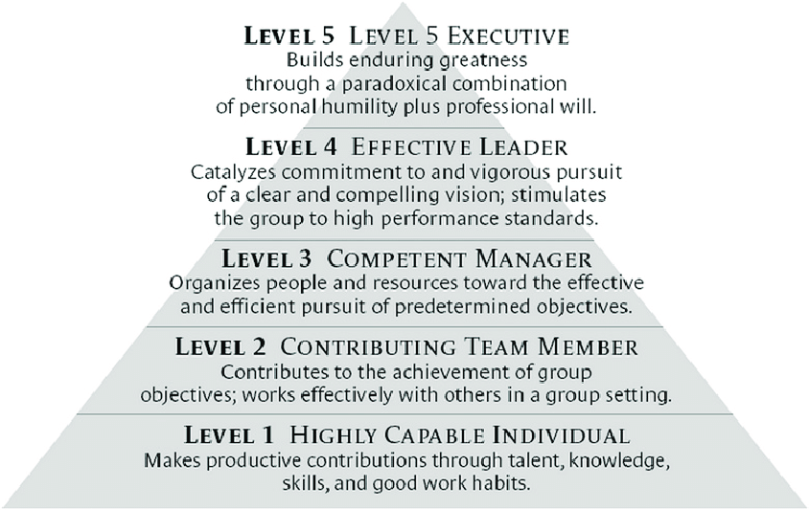
Figure 4: The Collins Level 5 leadership model
(Source: Jildeh et al. 2021)
The Five-Level Leadership Model places the performance of Trudeau mostly at Level 4, which is when a leader listens to, motivates, and encourages others to work towards a common objective. His positive qualities were high levels of communication, inspirational messages and mobilisation of cross-sectoral alignments (Boer and Charlina, 2022). But the model also cites that the Level 5 leadership model, which is marked by big vision and aggressive, transformative action, might have been crippled by structural, as opposed to personal, constraints.
The trait theory (OCEAN) can be used to explain the leadership behaviour of Trudeau. The ability to be open was high, as seen by the adaptive policies and the cultivation of the desire to consult scientific experts. The attributes of conscientiousness and agreeableness were conveyed in such aspects as collaborative decision-making and empathetic communication. Nevertheless, the reduced degrees of assertiveness in the neuroticism or extraversion can be a contribution to the slower national consensus on the approaches to testing and vaccination policies (‌Shokrkon, A. and Nicoladis, 2021). The decentralised format of Canada became a serious challenge to Trudeau because provinces set decisive factors of the pandemic reaction separately. His consensus-based and democratic style enhanced cohesiveness at the expense of the velocity of concerted national action. Empathy, communications, and flexibility were also strengths, with weaknesses arising in the capability to enforce and standardise policies.

3.4 Comparative Leadership Synthesis
In the three jurisdictions, the quality of leadership differed dramatically as to the kind of leader, fit to the system, and how responsive they were. The initial democratisation and relationship-oriented behaviour of Salvador Illa also made it difficult to act quickly in a disintegrated system of Spain, whereas his transition to directive leadership enhanced performance in the period of vaccination. On the contrary, the transformational leadership of Chung Sye-kyun did fit in the centralised (or centralised-technological) South Korean public health system. It is easy to understand why he was able to mobilise the nation and get no less than high public trust, through his high speed and clear and innovative political style. Justin Trudeau battled the most structural restraints because the provinces in Canada weakened his quick enforcement ability or standardisation (McDougall, 2020). His Theory Z-oriented and democratic style enabled the unified nature of the society, but led to a slower process of decision-making than the central command approach of South Korea.
In speed, Chung has been the fastest because of the agreement between the leadership style and system design. Illa failed to adapt in time, and structural constraints put the Jamaican Trudeau lagging behind South Korea in initial responsiveness. In South Korea and Canada, communication levels were the best because they were transparent and had an empathetic message, and in Spain, communication played down the risk and preparedness of the people. The role of systems alignment was prominent: those leaders whose approach corresponded to the structure of their governance made it better (Iannotta et al. 2020). The coordinated system of South Korea allowed transformational leadership to flourish, and further South Korean progress was achieved when the leadership started to be more centralised. The decentralised structure of Canada reduced the strength of Trudeau, which demonstrates that the excellence of the leader is greatly conditioned by the conditions of governance.

4. Centralisation vs Decentralisation as Determinants of COVID-19 Outcomes

4.1 Spain: Hybrid Centralisation with Delayed Activation
Spain had a hybrid form of governance, where the national government provides the overall jurisdiction in the event of a pandemic related to a state of emergency in the field of healthcare; the 17 autonomous regions of the country are in charge of delivering healthcare and implementing operational processes. This model was confused at the very beginning of COVID-19. In spite of the legal ability of the central government to introduce national emergency actions, it initially was rather conservative, consultative (Petrov, 2020). Lack of quick country intervention, combined with uneven surveillance capability in regions, facilitated postponements in community transmission identification as well as in standardising restrictions. Inequality in the distribution of resources and decision-making also diminished the response of Spain. Nevertheless, when the scale of the pandemic could not be ignored, Spain mobilised more centralised control with lockdowns across the nation, with coordinated movement controls, and eventually, a nationalised approach to vaccination. At the point of vaccination, the central government became a rigid authority over purchase, distribution structure, and communication. Such a centralised command played a significant role in enhancing coherence, and Spain became one of the most successful vaccination programmes in Europe. The case of Spain shows how hybrid systems may fail due to a lack of timely activation where the central authority is not mobilised at the outset, but how this may be corrected when decisive leadership on a national basis rises above the problem of fragmentation.

4.2 South Korea: High Centralisation Enabling Agility
Governance in South Korea is very centralised in matters relating to the management of the Public health crisis, and thus the mobilisation of resources is quick as well as in the decision-making process. Its statutory power to enact nationwide testing guidelines, surveillance and emergency policies is well-established in the Korea Disease Control and Prevention Agency (KDCA). This centralised command system, which was reinforced following the 2015 MERS outbreak, allowed the country to respond swiftly to the outbreak of COVID-19. Due to its protective measures and low incidence of cross-boundary cases, South Korea enforced border control, mass testing, aggressive contact tracing, and isolation within days of its initial cases, and the flow of decisions is efficient and vertical (‌Ryan, 2020). The digital infrastructure integrative, which was backed by lawmaking that enables the temporary access to mobility and transaction information, facilitated the real-time monitoring ability and quick case detection. Regional difference in either the application of policy or interpretation was minimised by an agreement-based communication and consistent national messaging that improved public compliance. The centralised system employed in South Korea was strong as it ensured the maintenance of agility, information cohesion, and integration of technology. In contrast to hybrid or decentralised systems, where negotiating authority can slow the pace at which action is taken, centralised governance of public health in South Korea gave an instituted channel of rapid containment. This structure was also instrumental in the prevention of extensive spreading within society in the early stages of the pandemic.

4.3 Canada: Extreme Decentralisation & Fragmented Responses
Canada is among the most devolved health systems in high-income countries. The provinces and territories are the primary control over the power of healthcare delivery, emergency treatment, school shutdowns, testing plans, and vaccination implementation (‌Gao and Yu, 2020). Although the federal government will help fund it, border control, procurement assistance, and national guidance under the Public Health Agency of Canada (PHAC), it can not force them to act in the same way. This structural decentralisation caused large levels of regional variability in COVID-19. The provinces had restrictions that were imposed at varying times, and the testing requirements were different, mask mandates, and economic reopening plans were also different. Their mismatches made the national situational awareness a challenging task and undermined the clarity of open communication. The sharing of data between provinces and the federal level was slow, which aided the disaggregated surveillance and delayed decisions. The introduction of vaccination demonstrated the problems of decentralisation, where provinces developed their unique distribution channels and priority categories and systems of appointment independently (Viphonephom et al. 2024). Other provinces had a faster uptake, whereas others encountered logistical problems. Though high rates of vaccination coverage had finally been achieved in Canada, initial coverage had lagged behind more centralised systems. On the whole, the decentralisation facilitated context-sensitive customisation at the expense of uniformity, expediency and alignment at the national strategic level. The pandemic has revealed major coordination failures, which prove the weakness of fragmented governance in the face of a rapidly spreading global menace.

4.4 What This Comparison Shows
The comparison helps to realise that the system of governance is a strong determinant of the consequences of the pandemic. The centralised systems that are observed in South Korea assist in speeding up the process of alignment, combined monitoring, and uniformity of public communication (Hong, 2024). High hybrid systems, such as Spain, might not perform at all at the beginning, but when national authority is triggered, then they can work. Decentralised systems like the Canadian experience intrinsic difficulties in the standardisation of policies, expediency in decision-making and consistency in decisions across boundaries. Finally, the design of governance cannot be discussed outside the context of leadership effectiveness: leaders who work in unitary forms are able to make decision-action; leaders who work in decentralised systems are forced to find consensus at the cost of time and cohesion.

5. Systems Thinking Evaluation of the Three Pandemic Responses

5.1 Systems Thinking Concepts Applied to COVID-19 Governance
Systems thinking offers a holistic perspective in the explanation of the responses of health systems to complex emergencies like COVID-19. It focuses on the areas of governance, health services, community behaviour and information systems interdependence where action in a given section of the system has repercussions in other sections. The level of surveillance, political decision-making, citizen adherence, and resource distribution are closely related during a pandemic (Gao and Yu, 2020). Feedback loops will allow early interventions, and slow or inaccurate feedback will further the transmission and system strain. Leverage points a fast testing system, effective communication, or a centralised data system, are one of the areas that can be changed by small factors, and have large effects on the entire system. Lastly, non-linear system behaviour is an aspect of a system that shows the ability of small delays or gaps to build exponentially to cases that strain capacity (Zhang et al. 2023). The assessment of Spain, South Korea, and Canada using this metric can demonstrate how successful each of the three nations was in terms of the way systems were interacting, the flow of information, and early warning signs and how the design of governance affected their capacity to cope with complexity.

5.2 Country-Specific Systems Analysis
Spain: Delayed Feedback and System Overwhelm
Fragments of information communication were the result of the hybrid form of government in Spain in the initial phases of the pandemic. The surveillance systems in regions had different capacities and reporting rates that took a long time to provide situational awareness to the national government. Such a delayed feedback loop led to the delayed activation of emergency measures and also caused the cases to start increasing rapidly. The negative loop of increasing demand and declining capacity was cemented as hospitals entered into bottlenecks of resources once the system was overwhelmed (John, 2025). Spain subsequently enhanced the integrative capability of the systems by centralising decision-making, creating an improved communication channel and synchronising the distribution of vaccines- this proves that improvement by the systems is achievable when feedback is provided in a timely fashion, as well as governing systems with more cohesion.
South Korea: Reinforcing Loop of Testing–Tracing–Isolating
The reaction of South Korea showed how the positive feedback loops work. Extensive testing created the effect of quick cases being identified, and contact tracing and targeted isolation became immediate (Chung et al. 2021). Those measures minimised the transmission, thus lessening the number of cases in the future and increasing the stability of the systems. The interventions could be refined continuously because the centralised digital infrastructure of the KDCA provided real-time streams of data flows. All the interdependencies (technology, public health agencies, and societal compliance) were well organised, and a resilient, adaptive system was developed. The early success of the rapid containment of the pandemic is an example of how the robust leverage points of the system, especially diagnostic capacity and the open flow of information, can change the system behaviour to achieve an equilibrium.
Canada: Fragmented Loops and Variable Policy Cycles
The decentralised system of government in Canada gave rise to disjointed feedback between the provinces and the federal government. There was inconsistency in surveillance data across jurisdictions, and degrees of variation in testing policy generated mixed early-warning signals. The cycles of policy responses had different provincial timings, and they resulted in asynchronous restriction, reopening and communication narratives (Blouin Genest et al. 2021). These broken loops contrived against the cohesiveness in the way the system served its purpose to achieve, and lessened the impact of the federal direction. Although it was possible to tailor solutions locally and respond to the specific circumstances in a particular area, due to the lack of unified data integration, initiatives on a nationwide level could not take their place in time. Canada began to be supported by the system subsequently during the vaccination, yet the early agility was obstructed by fragmentation.

5.3 Lessons Learned for Future Global Health Crises
The comparison shows the sensitivity of the information flows in which the decision-making will be presented in time and at the right time with the correct information. The multi-level governance alignment should be a priority area of the health systems, where the roles, information flow, and emergency response procedures are efficiently incorporated nationally and regionally (de Sá Freire et al. 2023). It is leadership that knows the dynamics of the system, specifically interdependencies and leverage points that can intervene earlier and more successfully. Those countries that enhance surveillance mechanisms, integrate the communication strategy, and incorporate systems thinking in emergency planning are in a better state to deal with subsequent global health threats.

6. Integrated Discussion: How Leadership and System Design Interacted
The COVID-19 responses in Spain, South Korea, and Canada were a critical issue since the leadership style and system design interacted. Every leader was considered to be within structural parameters that could have affected the quickness, air of consistency and functionality of their decision (Jerab, 2023). The hybrid model of governance in Spain, with the regions creating barriers to early data pooling and acting at the national level, hampered the initially democratic and consensus-based leadership of the then-leader, Salvador Illa. The system necessitated a rapidly coordinated centre, whilst his predispositional inclination toward relational and participatory behaviours was ill-suited. His more directive style would only work once the stronger national authority was enabled, resulting in better vaccination results.
Contrary to this, transformational leadership in South Korea worked as the centralised design of the system supported the leadership style of Chung Sye-kyun. The institutional authority of the KDCA, the integrated data systems it possesses and the cohesive policy channels helped to sustain transformational behaviours, but these behaviours were visionary, intellectually stimulating through innovation and trust-building communication (Adler et al. 2022). The coherence of structure made the leadership of Chung capable of cascading the leadership across the ministries and local authorities, making a nationwide response a synchronic reaction. The system architecture congruence with leadership resulted in terrific agility.
The reverse is exhibited in Canada. The leadership of Justin Trudeau was democratic, consensus-based, which indicated inclusivity values and collaboration, but was limited by extreme decentralisation. The health actions of provinces were still run separately, which made the Prime Minister less able to impose a national standard or make decisions faster. Consequently, the democratic form of leadership that depends on mutual consensus and unity failed in a system where there was diversity in the dispersion of power and policy choices (Head, 2022).
The comparison brings out the point that the success of crisis leadership does not rely on the ability of an individual but on the adaptability of the leadership style to governance design. Flexible leadership capable of changing fronts following participative, directive, and transformational behaviours whenever required by the system is a must in managing complex and quickly evolving health emergencies.

7. Conclusion
This discussion proves that the design of national health systems constituted a conclusive factor in defining the result of COVID-19 in each country. The highly centralised and technology-integrated structure of South Korea resulted in a quick and coordinated response, and Spain had a hybrid model, which initially was incompetent in terms of fragmented governance but improved under greater central command. The decentralised federation created uneven provincial performance in Canada, which underscored shortcomings of dispersed power in times of crises with a rapid, dynamic nature.
The styles of leadership were also different. South Korean systems aligned leadership led to better agility and public trust with transformational leadership, but there was no such effect on hard action in Spain with its early democratic style, later adjusted to a directive leadership style. Provincial autonomy undermined consensus-based leadership in Canada, which slowed down and diluted the effectiveness and coherence of national interventions.
The analogy points out that centralisation makes it possible to achieve quicker alignment, whereas decentralisation brings variability and delays unless well-coordinated systems are present. The systems thinking approach shows that the initiative to handle the pandemic effectively requires timely feedback, pathways to decision-making, and leverage points in the form of testing capacity and clear communication.
All in all, the global health preparedness in the future needs flexible leadership, semi-integrated information systems and governance organisations that can quickly coordinate the process. Empowering these aspects will improve the resilience to face multi-faceted emergencies in the field of health disorders.

8. Reference List
Adler, N.J., Sackmann, S.A., Arieli, S., Akter, M., Barmeyer, C., Barzantny, C., Caprar, D.V., Lee, Y.T., Liu, L.A., Magnani, G. and Marcus, J., (2022). ‘The grand challenge none of us chose: Succeeding (and failing) against the global pandemic.’ In Advances in global leadership (pp. 3-85). Emerald Publishing Limited. https://doi.org/10.1108/S1535-120320220000014002
Agarwal, S., Punn, N.S., Sonbhadra, S.K., Tanveer, M., Nagabhushan, P., Pandian, K.K. and Saxena, P., (2020). ‘Unleashing the power of disruptive and emerging technologies amid COVID-19: A detailed review.’ arXiv preprint arXiv:2005.11507. https://arxiv.org/pdf/2005.11507
Al Jazeera Center for Studies. (2020). Eight Heads of States versus Coronavirus: A Leadership Comparative Question – Part 2 | Al Jazeera Center for Studies. [online] Available at: https://studies.aljazeera.net/en/reports/eight-heads-states-versus-coronavirus-leadership-comparative-question-%E2%80%93-part-2.
‌Bermejo-Casado, R., (2024). ‘Spain, between its waves and experts–Navigating through a complex network of advisory committees in a context of political confrontation.’ In Comparing the place of experts during the first waves of the COVID-19 pandemic. Stockholm University Press. https://doi.org/10.16993/bco.h
Bernal-Delgado, E., Angulo, E., Manuel, P., Rosa, R.-L., Juan, M.U.-G., Daniel, O.-M., Cristina Hernández-Quevedo, G.-A. and Maresso, A. (2024). Health system summary 2024. [online] Available at: https://eurohealthobservatory.who.int/docs/librariesprovider3/publicationsnew/hit-summaries-no-flags/hit-summary-spain-2024-2p.pdf.
Blouin Genest, G., Burlone, N., Champagne, E., Eastin, C. and Ogaranko, C., (2021). ‘Translating COVID-19 emergency plans into policy: A comparative analysis of three Canadian provinces.’ Policy Design and Practice, 4(1), pp.115-132. https://doi.org/10.1080/25741292.2020.1868123
Boer, R.F. and Charlina, C., (2022). ‘Persuasive Communication by Prime Minister Justin Trudeau of Handling a Refugee in Canada.’ Jurnal Komunikasi Nusantara, 4(2), pp.277-287. https://jkn.unitri.ac.id/index.php/jkn/article/download/144/82
Campbell, M. and Chung, E., (2022). ‘Tending the garden: Possibilities and limitations of developing inclusive environments in the arts and culture sector.’ Journal of Cultural Analysis and Social Change. https://doi.org/10.20897/jcasc/12254
Chung, S.C., Marlow, S., Tobias, N., Alogna, A., Alogna, I., You, S.L., Khunti, K., McKee, M., Michie, S. and Pillay, D., (2021). ‘Lessons from countries implementing find, test, trace, isolation and support policies in the rapid response of the COVID-19 pandemic: a systematic review.’ BMJ open, 11(7), p.e047832. https://doi.org/10.1136/bmjopen-2020-047832
de Sá Freire, P., Kempner-Moreira, F. and Margherita, A., (2023). ‘Multi-Level Governance and Emergency Management: Building a Priority Assessment Matrix in the Pandemic Outbreak.’ Sustainability, 15(7), p.5836. https://doi.org/10.3390/su15075836
‌Gao, X. and Yu, J., (2020). ‘Public governance mechanism in the prevention and control of the COVID-19: information, decision-making and execution.’ Journal of Chinese Governance, 5(2), pp.178-197. https://doi.org/10.1080/23812346.2020.1744922
Gao, X. and Yu, J., (2020). ‘Public governance mechanism in the prevention and control of the COVID-19: information, decision-making and execution.’ Journal of Chinese Governance, 5(2), pp.178-197. https://doi.org/10.1080/23812346.2020.1744922
Head, B.W., (2022). ‘Political governance of wicked problems.’ In Wicked problems in public policy: Understanding and responding to complex challenges (pp. 37-60). Cham: Springer International Publishing. https://doi.org/10.1007/978-3-030-94580-0_3
HINMIKAIYE, O.R., ENIOLA, O. and ADEYEMI, O.W., (2024). ‘WORKPLACE SAFETY AND MANUFACTURING PRODUCTIVITY IN THE UNITED STATES: A DESCRIPTIVE RESEARCH APPROACH.’ http://ijssmr.org/uploads2024/ijssmr07_48.pdf
Hong, S.A., (2024). ‘Toward better pandemic governance and preparedness: South Korea’s whole-of-nation approach to COVID-19.’ BMC Public Health, 24(1), p.2126. https://doi.org/10.1186/s12889-024-19655-8
Hong, S.A., (2024). ‘Toward better pandemic governance and preparedness: South Korea’s whole-of-nation approach to COVID-19.’ BMC Public Health, 24(1), p.2126. https://doi.org/10.1186/s12889-024-19655-8
Iannotta, M., Meret, C. and Marchetti, G., (2020). ‘Defining leadership in smart working contexts: a concept synthesis.’ Frontiers in Psychology, 11, p.556933. https://doi.org/10.3389/fpsyg.2020.556933
Jerab, D., (2023). ‘How to Be an Effective Leader in Decision Making in an Unstable Environment.’ Available at SSRN 4525803. https://dx.doi.org/10.2139/ssrn.4525803
Jildeh, T.R., Hasan, L.K., Okoroha, K.R. and Parsons, T.W.I. (2021). Leadership in Orthopaedic Surgery. JBJS Reviews, [online] 9(4), p.e20.00187. :https://doi.org/10.2106/JBJS.RVW.20.00187.
John, B., (2025). ‘Development of a Dynamic Compartmental Model for Predicting Bottlenecks in Acute Inpatient Hospital Flow.’ https://www.researchgate.net/profile/Beauden-John/publication/390759951_Development_of_a_Dynamic_Compartmental_Model_for_Predicting_Bottlenecks_in_Acute_Inpatient_Hospital_Flow/links/67fd02eadf0e3f544f412fea/Development-of-a-Dynamic-Compartmental-Model-for-Predicting-Bottlenecks-in-Acute-Inpatient-Hospital-Flow.pdf
Lalancette, M. and Small, T.A., (2020). ‘“Justin Trudeau—I don’t know her”: An analysis of leadership memes of Justin Trudeau.’ Canadian Journal of Communication, 45(2), pp.305-325. https://doi.org/10.22230/cjc.2020v45n2a3445
Lee, D. and Lee, J., (2020). ‘Testing on the move: South Korea's rapid response to the COVID-19 pandemic.’ Transportation Research Interdisciplinary Perspectives, 5, p.100111. https://doi.org/10.1016/j.trip.2020.100111
MacDonald, N.E., Comeau, J., Dubé, E., Bucci, L. and Graham, J.E., (2020). ‘A public health timeline to prepare for COVID-19 vaccines in Canada.’ Canadian Journal of Public Health, 111(6), pp.945-952. https://doi.org/10.17269/s41997-020-00423-1
McDougall, A., (2020). ‘Stuck in the Middle with You: Is the Trudeau Government Really Representative of a Central Canadian “Laurentian Elite?”.’ Études canadiennes/Canadian Studies. Revue interdisciplinaire des études canadiennes en France, (89), pp.11-39. https://doi.org/10.4000/eccs.3850
‌Na, C. and Lee, B.H., (2023). ‘Improving Voluntary Compliance through Problem-Oriented Governance: A Case Study of South Korea’s Efforts to Increase the COVID-19 Vaccination Rate.’ Journal of Asian and African Studies, 58(2), pp.174-195. https://pmc.ncbi.nlm.nih.gov/articles/PMC9672989/pdf/10.1177_00219096221137689.pdf
Navarro, C. and Velasco, F., (2022). ‘From centralisation to new ways of multi-level coordination: Spain’s intergovernmental response to the COVID-19 pandemic.’ Local Government Studies, 48(2), pp.191-210. https://doi.org/10.1080/03003930.2022.2042683
Penn Today. (2022). South Korea’s response to COVID-19: Lessons for the next pandemic. [online] Available at: https://penntoday.upenn.edu/news/pwh-chung-sye-kyun-south-koreas-response-covid-19-lessons-next-pandemic.
Petrov, J., (2020). ‘The COVID-19 emergency in the age of executive aggrandizement: what role for legislative and judicial checks?.’ The Theory and Practice of Legislation, 8(1-2), pp.71-92. https://doi.org/10.1080/20508840.2020.1788232
Phillips, R.O., Baharmand, H., Vandaele, N., Decouttere, C. and Boey, L., (2023). ‘How can authorities support distributed improvisation during major crises? A study of decision bottlenecks arising during local COVID-19 vaccine roll-out.’ Journal of Cognitive Engineering and Decision Making, 17(2), pp.166-187. https://doi.org/10.1177/15553434221125092
Rabeneck, L., McCabe, C., Dobrow, M., Ruco, A., Andrew, M., Wong, S., Straus, S., Paszat, L., Richardson, L., Simpson, C. and Boozary, A., (2023). ‘Strengthening health care in Canada post-COVID-19 pandemic.’ FACETS, 8, pp.1-10. https://doi.org/10.1139/facets-2022-0225
Ricci, M., (2022). ‘Learning from South Korea’s COVID-19 Response: Why Centralizing the United States Public Health System Is Essential for Future Pandemic Responses.’ Seattle Journal of Technology, Environmental, & Innovation Law, 12(1), p.6. https://digitalcommons.law.seattleu.edu/cgi/viewcontent.cgi?article=1033&context=sjteil
‌Ryan, M., (2020). ‘In defence of digital contact-tracing: human rights, South Korea and Covid-19.’ International Journal of Pervasive Computing and Communications, 16(4), pp.383-407. https://doi.org/10.1108/IJPCC-07-2020-0081
Sbeih, A. and Jones, A., (2021). ‘The Impact of Leaders’ Behaviors on Organizational Performance at Government Organizations in Dubai.’ International Journal of Management (IJM), 12(4), pp.616-627. https://www.researchgate.net/profile/Alex-Jones-20/publication/351870390_THE_IMPACT_OF_LEADERS'_BEHAVIORS_ON_ORGANIZATIONAL_PERFORMANCE_AT_GOVERNMENT_ORGANIZATIONS_IN_DUBAI_INTERNATIONAL_JOURNAL_OF_MANAGEMENT_IJM/links/60ae1b7192851c168e40f722/THE-IMPACT-OF-LEADERS-BEHAVIORS-ON-ORGANIZATIONAL-PERFORMANCE-AT-GOVERNMENT-ORGANIZATIONS-IN-DUBAI-INTERNATIONAL-JOURNAL-OF-MANAGEMENT-IJM.pdf
‌Shokrkon, A. and Nicoladis, E., (2021). ‘How personality traits of neuroticism and extroversion predict the effects of the COVID-19 on the mental health of Canadians.’ Plos one, 16(5), p.e0251097. https://doi.org/10.1371/journal.pone.0251097
Surdu, I., Greve, H.R. and Benito, G.R., (2021). ‘Back to basics: Behavioral theory and internationalization.’ Journal of International Business Studies, 52(6), pp.1047-1068. https://doi.org/10.1057/s41267-020-00388-w
Tobing, F.B. and Aristama, F., (2023). ‘ASEAN's Role and Future Economic Cooperation Under the US-China Rivalry: The Quest for Effective Democratic Leadership.’ SINERGI: Journal of Strategic Studies & International Affairs, 3(2), pp.27-45. https://doi.org/10.17576/sinergi.0302.2023.03
Viphonephom, P., Kounnavong, S. and Reinharz, D., (2024). ‘Decentralization and immunization program in a single-party state: the case of the Lao People’s Democratic Republic.’ Tropical Medicine and Health, 52(1), p.35. https://doi.org/10.1186/s41182-024-00601-8
World Health Organization (2025). Health Systems Governance. [online] World Health Organization. Available at: https://www.who.int/health-topics/health-systems-governance#tab=tab_1.
Yang, C., (2022). ‘Digital contact tracing in the pandemic cities: Problematizing the regime of traceability in South Korea.’ Big data & society, 9(1), p.20539517221089294. https://doi.org/10.1177/20539517221089294
Zhang, Z.J., Chen, B.S., Bai, R. and Liu, Y.P., (2023). ‘Non-linear behavior and design of steel structures: Review and outlook.’ Buildings, 13(8), p.2111. https://doi.org/10.3390/buildings13082111

