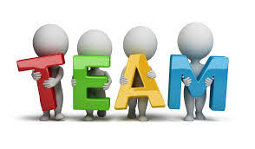
Student Name – Iqbal Hussain
Student Id – 1705770
Module Title - EFFECTIVE TEAM WORKING & COMMUNICATION
MODULE CODE: BMSK4002
Module Lecturer – John Paul

Contents
Introduction 1
The Tuckman Theory of group dynamics and teamwork 1
Application of Turkman’s theory in organisational context 2
Belbin’s theory of team roles 3
Application of Belbin’s theory in the workplace 4
Basic model of communication 4
Strategies to improve teamwork and communication within the organisation 6
Conclusion 7
References 9

Introduction
This report is about the effective teamwork and communication within the organisation. Effective teamwork means working in a group where various skills and knowledge will present and by using those skills and knowledge teams can achieve their goals. Communication means the exchange of information between sender and receiver. Various models and theories of group dynamics, team working and communication are analysed in this report within the organisational context. The application of the theories related to the teamwork and communication in the organisational situation is demonstrated in this report.

The Tuckman Theory of group dynamics and teamwork
Tuckman’s theory of group dynamics is one of the oldest and widely accepted theories which is applied in all the team development activities in the various organisation. Tuckman came up with the theory in 1965 where he suggested five stages of group development.
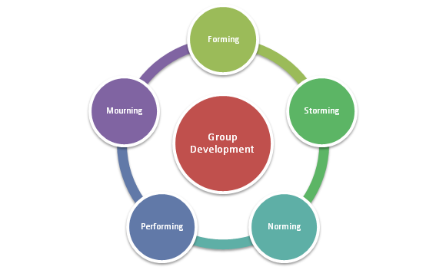

Figure: Tuckman’s group development
Source: http://www.mspguide.org/tool/tuckman-forming-norming-storming-performing
- Forming: First stage of the Tuckman's theory where a group is formed initially. Here management determines what types of team they will form. In a team, various knowledge and skills will be required (Scheid and Richter, 2017). For example in a product development team expertise from production, finance, marketing and sales will be needed. In the forming stage, a team leader will be selected and each member will get to know each other. Basic rules and regulations and roadmap of the project will be discussed in this step.
- Storming: Members starts to share their feelings at this stage. There are conflicts arise among the team members. Here members see themselves as individuals rather a team. Team members have power and role conflict and may not like the superiors or the colleagues (Levi, 2017). Team leaders make the purpose clear but the relationship between the team members seems blurry.
- Norming: This is the third stage of Tuckman's theory there members star to understand each other. Team leaders come to know the strengths and weaknesses of the team members. Roles and responsibilities of the team members are clear and mutual understanding is developed here. Members cooperate with each other and ready to perform the team works. Team leaders start to give importance to the viewpoints of the members and they understand that with cooperation and mutual respect they can achieve their goals (Brown, 2014).
- Performing: Actual team performance begins at this stage. Team leaders define and divide the roles and responsibilities of the team members. New strategies are built and applied to complete the task (Rosenhauer, 2013). All the members start to perform with their full capacity. Various alternative strategies are applied to achieve cost efficiency.
- Adjourning: Though this is not any formal stage of team development adjourning is necessary because a team will not perform eternally. After successful completion of the task, a team may close its activities which are called adjournment (Levi, 2017). The organisation can terminate any team if they cannot perform and achieve expected goals.

Application of Turkman’s theory in organisational context
Tesco is a supermarket giant in the UK having 3433 stores in various locations of the country. Tesco promotes teamwork at every stage of their activities. Tuckman’s team development theory can be applied in Tesco for its marketing operation of the new products. In the beginning, a stage which is called forming Tesco determine the goals and form a team with the expert people from marketing and braining, R&D, manufacturing, and finance. Here the marketing manager is selected as a team leader as the team is formed to market the new product. After formation of the team, Tesco defines the roles and responsibilities of the team members to control the conflict among the members. R&D managers conduct market research and design prototype of the new product. Finance managers determine the cost of manufacturing and marketing the new product. Operational managers produce the products according to the criteria determined by the team in a cost-effective way. Marketing and brand manager develop marketing programs to promote and launch the product in the market. After the successful launching of the new product, Tesco adjourns the team and look forward to developing a new team for a new purpose (Scheid and Richter, 2017).

Belbin’s theory of team roles
Dr. Meredith Belbin has suggested nine team roles after studying the teamwork of various organisations. More or less every team perform the nine tasks according to Belbin and the nine roles are:
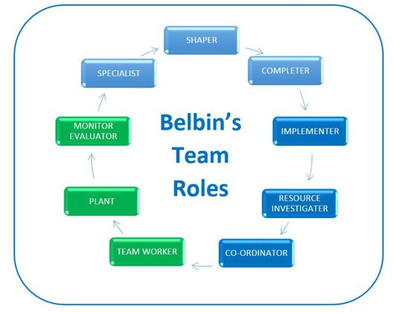
Figure: Belbin’s team roles
Source: http://www.educational-business-articles.com/belbin-team-roles/
- Shaper: shaper is dynamic takes challenges and has the drive and courage to overcome the obstacles. Shaper sometimes hurt the feelings of other members of the team.
- Completer: Completers finish their task on time but they are reluctant to delegate.
- Implementer: Implementers covert the thoughts into actions but they are not flexible and delay to respond to the opportunities (Mindtools.com, 2017).
- Resource investigators: Search for resources by communicating and making contacts with the related persons. They sometimes show over-optimism and loss enthusiasm very early (Mindtools.com, 2017).
- Co-ordinator: The mature person in the team who manage the resources and activities.
- Team-workers: They are good at working in a team and have various skills such as listening skills, perceptive and well mannered but sometimes they can be indecisive in pressure situations (Levi, 2017).
- Plant: They are the creative members of the team who has uncommon ways to solve the issues.
- Monitor evaluator: They examine all the options and judge them accurately. Evaluate the alternatives and inspire others (Mindtools.com, 2017).
- Specialist: Specialist has deep knowledge regarding specific issues but their knowledge is confined to narrow issues (Rosenhauer, 2013).

Application of Belbin’s theory in the workplace
Tesco can define the nine roles among the team members of the teams to get effective result. Tesco can divide the roles into three sections which are action-oriented, people oriented and thought oriented (Brown, 2014). In the action-oriented section, Tesco will use shaper, implementer, and completers to implement the strategies in the market. In the people-oriented section, Tesco will identify three groups of people which are a coordinator, team workers, and resource investigators. This group of people will search resources and market opportunities and co-operate with each other to implement strategies. In the thought oriented section, Tesco can identify three roles which are plat, monitor, and specialist. This group performs intellectually by designing plans and strategies to achieve team goals (Mindtools.com, 2017).

Basic model of communication
Communication is essential in every aspect of business activities. The model of communication will show how the employees and employer communicate with each other and also how to communicate with the third-party. By using the model an organisation can communicate with all the people within and outside the organisation (Overton, 2015). Within the organisation employers communicate with the employees and vice versa and outside the organisation, they communicate with the customers and other stakeholders. Two-way communication means both parties can simultaneously communicate with each other and within the organisation two-way communication is essential to managing the employees (Ober, 2014). There are two parties in a communication model who communicate with each other and there are some factors which influence the communication.
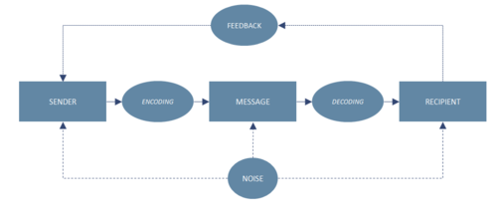
Figure: Basic communication model
Source: ManagementMania.com

- Sender: Sender is the person or organisation who sends communication messages. Within the organisation managers may send a message to the employers regarding the organisational decision. Organisations often communicate with the target customers through advertisement and here the organisation is the sender (Raman and Singh, 2014).
- Encoding: Encoding means putting thoughts, ideas and information in a symbolic form which initiate the communication. Employers may send written direction to the employees. Organisations may design posters or develop television advertisement campaign, for example, Tesco’s every little help campaign is the merging of thoughts, ideas, and information to communicate with the employees and customers (Ober, 2014).
- Message: It is the actual communication contents that are sent to the expected people with the intention of communication. The message can be written or verbal, audio-visual or symbolic. Employers basically communicate with the employees through written and verbal means. For example line managers in Tesco communicate the store employee every day by giving verbal briefing (Rai and Rai, 2015).
- Channel: It is the route or way to which message travel from the senders to the receivers. Within the organisation Tesco uses direct face to face channel. To communicate with the employees in the remote places Tesco use telecommunication and emails. Tesco uses various promotional mixes like an advertisement, sales promotion, and digital marketing to communicate with the target customers (Overton, 2015).
- Receivers: The person or group of people to whom the communication messages are sent called receivers. The employees are the receivers of the communication message within the organisation. Customers are the receivers of the communication message outside the organization (Rai and Rai, 2015).
- Decoding: The process of transforming the sender message into a meaningful thought is called decoding. Receivers decode the communication message. The sender has to be aware of the structure of the messages so that receivers can easily interpret the communication message (Ober, 2014).
- Feedback: Feedback from the receivers initiates two-way communication. The receivers’ reaction and response after decoding the communication message are called feedback. If employees of Tesco understand the message and carry out the activities assign by message then it can be considered as positive feedback (Overton, 2015).
- Noise: In the communication process the message can be distorted by many factors and this distortion is called noise. If lots of messages are sent to the employees they will be confused and this confusion will create noise (Raman and Singh, 2014).

Strategies to improve teamwork and communication within the organisation
Tesco can improve the team performance and communication within the organisation by applying the following strategies:
- Open door policy: In a team everyone should be encouraged to give their feedback. Open door policy provides accessibility to the top management and improves the working relationship with the employers and employees (Azendoo, 2017).
- Encourage two-way feedback: Managers or team leaders will expect feedback from the employees and team members so that mutual understanding can improve. Leaders will able to know the knowledge and skills of the team members through the two-way feedback (Ober, 2014).
- Clarity of roles and responsibility: In a team, all the members have to perform some roles. If the leaders clarify the roles and responsibilities it becomes easier to communicate with the team members and no overlapping take place during the communication (Levi, 2017).
- Build team spirit: To perform in an optimum level team spirit is essential. The third stage of Tuckman’s group dynamics model is norming where team spirit is developed through mutual understanding and cooperation (Brown, 2014).
- Using time wisely: timing is very important in communication. A minute delay in giving message can cause millions of pounds for the company. Employees should be given proper time to brainstorming and relaxation (Azendoo, 2017).
- Training: Training is an effective way to develop team performance. Employees’ lack of cooperation skills cannot perform well in a team. Tesco should provide training on time management, patient, social skills and interpersonal communication dynamics to improve the team performance and communication (Brown, 2014).
- Using the appropriate form of communication: Based on different situation Tesco has to use the appropriate form of communication. Where needed Tesco has to send a written message. In the group meeting, verbal communication is more effective (Azendoo, 2017). The team leader may have to use teleconferencing to communicate with the remote team members.
- Using online tools: To present physically in the team meeting causes huge time and money. By using intern tools like Skype and other video calling tools Tesco can save cost and time which will increase the team efficiency. Using online networking system like intranet team members can share information and save and protect them (Azendoo, 2017).

Conclusion
Tuckman’s theory of team dynamics will help Tesco to design and develop teams within the organisation. In every stage of team development, Tesco can control and monitor the activities to improve the efficiency. Belbin’s theory of teams roles will help Tesco to identify the action-oriented, and person-oriented and thought oriented team roles. The basic communication process shows the ways to communicate with the employees and employers. The strategies to improve team performance and communication should be applied carefully to get a better result.

References
Azendoo. (2017). 8 Simple and Effective Ways to Improve Team Communication. [online] Available at: https://blog.azendoo.com/8-ways-to-improve-team-communication/ [Accessed 22 Dec. 2017].
Brown, N. (2014). Teaching group dynamics. Westport, Conn.: Praeger.
Levi, D. (2017). Group dynamics for teams. Los Angeles [etc.]: Sage.
Mindtools.com. (2017). Belbin's Team Roles: How Understanding Team Roles Can Improve Team Performance. [online] Available at: https://www.mindtools.com/pages/article/newLDR_83.htm [Accessed 23 Dec. 2017].
Ober, S. (2014). Contemporary business communication. Boston: Houghton Mifflin.
Overton, R. (2015). Business communication. Boat Harbour, N.S.W.: Martin Books.
Rai, U. and Rai, S. (2015). Business communication. Mumbai [India]: Himalaya Pub. House.
Raman, M. and Singh, P. (2014). Business communication. New Delhi: Oxford University Press.
Rosenhauer, S. (2013). Teams and teamwork as the basis of effectiveness /developing business knowledge. Grin Verlag Ohg.
Scheid, J. and Richter, L. (2017). What Are the Theories of Group Work Dynamics?. [online] Brighthub Project Management. Available at: http://www.brighthubpm.com/resource-management/96930-theories-of-group-work-dynamics/ [Accessed 20 Dec. 2017].

