Freya Jaleh Vafadari
s2112275@uwtsd.student.ac.uk
Abstract
Density based traffic with ultrasonic motion sensors and humans walking at traffic lights with passive infra-red sensors. The density-based traffic systems have been built and tested as a software simulation in Proteus and in embedded Arduino hardware.
Electronics Engineering 1 Assignment
Density based traffic system

Introduction
The assignment for Electronics Engineering 1 is to design, build and test a density-based traffic systems using ultrasonic distance and passive infra-red motion sensors in both Proteus simulation software and hardware using Arduino microcontrollers. The traffic junction is a four-way intersecting junction with four traffic light signals to control the movement of vehicles and pedestrians. The traffic system was first simulated in Proteus utilising a PIC16F877A microcontroller to control the: LEDs which simulated the traffic lights at each of the four signals; variable potentiometers which simulated an ultrasonic distance sensor detecting motion of a vehicle at any of the four signals and a closed switch circuit which simulated a passive infra-red sensor detecting the motion of a human at any of the four signals. The Proteus simulation circuit was also built in embedded hardware using an Arduino MEGA 2560 and Arduino UNO R3 to interface with the LEDs and 7-character display as external peripherals to interface with the microcontrollers because of the inputs from the ultrasonic distance and passive infra-red motion sensors.
Assumptions
- Initial state of the circuit is all Red LEDs in the traffic lights are set to “HIGH” and all other LEDs in the traffic lights and the LEDs on the human crossings are set “LOW”, so it is assumed in the initial state of the circuit that there are cars moving.
- The signals SIGNAL_1 to SIGNAL_4 can be controlled individually.
- The system will skip a signal and proceed to the next one if there are no cars.
- The system remains at its current signal if there are no cars present at any of the other four signals and moves onto the next signal only if there is traffic at any other signal.
- The LED – BIRGs and 7 – character display can act as a peripheral for any of the four outputs S1_HUMAN_DIGITAL – S4_HUMAN_DIGITAL but only a single output out of the four outputs at any one time.
- Only one car can move at a time
- Only one human can cross at a time

Background Research
There are several examples online where similar traffic light systems have been density based using environment-based sensors to detect cars or humans with the circuits being controlled by microcontrollers. [5] Density based traffic signal systems using microcontroller is an example of similar project utilising passive infrared transmitters to control an ATMEGA8 microcontroller in a four-way traffic junction circuit. The circuit is designed and tested in Proteus, the PIR transmitter circuit is repeated four times once for each signal and includes an NPN transistor attached to a potentiometer which are connected in parallel to two IR receivers and two $330Ω$ resistors. Figure 21 shows the example of the PIR transmitter circuit at each signal.

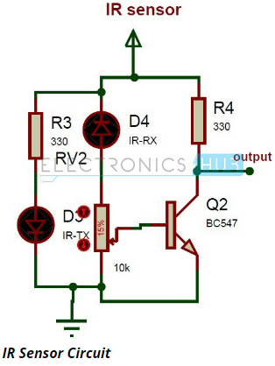
Figure 21 Example of a PIR transmitter circuit in an example density-based traffic control system project

Calculations
Ohm’s Law calculations for the Proteus software simulation with a PIC 16F877A microcontroller
LEDs D1_RED – D12_GREEN
Forward voltage of the LEDs D1_RED – D12_GREEN $=2.2v$
Full drive current $=10mA$
Ohm’s Law Voltage = Current x Resistance
Maximum possible of the current limiting resistors connected in series with the LEDs D1_RED – D12_GREEN $=220Ω$
LEDs D13_BIRG – D16_BIRG
Forward voltage of the LEDs D1_RED – D12_GREEN $=2.2v$
Full drive current $=10mA$
Ohm’s Law Voltage = Current x Resistance
Maximum possible of the current limiting resistors connected in series with the LEDs D13_BIRG – D16_BIRG $=220Ω$
7 – Character display hexadecimal calculations
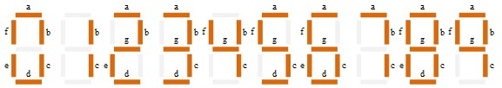
Figure 1 Digital output displays for numbers 0 – 9 on a 7-character display
Figure 1 shows the digital output displays for the numbers 0 – 9 on a 7-character display. If the character a – f is “HIGH” then the character will be illuminated and represented in binary as logic level “1” and if the character a – f is “LOW” then the character will not be illuminated and represented in binary as logic level “0”.
Proteus code section for initial condition that sets all Red LEDs to “HIGH” and the binary calculations
output_b (0x21); // Initial condition of D1_RED & D6_RED LEDs set to "HIGH"
output_c (0x24); // Initial condition of D9_RED & D10_RED LEDs set to "HIGH"
PORTB Output D1_RED & D6_RED LEDs = 0 x 24
8 | 4 | 2 | 1 | 8 | 4 | 2 | 1
0 | 0 | 1 | 0 | 0 | 1 | 0 | 0

PORTC Output D1_ D9_RED & D10_RED LEDs = 0 x 21
8 | 4 | 2 | 1 | 8 | 4 | 2 | 1
0 | 0 | 1 | 0 | 0 |  | 0 | 1

Table 1 Binary output from the 7 – character display of numbers 0 -9 and their binary to hexadecimal conversion.
Decimal digit | Output binary display | Binary to hexadecimal conversion
0 | 1111110 | 0 x 3F
1 | 0110000 | 0 x 06
2 | 1101101 | 0 x 5B
3 | 1111001 | 0 x 4F
4 | 0110011 | 0 x 66
5 | 1011011 | 0 x 6D
6 | 1011111 | 0 x 7D
7 | 1110000 | 0 x 07
8 | 1111111 | 0 x 7F
9 | 1111011 | 0 x 6F

Electronics components list and cost
Table 2 Electronic components list and cost for the human traffic crossing hardware circuit involving an Arduino UNO R3 and a HC – SR312 Passive Infra-red motion sensor.
Electronic component | Quantity | Cost per individual component | Total cost (£)
Arduino UNO R3 | 1 | £12.99 | £12.99
Green LEDs | 3 | 1.80p | 5.40p
Yellow LEDs | 2 | 1.80p | 3.60p
Red LEDs | 3 | 1.80p | 5.40p
White LED | 1 | 1.80p | 1.80p
HC – SR312 Passive Infra-red motion sensor | 1 | £2.25 | £2.25
7-character display | 1 | £2.79 | £2.79
300-ohm Resistors | 6 | 4.20p | 25.2p
390-ohm Resistors | 9 | 4.20p | 37.8p
830-point holes Breadboard | 1 | £2.25 | £2.25

Total cost for the first circuit ≈ £21
Total cost for me ≈ £8 (already owned Arduino UNO R3)
Table 3 Electronic components list and cost for the car traffic crossing hardware circuit involving an Arduino MEGA 2560 and a HC – SR04 Ultrasonic distance sensor.
Electronic component | Quantity | Cost per individual component | Total cost
Arduino MEGA 2560 | 1 | £15.99 | £15.99
Green LEDs | 3 | 1.80p | 5.40p
Yellow LEDs | 3 | 1.80p | 5.40p
Red LEDs | 3 | 1.80p | 5.40p
HC – SR04 ultrasonic distance sensors | 4 | £2.00 | £8.00
220-ohm Resistors | 12 | 4.39p | 52.68p
830-point holes Breadboards | 4 | £2.25 | £9.00

Total cost for the second circuit ≈ £33
Total cost for me ≈ £17 (already owned Arduino MEGA 2560)

Proteus software simulation
The Proteus software circuit shows the potential to control the four signals at the junction individually for both cars and humans and the traffic light sequences cycles if the potentiometer’s analogue value is greater than zero and or a switch is latched in the series circuit.

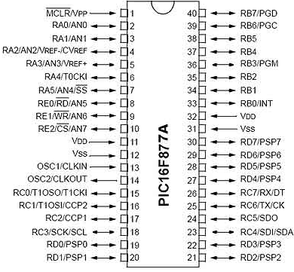
Figure 2 PIC 16F877A pin out diagram
Figure 2 shows the PIC 16F877A pin out diagram - [3] PIC16F877A Pin Out diagram and data sheet information and pin out. The PIC can function at a maximum frequency of 20MHz and has operating voltage in the range $4.2-5.5v.$ The PIC does not have an internal oscillator and the maximum current each PORT can sink, or source is approximately $100mA.$The circuit has the input analogue pins on Pins A0 – A3 and the input digital pins on Pin E2, Pins C3 & C4 and Pin D7. Pins A0, A1, A2 & A3 are bidirectional input/output analogue pins on PORTA. Pin E2 is an analogue input pin or for the parallel slave port it can act as the ‘control select.’ Pin C3 can be the output pin for SPI or I2C modes and Pin 14 in I2C mode can be the data input/output pin. Pin 1 on the PIC is the Master Clear Pin of the integrated circuit which resets the microcontroller and is in active low state so it has a constant voltage of $5v$ and if the voltage is $0v$then the microcontroller is reset. Pins 11 and 32 are VDD pins which are the positive supply for the input/output and should be connected in series to $5v.$ Pins 12 and 32 are VSS pins which are ground reference pins for the input/output pins and are connected in a series to a $0v$potential difference. Pin 13 is the OSC1/CLKIN pin which is the oscillator input or the external clock input pin. Pin 14 is the oscillator output pin, and a crystal resonator is connected between the Pin 13 & 14 to provide external clock to the microcontroller. $1/4$ of the frequency of OSC1 is output on OSC2 in the case of RC mode which shows the instruction cycle rate. Pin 25 is the USART asynchronous transmit pin and Pin 26 is the USART receive pin.
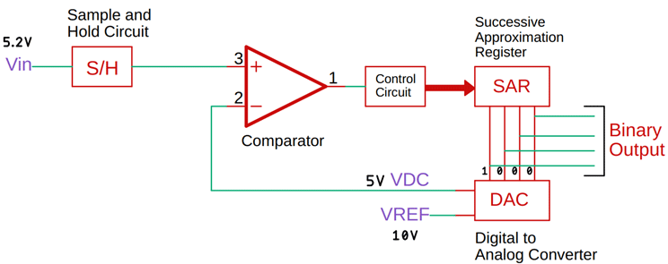
Figure 3 Explanation of how successive approximation registers work
Figure 3 shows a block diagram of how successive approximation registers work. The PIC 16F877A has a successive approximation register analogue to digital converter. A successive-approximation ADC is a type of analogue-to-digital converter that changes a continuous analogue waveform into a discrete digital representation using a binary search through all possible quantisation levels before finally converging upon a digital output for each conversion. The typical conversion speed is of successive approximation ADC is approximately 2 – 5 mega samples per seconds (MSPS). The PIC 16F877A interfaces through USART (universal synchronous/asynchronous receiver/transmitter) which is hardware that enables a device to communicate using serial protocols. It can function in a slower asynchronous mode, like a universal asynchronous receiver/transmitter (UART) or in a faster synchronous mode with a clock signal.

PIC16F877A Features
- Total number of Pins – 40
- Total number of ports – 5 (PORTA, PORTB, PORTC, PORTD and PORTE)
- Operating Voltage – 2 - 5.5V
- Number of input/output pins – 33
- Number of ADC pins – 14
- ADC Resolution – 10-bit
- Number of Comparators – 2
- Number of timers – 3
- Communication protocols – UART, SPI, I2C
- External Oscillator – > 20Mhz
- Program Memory – 14KB
- RAM – 368 bytes

A potentiometer resistor in series circuit was implemented at each of the four signals S1_CAR_ANALOGUE – S4_CAR_ANALOGUE to simulate ultrasonic distance sensors. A potentiometer resistor in series circuit was implemented in place of HC – SR04 ultrasonic distance sensors because the Proteus version, Proteus 8.14 the simulation circuit software the circuit was designed on didn’t have a functioning built in HC – SR04 ultrasonic distance sensor library with drivers. A potentiometer is a three terminal variable resistor where the resistance is manually varied to control the flow of electric current. A potentiometer acts as an adjustable voltage divider. A voltage divider is a passive linear circuit which produces an output voltage $V_{out}$ that is a fraction of the input voltage$V_{in}$. Current is equal at all points in the linear circuit. A potentiometer is a passive electronic component which works by varying the position of a sliding contact across a uniform resistance and has the two terminals of the input source fixed to the end of the resistor. To change the output voltage the sliding contact gets moved along the resistor on the output side. Figure 4 shows how a potentiometer works in a passive linear circuit.
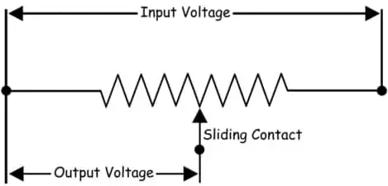
Figure 4 How does a potentiometer work?
The switches were implemented in the circuit for each of the four signals with the outputs S1_HUMAN_DIGITAL – S4_HUMAN_DIGITAL to simulate passive infra-red motion sensors. A push button switch series circuit was implemented in place of HC – SR312 passive infra-red motion sensors because there were no Proteus libraries on Proteus 8.14 which supported the low-level drivers to program HC – SR312 passive infra-red motion sensors. A Switch is a device which interrupts the current flow in a circuit. When the contacts of a switch are closed, the switch creates a closed path for the current to flow and hence load consumes the power from source and when the contacts of a switch are open, no power will be consumed by the load.
An LED or Light Emitting Diode, is a solid state optical PN-junction diode which emits light energy in the form of photons. A seven-character display is a form of electronic display device for displaying decimal numerals as an alternative to the more complex dot matrix displays. Figure 5 shows the pin configuration and LED output for a common cathode 7-character display. In the common cathode 7 – character display all the cathode connections of the LED characters are connected together to logic “0” or GND. The individual characters are illuminated by the application of a “HIGH” or logic “1” signal through a current limiting resistor to forward bias the individual anode terminals (a – g).
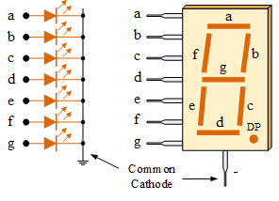
Figure 5 7 – character display common cathode pin configuration
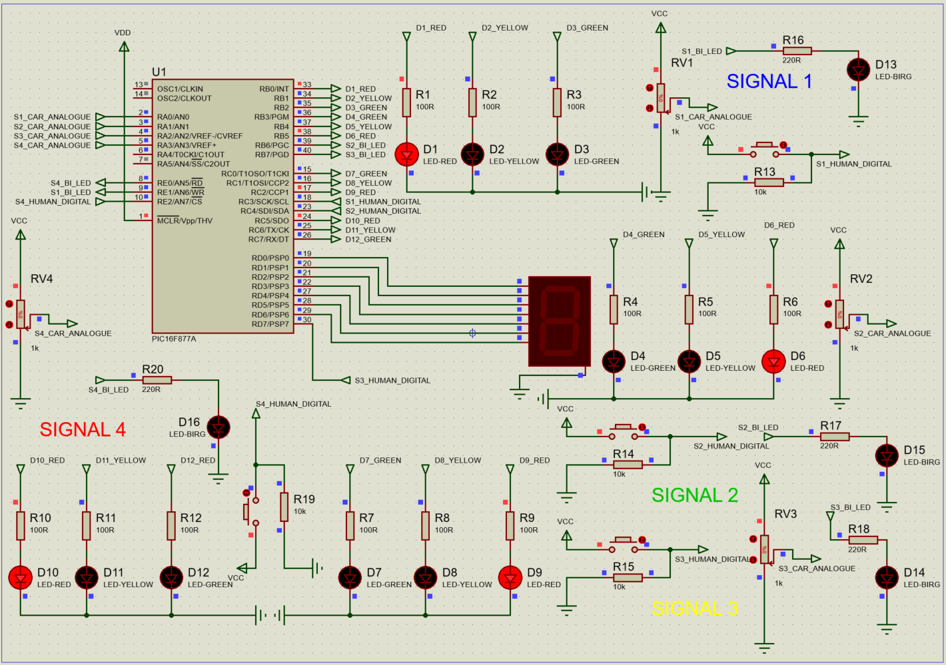
Figure 6 Initial condition at the traffic and crossing lights, all Red LEDs “HIGH”
Figure 6 shows the initial conditions of the circuit. The red LEDs D1, D6, D9 & D10 are “HIGH” initially when RV1 = RV2 = RV3 = RV4 = 0 because there is no change in the resistance of the potentiometers SIGNALS 1, 2, 3 & 4. In the density-based traffic system it means the ultrasonic distance sensors have not detected the motion of any cars. The red/green LEDs D13, D14, D15 & D16 are “LOW” initially when the button switches aren’t latched. In the density-based traffic system it means the passive infra-red motion sensors have not detected the motion of any humans.
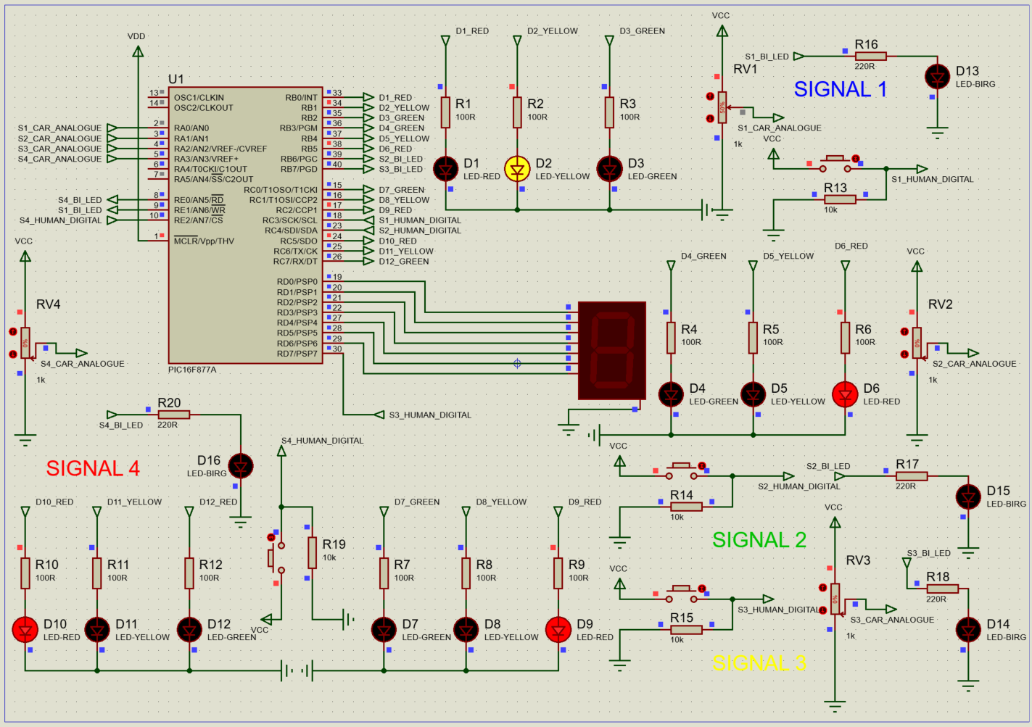
Figure 7 Car waiting at signal 1 all other signals red
Figure7 above shows the Proteus circuit where $RV1 > 0$and the traffic light at SIGNAL1 is yellow which means at SIGNAL1, a car waiting and therefore for the signals at all other traffic lights are red. Figure 8 below shows the circuit where $RV1>0$ and the traffic light at SIGNAL1 is green which means
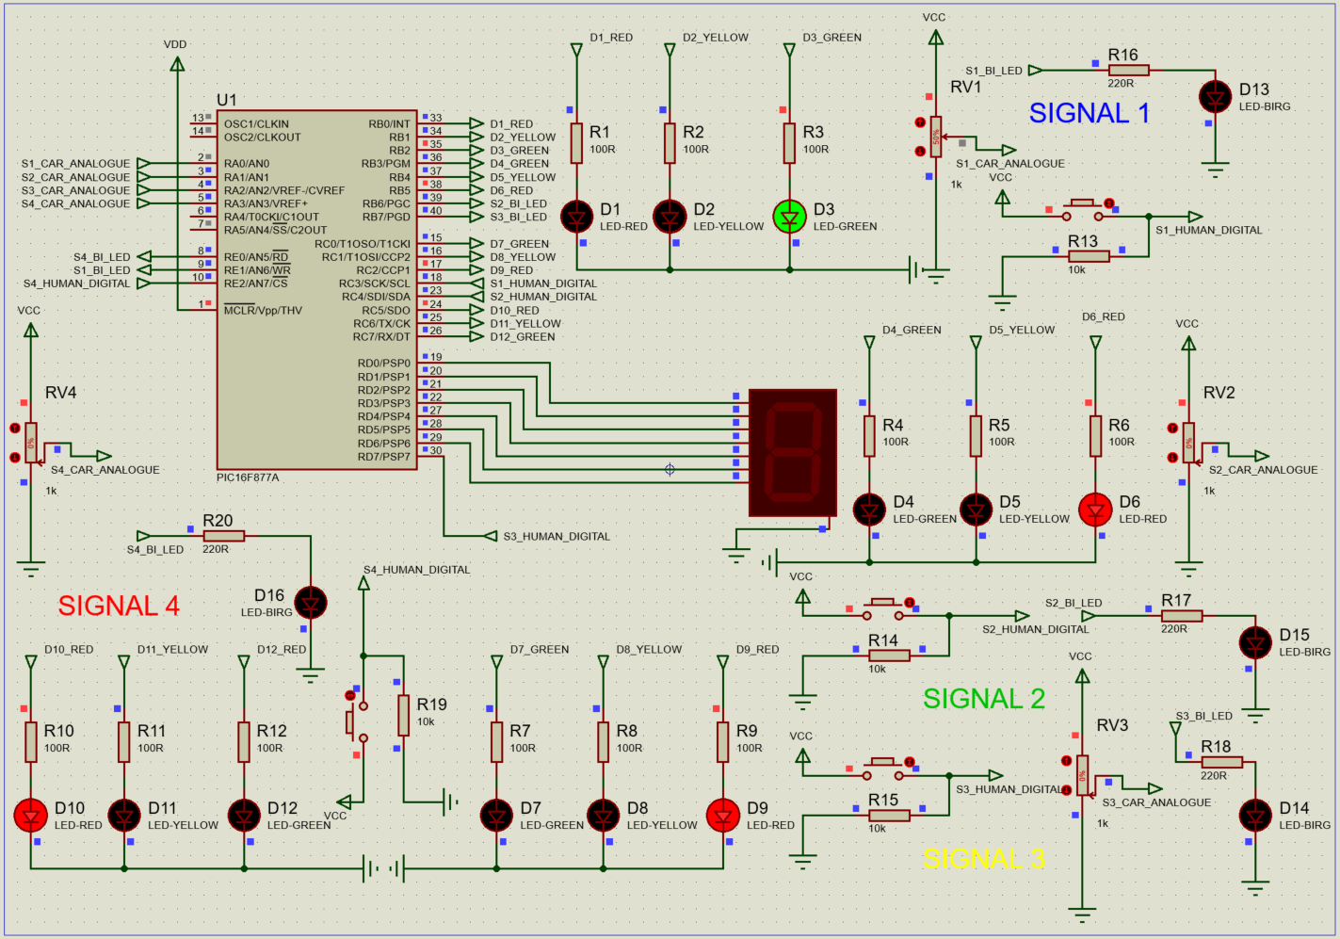
Figure 8 Car moving at signal 1 all other signals red
Figure 9 below shows the switch state is “HIGH” and the switch is latched at SIGNAL1, so all the traffic lights are red which shows there’s no cars moving. The LED BIRG is green which shows human can cross.
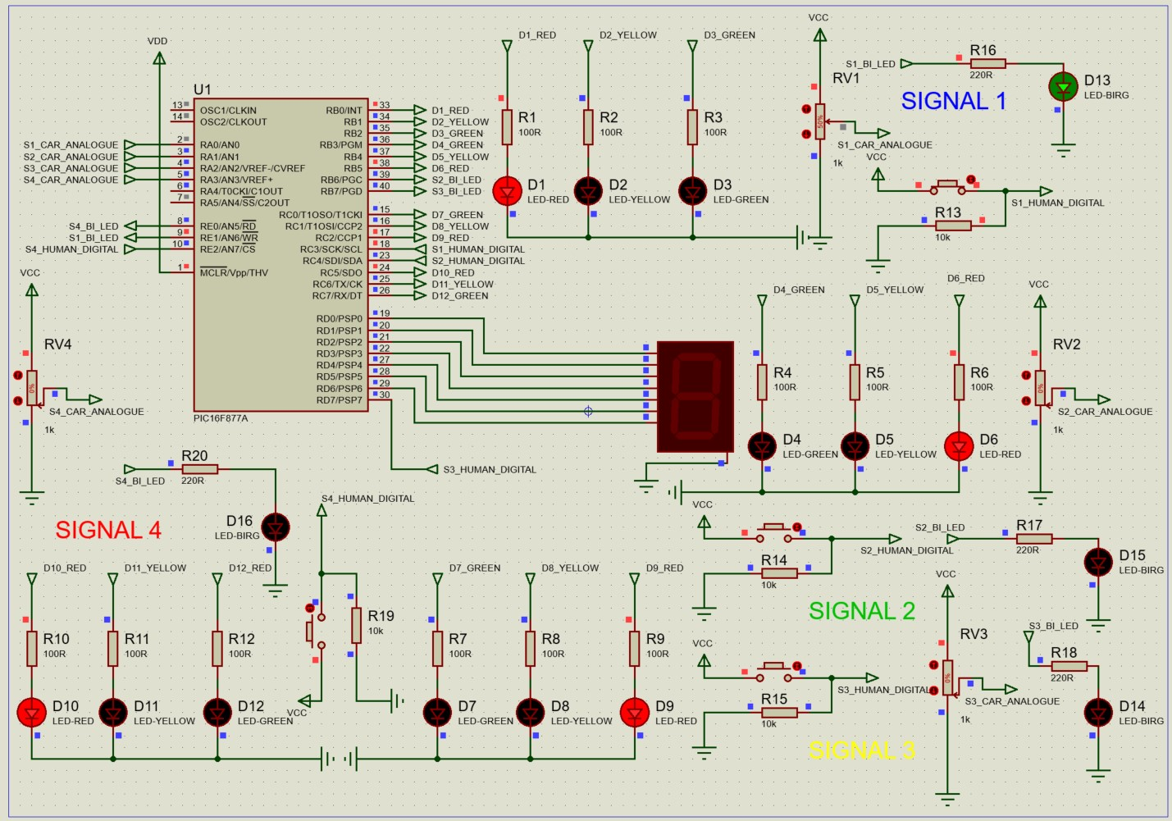
Figure 9 Humans crossing at signal 1 all other signals red
The figures 10 below show the circuit running where the switch series circuit is in “HIGH” state so the traffic lights are yellow at SIGNAL1 so cars are waiting and the LED BIRG at SIGNAL1 is flashing green so humans can cross, the 7-character display is also incrementing up from 0 – 9.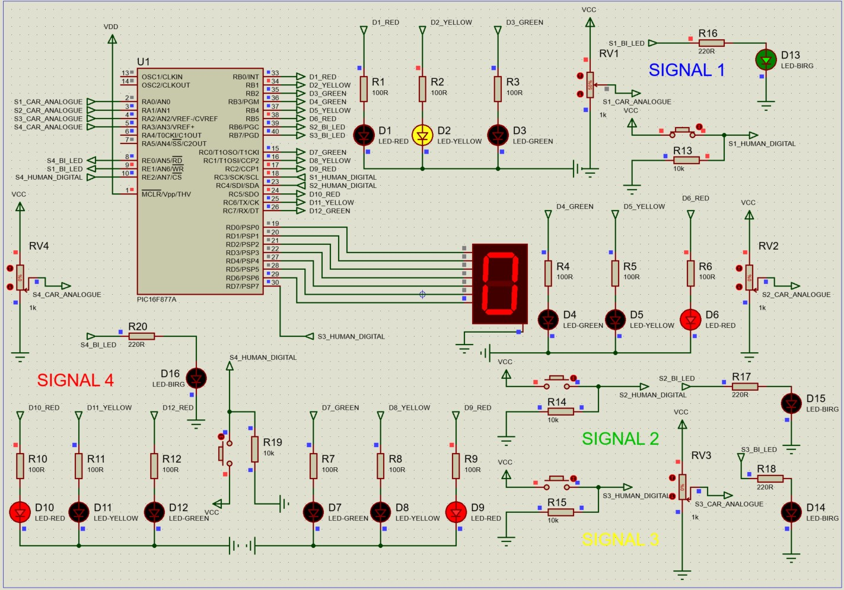
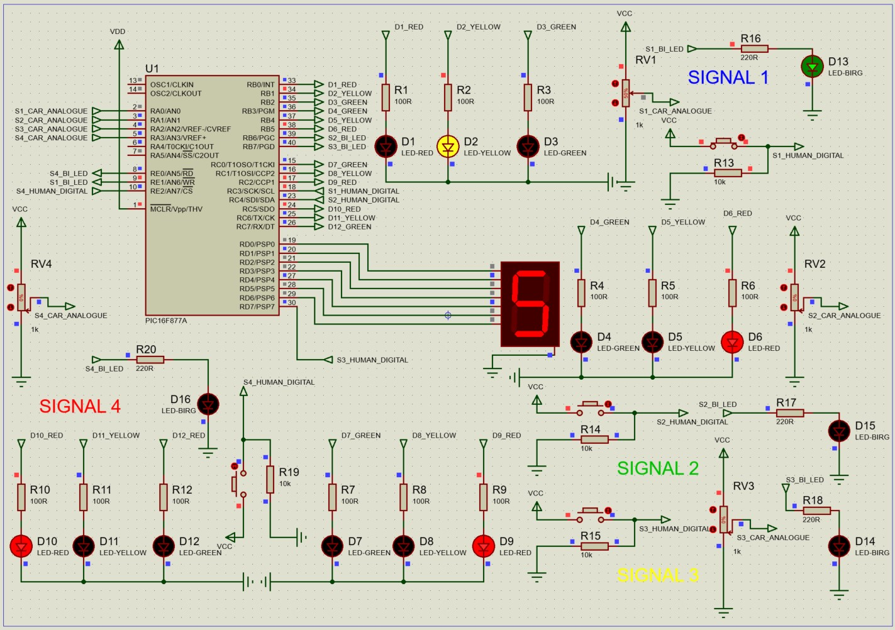
Figure 20 Humans crossing at signal 1 all other signals are red or yellow so cars are stopped or waiting

Arduino hardware – Car traffic crossing
Explain circuit
A passive infra-red sensor is an electronic sensor that measures infrared light radiating from a source in its field of view. A PIR sensor can detect changes in the quantity of infrared radiation incident on the sensor’s peripherals which varies depending on the temperature and the surface characteristics of the source in front of the sensor. When a change in radiation from a source is detected the PIR sensor will convert the resulting change in the incoming radiation into a change in the output voltage which results in the sensor detecting passive infra-red radiation. Infrared radiation is a type of radiation on the electromagnetic spectrum that extends from the long wavelength, red end of the visible light to the microwave end of the spectrum. Infrared radiation is divided into three regions: the near infrared (nearest to the visible spectrum) has wavelengths of $0.78-2.5×{10}^{-6}m$; the middle infrared region has radiation with wavelengths of $2.5-50×{10}^{-6}m$ and far infrared radiation has wavelengths of $50-1000×{10}^{-6}m.$ Figure 11 shows the timing diagram for a PIR sensor.
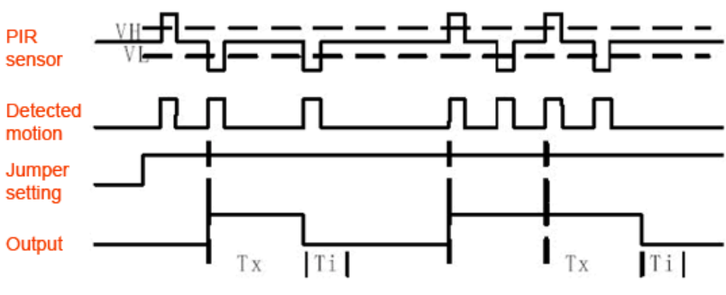
Figure 11 PIR sensor timing diagram
Ultrasonic sensors are electronic devices that calculate the target’s distance by emission of ultrasonic sound waves and change those waves into electrical signals. Figure 12 shows the timing diagram for an ultrasonic sensor. The speed of emitted ultrasonic waves traveling speed is faster than the audible sound. The ultrasonic sensor working principle is like sonar or radar which evaluates the target attributes and characteristics by understanding the received echoes from sound or radio waves. These sensors produce high-frequency sound waves and analyse the echo which is received from the sensor. The sensors measure the time interval between transmitted and received echoes so that the distance to the target is known. Consider HC-SR-04 ultrasonic sensor where we should provide a TRIGGER pulse. It produces a sound wave with a frequency of $40 kHz$ which corresponds to 8 pulses. This makes the ECHO pin to the HIGH state. The ECHO pin will stay in a HIGH state until and unless it receives the ECHO sound. Therefore, the ECHO pin width is calculated as the time for the sound to travel from a target and back which can be used to measure the distance. The range ability of HC-SR-04 is$2 –400 cm$. Figure x shows the ultrasonic distance sensor timing diagram. [4] HC – SR04 Ultrasonic distance sensor data sheet - information and pin out diagram.
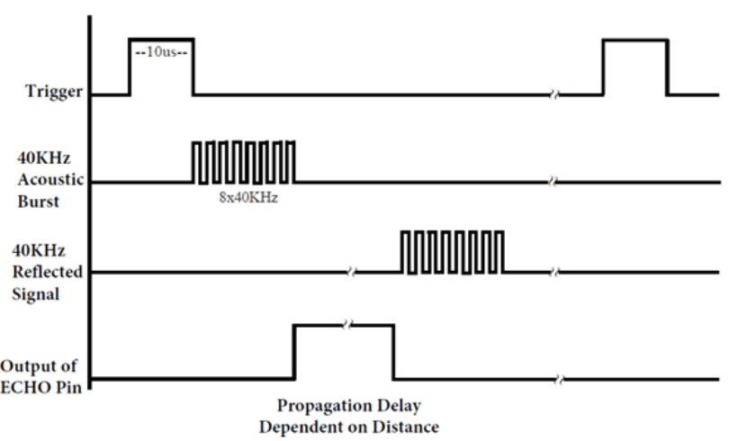
Figure 12 Ultrasonic distance sensor timing diagram
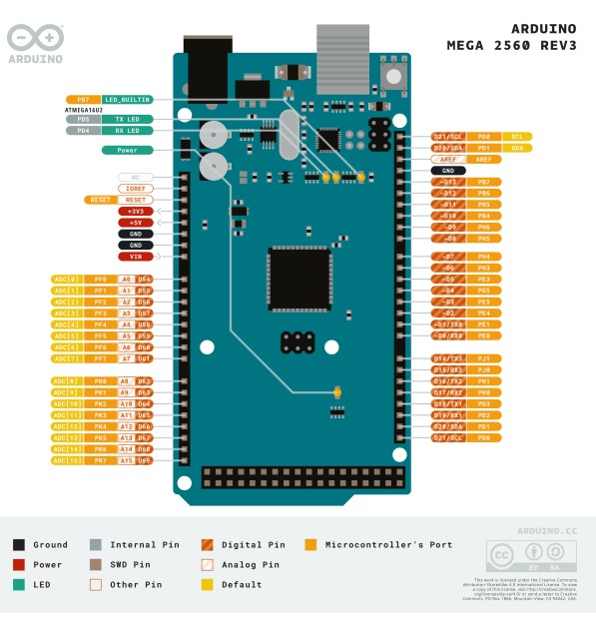
Figure 13 Arduino MEGA 2560 pin out diagram
An Arduino MEGA 2560 was implemented in the design and construction of the Car_Traffic_Crossing circuit because as shown in Figure 13 the Arduino MEGA 2560 has 54 digital IO pins and 16 analogue input pins and the circuit had required many digital IO pins as for example there are 4 HC – SR04 ultrasonic sensors which all need a VCC, GND, ECHO and TRIGGER IO connection. The digital IO pins two states either “HIGH” or “LOW” and when receive an input voltage of $5v$ the pins are at “HIGH” state and when they receive $0v$ the pins are at “LOW” state. The Arduino MEGA has three GND ports. Pulse width modulation is supported by 15 digital IO pins on Arduino MEGA 2560 and the ports are in a “HIGH” or “LOW” state. Pulse-width modulation (PWM), or pulse-duration modulation (PDM), is a method of controlling the average power delivered by an electrical signal. The average value of voltage (and current) fed to the load is controlled by switching the supply between 0 and 100% at a rate faster than it takes the load to change significantly. The longer the switch is on, the higher the total power supplied to the load. The Arduino MEGA has one SPI communication protocol that has two Pins – a MISO (master input slave output) for communication between the controller and other peripherals like external sensors and shift registers and MOSI (master output slave input) for the SPI communication. Serial peripheral interface (SPI) is a synchronous serial communication interface utilised for short-distance communications in embedded systems. The SPI bus has four specific logic signals which are: SCLK serial clock (output from master); MOSI Master Out Slave In (data output from master); MISO Master In Slave Out (data output from slave) and CS/SS Chip Slave/Slave Select (often active low output from master). The board has one I2C communication protocol that has two pins SDL and SCL. The SCL is the serial data pin that transfers the data and SLC is the serial clock line that ensures the synchronisation of data transfer over I2C bus. I2C is a bidirectional serial communication bus utilised for communication between a microcontroller representing the I2C master and a single or multiple slave devices which could be sensors like HC – SR04 ultrasonic sensors, LEDs, 7-character displays, ADCs/DACs and other devices. The Arduino MEGA 2560 has four serial ports on the board and each UART serial port has two pins Rx and Tx. The Rx is the receiving pin that ensures the receiving of data over the serial port and Tx is the transmission pin that ensures the transmission of serial data. A universal asynchronous receiver/transmitter (UART) is a computer hardware device for asynchronous serial communication where the data format and transmission speeds are configurable. It sends data bits one at a time from the least to the most significant and framed by stop and start bits so the precise timing is handled by the communication channel. [1] Arduino MEGA 2560 Pin Out diagram and data sheet – information and pin out diagram.
Figure 14 shows the circuit schematic diagram for the Car_Traffic_Crossing drawn on Fritzring. Figure 15 shows the breadboard circuit diagram for the same circuit, the circuit has been powered using two AA batteries as an external power supply but alternatively it can be powered directly by the Arduino MEGAs on-board $5v$power supply.

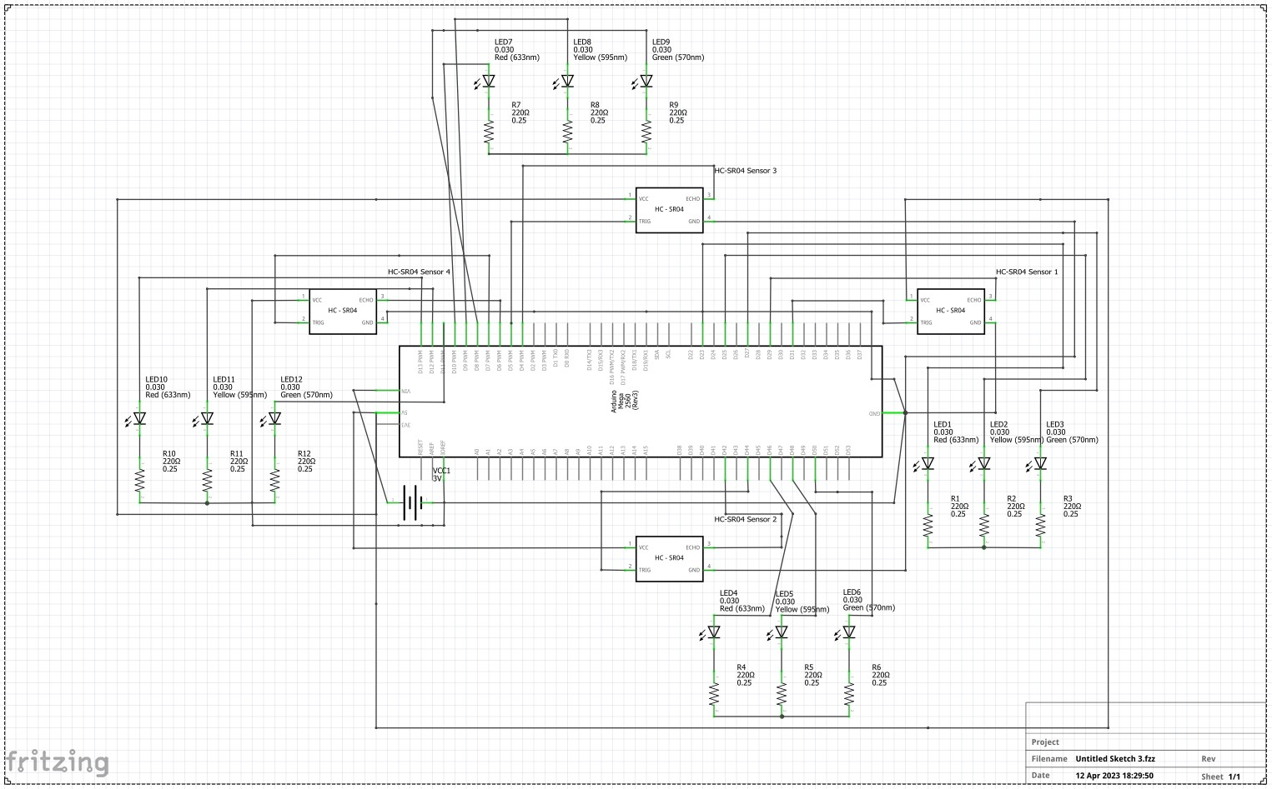
Figure 14 Car traffic crossing circuit diagram
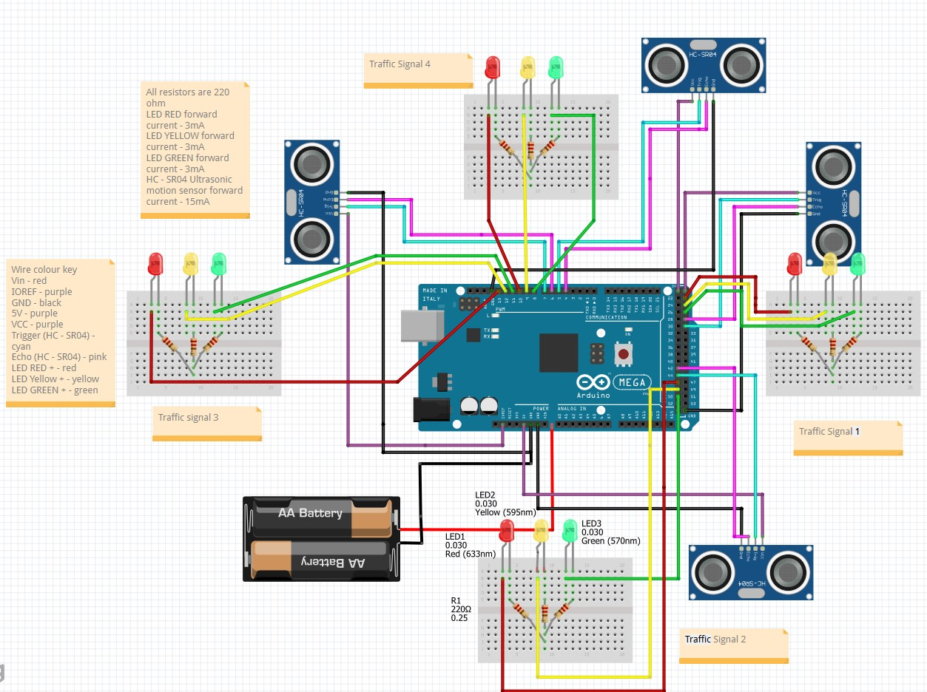
Figure 15 Car traffic crossing breadboard diagram
Figures 16 shows the Car_Traffic_Crossing circuit built with resistors, LEDs, HC – SR04 ultrasonic sensors on breadboards around a microcontroller. Figure x shows the Car_Traffic_Crossing circuit successfully working where all the signals can be controlled individually and the traffic light sequences functions if a car is detected by the ultrasonic distance sensor.
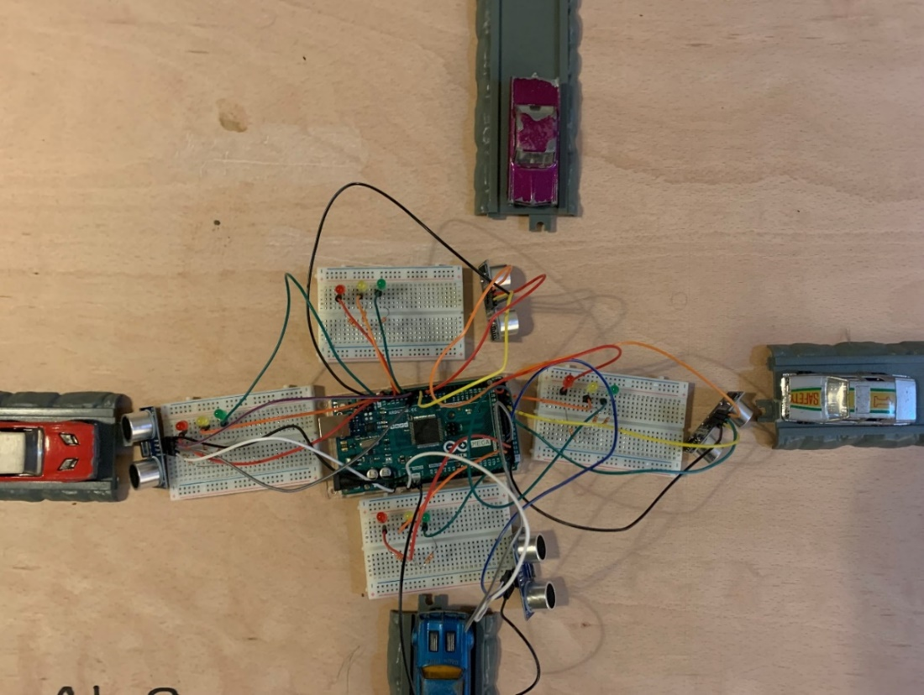
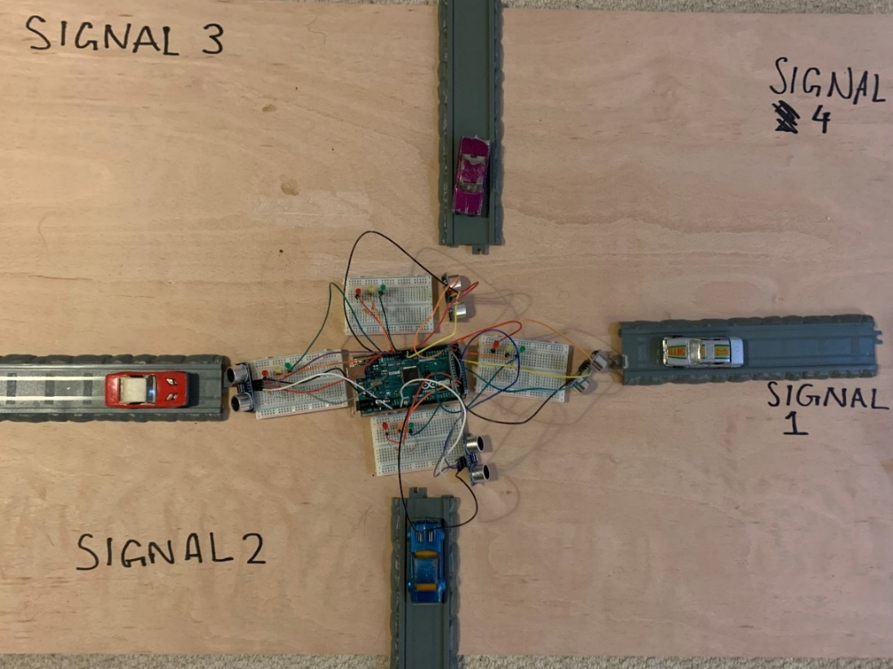
Figure 16 Embedded Arduino hardware for the Car_Traffic_Crossing circuit
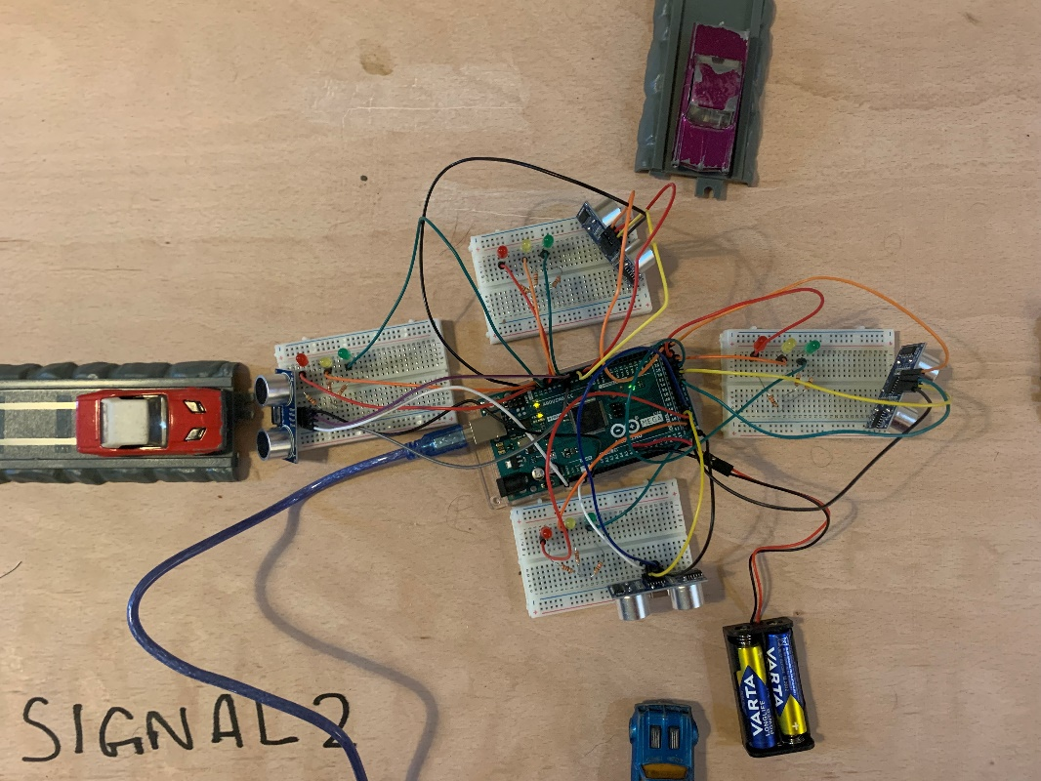

Arduino hardware – Human traffic crossing
The circuit is embedded hardware designed and simulated around an Arduino UNO R3. The PIR sensor is an input sensor which if there is motion the traffic lights in front of the cars will turn red and the crossing lights in front of the people will turn green. The 7 – character display will then increase from 0 – 9 and a buzzer will sound if motion has been detected.
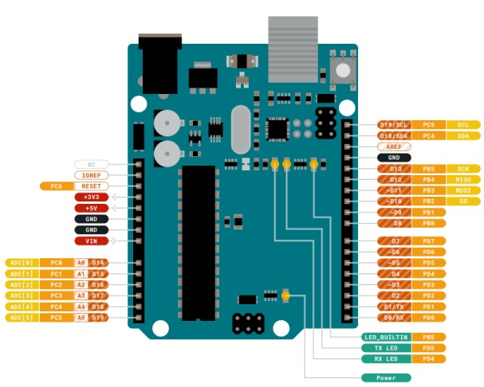
Figure 17 Arduino UNO R3 pin out diagram
The Arduino UNO R3 has 14 digital IO pins and 6 out of 14 digital IO pins can be utilised as PWM outputs. There are 3 GND pins on the board, 6 analogue input pins and the clock frequency of the board is 16MHz which synchronises internal functions. Figure 18 shows the circuit schematic diagram on Fritzring of the Human_Traffic_Crossing circuit where the PIR sensor is an input interfacing through the LEDs to show the traffic light situation and the 7-character display is counting for the time the people must cross. Figure x shows the breadboard circuit diagram on Fritzring of the Human_Traffic_Crossing circuit. [2] Arduino UNO R3 Pin Out diagram and data sheet – information and pin out diagram.
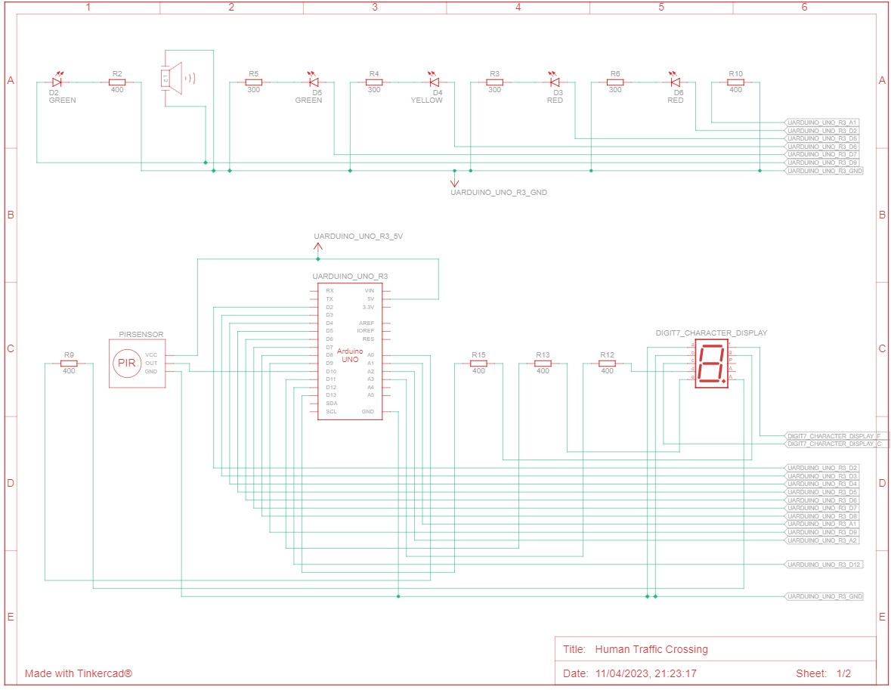
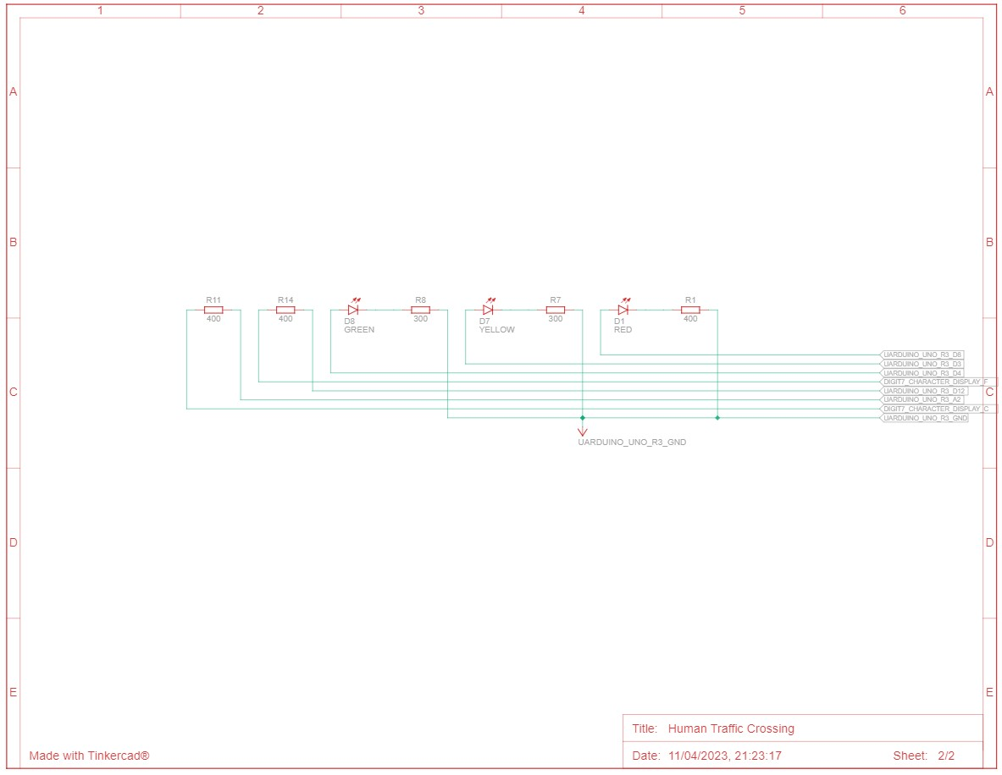
Figure 18 Circuit schematic diagram for the Human_Traffic_Crossing circuit
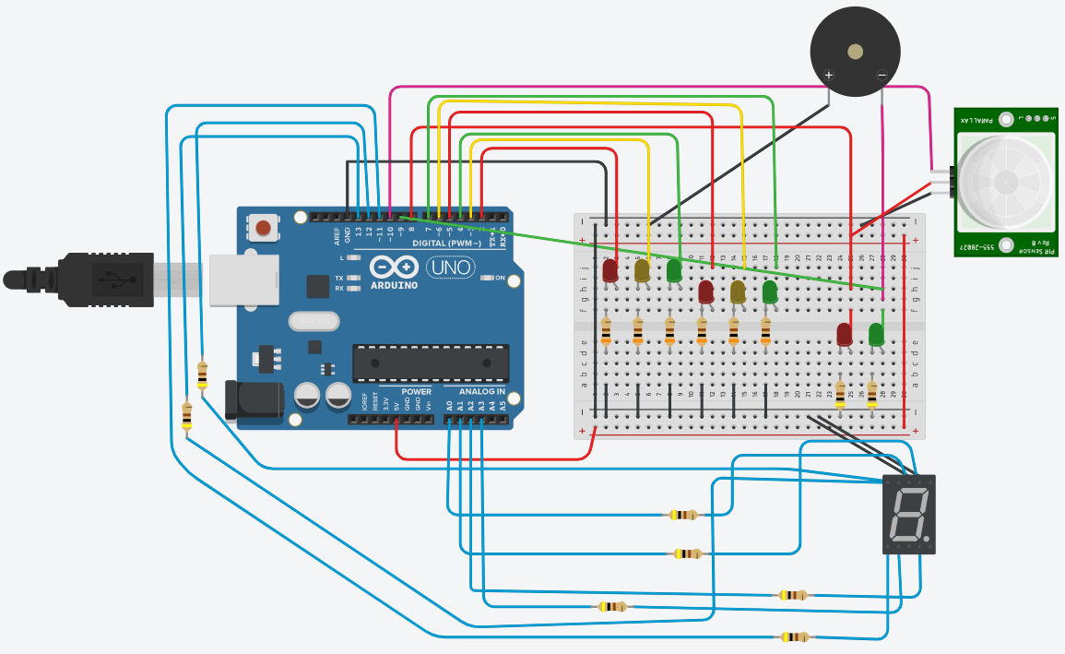
Figure 19 Human traffic crossing breadboard diagram

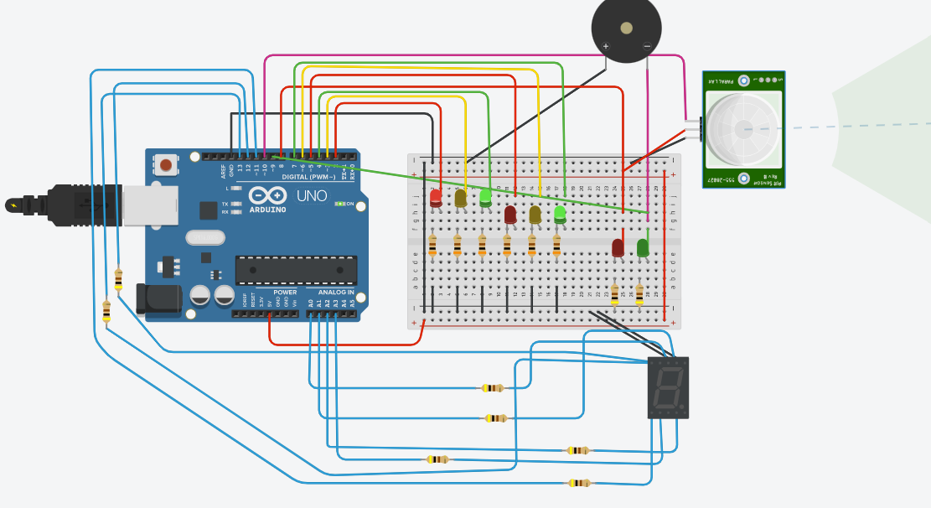
Figure 20 Successfully working simulation of the Humam_Traffic_Crossing circuit
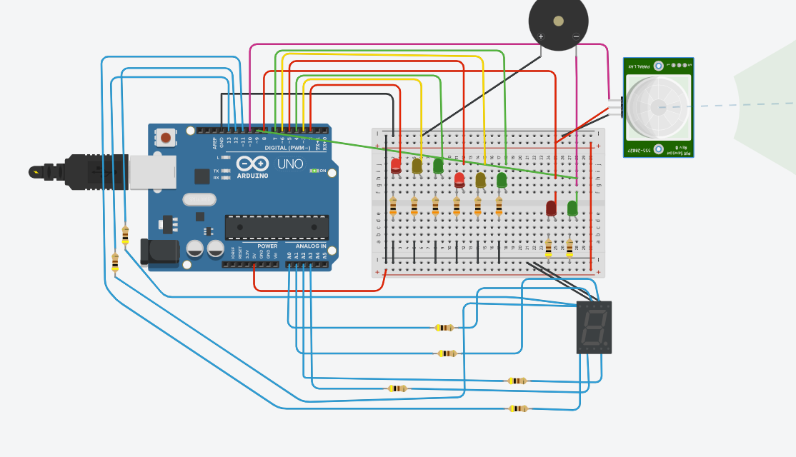
Figures 20 shows the successful working simulation of the Human_Traffic_Crossing circuit so if the PIR sensor detects the motion of human

Software and hardware system testing

Conclusion
I successfully designed, built, and tested a density-based traffic systems to control cars moving and pedestrians walking at traffic lights and crossing lights. I implemented a variety of analogue or digital sensors into the Proteus software simulation and embedded Arduino hardware circuits to detect motion and distance to control the LED traffic and crossing lights and the 7 – character display as external peripherals. My next steps for expansion of my current work are to build a working hardware simulated model of my Proteus software model using a PIC16F877A microcontroller. I would also like to interface other external peripherals with the PIC16F877A like an LCD display, in both Proteus software and PIC microcontroller hardware circuits, to display real time status of each of the four signals. I would improve the Human_Traffic_Crossing microcontroller circuit by building the circuit on Verraboard and soldering the components in place before programming the firmware on the Arduino UNO R3.

References
[1] Arduino MEGA 2560 Pin Out diagram and data sheet “Arduino® MEGA 2560 Rev3.” Accessed: Apr. 28, 2023. [Online]. Available: https://docs.arduino.cc/static/292cc2565bbc3c3998b52614a7e620d2/A000067-datasheet.pdf
[2] Arduino UNO R3 Pin Out diagram and data sheet “Arduino® UNO R3.” Accessed: Apr. 28, 2023. Available: https://docs.arduino.cc/static/6369d387aa04366ada1eba441db3a546/A000066-datasheet.pdf
‌[3] PIC16F877A Pin Out diagram and data sheet Accessed: Apr. 28, 2023. [Online] “PIC16F877A Introduction, pinout, features, Examples, Datasheet,” Microcontrollers Lab, Aug. 10, 2015. https://microcontrollerslab.com/pic16f877a-introduction-features/
‌[4] HC – SR04 Ultrasonic distance sensor data sheet Accessed: Apr. 28, 2023. [Online] “HC-SR04 datasheet,” datasheetspdf.com. https://datasheetspdf.com/pdf-file/1380138/ETC1/HC-SR04/1
[5] Density based traffic signal systems using microcontroller Accessed: Apr. 28, 2023. [Online] http://www.facebook.com/electronicshub.org, “Density Based Traffic Signal System using Microcontroller,” Electronics Hub, Dec. 24, 2017. https://www.electronicshub.org/density-based-traffic-signal-system-using-microcontroller/

Appendices
Human_Traffic_Crossing – Arduino code
int LED_Traffic_Red1 = 2; // Initialising GPIO pins for RED, YELLOW and GREEN LEDs for 1st traffic lights on Pins 2, 3 & 4
int LED_Traffic_Yellow1 = 3;
int LED_Traffic_Green1 = 4;

int LED_Traffic_Red2 = 5; // Initialising GPIO pins for RED, YELLOW and GREEN LEDs for 2nd traffic lights on Pins 5, 6 & 7
int LED_Traffic_Yellow2 = 6;
int LED_Traffic_Green2 = 7;

int LED_Human_Red1 = 2; // Initialising GPIO pins for RED and GREEN LEDs for crossing light on Pins 8 & 9
int LED_Human_Green1 = 3;

int PIR_Sensor = 10; // Initialising GPIO pin for the digital output signal from the PIR sensor
int PIR_Active_State = LOW; // Default state of the PIR if no movement is detected by the PIR sensor
int PIR_Sensor_Store = LOW; // Variable to store the state of the PIR sensor
int timer = 10000;
unsigned const int char_a = 14; // Initialising GPIO pins for the digital output signal from the 7-character display - character_a
unsigned const int char_b = 15; // character_b
unsigned const int char_c = 16; // character_c
unsigned const int char_d = 17; // character_d
unsigned const int char_e = 11; // character_b
unsigned const int char_f = 12; // character_f
unsigned const int char_g = 13; // character_g
int COUNT;

int Delay_Green = 5000; // Delay on the LED for each LED in the traffic light signal
int Delay_Yellow = 2500;
int Delay_Red = 5000;

void setup(){
pinMode(2, OUTPUT); // Traffic light 1 RED
pinMode(3, OUTPUT); // Traffic light 1 YELLOW
pinMode(4, OUTPUT); // Traffic light 1 GREEN
pinMode(5, OUTPUT); // Traffic light 2 RED
pinMode(6, OUTPUT); // Traffic light 2 YELLOW
pinMode(7, OUTPUT); // Traffic light 2 GREEN
pinMode(8, OUTPUT); // Human crossing light RED
pinMode(9, OUTPUT); // Human crossing light GREEN
pinMode(LED_Human_Green1, OUTPUT);
Serial.begin(9600); // ARDUINO MEGA baud rate
pinMode(timer, OUTPUT);
pinMode(char_a, OUTPUT);
pinMode(char_b, OUTPUT);
pinMode(char_c, OUTPUT);
pinMode(char_d, OUTPUT);
pinMode(char_e, OUTPUT);
pinMode(char_f, OUTPUT);
pinMode(char_g, OUTPUT);
analogReference(DEFAULT);

pinMode(PIR_Sensor, OUTPUT);
digitalWrite(PIR_Sensor, LOW);
delayMicroseconds(2);
digitalWrite(PIR_Sensor, HIGH);
delayMicroseconds(5);
digitalWrite(PIR_Sensor, LOW);
pinMode(PIR_Sensor, INPUT);
}

void loop()
{
if(digitalRead(PIR_Sensor) == HIGH){
delay(15);
if(digitalRead(PIR_Sensor) == HIGH){
PIR_Active_State == HIGH; // Motion detected
changeLights(); //function calling
delay(1000); // Wait 10 seconds before changing
}
}

if(digitalRead(PIR_Sensor) == LOW){
delay(15);
if(digitalRead(PIR_Sensor) == LOW){
PIR_Active_State == LOW; // No motion detected
// Function calling
green_light();
delay(Delay_Green);
yellow_light();
delay(Delay_Yellow);
red_light();
delay(Delay_Red);
}
}
}

void Seven_Character_Display()
{
delay(500);
digitalWrite(LED_Human_Green1, HIGH);

// 9
digitalWrite(14, HIGH); //character_a
digitalWrite(15, HIGH); //character_b
digitalWrite(16, HIGH); //character_c
digitalWrite(17, LOW); //character_d
digitalWrite(11, LOW); //character_e
digitalWrite(12, HIGH); //character_f
digitalWrite(13, HIGH); //character_g
delay(500);

//8
digitalWrite(14, HIGH); //a
digitalWrite(15, HIGH); //b
digitalWrite(16, HIGH); //c
digitalWrite(17, HIGH); //d
digitalWrite(11, HIGH); //e
digitalWrite(12, HIGH); //f
digitalWrite(13, HIGH); //g
delay(500);

//7
digitalWrite(14, HIGH); //a
digitalWrite(15, HIGH); //b
digitalWrite(16, HIGH); //c
digitalWrite(17, LOW); //d
digitalWrite(11, LOW); //e
digitalWrite(12, LOW); //f
digitalWrite(13, LOW); //g
delay(500);

//6
digitalWrite(14, HIGH); //a
digitalWrite(15, LOW); //b
digitalWrite(16, HIGH); //c
digitalWrite(17, HIGH); //d
digitalWrite(11, HIGH); //e
digitalWrite(12, HIGH); //f
digitalWrite(13, HIGH); //g
delay(500);

//5
digitalWrite(14, HIGH); //a
digitalWrite(15, LOW); //b
digitalWrite(16, HIGH); //c
digitalWrite(17, HIGH); //d
digitalWrite(11, LOW); //e
digitalWrite(12, HIGH); //f
digitalWrite(13, HIGH); //g
delay(500);

//4
digitalWrite(14, LOW); //a
digitalWrite(15, HIGH); //b
digitalWrite(16, HIGH); //c
digitalWrite(17, LOW); //d
digitalWrite(11, LOW); //e
digitalWrite(12, HIGH); //f
digitalWrite(13, HIGH); //g
delay(500);

//3
digitalWrite(14, HIGH); //a
digitalWrite(15, HIGH); //b
digitalWrite(16, HIGH); //c
digitalWrite(17, HIGH); //d
digitalWrite(11, LOW); //e
digitalWrite(12, LOW); //f
digitalWrite(13, HIGH); //g
delay(500);

//2
digitalWrite(14, HIGH); //a
digitalWrite(15, HIGH); //b
digitalWrite(16, LOW); //c
digitalWrite(17, HIGH); //d
digitalWrite(11, HIGH); //e
digitalWrite(12, LOW); //f
digitalWrite(13, HIGH); //g
delay(500);

//1
digitalWrite(14, LOW); //a
digitalWrite(15, HIGH); //b
digitalWrite(16, HIGH); //c
digitalWrite(17, LOW); //d
digitalWrite(11, LOW); //e
digitalWrite(12, LOW); //f
digitalWrite(13, LOW); //g
delay(500);

//0
digitalWrite(14, HIGH); //a
digitalWrite(15, HIGH); //b
digitalWrite(16, HIGH); //c
digitalWrite(17, HIGH); //d
digitalWrite(11, HIGH); //e
digitalWrite(12, HIGH); //f
digitalWrite(13, LOW); //g
delay(500);

//off
digitalWrite(14, LOW); //a
digitalWrite(15, LOW); //b
digitalWrite(16, LOW); //c
digitalWrite(17, LOW); //d
digitalWrite(11, LOW); //e
digitalWrite(12, LOW); //f
digitalWrite(13, LOW); //g
digitalWrite(LED_Human_Green1, LOW);
delay(500);
}

void changeLights()
{
digitalWrite(LED_Traffic_Yellow1, LOW); //
Traffic light 1 yellow off
digitalWrite(LED_Traffic_Yellow2, LOW); // Traffic light 2 yellow off
digitalWrite(LED_Traffic_Red1, HIGH); // Traffic light 1 red on
digitalWrite(LED_Traffic_Red2, HIGH); // Traffic light 2 red on
digitalWrite(LED_Human_Red1, HIGH); // Human crossing light red on
digitalWrite(LED_Human_Green1, HIGH); // Human crossing light green on
digitalWrite(LED_Traffic_Green2, LOW); // Traffic light 2 green off
digitalWrite(LED_Traffic_Green1, LOW); // Traffic light 1 green off
delay(1000);

digitalWrite(LED_Traffic_Yellow1, LOW); // Traffic light 1 yellow off
digitalWrite(LED_Traffic_Yellow2, LOW); // Traffic light 2 yellow off
digitalWrite(LED_Traffic_Red1, HIGH); // Traffic light 1 red on
digitalWrite(LED_Traffic_Red2, HIGH); // Traffic light 2 red on
digitalWrite(LED_Human_Red1, LOW); // Human crossing light red off
digitalWrite(LED_Human_Green1, LOW); // Human crossing light green off
digitalWrite(LED_Traffic_Green2, LOW); // Traffic light 2 green off
digitalWrite(LED_Traffic_Green1, LOW); // Traffic light 1 green off
delay(1000);
Seven_Character_Display(); // 7-character display count down from 9 - 0
delay(100);
}

void green_light()
{
digitalWrite(LED_Traffic_Green1, HIGH);
digitalWrite(LED_Traffic_Red1, LOW);
digitalWrite(LED_Traffic_Yellow1, LOW);

digitalWrite(LED_Traffic_Green2, HIGH);
digitalWrite(LED_Traffic_Red2, LOW);
digitalWrite(LED_Traffic_Yellow2, LOW);

digitalWrite(LED_Human_Green1, LOW);
digitalWrite(LED_Human_Red1, HIGH);
}

void yellow_light()
{
digitalWrite(LED_Traffic_Green1, LOW);
digitalWrite(LED_Traffic_Red1, LOW);
digitalWrite(LED_Traffic_Yellow1, HIGH);

digitalWrite(LED_Traffic_Green2, LOW);
digitalWrite(LED_Traffic_Red2, LOW);
digitalWrite(LED_Traffic_Yellow2, HIGH);

digitalWrite(LED_Human_Green1, LOW);
digitalWrite(LED_Human_Red1, HIGH);
}

void red_light()
{
digitalWrite(LED_Traffic_Green1, LOW);
digitalWrite(LED_Traffic_Red1, HIGH);
digitalWrite(LED_Traffic_Yellow1, LOW);

digitalWrite(LED_Traffic_Green2, LOW);
digitalWrite(LED_Traffic_Red2, HIGH);
digitalWrite(LED_Traffic_Yellow2, LOW);

digitalWrite(LED_Human_Green1, LOW);
digitalWrite(LED_Human_Red1, HIGH);
}

Car_Traffic_Crossing – Arduino code
#include <Arduino_BuiltIn.h>

#include<TimerOne.h>
int Car_Traffic_S1[] = {23, 25, 27};
int Car_Traffic_S2[] = {46, 48, 50};
int Car_Traffic_S3[] = {13, 12, 11};
int Car_Traffic_S4[] = {10, 9, 8};

int Delay_Red = 5000;
int Delay_Yellow = 2000;

volatile int Trigger_Pin1 = 31;
volatile int Echo_Pin1 = 29;
volatile int Trigger_Pin2 = 44;
volatile int Echo_Pin2 = 42;
volatile int Trigger_Pin3 = 7;
volatile int Echo_Pin3 = 6;
volatile int Trigger_Pin4 = 5;
volatile int Echo_Pin4 = 4;

volatile long Ultrasonic_Sensor_Time; // Variable for storing the time travelled
volatile int Car_Signal1, Car_Signal2, Car_Signal3, Car_Signal4; // Variables for storing the distance covered

int t = 5; // Minimum distance ultrasonic sensor will detect motion
void setup() {
Serial.begin(115200);
Timer1.initialize(100000); //Begin using the timer. This function must be called first. "microseconds" is the period the timer takes.
Timer1.attachInterrupt(TimeInterrupt); //Run a function each time the timer period finishes.

// Declaring LED pins as output
for(int i = 0; i < 3; i++){
pinMode(Car_Traffic_S1[i], OUTPUT);
pinMode(Car_Traffic_S2[i], OUTPUT);
pinMode(Car_Traffic_S3[i], OUTPUT);
pinMode(Car_Traffic_S4[i], OUTPUT);
}

// Declaring ultrasonic sensor pins as output
pinMode(Trigger_Pin1, OUTPUT);
pinMode(Echo_Pin1, INPUT);
pinMode(Trigger_Pin2, OUTPUT);
pinMode(Echo_Pin1, INPUT);
pinMode(Trigger_Pin3, OUTPUT);
pinMode(Echo_Pin1, INPUT);
pinMode(Trigger_Pin4, OUTPUT);
pinMode(Echo_Pin4, INPUT);
}

void loop() {
// If there are vehicles at signal 1
if(Car_Signal1 < t)
{
Car_UltrasonicSignal1();
}

// If there are vehicles at signal 2
if(Car_Signal2 < t)
{
Car_UltrasonicSignal2();
}

// If there are vehicles at signal 3
if(Car_Signal3 < t)
{
Car_UltrasonicSignal3();
}

// If there are vehicles at signal 4
if(Car_Signal4 < t)
{
Car_UltrasonicSignal4();
}
}

// This is interrupt function and it will run each time the timer period finishes. The time is set at 100 milli seconds.
void TimeInterrupt()
{
// Reading from first ultrasonic sensor
digitalWrite(Trigger_Pin1, LOW);
delayMicroseconds(2);
digitalWrite(Trigger_Pin1, HIGH);
delayMicroseconds(10);
digitalWrite(Trigger_Pin1, LOW);
Ultrasonic_Sensor_Time = pulseIn(Echo_Pin1, HIGH);
Car_Signal1 = Ultrasonic_Sensor_Time*0.034/2;

// Reading from second ultrasonic sensor
digitalWrite(Trigger_Pin2, LOW);
delayMicroseconds(2);
digitalWrite(Trigger_Pin2, HIGH);
delayMicroseconds(10);
digitalWrite(Trigger_Pin2, LOW);
Ultrasonic_Sensor_Time = pulseIn(Echo_Pin2, HIGH);
Car_Signal2 = Ultrasonic_Sensor_Time*0.034/2;

// Reading from third ultrasonic sensor
digitalWrite (Trigger_Pin3, LOW);
delayMicroseconds(2);
digitalWrite (Trigger_Pin3, HIGH);
delayMicroseconds(10);
digitalWrite(Trigger_Pin3, LOW);
Ultrasonic_Sensor_Time = pulseIn(Echo_Pin3, HIGH);
Car_Signal3 = Ultrasonic_Sensor_Time*0.034/2;

// Reading from fourth ultrasonic sensor
digitalWrite(Trigger_Pin4, LOW);
delayMicroseconds(2);
digitalWrite(Trigger_Pin4, HIGH);
delayMicroseconds(10);
digitalWrite(Trigger_Pin4, LOW);
Ultrasonic_Sensor_Time = pulseIn(Echo_Pin4, HIGH);
Car_Signal4 = Ultrasonic_Sensor_Time*0.034/2;

// Print distance values on serial monitor for debugging
Serial.print("Signal 1 Distance: ");
Serial.print(Car_Signal1);
Serial.print("Signal 2 Distance: ");
Serial.print(Car_Signal2);
Serial.print("Signal 3 Distance: ");
Serial.print(Car_Signal3);
Serial.print("Signal 4 Distance: ");
Serial.println(Car_Signal4);
}

void Car_UltrasonicSignal1()
{
Serial.println("1");
low_LED();
// Make RED LED LOW and make Green HIGH for 5 seconds
digitalWrite(Car_Traffic_S1[0], LOW);
digitalWrite(Car_Traffic_S1[2], HIGH);
delay(Delay_Red);

// if there are vehicles at other signals
if(Car_Signal2 < t || Car_Signal3 < t || Car_Signal4 < t)
{
// Make Green LED LOW and make yellow LED HIGH for 2 seconds
digitalWrite(Car_Traffic_S1[2], LOW);
digitalWrite(Car_Traffic_S1[1], HIGH);
delay(Delay_Yellow);
}
}

void Car_UltrasonicSignal2()
{
Serial.println ("2");
low_LED ();
digitalWrite (Car_Traffic_S2[0], LOW);
digitalWrite (Car_Traffic_S2[2], HIGH);
delay (Delay_Red);

if (Car_Signal1 < t || Car_Signal3 < t || Car_Signal4 < t)
{
digitalWrite (Car_Traffic_S2[2], LOW);
digitalWrite (Car_Traffic_S2[1], HIGH);
delay (Delay_Yellow);
}
}

void Car_UltrasonicSignal3()
{
Serial.println("3");
low_LED();
digitalWrite(Car_Traffic_S3[0], LOW);
digitalWrite(Car_Traffic_S3[2], HIGH);
delay(Delay_Red);

if(Car_Signal1 < t || Car_Signal2 < t || Car_Signal4 < t)
{
digitalWrite (Car_Traffic_S3[2], LOW);
digitalWrite (Car_Traffic_S3[1], HIGH);
delay(Delay_Yellow);
}
}

void Car_UltrasonicSignal4 ()
{
Serial.println("4");
low_LED ();
digitalWrite (Car_Traffic_S4[0], LOW);
digitalWrite (Car_Traffic_S4 [2], HIGH);
delay (Delay_Red);

if(Car_Signal1 < t || Car_Signal2 < t || Car_Signal3 < t)
{
digitalWrite (Car_Traffic_S4[2], LOW);
digitalWrite (Car_Traffic_S4[1], HIGH);
delay(Delay_Yellow);
}
}

// Function to make all LED's LOW except RED LEDs
void low_LED ()
{
for (int i = 1; i < 3; i++)
{
digitalWrite (Car_Traffic_S1[i], LOW);
digitalWrite (Car_Traffic_S2[i], LOW);
DigitalWrite (Car_Traffic_S3 [i], LOW);
digitalWrite (Car_Traffic_S4[i], LOW);
}
for (int i = 0; i < 1; i++)
{
digitalWrite (Car_Traffic_S1 [i], HIGH);
digitalWrite (Car_Traffic_S2 [i], HIGH);
digitalWrite(Car_Traffic_S3 [i], HIGH);
digitalWrite (Car_Traffic_S4 [i], HIGH);
}
}

Human_Traffic_Crossing & Car_Traffic_Crossing – Proteus code
#include <main.h>
#include <stdio.h>
#include <16F877A.h>

void switch_seven_character (void); //PIR sensor simulation - if button is "ON" then increment 7 - character display 0-9
void RV1_S1_CAR (void); // Ultrasonic sensor simulation - Read analogue signal from RV1 at S1 if RV1 > 0 Run LED sequence Initial LED_RED "ON" & LED_ORANGE, LED_GREEN"OFF".
//DELAY 10 seconds then LED_ORANGE "ON" & LED_RED, LED_GREEN "OFF". Delay 2 seconds LED_GREEN "ON" & LED_ORANGE, LED_RED "OFF". Delay 5 seconds and return to initial conditions
void RV2_S2_CAR(void); // Same sequence as for RV1_S1_CAR
void RV3_S3_CAR(void);
void RV4_S4_CAR(void);
unsigned int adc_S1_CAR = 0;
unsigned int adc_S2_CAR = 0;
unsigned int adc_S3_CAR = 0;
unsigned int adc_S4_CAR = 0;
unsigned int i;
unsigned int a,b,c,d,e,f,g,h;
unsigned char binary_pattern[]={0x3F,0x06,0x5B,0x4F,0x66,0x6D,0x7D,0x07,0x7F,0x6F}; // Initialise 7 - character display 0-9
void main()
{
setup_adc_ports(AN0_AN1_AN2_AN3_AN4); // Set up Pins AN0, AN1, AN2 & AN3 to analogue input ports all other ports are digital signal
setup_adc(ADC_CLOCK_INTERNAL); // Set up adc operation
set_tris_A(0x2F); // Define Pins A0 - A3 & Pin A5 as input pins
set_tris_E(0x07); // Define Pins E0 - E2 as input pins - always input pins PORT A and PORTE
output_d(0x00); // Define PORT D as an output pin - 7 character 1-digit display output on PORT D (decimal numbers 0 - 9). If button is "ON" then increment 7 - character display 0-9 0 1 2 3 4 5 6 9 off

while(TRUE)
{
output_b(0x21); // Initial condition of D1_RED & D6_RED LEDs set to "HIGH"
output_c(0x24); // Initial condition of D9_RED & D10_RED LEDs set to "HIGH"
//this loop sends all binary patterns to PORTD - Increments 7 - character display 0 1 2 3 4 5 6 7 8 9
if(input(S1_HUMAN_DIGITAL))
{
for (int i = 0; i <= 9; i++)
{
output_high (S1_BI_LED); // output_high S1_BI_LED "ON"
output_high(D1_RED); // output_high D1_RED "ON"
delay_ms(5000); // delay 5s
output_low(D1_RED); // output_low D1_RED "OFF"
output_high(D2_YELLOW); // output_high D2_YELLOW "ON"
delay_ms(2000); // delay 2s
output_low(D2_YELLOW); // output_high D2_YELLOW "OFF"
output_low(S1_BI_LED); // output_high S1_BI_LED "OFF"
output_high(D3_GREEN); // output_high D3_GREEN "ON"
delay_ms(10000); // delay 10s
output_low(D3_GREEN); // output_low D3_GREEN "OFF"
output_low(D1_RED); // output_low D1_RED "OFF"
output_d(binary_pattern[i]); // Increments 7 - character display 0 1 2 3 4 5 6 7 8 9
delay_ms(1000); //add delay of one second
}
}
if(input(S2_HUMAN_DIGITAL)) // Repeat process for Signal 2
{
for (int I = 0; i <= 9; i++)
{
output_high(S2_BI_LED);
output_high(D6_RED);
delay_ms(5000);
output_low(D6_RED);
output_high(D5_YELLOW);
delay_ms(2000);
output_low(D5_YELLOW);
output_low(S2_BI_LED);
output_high(D4_GREEN);
delay_ms(10000);
output_low(D4_GREEN);
output_low(D6_RED);
output_d(binary_pattern[i]); // Initialise 7 - character display 0-9 and increment up
delay_ms(1000); //add delay of one second
}
}

if(input(S3_HUMAN_DIGITAL)) // Repeat process for Signal 3
{
for (int i = 0; i <= 9; i++)
{
output_high(S3_BI_LED);
output_high(D9_RED);
delay_ms(5000);
output_low(D9_RED);
output_high(D8_YELLOW);
delay_ms(2000);
output_low(D8_YELLOW);
output_low(S3_BI_LED);
output_high(D7_GREEN);
delay_ms(10000);
output_low(D7_GREEN);
output_high(D9_RED);
output_d(binary_pattern[i]);
delay_ms(1000); //add delay of one second
}
}

if(input(S4_HUMAN_DIGITAL)) // Repeat process for Signal 4
{
for (int i = 0; i <= 9; i++)
{
output_high(S4_BI_LED);
output_high(D10_RED);
delay_ms(5000);
output_low(D10_RED);
output_high(D11_YELLOW);
delay_ms(2000);
output_low(D11_YELLOW);
output_low(S4_BI_LED);
output_high(D12_GREEN);
delay_ms(10000);
output_low(D12_GREEN);
output_high(D10_RED);
output_d(binary_pattern[i]);
delay_ms(1000); //add delay of one second
}
}
set_adc_channel (0); // set adc channel to Pin_A0/AN0
delay_us (30); // delay 30us
adc_S1_CAR = read_adc (); // read adc function
set_adc_channel (1); // set adc channel to Pin_A1/AN1
delay_us(30);
adc_S2_CAR = read_adc();
set_adc_channel(2); // set adc channel to Pin_A2/AN2
delay_us(30);
adc_S3_CAR = read_adc();
set_adc_channel(3); // set adc channel to Pin_A3/AN3
delay_us(30);
adc_S4_CAR = read_adc ();

RV1_S1_CAR ();
RV2_S2_CAR ();
RV3_S3_CAR ();
RV4_S4_CAR ();
}
}
void RV1_S1_CAR(void)
{
if(adc_S1_CAR > 0) // RV1 > 0 so S1_CAR_ANALOGUE > 0
{
output_high (D3_GREEN); // output_high D3_GREEN "ON"
output_low (D1_RED); // output_low D1_RED "OFF"
delay_ms (10000); // delay 10s
output_low (D3_GREEN); // output_low D3_GREEN "OFF"
output_high (D2_YELLOW); // output_high D2_YELLOW "ON"
delay_ms (2000); // delay 2s
output_low (D2_YELLOW); // output_low D2_YELLOW "OFF"
output_high (D1_RED); // output_high D1_RED "ON"
}
}

void RV2_S2_CAR(void)
{
if(adc_S2_CAR > 0) // RV2 > 0 so S2_CAR_ANALOGUE > 0
{
output_high(D4_GREEN);
output_low(D6_RED);
delay_ms(10000);
output_low(D4_GREEN);
output_high(D5_YELLOW);
delay_ms(2000);
output_low(D5_YELLOW);
output_high(D6_RED);
}
}
void RV3_S3_CAR (void)
{
if (adc_S3_CAR > 0) // RV3 > 0 so S3_CAR_ANALOGUE > 0
{
output_high (D7_GREEN);
output_low (D9_RED);
delay_ms (10000);
output_low (D7_GREEN);
output_high (D8_YELLOW);
delay_ms (2000);
output_low (D8_YELLOW);
output_high (D9_RED);
}
}
void RV4_S4_CAR (void)
{
if (adc_S4_CAR > 0) // RV4 > 0 so S4_CAR_ANALOGUE > 0
{
output_high(D12_GREEN);
output_low(D10_RED);
delay_ms (10000);
output_low (D12_GREEN);
output_high (D11_YELLOW);
delay_ms (2000);
output_low (D11_YELLOW);
output_high (D10_RED);
}
}
Main.h
#include <16F877A.h>
#device ADC=10

#FUSES PUT //Power Up Timer
#use delay (crystal = 8000000)
#use rs232 (baud = 9600, parity = N, xmit = PIN_A1, rcv = PIN_A0, bits = 8, stream = PORT1, FORCE_SW)

#define sAN4 Pin_A5
#define sAN5 Pin_E0
#define sAN6 Pin_E1
#define sAN7 Pin_E2

#define S1_CAR_ANALOGUE Pin_A0
#define S2_CAR_ANALOGUE Pin_A1
#define S3_CAR_ANALOGUE Pin_A2
#define S4_CAR_ANALOGUE Pin_A3

#define S1_HUMAN_DIGITAL Pin_C3
#define S2_HUMAN_DIGITAL Pin_C4
#define S3_HUMAN_DIGITAL Pin_D7
#define S4_HUMAN_DIGITAL Pin_E2

#define S1_BI_LED Pin_A3
#define S2_BI_LED Pin_B6
#define S3_BI_LED Pin_B7
#define S4_BI_LED Pin_A2

#define D1_RED Pin_B0
#define D2_YELLOW Pin_B1
#define D3_GREEN Pin_B2

#define D6_RED Pin_B5
#define D5_YELLOW Pin_B4
#define D4_GREEN Pin_B3

#define D9_RED Pin_C2
#define D8_YELLOW Pin_C1
#define D7_GREEN Pin_C0

#define D10_RED Pin_C5
#define D11_YELLOW Pin_C6
#define D12_GREEN Pin_C7

