Health, Wellbeing and Sustainable Development
Component 1: Written assignment (Report)
student name: ruth sene
student ID:20229258
lecture name: dr laila surani
module code: bmhp6021

Table of Contents
Introduction 3
Discussing the 17 Sustainable Development SDGs (SDGs) 3
Discussing the three selected SDGs 4
Policies/initiatives adopted by UK government in meeting these three SDGs 6
Policies for the SDGs in Birmingham, UK 8
Examining the benefits gained by Birmingham from the selected SDGs 10
Recommendations for the city/borough and suggested improvements for meeting the vital SDGs 14
Conclusion 15
References 16

Introduction
Sustainable development SDGs or SDGs are universal matters to take action for reducing poverty, bringing improvement in the lives of everyone, and planet protection. Therefore, every UN member adopted 17 SDGs in 2018 to maintain this agenda. The UK is proud as it can continuously keep punishment to make a better environment rather than inherit. As per SDG 3 health and well-being, the UK ensures the health of the general population and has been promoting the well-being of everyone through maternal, reproductive, and child improvement. Based on the report, the UK has been performing well on 17% of SDG targets. Compared with 2018, 23 targets regression, and 18 others with no changes on the 65 SDGs.

Discussing the 17 Sustainable Development SDGs (SDGs)
SDG 1 is “End poverty in all its forms everywhere” which has a target to eradicate extreme amounts of poverty from everywhere by 2030. The UK government has the target to reduce by proportion of women, men, and children who are living in poverty according to definitions of nations. SDG 2 is to End hunger with the promotion of sustainable agriculture. All times of malnutrition will be ended by 2030 and agreed on targets by 2025 on wasting and stunting in children under 5 years and identify the nutritional needs of adolescent girls, lactating women, and the old age population. SDG 3 targets health and tries to promote well-being through the improvement of maternal, reproductive, and health of children (Sdgdata.gov.uk, 2023). SDG 4 aims to access impartial, fair including quality education through various life stages. These include an increased number of adults and young people who have relevant skills for decent jobs, employment, and entrepreneurship which can eliminate income and gender disparities during access to education (Fuso Nerini et al. 2019). SDG 5 seeks to achieve equality gender through ending all types of violence, and discrimination against girls and women. This can ensure equal participation of equal opportunities for leadership at all levels of economic and political decision-making.
SDG 6 aims to ensure universal access to affordable and safe drinking water including hygiene and sanitation. It also has the target to provide end defection and improve the quality of water and supply fresh water. The main target of SDG 7 is to ensure universal access to services of modern energy and increase renewable energy. SDG 8 is based on the recognized importance of sustainable economic growth and economic productivity to create well-paid jobs. The progressive improvement of efficient resources in production and consumption can bring the rights of labor rights and secure and safe working environments. Sustainable and resilient infrastructure falls under SDG 9 to promote sustainable and inclusive industrialization. It recognizes innovation and research's importance in finding lasting solutions to environmental, economic, and social challenges (Sdgdata.gov.uk, 2023). SDG 10 has been addressing inequalities within different countries based on age, sex, income, origin, economic and others. It addresses inequalities among different countries and calls for safe and orderly mobility and migration of people. SDG 11 targets renewing plans for cities and human settlements whilst reducing the uses of resources that can have an impact on the environment. SDG 12 addresses a comprehensive set of actions from businesses, consumers, and researchers to adopt sustainable practices. It envisions consumption and sustainable production based on advanced technological capacity, reduced waste, and improved resource efficiency. SDG 13 aims to implement a framework of the UN based on commitment towards climate change for achieving a neutral climate world. SDG 14 seeks to ensure and protect the uses of different oceans and sustainability. The acidification of oceans can force to end of overfishing and the conservation of coastal and marine ecosystems. On the other hand, the aims of SDG 15 are to protect, promote, and restore sustainable uses and conservation of inland water, terrestrial, and the ecosystem of mountains. These can be possible by combating desertification, halting deforestation, loss of biodiversity, and so on. The call of SDG 16 is to develop an inclusive and peaceful society based on providing equal human rights and maintaining good government at every level (Sdgdata.gov.uk, 2023). The last SDG 17 seeks global partnerships for sustainable development as it highlights the importance of macroeconomic stability across the globe. This includes trade for the development of countries, equitable rules for international trade, internet-based communication technology, and scientific innovation.

Discussing the three selected SDGs
The SDGs are aimed at transforming the world and reducing the inequities on different scales. Here, three SDGs will be discussed to shed light on progress in the context of health, well-being, and sustainable development.
a) SDG 3: Good health and wellbeing
SDG 3 is focused on improving health globally, achieve global health coverage, and reduce health inequalities by promotion safe medicines and vaccines throughout the world (United Nations, 2023a). However, there have been setbacks in this SDG owing to the recent COVID-19 pandemic. There are targets and indicators in place for measuring progress (World Health Organisation [WHO], n.d.). The United Nations (UN) has set visionary SDGs for the world by 2030. It included tobacco control, access to quality healthcare services, research and development of vaccines, improving the quality of health workforce, and better national management of global health risks.
Naidoo and Fisher (2020) pointed out a speculation about the achievement of SDGs stating two-thirds of the 169 targets from the 17 SDGs are under threat because of the pandemic. Fonseca et al. (2020) and WHO (n.d.) acknowledge that the SDG 3 has interrelationships with other SDGs too. Gasper (2019) asserts that some considerations like terrorism, migration, democracy, and capital flight are missing from the SDGs themes. Thus, if the meeting of SDGs is under threat, then one SDG can have a negative domino effect on other SDGs easily.
b) SDG 4: Quality Education
This SDG is focused on pre-primary education and quality early childhood development by 2030 so that the children are prepared for primary education (The Global SDGs, n.d.). SDG 4 focuses on vocational education and skills so that education is not a ground or discrimination. However, at a global scale, it is estimated that a record 84 million youth and children will be out of school (United Nations, 2023b). Naidoo and Fisher (2020) highlights there is a need for setting up broader SDGs given the government’s cash-strapped condition. The status of SDG 4 is ‘threatened’ (Naidoo and Fisher, 2020). To meet this SDG, it is essential that sensitive towards gender, disability, and child (The Global SDGs, n.d.). This could be needed for promoting an effective learning environment for all young learners.
c) SDG 13: Climate change
The frequency of climate change along with the extreme nature of weather-related events like heat waves, cyclones, floods, and others are escalating (UN Environment Programme [UNEP], 2017). These are having negative influence on health, infrastructure is being damaged, and the basic services are hampered largely (UNEP, 2017). Warming of global temperatures, reduction in ice caps, increase in sea levels, increase in CO₂ emissions, all harm the climate and contribute towards a faster climate change. Going by the current measures, the accomplishment of this SDG by 2030 is ‘threatened’ (Naidoo and Fisher, 2020). Therefore, capacity improvement, awareness, education, and fulfilling commitments undertaken by the nations are pivotal to slowing down the climate change. Sachs et al. (2019) points out that SDG 13, connected to the Paris Agreement, is focused on certain targets involving 5Ps- “Prosperity, People, Planet, Peace, and Partnership”. Education promotes human capital and, consequently, economic growth; industrial pollution needs to be tackled and greenhouse gas emissions (GHGs) have to be significantly reduced (Sachs et al. 2019).
These three SDGs will be explored deeper for Birmingham in the United Kingdom.

Policies/initiatives adopted by UK government in meeting these three SDGs
SDG 3 “Ensure healthy lives and promote well-being for all at all ages”
The government of the UK has been investing in tackling the spread of diseases that do not have any respect for age boundaries. The UK has already contributed to unprecedented improvements in global health. It is included in the 5.6 million births along with skilled attendants of births as well as saving the lives of 103,000 women during the pregnancy period. Apart from this, the UK government has contributed to the immunization of children by approximately 67.1 million and helped girls more than 9.9 million including women with voluntary access to family planning (assets.publishing.service.gov.uk, 2017). Progress of SDG 3 across the globe has been impacted dramatically by the COVID-19 pandemic, conflict, and climate change. There is rising recognition of the UK in 2021 and a conference based on climate change, or COP26 has been hosted by the UK including health strands (bond.org.uk, 2022). UHC or universal coverage aims to provide access to everyone to health care services without confronting any hardship for monetary resources. While these efforts combat diseases that can be infectious like TB, HIV, and malaria can have a significant effect in the service coverage from 2000 to 2015 where progress was slowed. Substantially has been an increase in recruitment and health financing, development, retention training and health workforce within developing countries, especially within low-developed countries as well as developing states (un.org, 2023). Strengthen treatment and the prevention of the abuse of substances which includes narcotic abuses of drugs and harmful use of alcohol.
SDG 4 “Ensure inclusive and equitable quality education and promote lifelong learning opportunities for all”
The government of the UK has been building a framework of policy, accountability, and legislation that provides basic overall delivery and governance along with the deliverance of education. The government of the UK will continue to contribute to setting SDG 4 by helping more than 11 million children gain decent education between 2015 and 2022 as well as supporting 6.5 million. The UK recently announced additional investment within GEC or Girls Education Challenge to help the 175,000 most marginalized girls in the world for education. The biggest funder for education must be ready for the fund to reach 13.6 million children within the first year by implementing the project UNICEF (assets.publishing.service.gov.uk, 2017). The government of the UK has developed a program of educational research that is included in the flagship of RISE or “Improving the System of Education”. The UK government has developed a highly qualified program that increases free childcare for three-year-old to 4 years of age children of working parents. Rising educational level is one of the aims of SDG 4 therefore young people and children can contribute to the growth of the country as they can have skills, qualifications, and knowledge in their field (unglobalcompact.org.uk, 2023). DCMS has a role to play in ensuring that the UK can be a more united and stronger country by leveling up various opportunities (gov. uk, 2021). Therefore, the government needs to take an unashamed approach to pre-growth which can deliver both cultural renewal and economic growth to the UK. Due to the various restrictions on social contact that are lifted, DCMS can lead programs for reopening various life events in several areas like the arts, sports, business, and creative industries. The UK has decided to make a fund to recover the culture of the country which is the biggest investment by the Arts Council of the country and other ALBs. This needs to be done as it can drive cultural renewal, and regeneration by creativity, education, and culture.
SDG 13 “Take urgent action to combat climate change and its impacts”
DfT has a role in increasing the global impact of the UK and leadership across the international system. A strategic framework is needed to design for coordinate with the activity of DfT under the agenda of Global Britain. Aviation, Maritime as well and functioning logistics and freight services remain the fundamental to global trade of the UK. Investment and exports are the only key economic recovery of the UK after the pandemic (gov.uk, 2021). The government of the UK has increased funding for the betterment of climate-related challenges by ICF. Therefore, 200 programs are helping country how to manage risks related to extreme weather conditions and maximize opportunities for sustainable markets including infrastructure. Apart from this, the UK helped to secure successful deliverables or outcomes in the Paris Summit on the climate in 2015. The UK has conveyed the message about the global agreement for phasing down greenhouse gasses like hydrofluorocarbon (assets.publishing.service.gov.uk, 2017). Now, the Government is meeting SDG 13 by using the “Climate Change Act, of 2008” to reduce greenhouse gas emissions. Centre of the UK Government for Environment, aquaculture, fisheries, the Center of Marine Climate Change has been providing world-class facilities. These are dedicated to providing a new perspective to science for understanding the impacts of ocean acidification and climate change. The UK made an approach for monitoring energy which is a “smart meter rollout” that can help businesses and hardworking families take control of uses of energy (sdgdata.gov.uk, 2023). This approach can bring an end to the estimated bills as well as can help billpayers in becoming more efficient in energy use.

Policies for the SDGs in Birmingham, UK
Based on the three SDGs identified, policies for those SDGs, as launched by Birmingham, will be presented. This will allow understanding the progress the city is aiming for and the actions it is taking towards them.
a) SDG 3
The “National Trust and The National Lottery Heritage Fund” selected Birmingham as one of the eight cities in the UK to aid its Council in promoting sustainable and green infrastructure in the city. ‘Naturally Birmingham’ is the SDG of “The Future Parks Accelerator (FPA) Programme” under which health and wellbeing promotion of people across all ages, especially children, is the top priority (Future Parks Accelerator, 2022). In this context, the “Health Belief Model (HBM)” can be useful to understand people’s perceptions regarding health issues and their attitudes in adopting positive health behaviours.
‘Change4Life’ is Public Health England’s (PHE) marketing programme in the “childhood policy obesity agenda” (Public Health England, 2019). Besides this programme, the “Department of Health and Social Care” and PHE engage in other programs like ‘One You’ and ‘Every Mind Matters’. These two national programmes are aimed at strengthening one’s life by integrating healthier choices manage mental health as well (Birmingham City Council, n.d.).
b) SDG 4
In 2022, Good Level of Development (GLD) comparisons between Birmingham and the national levels revealed 62.7% students with GLD against 65.2% nationally (Birmingham City Council, 2022). Between 2011 and 2015, the UK was able to provide access to primary education to 11 million children (Gov.UK, 2018). However, the focus now is on improving ‘quality of education’. The UK Government estimates that approximately 300 million children (from lower middle-income and low-income countries) are poor at reading or doing math by the time their primary schooling finishes (Gov.UK, 2018). In the UK’s ‘Education Policy’, three crucial target improvements are:
Investing in good teaching
Training of teachers is prioritised and they are motivated to work with proven strategies that give results for poor and marginalised kids.
Delivering results in the classroom via back system
Basic learning for the children includes waste cutting and judicious use of resources so that collaboration with the national-level decision-makers is aimed at making a ‘sustainable footing’ for the education system (Gov.UK, 2018).
Targeted support provision to the ‘most marginalised’
Plans for “multi-year investments” are in-place to provide quality and safe education. This will allow the ‘most marginalised’ children to become a part of the mainstream and learn better (Gov.UK, 2018).
c) SDG 13
A globally recognised non-profit environment impact group, “Carbon Disclosure Project (CDP)”, has recognized the efforts shown by Birmingham in mobilising itself for climate change leadership. The CDP publishes its ‘A-List’ cities involved in building climate change momentum (Birmingham City Council, 2023a). It was in 2019 when the city had committed to take action for climate change and carbon reduction. By 2027, the City Council has aimed to reduce 60% of its CO₂ emissions (planvu.co.uk, n.d.). Under the climate change policy, actions were taken to support Birmingham’s air quality. The “Brum Breathes Fund” aims to raise awareness on negative effect of poor air quality on the health. It is a £4 million fund (Flash, 2023) comprising the setting up of “sustainable transport measures”, cycle racks, “school traffic exclusion plans” and other plans that would foster clear air quality (Birmingham City Council, 2023c).
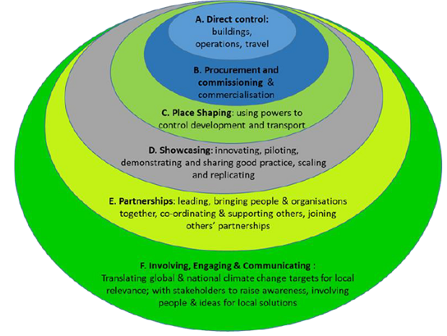
Figure 1: Model of influencing change used by “Birmingham City Council”
(Source: Birmingham City Council, n.d.)
There are limitations to how much the Council alone can do to achieve the climate change targets. It has to have the support of and collaboration from varied stakeholder groups to ensure the 2030 SDG of net zero GHG emissions is achieved (See Figure 1) (Birmingham City Council, n.d.). The council itself is taking actions to decarbonise its housing stocks and assets (Birmingham City Council, 2023a).
Thus, these policies and initiatives (or schemes and programmes) are undertaken by Birmingham to boost its progress in the selected three sustainable development areas.

Examining the benefits gained by Birmingham from the selected SDGs
Investigating the extent of benefits gained by the city is vital to identify the shortcomings and keep up the progress towards achievement of the SDGs. The extent of benefits gained or missed is presented below for each SDG identified earlier:
a) SDG 3
Research by PHE, based on “NHS Weight Loss Plan” application, found that approximately a stone’s weight (5.8 kg) was lost by those who followed that Plan for over 12 weeks (Jackson, 2021). However, due to the pandemic, reports about weight gain had emerged too. The “Better Health campaign” of PHE operates with the help of local authorities.
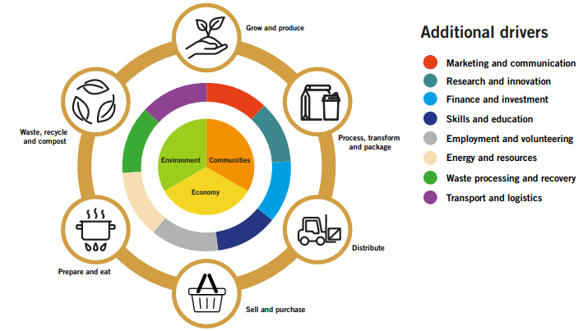
Figure 2: The “Urban Food System”
(Source: Birmingham Be Heard, 2022)
The Urban Food System in Birmingham is associated with its Health & Wellbeing (HWB) Strategy (Birmingham Be Heard, 2022). This approach spans eight years (2022-2030) and aims to boost a thriving, sustainable, and healthy food system in the City. Comparison of Birmingham with different cities has been shown by Public Health England (2023) - the “Child obesity summary rank (2018/19)” of Birmingham is 130 out of 149 local authorities; the “NHS Health Check summary rank (2014/15 - 18/19)” is 22. However, in terms of tobacco and alcohol, the ranks are 76 and 103 respectively. Thus, it can be understood that Birmingham is doing good in some areas while it needs to improve considerably in others.
b) SDG 4
The city has been making progress in this SDG’s achievement. Nevertheless, some shortfalls have been noticed in comparison to national averages.
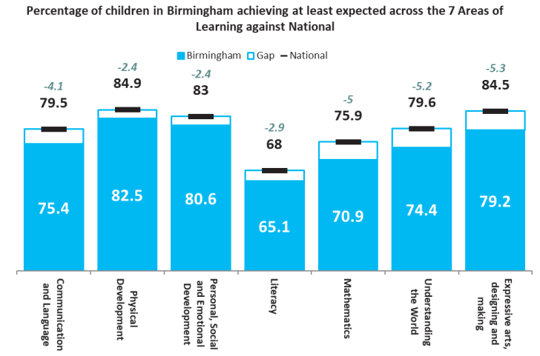
Figure 3: Comparison between City levels and nationals’ levels in 7 learning areas
(Source: Birmingham City Council, 2022)
Birmingham has been showing efforts in improving quality education for its students; however, the City’s average is below the national average in all seven learning areas examined (See Figure 3).
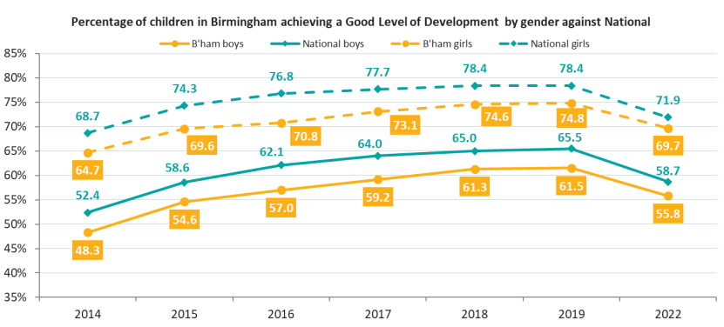
Figure 4: GLD accomplishment by Birmingham boys and girls against national boys and girls (Key Stage 1)
(Source: Birmingham City Council, 2022)
The city is below national averages as of 2022 (See Figure 4); however, the gap between boys of the city and those at national levels has reduced (2.9% currently); it is the case for girls (2.2% currently). This shows the City is progressing in terms of providing good development and education to the pupils in early years’; however, the mark is a little below national average. The scenario changes when later stages are considered. The 16–18-year-old students showed promise with their performances in Birmingham where the A grade percentage of students surpassed the national average levels.
The performance showed by Birmingham cannot be called poor simply because it failed to exceed national averages in all areas. It needs to escalate its efforts in assisting students in their early years of education. Teacher student interactions, teacher capabilities, student performances and assessments might be some reasons in below-expected performance for the early years’ kids.
c) SDG 13
The Clean Air Zone (CAZ) of Birmingham is the zone where vehicles are charged a fee if they fail to meet vehicle emission standards (Birmingham City Council, 2023). There has been modest reduction in NO₂ levels due to CAZ (Eichler, 2023). However, PM2.5 (Particulate Matter 2.5) levels (inhalable) stay at elevated levels in comparison to the prescribed guidelines by the WHO (Eichler, 2023). Cost to economy is £20 billion because of people under the age of 75 losing their lives (approximately 30,000/year). Nevertheless, further reduction in NO₂ levels can be expected in the future by close monitoring of the CAZ. For this to be combated, PM2.5 contributing non-vehicle sources need to be addressed. Krauss et al. (2022) asserted that SDGs (some of them including SDG 13) are falling short in transformation of the world.
Pollution levels have reduced by 40% in Birmingham, owing to its CAZ (Birmingham City Council, 2023b). The Council have already taken action to find the sources of exceeding NO₂ in the “Zone and on the A4540 Middleway”. This is a contribution from the City’s end towards a sustainable country, nation, and a sustainable world largely. Health promotion and wellbeing was a primary aim behind launching the CAZ. However, NO₂ levels seem to be a menace because the actual drop percentage for NO₂ is 7% and not 13%, as was reported earlier (Gregory-Kumar, 2023). Thus, it is without doubt that despite the considerable results, a long way of progress is still to be paved.
Thus, based on the examination of the three selected SDGs, Birmingham can be said as a progressive city with all of its efforts in accomplishing its SDGs. Nevertheless, considerable improvement is still needed for long-term improvement and sustainable world for the future generation.

Recommendations for the city/borough and suggested improvements for meeting the vital SDGs
Implementation of SDG 3 across Birmingham City involves the multistakeholder approach. Investment in the infrastructure upgradation of healthcare for ensuring access the quality services to every resident. Fostering community engagement through the involvement of the residents within the decision-making related to wellbeing and healthcare (Adams et al.2020). Collaborate with various pharmaceutical companies, international organizations, and NGOs to make improvements in access to required unnecessary medications. Implement policies to address inequalities in health care and disparities and ensure that vulnerable residents have enough access to services in healthcare (Fox and Macleod, 2023) The city needs to encourage collaboration for innovation and research with academic institutions.
The government needs to provide universal access to education to every child therefore support programs can promote opportunities of lifelong experiences to every individual. Collaboration with the local business and institution for providing vocational training, adult education as well as programs of skill development throughout the city. Education related to global citizenship within the curriculum can help students to understand global issues (Adams et al.2020). Promotion of linguistic and cultural diversity within education which can ensure that educational practices and materials reflect and respect the cultures and backgrounds of students across Birmingham. Implementation of financial mechanisms like grants, scholarships for ensuring economic constraints that do not hinder education. Through the implementation of the above recommendation, the city Birmingham can be able to make important strides in achieving SDG 4 (Ndubuka and Rey-Marmonier, 2019). An actionable and comprehensive action plan can be created in Birmingham which can include specific timelines, and targets to reduce emissions of greenhouse gas and build resilience towards climate change. Adoption of technologies related to renewable energy in both commercial and residential sectors can be helpful in fulfilling the aim of SDG 13 in the city (Louman et al. 2019) Green infrastructure like increment of green spaces with a rising investment in urban forests and parks to enhance the resilience of the city to the climate impacts can be used.

Conclusion
UK has been working on selected three SDG goals however by implementing of above recommendation, Birmingham can be able to contribute its global efforts by reducing emissions of greenhouse gasses and impacts of climate change, equal educational and healthcare access to every resident despite having several barriers in society. The City Council can use these models to understand the perceptions of its city members around susceptibility to health risks, severity, benefits, barriers, and the cues to action. This can allow the FPA and the Council alike to remove chances of support shortage from the community members.

References
Adams, C.A., Druckman, P.B. and Picot, R.C., 2020. Sustainable development goals disclosure (SDGD) recommendations. ACCA: London, UK.
Assets.publishing.service.gov.uk, 2017.Agenda 2030. Available at:https://assets.publishing.service.gov.uk/media/5a75176e40f0b6360e47348f/Agenda-2030-Report4.pdf[Accessed 23 Nov. 2023].
Available at:https://www.un.org/sustainabledevelopment/health/[Accessed 23 Nov. 2023].
Birmingham Be Heard (2022). CREATING A BOLDER, HEALTHIER AND MORE SUSTAINABLE FOOD CITY B I R M I N G H A M F O O D R EVOLU T I O N. [online] Available at: https://www.birminghambeheard.org.uk/people-1/birmingham-food-system-strategy-consultation/supporting_documents/Birmingham%20Food%20System%20Strategy.pdf [Accessed 24 Nov. 2023].
Birmingham City Council (2022). Annual education performance report for 2022. [online] Available at: https://www.birmingham.gov.uk/downloads/file/26405/annual_education_performance_report_for_2022 [Accessed 24 Nov. 2023].
Birmingham City Council (2023a). Birmingham one of 119 cities worldwide named as climate action leaders. Birmingham City Council. [online] 14 Nov. Available at: https://www.birmingham.gov.uk/news/article/1407/birmingham_one_of_119_cities_worldwide_named_as_climate_action_leaders [Accessed 23 Nov. 2023].
Birmingham City Council (2023b). Birmingham’s Clean Air Zone continues to help improve air quality in the city centre. Birmingham City Council. [online] Available at: https://www.birmingham.gov.uk/news/article/1395/birminghams_clean_air_zone_continues_to_help_improve_air_quality_in_the_city_centre#:~:text=Pollution%20levels%20in%20Birmingham [Accessed 24 Nov. 2023].
Birmingham City Council (2023c). Brum Breathes Fund launched to help improve air quality across Birmingham. Birmingham City Council. [online] 1 Jun. Available at: https://www.birmingham.gov.uk/news/article/1342/brum_breathes_fund_launched_to_help_improve_air_quality_across_birmingham [Accessed 23 Nov. 2023].
Birmingham City Council (n.d.). National campaigns. [online] Available at: https://www.birmingham.gov.uk/info/50267/public_health_campaigns/2422/national_campaigns [Accessed 24 Nov. 2023].
Birmingham City Council (n.d.). What is the council doing about climate change. [online] Available at: https://www.birmingham.gov.uk/info/50282/climate_change/2642/what_is_the_council_doing_about_climate_change/3 [Accessed 24 Nov. 2023].
Eichler, W. (2023). Highways Magazine - Birmingham CAZ less effective than was thought. [online] Available at: https://www.highwaysmagazine.co.uk/Birmingham-CAZ-less-effective-than-was-thought/12471# [Accessed 23 Nov. 2023].
Flash, O. (2023). Birmingham launches £4m fund to improve air quality. BBC News. [online] 1 Jun. Available at: https://www.bbc.com/news/uk-england-birmingham-65775379 [Accessed 24 Nov. 2023].
Fonseca, L.M., Domingues, J.P. and Dima, A.M., 2020. Mapping the sustainable development SDGs relationships. Sustainability, 12(8), p.3359.
Fox, S. and Macleod, A., 2023. Localizing the SDGs in cities: reflections from an action research project in Bristol, UK. Urban Geography, 44(3), pp.517-537.
Fuso Nerini, F., Sovacool, B., Hughes, N., Cozzi, L., Cosgrave, E., Howells, M., Tavoni, M., Tomei, J., Zerriffi, H. and Milligan, B., 2019. Connecting climate action with other Sustainable Development Goals. Nature Sustainability, 2(8), pp.674-680.
Future Parks Accelerator (2022). Birmingham. [online] Available at: https://www.futureparks.org.uk/birmingham [Accessed 23 Nov. 2023].
Gasper, D., 2019. The road to the sustainable development SDGs: Building global alliances and norms. Journal of Global Ethics, 15(2), pp.118-137.
Gov.UK (2018). DFID Education Policy. [online] Available at: https://www.gov.uk/government/publications/dfid-education-policy-2018-get-children-learning/dfid-education-policy [Accessed 24 Nov. 2023].
Gov.uk, 2021.DfT Outcome Delivery Plan: 2021 to 2022.Available at:
Gov.uk,2022. DCMS Outcome Delivery Plan: 2021 to 2022.https://www.gov.uk/government/publications/department-for-digital-culture-media-sport-outcome-delivery-plan/dcms-outcome-delivery-plan-2021-to-2022. [Accessed 23 Nov. 2023].
Gregory-Kumar, D. (2023). Birmingham Clean Air Zone pollution cut ‘smaller than thought’. BBC News. [online] 31 Aug. Available at: https://www.bbc.com/news/uk-england-birmingham-66660039 [Accessed 24 Nov. 2023].
https://sdgdata.gov.uk/#:~:text=UK%20data%20for%20the%20Sustainable%20Development%20Goals&text=The%20Sustainable%20Development%20Goals%20(SDGs)%20are%20a%20universal%20call%20to,and%20prospects%20of%20everyone%2C%20everywhere. [Accessed 23 Nov. 2023].
https://www.gov.uk/government/publications/department-for-transport-outcome-delivery-plan/dft-outcome-delivery-plan-2021-to-202. [Accessed 23 Nov. 2023].
Jackson, J. (2021). PHE launch campaign to encourage healthier lifestyle. [online] National Health Executive. Available at: https://www.nationalhealthexecutive.com/articles/phe-launch-campaign-encourage-healthier-lifestyle [Accessed 24 Nov. 2023].
Krauss, J.E., Jiménez Cisneros, A. and Requena-i-Mora, M., 2022. Mapping Sustainable Development SDGs 8, 9, 12, 13 and 15 through a decolonial lens: falling short of ‘transforming our world’. Sustainability Science, 17(5), pp.1855-1872.
Louman, B., Keenan, R.J., Kleinschmit, D., Atmadja, S., Sitoe, A.A., Nhantumbo, I., de Camino Velozo, R. and Morales, J.P., 2019. SDG 13: Climate action—impacts on forests and people. Sustainable development goals: their impacts on forests and people, pp.419-444.
Naidoo, R. and Fisher, B., 2020. Reset sustainable development SDGs for a pandemic world. Nature, 583(7815), pp.198-201.
Ndubuka, N.N. and Rey-Marmonier, E., 2019. Capability approach for realising the Sustainable Development Goals through Responsible Management Education: The case of UK business school academics. The International Journal of Management Education, 17(3), p.100319.
planvu.co.uk. (n.d.). Birmingham City Council: Development Plan - Birmingham Development Plan - Environment and sustainability. [online] Available at: https://www.planvu.co.uk/bcc/written/bdp/cpt6.php [Accessed 24 Nov. 2023].
Public Health England (2019). PHE Strategy 2020-25. [online] Available at: https://assets.publishing.service.gov.uk/media/5d7b72c8ed915d5257b5b66c/PHE_Strategy_2020-25.pdf [Accessed 24 Nov. 2023].
Public Health England (2023). Public health profiles - Area Details. [online] Available at: https://fingertips.phe.org.uk/topic/public-health-dashboard/area-details#are/E08000025/ati/202/gid/1938133162/par/E92000001 [Accessed 24 Nov. 2023].
Sachs, J.D., Schmidt-Traub, G., Mazzucato, M., Messner, D., Nakicenovic, N. and Rockström, J., 2019. Six transformations to achieve the sustainable development SDGs. Nature sustainability, 2(9), pp.805-814.
Sdgdata.gov.uk, 2023. Goal 3 - Good Health and Well-Being, Available at:https://sdgdata.gov.uk/[Accessed 23 Nov. 2023].
Sdgdata.gov.uk, 2023.UK data for the Sustainable Development Goals. Available at:
Sdgdata.gov.uk, 2023.UK data for the Sustainable Development Goals. Available at: https://sdgdata.gov.uk/.[Accessed 23 Nov. 2023].
The Global SDGs (n.d.). SDG 4: Quality education. [online] The Global SDGs. Available at: https://www.globalSDGs.org/SDGs/4-quality-education/ [Accessed 23 Nov. 2023].
UN Environment Programme [UNEP] (2017). SDG 13: Climate action. [online] Available at: https://www.unep.org/explore-topics/sustainable-development-SDGs/why-do-sustainable-development-SDGs-matter/SDG-13 [Accessed 23 Nov. 2023].
Un.org, 2023. Goal 3: Ensure healthy lives and promote well-being for all at all ages
un.org,2023.WHAT IS GOAL 3 - GOOD HEALTH AND WELL-BEING Available at:https://www.un.org/sustainabledevelopment/wp-content/uploads/2023/09/Goal-3_Fast-Facts.pdf. [Accessed on: 24/11/23]
unglobalcompact.org.uk, 2023. Halfway to 2030: How is the UK Performing on the Sustainable Development Goals? Available at:https://www.unglobalcompact.org.uk/halfway-to-2030-how-is-the-uk-performing-on-the-sustainable-development-goals/ [Accessed 23 Nov. 2023].
United Nations (2023a). SDG 3: Ensure Healthy Lives and Promote well-being for All at All Ages. [online] United Nations Sustainable Development SDGs. Available at: https://www.un.org/sustainabledevelopment/health/ [Accessed 23 Nov. 2023].
United Nations (2023b). SDG 4 | Ensure Inclusive and Equitable Quality Education and Promote Lifelong Learning Opportunities for All. [online] Available at: https://sdgs.un.org/SDGs/SDG4 [Accessed 23 Nov. 2023].
World Health Organization [WHO] (n.d.). Sustainable Development SDGs. [online] Available at: https://www.who.int/europe/about-us/our-work/sustainable-development-SDGs#:~:text=The%20Sustainable%20Development%20SDGs%20(SDGs [Accessed 23 Nov. 2023].

