Task 1: Report
1.Introduction – Evidence-based practice and how it can be used to support sound decision-making (AC1.1)
Waite, K. et al. (2021) describes EBP as a “process where evidence from reliable sources is used to develop knowledge and understanding to inform practice”. EBP can be used when making decisions and is important for people professionals as they experience a range of people and business decisions as part of everyday practice.
The concept of EBP is that it helps make better, more effective decisions by choosing reliable, trustworthy solutions (CIPD, 2023) and informing decisions on HR strategies, innovations, and practices with the best available evidence (Armstrong and Taylor, 2020).
According to Briner (2024), people don’t always like being guided by structure and the CIPD (2023) argues that we tend to ‘cherry pick’ research that backs up our perspective or opinion. Evidence-based decision-making will help reduce errors caused by ill-founded judgments (Taylor and Woodhams, 2022). The consequences of poor decisions can be substantial for the organisation with a financial impact as well as affecting morale and poor performance. Individual opinion could be risky as can also be prone to bias.
People Professionals should consider evidence from 4 sources; scientific literature (e.g. what does research tell us?), Experiential (what do people in organisation tell us), organisational data (HR systems/customers), and stakeholders (people with interest) (CIPD, 2023). Evidence is all around us, however, it can be difficult to sort value from waste, requiring the use of critical thinking in decision-making. CIPD (2019) describes critical thinking as the ability to think well, and reflect objectively on ideas, opinions, and arguments of others. Today, problems require more thought and are more complex. EBP is about asking good questions and keeping an open mind, a key aspect of critical thinking.
Another thing to remember is that we ensure the evidence considered is factual rather than opinion. According to Taylor & Woodhams (2022), a great deal of evidence, especially on the internet is presented as neutral but is driven by personal or political agenda. No one source is more valid than another, misconceptions should be challenged and corrected (Badens and Rousseau, 2018). Briner (2023) suggests that HR professionals can look for solutions from the latest ‘fads’ that are promoted at conferences or are the ‘new best thing’. The way to ensure that introducing this ‘fad’ will add value, not have a negative impact, and support the organisational objective is to ensure the decision has been made using EBP approach. Johny Gifford, Research Advisor for CIPD (2023) also states that EBP is a move away from making decisions guided by ‘what’s in favour’.
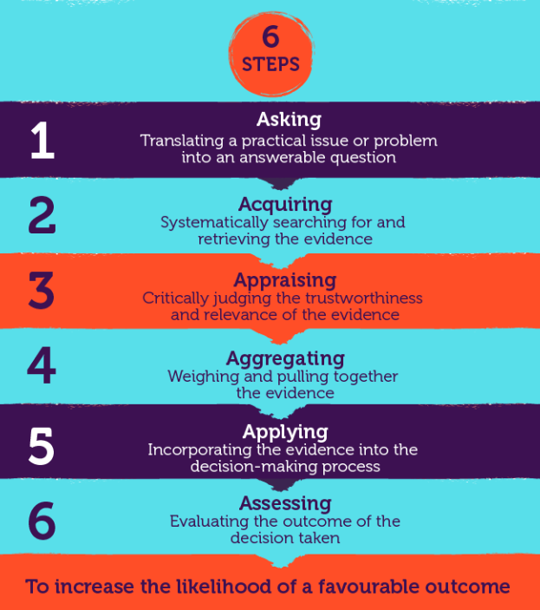
The 6-step model by Briner (2019) (see below) uses a logical approach of using facts and information then analysing to reach a decision. The evidence presented supports the view that using this process, combining evidence from different sources and using elements of EBP, practitioners will make the best-informed decision.

There is no doubt that the three areas of focus for HR practice in EBP is systematic reading, understanding the organisation, and the ability to ask critical questions (how things work and why).
Barends & Rousseau (2018) highlight 6 misconceptions about EBP and argue that they are a major barrier to its implementation for people professionals.
The CIPD Profession Map is a set of standards that defines the knowledge and behaviors that people professionals need. This won’t tell you what to do but will show you how being evidence-based contributes to making better decisions in any situation. One of the core values of the professional map is that we should be Principles-led, evidence-based, and outcomes-driven. To sum up, this will ensure that decisions made around organisation issues and people practice are evidence-based and outcomes-driven.
2. PESTLE as an analysis tool and Focus Group Method to recognise and diagnose issues, challenges, and opportunities (AC 1.2)
Several tools could be used to identify an issue or challenge within the workplace and it is important to recognise that different methods of analysis, will be appropriate in different situations. Taylor & Woodhams (2022) identify some commonly known tools, such as;
- SWOT Analysis (strengths, weaknesses, opportunities, threats)
- PESTLE
- Porter’s Five Forces analysis.
The PESTLE analysis tool audits the external environment considering factors such as political, economic, social, technological, legal, and environmental. This tool requires detailed analysis (Taylor & Woodhams, 2022) and is described by Armstrong and Taylor (2020) as an environmental scanning tool. CIPD (2024) suggests that it is worth collaborating as well as using expertise within the organisation when using this framework. This tool is useful to support business planning activities and is quite a simple tool to use. It can enable a wider strategic vision identifying opportunities and potential threats. As an example, when putting together a strategy for flexible working, considering the political factor –would identify that there is legislation and a statutory right for employees to request flexible working under the Employment Rights Act 1996 and this should be considered. This would ensure that the risks are mitigated and the strategy has been developed using EBP.
CIPD (2024) does argue, however, that a disadvantage of this tool is that the pace of change can make it difficult to predict developments in the future for the organisation as well as having too much data which becomes an overload. In addition, some assumptions made may be unfounded. However, worth noting is that the PESTLE tool (as well as the SWOT tool) is encouraged to be repeated at regular intervals to be most effective (Taylor & Woodhams, 2022).
Some commonly used methods for diagnosing challenges and issues are:
- focus groups with staff,
- Speaking to Trade Union representatives
- Interviews/observations,
- People analytics
Whilst there may be a requirement to use different methods, it could also be beneficial to start with one method and then add further methods to gather additional evidence.
Specifically, holding focus groups, a form of qualitative data collection, will gain deeper insights and can be more efficient and cost-effective than holding interviews. Notably, Taylor and Woodhams (2022) state that focus groups promote discussion and allow researchers to find out about a range of attitudes and opinions on a given topic. Barends and Rousseau (2018) maintain that focus groups are one of the most widely used methods to gather evidence from stakeholders. An example may be where an organisation is attempting to gauge reactions to an organisational change proposal. It can also promote that employee feedback is valued. Whilst there are benefits, it can sometimes prove difficult to get people together and can be challenging if you have 1 or 2 dominant people, so it is important to ensure all participants have a voice and that the information gathered is representative of the whole group. In conclusion, whilst people practice now has a more strategic role, using focus groups as best practice ensures that organisations don’t lose the human element when it comes to strategic decision-making.

3. Critical thinking and how these might apply to your own and others’ ideas to assist objective and rational debate (AC 1.3)

Critical thinking is the process of analysing and evaluating the quality of ideas, theories, and concepts to establish the degree to which they are valid and supported by the evidence and the extent to which they are biased. It involves reflecting on and interpreting data, drawing warranted conclusions, and recognising ill-defined assumptions. (Armstrong and Taylor, 2017). When making decisions in people practice, there should be a structure approach ensuring decisions are well informed, rational, and fair. It is a key skill for people professionals (CIPD, 2019)
This is an approach that requires critical thinking to sources, and evidence and considers the wellbeing of the employees and the organisation. People professionals need to be critical about data – is it reliable, is it from a credible source, are we comparing like for like? Essential that there is rational debate, free from emotion, no bias or preconceived notion. Essential to weigh up positive aspects but also question the information we have. Armstrong and Taylor (2020) states that ‘critical’ in this context does not mean disapproval or being negative as there are many positive uses of critical thinking.
Chadfield, T (2022) describes critical thinking as the ability to think twice about the information before your eyes and ask what is going on. Can this evidence be trusted?
As an example, within my workplace, it's essential to have the ability to critically think when considering a problem within the team. The next step is to define or formulate the question/problem, what else has influenced this? Understanding the opinions of others who have been involved, the staff – is the situation a result of group polarisation, listening carefully and being open-minded to ensure there is no bias or manipulation. Ensuring that we use information that is factual and relevant with a focus on involving those involved in the situation and being open to other suggestions, will provide an opportunity to weigh up and reflect on the information gathered. Keeping others informed, communicating findings, and updating on the next steps will ensure those involved feel engaged. It is my opinion that critical thinking skills are a key skill for all people. Critical thinking subjects all available options to scrutiny and skepticism (Ted-Ed, 2016).

To conclude, to assist objective and rational debate, critical thinking clarifies goals, examines assumptions, discerns hidden value, evaluates evidence, accomplishes actions and assesses conclusions (Armstrong and Taylor. 2020).

4. Explain three decision-making processes that can be applied to ensure that effective outcomes are achieved. (AC 1.4) 456 words

Decision-making is essentially about making choices, often in conditions of uncertainty according to Armstrong and Taylor (2020). Adair (2016) highlights a rational approach for decision-making using six steps; defining problem, collect information, generating options, make decisions and then evaluate. This particularly highlights when there is a need to seek input from others. Being able to understand the implications of your decisions including its impact on the department and organisational objectives will help avoid costly mistakes and add value to your business (CMI, 2020).
De Bono six thinking hats (1985), and Kepner and Tregoe’s model (1965) enable us to look at decisions from several different perspectives and are particularly effective in avoiding biases and assumptions. The drawbacks identified by CMI (2016) are that it allows very little regard to intuition or previous lessons learned. This model is a problem and risk analysis with four basic steps;
- Situation appraisal
- Problem analysis
- Decision analysis
- Potential problem analysis

The Six Thinking Hats requires people professionals to use a variety of thinking styles and perspectives when analysing a challenge/issue and considering solutions and decisions. Hats represent a color for each of the areas listed;
- process driven,
- creativity
- feelings/emotions
- benefits/values,
- risk assessing
- information gathering.
One person can take on multiple hats to make a decision, but this approach does work well within a team decision situation.

In contrast, a future pacing approach allows the decision to be made by the individual. The individual then must make the decision considering and visualising the effect of the decision from different perspectives. This approach can lead to decisions prompted by a complex array of factors influenced by our background or experiences as well as impairing our judgement and decision by bias or tunnel vision (CMI, 2024). Having said that, Adair (2016) emphasises that behind our everyday thinking is our human mind which also requires knowledge about a subject to be able to decide during unforeseen circumstances.

There may be occasions where situation may require intuitive or heuristic decision making, reacting to information at hand without the ability to gather more. The extent to which you can apply intuition may depend on your organisation or role (CMI, 2016). In addition, the new ‘Profession Map’ developed by the CIPD with core value in that decision-making should be ‘evidence-based’. The result of poor decision making in people practice can have a major impact on the wellbeing, performance, quality of service. It is therefore essential that decision making in people practice is determined using a balanced approach free from bias and ensuring that different perspectives are considered. Whether different perspectives are from an individual using an approach such as De Bono or involving a group, the best outcome will be achieved by a balanced approach.

5. Assess three different ethical perspectives and explain how understanding of these can be used to inform and influence moral decision-making. (AC 1.5)

Armstrong and Taylor (2020) define Ethics as a concept of making judgements and decisions on the right course of action. The CIPD has a set of standards for the people profession, which sits under ‘core behaviours’ in the ‘Profession Map’. It describes ethical practice as ‘building trust by role modelling ethical behaviour and applying principles and values consistently in decision-making' (CIPD, 2024).
People professionals have a responsibility to guard core values and raise awareness of ethical issues, promoting ethical behaviour, disseminate ethical practices widely among managers and manage compliance and monitor arrangement (Armstrong and Taylor, 2020). As individuals, we should want to do what’s right without causing harm to ourselves or others.
While there is no right or wrong way in making ethical decisions, the CIPD (2015) has introduced 8 ethical lenses to considering workplace decisions. These are using 8 different perspectives when faced with a workplace decision and understanding these will ensure ethical and moral decision making. These are; fairness, merits, markets, democracy, wellbeing, right and duties, character, handing down. Using the lenses will ensure that decisions are legal, and aligned with organisational values as well as transparent ensuring that the organisation is sustainable for the future.

There are however, certain challenges with following the framework. As an example, wellbeing initiatives can be quite costly so when making decisions its essential to assess the return on investment, whereas fairness may not always allow for dealing with unique situations.
According to the People Profession survey of 2021, people professionals said they would not compromise their professional principles in their work, however, meeting business needs and pressure from senior stakeholders are areas where they are most likely to compromise (CIPD, 2023).

Notably, there are different ethical frameworks such as Utilitarianism and deontological theory. Utilitarianism is about making decisions to maximise happiness and alleviate suffering to others. An example may be introducing a policy that will maximise wellbeing of a large group of employees. Unfortunately, this framework may sometimes have short term benefits but lack longer term effectiveness.

Deontological theory is an approach that forbids and follows certain sets of rules regardless of consequences. This is a structures approach, however, lacks flexibility and does not allow for personal autonomy.

To operate ethically, an organisation needs an ethics program, this could be formal or informal and should include a code of ethics (CIPD, 2023). This code should be regularly reviewed and discussed with staff.

6. Appraise two different ways organisations measure financial and non-
financial performance, providing one example of each. (AC 3.1)

Measuring performance is an important step and some sectors require very detailed performance measures (CIPD, 2024). With a better understanding of how organisations measure performance, we can take additional steps to provide additional value in daily activities (HBS, 2020). The type of sector can also influence how and what measures are used to monitor performance.
Notably in the private sector, they may use financial performance measures. The financial KPI’s measure the financial health of an organisation (HBC Online). An article by Indeed (2022) states that financial measures involve assessing an organisations asset, liabilities, revenue and profitability. Having clear quantifiable financial performance measures can be compared over time and against competitors to determine its trajectory and can help determine areas for improvement to increase profitability (Indeed, 2022).
By contrast, Ittner and Larcker (2024) suggest that financial data have limitations as a measure of a company's performance. They often don’t capture the full picture and can sometimes encourage short term focus rather than longer term objectives. By placing too much emphasis on financial measures, it takes little account on drivers of value such as customer and employee satisfaction, innovation and quality (Ittner and Larcker 2024).
The public sector often focusses on non-financial value performance measures. One of their advantages, is that they link to longer term organisational objectives (Ittner and Larcker 2024). According to Welsh Value in Health Centre (2024), a key aspect is the capture and commonly codified non-financial performance indicators as they report the symptom and quality of life of an individual on a given day and to involve patients in decisions about their care. These are qualitative measures providing a holistic comprehensive view beyond finance. It can help demonstrate transparency and accountability to stakeholders including public bodies and government. They are often linked to wider priorities and frameworks, Welsh Government (2023) demonstrates this in its performance framework as it aligns to Ministerial priorities and core support functions in the Planning Framework. As an example, Welsh Government (2023) performance framework maps to the ‘A Healthier Wales’ Strategy (Hywel Dda University Health Board, 2024).
For the organisation to make informed decisions, it is important to choose metrics that align with the organisational objectives and provide the most value. LinkedIn (2024) shares tips on how to measure performance in a way that balances quality and quantity and can provide an enhanced method for tracking performance and making informed decisions. A balanced presentation of financial and non-financial measures in my opinion would be preferred and advantageous to managers and is noted in Havard Business Review (1992). The Balanced Scorecard was developed to include financial measures to inform results of what has happened, and it complements with non-financial operational measures such as customer satisfaction, innovation, improvement placing strategy and vision, not control, at the centre (HBR, 1992).

7. Explain how people practices add value in an organisation and identify two methods that might be used to measure the impact. (AC 3.2)

There has been a significant shift in the focus of people's practices. Significantly, the rise of Human Resources management (HRM) has brought with it a new emphasis on the role of practitioners in improving the performance of the organisation (Bennett, T. et all, 2020, p.4). People practices play a crucial role in shaping culture, employee behaviour and performance. According to CIPD (2022), people professionals have stepped up through recent crises to support their organisations, yet the perceived value of the profession remains under constant challenge. Waite, L. et al. (2021) highlights that there are numerous debates about how human resources management (HRM) can assist value creation and high performance.

Practices such as supporting the maintenance practice (ensuring employee are paid), recruitment process, a systematic induction process, job autonomy and gathering employes views can be used to foster value creation by an organisation (Waite, et al., 2021).

Taylor & Woodhams (2022) state that HR managers are not just concerned with achieving tasks; they are also integral to the delivery of an organisations longer-term strategic objectives whilst also keeping an eye on the future in an increasingly volatile, unpredictable, competitive and highlight regulated global environment. For instance, employee development through continuous learning will lead to increased morale, improved retention levels, and better productivity.

One method to measure the impact on people's practice would be looking at the return on investment on learning and development which can often be more time-consuming to measure, this would evaluate the effectiveness of training delivered and how it has affected employee performance/wellbeing and if it has contributed to achieving organisational objectives.
Another method would be measuring employee satisfaction and engagement through staff feedback. This may be surveys, interviews linked to people practice initiatives such as work-life balance, or learning and development initiatives.

In an article, LinkedIn (2017) reports that Boston Consulting Group have measured the value of investing in people practice and it found that improved recruiting practices result in 3 x revenue growth and 2 x profit margins.

In conclusion, to quote from Taylor & Woodhams, (2022) ‘Organisational values’ has much in common with thinking about ‘organisational culture’. People practice activities add value to an organisation through employee engagement, productivity and overall organisational performance.

Task 2
Analysis of Data and presentation of key findings (AC 2.1)
1.a
The pie chart in Chart 1 shows the percentage of the workforce by gender. This is quantitative data displayed in a pie chart. This is a reasonably balanced gender workforce with 53.85% male, 45.38% female and 0.77% non-binary.

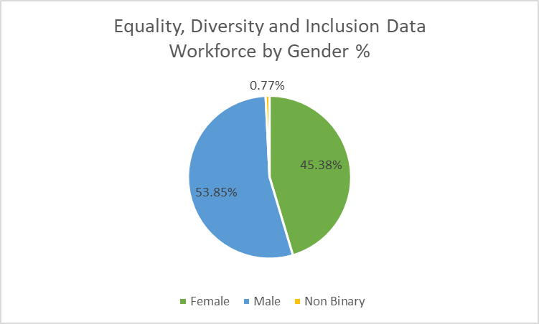

Chart 1

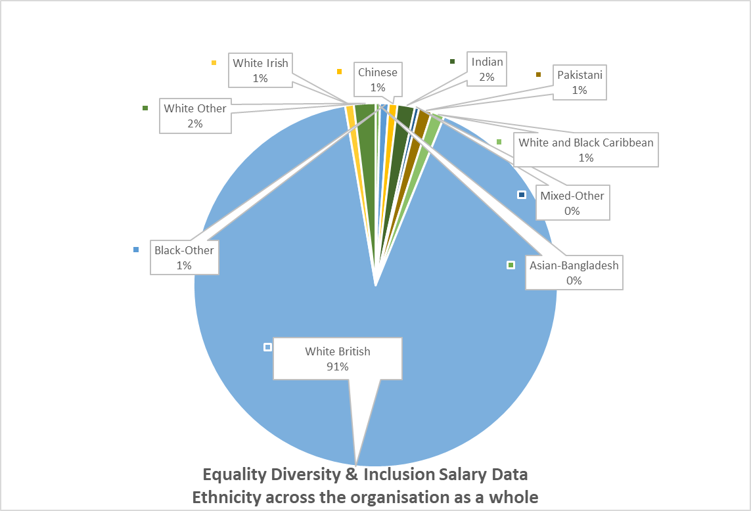
Illustrated in the pie chart below, 91% of the organisation’s whole workforce is of white British ethnic origin. ACAS (2024) defines Diversity as the range of people within the workforce with different characteristics, ethnicity being one of them.
Chart 2
On Chart 3 below, the stacked column illustrates ethnicity by team. Facilities, Lettings, Marketing and regeneration’s workforce are all white British origin, meaning there is no diversity within those teams. The team with the most diversity is Community Engagement and Partnerships, with 14.29% Indian, 14.29% Mixed Other, 14.29% white and black Caribbean and 57.14% white British. | Chart 3
c) 8.08% of the workforce are disabled. This is displayed on a pie chart in Chart 4.
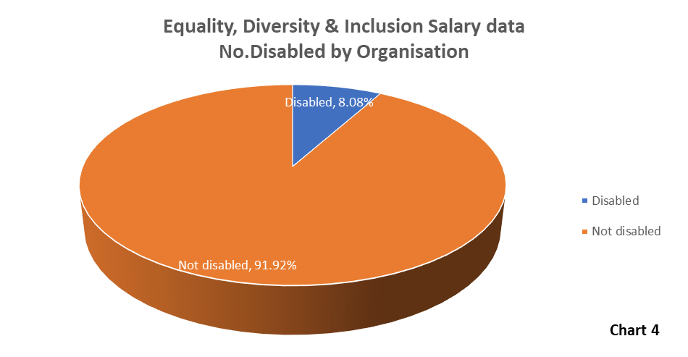
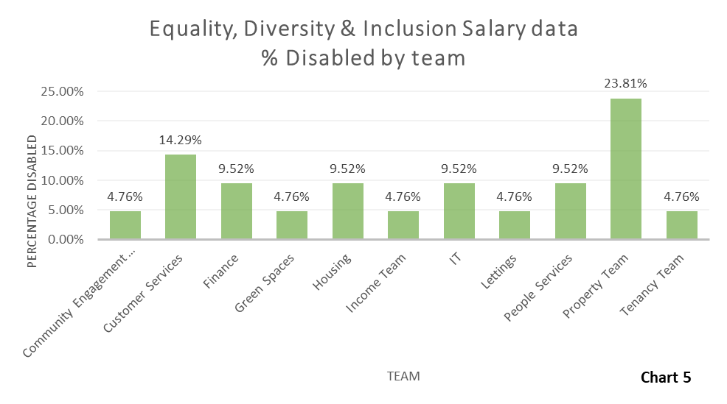
Chart 5 is a bar chart and is used to display the percentage of disabled employees per team. The property team has the highest number of disabled employees with 23.81% of its workforce. Business Services, Directors, Facilities, Governance, Marketing, Regeneration, Supported Housing have no disabled employees.
d) 95.38% of the workforce earn a salary from £17.5k to £50k. Of those, 56.66% are female. To note, however, males are the most dominant gender in the £22-£50k salary bracket.
When comparing the top 10 paid females and the top 10 paid males – the average pay for females is £77,280 in comparison to males at £48,934.50.
The Chief Executive and Director of People are the highest-paid roles, both being undertaken by females. Director of Finance is also female, whereas the Director of Customer Services is male providing an equal 50/50 split for those earning between £90k to £100k. In the Business Services Team, there are 2 employees (1 male/1 female), it is concerning that the female is being paid £10k more than the male.
e) The overall average salary paid by the organisation is £31,757.46. £31,900.03 is the average salary across the organisation for female with £31,812.18 for males and £19,500 for non-binary. To note, is that there are roles such as Development Manager, where two employees in different departments (property and development) are being paid a different salary. The Head of Service and Directors role appears to have a significant range of salary, it would be interesting to understand how the job evaluation process has been conducted and calculated. The Trades Operatives have a significant variation between trades, difference in 4k. A market pricing exercise could be undertaken to compare pay rates for similar jobs and a review of the job specifications. (CIPD, 2023) Pay rates for the same job role cannot be different based on gender alone. There can, however, be legitimate reasons such as experience, responsibilities or market forces.

1 (b) Results from recent survey on Hybrid Working
Qualitative data has been gathered from employees from a recent survey on hybrid working practices. Undertaking surveys are generally cheaper and faster to administer than interviews and more convenient as responders can complete them in their own time (Taylor and Woodhams, 2022). However, one disadvantage is that it doesn’t allow to prompt to provide more information on certain areas.
Below is a graph (chart 6) which shows the results of the survey.

Findings
- 56.3% of employees surveyed state they enjoyed working from home for some days of the week with 82.3% either very strongly or strongly agreeing that it supports their work-life balance and wellbeing.
- There appears to be a distinct differing opinion on employees’ ability to access resources from home with 147 stating they very or strongly agree they can access resources with the other 147 stating they very strongly or strongly disagree. 6 employees were not sure.
- In terms of Hybrid Working, there appears to be a balance of responses with 148 respondents stating it makes them more productive, and 147 stating they very strongly or strongly disagree.
- The Working from Home option has a higher proportion of negative responses with 66% stating that they disagree that this option allows them to meet their targets.
- Employees are reporting that they disagree that being away from the office gives less stress.
- Employees do not miss engaging with their colleagues – 83% very strongly or strongly disagree with the statement asked in the survey.
- Only 14% of those surveyed very strongly or strongly agreed and reported being fully supported when working at home.
- 101 employees answered as ‘not sure’ to finding working remotely being a challenge.
- Hybrid working appears to be connecting employees to the company culture with 62% stating they very strongly or strongly agree to the statement.

2. Recommendations
Recommendation 1 : Improve Equity, Diversity and Inclusion (EDI) -
The organisation should consult with employees and representatives to develop an Inclusive Workplace Policy. Implement an action plan to ensure EDI is embedded within everyday workplace practices such as recruitment. Training, religious beliefs. Some UK politicians criticise EDI as a ‘wasteful expenditure’, however, a global survey Catalyst conducted revealed that 76% of employees believe diverse, equitable, and inclusive workplaces are important, with 93% wanting to know what organisations are doing to foster such workplaces. The benefits for the organisation can be better performance and increased profits according to CIPD (2024) if it improves its representation of diverse backgrounds.
The CIPD (2024) states that ‘Employers who take action to ensure equal progression and participation in the workplace, across people from all black and ethnic minority backgrounds, will benefit from attracting and retaining the best people, addressing skill shortages, and improving performance in the process’.
Recommendation 2: Gender Pay Gap
As the organisation employs over 250 staff, it is recommended that a gender pay gap evaluation is undertaken (CIPD, 2024).
Under the Equality Act 2010 which outlaws any less favourable treatment between men and women when it comes to pay and conditions of employment (CIPD, 2023), an employer could end up in tribunal which has implications of cost, and reputation and can cause considerable stress. The Gender pay gap has been declining slowly and over the past decade has declined by a quarter (ONS, 2022).
Recommendation 3 : Ongoing communication and monitoring of Hybrid Work arrangement
It is recommended that follow-up interviews are held with employees regarding Hybrid Working to gather deeper insights, particularly in areas of feeling supported and engagement.

Recommendation 4 : Address the provision of resources for employees working away from the office
It is recommended that the Hybrid Working Policy is reviewed and that there is engagement with all employees. Specifically, ensuring that there is adequate provision of resources, digital and physical, and a mechanism to continuously measure employee experience.

Bibliography
ACAS (2024) Equality Diversity and Inclusion. Available at : If employees feel excluded - Equality, diversity and inclusion - Acas (Accessed: 22 May 2024)
Adair, John. (2016) Develop your Leadership Skills. 1st. London: Kogan Page.
Armstrong, M. and Taylor, S. (2020) Armstrong’s Handbook of Human Resource Management Practice. 15th edn. London: Kogan Page
Barends, E. and Rousseau, D. (2018) Evidence-Based Management. 1st edition. London: Kogan Page Limited.
Bennett, T, Saundry, R, Fisher, V (2020) Managing Employment Relations. London: Kogan Page.

Briner. (2023) Personnel Today. Available at: HR fads: How to recognise and avoid them (personneltoday.com) (Accessed: 24 May 2023).
Briner, R. (2024) What is Evidence Based Practice 2024. Available at https://www.youtube.com/watch?v=tSfo2XhEWkE (Accessed : 24 April 2024).
Chartered Management Institute (2020) Decision Making. Available at: Decision Making - CMI (managers.org.uk) (Accessed: 13 May 2024).
Chartered Management Institute (2020) Rational Decision Making. Available at: Rational_decision_making.pdf (futurelearn.com) (Accessed: 15 May 2024).
CIPD (2017) Evidence Based Practice : an introduction. Available at: Evidence-based practice: an introduction (youtube.com) (Accessed : 24 May 2024)
CIPD (2018) People Analytics: driving business performance with people data. Available at: people-analytics-report_tcm18-43755.pdf (cipd.org) (Accessed : 20 May 2024).
CIPD. (2019) Critical Thinking [Podcast]. 5 November 2019. Available at: Critical thinking | Podcast | CIPD (Accessed : 22 May 2024).
CIPD (2020) When the going gets tough, the tough gets evidence. Available at : When the going gets tough, the tough get evidence | CIPD (Accessed : 15 May 2024).
CIPD (2021) Evidence-based L&D - ‘Why does evidence matter’ [Podcast]. 2 March 2021. Available at: Evidence-based L&D - ‘Why does evidence matter?’ | Podcast | CIPD (Accessed : 14 May 2024).
CIPD. (2022) What value does HR bring to today's organisations [Podcast]. 12 July 2022. Available at: What value does HR bring to today's organisations? | Podcast | CIPD (Accessed: 20 May 2024).
CIPD (2023) Evidence-based practice for effective decision-making. Available at: Evidence-based practice for effective decision-making | Factsheets | CIPD (Accessed: 14 May 2024).
CIPD. (2023) Strategic Human Resource Management. Available at: Strategic human resource management | Factsheets | CIPD (Accessed: 20 May 2024).
CIPD. (2023) Ethical Practice and the role of people professionals. Available at: Ethical practice and the role of people professionals | Factsheets | CIPD (Accessed: 20 May 2024).
CIPD. (2023) Pay fairness and pay reporting. Available at: Pay Fairness & Pay Reporting | Factsheets | CIPD (Accessed: 23 May 2024).
CIPD. (2023) Job evaluation and market pricing. Available at: Job Evaluation & Market Pricing | CIPD (Accessed: 23 May 2024).
CIPD. (2024) Ethics at work: An employers guide. Available at: Ethics at work: An employer’s guide | CIPD (Accessed: 20 May 2024).
CIPD (2024) Performance Management: an Introduction. Available at: Performance Management | Factsheets | CIPD (Accessed : 13 May 2024)
CIPD (2024). Available at: Gender pay gap reporting: Understand what it is, if you need to report and why | CIPD [Accessed: 21 May 2024]
CIPD. (2024) 'HR leaders can address the backlash against EDR - this is how', People Management, May-July 2024, Page 27.
CIPD (2024) Race Inclusion in the workplace. Available at : Race inclusion in the workplace | CIPD (Accessed : 22 May 2024).
Havard Business Review (1992) The Balanced Scorecard. Available at: The Balanced Scorecard—Measures that Drive Performance (hbr.org) (Accessed: 18 May 2024).
Havard Business Review (2007) Maximising your return on people. Available at: Maximizing Your Return on People (hbr.org) (Accessed: 20 May 2024).
Havard Business School (2020) 13 financial performance measures managers should monitor. Available at: 13 Financial Performance Measures Managers Should Monitor (hbs.edu) (Accessed: 18 May 2024).
Horn, R. (2009) The Business Skills Handbook. London: CIPD. For information on Teams, Project Planning and more.
Hywel Dda University Health Board (2024) Healthier Mid and West Wales. Available at: Healthier mid and west Wales - Hywel Dda University Health Board (nhs.wales) (Accessed: 18 May 2024).
Indeed (2022) Financial Performance Analysis. Available at: Financial performance analysis (with techniques and metrics) | Indeed.com UK (Accessed: 18 May 2024).
Ittner, C. and Larcker, D. (2024) 'Non-financial performance measures: what works and what doesn't' [podcast]. 6 December. Available at : Non-financial Performance Measures: What Works and What Doesn't - Knowledge at Wharton (upenn.edu) (Accessed : 18 May 2024)
LinkedIn (2017) The ROI of people and culture. Available at: The ROI of people & culture: measurement, challenges and opportunities (linkedin.com) (Accessed: 20 May 2024).
LinkedIn (2024) 'What are the key skills and competencies for driving results in a dynamic and uncertain environment' [LinkedIn]. 14 May. (Accessed: 20 May 2024).
Mullins, L, J. (2013) Management & Organisational Behaviour, 10th ed, Harlow: Pearson Education Limited.
Office for National Statistics (2022) Gender pay gap in the UK. Available at: Gender pay gap in the UK - Office for National Statistics (ons.gov.uk) (Accessed: 21 May 2024).
Stobierski, T. (2019) 'How to do a cost-benefit analysis and why it's importamt', Havard Business School, 5 September. Available at: Cost-Benefit Analysis: What It Is & How to Do It (hbs.edu) (Accessed: 20 May 2024).
Taylor, S. & Woodhams, C. (2022) Studying Human Resource Management. London: Kogan Page.
Ted-Ed (2016) [You Tube] 13 May.
Waite, K. et al. (2021) People Practice. 1st. London: Kogan Page Limited.
Welsh Government (2023) NHS Wales performance Framework 2023-2024. Available at: nhs-wales-performance-framework-2023-2024.pdf (gov.wales) (Accessed: 18 May 2024).
Welsh Value in Health Centre (2024) Health Informatics. Available at: https://www.vbhc.nhs.wales/value-based-healthcare-for-wales/health-informatics/ (Accessed: 17 May 2024)

