Student Name: Nafia Tasnim Rinbi

Student Code: 2409141

Module Name and Code: Building your personal brand for sustainable employment (BMHP5015)

Date: 20/07/2026

“Developing Employability Skills and Career Development for a Future Role as a Healthcare Assistant in the UK Health and Social Care Sector”

Introduction
This report explores the employability skills, personal development, and career planning required to become a Healthcare Assistant (HCA) in the United Kingdom. Healthcare Assistants play a vital role in supporting nurses and other healthcare professionals by delivering person-centred care to patients in hospitals, care homes, GP practices, and community settings. Their responsibilities include assisting with personal care, monitoring patients' health, maintaining accurate records, and promoting patients' dignity, safety, and wellbeing (National Careers Service, 2026; NHS Professionals, 2026).I have chosen this career because I am passionate about helping others and making a positive difference to people's lives. Although I currently have no professional healthcare experience, I am motivated to develop the knowledge, practical skills, and qualifications needed to succeed in this role. This report will analyse the key employability skills required of a Healthcare Assistant, evaluate my current skills against the job requirements, and present a five-year action plan for achieving my career goal. In addition, it will discuss strategies for building my personal brand, promoting my professional identity, and developing a professional network to improve my future employment opportunities within the UK health and social care sector.

Current Healthcare Assistant Job Advertisement
For this report, I selected a current Healthcare Assistant (Band 3) vacancy at Buckinghamshire Healthcare NHS Trust published on the NHS Jobs website. The role involves supporting registered nurses and the wider multidisciplinary team to deliver safe, compassionate and person-centred care to patients. Key duties include assisting with personal care, monitoring patients' physical condition, recording observations, maintaining patient dignity, supporting mobility, and communicating effectively with patients, relatives and healthcare professionals. The person specification also highlights the importance of excellent communication skills, teamwork, compassion, reliability, respect for confidentiality, and a willingness to undertake further training and professional development (NHS Jobs, 2026).
The Screenshot Here
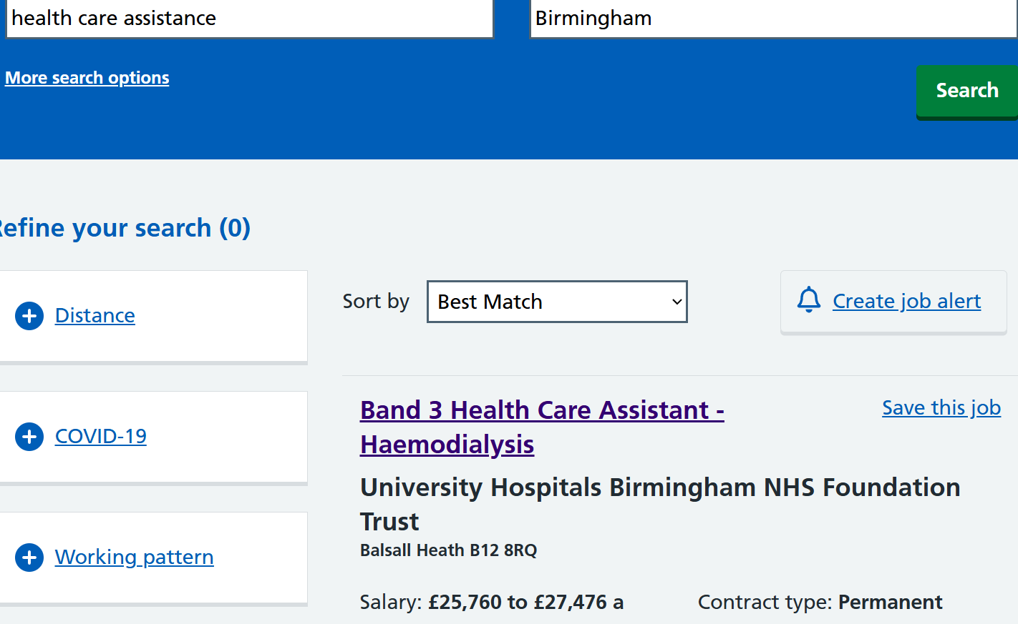
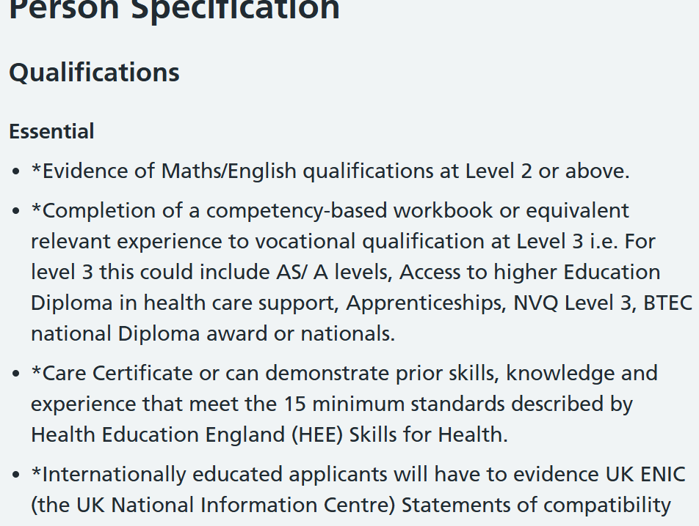

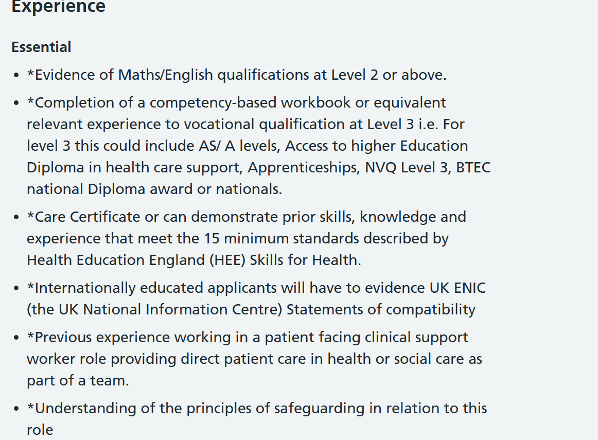
(NHS Jobs, 2026)

Job Role Employability Skills
The Healthcare Assistant (HCA) role requires a combination of personal, interpersonal, and practical skills to ensure safe and effective patient care. According to the NHS Jobs (2026) person specification for the selected Healthcare Assistant vacancy, candidates are expected to demonstrate relevant healthcare knowledge, the ability to work effectively within a team, and commitment to providing compassionate care. These employability skills are essential because Healthcare Assistants work closely with patients, nurses, doctors, and other healthcare professionals. One of the most important skills required for a Healthcare Assistant is communication. HCAs must communicate clearly and respectfully with patients, relatives, and members of the multidisciplinary team. Effective communication helps healthcare workers understand patients’ needs, provide reassurance, and maintain accurate information when reporting changes in a patient’s condition (NHS England, 2023). Good listening skills are also important when supporting patients who may feel anxious, vulnerable, or unwell. Teamwork is another essential employability skill because Healthcare Assistants work as part of a wider healthcare team. They must cooperate with registered nurses and other professionals to provide coordinated care. The ability to support colleagues, follow instructions, and contribute positively to the team helps improve patient safety and quality of care (NHS Jobs, 2026).
Healthcare Assistants also require compassion, empathy, and a patient-centred approach. The role involves supporting individuals with personal care and daily activities while respecting their dignity, privacy, and independence. These values are central to health and social care practice and are reflected in the NHS commitment to providing compassionate and respectful care (NHS, 2023).
Other important skills include attention to detail, reliability, organisation, and the ability to follow procedure. Healthcare Assistants must accurately record information, follow infection prevention guidelines, and recognise when a patient’s condition changes. These skills contribute to maintaining safe standards of care.
Overall, the Healthcare Assistant role requires both technical understanding and strong personal qualities. Developing these employability skills will enable me to provide high-quality care and become a valuable member of the healthcare workforce.

Evaluate My Own Skills
To understand my suitability for the Healthcare Assistant (HCA) role, I have reflected on my current skills, strengths, and areas that require further development. Self-assessment is an important part of career development because it helps identify existing abilities and the skills needed to achieve future employment goals. Although I currently have no professional healthcare experience, I have developed transferable skills through my education and personal experiences that can support my progression towards a career in health and social care.One of my strengths is my communication skills. Through academic activities, group discussions, and presentations, I have developed the ability to listen to others, share ideas, and communicate respectfully. These skills are important for a Healthcare Assistant because the role requires regular communication with patients, families, nurses, and other healthcare professionals. I believe my ability to communicate with different people will help me build positive relationships with patients and provide person-centred support.Another strength I have identified is teamwork. Working with classmates on assignments and activities has helped me understand the importance of cooperation, responsibility, and supporting others to achieve shared goals. Healthcare Assistants work as part of a multidisciplinary team, so being able to collaborate effectively is essential for delivering safe and effective care (NHS Jobs, 2026).I also consider empathy, patience, and willingness to learn as personal strengths. A Healthcare Assistant must treat patients with dignity, compassion, and respect. Although I have not yet worked in a healthcare environment, I am motivated to develop these qualities further through training, volunteering, and practical experience.However, I recognise that I currently have areas for improvement. My main development needs are gaining practical healthcare experience, learning clinical skills, and understanding healthcare procedures such as infection prevention, patient safety, and supporting individuals with personal care needs. I also need to gain relevant qualifications, such as the Care Certificate and further health and social care training, to improve my employability.To identify and improve my skills, I can use self-assessment tools, feedback from tutors, advice from careers advisers, and discussions with healthcare professionals. University careers services can support me with CV development, interview preparation, and identifying suitable work experience opportunities.My unique value as a future Healthcare Assistant is my motivation, commitment to learning, and willingness to provide compassionate support to patients. By developing my knowledge and practical abilities, I aim to become a reliable healthcare professional who contributes positively to patient care.

Action Plan and Timeline for Developing Required Skills
To achieve my goal of becoming a Healthcare Assistant, I need to develop the knowledge, practical skills, and professional experience required for the role. Creating an action plan allows me to identify clear steps and set realistic goals over the next five years. My plan focuses on gaining healthcare knowledge, improving employability skills, gaining practical experience, and building professional confidence.

Short-term goals (0–12 months)
My first priority is to develop a strong foundation in health and social care. I will complete relevant training courses, including the care certificate, which introduces essential healthcare skills such as communication, safeguarding, infection prevention, equality and diversity, and person-centred care. I will also continue developing my academic knowledge through my studies and seek feedback from lecturers to improve my professional skills.
To gain practical experience, I will look for volunteering opportunities in healthcare settings, such as hospitals, care homes, or community support services. This will allow me to understand the responsibilities of a Healthcare Assistant and develop confidence when supporting patients. I will also improve my CV and create a LinkedIn profile to begin building my professional identity.

Medium-term goals (1–3 years)
Within the next three years, I aim to gain healthcare-related work experience through volunteering, work placements, or an entry-level Healthcare Assistant position. This experience will help me develop practical skills, including supporting personal care, communicating with patients, maintaining confidentiality, and working effectively within a healthcare team.I will continue improving my employability skills by attending training sessions related to healthcare, such as first aid, moving and handling patients, and safeguarding training. I will also seek guidance from healthcare professionals, tutors, and career advisers who can provide advice about career progression and employment opportunities.

Long-term goals (3–5 years)
Within five years, my aim is to secure a permanent Healthcare Assistant position within an NHS organisation. I will continue developing professionally through workplace training and ongoing learning opportunities. I will regularly review my progress and identify further skills required for career advancement, such as progressing to higher-level healthcare support roles or further professional qualifications.To achieve these goals, I will require resources including access to training courses, support from university careers services, healthcare volunteering opportunities, professional networks, and guidance from experienced healthcare workers. By following this action plan, I will gradually develop the confidence, knowledge, and skills needed to become a compassionate and effective Healthcare Assistant.

Building Your Personal Brand
Developing a strong personal brand is important for creating a professional identity and improving my future employment opportunities as a Healthcare Assistant. A personal brand represents the skills, values, experiences, and qualities that I can offer to potential employers. As I currently have limited healthcare experience, I will focus on demonstrating my motivation, willingness to learn, compassion, and commitment to providing high-quality patient care. One way I can build my personal brand is by creating and maintaining a professional LinkedIn profile. This platform will allow me to highlight my education, developing healthcare knowledge, training courses, volunteering experiences, and career goals. I can connect with healthcare professionals, follow NHS organisations, and engage with relevant health and social care content to increase my professional visibility.I can also strengthen my personal brand by participating in healthcare-related activities, attending career events, and completing relevant training courses. Sharing evidence of my learning, such as certificates, reflections, and achievements, can demonstrate my commitment to professional development. My personal brand should reflect the values expected within health and social care, including respect, compassion, confidentiality, teamwork, and patient-centred care. By consistently presenting these qualities through my CV, online presence, and professional interactions, I can create a positive impression on employers and demonstrate my suitability for a Healthcare Assistant role.

Promoting Your Professional Identity
Promoting my professional identity involves effectively communicating my skills, values, and career goals to potential employers. As an aspiring Healthcare Assistant, I need to demonstrate that I understand the responsibilities of the role and that I am committed to developing the skills required to provide safe, compassionate, and person-centred care.One important method of promoting my professional identity is creating a clear and targeted CV and cover letter. My CV will highlight my education, transferable skills, training courses, volunteering experiences, and personal qualities that are relevant to healthcare, such as communication, teamwork, empathy, and reliability. I will adapt my CV and cover letter for each Healthcare Assistant application to ensure that they directly address the requirements listed in the job description and person specification (NHS Jobs, 2026).I will also maintain a professional online presence through platforms such as LinkedIn. By regularly updating my profile with new skills, qualifications, and healthcare-related achievements, I can demonstrate my commitment to continuous professional development. Sharing relevant articles or reflections about health and social care topics can also help establish my interest and knowledge within the sector.In addition, I will communicate my professional identity through interviews by providing examples of my skills, willingness to learn, and motivation to support patients. Presenting myself professionally and confidently will help potential employers recognise my suitability for a Healthcare Assistant position.

Building a Network for Successful Employment
Building a professional network is an important part of achieving successful employment as a Healthcare Assistant. Networking allows me to develop connections with healthcare professionals, gain knowledge about the sector, and discover potential employment and development opportunities. Establishing professional relationships can also help me understand the expectations of healthcare employers and improve my career planning.One way I can build my network is by engaging with healthcare professionals during volunteering opportunities, work placements, and training courses. Developing relationships with nurses, Healthcare Assistants, and other members of the multidisciplinary team can provide valuable advice and guidance about working in healthcare. I can also seek support from university lecturers, career advisers, and healthcare mentors who can help me improve my employability skills, CV, and interview techniques.
I can use professional platforms such as LinkedIn to connect with healthcare organisations, NHS employees, and health and social care communities. Attending healthcare career fairs, university employment events, and professional workshops will also allow me to meet employers and learn about available opportunities.
Professional organisations and healthcare networks can support my continued development by providing access to resources, training opportunities, and industry information. By actively building and maintaining my professional network, I can increase my awareness of career opportunities and develop relationships that may support my progression towards becoming a Healthcare Assistant.

Conclusion
This report has explored the skills, personal development, and career planning required to achieve my goal of becoming a Healthcare Assistant within the UK health and social care sector. The analysis of the selected NHS Healthcare Assistant vacancy demonstrated that the role requires a range of employability skills, including effective communication, teamwork, compassion, reliability, attention to detail, and the ability to provide safe and person-centred care. These skills are essential for supporting patients and working effectively alongside healthcare professionals.
Through self-evaluation, I identified that although I currently have no professional healthcare experience, I possess transferable skills such as communication, teamwork, willingness to learn, and empathy. However, I also recognised the need to develop practical healthcare knowledge, gain relevant experience, and complete appropriate training to meet the requirements of the role. My five-year action plan provides a structured approach to achieving these goals through education, volunteering, training, and gaining healthcare employment experience.
Furthermore, this report highlighted the importance of building my personal brand, promoting my professional identity, and developing a strong professional network. By using tools such as LinkedIn, a tailored CV, career events, and relationships with healthcare professionals, I can increase my employability and present myself effectively to potential employers.
Overall, I am motivated to pursue a career as a Healthcare Assistant and committed to continuous professional development. By developing the required skills and gaining practical experience, I aim to become a compassionate and reliable healthcare professional who contributes positively to patient care.

Reference List (Harvard Style)
Department of Health and Social Care (2023) The Care Certificate: Standards for healthcare support workers. Available at: https://www.skillsforhealth.org.uk/resources/the-care-certificate/ (Accessed: 23 July 2026).
Health and Care Professions Council (HCPC) (2024) Standards of conduct, performance and ethics. Available at: https://www.hcpc-uk.org/standards/ (Accessed: 23 July 2026).
National Careers Service (2026) Healthcare assistant. Available at: https://nationalcareers.service.gov.uk/job-profiles/healthcare-assistant (Accessed: 23 July 2026).
NHS (2023) The NHS Constitution for England. Available at: https://www.gov.uk/government/publications/the-nhs-constitution-for-england (Accessed: 23 July 2026).
NHS England (2023) Compassionate and inclusive care. Available at: https://www.england.nhs.uk/ (Accessed: 23 July 2026).
NHS England (2024) NHS Long Term Workforce Plan. Available at: https://www.england.nhs.uk/publication/nhs-long-term-workforce-plan/ (Accessed: 23 July 2026).
NHS Jobs (2026) Band 3 Health Care Assistant – Haemodialysis, University Hospitals Birmingham NHS Foundation Trust. Available at: https://www.jobs.nhs.uk/ (Accessed: 23 July 2026).
NHS Professionals (2026) Healthcare Support Worker or Healthcare Assistant. Available at: https://www.nhsprofessionals.nhs.uk/ (Accessed: 23 July 2026).
Skills for Health (2024) The Care Certificate. Available at: https://www.skillsforhealth.org.uk/ (Accessed: 23 July 2026).
UK Government (2024) Care and support statutory guidance. Available at: https://www.gov.uk/government/publications/care-act-statutory-guidance (Accessed: 23 July 2026).

