Sarah Ali, 2119052.
BMIH5005
Lecturer: Kathryn Roberts
Title: What are the current challenges that the industry is facing that is affecting employee recruitment and retention.
‘Hilton Hotel’

Contents Page

Page 3 Introduction
Page 4 – 10 Main Findings
Page 11 Evaluation and Conclusion
Page 12 Further Research
Page 13 – 14 References

Introduction

This report is for the general manager based in Hilton Hotel France ‘Paris Opera’ a Four-star rating by TripAdvisor guests, (TripAdvisor, 2023), Improvements must reach five stars. A nineteenth century architecture building its surrounded by attractions of Paris, (Paris Opera, 2023). Several issues identifying problems and benefits for the hotel is staff retention. The Hilton Introduces a passport gate way to employment to find a solution to retention globally. Achieving “to date, over 15,000 young people have been training in PTS at Hilton properties or within their communities. In addition, in a survey with three hundred supervisors, Hilton Team Members who received PTS training, 96% were retained after six months and 40% were promoted” (Hilton 2023, passport gateway).
The first Hilton Hotel dates to “Conrad Hilton entering the hotel business in Cisco, Texas, 1919’, In ‘1945’ Hilton became an International Hotel, in ‘1973’ hotel was developed to the first centralized reservation service using computer technology, in ‘1987’ Hilton introduced guest loyalty programmes, ‘1995’ The Hilton introduced their website” (Hilton history, 2023). The Hilton Mission is to be the first choice for everyone, Values, to be passionate about delivering exceptional guest service, to be the leaders in the hospitality industry and within the communities.
The Hilton Hotel have a total of eighteen distinct brands, one being the Paris Opera, with the most luxurious being the “Waldorf Astoria, offers unforgettable experiences at iconic destinations around the world” (2023), supplying personal chauffer services, top luxuries, and expensive interiors. The Least luxurious, is ‘Conrad Hotel’ which is known as downtown, but still offering smart guest experience. The lowest budget being mid-range simple collection ‘Hampton by Hilton’ (Hilton Brands, 2023).

Main Findings
The Hilton group of hotels is competing amongst the Hyatt group (world of Hyatt, 2023) a main competitor along with the Marriott Group of hotels (Marriott, 2023). Hyatt offer benefits such as loyalties for guests’ members and employees. The Hilton creates opportunities globally to satisfy the employee retention using a variety of strategies. One of the key strategies that Hilton use is through investing heavily in the training and development of its employee’s such as Hilton Honours (Hilton, Jobs 2022). Overall, Hilton has been more successful in retaining customers than Hyatt this could be based on factors such as location, pricing, and amenities.
Skift.C. S, (2022) gathers data “45,000 employees across Hilton’s 203 owned and managed properties in the U.S., as well as the company’s reservations and customer care centre and corporate offices will be eligible for the ‘Honours’ program”.
The Hilton moto, “Every call is an opportunity to build trust with our guests and convert every customer into a lifetime Hilton guest,” A strong recruitment process can ensure that the hotel has access to a diverse pool of candidates qualified to contribute to the hotel’s success. A slow recruitment process can result in shortage and decreased efficiency of employee engagement and customer dissatisfaction. (Jobs, Hilton 2022)

Torrington (pp.-10, 2020) explains how in a tough market economy, an organization's ability to effectively manage its relationships with suppliers and resources often decides its success. Finding employees was not a problem more than a generation ago; physical labour that demanded little skill was commonly available. This is the situation globally in some nations right now. The need for specialty employment with the right skills and certificates has increased for higher level skilled work around the world in a variety of employment industries and the hospitality industry where retention is a big focus. Based on the most recent publicly available information as of the end of 2022 Hyatt reported “our worldwide employee retention rate of 80% while Hilton reported a 79% retention rate for its global workforce”, other global findings from Statista within hospitality below.

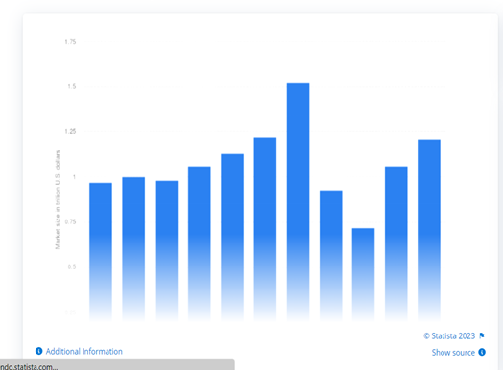

Statista (2023) “Market size of the hotel and resort Industry from 2013 to 2022”
“The number of employees in the hospitality sector between 2010 and 2017 in France varied only slightly over this period. In 2010, the hotel industry had approximately 175,000 employees compared to 173,000 employees in 2017” (Statista, 2023).
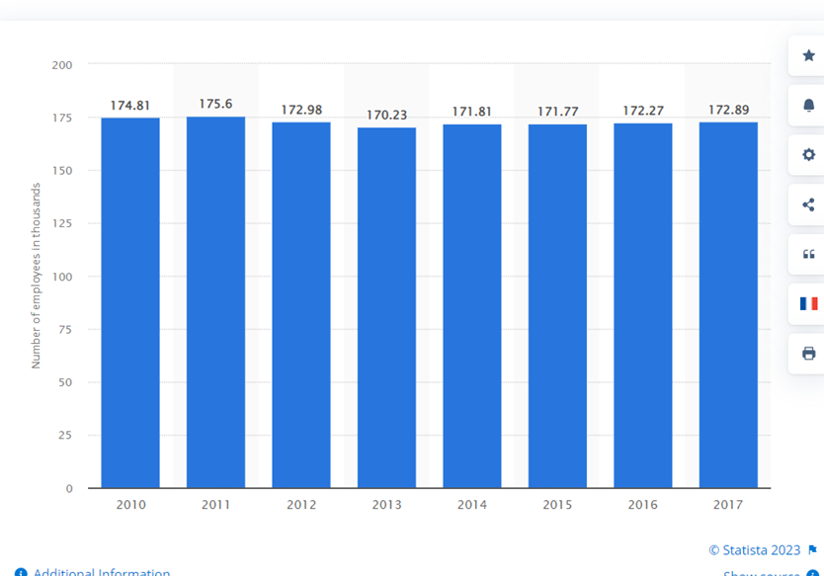

The Hilton Group Paris Opera (Careers, 2023) is Based centrally amongst popular attractions popular visits expected from the international guests, a lot of standards expected from the employees. Hyatt (benefits 2023) offer employees support and training where the Hilton group go beyond in offering debt free education a focus of attraction for employee engagement as current global finance issues affecting households where wages in hospitality show increase in wages is outdated compared to other industries. The employees have an advantage to gain further skills with debt free learning, support availability online as mentioned by the Hilton Careers, “We support the well-being and performance of Team Members with industry-leading rewards, recognition and support to meet their needs and dreams” Skills such as interpreting learning for other languages would be beneficial the employees understanding of culture awareness another advantage, these learning outcomes could also be a disadvantage when facing staff turn overs and retention.
The Hilton Paris Opera, a few of the amenities guest can expect, (Paris Opera 2023).
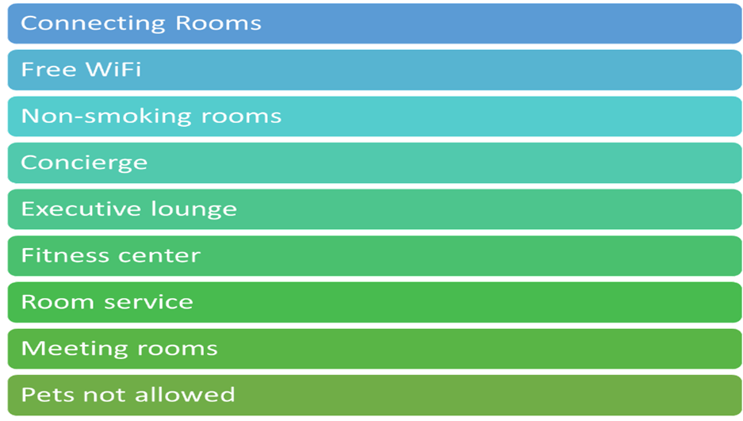
According to the Hilton group, Covid-19 had a negative impact on recruitment and retention within hospitality. The Pandemic Covid challenges such as reduced travel and occupancy. The Hilton have proved to move with the fast changes and adapt to department changes such as work from home schemes ‘Guest facing opportunities’ to “Leadership opportunities in driving positive engagement for team members and customers while maximising profitability” A negative impact was labour shortages due to changes in policies and an overall shift in the labour market. Departments where employees must be present at work to carry out duties such as cleaning, making the room, these duties can only carry out in the Hotel itself, to overcome this the Hilton introduced work shifts and flexible days.
Statistas recent survey, concludes in ‘2021, Hilton Worldwide Holdings Inc., a multinational hotel firm, employed about 142 thousand workers worldwide, the coronavirus (COVID-19) pandemic, which led to temporary furloughs and organisational adjustments in its global operations, has blamed for the fall in staff numbers’. “The number of employees reached its peak in 2019, topping 170,000” (Statista, 2022), ‘Hilton Hotel laid off “50,000 people and still voted number three place of work in America” (CIPD, 2022)
Researched by Armstrong, M (pp580-585, 2020), Managing flexibility has four key criteria in employment within organisations,
- Functional Flexibility - includes the ability to reassign people swiftly and smoothly, as well as plan for them to quickly pick up the new skills they need to start working in new positions.
- Structural Flexibility- in the organization's structure allows a peripheral group of part-time workers on short- or fixed-term contracts or subcontracts to supplement the core of permanent staff.
- Numerical Flexibility -Demand for overtime fixed time contracts zero hours, temporary, and free-lance outsourced labourers might alter, which can lead to an increase or reduction for labour available in the short term.
- Work Flexibility- A degree of understanding between employee and employer with increase agility within organisations and contribute to employee well-being.
Case study within the Hilton Hotel Group states “Introducing flexible working in a hotel is difficult. It is essential to set peoples schedules in advance so work can plan around that. In an accounts department, opportunities for flexible working were poor. However, employees in the department split into four groups to produce four different proposals for flexibility could introduced without impairing operational efficiency all were trialled and now anyone who wants to work flexibly has the means to do so” (Armstrong, p585, 2020).

Yam, (2018) research shows on exploring the role on jobs “A total of twenty-five extended interviews conducted across five properties, each lasting between 20 and 40 minutes. Sixty per cent of the interviewees were female. Ages ranged from 40 to 70 years and there was an even balance between operational staff (48%) and management staff (52%). Seventy-two per cent had full time employment and 28 per cent part time (most of those by choice), while 44 per cent of interviewees had dependent children at home. Almost half of the participants (48%) had been with the same employer for 20 or more years (mean = 17 years). Table 1 summarizes the socio-demographic profile of interviewees” One of the biggest challenges in the hotel industry affecting employee retention is the high turnover rates with many factors contributing to it.
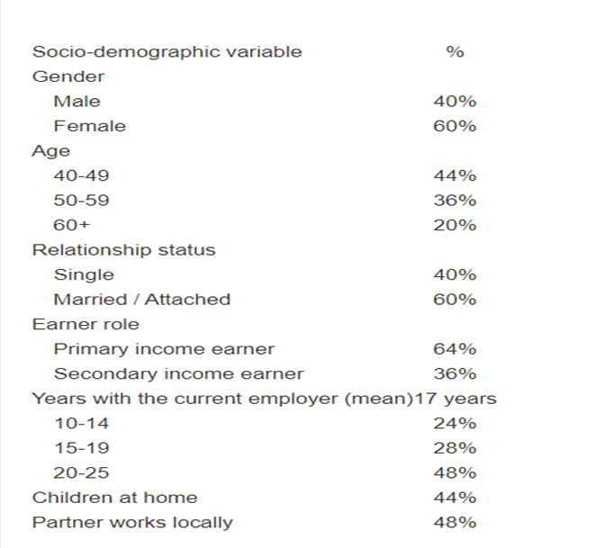

In the hotel industry tangible rewards may include things such as bonuses paid time off travel benefits access to exclusive hotel amenities such as spa services gym facilities, complimentary meals. Intangible rewards include recognition for outstanding performance opportunities, career advancement in the Hilton Group. The Hilton France Paris Opera (Passport to success, 2023), ‘Passport to education’ in place, to give employees confidence in their roles may have positive feedback from guests or colleagues and then staff may be rewarded, this can contribute to a sense of accomplishment and positive company culture a supportive work environment and opportunities for professional development and contribute to the overall success of the hotel (Knight.L 2023)
(Wang, Anderson, 2023) reviews brands with a strong reputation for luxury and high-end services wide variety of accommodation options including luxury hotels resorts.
Hyatt (2023) and The Marriott Bonvoy (Bonvoy, 2023) properties multiple revenue streams including lodging food and beverage and events and conference services, strong loyalty programme with a large membership base. The Hilton hotel group in France locations from urban centres to resort areas supplying various market segments weaknesses could be high price points may limit accessibility to certain market segments inconsistent quality levels across properties reliance on third party booking platforms and internationally development in technology. The Marriott Bonvoy App (2023), however is ahead by introducing the mobile app check in and out, requests for product services to improve guest experiences and streamline operations using sustainability and eco-friendly initiatives to appeal to socially conscious consumers.

Claydon and Beardwell, (pp15-21, 2010), “The impact of human recourses management on the roles of HR professional”,
asserts that not all measures of human resource management as support are improving performance. Strong theoretical basis for the application of HRM would not only increase employee engagement but will also improve organisational performance and productivity, according to studies that have conducted to understand the relationship between HRM performance.

(Claydon and Beardwell, 2010)

Evaluation and Conclusion

Hilton is a well-known international hotel brand that works in many countries around the world with over 4900 properties in more than one hundred countries. The Marriott however have growth and development successfully as the Marriott expect to expand Internationally introducing ‘more than 35 luxury hotels around the world in 2023’, (Cannes, France 2022).
The crucial issue the Hilton directly effects on the company's success and the satisfaction of its guests are,
- High price points
- Reliance on third-party booking platforms for a significant portion of bookings.
Hilton should consider offering their employees’ salaries and benefits that are competitive with the market rates to attract and keep top talent for growth and development, supplying various training programmes professional development opportunities the rare advancement opportunities can help employees build their skills and progress in their careers within the company. Three positive word culture Hilton should create for positively effect on employee engagement and retention.
- Opportunities for the Hilton Group, development of new partnerships
- Strategic investment in technology to improve guest and employee experience.
- Leveraging sustainability and eco-friendly initiatives to appeal to socially conscious consumers and employees.
The Hilton Hotel globally have been relatively stable over the past two years with an average annual turnover rate of 15% this is considered an acceptable rate by industry standards but it is still a challenge for the hotel to maintain high quality service and take advantage of opportunities for growth departments with the highest turnover rates include housekeeping and food service where rates are 20% and 18% respectively these departments are often considered the most challenging to work in due to high workload (Statista 2021, 2022).

Research further and Recommendations
Employee retention Recommendations, Solutions
- Employee Recognition Programs, encourage continuous improvements.
- Positive Work Environment, open communications, mutual respect.
- Employee Feedback: surveys, focus groups, 1-1 conversations to understand their needs, expectations address effectively.
- Training in Culturally diverse equality and diversity to meet all the characteristics of international guests and employees.
• employee work and engagement (Moodle)
WU, P. et al. (2021) ‘Research on the Work Engagement of Hospitality Industry Staff from the Perspective of Tourism Management Informatization’, in E3S Web of Conferences. Les Ulis: EDP Sciences, p. 01166–. Available at: https://doi.org/10.1051/e3sconf/202123301166.
• Measuring the importance of employee skills (Moodle)
Cuic Tankovic, A., Kapeš, J. and Benazić, D. (2023) ‘Measuring the importance of communication skills in tourism’, Ekonomska istraživanja, 36(1), pp. 460–479. Available at: https://doi.org/10.1080/1331677X.2022.2077790.
Implementing these recommendations, the Hilton Paris Opera and the Hilton group can boost its employee retention rate, reduce turnover, and increase employee loyalty and commitment which can lead to improved productivity, customer service and profitability.

Reference List
- Armstrong, M. (2020) Armstrong’s handbook of human resource management practice. Fifteen editions. London, England; New York, New York; New Delhi India: London, England; New York, New York; New Delhi India: London, England; New York, New York; New Delhi India: Kogan Page.

- Claydon & J. Beardwell (eds.) (2010) Human resource management [electronic resource] / a contemporary approach. 6th ed. /. Harlow: Financial Times Prentice Hall. BUS7AD. (Moodle, pp15-21) https://r2.vlereader.com/Reader?ean=9780273722892#

- Knight. Lisa, In class discussion (2023) Moodle 16th February 2023.

- Torrington, D. (p5-10, 2020) Human resource management. Eleventh edition. Harlow, England: Pearson.

- Wang, F.X. and Anderson, C., 2023. How Firm Strategies Affect Consumer Biases in Online Reviews. Service Science.

- Yam, L., Raybould, M. and Gordon, R. (2018) ‘Employment stability and retention in the hospitality industry: Journal of Human Resources in Hospitality & Tourism, 17(4), pp. 445–464. doi:10.1080/15332845.2018.1449560.
(Accessed 25th February 2023)
- Brands Hotels by Hilton - Book the Best Rates Across All Brands https://www.hilton.com,2023. (Accessed 1st March 2023)

- CIPD (2022) Hilton, https: www.cipd.co.uk/knowledge/work/... (Accessed 3rd March 2023)

- France Paris Opera ‘Hilton Hotel’ 2023, https://www.hilton.com/en/hotels/parophi-hilton-paris-opera/ (Accessed 27th February and 3rd March)
- History, Hilton Hotel 2023, https://stories.hilton.com/history (Accessed 28th February)

- Hyatt world benefits, "World of Hyatt Member Benefits | Hotel Loyalty Program | World of Hyatt." https://world.hyatt.com/content/gp/en/tiers-and-benefits.html (Accessed 1st March 2023)

- Jobs https://jobs.hilton.com/us/en2022 (Accessed 27th February 2023)

- Passport to success, Hilton increases employee retention with Passport to Success | Passport to Success 2023. (Accessed 2nd March 2023)

- Skift (2022) Hilton’s Latest Employee Benefit Leans Into the Labour Shortage Crisis (skift.com) (Accessed 3rd March 2023)

- https://www.statista.com/statistics/1186201/hotel-and-resort-industry-market-Hotels and similar accommodation: salaried workforce in France | Statistasize-global/,
https://www.statista.com/statistics/297758/number-of-hilton-worldwide-employees/(2021)
(Accessed 2nd March 2023)
- Marriott, https://news.marriott.com/news/2022/12/07/marriott-international-expects-to-introduce-more-than-35-luxury-hotels-around-the-world-in-2023 (16th February 2023)
- Marriott Bonvoy App “Marriott Bonvoy App | Access more." https://mobile-app.marriott.com/. (16th February 2023)

- TripAdvisor, HILTON PARIS OPERA - Updated 2023 Reviews (France) - TripAdvisor (Accessed 27th February 2023)

