Name: Nipha Begum

Student I.D: 1818766

Module Title: Effective Team working and Communication

Module code: BMSW4002

Lecturer’s Name: Navami Sudarsan

Contents page

- Introduction……………………………………………..3

- Communication…………………………………..........3

- Models of communication…………………………….3

- The importance of effective communication………..5

- Challenges of communication in the work place…...6

- Solutions of effective communication……………….6

- Conclusion……………….………………………….…7

- References…………………………………………….9

- Appendix……………………………………..............10

Introduction
This report will analyse a range of communication skills and the way in which these skills integrate within a place of work by thinking of a personal experience from within my own place of work to show the importance of effective communication and team work. Within this report two models of communication that have been studied will also be included.
Communication
There are many forms of communication, everyone has their own meaning and understanding but in simple terms communication is the process of creating shared understanding (Barker, 2006).
Miscommunication is when the message received has not been interpreted correctly due to misinterpretation. Communication in any form should be significantly important to the sender and receiver.
There are two categories that the different types of communication fall into; Verbal and Non-verbal.
Verbal communication is both our words and verbal fillers (e.g., um, like). Verbal messages are created through language (Maund, et al 2017).
For example, face to face interactions, on the phone or even written communication like for instance letters or through emails via the internet, books and magazines.
A technical definition for nonverbal communication is “Communication other than written or spoken language that creates meaning for someone”
(Ivy and Wahl, 2014, p. 5).
For example, gestures, body language, posture can also translate as a means to communication and sometimes even the way people are dressed.
Communication is an essential skill within business and management, without communication a business and management would cease to exist. Poor communication can cost an organisation immensely and stop it from being truly competitive and successful (Fielding, 2006).
Models of communication
Models of communication are used to interpret the way in which communication is processed. Models make understanding the way communication works in a simple and efficient way by using diagrams and pictures. There are various models of communication created by many theorists who have different disciplines and amongst all these I have studied two in which I can easily relate to and translate even though each one has various differences in the way they work.

Shannon and Weaver’s Model of communication (1949) is the most known and used to date due to its simplicity and ease of understanding. The Shannon-Weaver theory of communication was primarily designed to improve technical communication, but was later used to describe different fields of communication.
(Communicationtheory 2010)

This model approaches numerous concepts like Information source, transmitter, noise, channel, message, receiver, channel, information destination, encode and decode (Communicationtheory 2010).
This Model takes communication as a two-way process and unlike other Model’s of communication Shannon and weaver’s model includes the concept of noise. Although many would agree this is the most quantifiable Model, many would argue there are also many flaws, one being that it is more effective within a conversation between two people rather than a group or a big audience also the model is purely based on just a sender and receiver which in fact gives the sender the primary role leaving the receiver to play a secondary role which would not be realistic when having a real conversation.
In 1960 Berlo advanced on Shannon and Weavers Model of communication and proposed his own called Berlo’s SMCR Model. This Model is known as a Linear communication Model which takes into account the emotional aspect of the message. Berlo’s model of communication operates on the SMCR model.
- S - Stands for Source
- M - Message
- C – Channel
- R – Receiver Management study guide (2015)

(Communicationtheory 2010)
Berlo’s model mainly consists of four parts which describe the communication process which are shown above. These parts are then broken down to show what each one consists of. Berlo believes that for an effective communication to exist the source and the receiver need to be on the same level.
There are also arguably faults within Berlo’s model of communication like for instance communication is not on a continuous loop as there is no concept of feedback being received. The concept of noise is not considered eliminating the process of a two-way communication process.
The importance of effective communication
In my current place of work, in a private hospital I am working part-time on the main reception desk.
I have had many situations arise whilst working on reception but one stands out the most for me as it shows the importance of communication and how one misunderstanding can make a situation escalate.
I received a call whilst on reception, at this point in time I was still training but the colleagues training me were dealing with other cases so I used my initiative to show that I can work as part of a team and deal with any issue that arises and I decided to take the call. The call was from a patient’s mother who had taken her daughter home in the previous week from an operation she had at our hospital. The call was regarding picking up of post-operative medication for her daughter, the mother seemed quite frustrated as she had said that she had rang several times and had not managed to solve the solution as to why she had called so I transferred the patient’s mother to the pharmacy department as they would be able to advise her accurately.
The call had then been transferred back to the main reception as the patient’s mother had not been able to get through due to the line being busy. Knowing the patient’s mother was already frustrated I took all the details needed and went to solve the issue.
The pharmacy department said that there had been a misunderstanding between the doctor and the patient’s mother and no post-operative medication was needed to be collected and that they had already advised her of this a few days before.
I responded back to the patient’s mother and she was grateful towards the way I had assisted her. The patient’s mother then explained that someone else had taken the call on her behalf at home and had forgotten to mention that someone in fact had called a few days earlier.
Challenges of communication in the workplace
Communication skills is a skill everyone should be well asserted in within a professional space of work as it can build trust and confidence. Ineffective communication can lead to the wrong message being sent across which can lead to misconceptions. There were many miscommunications which had arisen before the patient’s mother had reached to my point of communication with her, which in turn led to a few misunderstandings and miscommunications.
The weakness of communication was misinterpreted from the very beginning when the doctor had advised incorrectly that the patient would need post-operative medication which in the end was not needed at all.
Another communication weakness could be placed at the patient’s mothers place of home where the lack of communication was dysfunctional and was not fed back meaning the mother was not informed of the correct information leading to the phone-call situation which could have been prevented, this is due to the lack of attention and interest from the third party. The lack of feedback had deterred the effective communication process which could relate back to Berlo’s communication model as well as Aristotle’s communication model as no feedback was received which was what created the many miscommunications.
Non-verbal communication was not present within this situation as we both were not visible to the way in which we were both behaving on each side of the phone and I’m sure if this was a face to face interaction the issue would have been resolved much faster and this made our communication less effective.
Getting our language right with someone who might be used to interpreting the same words and messages in different ways is not easy, so getting feedback wherever possible is important. (Morgan, 2017, p.265).
Solutions of effective communication
The use of my affirming responses was a solution by acknowledging their experience, I gained trust. Actively listening provided positivity and reassurance for the other party, I was able to do this by simply adjusting my tone and by asserting confidence through the tone of my voice. The level of formality is also essential while communicating with people as the way in which you communicate with others is a self-reflection of what you will be receiving back.
In every professional place of work, you will have to know the customer type you will encounter and based on this you will be able to evaluate the context and the type of communication required to interact with others. Working in a hospital setting, you will need be aware of your communication interaction with people. Being respectful, understanding and polite are essential requirements and this should not just be the case within a hospital but in all areas of work where communication is essential. Working in a hospital both verbal and non-verbal communication is imperative regardless of the job role you have. Every person is to be treated equally and fairly.
Reflecting back, I dealt with the situation well and was praised by my colleagues for dealing with the issue with clarity and concision which in turn displayed to my colleagues I was more than capable and equipped with the right skills to continue with working in reception.
Above I have applied the KEYS approach from Keys to excellence in verbal and nonverbal communication (Maund, et al 2017). I have used the KEYS four strategies to show the way in which communication should be assessed to perform personal excellence in the work place. The KEYS approach consists of:
- Know yourself
- Evaluate the professional context
- Your communication interaction with others
- Step back and reflect
Every day is spent communicating, whether it is by phone calls, messages, emails and so on but what is essential within these forms of communication is that we are clear and concise when we do communicate with people. This is where the seven c’s of communication are vital.
According to the seven Cs, communication needs to be: clear, concise, concrete, correct, coherent, complete and courteous (Education executive 2017).
I have been applying the seven c’s within my daily oral and written communication process to increase my skills and understanding of effective communication and this has helped me to further improve on my own communication skills. This was also a major support in assisting me with the situation I dealt with at work, the seven c’s reminded me of how to deal with a situation appropriately and in a professional manner.
Conclusion
This report has analysed the way in which a range of communication skills is used and the way people use these variations to communicate and interact with people each and every day. I have learnt that communication is a complex process and through gaining knowledge and understanding on the subject, I have come learn that everyone communicates in their own different ways to each other.
Whether people are talking verbally or non-verbally a message is still being sent across and received, like for instance the way we dress communicates to others who we are as a person. Communication is without doubt an unacknowledged essential skill that people tend to forget is even a skill that we use every day.
A key learning point learnt is that communication is a complex process which does not always produce the outcomes you intend. Checking that the understanding of your message(s) is the same as you intend with those who receive it is always important. (Morgan, 2017, p.249).
Through studying this module, I feel as though I have gained more knowledge and I have improved in my own communication skills whilst studying. The skills I have studied are ones that I can apply to my life as well as in the future in my working career. Since studying I have become observant and efficient in my everyday life and the skills I have gained, will not just help me now but for many years to come. My willingness to learn and better myself will hopefully be an assurance towards my future prospects.

References

Barker, A. (2006) The sunday times creating success: improve your communication skills. 2nd edition. London and Philadelphia.

Communicationtheory (2010) Shannon and Weaver Model of Communication. Communicationtheory. [online]
Available from:
http://communicationtheory.org/shannon-and-weaver-model-of-communication/ (Accessed: 28 July 2019).

Education executive (2017) The seven cs of communication [Online].
Available from:
https://edexec.co.uk/the-seven-cs-of-communication/ (Accessed: 6 July 2019).

Fielding, M. (2006) Effective communication in organisations: preparing messages that communicate. 3rd edition. Cape town.

Juneja, P. (2015) Management study guide [Online].
Available from:
https://www.managementstudyguide.com/berlo-model-of-communication.htm (Accessed: 6 July 2019).

Maund, A. Schriek, M. and Tinkler, P. (2017) Certificate in higher education: skills for the workplace student yearbook. London. Sage publications

Morgan, P. (2017) The business student’s guides to study and employability. 1st edition. London. Sage publications

Wandberg, R. (2001) Communication: creating understanding. United State of America. Capstone press.

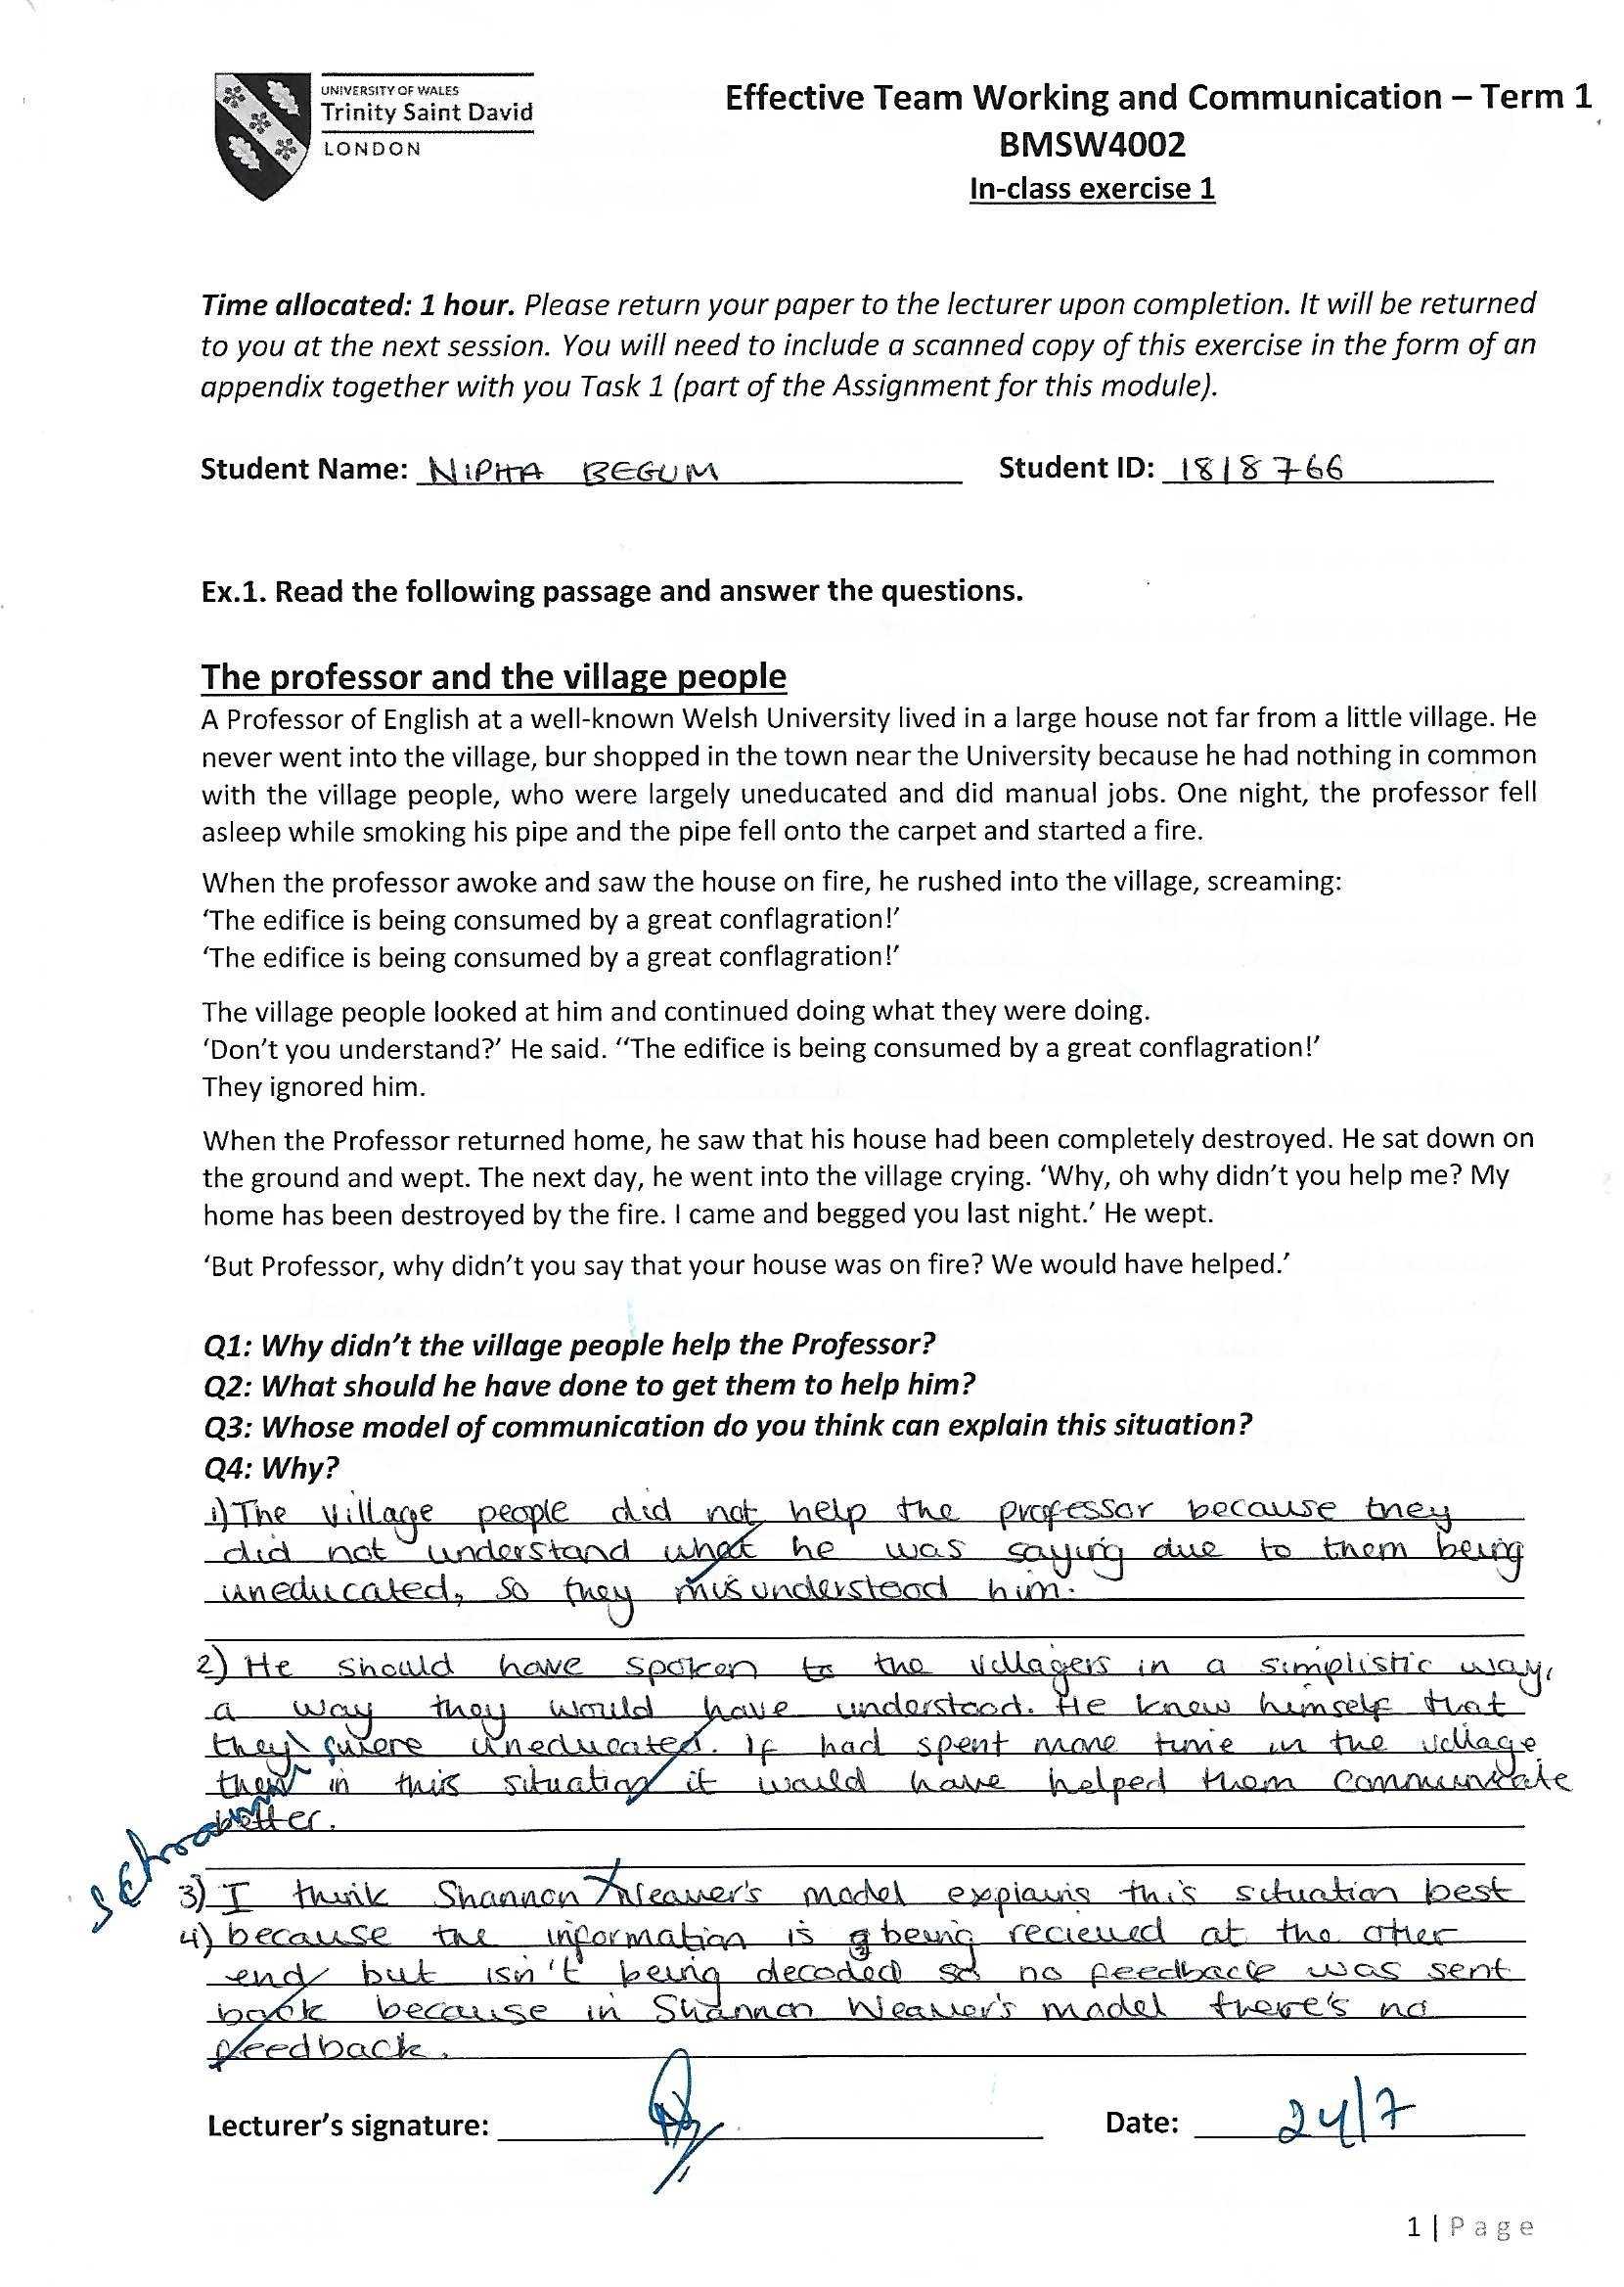
Appendix



