Module: Coaching and Mentoring Skills for the Workplace
Module code: BMSW6105
Student id2112789
Student name: Elvis Liviu Nassiri Basti
Lecturer: Dennis Pepple

Table of Contents
TASK 3 3
Introduction 3
Critical Evaluation of the Purpose of Coaching and Mentoring Within a Workplace 3
Critical Analysis of a Specific Model of Coaching 5
Reflection on Practical 1 – Coaching and Goal Setting 7
Reflection on Practical 2 – Mentoring and Providing Feedback 9
Conclusion 10

TASK 3

Introduction
This reflective report analyses my coaching and mentoring experiences by evaluating them through a structured theoretical lens. It critically reviews coaching and mentoring purposes while analysing methods and outcomes through personal experiences. Throughout this report, I will employ Gibbs’ Reflective Cycle as my reflection model because this framework provides a systematic method for analysing practical experiences.
In the workplace, two major developmental tools exist for personal development: coaching and mentoring. Though their purposes and methods tend to differ, the coaching process focuses on short-term performance improvement in specific areas, while mentoring involves the long-term development of the mentee's career and personal aspects. Richardson et al. (2024) describe coaching as performance-focused, while mentoring focuses on development and personal growth. Different objectives characterise each method, yet they both empower people while improving their abilities and workplace effectiveness.
Successful coaching demands skills in active listening, empathy, emotional intelligence and posing questions that drive self-reflection (KORNIIENKO and BARCHI, 2023). Effective coaching qualities enable coaches to run reflective conversations, which empower individuals to find their own answers instead of coaches supplying direct solutions. In this report, I will examine how coaching and mentoring influence individual and organisational performance by using relevant theories and models to support my analysis.

Critical Evaluation of the Purpose of Coaching and Mentoring Within a Workplace
Organisations employ coaching and mentoring as essential instruments to develop personal abilities and improve employee skills. Each method of coaching and mentoring has distinct objectives and uses, which result in varying effects on both people and organisations. Ribeiro et al. (2020) study explains that coaching aims to develop specific skills or performance levels for individuals in particular settings. This practice could involve developing leadership competencies along with communication abilities or other job performance-related areas. Mentoring stands apart as a holistic development method which targets skill enhancement alongside career advancement and personal development.
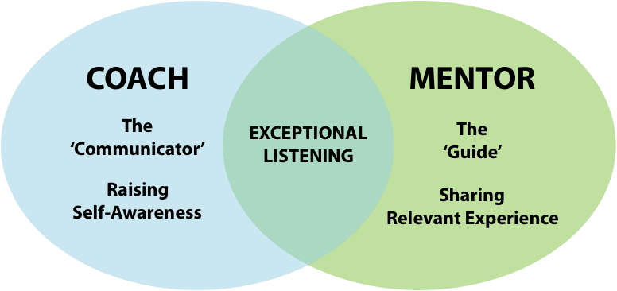
Fig 01: Coaching and Mentoring
Source: (Khan, 2020)
Coaching in a workplace aims to enhance individual performance by targeting specific knowledge or skill deficiencies as well as behavioural issues. Through coaching, individuals learn to create actionable plans to conquer obstacles and meet immediate objectives. (Plotkina and Ramalu (2024) state that coaching becomes necessary when situations require quick and concentrated advancements like the elimination of performance obstacles or skill enhancement. Mentoring concentrates on the extended development of both personal and professional aspects as individuals receive support through career choices and competency building while managing various challenges. The mentoring relationship operates with less formality, which allows for adaptable support that develops over time.
Coaching and mentoring in the workplace produce significant results (Stelter et al., 2020). Organisations gain from coaching because it leads to direct job performance upgrades, which then result in enhanced productivity and operational efficiency. Mentoring creates sustained advantages through community building and career support, which leads to better retention and employee satisfaction. Employees who received mentoring support showed increased job satisfaction levels and commitment plus greater career success, according to Kumari et al. (2022). Organisations advance through continuous employee learning and development, which is achieved via coaching and mentoring and helps employees maintain adaptability during rapid workplace transitions.
Employee development depends on coaching and mentoring, but each method yields different outcomes because it uses unique approaches. According to De and Doyle's (2021) research, mentoring lacks structured timelines and formal guidelines, in contrast to coaching, which concentrates on achieving specific goals. Coaching is an organised procedure with a specific framework designed to accomplish targeted goals. Mentoring serves as a flexible teaching method in which mentors provide guidance based on their own experiences to mentees.

Critical Analysis of a Specific Model of Coaching
Coaching professionals frequently use the GROW model, which Sir John Whitmore established during the 1980s. The GROW acronym represents “Goal, Reality, Options, and Way Forward”. It is together to create a defined process that helps people achieve their goals according to Sir John Whitmore's framework (Rahman, 2023). This model stands out as both clear and effective at converting complex goals into manageable tasks. Through this analysis, I will evaluate the core elements of the GROW model and identify its advantages and disadvantages.
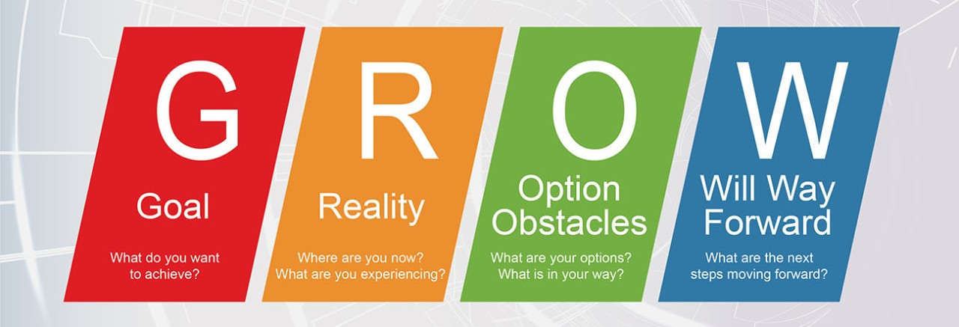
Fig 02: Gibbs’ Reflective Cycle
Source: (Chakravorty, 2023)
The GROW model consists of four phases: The GROW model has four separate phases called “Goal, Reality, Options, and Way Forward”. In the Goal phase of the GROW model, the coachee defines a measurable objective with guidance from the coach. In the Reality phase of the GROW model, professionals must examine current conditions and pinpoint both challenges and resources. In the Options phase, which belongs to the GROW model, participants create multiple approaches to achieve their goals, thus stimulating creative thinking (Elective, 2023). The Way Forward phase leads to an action plan that outlines precise steps and timelines, which obliges the coachee to initiate action. As individuals proceed through each phase, their clarity and self-awareness increase, which helps them advance toward achieving their goals.
The GROW model stands out as it merges straightforward design elements with adaptable application methods. The GROW model provides a structured design which delivers clear action steps for coachees who need them. The GROW model serves multiple coaching areas, including leadership development and career coaching, as well as performance enhancement, according to Goldsby et al. (2021). The Options phase flexibility of this framework enables creative thinking about possible solutions for the coachee. Carden et al. (2022) state that self-reflection allows people to identify their strengths and growth areas, which improves coaching effectiveness. The GROW model focuses on self-reflection, which leads to increased self-awareness for the coachee.
The GROW model includes advantages while also displaying significant limitations. Many practitioners argue that the GROW model reduces the coaching process to an overly simplistic framework, which does not work well in complex scenarios. The GROW model's emphasis on goal-setting proves insufficient when the coachee experiences severe emotional challenges or systemic obstacles because it does not tackle the root problems. Jarosz (2021) suggests that holistic coaching methods are essential to deal with emotional and psychological influences when a coachee's progress shows complexity. Human behaviour contains complexities that the GROW model’s linear framework neglects because personal development and goal attainment tend to be nonlinear processes.
The GROW model presumes the coachee already possesses the motivation to act on their goals. Success with the GROW model occurs when the person has both a strong commitment and readiness to implement changes. The GROW model fails to generate actionable results when the coachee shows uncertainty or lacks the drive to make changes. According to Coetzee et al. (2023), the GROW model proves ineffective when the coachee shows resistance or is not prepared for change. The GROW model may prove ineffective for exploratory or developmental coaching approaches because it concentrates on defined goals, which contrasts with the self-exploration and personal growth objectives of these coaching types.
Threadgould (2023) states the GROW model achieves the best results in coaching scenarios that demand precise and quantifiable results. Managers in a business environment can apply the GROW model to assist employees in reaching goals that pertain to their job performance and leadership abilities, as well as skill development. A structured approach keeps the coachee organised and focused, which guarantees advancement toward predefined results. For these situations, alternative coaching approaches like the Co-Active Coaching model, which provides a more adaptable non-linear method, would likely be more appropriate (Coach Foundation, 2023). The GROW model may appear overly structured for developmental settings which focus on personal discovery and emotional development.

Reflection on Practical 1 – Coaching and Goal Setting
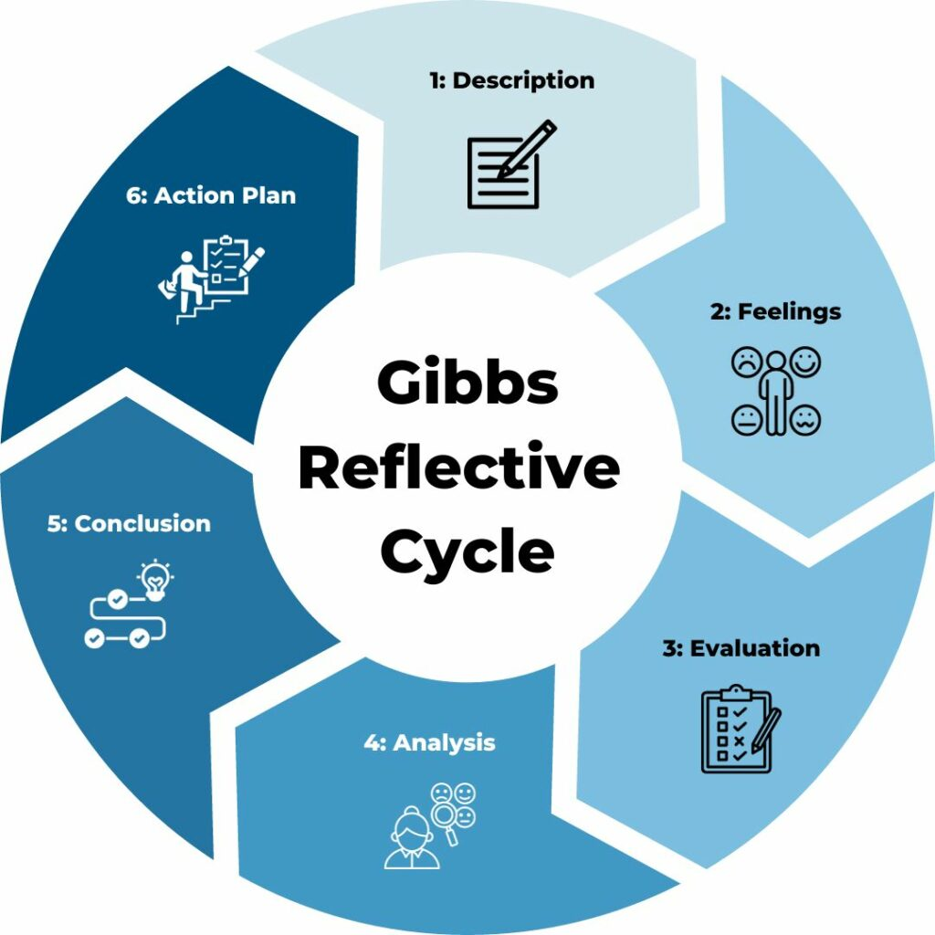
Fig 03: Gibbs’ Reflective Cycle
Source: (Channell, 2023)
During my first assessed coaching experience, I applied the GROW model to assist an individual in setting professional goals. Using the model, I guided the individual through the four stages. During the session, I led the individual through the GROW model, which consists of four phases: establishing clear goals, current situation assessment, exploring possible options, and creating a forward plan. By evaluating my coaching experience with Gibbs’ Reflective Cycle, I discovered multiple important takeaways.
Description: The coachee sought to improve their time management skills, which were impacting their productivity at work (Jarosz, 2021). I used the GROW model to address this challenge. First, identify the goal of improving time management and set specific objectives, including creating a structured daily schedule and applying task prioritisation techniques. Through the process, the coachee gained clarity on their priorities and learned strategies to better manage their time. Regular progress tracking helped them stay focused, ultimately enhancing productivity and efficiency at work.
Feelings: At first, I trusted my ability to use the GROW model because I knew its structured format well. The awareness of needing to conduct an effective session created pressure for me. The responsibility during the coaching session increased because I aimed to empower the coachee throughout the process (Stoetzel and Taylor-Marshall, 2022). Even though the model provided clear direction, I understood that successful coaching requires both goal setting and the development of an environment that builds trust and support, which enables the coachee to participate actively in reflection and planning tasks. Balancing a structured approach with emotional awareness became essential during coaching.
Evaluation: The session succeeded because we clearly defined the coachee’s goal. With the aid of the GROW model, we achieved a goal-oriented conversation focus. I faced difficulties in the Reality phase because the coachee found it hard to evaluate their time management practices truthfully. I had to ask deeper questions to assist them in reflecting on their behaviour and discovering areas for improvement.
Analysis: The GROW model offered a structured approach to goal-setting, but I discovered that coaching extends beyond goal development (Grant and O’Connor, 2022). The coaching process requires building trust and establishing a secure environment for genuine self-examination. During our session, I discovered that although the model led the coachee to find actionable steps, they still needed help with the deeper time management issues. The coachee displayed uncertainty about the fundamental reasons behind their difficulties, which suggested they needed additional assistance to examine these basic elements (Crosby et al., 2022). The coaching experience showed me that emotional awareness, together with active listening, creates a supportive environment where coachees can comfortably talk about personal barriers affecting their performance.
Conclusion: The GROW model works well for goal setting but requires a supportive environment where the coachee can openly discuss deep issues. I plan to use more open-ended questions and extend reflection periods before starting the Options and Way Forward stages.

Reflection on Practical 2 – Mentoring and Providing Feedback
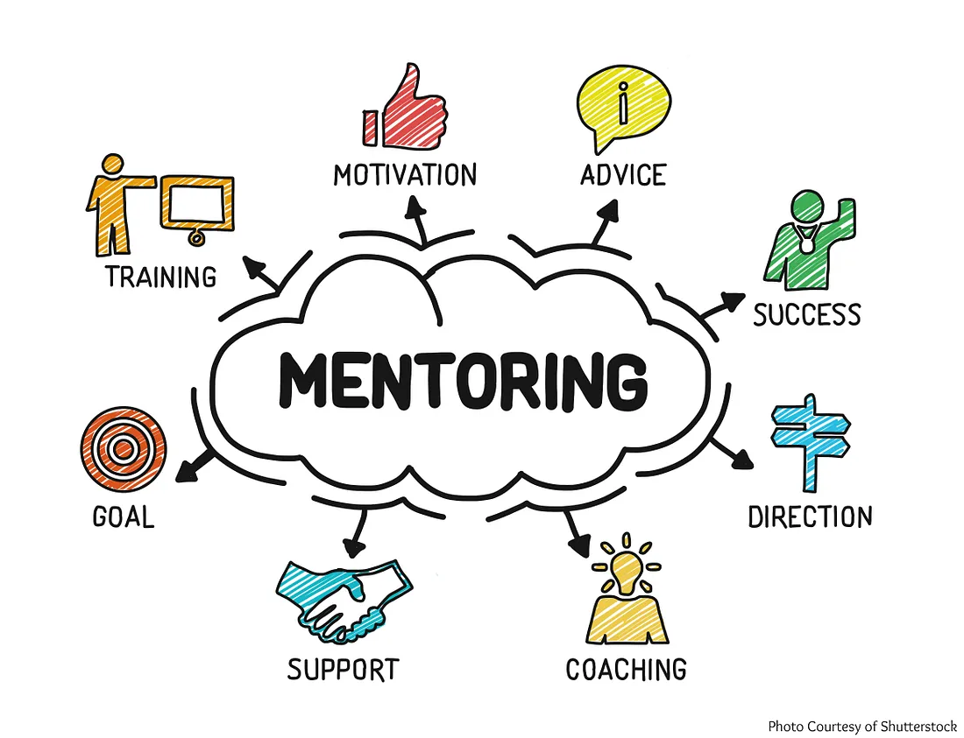
Fig 04: Mentoring
Source: (Thambawita, 2020)
During my second assessed experience I had to mentor someone and give feedback on their performance. I aimed to support the mentee in developing stronger communication abilities at work. By applying the Gibbs’ Reflective Cycle to this experience I discovered important learning points.
Description: The mentee asked for advice on how to better communicate with their team members (Sarabipour et al. 2021). During feedback sessions I pointed out moments where their communication would benefit from clarity and recommended active listening practice along with regular feedback requests. These strategies helped them build better connections with others.
Feelings: My sense of responsibility stayed strong because I understood that mentorship requires continuous support and guidance. I provided feedback that encouraged skill development and mentee support so they could improve abilities without damaging their confidence. Throughout the mentoring period I consistently monitored the influence of my language on their motivation levels and self-esteem (Birtch et al. 2023). To develop a positive mentoring dynamic I maintained an equilibrium between critical feedback and motivational support.
Evaluation: The mentoring session succeeded because the mentee embraced every piece of feedback provided. I struggled to discover the right combination of constructive feedback and positive reinforcement. I frequently questioned whether my direct feedback approach left recipients demotivated. To benefit the mentee the feedback should be understandable and actionable along with maintaining an encouraging tone. Feedback delivery becomes effective when the mentor understands mentee emotions and presents constructive critiques that support growth without undermining progress (Kiadarbandsari, 2023).
Analysis: My reflection showed me that mentoring demands both feedback delivery and emotional sensitivity toward the mentee. When I observed the mentee have difficulty accepting my feedback I decided to change my feedback method. I began to emphasise their strengths and positive communication traits to motivate them to enhance these existing skills. As a result of this strategy I created an environment that supported motivation and acceptance which led to improved feedback engagement (Rad et al. 2023). Through this experience I learned how crucial emotional intelligence is in guiding others because it made me more aware of the viewpoint of those I mentor.
Conclusion: My future feedback approach will be more balanced and empathetic because I will focus equally on both strengths and areas that need improvement. I will pay closer attention to how mentees react emotionally and modify my approach based on their responses.
Reflection 3
Using Gibbs' reflective cycle, I reflect on the two coaching scenarios presented. In the first scenario, a Christian female team leader faces resistance from Muslim employees due to cultural and religious differences. The challenge was clear: bridging these differences while maintaining authority and respect. The coaching approach, using the RAW model, emphasises understanding the issue (Realistic), taking actionable steps (Action-Oriented), and planning for long-term solutions (Way Forward). The leader must focus on open communication, mutual respect, and inclusivity, while actively listening and addressing concerns. It highlights the importance of balancing authority with empathy to foster teamwork. Similarly, in the second scenario, a manager transitions to handling both pizza and sweets product lines. The Johari Window model is used to understand the manager's strengths, weaknesses, and areas for growth. The manager’s lack of knowledge about sweets products and fear of mistakes are acknowledged in the Hidden area, while strengths in operations management are emphasised in the Open area. The mentor’s role is to guide the manager through active listening, constructive feedback, and time management strategies to prevent overwhelm and foster collaboration between teams. Both scenarios underscore the significance of coaching in developing leadership skills, self-awareness, and a supportive environment to overcome challenges. Reflecting on these coaching models reveals the critical need for patience, adaptability, and ongoing learning to navigate complex workplace situations effectively.

Conclusion
This report uses relevant theoretical frameworks and models to analyse my coaching and mentoring experiences. My analysis of workplace applications revealed these methods' differences and effectiveness. In my coaching session, I did not try to push the coachee to find a solution. Still, the feedback from our professor helped me identify my strengths and weaknesses, enhance self-awareness and encourage me to adopt a growth mindset and score a better percentage for the mentoring session. Because of the growth in my mentoring session, my professor congratulated me for a better understanding of my strengths and areas for improvement; I still had some constructive criticism, which will help me approach future challenges with greater confidence, increasing my chances for success. The GROW model helped us create specific goals but worked best when the coach and coachee developed mutual trust. Coaching includes goal-setting and teaching clients to reflect on themselves and understand their situation before solving problems.
Constructive feedback must be delivered thoughtfully in my mentoring practice because it needs to be balanced with positive reinforcement (Jean and Gading, 2024). Mentoring success hinges on the emotional dimension, which supports mentees in accepting feedback and developing their personal abilities. Through reflection, I learned that effective mentoring requires building a supportive relationship that promotes the mentee's personal and professional development rather than only sharing knowledge or giving advice. This experience demonstrated that a psychologically safe environment which makes mentees feel listened to and supported is crucial for their effective development. These practical experiences taught me how coaching and mentoring simultaneously enhance personal development and workplace performance outcomes. In my future work, I will implement these new understandings by using a comprehensive method of coaching and mentoring, which will include addressing both personal objectives and individuals' emotional and developmental needs. I aim to build a workplace environment that supports learning and growth by attending to measurable results and emotional experiences to improve performance. As I began applying the suggestions and seeing results, my confidence and motivation would have grown. This improvement cycle would have made you more proactive in seeking challenges and opportunities for growth.

Reference
Birtch, T.A., Cai, Z. and Flora (2023). Effects of formal mentoring support on newcomer–protégé affective organisational commitment: a self‐concept‐based perspective. Human Resource Management, 63(2). doi:https://doi.org/10.1002/hrm.22198.
Carden, J., Passmore, J. and Jones, R.J. (2022). Exploring the role of self‐awareness in coach development: A grounded theory study. International Journal of Training and Development, [online] 26(2). doi:https://doi.org/10.1111/ijtd.12261.
Chakravorty, M. (2023). How the GROW Model Empowers Leaders: Achieving Business Success with Beyond Red Ocean Consulting. [online] www.linkedin.com. Available at: https://www.linkedin.com/pulse/how-grow-model-empowers-leaders-achieving-business-red-chakravorty/.
Channell, M. (2023). Gibbs Reflective Cycle – How to Learn from Experience and Become a Better Leader. [online] TSW Training. Available at: https://www.tsw.co.uk/blog/leadership-and-management/gibbs-reflective-cycle/.
Coach Foundation (2023). Co-Active Coaching Model. [online] coachfoundation.com. Available at: https://coachfoundation.com/blog/co-active-coaching-model/.
Coetzee, M.E., Veldsman, T. and Odendaal, A. (2023). Problematising current coaching strategies from a worldview perspective. SA Journal of Industrial Psychology, 49. doi:https://doi.org/10.4102/sajip.v49i0.2034.
Corsby, C.L.T., Jones, R. and Lane, A. (2022). Contending with vulnerability and uncertainty: what coaches say about coaching. Sports Coaching Review, pp.1–20. doi:https://doi.org/10.1080/21640629.2022.2057697.
De and Doyle, L. (2021). The mentoring relation as an interpersonal process in EDUCATE: A qualitative case study of mentor-mentee perspectives - UCL Discovery. Ucl.ac.uk. [online] doi:https://discovery.ucl.ac.uk/id/eprint/10123579/1/rfa05010004.pdf.
Eletive (2023). The GROW Coaching model: a Complete Guide. [online] Eletive. Available at: https://eletive.com/blog/the-grow-coaching-model-a-complete-guide/.
Goldsby, M.G., Goldsby, E.A., Neck, C.B., Neck, C.P. and Mathews, R. (2021). Self-Leadership: A Four Decade Review of the Literature and Trainings. Administrative Sciences, [online] 11(1), p.25. doi:https://doi.org/10.3390/admsci11010025.
Grant, A.M. and O’Connor, S. (2022). Goals in Coaching Practice. International Handbook of Evidence-Based Coaching, pp.391–406. doi:https://doi.org/10.1007/978-3-030-81938-5_32.
Jarosz, J. (2021). The impact of coaching on well-being and performance of managers and their teams during pandemic. International Journal of Evidence Based Coaching & Mentoring, [online] 19(1), pp.4–27. doi:https://doi.org/10.24384/n5ht-2722.
Jarosz., J. (2021). Psychoeducational Role of Coaching in developing Emotional Intelligence and Well-Being. [online] opus.us.edu.pl. Available at: https://opus.us.edu.pl/info/phd/USL2def8e8b66694ab6898982245af938b4/?ps=20&lang=pl&pn=1&cid=123943.
Jean, S. and Gading, L. (2024). Instructional Leadership Practices of the School Heads to Improve Teachers Performance. [online] Available at: https://uijrt.com/articles/v5/i6/UIJRTV5I60006.pdf.
Khan, N. (2020). Coaching vs Mentoring – and why it matters? [online] www.linkedin.com. Available at: https://www.linkedin.com/pulse/coaching-vs-mentoring-why-matters-nadeem-khan/.
Kiadarbandsari, A. (2023). Mentors’ Supporting Approaches of Mentees’ Cognitive Emotion Regulation Strategies. Journal of Adolescent Research, p.074355842311635. doi:https://doi.org/10.1177/07435584231163568.
KORNIIENKO, I. and BARCHI, B. (2023). THE CONCEPT OF THE SOFT SKILLS AND EMOTIONAL INTELLIGENCE DEVELOPMENT. Psychology Travelogs, (1), pp.16–26. doi:https://doi.org/10.31891/pt-2023-1-2.
Kumari, K., Ali, S.B., Batool, M., Cioca, L.-I. and Abbas, J. (2022). The interplay between leaders’ personality traits and mentoring quality and their impact on mentees’ job satisfaction and job performance. Frontiers in Psychology, 13. doi:https://doi.org/10.3389/fpsyg.2022.937470.
Plotkina, L. and Ramalu, S.S. (2024). Determinants and trends of executive coaching effectiveness in post-pandemic era: A critical systematic literature review analysis. Management review quarterly. doi:https://doi.org/10.1007/s11301-024-00428-x.
Rad, H.S., Alipour, R. and Jafarpour, A. (2023). Using artificial intelligence to foster students’ writing feedback literacy, engagement, and outcome: a case of Wordtune application. Interactive Learning Environments, pp.1–21. doi:https://doi.org/10.1080/10494820.2023.2208170.
Rahman, M.A. (2023). Professional Development in an Institution through the GROW Model. Assyfa Learning Journal, 1(2), pp.112–121. doi:https://doi.org/10.61650/alj.v1i2.187.
Ribeiro, N., Nguyen, T., Duarte, A.P., Torres de Oliveira, R. and Faustino, C. (2020). How managerial coaching promotes employees’ affective commitment and individual performance. International Journal of Productivity and Performance Management, 70(8), pp.2163–2181. doi:https://doi.org/10.1108/ijppm-10-2018-0373.
Richardson, D., Landreville, J.M., Trier, J., Cheung, W.J., Farhan Bhanji, Hall, A.K., Frank, J.R. and Oswald, A. (2024). Coaching in Competence by Design: A New Model of Coaching in the Moment and Coaching Over Time to Support Large Scale Implementation. Perspectives on medical education, 13(1), pp.33–43. doi:https://doi.org/10.5334/pme.959.
Sarabipour, S., Hainer, S.J., Arslan, F.N., de Winde, C.M., Furlong, E., Bielczyk, N., Jadavji, N.M., Shah, A.P. and Davla, S. (2021). Building and sustaining mentor interactions as a mentee. The FEBS Journal, [online] 289(6), pp.1374–1384. doi:https://doi.org/10.1111/febs.15823.
Stelter, R.L., Kupersmidt, J.B. and Stump, K.N. (2020). Establishing effective STEM mentoring relationships through mentor training. Annals of the New York Academy of Sciences, 1483(1). doi:https://doi.org/10.1111/nyas.14470.
Stoetzel, L. and Taylor-Marshall, S. (2022). Coaching for change: redefining the concept of change within a practice-based coaching model. International Journal of Mentoring and Coaching in Education, 11(4). doi:https://doi.org/10.1108/ijmce-12-2021-0111.
Thambawita, D. (2020). A simple guide to mentoring. [online] Medium. Available at: https://medium.com/@dilshan.t/a-simple-guide-to-mentoring-f761031b6194.
Threadgould, M.V. (2023). What Is the GROW Coaching Model? [online] Lattice.com. Available at: https://lattice.com/articles/everything-you-need-to-know-about-the-grow-coaching-model.

