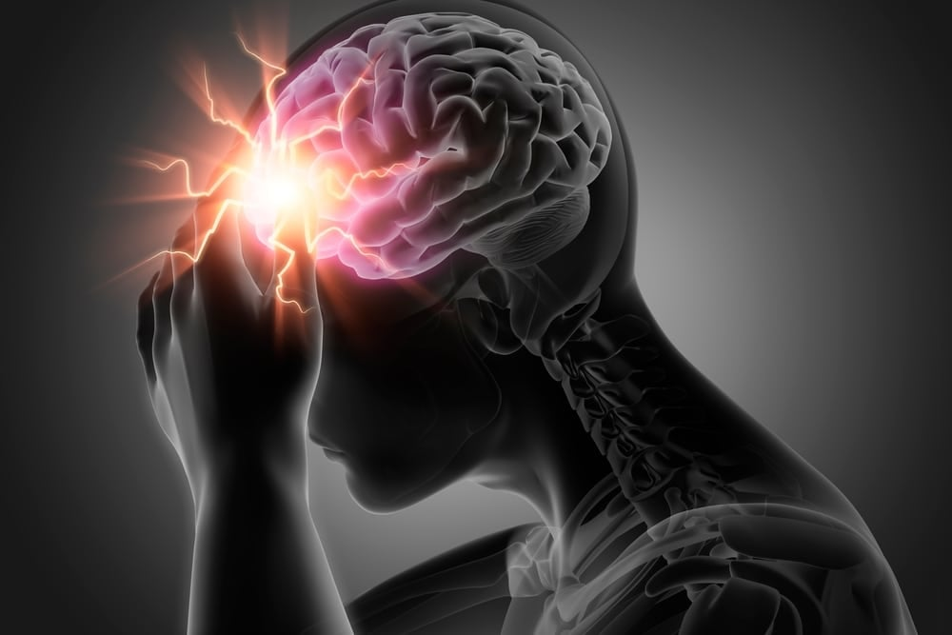
Module Code:
LCHS 4008
Lecturer Name: Farah Islam
Assessment 2 -Report on a Health Issue
Introduction to Public Health
Hira Shahnaz
Student no. 2504719
Contents
Introduction 2
Definition of Stroke 2
Signs and Symptoms of Stroke 3
Incidence and Statistics of Stroke 4
Measuring and Monitoring Stroke 4
Control and Prevention of Stroke 5
Consequences of Stroke for Communities 6
Health and Social Care Support Services 6
Conclusion 7
Refrence List 8

Stroke as a Public Health Issue

Introduction
Public health focuses on improving the health and wellbeing of populations by preventing disease, prolonging life, and promoting healthy lifestyles (WHO, 2023). The concept of public health involves understanding diseases that affect communities and identifying strategies to prevent and control them. According to the World Health Organization, health is defined as a state of complete physical, mental, and social wellbeing rather than simply the absence of disease (WHO, 1948).
One major public health issue worldwide is stroke. Stroke occurs when the blood supply to part of the brain is interrupted or reduced, preventing brain tissue from receiving oxygen and nutrients. This can lead to brain damage, disability, or death if not treated quickly (NHS, 2024). Stroke is a leading cause of death and long-term disability globally, making it an important concern for public health professionals.
This report will define stroke, explain its signs and symptoms, and examine statistics that demonstrate its impact worldwide and in the UK. It will also discuss how stroke is measured, monitored, and controlled, the consequences for communities, and the health and social care support services required for individuals affected by this condition.

Definition of Stroke
Stroke is a medical condition that occurs when the blood supply to the brain is interrupted or reduced, which prevents brain cells from receiving oxygen and nutrients. Within minutes, brain cells begin to die, which can cause permanent damage to the brain (Johnson et al., 2021).
There are two main types of strokes. The first type is ischaemic stroke, which occurs when a blood clot blocks or narrows an artery leading to the brain. The second type is haemorrhagic stroke, which occurs when a blood vessel in the brain bursts and causes bleeding in the brain (NHS, 2024).
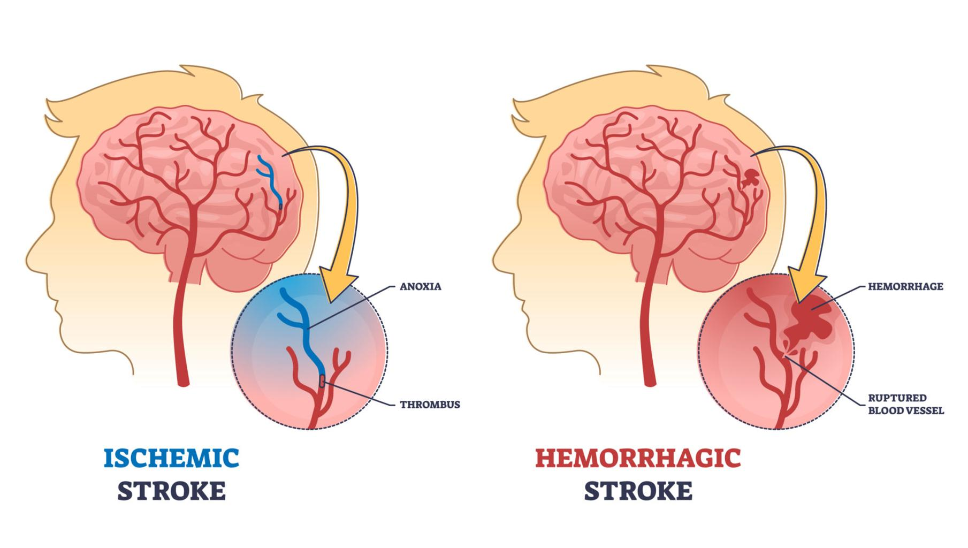
Figure 1:Types of stroke showing ischaemic and haemorrhagic stroke (Sunkara, 2024).
Stroke is strongly linked with several risk factors such as high blood pressure, smoking, obesity, poor diet, lack of physical activity, and excessive alcohol consumption (Feigin et al., 2022).
Table 1:Major risk factors associated with stroke (Feigin et al., 2022).
Risk Factor | How it increases stroke risk
High blood pressure | Damages blood vessels and increase risk of clots
Smoking | Reduces oxygen in blood and damages arteries
Obesity | Linked with high cholesterol and diabetes
Physical inactivity | Increases cardiovascular disease risk

These risk factors are closely connected with the wider determinants of health, such as lifestyle, environment, and access to healthcare services.
Public health research shows that many diseases are influenced by determinants such as genetics, behaviour, social environment, and healthcare services. These determinants can increase or decrease the risk of illness in individuals and communities.
Understanding these determinants is important for preventing diseases like stroke and improving health outcomes.

Signs and Symptoms of Stroke
The signs and symptoms of stroke usually appear suddenly and require urgent medical attention. One of the most common ways to recognise stroke symptoms is through the FAST test, which stands for Face, Arms, Speech, and Time (NHS, 2024).
The main symptoms include:
- Sudden weakness or numbness on one side of the body
- Difficulty speaking or understanding speech
- Drooping of one side of the face
- Sudden confusion or dizziness
- Severe headache
- Loss of balance or coordination
Some individuals may also experience vision problems, difficulty swallowing, or memory problems. The severity of symptoms depends on the area of the brain affected and the amount of damage caused.
Stroke can lead to long-term complications such as paralysis, speech difficulties, cognitive impairment, and emotional problems. Early recognition and treatment are therefore essential to reduce the risk of severe disability or death.

Incidence and Statistics of Stroke
Stroke is one of the most common causes of death and disability worldwide. According to the World Health Organization, around 12 million people experience a stroke each year globally, and approximately 6.5 million people die from stroke annually (WHO, 2023).
In the United Kingdom, stroke is also a significant public health issue. The Stroke Association reports that more than 100,000 people experience a stroke each year in the UK, which means one stroke occurs approximately every five minutes (Stroke Association, 2024).
Stroke is also a major cause of disability in the UK. Many survivors experience long-term health problems that affect their daily activities and quality of life. These conditions may require ongoing treatment, rehabilitation, and support from health and social care services.
Epidemiology is an important field in public health that helps researchers understand the distribution and causes of diseases within populations. Epidemiology involves collecting and analysing data about health conditions to identify patterns and risk factors (Naidoo and Wills, 2016).
Through epidemiological studies, public health professionals can identify groups that are at higher risk of stroke and develop strategies to reduce the incidence of the disease.

Measuring and Monitoring Stroke
Public health professionals use several methods to measure and monitor diseases like stroke. These methods help governments and healthcare organisations understand how common the disease is and how it affects populations.
Two important measures used in public health are mortality and morbidity. Mortality refers to the number of deaths caused by a disease, while morbidity refers to the number of people living with the disease or experiencing illness (Naidoo and Wills, 2009).
Another important way to measure disease is through incidence and prevalence. Incidence refers to the number of new cases of a disease within a specific time period, while prevalence refers to the total number of people living with the disease in a population (Friis and Sellers, 2021).
Public health surveillance systems also play a major role in monitoring diseases. Surveillance involves collecting, analysing, and interpreting health data in order to detect patterns and trends in diseases (WHO, 2022).
In the UK, organisations such as the NHS, Office for National Statistics (ONS), and Public Health England collect and analyse health data related to stroke. These organisations monitor hospital admissions, mortality rates, and other health indicators to identify changes in disease patterns.
Monitoring disease trends allows governments to develop public health policies and prevention strategies to reduce the burden of stroke.

Control and Prevention of Stroke
Preventing and controlling stroke is a key priority for public health systems. Many strokes can be prevented by addressing lifestyle risk factors and promoting healthier behaviours.
One of the most important prevention strategies is health promotion, which involves educating individuals and communities about healthy lifestyles. Health promotion campaigns encourage people to stop smoking, maintain a healthy weight, eat a balanced diet, and engage in regular physical activity (WHO, 2023).
Another important approach is early detection and treatment. Regular health checks can help identify risk factors such as high blood pressure, diabetes, and high cholesterol. Treating these conditions can significantly reduce the risk of stroke.
Public health policies also play a role in preventing stroke. Governments may introduce policies aimed at reducing smoking, improving food quality, and encouraging physical activity in communities (Feigin et al., 2021).
Additionally, medical treatments such as medication to control blood pressure or blood thinning drugs can help prevent strokes in individuals at high risk. These prevention strategies demonstrate how public health approaches can reduce the incidence of disease in communities.

Consequences of Stroke for Communities
Stroke has serious consequences for individuals, families, and communities. For individuals, stroke can cause physical disabilities such as paralysis, speech difficulties, and problems with mobility. Many stroke survivors require long-term rehabilitation and support to regain independence.
Stroke can also have psychological effects. Survivors may experience depression, anxiety, or emotional changes due to the impact of the illness on their lives (Johnson et al., 2021).
For families, stroke can create emotional and financial stress. Family members often become caregivers for stroke survivors, which may affect their employment, finances, and wellbeing.
At a community level, stroke places significant pressure on health and social care services. Hospitals, rehabilitation centres, and community health services must provide treatment, therapy, and long-term support for individuals affected by stroke (Benjamin et al., 2021).
Public health professionals must therefore develop strategies that reduce the risk of stroke and support individuals living with the condition.

Health and Social Care Support Services
Individuals affected by stroke often require a wide range of health and social care services. These services help patients recover and improve their quality of life.
In the UK, the National Health Service (NHS) provides emergency treatment, hospital care, and rehabilitation services for stroke patients. Rehabilitation may involve physiotherapy, occupational therapy, and speech therapy to help individuals regain physical and communication abilities (NHS, 2024).
Community-based services also play an important role in supporting stroke survivors. These services may include home care support, social care services, and community rehabilitation programmes.
Charitable organisations such as the Stroke Association provide additional support through information, counselling, and support groups for stroke survivors and their families.
These services are essential for helping individuals recover from stroke and reintegrate into their communities.

Conclusion
Stroke is a serious public health issue that affects millions of people worldwide. It occurs when the blood supply to the brain is interrupted, which can lead to brain damage, disability, or death. Stroke has many risk factors, including high blood pressure, smoking, obesity, and unhealthy lifestyles.
Public health approaches are essential for understanding and managing stroke. Epidemiology helps health professionals measure and monitor the disease through methods such as incidence, prevalence, morbidity, and mortality. These methods provide valuable information that helps governments and healthcare organisations develop prevention strategies.
Preventing stroke requires a combination of health promotion, early detection, and public health policies aimed at reducing risk factors. In addition, health and social care services are necessary to support individuals affected by stroke and help them recover.
Overall, addressing stroke through public health strategies is essential for improving health outcomes and reducing the burden of disease in communities.

Refrence List
Benjamin, E.J., Muntner, P., Alonso, A., Bittencourt, M.S., Callaway, C.W., Carson, A.P., Chamberlain, A.M., Chang, A.R., Cheng, S., Das, S.R. and Delling, F.N. (2021) ‘Heart disease and stroke statistics—2021 update: a report from the American Heart Association’, Circulation, 143(8), pp. e254–e743. Available at: https://doi.org/10.1161/CIR.0000000000000950.
Feigin, V.L., Brainin, M., Norrving, B., Martins, S., Sacco, R.L., Hacke, W., Fisher, M., Pandian, J. and Lindsay, P. (2021) ‘World Stroke Organization (WSO): global stroke fact sheet 2021’, International Journal of Stroke, 16(8), pp. 929–938. Available at: https://doi.org/10.1177/17474930211065917.
Feigin, V.L., Brainin, M., Norrving, B., Martins, S., Sacco, R.L., Hacke, W., Fisher, M., Pandian, J. and Lindsay, P. (2022) ‘Global, regional, and national burden of stroke and its risk factors, 1990–2019: A systematic analysis for the Global Burden of Disease Study 2019’, The Lancet Neurology, 21(10), pp. 795–820. Available at: https://www.thelancet.com/article/S1474-4422(21)00252-0/fulltext (Accessed: 18 March 2026).
Friis, R.H. and Sellers, T.A. (2021) Epidemiology for Public Health Practice. 6th edn. Burlington, MA: Jones & Bartlett Learning. Available at: https://books.google.co.uk/books/about/Epidemiology_for_Public_Health_Practice.html?id=ci_XDwAAQBAJ (Accessed: 16 March 2026).
Johnson, W., Onuma, O., Owolabi, M. and Sachdev, S. (2016) ‘Stroke: a global response is needed’, Bulletin of the World Health Organization, 94(9), pp. 634–634A. Available at: https://pmc.ncbi.nlm.nih.gov/articles/PMC5034645/ (Accessed: 15 March 2026).
Naidoo, J. and Wills, J. (2016) Foundations for Health Promotion. 4th edn. London: Elsevier. Available at: https://books.google.com/books/about/Foundations_for_Health_Promotion_E_Book.html?id=OkHdCwAAQBAJ (Accessed: 19 March 2026).
NHS (2024) Stroke. Available at: https://www.nhs.uk/conditions/stroke/ (Accessed: 17 March 2026).
Stroke Association (2024) Stroke statistics. Available at: https://www.stroke.org.uk/stroke/statistics (Accessed: 20 March 2026).
Sunkara, R. (2024) Types of brain strokes: Ischemic vs hemorrhagic strokes explained. Available at: https://drraveesh.com/blogs/types-of-brain-strokes-ischemic-vs-hemorrhagic-strokes-explained/ (Accessed: 16 March 2026).
World Health Organization (2023) Stroke. Available at: https://www.who.int/news-room/fact-sheets/detail/stroke (Accessed: 18 March 2026).

