

Critically Evaluate the Public’s Perception on the Age of Criminal Responsibility and how the media can influence this.

The murder of James Bulger in 1993 shocked the United Kingdom and changed the approach to children and young people who offend. The juxtaposition of the public’s attitude and treatment to the offenders within the James Bulger case and the Siji Redergard case provides the incentive for this research. The case’s portrayed contrasting coverage within media reports and an opposing governmental approach which resulted in the abolishment of the doli incapax within the United Kingdom. Therefore, this research aims to evaluate current public perception of children and young people who offend and how the media influences this perception. This research is extremely valuable to promote a better understanding of children and young people who offend, and the implications imposed by criminalising children at such a young age. The United Kingdom’s government remains resistant against the recommendations made by the United Nations Convention on the Rights of the Child to raise the age of criminal responsibility within England and Wales. This research proposes that the age of criminal responsibility needs to be reformed to prioritise vulnerable children and young people from the harmful effects of criminalisation.

Jacey Punter

Programme of Criminology and Policing

University of Wales Trinity Saint David

Supervisor: Laura Knight

May 2023
Declarations

This work has not previously been accepted in substance for any degree and is not being concurrently submitted in candidature for any degree.
STATEMENT 1
This dissertation is being submitted in partial fulfilment of the requirements for the degree of BA/BSc.
STATEMENT 2
This dissertation is the result of my own independent work/investigation, except where otherwise stated.
Other sources are acknowledged in the Reference Section.
STATEMENT 3
I hereby give consent for my dissertation, if accepted, to be available for photocopying and for interlibrary loan, and for the title and summary to be made available to outside organisations.
STATEMENT 4
I hereby give consent for my dissertation, if accepted, to be available on the university’s IT system to those who have consent to use the system.

Jacey Punter

Signed: Jacey Leigh Punter

Date: 01/05/2023

Acknowledgements

As a thank you to those who have supported and endlessly encouraged the success in completing this dissertation. I would like to voice my gratitude to my supervisor and lecturer Laura Knight for her constant support and invaluable guidance throughout the entire process of composing this dissertation. I would also like to thank the lecturers whom I have had the pleasure of being their student on the Criminology and Policing course who have each contributed to my accomplishments throughout my academic journey.

I would also like to thank my family for their unlimited support, patience and eagerness to see me succeed. I would like to thank particularly my nan, grandad and my partner for their continued support, their indispensable advice, the heartening phone calls and endless cups of comfort tea. Without my family’s helpful and devoted encouragement, I would not be where I am today.

I would also like to thank my fellow peers at UWTSD who have played a vital part in the success of this research project, offering each other empathy, additional perspectives and beneficial discussions that have aided me for the duration of my university experience.

Contents

Abbreviations....................................................................................................Page 5

Chapter One - Introduction…………………………………………………..........Page 6
  - Background................................................................................................Page 6
  - Aims...........................................................................................................Page 8
  - Objectives..................................................................................................Page 8

Chapter Two – Literature Review.....................................................................Page 9
2.1 Explore current literature to identify arguments for and
against raising the age of criminal responsibility..........................................Page 9
2.2 Consider the portrayal of young people who offend in the
media and how does this influence public perception.................................Page 16

Chapter Three – Methodology........................................................................Page 20
3.1 Research Onion.........................................................................................Page 20
3.2 Research Philosophy.................................................................................Page 21
3.3 Research Approach...................................................................................Page 21
3.4 Methodological Choice...............................................................................Page 22
3.5 Research Strategy.....................................................................................Page 22
3.6 Time Horizon..............................................................................................Page 23
3.7 Techniques for Data Collection, Processes and Analysis.........................Page 24
3.7.1 Sampling.................................................................................................Page 24
3.7.2 Reliability and Validity.............................................................................Page 25
3.7.3 Limitations...............................................................................................Page 25

Chapter Four – Findings.................................................................................Page 27
4.1 Evaluate public perceptions on the ACR in England and Wales.................Page 27
4.2 Introduction................................................................................................Page 27
4.3 Findings: Description of analysis and results............................................Page 27

Conclusions....................................................................................................Page 40
5.1 Research Objective 1: Explore the current literature
to identify arguments for and against raising the ACR
within England and Wales..........................................................................Page 40
5.2 Research Objective 2: Consider the portrayal of young
people in the media and how does this influence public
perception...................................................................................................Page 41
5.3 Research Objective 3: Evaluate public perceptions on
the ACR in England and Wales...................................................................Page 42
5.4 Recommendations......................................................................................Page 43

References......................................................................................................Page 45

Appendices.....................................................................................................Page 56

Abbreviations

ACEs – Adverse Childhood Experiences

ACR – Age of Criminal Responsibility

CJS – Criminal justice system

DI – Doli Incapax

UNCRC – United Nations Convention on the Rights of the Child

UK – United Kingdom

YJS – Youth Justice System

Chapter One – Introduction

  - Background
The Children and Young Persons Act (1963) amended the age of criminal responsibility (ACR) from eight to ten and included a legal presumption of doli incapax (DI) up until 1998. According to Goldson (2013) the DI gave some shielding for child offenders aged ten to fourteen, due to the presumption that children of this age were unable to differentiate between right and legally wrong. According to Gibbon (2016) in 1998 the UK Government established that to tackle youth crime the correct tactic was to abolish the DI. The purpose of abolishing the legal presumption was to promote awareness amongst the public in England and Wales that children would be held accountable for their actions. In addition to the abolishment of the DI in 1998, the murder of James bulger in 1993 greatly impacted the perception of the child offender. The James Bulger case gained national coverage and uproar due to the deliberate and violent nature of the crime committed by two ten-year-old boys, which criminologist Phil Scaton describes as a defining moment in youth justice history (Torney, 2011).

The discussion surrounding the ACR is still relevant within today’s society, with the ACR currently being ten years old within England and Wales, which is one of the youngest in Europe (Queens University Belfast Research Portal, 2022). This is despite the United Nations Convention on the Rights of the Child (UNCRC) announcing in 2007 that any ACR below twelve is unacceptable, and specifically encouraged the United Kingdom (UK) to increase the age (Equality and Human Rights Commission, 2015). Both England and Scotland responded very differently to the UNCRC. According to the Cabinet Secretary for Justice Veterans (2022) as of December 2021, The Age of Criminal Responsibility (Scotland) Act 2019 changed the minimum ACR so that children under twelve could no longer be criminalised. However, the UK Government rejected the statement and claimed that ten-year-old children are able to distinguish mischief from severe delinquency (Brown and Charles, 2019). With varying legislation, a child living in Carlisle in the North of England and a child living in Gretna Green in the South of Scotland may commit the same crime at the age of 10 but will be treated very differently. This inequality in treatment of children is the incentive for this study to be conducted. There have been many attempts to raise the ACR within England and Wales, the most recent being a private members bill which had its first reading in the House of Lords in February 2020 (Age of Criminal Responsibility Bill, 2020).

The media’s involvement in the coverage of the James Bulger murder created and spread outrage through the entirety of the United Kingdom, demanding vengeance. The reaction from the media was unparalleled with the reports representing a punitive and ruthless tone throughout various newspaper articles. With Berry et al (2012) describing the experience as an outbreak of moral denunciation. The media had not only added fuel to the public’s shock and hatred for the offenders but also highlighted wider societal anxieties surrounding frustrations with the education system and a lack of control on issues such as youth crime (Smith and Sueda, 2008). The media intensified the public’s perception on the case which subsequently impacted the decisions made by the criminal justice system. For example, King (1995) states that the judge assigned to the trial of the James Bulger murder suggested the offenders would not be released until a minimum eight years were served, the Home Secretary then attempted to change this decision to fifteen years in response to a public petition that the offenders should serve life in prison.

There are many discrepancies that arise from the low ACR, therefore the aim of this study is to:

1.2 Aims
Critically evaluate the public’s perception on the age of criminal responsibility and how the media can influence this.

  - Objectives
- Explore the current literature to identify arguments for and against raising the ACR in England and Wales.
- Consider the portrayal of young people who offend in the media and how does this influence public perception.
- Evaluate public perception on the ACR in England and Wales and propose recommendations for change.

Chapter Two – Literature Review

2.1 “Explore current literature to identify arguments for and against raising the age of criminal responsibility in England and Wales”

With the ACR in England and Wales remaining at ten years old, children below this age cannot be held criminally liable for their actions (Houses of Parliament, 2018). Although children under the age of 10 cannot be charged, they can be issued a local child curfew, a child safety order, put into care or the parents will be held accountable (UK Government, 2022). According to Walsh (1999) the local child curfew prohibits children from entering specific places between the hours of 9pm – 6am. A child safety order according to the Crime and Disorder Act (1998) is provided when a child, had they been ten or over, would have been charged with an offence. The Crime and Disorder Act (1998) also includes that the child will work closely with a social worker and a member of the youth offending team to prevent future delinquency. Children aged 10-17 can be issued with a referral order, a youth rehabilitation order or a detention and training order (Crown Prosecution Service, 2020). According to the Ministry of Justice (2018) a referral order is a community sentence for children who have committed their first offence and involves a restorative justice contract which must be followed. A youth rehabilitation order is aimed for children who have committed multiple offences or have committed an offence during their referral order. The Home Office (2022) states that the youth board can choose from 18 requirements for the child, such as unpaid work, educational courses and further curfews. A detention and training order according to the Youth Justice Board (2008) is a custodial sentence which can last up to two years for high-risk child offenders.

The House of Commons Justice Committee (2020) issued a detailed report with recommendations and guidance regarding children entering the criminal justice system, with a key concern raised in relation to the current ACR and gave suggestions that a review is necessary. A response document was published by the House of Commons Justice Committee (2021) and gave justifications for why the ACR will not be raised in the near future. The first justification by the House of Commons Justice Committee (2021) stated that children are able to know the difference between careless behaviour and serious illegal activity. However, this justification has been proven to demonstrate conflicting evidence. Arain et al (2013) states that during puberty and adolescent years the brain is underdeveloped and is constantly changing, growing and goes through the process of brain maturation from ten to twenty-four years old. Arain et al (2017) explains that during this process, the intensity of sex hormones such as testosterone, oestrogen and progesterone can highly influence children’s self-control, logical risk assessment, emotions, and their ability to make decisions. Therefore, this evidence shows that children are more likely to make illogical impulsive choices and cannot make rational and intentional judgements. Furthermore, the Sentencing Advisory Council (2012) provides evidence that children are not capable of making coherent choices, stating that the final area of the brain to develop is the frontal lobe. The frontal lobe is responsible for arrangements, reasoning and forethought. The Sentencing Advisory Council (2012) argues that, due to this part of the brain being underdeveloped at ten and the combined intensity of hormones, children and teenagers have an appeal for thrill seeking, risky behaviour and are unlikely to control these urges as they do not consider the weight of the consequences to their actions.

The House of Commons Justice Committee (2021) also justifies the ACR by arguing that the age warrants for earlier intervention to prevent further offending. Crofts (2022) demonstrates one supporting argument in which the criminal justice system (CJS) examines and carefully considers a child’s age, the context and the crime itself, which may adjust what sentence they might receive. According to the Sentencing Council (2017) when considering the sentence for a child, there are six central components to examine. The first component is to consider the wellbeing of the child, the second component is to honour the fundamental objective of the CJS, which is to prevent recidivism by children and young people. The third component is the age of the child, and the fourth component is the severity of the offence. The fifth component is the likelihood of reoffending and finally the sixth component is the degree of harm that is likely to arise from further offending. With each case carefully examined and personalised to the young offender’s circumstances, custodial sentences are only issued as a last resort due to the seriousness of the offence (Local Government Association, 2018). Youth offending teams and other collaborating agencies are able to assist young offenders through the community sentencing and reduce the likelihood of reoffending. According to the Justice Analytical Services Scottish Government (2015) a various quantity of academic research has been conducted which found that constructive and well-funded community sentences are more effective than short prison sentences. However, the positive impact of community sentencing is only successful if the resources and the amenities are readily available.

Children that enter the CJS are those who have a multitude of complex needs and often need to be treated with customised services. 70% of children assessed under the supervision of a Youth Offending team had at least five of the nineteen concerns (Youth Justice Board, 2020). The Youth Justice Board (2020) explains that a concern type is what a specialist perceives to be influencing the child negatively, such as the safety and mental health of the child, a child’s drug and alcohol dependency and the child’s language and communication skills. Many children within the youth justice system (YJS) have also experienced adverse childhood experiences (ACEs). According to Gray et al (2021) ACEs, are traumatic incidences that occur during childhood such as witnessing domestic violence, emotional abuse and parental substance misuse. Gray et al (2021) also conducted a study which involved the assessment of 200 children and young people within the YJS and found that 66% had five or more ACEs. The Ministry of Justice (2016) also reports that children who offend are often victims of crime themselves, are involved within the care system and are familiar with social services. These children often have inadequate school attendance and have difficulties with learning and social skills. The process and contact with the CJS can be overwhelming and damaging to children that have complicated and elaborate difficulties. For example, the House of Commons Library (2022) states that incidents of children self-harming are beginning to rise with an average of 121 incidents per month. The Youth Justice Board (2022) also reports an inappropriate 40% of all children in custody are waiting to be sentenced with 74% of these children not receiving a custodial sentence. According to the Howard League for Penal Reform (2021) children who were waiting to be sentenced during the pandemic consequently faced unnecessary extension, due to the delay caused by COVID-19 and often spent over 22 hours in their cell for months. The charity organisation Just for Kids Law (2022) has also launched a report to end the overnight detention of children and young people, with an estimated 244 children under the age of 12 held in custody overnight in the year ending 2019. Thus, children who are waiting to be sentenced may not receive a formal custodial sentence but, still have a similar experience of a short prison sentence. This includes the negative effects that custodial sentences can have on children. For example, high levels of bullying, isolation and racial discrimination. Young offenders expressed that they were treated the same as children who did receive a custodial sentence and felt as though they were receiving a double punishment (Howard League for Penal Reform, 2022). Therefore, while the House of Commons Justice Committee (2021) argues that the low ACR has positive implications for early intervention, existing research suggests that the ACR has noticeably negative effects for these children, creating negative associations with the police and the CJS.

In contrast with The House of Commons Justice Committee’s (2021) argument stating the age grants for earlier intervention, by raising the ACR, there are still procedural strategies that can occur without criminalising children. Day (2021) suggests the use of early intervention within the community, before children are introduced to the CJS of any level to prevent the further criminalisation. As mentioned previously, children are known to social agencies such as social services and are often victims of crime before they offend themselves. Lennox and Khan (2012) suggest that the use of early child development and school preparedness checks will allow practitioners to view the very initial signs of a child’s poor mental health, any behavioural difficulties or allow families to access beneficial parenting courses at the earliest possible moment. Case and Haines (2020) also made recommendations to propose child-centred informed response to children committing crime. For example, removing the defining label of being an offender and promoting positive attitudes through child-focused, evidence-based strategies, such as the Welsh Bureau model which was introduced in Swansea in 2008 (Case and Haines, 2020). The labelling and othering of children that commit crime as “youth offenders” has resulted in destructive negative connotations with extreme violence leading to punitive, controlling and discriminatory behaviours that can have lasting effects to a child’s likelihood of reoffending and their mental health (Case and Haines, 2015). In contrast, The Welsh Bureau model aims to resolve the root cause of a child’s offending, to redirect children from formal sanctions of the CJS and to treat children who commit crime as children first (Case and Haines, 2020). Drakeford (2010) advises a review as the YJS has proven to be ineffective, with 80% of 10 to 14-year old’s reoffending within 12 months.

Taking into consideration all arguments for and against raising the ACR, the central perspective is that children are duplicates of adults who are more than capable of understanding the consequences of committing crime (Haines et al, 2020). The contrasting perspective is that children are unable to fully comprehend repercussions of committing crime. Frank (2006) conducted 41 focus groups; with 30 out of the 41 groups noting that when a child had been arrested for an offence, they had often committed the offence with an adult counterpart. This may illustrate a form of manipulation is present, violent threats are made to the child or the adult has undermined the role fulfilled by the child. There is also the perspective that children have a multitude of complex needs and reasons why they commit crime which need to be resolved within the community to prevent offending. A report by Beyond Youth Custody (2016) emphasises that there is a high correlation rate between offending behaviour and the most vulnerable children in society, experiencing ACEs and social and economic deprivation. This evidence suggests that a review is necessary for the ACR. The Welsh Government (2019) is aiming to employ a more child-focused individualistic approach and considering trauma informed strategies within the community. This is due to almost 50% of adults in Wales having faced at least one ACE (Welsh Government, 2021). Britain, however, has remained with the tough on crime, punitive approach to the YJS by not considering raising the ACR. Dwyer and McAlister (2017) argue that if the age was raised to 12 to 14 years-old, the legislation will not completely ignore the actions of younger children, with policies already having procedures for children under the age of ten. The new legislation will acknowledge and react to children committing crime under the minimum ACR through procedures that will not further criminalise children. The House of Commons Justice Committee’s (2021) final justification for the ACR highlights that no 10-11-year-old has served a custodial sentence since 2010. With constant reviews of the YJS, positive reforms of the treatment of children, the multi-agency action taking place within communities and no custodial sentences have been received by a 10 to 11-year-old since 2010, then what is the logical thinking for the legislation to not be changed?

2.2 “Consider the portrayal of young people who offend in the media and how does this influence public perception?”

The media portrayal of young people who offend has been a debated topic for many years. Halsey and White (2008) suggest that there is a tendency for the media to focus on cases which involve significant levels of violence, leading to a misrepresentation of the type of crime that is typically committed by children and young people. Hugh and Roberts (2004) also conducted a study which found that the public’s perception of youth crime was consistently misinformed due to the media’s coverage of young people who offend. This can be harmful to children and young people as it can damage their relationship and perception of the CJS. Haines and Case (2007) discuss that public perception has the ability to influence and govern public policies for the treatment or punishments of young people who commit crime. However, when the Welsh Government follows statistical information and pursues child-focused policies, the public, which overestimates the seriousness of crime committed by young people, view the YJS negatively. This creates a lack of public confidence in a system that has demonstrated to reduce and prevent crime. A lack of public confidence within the YJS can lead to the public disengaging, being uncooperative with the police and a reduction in crime reports, due to the public feeling as though nothing will be achieved from disclosing incidents of crime (Mayhill and Beak, 2008). The Sentencing Council (2019) conducted a study which suggests that the public need a fair and informed source of knowledge and a well-balanced understanding of the YJS to improve the public’s confidence and attitude.

To examine the effects and influence the media has on the public’s perception of children who offend, this research will look closely at two central cases. The first is the James Bulger murder who was two at the time of his abduction and murder committed by two ten-year-old boys in 1993 (Roberts, 2014). The second case is the Silje Redergard, a five-year old girl who was murdered in Norway by three 6-year-old boys in 1994 (Staksrud and Livingstone, 2011).

The Times (1993) newspaper published an article entailing the details of the James Bulger murder trial, applying language such as “wicked” “cunning” and “evil” to describe the offenders. The Times (1993) also details that the crime was “evil to the extreme”. The shocking essence of the James Bulger case rearranged the idea of what a “child” is, with the public perceiving the offenders to lack innocence, vulnerability and dependency. This led to British newspapers sensationalising and amplifying the shock value of the crime. With The Guardian in a 1993 article describing the offenders as “the spawn of Satan...who committed... acts of unparalleled evil and barbarity” (as cited in James and Jenks, 1996). James and Jenks (1996) also analyse that while the James bulger case is not the first incident of child-on-child murder, but the magnitude of the public’s reaction undeniably led to an unparalleled social phenomenon.

However, the reporting of Silje Redergard was very different, with James and MacDougall (2020) stating that Redergard’s pictures or descriptions were not included in the Norwegian newspapers. James and MacDougall (2020) also describe that the Norwegian press had never disclosed the identity of the three boys that were involved in the murder and the public have respected their anonymity. Whereas, according to Pilcher and Wagg (1996) nine months after the crime had occurred, the offenders of James bulger were displayed with photos and headlines reading “Killer Bobby Thompson – Boy A, Killer Jon Venables – Boy B ... How do you feel now you little bastards?”, a much more vindictive and unforgiving approach to representing the offenders of the crime. Barry and Leonardsen (2006) also discusses Redergard’s mother’s response by which she expressed her concerns for the offenders, displaying her empathy, compassion, and vocalising that the offenders should be treated with kindness as opposed to seeking retribution. Whereas, according to Asquith (1996) the parents of James Bulger had pledged a campaign for the offenders to face life in prison for the crime against their son.

The comparative differences in the media and societal responses of both murders have shaped and moulded the attitudes and perspectives that the public hold towards the YJS into today’s society. Green (2008) claims that cases such as these demonstrate that the significance and value of the crime is socially constructed based on existent cultural insecurities and public anxiety. This is also suggested by Storrs (2006) who articulates that the publishing of the video footage of the abduction of James Bulger, which was captured by CCTV within the shopping centre, fuelled the pre-existent moral panic there is a need for control over youth crime. Storrs (2006) explains that due to the surveillance footage being a central focus in the murder investigation and the insufficient clarity of the images, created public anxieties surrounding the idea that the presence of surveillance technology would not be enough to deter similar crimes in the future. The media maintains the use of this moral panic strategy by continuing to publish the custody images of Jon Venables and Robert Thompson, the most recent article published by The Mirror (2023) highlighting the “30th anniversary” of James Bulger’s death. The suggestion by Green (2008) is also supported by Ghetti and Redlitch (2001) which suggested that in varying studies collecting the public perception of the YJS society, victims and families have favoured more punitive, harsher punishments for children who commit crime. With participants claiming that the CJS was not strict enough, despite there being a reduction in youth crime. This is also supported by the Youth Justice Board (2023a) which state a 78% decrease in first time offenders since the year ending March 2012. To conclude, from the comparative analysis of the media reports of each case, the British media actively chooses to misrepresent children and young people who offend which can directly impact the public’s perception. Thus, with a continued perspective and attitude that the YJS is required to use punitive and severe correctional strategies to reduce crime, has significant potential to result in damaging and harmful repercussions for children and young people who offend.

Chapter Three – Methodology
Upon the literature review that examined the arguments for and against raising the ACR and having investigated whether the media’s portrayal in the James Bugler case had an impact on the public’s perception of child offenders, the motivation for this section of the research is the comparative differences in which the media in the UK treated the offenders of James Bulger and the media in Norway responded to the murder of Silje Redergard. The two murders are comparable for a number of factors including the similarity in age of the offenders, the fact the murders occurred a year apart but were treated so differently within the media is intriguing. These cases in particular are the incentive for this research into whether the media vilifies child offenders in England and Wales.

This chapter will provide explanations and justifications to the chosen research methods that are to be used within this research study. This chapter will also evaluate the strengths, weaknesses and ethical aspects of the research study that need to be considered.

3.1 Research Onion
According to Saunders et al (2019) the research onion is a methodology framework is divided into sections, for researchers to select and justify their particular methods within a research project. See figure 3.1.1 (Saunders et al, 2019). This study will follow the research onion to ensure the chosen research methods and procedures are beneficial to the study and produce substantial comprehensive results.

3.2 Research Philosophy
According to Al-Ababneh (2020) the research philosophy is the perspective that corresponds with the selected research methods. This research follows the interpretivism research philosophy. According to Alharahsheh and Pius (2020) the interpretivism perspective considers that reality is distinct and unique to an individual that can differ due to different circumstances. When considering what type of responses will be gathered from the research survey, there may be external variables that will influence the participants’ feedback. The interpretivism approach is followed within this study due to such external variables that need to be considered when examining the results from the research. Lin (1998) argues that the advantage of adopting an interpretivist approach allows for strong and cogent conclusions to be drawn from research. According to Moon and Blackman (2014) the results from the research are examined and will consider the circumstantial variables, such as historical or cultural variables, which impact how the participant views and constructs their own perspective of their own world. Due to this study collecting data on the public’s perception of the ACR, it is vital to consider how circumstantial factors may influence participants responses.

3.3 Research Approach
Once establishing that the research philosophy follows the interpretivism perspective, it is believed that the inductive reasoning approach would be the most beneficial for this study. According to Steefkerk (2022) inductive reasoning develops a theory during the research. Steefkerk (2022) explains that inductive reasoning observes, recognises a pattern and then forms a theory or conclusion from the information gathered. Klauer and Phye (2008) also explains that when analysing data, the inductive reasoning compares and contrasts the evidence to form a generalising conclusion. With the combined interpretivism inductive approach, comparing and evaluating the public’s perceptions, taking into consideration all external variables and establishing an informed conclusion will produce a resourceful and compelling research study.

3.4 Methodological Choice
The methodological choice according to Meyer (2016) determines if the research will consist of quantitative or qualitative data. Bailey (2008) explains that qualitative data can be in a written format, audio or visual recordings and can consist of great detail. Qualitative data is beneficial for research that examines the why or how, such as studying human behaviour. Albers (2017) state that quantitative data is numerical, statistical data such as the mean age of participants. This research study aims to collect both quantitative and qualitative data. Doyle et al (2009) suggests that the advantage of using a mixed methods approach is that it allows for research to be conducted which cannot be discussed using simply just quantitative or just qualitative methods. Doyel et al (2009) also suggests that the use of mixed methods allows for research which is more complex to be explored intensely. This advantage can be applied to this research project. Due to the research project gathering the public’s opinion surrounding the ACR, using closed questions and gathering solely quantitative data would not produce a true outlook of the public’s perspective.

3.5 Research Strategy
According to Wedawatta et al (2011) the research strategy communicates the objective of the research and the technique in which the research is administered. This research strategy that has been determined for this study is a survey. Aldridge and Levine (2001) describe that when using a survey, the same information is collected from all participants within the sample, while analysing and examining each response individually and contextually. The advantage of using a quantitative and qualitative survey, according to Glik et al (2016) the data can offer the researcher further insight and provide a continual comparative method during analysis. The advantage of distributing an online survey for this research is, with the help of advancing modern technology, the online survey will develop more responses and is more easily accessible for participants than a paper survey. A study conducted by Woo et al (2014) found that online mobile phone surveys had a significant advantage over website survey’s concerning the quantity of feedback from participant. The Office for National Statistics (2016) also reported an estimate of 93% of adults within the UK own a mobile phone for their personal use.

3.6 Time Horizon
From the research onion provided by Saunders et al (2019) the inner circle suggests a time horizon to be selected. Saunders et al (2019) suggests that this determines if the research conducted will capture a compact level of results within a particular time or a larger series of data that has been taken periodically. A cross-sectional study collects relevant information over one phase of time such as a course of four weeks or four months (Kesmodel, 2018). Levin (2006) argues an advantage of a cross-sectional research study is the data is collected quickly and completion of the study is short-term meaning multiple outcomes and risk factors are easily assessable. Therefore, it is logical for this research to be conducted as a cross sectional study to adhere to the time constraints of academic research deadlines. The survey will collect data over the course of 2 weeks and will be accessible over this period. Once the 2 week period has concluded, the researcher will close the survey and will begin analysing the results.

3.7 Techniques for Data Collection, Processes and Analysis
For the primary data to be collected, the use of a survey as previously mentioned will be used to gather qualitative and quantitative data through open and closed questions. Open questions provide results with more detail whereas, closed questions receive a more direct response such as ‘yes’, ‘no’, ‘I am 19 years old’ etc. Google Forms will be utilised for the creation of the survey, this will also allow for the survey to be easily accessible and responsive. Coomber (2017) states that with the introduction of modern technology, the internet allows researchers to reach participants that would have been inaccessible when using a paper questionnaire. Once the data is collected, the data will be examined and analysed using thematic analysis. Thematic analysis assesses, investigates and details patterns that occur from the data collection (Scharp and Sanders, 2018).

3.7.1 Sampling
According to Turner (2020) the sample within a research study involves choosing participants to gather data from, as it is impractical to attempt to collect data from the whole population. This research will use the non-probability convenience sampling method. According to Stratton (2021) this method involves the researcher announcing the research and participants self-select themselves to engage in the study.

3.7.2 Reliability and Validity
Reliability according to Bermingham (2020) is the emphasis on how precise the research is described and evaluated in order for the study to be duplicated, such as the research methods, techniques, research design in order to reproduce similar results. To ensure the reliability of the study, it is important to be clear and exact in the explanation of research methods and also within the survey questions. Lee (2004) demonstrates that reliability can be strengthened when research is not easily misinterpreted or difficult to understand. Validity, according to Sullivan (2011), is how effectively the research can answer the research question. For example, within this study, if the participants gave false opinions the results of the research would not be valid. Cobern and Adams (2020) also explains that the survey research questions need to be constructed in a way that accumulates information that is important to the research. Cobern and Adams (2020) argues that if the survey generates invalid results, it is likely due to respondent error, which is the participant answering the survey question differently from what the researcher was anticipating. For example, simply asking “how should children be punished?” would not generate valid answers concerning children within the CJS.

3.7.3 Limitations
The limitations to a research study are the imperfections and drawbacks of the research that could impact the data collected. According to Greener (2018) recognising limitations and clarifying the impact they have onto the study, communicates to the reader that the researcher has been meticulous and allows the research to be developed and refined in the future.
One limitation to the study that could occur is sampling bias. As the survey will be published across the researcher’s social media, the sample is restricted to those who have access to the researcher’s social media platforms and those who have access to the internet when the survey is posted. Andrade (2020) also states that online surveys are more likely to be completed by individuals who have a particular interest in the subject, reducing the likelihood of an even and well-balanced data collection.

A further limitation to the research is due to the academic time constraints of the research this could result in a low response rate. As a result, this leads to an unrepresentative sample size that does not correctly reflect the current society. Baruch and Holton (2008) states this will also induce a higher probability of statistical bias.

Chapter 4 – Findings

4.1 “Evaluate public perceptions on the ACR in England and Wales.”

4.2 Introduction
The purpose of this chapter is to present the findings from the primary data that was collected within the survey. The survey was created using Google Forms to allow participants to easily access the survey which was posted across social media. The survey included 10 questions and accumulated 37 responses. Before the participants completed the survey, an introductory briefing statement was provided to ensure the participants possessed sufficient information to achieve informed consent. This included explaining to participants what the survey would involve, how their participation and data within the survey was going to be used, their anonymity and data was secure and assured and contact information was provided in the case that emotional harm was caused or to withdraw from the research. See figure 4.2.1 within the appendices for the survey in its entirety.

Within this chapter, the data from the survey will be analysed and examined to evaluate the public’s perceptions surrounding the ACR. This data will provide more insight into the thoughts and opinions of the public and will also be used in comparison to the secondary data that was evaluated within the literature review.

4.3 Findings: Description of Data Analysis and Results
The first question as part of the survey was used to achieve formal consent from the participants. This insured that the introduction brief was read, and participants were given the option to not take part within the research. This question was also included to avoid the survey from becoming unethical. According to the University of Surrey (2007) human participants have a right to privacy, and it could be considered that the public’s opinions are their own private information and to use this information as part of the research project without formal written consent would be a violation of the code of ethics. All 37 participants consented to the participation and the use of their data within the research.
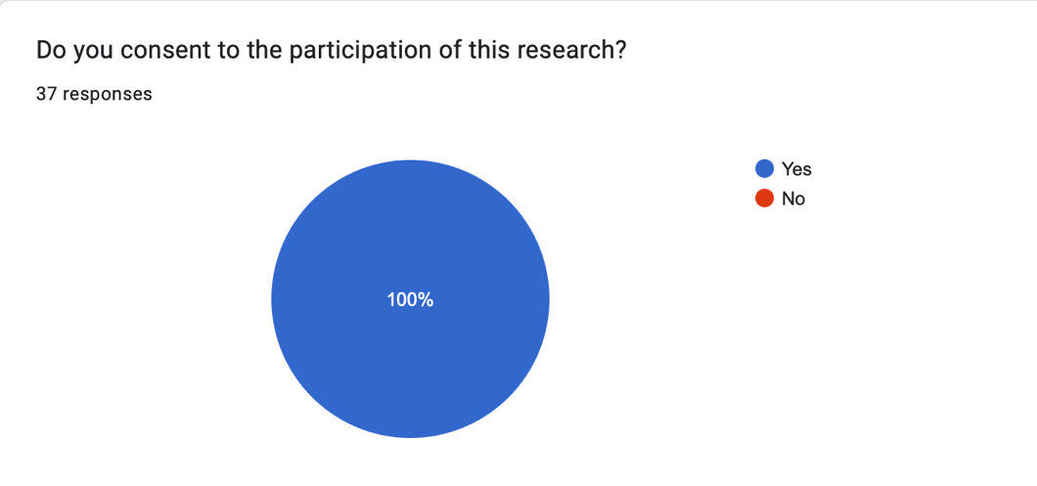
1.

Within the briefing information, to obtain the participants privacy and anonymity, if the participants wished to withdraw from the research, the participants were asked to provide a unique 4-digit code to include when emailing the contact information. This was asked as part of the second question of the survey to ensure that the participants data could easily be removed.

The third question of the survey asked what age category represented the participants to provide context to the qualitative open questions that would later be included within the survey. The age categories provided ranged from 18 to 60+, with the majority of participants aged 18 – 24 (51.4%).

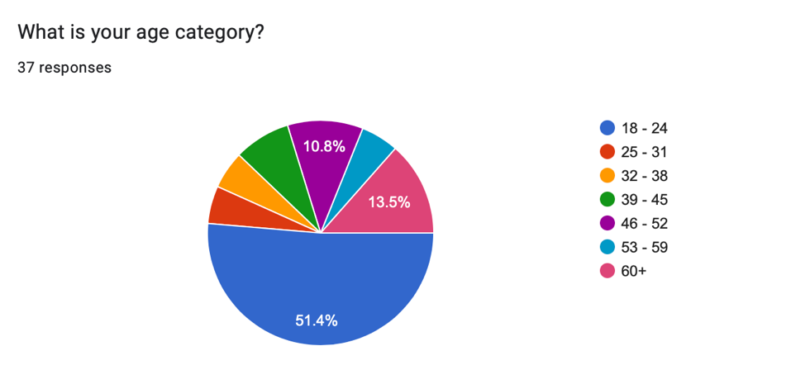
3.

The fourth question of the survey was to determine the gender of each participant. The purpose of this question was to analyse gender as a variable within qualitative open questions later included. Comparing the contents of the participants responses and if this had a relationship to the gender of the participant. 62.2% of participants (23 participants) identified as female, 35.1% of participants (13 participants) identified as male and 2.7% of participants (1 participant) identified as non-binary.
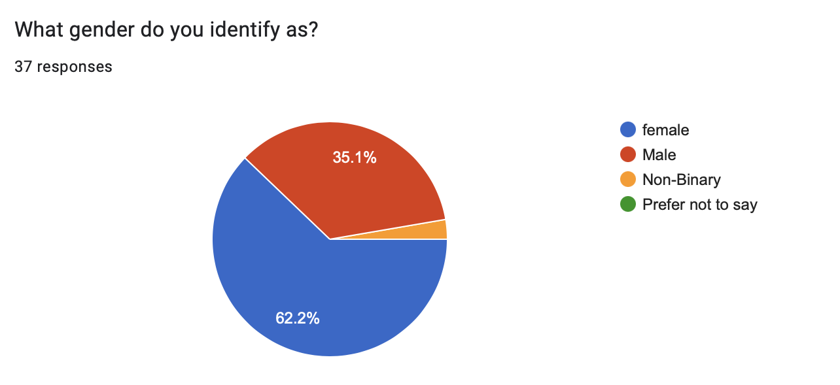
4.

The purpose of the fifth question of the survey was to determine if the participants were responsible for a child under 18. This was asked to compare and analyse the responses of participants with children and without children. 75.5% of participants responded ‘no’ to this question and 24.3% of participants responded ‘yes’ to this question.

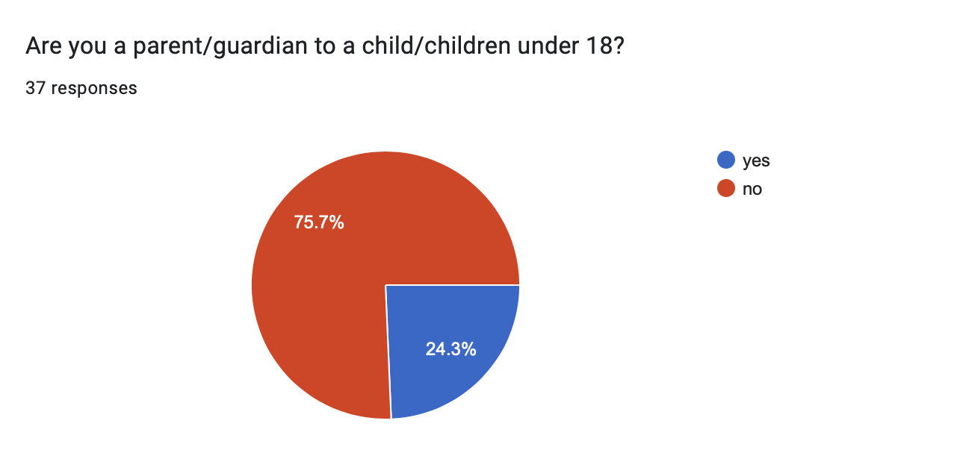
5.

The purpose of the sixth question of the survey was to understand if anyone from outside of the UK participated within the research. This was important to the research as the UK (Northern Ireland, England and Wales) has the lowest ACR in Europe (Queens University Belfast Research Portal, 2022). 100% of participants responded with ‘within the UK’.
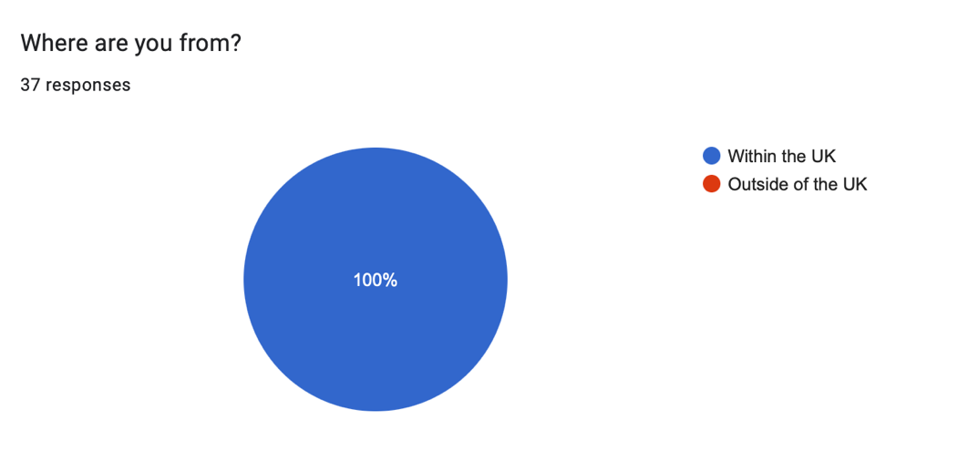
6.

The purpose of the seventh question of the survey was to reveal how much knowledge the public already had on the ACR. The results from the survey showed that 32.4% of participants responded that they did not know, whereas 67.2% of participants responded that they did know what the ACR is (see figure 7.1). However, when looking at the eighth question of the survey which asked, “Under the UK Government, the age of criminal responsibility is when a person can be criminally charged and sentenced at court. At what age do you think the UK Government deems a person to be criminally responsible and why?” out of the 25 respondents that claimed they knew what the ACR was, only 16 were correct. Through the combination of these questions, the more accurate representation shows that 56.8% of participants did not know what the ACR is and 43.2% of participants did know. See figure 7. 2.
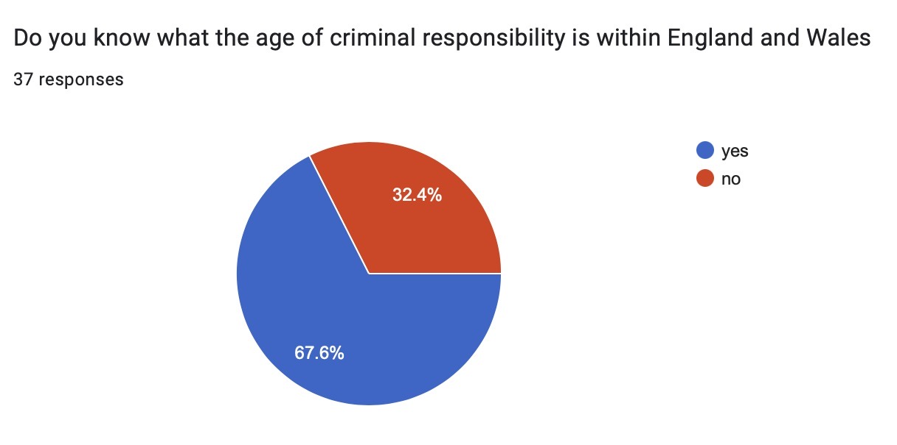
figure 7.1

Figure 7.2

Figure 7.3 also shows the responses in relation to the gender of the participants, of the 56.8% of participants that did not know what the ACR is, 66.7% of responses were female participants and 33.3% of responses were male participants.
From the findings, it is demonstrated that female participants had less knowledge surrounding the ACR, when compared to male participants. The findings representing the male participants showed that there was an even level of knowledge. Upon examining the findings, gender appears to make no impact on the public’s knowledge of the ACR.

Female. Figure 7.3
Male
Non-Binary

However, 68.6% of participants that knew what the ACR is, were aged 25 to 60+ (see figure 7.4). This shows that the younger generation, such as the 18 - 24 age category, are unaware of the legislation surrounding the ACR. This could be caused due to 25 to 60-year-olds predominately using mainstream news as their source of information and, with the rise of technology, younger generations are gathering their information from other sources. For example, a study conducted by Newman et al (2022) found that younger audiences are choosing to use social media as their source of news and distrust the mainstream news. With Newman et al (2022) reporting that particularly 18 to 34-year-olds are purposefully avoiding the news, due to feeling as though the reports negatively impacts their emotions.

Figure 7.4

In the context of participants who had children, 19.1% of participants who did not know what the ACR is, are responsible for a child or children under 18-years-old. Whereas 31.3% of participants who did know what the ACR is, are parents/guardians to 1 or more children under 18-years-old. Figure 7.5 represents the data for participants with and without children and their responses to question seven. The data may show that participants without children were more likely to be unaware of the ACR. Due to a only a small total of parents participating within the research, the data shows that having children made little to no impact on the participants’ knowledge of the ACR.

Figure 7.5
Yes

No

The eighth question of the survey asked:
“Under the UK Government, the age of criminal responsibility is when a person can be criminally charged and sentenced at court. At what age do you think the UK Government deems a person to be criminally responsible and why?”

A range of different answers were achieved however, only 51.4% of participants gave justifications for their answers. 42.2% of participants correctly answered that the ACR was 10 years old, with 6 participants including their reasoning for their answers and 1 of these participants was a parent/guardian to a child. The justifications for 5 of the participants (including the parent/guardian) justified their answers responding this is the age that children “should” or are “capable” of knowing right from wrong. The remaining participant responded that the ACR is “to reduce offending and prevent further criminal activity as an adult”.
Of the 56.8% of participants that did not know the ACR, the majority of participants (24.3%) had responded with 16 years old. 5 of the participants that thought the ACR was 16 justified their answer because it’s the “age of consent”, it’s “the legal age”, when “a child leaves school” and when “a child understands the depth of their actions”.
The participants that correctly recognised that the ACR is 10 years-old and justified their answers by stating children should know right from wrong, fail to acknowledge the premature and inexperienced mindset of a child of this age. Reiterating a viewpoint from the literature review, a child’s brain at 10 years old is at its initial stage of maturing, evolving and continues to do so for 14 years until 24 years old (Arian et al, 2013). Bateman (2013) supports the perspective of neuroscience and argues a child obtaining a moral grasp such as ‘knowing right from wrong’ is not a one-time achievement but rather a skill that is refined gradually with experience, time, and a progressing maturity. Therefore, the government and the public actively ignore a child’s vulnerabilities such as the inability to comprehend their actions, the impact their actions have and the influence of peer pressure and manipulation. This results in an undeniably harsh system that results in a criminal record, that can and will affect the trajectory of the child’s life.

The participants that expected the ACR to be 16, similar to other regulations such as the age of consent, identified that if the law allows 16-year-olds to, apply for housing (provided by the council) (UK Government, 2023), drive a moped (Driver and Vehicle Standards Agency, 2013) and work full time (NSPCC Learning, 2022) then it is logical to assume the ACR is also 16. With the evidence of neurological science and the contradictory of legislation, it is problematic to set the ACR considerably low, while civil responsibilities are much higher. Delmage (2013) acknowledges that within medicine, the age of consent to an extensive surgery is higher than the age of consent to a blood pressure check. The age threshold depends on the perceived weight of the decision. Delmage (2013) recommends that this structure of decision making could be transferred to the criminal setting whereby the ACR is higher for more serious crimes such as murder and rape.

The nineth question of the survey asked:
“The age of criminal responsibility for England and Wales is 10. Do you think this is an appropriate age for someone to be criminally responsible? Why?”

Of the 37 participants, 56.8% of participants responded that the age was unsuitable, 37.8% agreed with the legislation and responded that the age is suitable and 5.4% of participants gave responses that were deemed undetermined. See figure 8. Of the 56.8% of participants that deemed the ACR to be unsuitable many justifications included that children at 10 are “still mentally developing”, “still learning”, their “front cortex hasn’t fully developed” and they “don’t understand the consequences to their actions”. The consensus alluding to the idea that children at 10, lack the capacity to be held criminally responsible. The 37.8% of participants that consider the ACR to be suitable justified their responses by stating that children “should understand what they’re doing”, the legislation “is a preventative measure of continued offending in the future” and reaffirming that children “know right from wrong”. Thus, the public’s perspective represents the contemporary principles that are portrayed within the literature review.

The 5.4% of participants that were considered to be undetermined due to their responses represented a mixed opinion of both suitable and unsuitable, with the explanation for their answers being “it depends on the crime”. It could be argued that the public may have agreed with Delmage’s (2013) recommendation that the age threshold of the ACR, could be placed at separate ages for differentiating crimes.

Figure 8

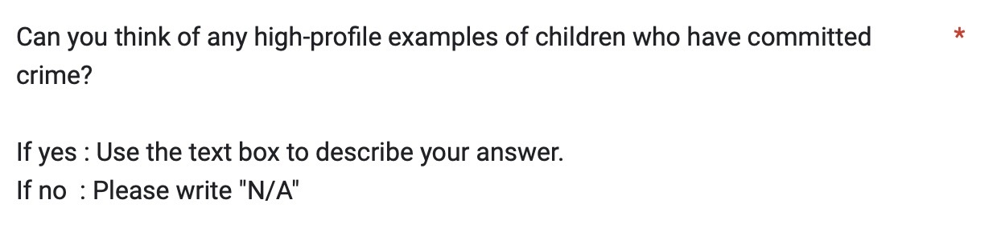
The tenth question asked:

73% of participants responded with “James Bulger”, 13.5% of participants responded with other cases of children committing acts of murder and 13.5% responded N/A. See figure 9. The ages of participants that responded James Bulger ranged between all age categories. However, 80% of participants that could not name a high-profile case or responded with a different case were under the age of 25. This could be supported by Newman et al (2022), as previously mentioned, many 18-24 year olds do not engage with mainstream news, therefore these participants are not engaging in the continued reports of the offenders that murdered James Bulger and have possibly not heard of this particular case. This data could also be explained that due to the James Bulger murder occurring 30 years ago, it is probable to interpret that these particular participants do not believe that this case can be considered high-profile within today’s society.
It was also noted that while 73% of participants acknowledged and recognised the James Bulger murder, the public still deemed the legislation to be unsuitable (56.8%) and also did not have previous knowledge of what the ACR was (56.8%). This shows that while public opinion and perspectives may have resulted in a change of legislation in 1998 through the abolishment of the Doli Incapax (Gibbon, 2016), the perspective of the public has changed and evolved in alliance to form today’s modern society, leading to the current ACR to be archaic.

Figure 9

The data from the survey indicates that the public do not have a sufficient extent of knowledge surrounding the ACR due to almost 60% of participants not knowing when a child is deemed criminally responsible within the UK. Upon learning what the ACR is and what age this begins a staggering 56.8% deemed this age was not suitable. One may believe, that if it is possible for the public’s opinions to have the authority to change the government’s policy then it is reasonable to deduce that if the public deem legislation to be unsuitable, it is possible for the ACR to be revised once more. With a multitude of research academic’s and the public supporting the reform of the ACR, it is evident that the ACR needs to be revised in today’s modern society. The Police Foundation (2020) also supports that when law organisations support and listen to the public’s opinions, this generates a perception of moral alignment resulting in the public having an improved attitude, feelings of trust and public confidence within police and the government.

Chapter 5 - Conclusions (800)
The overall aim of this research was to critically analyse the ACR within England and Wales. The objectives that were set out to achieve this research aim were as presented:
- Explore the current literature to identify arguments for and against raising the ACR.
- Consider the portrayal of young people who offend in the media and how does this influence public perception.
- Evaluate public perceptions on the ACR in England and Wales

5.1 Research Objective 1: Explore the current literature to identify arguments for and against raising the ACR.

The first research objective was addressed within the literature review, which examined and analysed the justifications for not raising the age purposed by the House of Commons Justice Committee (2021). The first justification for not raising the ACR was that children are able to comprehend the distinction between misbehaving and severe delinquency. Multiple journal articles have challenged this justification by suggesting that children of the age of 10 are incapable of logical risk assessment, authority over their emotions and capacity to make objective decisions due to the brain maturing and experiencing an intense surge of sex hormones (Arain et al, 2013). The initial criminalisation of children, during a period where the brain is still under-developed can have lasting damaging effects. The attached stigmatisation that may remain for many years can only encourage more damage and may lead to further offences.

A further central justification for not raising the ACR is that the age warrants early intervention within the YJS. This justification was also disputed, acknowledging that many children that are introduced to the CJS are already known to social services, have experience in the care system and are often victims of crime themselves (Ministry of Justice, 2016). Forming policies through a child-focused, trauma informed approach will benefit children by averting the harmful ramifications resulting from formal CJS sanctions but also positively promote restorative justice to reduce the likelihood of reoffending.

Analysis of the arguments presented suggests that existing literature supports raising the ACR within England and Wales. it is apparent that for the age to remain at 10 years old this will only affect individuals negatively rather than the intended aim of reducing youth crime and decreasing recidivism.

5.2 Research Objective 2: Consider the portrayal of young people who offend in the media and how does this influence public perception.

The second research objective was also addressed as part of the second chapter within the literature review. It was established that the media has been recognised for reporting selective crimes that are committed by young people. Halsey and White (2008) expressed that the media particularly desires publishing crimes that are extreme and notably violent. This was supported by the findings of Hugh and Roberts (2004) which found that the public were persistently misinformed on the subject of youth crime due to the media’s reporting.

The tone of the media reports for the James Bulger murder resembled a vindictive, apathetic approach with the media revealing their stance towards the offenders with an article titled “How do you feel now you little bastards?” (Piltcher and Wagg, 1996). The nature and manner of these reports were analysed against the reports of the Silje Redergard murder which embraced the offenders with compassion and sensitivity. The findings found that the media within the UK, utilized the public’s anxieties and concerns to sensationalise and cause moral panic regarding the magnitude of youth crime.

The media disregarded the level of impact that would affect the public’s perception and public confidence within the CJS, despite these organisations systematically reducing youth crime. Upon examining the reports within the literature review, the findings demonstrate that when the media negatively misinforms the public on topics such as youth crime, this creates an inaccurate public perception and results in adverse effects for children and young people within the YJS.

5.3 Research Objective 3: Evaluate public perceptions on the ACR within England and Wales.

The data gathered from the online survey established that the public’s perspective surrounding the ACR align and represent the same perspectives and contemporary arguments that occurred within the literature review. The data showed that the participants interpretation of the ACR is torn between determining if a child at 10 years old has the mental capacity to understand their actions and if children should know the moral understanding of right and wrong. With the combined research from the literature review, and the data of public opinion, the research project concludes that children are simply not capable of this understanding due to the brain beginning the first early stages of maturing. With the government resisting to revise the legislation it is neglectful to ignore the public’s and academic researcher’s opinion that the legislation is unsuitable.

The majority of participants also did not know what the ACR was before engaging with the study, showing a lack of understanding and awareness of the YJS. Upon discovering the ACR the majority of participants deemed the legislation to be unsuitable, while a vast majority of participants recognised the James Bulger murder as a high-profile case. This data shows that while public opinion may have induced a change in legislation previously, the current ACR does not accurately represent the contemporary perspective of the public’s opinion.

Recommendations

Due to the research project concluding that the ACR needs to be revised to conform with contemporary modern perspectives of children and young people who offend, it is also important to propose recommendations. As previously discussed within the literature review, one recommendation to be made is the introduction of early intervention before criminalising children. Crofts (2009) discusses that children and young people who commit crime have been failed by systems and individuals who are responsible for their upbringing such as, the general community, the education system and their home life. Due to such failures, it is vital to view children and young people who offend as children first. The Youth Justice Board (2021) proposes in accordance with their Child First vision, that children are not criminalised as an outcome of the challenges and vulnerabilities which they cannot control. One method of implementing child-focused strategies is to consistently consider the child’s best interests by actively diverting children from prosecution, having the child as a priority over punitive punishment or correction (Case and Browning, 2021). Through connecting community organisations such as the education system and the health department within partnership schemes will improve the integration of services to recognise children’s vulnerabilities at the earliest possible stage (Youth Justice Board, 2023b). The introduction of trauma-informed based decisions is also vital to meeting the needs of vulnerable children, with six hundred schools in Wales receiving ACE training (Walker et al, 2021). Contributing to tackle and prevent children from offending via trauma-informed approaches has the potential to give children and young people the best possible opportunity to reach their full potential and avoid the negative impact of criminalisation.

References

Age of Criminal Responsibility, (2020), HL 90, Available at: https://bills.parliament.uk/bills/2613 , [accessed 5th April 2023]

Asquith. S, (1996), ‘When Children Kill Children: The Search for Justice’, Childhood, Vol. 3, pp. 99-116, Available at: https://journals.sagepub.com/doi/pdf/10.1177/0907568296003001007 , [accessed 4th March 2023]

Arain. M, Haque. M, Johal. L, Mathur. P, Nel. W, Rais. A, Sandhu. R, Sharma. S, (2013), ‘Maturation of the Adolescent Brain’, Neuropsychiatric Disease and Treatment, Vol. 9, pp. 449-461, Available at: https://www.ncbi.nlm.nih.gov/pmc/articles/PMC3621648/ , [accessed 14th November 2022]

Alharahsheh. H, Pius. A, (2020), ‘A Review of Key Paradigms: Positivism vs Interpretivism’, Global Academic Journal of Humanities and Social Sciences, Vol. 2, issue 3, pp. 39-43, Available at: https://gajrc.com/media/articles/GAJHSS_23_39-43_VMGJbOK.pdf , [accessed 1st December 2022]

Albers. M, (2017), ‘Quantitative Data Analysis – In the Graduate Curriculum’, Journal of Technical Writing and Communications, Vol. 47, issue 2, pp. 215-233, Available at: https://journals.sagepub.com/doi/epub/10.1177/0047281617692067 , [accessed 4th January 2023]

Aldridge. A, Levine. K, (2001), Survey the Social World: Principles and Practice in Survey Research, Buckingham: Open University Press.

Andrade. C, (2020), ‘The Limitations of Online Survey’s’, Indian Journal of Psychological Medicine, Vol. 42, issue 6, pp. 575-576, Available at: https://journals.sagepub.com/doi/pdf/10.1177/0253717620957496 , [accessed 4th April 2023]

Brown. A, Charles. A, (2019), ‘The Minimum Age of Criminal Responsibility: The Need for a Holistic Approach’, Youth Justice, Vol. 21, issue 2, Available at: https://journals.sagepub.com/doi/full/10.1177/1473225419893782 , [accessed 25th October 2022

Bailey. J, (2008), ‘First Steps in Qualitative Data Analysis: Transcribing’, Family Practice, Vol. 25, issue 1, pp. 127-131, Available at: https://academic.oup.com/fampra/article/25/2/127/497632?login=false , [accessed 4th January 2023]

Bermingham. R, (2020), Interpreting Research Evidence, Available at: https://post.parliament.uk/interpreting-research-evidence/ , [accessed 20th January 2023]

Barry. M, Leonardensen. D, (2006), ‘Inequality and Punitivism in Late Modern Societies: Scandinavian Exceptionalism Revisited’, European Journal of Probation, Vol. 4, issue 2, pp. 46-61, Available at: https://journals.sagepub.com/doi/pdf/10.1177/206622031200400204 , [accessed 20th February 2023]

Bateman. T, (2013), ‘Keeping up (Tough) Appearances: The Age of Criminal Responsibility’, Criminal Justice Matters, Vol. 92, issue 1, pp. 28-29, Available at: https://www.tandfonline.com/doi/abs/10.1080/09627251.2013.805372 , [accessed 31st March 2023]

Baruch. Y, Holton. B, (2008), ‘Survey Response Rate Levels and Trends in Organisational Research’, Human Relations, vol. 61, issue 8, pp. 1139-1160, Available at: https://journals.sagepub.com/doi/pdf/10.1177/0018726708094863?casa_token=7-12MvuLJcIAAAAA:AoEZWpWJMTRbLZfPx69cOcd7-9BJehBONXYqVJixSl12GhPo0KFRmp6_qNbZW5FaY89fUc103Ns , [accessed 4th April 2023]

Beyond Youth Custody, (2016), Trauma and Young Offenders: A Review of the Research and Practice Literature, Available at: http://www.beyondyouthcustody.net/wp-content/uploads/Trauma-and-young-offenders-a-review-of-the-research-and-practice-literature.pdf , [accessed 9th April 2023]

Berry. M, Philo. G, Tiripelli. G, Docherty. S, Macpherson. C, (2012), ‘Media Coverage and Public Understanding of Sentencing Policy in Relation to Crimes Against Children’, Criminology and Criminal Justice, Vol. 12, issue 5, pp. 567-591, Available at: https://journals.sagepub.com/doi/10.1177/1748895811432956 , [accessed 26th April 2023]

Children and Young Persons Act 1963, c.37, Available at: https://www.legislation.gov.uk/ukpga/1963/37 [accessed 9th October 2022]

Cabinet Secretary for Justice and Veterans, (2022), Youth Justice: Age of Criminal Responsibility, Available at: https://www.gov.scot/policies/youth-justice/raising-age-criminal-responsibility/ , [accessed 25th October 2022]

Crown Prosecution Service, (2020), Youth Offenders, Available at: https://www.cps.gov.uk/legal-guidance/youth-offenders , [accessed 10th November 2022]

Crime and Disorder Act 1998, c. 1, Available at: https://www.legislation.gov.uk/ukpga/1998/37/section/11 , [accessed 10th November 2022]

Crofts. T, (2022), ‘Act Now: Raise the Minimum Age of Criminal Responsibility’, Current Issues in Criminal Justice, Available at: https://www.tandfonline.com/doi/full/10.1080/10345329.2022.2139892?scroll=top&needAccess=true , [accessed 24th November 2022]

Coomber. R, (2017), ‘Using the Internet for Survey Research’, Sociological Research Online, Vol. 2, issue 2, pp. 49-58, Available at: https://journals.sagepub.com/doi/10.5153/sro.73 , [accessed 16th January 2023]

Case. S, Haines. K, (2020), ‘Abolishing Youth Justice Systems: Children First, Offenders Nowhere’, Youth Justice, Vol. 21, issue 1, pp. 3-17, Available at: https://journals.sagepub.com/doi/epub/10.1177/1473225419898754 , [accessed 20th January 2023]

Cobern. W. Adams. B, (2020), ‘Establishing Survey Validity: A Practical Guide’, International Journal of Assessment Tools in Education, Vol. 7, Issue 3, pp. 404-419, Available at: https://files.eric.ed.gov/fulltext/EJ1272902.pdf , [accessed 21st January 2023]
Case. S, Haines. K, (2015), Positive Youth Justice: Children First, Offenders Second, Bristol: Policy Press.

Crofts. T, (2009), ‘Catching Up With Europe: Taking the Age of Criminal Responsibility Seriously in England’, European Journal of Crime, Criminal Law and Criminal Justice, Vol. 17, pp. 267-292, Available at: https://www.researchgate.net/profile/Thomas-Crofts-3/publication/240679349_Catching_Up_With_Europe_Taking_the_Age_of_Criminal_Responsibility_Seriously_in_England/links/606fcee0299bf1c911ba2390/Catching-Up-With-Europe-Taking-the-Age-of-Criminal-Responsibility-Seriously-in-England.pdf , [accessed 29th April 2023]

Case. S, Browning. A, (2021), Child First Justice: The Research Evidence-Base, Available at: https://yjresourcehub.uk/images/Evaluation%20Library/YOT_Talk_Full_Report_European_Journal_of_Criminology_March_2021.pdf , [accessed 30th April 2023]

Day. A, (2021), Experiences and Pathways of Children in Care in The Youth Justice System, Available at: https://www.justiceinspectorates.gov.uk/hmiprobation/wp-content/uploads/sites/5/2021/09/LL-Academic-Insights-v1.0-Day.pdf , [accessed 20th January 2023]

Drakeford. M, (2010), ‘Devolution and Youth Justice in Wales’, Criminology and Criminal Justice, Vol. 10, issue 2, pp. 137-154, Available at: https://journals.sagepub.com/doi/epdf/10.1177/1748895809360967 , [accessed 20th January 2023]

Dwyer. C, McAlister. S, (2017), Raising the Age of Criminal Responsibility: Endless Debate, Limited Progress, Available at: https://pureadmin.qub.ac.uk/ws/portalfiles/portal/163931412/Ark_Feature_MACR.pdf , [accessed 22nd January 2023]

Doyel. L, Brady. A, Byrne. G, (2009),’ An Overview of Mixed Methods Research’, Journal of Research in Nursing, vol. 14, issue 2, pp. 175-185, Available at: https://journals.sagepub.com/doi/epdf/10.1177/1744987108093962 , [accessed 1st February 2023]

Driver and Vehicle Standards Agency, (2013), How to Get a Motorcycle Licence, Available at: https://www.gov.uk/government/publications/the-routes-to-your-motorcycle-licence , [accessed 2nd April 2023]

Delmage. E, (2013), ‘The Minimum Age of Criminal Responsibility: A Medico-legal Perspective’, Youth Justice, Vol. 13, issue 2, pp. 102-110, Available at: https://journals.sagepub.com/doi/pdf/10.1177/1473225413492053?casa_token=FIB6YsXhYacAAAAA:rBmSlroliSpT7OzX01fannPd6VQGuF1c4mGndtDBtQLfXNXa3Fqwzik9yP87m2QaQxGK_7YAK0Q , [accessed 2nd April 2023]

Equality and Human Rights Commission, (2015), Children’s Rights in the UK: Equality and Human Rights Commission Submission to the United Nations Committee on the Rights of the Child on the United Kingdom’s Implementation of the Convention on the Rights of the Child, Available at: https://www.equalityhumanrights.com/sites/default/files/childrens_rights_in_the_uk_sept_2015.pdf , [accessed 25th October 2022]

Frank. C, (2006), ‘Adults using Children to Commit Crime: Abuse of a Different Kind’, SA Crime Quarterly, Vol. 16, Available at: https://journals.co.za/doi/abs/10.10520/EJC47569 , [accessed 20th January 2023]

Franklin. B, Petley. J, (1996),’ Killing The Age of Innocenc: Newspaper Reporting of the Death of James Bulger’, in Pilcher. J, Wagg. S. (ed) Thatcher’s Children?: Politics, Childhood and Society in the 1980’s and 1990’s, London: Falmer Press.

Goldson. B, (2013), ‘Unsafe, Unjust and Harmful to Wider Society’: Grounds for Raising the Minimum Age of Criminal Responsibility in England and Wales’, Youth Justice, Vol. 13, issue 2, Available at: https://journals.sagepub.com/doi/full/10.1177/1473225413492054 , [accessed 9th October 2022]

Gibbon. K, (2016), Protections for Children before the Law: An empirical analysis of the age of criminal responsibility, the abolition of doli incapax and the merits of a developmental immaturity defence in England and Wales’, Criminology and Criminal Justice, Vol. 16, Issue 4, Available at: https://journals.sagepub.com/doi/10.1177/1748895816632579 , [accessed 9th October 2022]

Green. A, (2008), ‘Suitable Vehicles: Framing Blame and Justice When Children Kill a Child’, Crime, Media, Culture, Vol. 4, Issue 2, pp. 175-308, Available at: https://journals.sagepub.com/doi/epdf/10.1177/1741659008092328 , [accessed 4th March 2023]

Glik. D, Parker. K, Hategikamana. G, (2016), ‘Integrating Qualitative and Quantitative Survey Techniques’, Community Health Equity Research and Policy, Vol. 25, issue 1, Available at: https://journals.sagepub.com/doi/abs/10.2190/W18N-5210-0457-XJN7 , [accessed 5th January 2023]

Ghetti. S, Redlitch. A, (2001), Reactions to Youth Crime: Perceptions of Accountability and Competency, Behavioural Sciences and the Law, Vol. 19, pp. 33-52, Available at: https://onlinelibrary.wiley.com/doi/epdf/10.1002/bsl.426?saml_referrer , [accessed 4th March 2023]

Gray. P, Smithson. H, Jump. D, (2021), Serious Youth Violence and It’s Relationship With Adverse Childhood Experiences, Available at: https://www.mmu.ac.uk/media/mmuacuk/content/documents/mcys/Serious-Youth-Violence-Report---MCYS.pdf , [accessed 29th March 2023]

Greener. S, (2018), ‘Research limitations: The Need For Honesty and Common Sense’, Interactive Learning Environments, Vol 26, issue 5, pp. 567-568, Available at: https://www.tandfonline.com/doi/full/10.1080/10494820.2018.1486785?scroll=top&needAccess=true&role=tab , [accessed 4th April 2023]

Houses of Parliament, (2018), Age of Criminal Responsibility, Available at: https://researchbriefings.files.parliament.uk/documents/POST-PN-0577/POST-PN-0577.pdf , [accessed 10th November 2022]

House of Commons Justice Committee, (2021), Children and Young People in Custody (Part 1): Entry into the Youth Justice System: Government Response to Committee’s Twelfth Report of Session 2019-21 – Ninth Special Report of Session 2019-21, Available at: https://committees.parliament.uk/publications/4636/documents/46905/default/ , [accessed 10th November 2022]

House of Commons Justice Committee, (2020), Children and Young People in Custody (Part 1): Entry into the Youth Justice System – Twelfth Report of Session 2019-21, Available at: https://committees.parliament.uk/publications/3399/documents/32490/default/ , [accessed 10th November 2022]

House of Commons Library, (2022), Youth Custody, Available at: https://researchbriefings.files.parliament.uk/documents/CBP-8557/CBP-8557.pdf , [accessed 7th April 2023]

Home Office, (2022), Youth Community Sentences: Police, Crime, Sentencing and Courts Act 2022 Factsheet, Available at: https://www.gov.uk/government/publications/police-crime-sentencing-and-courts-bill-2021-factsheets/police-crime-sentencing-and-courts-bill-2021-youth-community-sentences-factsheet , [accessed 14th November 2022]

Howard League for Penal Reform, (2021), What’s Wrong with Remanding Children to Prison?: Remand Briefing One: Emerging Themes, Available at: https://howardleague.org/wp-content/uploads/2021/09/Whats-wrong-with-remanding-children-to-prison.pdf , [accessed 16th January 2023]

Howard League for Penal Reform, (2022), Howard League Project Reveals Harmful Impact of Remanding Children to Prison, Available at: https://howardleague.org/news/howard-league-project-reveals-harmful-impact-of-remanding-children-to-prison/ , [accessed 16th January 2023]

Haines. K, Case. S, Gray. P, (2020), ‘Children and Crime: In the Moment’, Youth Justice, Vol. 21, issue 3, pp. 275-298, Available at: https://journals.sagepub.com/doi/10.1177/1473225420923762 , [accessed 20th January 2023]

Haines. K, Case. S, (2007), ‘Individual Differences in Public Opinion about Youth Crime and Justice in Swansea’, The Howard Journal of Criminal Justice, vol. 46, issue 4, pp. 338-355, Available at: https://onlinelibrary.wiley.com/doi/full/10.1111/j.1468-2311.2007.00481.x , [accessed 1st February 2023]

Halsey. K, White. R, (2008), Young People, Crime and Public Perceptions, Available at: https://www.nfer.ac.uk/publications/LYC01/LYC01.pdf , [accessed 1st February 2023]

Hugh. M, Roberts. J. V, (2004), Youth Crime and Youth Justice: Public Opinion in England and Wales. Bristol: Policy Press.

Justice Analytical Services Scottish Government, (2015), What Works to Reduce Reoffending: A Summary of the Evidence, Available at: https://www.gov.scot/binaries/content/documents/govscot/publications/research-and-analysis/2015/05/works-reduce-reoffending-summary-evidence/documents/works-reduce-reoffending-summary-evidence/works-reduce-reoffending-summary-evidence/govscot%3Adocument/00476574.pdf , [accessed 20th December 2022]

James. E, MacDougall. I, (2010), The Norway Town that Forgave and Forgot It’s Child Killers, Available at: https://www.open.edu/openlearn/pluginfile.php/2656939/mod_resource/content/1/The%20Norway%20town%20that%20forgave%20and%20forgot%20its%20child%20killers.pdf , [accessed 17th February 2023]

James. A, Jenks. C, (1996), ‘Public Perceptions of Childhood Criminality’, The British Journal of Sociology, Vol. 47, issue 2, pp. 315-331, Available at: https://www.jstor.org/stable/591729?searchText=public+perceptions+on+childhood+criminality&searchUri=%2Faction%2FdoBasicSearch%3FQuery%3Dpublic%2Bperceptions%2Bon%2Bchildhood%2Bcriminality&ab_segments=0%2FSYC-6744_basic_search%2Ftest-1&refreqid=fastly-default%3A9deba583258052e0cdc5cf1b1739757c&seq=9 , [accessed 6th February 2023]

Just for Kids Law, (2022), “End Overnight Police Detention of Children” says Children’s Rights Charity, Available at: https://www.justforkidslaw.org/news/end-overnight-police-detention-children-says-childrens-rights-charity , [accessed 7th April 2023]

Kesmodel. U, (2018), ‘Cross-Sectional Studies – What Are They Good For?’, Acta Obstetricia et Gynecologica Scandinavica, Vol. 97, issue 4, pp. 388-393, Available at: https://obgyn.onlinelibrary.wiley.com/doi/full/10.1111/aogs.13331 , [accessed 6th January 2023]

Klauer. K, Phye. G, (2008), ‘Inductive Reasoning: A Training Approach’, Review of Educational Research, Vol. 78, issue 1, pp. 85-123, Available at: https://journals.sagepub.com/doi/epub/10.3102/0034654307313402 , [accessed 12th March 2023]

King. M, (1995), ‘The James Bulger Murder Trial: Moral Dilemmas, and Social Solutions’, The International Journal of Children’s Rights, Vol. 3, pp. 167-187, Available at: https://brill.com/view/journals/chil/3/2/article-p167_1.xml?casa_token=bVmXdLeLAyAAAAAA:IbZbYh0LHic7PD3WzBtuYTYG3YokXs4vmyzU8C0N-RqZVaycOyCxXOaJgR5NXAxXDfvWFug , [accessed 29th April 2023]

Local Government Association, (2018), Youth Justice: Resource Pack, Available at: https://www.local.gov.uk/sites/default/files/documents/15.33%20Youth%20justice%20resource%20pack_v04_1.pdf , [accessed 20th December 2022]

Levin. K, (2006), ‘Study Design ||| : Cross-Sectional Studies’, Evidence-Based Dentistry, Vol. 7, pp. 24-25, Available at: https://www.nature.com/articles/6400375 , [accessed 6th January 2023]

Lennox. C, Khan. L, (2012), Chapter 12: Youth Justice, Available at: https://assets.publishing.service.gov.uk/government/uploads/system/uploads/attachment_data/file/252662/33571_2901304_CMO_Chapter_12.pdf , [accessed 16th January 2023]

Lee. D, (2004), ‘Survey Research: Reliability and Validity’, Library Administration and Management, Vol. 18, issue 4, Available at: https://www.proquest.com/openview/56802a585fa9895fbe89870540a315e6/1?pq-origsite=gscholar&cbl=40174 , [accessed 20th January 2023]

Lin. A, (1998), ‘Bridging Positivist and Interpretivist Approaches to Qualitative Methods’, Policy Studies Journal, Vol. 26, issue 1, pp. 162-180, Available at: https://onlinelibrary.wiley.com/doi/epdf/10.1111/j.1541-0072.1998.tb01931.x?saml_referrer , [accessed 1st February 2023]

Ministry of Justice, (2018), Referral Order Guidance, Available at: https://assets.publishing.service.gov.uk/government/uploads/system/uploads/attachment_data/file/746365/referral-order-guidance-9-october-2018.pdf , [accessed 14th November 2022]

Ministry of Justice, (2016), Review of the Youth Justice System in England and Wales, Available at: https://webarchive.nationalarchives.gov.uk/ukgwa/20221029010359/https://www.iicsa.org.uk/key-documents/7330/view/INQ001422.pdf , [accessed 14th January 2023]

Moon. K, Blackman. D, (2014), ‘A Guide to Understanding Social Science Research For Natural Scientists’, Conservation Biology, Vol. 28, issue 5, pp. 1167 – 1177, Available at: https://conbio.onlinelibrary.wiley.com/doi/full/10.1111/cobi.12326?saml_referrer , [accessed 29th December 2022]

Meyer. S, (2016), ‘Qualitative Research with a Focus on Qualitative Data Analysis’, International Journal of Sales, Retailing & Marketing, vol. 4, issue 9, available at: https://www.circleinternational.co.uk/wp-content/uploads/2021/01/IJSRM4-9.pdf#page=57 , [accessed 4th January 2023]

Mayhill. A, Beak. K, (2008), Public Confidence in the Police, Available at: https://library.college.police.uk/docs/npia/public-confidence-in-the-police.pdf , [accessed 1st February 2023]

Mirror, (2023), James Bulger’s Brother Will Never Forgive Killer and Jon Venables ‘Must Die in Prison’, Available at: https://www.mirror.co.uk/news/uk-news/james-bulgers-brother-never-forgive-29196055 , [accessed 9th April 2023]

Newman. N, Fletcher. R, Robertson. C, Eddy. K, Nielson. R, (2022), Reuters Institute Digital News Report 2022, Available at: https://reutersinstitute.politics.ox.ac.uk/sites/default/files/2022-06/Digital_News-Report_2022.pdf , [accessed 21st March 2023]

NSPCC Learning, (2022), Children and The Law, Available at: https://learning.nspcc.org.uk/child-protection-system/children-the-law , [accessed 2nd April 2022]

Office for National Statistics, (2016), ONS Methodology Working Paper Series No. 8 – Statistical Uses for Mobile Phone Data: Literature Review, Available at: https://www.ons.gov.uk/methodology/methodologicalpublications/generalmethodology/onsworkingpaperseries/onsmethodologyworkingpaperseriesno8statisticalusesformobilephonedataliteraturereview , [accessed 12th March 2023]

Queens University Belfast Research Portal, (2022), Minimum Age of Criminal Responsibility [MACR] – Why it Should Be Raised in Northern Ireland, Available at: http://qpol.qub.ac.uk/minimum-age-of-criminal-responsibility-macr-why-it-should-be-raised-in-northern-ireland/ , [accessed 3rd March 2023]

Roberts. L, (2014), ‘The Bulger case: A Spatial Story’, The Cartographic Journal, Vol. 51, issue 2, pp. 141-151, Available at: https://www.tandfonline.com/doi/full/10.1179/1743277413Y.0000000075?needAccess=true , [accessed 3rd February 2023]

Sentencing Advisory Council, (2012), Sentencing Children and Young People in Victoria, Available at: https://core.ac.uk/download/pdf/30679503.pdf , [accessed 24th November 2022]

Sentencing Council, (2017), Sentencing Children and Young People, Available at: https://www.sentencingcouncil.org.uk/overarching-guides/crown-court/item/sentencing-children-and-young-people/#Section%20four:%20Determining%20the%20sentence , [accessed 20th December 2022]

Sentencing Council, (2019), Public Knowledge of and Confidence in the Criminal Justice System and Sentencing, Available at: https://www.sentencingcouncil.org.uk/wp-content/uploads/Public-Knowledge-of-and-Confidence-in-the-Criminal-Justice-System-and-Sentencing.pdf , [accessed 1st February 2023]

Saunders. M, Lewis. P, Thornhill. A, (2019), Research Methods for Business Students, Eighth edition, Harlow: Pearson Education Limited.

Sullivan. G, (2011), ‘A Primer on the Validity of Assessment Instruments’, Journal of Graduate Medical Education, Vol. 3, issue 2, pp. 119-120, Available at: https://meridian.allenpress.com/jgme/article/3/2/119/33876/A-Primer-on-the-Validity-of-Assessment-Instruments , [accessed 21st January 2023]

Staksrud. E, Livingstone. S, (2011), ‘Children and Online Risk: Powerless Victims or Resourceful Participants?’, Information, Communication and Society, Vol. 12, issue 2, pp. 364-387, Available at: https://www.tandfonline.com/doi/full/10.1080/13691180802635455 , [accessed 3rd February 2023]

Storrs. E, (2006), ‘’All You Need Is Love, Love... Love Is All You Need’: Christianity and the Murder of James Bulger, Culture and Religion, Vol. 7, Issue 3, pp. 205-327, Available at: https://www.tandfonline.com/doi/full/10.1080/14755610601058120?needAccess=true , [accessed 12th March 2023]

Steefkerk. R, (2022), Inductive vs Deductive Reasoning: Differences and Examples, Available at: https://www.scribbr.co.uk/research-methods/inductive-vs-deductive-reasoning/ , [accessed 12th March 2023]

Stratton. S, (2021), ‘Population Research: Convenience Sampling Strategies’, Prehospital and Disaster Medicine, Vol. 36, issue 1, Available at: https://www.cambridge.org/core/services/aop-cambridge-core/content/view/B0D519269C76DB5BFFBFB84ED7031267/S1049023X21000649a.pdf/population-research-convenience-sampling-strategies.pdf , [accessed 4th April 2023]

Scharp. K, Sanders. M, (2018), ‘What is a Theme? Teaching Thematic Analysis in Qualitative Communication Research Methods’, Communication Teacher, Vol. 33, issue 2, pp. 117-121, Available at: https://www.tandfonline.com/doi/full/10.1080/17404622.2018.1536794?casa_token=BuLJWvqTlqoAAAAA%3Al_tvcVI5Qz2EOZB1RTyeIAFYXxXZCg5VMFma5gkgIhBNiPrXDtiZj3ko2C57PTARIxgSl9XLs9g , [accessed 4th April 2023]

Smith. D, Sueda. K, (2008), ‘The Killing of Children by Children as a Symptom of National Crisis: Reactions in Britain and Japan’, Criminology and Criminal Justice, Vol. 8, issue 1, pp. 5-25, Available at: https://journals.sagepub.com/doi/pdf/10.1177/1748895807085867?casa_token=Mod0u8eANVAAAAAA:xkNr2pm8Y_DL9Q78SzMFOo23Z80nBkLOU4ln0dWqFrbQNsfNEZMaSs-7VOrs98q2Sg6RjQnK3Nc , [accessed 26th April 2023]

Torney. K, (2011), The case which changed the face of youth justice, Available at: https://www.thedetail.tv/articles/the-case-which-changed-the-face-of-youth-justice, [accessed 9th October 2022]

Turner. D, (2020), ‘Sampling Methods in Research Design’, American Headache Society, Vol. 60, issue 1, Available at: https://headachejournal.onlinelibrary.wiley.com/doi/abs/10.1111/head.13707 , [accessed 20th January 2023]

The Times, (1993), Boys Guilty of Bulger Murder, Available at: https://www.thetimes.co.uk/article/boys-guilty-of-bulger-murder-37lmzwl8djd , [accessed 4th February]

The Police Foundation, (2020), Policing and the Public: Understanding Public Priorities, Attitudes and Expectations, Available at: https://www.police-foundation.org.uk/2017/wp-content/uploads/2010/10/insight_paper_1.pdf , [accessed 19th April 2023]

University of Surrey, (2007), Social Research Update: Research Without Consent, Available at: https://sru.soc.surrey.ac.uk/SRU51.pdf , [accessed 3rd March 2023]

UK Government, (2022), Age of Criminal Responsibility, Available at: https://www.gov.uk/age-of-criminal-responsibility , [accessed 10th November 2022]

UK Government, (2023), Council Housing, Available at: https://www.gov.uk/council-housing , [accessed 2nd April 2023]

Walsh. C, (1999), ‘Imposing Order: Child Safety Orders and Local Child Curfew Schemes, The Journal of Social Welfare & Family Law, Vol. 21, Issue 2, pp. 135-149, Available at: https://www.tandfonline.com/doi/pdf/10.1080/09649069908410561?needAccess=true , [accessed 10th November 2022]

Wedawatta. G, Ingirige. B, Amaratunga. D, (2011), Case Study as a Research Strategy: Investigating Extreme Weather Resilience of Construction SMEs in the UK, Available at: https://usir.salford.ac.uk/id/eprint/18250/1/6_Wedawatta_Case_study_as_a_research_strategy_Investigating_extreme_weather_resilience_of_construction_SMEs_in_the_UK.pdf , [accessed 5th January 2022]

Welsh Government, (2019), Youth Justice Blueprint for Wales, Available at: https://www.gov.wales/sites/default/files/publications/2019-05/youth-justice-blueprint_0.pdf , [accessed 22nd January 2023]

Welsh Government, (2021), Review of Adverse Childhood Experiences (ACE) Policy: Report, Available at: https://www.gov.wales/review-adverse-childhood-experiences-ace-policy-report-html , [accessed 22nd January 2023]

Woo. Y, Kim. S, Couper. M, (2014), ‘Comparing a Cell Phone Survey and a Web Survey of University Students’, Social Science Computer Review, Vol. 33, issue 3, pp. 399-410, Available at: https://journals.sagepub.com/doi/full/10.1177/0894439314544876 , [accessed 12th March 2023]

Walker. A, Jones. V, Hopkins. J, (2021), An Exploration of the Trauma Informed Terminology and Approaches being Used by Significant Projects, Programmes and Interventions in Wales, Available at: https://phwwhocc.co.uk/resources/an-exploration-of-the-trauma-informed-terminology-and-approaches-being-used-by-significant-projects-programmes-and-interventions-in-wales/ , [accessed 30th April 2023]

Youth Justice Board, (2008), Education, Training and Employment, Available at: https://assets.publishing.service.gov.uk/government/uploads/system/uploads/attachment_data/file/355694/ETE_source_final.pdf , [accessed 14th November 2022]

Youth Justice Board, (2021), Strategic Plan 2021-2024, Available at: https://assets.publishing.service.gov.uk/government/uploads/system/uploads/attachment_data/file/966200/YJB_Strategic_Plan_2021_-_2024.pdf , [accessed 29th April 2023]

Youth Justice Board, (2020), Assessing the Needs of Sentenced Children in the Youth Justice System 2018/2019, Available at: https://assets.publishing.service.gov.uk/government/uploads/system/uploads/attachment_data/file/887644/assessing-needs-of-sentenced-children-youth-justice-system.pdf , [accessed 14th January 2023]

Youth Justice Board, (2022), Annual Statistics: A Youth Justice System Failing Black Children, Available at: https://www.gov.uk/government/news/annual-statistics-a-system-failing-black-children , [accessed 14th January 2022]

Youth Justice Board, (2023a), Youth Justice Statistics 2021/22: England and Wales, Available at: https://assets.publishing.service.gov.uk/government/uploads/system/uploads/attachment_data/file/1131414/Youth_Justice_Statistics_2021-22.pdf , [accessed 4th March 2023

Youth Justice Board, (2023b), Prevention and Diversion Project – Final Report, Available at: https://yjresourcehub.uk/images/YJB/Prevention_and_Diversion_Project_Final_Report_YJB_Feb_2023.pdf , [accessed 30th April 2023]

Appendices

Figure 3.1.1
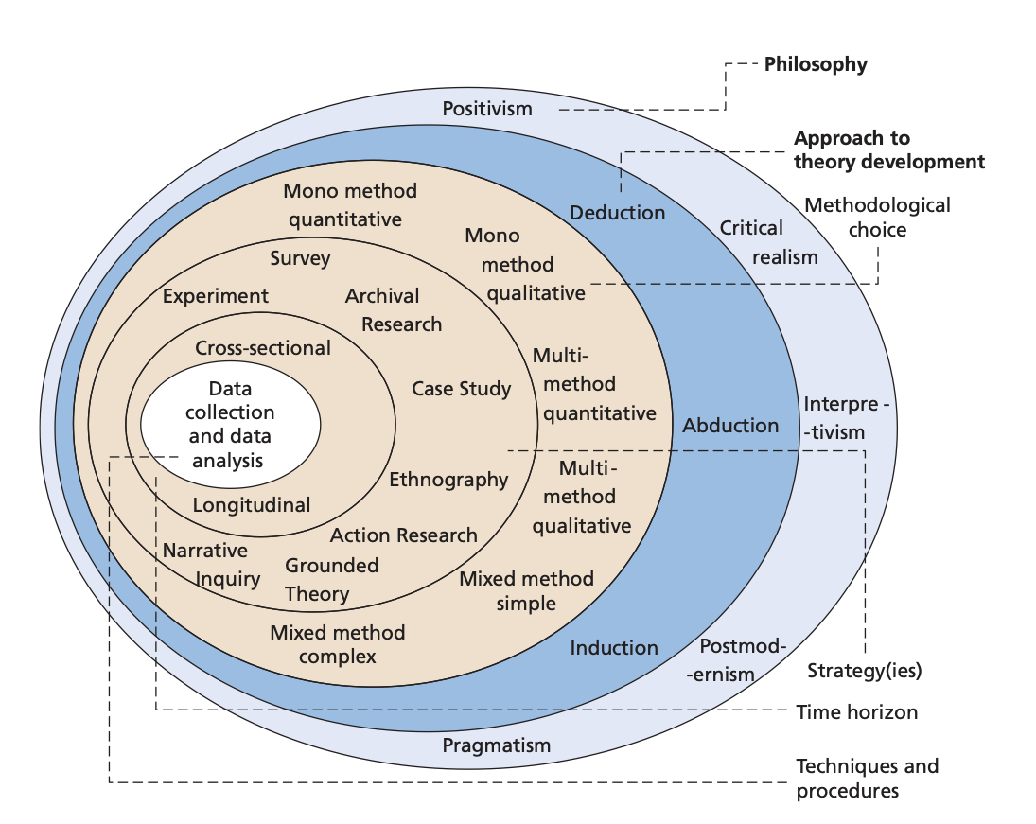

Figure 4.2.1



