BMIH4002
FOOD AND BEVERAGE OPERATIONS
(ASSESSMENT COMPONENT 2)
Rebecca Macavei
Student ID:2232071

Table of Contents
PART 1: Restaurant Concept 3
1. Explaining the restaurant concept 3
2. Target Audience 4
3. Justification of the choice of menu 5
PART 2: Menu Design 7
1. Food and Beverage Selection 7
2. Pricing Strategy 9
3. Nutrition and Special Dietary Requirements 11
4. Menu Layout and Design 12
5. Sustainability and Seasonality 13
References 14

PART 1: Restaurant Concept

1. Explaining the restaurant concept
The Trinity Hotel Chain is a four-star restaurant within the hospitality industry of the UK, Ireland, the US and many other places worldwide. The focus of the hotel is to bring in the food culture of the world within the UK. The concept of the hotel to fuse the modern influence of the food style with the ever-changing seasonal food is ensured with the inclusion of different cuisines and food cultures within the UK (Trinity Hotel, 2023).
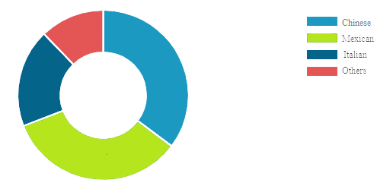
Figure 1: Demand for different cuisines in the UK
(Source: Custom Neon, 2023)
As shown in the above Fig 1, the demand for Chinese and Mexican cuisines has evolved post the impact of the Covid-19 pandemic. Therefore, the inclusion of Chinese and Mexican cuisines within the restaurants of the Trinity Hotel chain would ensure the development of the customer base. The offering of these cuisines within the new restaurant in London would ensure the meeting of the vision of the brand. The motive of Trinity Hotel to offer the best quality food and service to the tourist and students would be met with the inclusion of the two cuisines. The restaurant concept of 'Trinity Hotel' would be to include a stylish monochromatic design along with the contemporary food style within the traditional Chinese and Mexican foods and beverages would establish the brand value of Flames Inn, a restaurant chain of the Trinity Hotel Groups.

2. Target Audience
Segmentation
Geographic | Demographic | Psychographic | Behavioural
The restaurant is based in London, UK. | - The restaurant will target people in the age range of 18 to 60.  - Men and Women will be effective to use the services offered.  - Low to High-income background people will be targeted due to the affordable pricing strategy. | The company targets people looking for high-quality food and service in the hospitality sector. | - People looking for affordable yet high-quality services.  - People with healthy food service preferences.
Table 1: Segmentation of Trinity Hotel
(Source: Self-developed)
Targeting
The new restaurant concept of 'Trinity Hotel' targets people in the UK, who are looking for affordable high-quality services that include a variety of food and beverage items. People aged 14-60 years are the main target customers of the restaurant.
Positioning
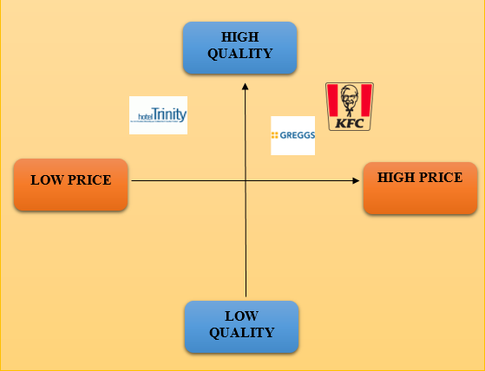
Figure 2: Positioning Map of Hotel Trinity
(Source: Self-developed)

3. Justification of the choice of menu
The menu of the Trinity Hotel will be created to provide the best food products to its customers. The menu will provide the customers with a wide range of options to enjoy. As found in a survey conducted in 2022, 62% of consumers in the UK prefer to eat healthy food (Kunst, 2023). The menu of Trinity Hotel will provide a wide range of healthy options to its customers in an affordable range. This will also allow the customers to enjoy the services offered by the hotel at a rational price. 48% of the UK consumers have agreed that value for the money is an important aspect when choosing food items to consume (Ozbun, 2022). This aspect provides evidence towards the appropriation of the menu.

PART 2: Menu Design

1. Food and Beverage Selection
The Trinity Hotel in London would offer customers, Chinese and Mexican cuisines. The following are the two menus of Chinese and Mexican Cuisines:
Chinese Cuisine
Starters | Prices
Crispy Chicken Wings | £1.55
Egg Foo Young | £1.15
Prawn Potstickers | £1.95
Roasted Pork Pastry | £2.20
Chicken Salad in Chinese-style | £1.75
Main Course | Prices
Kung Pao Chicken | £2.65
Sweet and Sour Pork | £2.99
Vegetarian Egg Drop Soup | £1.99
Yangzhou Fried Rice | £3.15
Mandarin Chow Mein | £3.20
Desert | Prices
Egg Tart | £0.75
Pumpkin Pancake | £0.99
Red Bean Bun | £1.00
Dragon's Beard Candy | £0.95
Deep Fried Durian | £1.10
Beverages | Prices
White Tea | £0.25
Bubble Tea | £0.55
Baijiu | £0.70
Suanmeitang | £0.50
Osmanthus Wine | £0.95
Table 2: Chinese Menu for Trinity Hotel
(Source: Created by author)
Mexican Cuisine
Starters | Prices
Chicken Nachos | £1.50
Chicken Taquitos | £1.25
Grilled Shrimp | £1.75
Chorizo Salad | £1.20
Pulled Pork Chimichanga | £1.99
Main Course | Prices
Costillas de Puerco en Salsa Verde | £2.85
Mole | £2.15
Butternut Squash Casserole | £2.50
Mexican Rice | £3.00
Sopa Seca | £3.50
Desert | Prices
Caramel Flan | £0.65
Sweet Mexican Corn Cake | £0.70
Mexican Wedding Cakes | £0.50
Dulce De Leche Donuts | £0.95
Mexican Fried Icecream | £1.00
Beverages | Prices
Agua de Jamaica | £0.65
Tascalate | £0.25
Pasita | £0.70
Tommy’s margarita | £1.50
Espresso martini | £1.65
Table 2: Mexican Menu for Trinity Hotel
(Source: Created by author)

2. Pricing Strategy
The pricing strategy of the hotel will follow an economic pricing strategy which can help the customers in the UK to afford and have them in a considerable range. The price will range from 13 pounds to 50 pounds and above making all the economy class customers have access to the products and the food items. In the UK, the household income was £32,300 in 2022 yet a decrease was found in 2021 by 0.6% (ONS, 2022). Therefore, the pricing strategy has been set in such a way that all the customers from every class can avail of it. However, there are competitors such as Greggs, Costa Coffee, KFC, Krispy Creme and others who have 67% having a positive opinion of the brand (Statista, 2023).

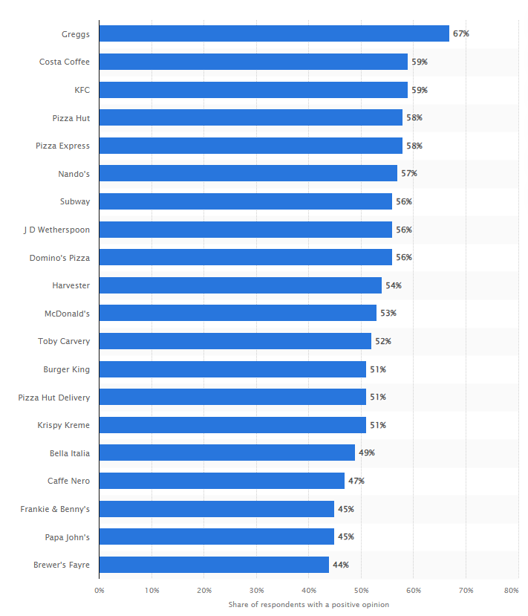
Figure 3: Top brands of restaurants in the UK
(Source: Statista, 2023)
The above brands might become stiff competitors of the hotel chain and this can also help the restaurant to set its prices by adopting a competitive pricing strategy. Gupta et al. (2021, p.102279), opined that a high profit is achieved when prices are set competitively. Hence, it can be evaluated that this pricing strategy can help in achieving the aim and objectives of the restaurant. Therefore, it can be understood that the restaurant will be able to gain a huge customer base within a period of a few months.

3. Nutrition and Special Dietary Requirements
Nutrition and dietary requirements are one of the basic and the most demanding attributes of the customers nowadays. It has been observed that half of the UK population is motivated to change their lifestyles by incorporating healthy food into their diet. They are aimed to eat “healthy food by 40%, lose weight by 39%, and exercise more by 41%” (GOV, 2021). Hence, including healthy food in their diet is important and considering this concern, Hotel Trinity has included gluten-free, lactose-free, and vegetarian food items. This includes Suanmeitang (health benefit Chinese drink), Chicken Salad in Chinese style (gluten-free healthy breakfast), and Vegetarian Egg Drop Soup (fibre free protein containing Chinese main course). These dishes are specially meant for the consumers who have a healthy attitude towards life and eating habits. The food items in Trinity contain healthy fibres, proteins, vitamins, and minerals found especially in the Suanmeitang (health benefit Chinese drink) which is really meant for health-conscious customers. The restaurant has also incorporated salads in the starters where Chorizo Salad (a Mexican healthy starter) can be consumed by the healthy and fit freak customers. The UK consumers have a tendency of consuming organic food and there is also a trend of healthy food and drinks in the food sector that has contributed over 2 billion pounds and is also growing rapidly (Statista, 2022). The number of vegans in the UK is also increasing with time which can help the restaurant in gaining a massive customer base. The content of Chorizo salad is made up of tempeh, tofu, and soy products along with garbanzo beans chunks which is really healthy for consumers. This directs that the hotel has followed the trends of a healthier and organic lifestyle in the UK and therefore, these items will suit them. Hence, it can be evaluated that the restaurant can gain a profit by incorporating more vegan items.

4. Menu Layout and Design
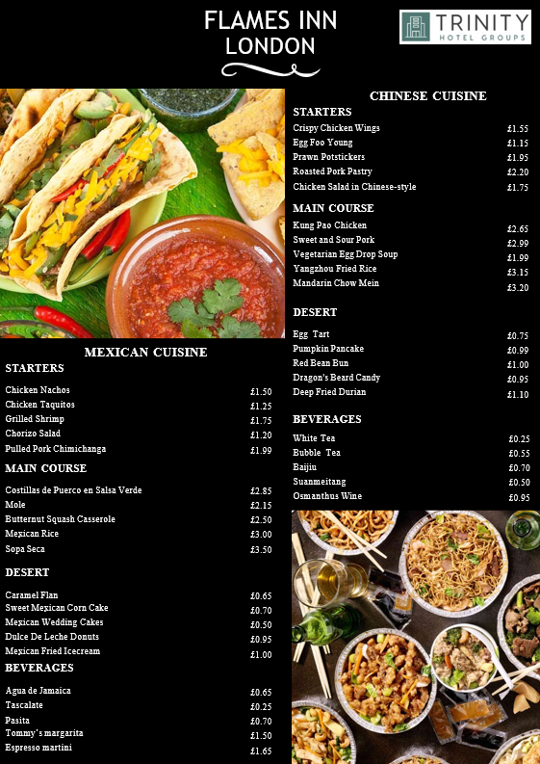
Figure 4: Menu of Flames Inn, a restaurant under the Trinity Hotel Groups
(Source: Created by author)

5. Sustainability and Seasonality
The sustainability is an essential factor that is required to be maintained to gain a relevant advantage in the market. The hospitality industry in the UK is highly competitive due to this aspect maintenance of the required ethical standards is essential to build a profitable business. As stated by Jones and Comfort (2020, p.3), sustainability in the business operations is essential to meet the needs of the stakeholders. For Trinity Hotel it is essential to develop the business operations by following the government regulations. The “Environmental Act 2021” is a UK-based regulation that is introduced by the UK government to reduce carbon emissions, and waste reduction in businesses to maintain sustainability (Legislation, 2023). The minimal impact on the planet is essential to address the ethical standards in the market. On the other hand, the target customers of the UK are becoming more aware of sustainability, which affects customer behaviour towards the brands. In 2022, 30% of adult residents in the UK have agreed that they will pay more money for attaining products and services for the brands with a commitment towards ethical business practice (Tighe, 2022). Thus, maintaining sustainability in the business process is essential for the business development of Trinity Hotel.
On the other hand, Seasonality can be utilised by companies to maintain business profitability in the target market. Seasonal changes in customer preference and emerging trends can be obtained by the company by changing the operational decisions with time. In order to provide relevant service and food for the customers the use of appropriate ingredients will help Trinity Hotel to maintain competitiveness in the market.

References
Custom Neon, (2023). ‘Restaurant Statistics’. Available at: https://customneon.com/restaurant-statistics/ (Accessed on 6 June 2023)
GOV, (2021). ‘Seven in 10 adults are motivated to get healthier in 2021 due to COVID-19’. Available at: https://www.gov.uk/government/news/seven-in-10-adults-are-motivated-to-get-healthier-in-2021-due-to-covid-19 (Accessed: 3 June 2023).
Gupta, V., Ivanov, D. and Choi, T.M., (2021). ‘Competitive pricing of substitute products under supply disruption’. Omega, 101, p.102279.
Jones, P. and Comfort, D., (2020). ‘The COVID-19 crisis and sustainability in the hospitality industry’. International journal of contemporary hospitality management, 32(10), pp.3037-3050.
Kunst, A. (2023). ‘Attitudes towards food in the UK 2022, Statista’. Available at: https://www.statista.com/forecasts/997914/attitudes-towards-food-in-the-uk (Accessed: 01 June 2023).
Legislation, (2023). ‘Environment act 2021, Legislation’. Available at: https://www.legislation.gov.uk/ukpga/2021/30/contents/enacted (Accessed: 01 June 2023).
ONS, (2022). ‘Average household income, UK: financial year ending 2022’. Available at: https://www.ons.gov.uk/peoplepopulationandcommunity/personalandhouseholdfinances/incomeandwealth/bulletins/householddisposableincomeandinequality/financialyearending2022#:~:text=Median%20household%20disposable%20income%20in,(ONS)%20Household%20Finances%20Survey. (Accessed: 5 June 2023).
Ozbun, T. (2022). ‘U.K.: Which foods to purchase by factor 2021, Statista’. Available at: https://www.statista.com/statistics/1258892/factors-when-choosing-which-foods-to-purchase-in-the-united-kingdom/ (Accessed: 26 May 2023).
Statista, (2022). ‘Health and wellness food trends in the United Kingdom - statistics & facts’. Available at: https://www.statista.com/topics/6843/health-and-wellness-food-trends-in-the-uk/#topicOverview (Accessed: 2 June 2023).
Statista, (2023). ‘Most popular dining brands in the United Kingdom (UK) as of the fourth quarter of 2022’. Available at: https://www.statista.com/statistics/950444/most-popular-restaurant-brands-in-the-united-kingdom-uk/ (Accessed: 1 June 2023).
Tighe, D. (2022). ‘Shopping behavior for ethical & sustainable brands UK 2022, Statista’. Available at: https://www.statista.com/statistics/1325387/paying-more-for-sustainable-and-ethical-brands-uk/ (Accessed: 02 June 2023).
Trinity Hotel, (2023). ‘About Us’. Available at: https://trinityhotelgroups.com/about-us (Accessed on 6 June 2023)

