

Cover Page
Name: Sherelle Mclean
Student Number: 2407059
Module: Changemakers: Building your Personal Brand for Sustainable Employment
Module Code: BMHP5015
Lecturer: Olufemi Oluranti
Assignment Title: Component 1: Online Portfolio of Set Exercises

Task 1 – Personal Brand
Introduction
Personal branding is how an individual presents their skills, values and professional identity to others. It helps employers recognise a person’s strengths and improves employability in a competitive job market (Gujarathi and Kulkarni,2018). In health and social care, a strong personal brand reflects professionalism ,compassion, and commitment to continuous development.
Main Body
I would describe my personal brand as hardworking, reliable and committed to learning. Throughout my studies and employment, I aim to be organised, supportive and professional. I enjoy helping others and completing tasks to a high standard, reflecting the values expected within health and social care. Balancing university, work and family responsibilities has strengthened my resilience, adaptability and time-management skills. These qualities are essential because professionals must respond effectively to changing situations and deliver person-centred care
My long-term career goal is to open an Afro-Caribbean care home providing culturally sensitive care for older adults. Achieving this ambition requires leadership, communication and management skills alongside professional knowledge. Gorbatov, Khapova and Lysova (2018) suggest personal branding is built through consistently demonstrating professional values and behaviours. I recognise the importance of improving my confidence when networking and speaking professionally. I plan to attend workshops, gain leadership experience and engage in continuous professional development.
Conclusion
Overall, developing my personal brand will improve my confidence, professionalism, and employability. By continuing to build my skills, gain experience and demonstrate my values, I will be better prepared to achieve my ambition of opening an Afro-Caribbean care home and delivering high-quality, person-centred care.

Task 2 - Network Map and Rationale
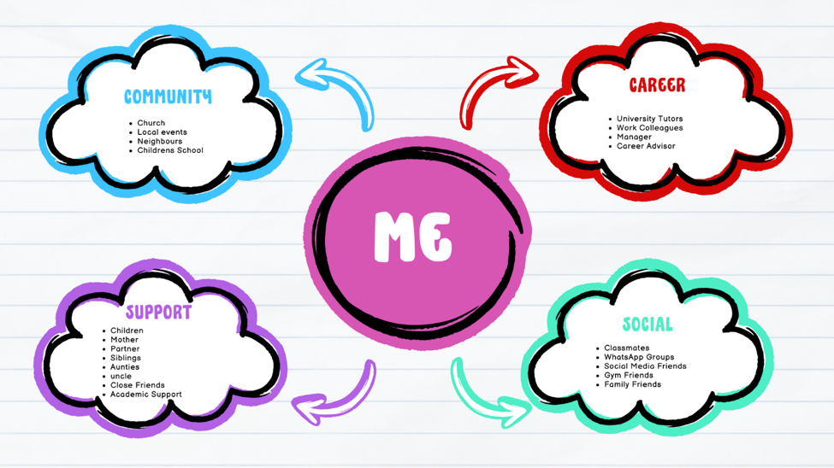
My network can be described as a hybrid network because it includes both close personal relationships and professional connections. It consists of family members, friends, classmates, work colleagues, my manager, university tutors and my church community. These relationships provide emotional support, guidance and motivation in both my personal and professional life. Social networks are important because they provide access to support, information and opportunities that contribute to personal and career development (Kyne and Aldrich, 2020).
The strongest part of my network is my bonding social capital. I have close relationships with my children, partner, mother, siblings, aunties, uncles and friends. These are people I trust and communicate with regularly. They provide emotional support, encouragement and practical help during challenging times. Claridge (2018) explains that bonding social capital strengthens wellbeing and resilience through trusted relationships.
My bridging social capital is developing because I communicate with classmates, tutors and work colleagues from different backgrounds. These relationships broaden my knowledge and expose me to different perspectives and experiences. However, I could strengthen this area by attending networking events and engaging with professionals outside my immediate workplace.
My linking social capital is also developing through relationships with my manager and university tutors, who provide guidance and professional advice. Strengthening these connections will support my long-term ambition of opening an Afro-Caribbean care home by providing mentoring, leadership development and opportunities to learn from experienced professionals within the health and social care sector.

Task 3- Blog
Title: Is Healthcare Becoming Too Digital?
Introduction
Have you noticed how much healthcare has changed in recent years? Many GP appointments are now booked online, repeat prescriptions can be ordered through apps, and patients can access their medical records digitally. These changes have made healthcare more convenient for many people. However, not everyone finds digital technology easy to use. Older adults and vulnerable groups may face challenges because of limited digital skills, lack of confidence or poor internet access. As healthcare becomes increasingly digital, it is important to ask whether everyone is benefiting equally.
Main Body
Digital healthcare includes online appointment booking, video consultations, electronic prescriptions and healthcare apps. Following the COVID-19 pandemic, digital services became more widely used. According to Castle-Clarke and Imison (2016), digital healthcare has the potential to improve access to services and make healthcare more convenient. For many patients, these services save time and provide greater flexibility when accessing care.
Despite these benefits, digital exclusion remains a significant issue. Without suitable alternatives, increased reliance on digital services may unintentionally widen existing health inequalities. Many older adults did not grow up using digital technology and may feel anxious about using online healthcare systems. Others may not have access to a smartphone, computer or reliable internet connection. Age UK (2024) reports that many older people feel frustrated when services become increasingly digital because they worry about making mistakes or missing important information.
Digital exclusion can also affect health outcomes. Patients who struggle to use online systems may delay seeking medical advice, miss appointments or find it difficult to manage long-term health conditions. Family members and carers often provide additional support. Many people also value face-to-face communication with healthcare professionals, particularly when discussing sensitive health concerns.
Healthcare providers can improve digital inclusion by offering support and training to those who lack confidence with technology. Community centers and libraries can provide digital skills workshops, while healthcare services should continue offering face-to-face and telephone appointments. Giving people a choice in how they access care will help ensure digital healthcare improves access rather than creating barriers.
Conclusion
Digital healthcare offers many advantages, but it should not replace traditional methods of care entirely. A balanced approach that combines technology with personal support is essential to ensure healthcare remains accessible and inclusive for everyone. By giving people, a choice in how they access healthcare services, organisations can reduce inequalities while improving patient experience and outcomes across the NHS.
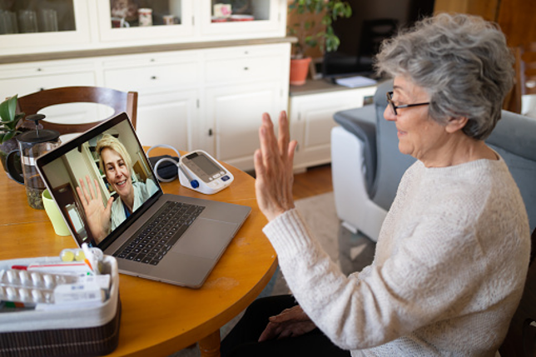
(istock,2022)

Task 4- NHS Equality, Diversity and Inclusion Quiz (250 words equivalent)
1.What is the primary goal of the NHS Equality, Diversity, and Inclusion Improvement Plan? The plan aims to create a fair, inclusive workplace where everyone is treated equally and has opportunities to succeed, improving both staff experience and patient
2.How does the NHS EDI Improvement Plan propose to tackle the gender pay gap? It improves pay transparency ,monitor inequalities and removes barriers preventing woman from progressing into higher-paid leadership roles.
3.What is meant by the term ‘intersectionality’ as used in the NHS EDI Improvement Plan? Intersectionality recognises that people may experience multiple forms of discrimination because of characteristics such as ethnicity, gender, disability or age.
4.Why is it important for the NHS to create a psychologically safe work environment? It encourages staff to speak up without fear, improving wellbeing, teamwork, learning and patient safety.
5.How does the NHS EDI Improvement Plan suggest improving the experience of internationally recruited staff? The plan recommends better induction, mentoring and culturally sensitive support to help internationally recruited staff feel welcomed and valued.

6.What role does leadership play in advancing EDI objectives according to the NHS Improvement Plan? Leaders promote inclusive behaviour, embed EDI into practice and monitor progress to create a positive workplace culture.
7.Identify one way the NHS EDI Improvement Plan aims to reduce health inequalities within the workforce. It improves representation of underrepresented groups in senior leadership roles, creating fairer opportunities for career progression and reducing workforce inequalities.
8.Why does the NHS EDI Improvement Plan emphasise the importance of collecting and analysing data on protected characteristics? Collecting data helps identify inequalities, monitor progress and ensure decisions are evidence-based.
9.Explain how flexible working policies can contribute to equality and inclusion in the NHS workforce. Flexible working supports staff with caring responsibilities or health needs, improving retention and equal opportunities.
10.What is one strategy mentioned in the NHS EDI Improvement Plan to combat bullying and harassment in the workplace? The plan strengthens reporting systems and ensures bullying concerns are investigated consistently and addressed appropriately.

Task 5- A Letter to Yourself
Dear Younger Me,
If I could go back and talk to you, I would not tell you to work harder. I'd tell you to be kinder to yourself.
I remember how determined you were to keep everything together. You were working, looking after your family and trying to build a better future through education. You convinced yourself that you had to cope with everything alone because that's what strong people do. The truth is you were exhausted. You ignored your own needs because everyone else's always came first.
Since learning about emotional intelligence, I've realised how much it could have helped you then. You rarely stopped to think about how you were feeling. Instead, you buried your emotions and carried on until the stress became overwhelming. Being more self-aware would have helped you recognise when you were becoming emotionally drained. It would also have encouraged you to speak honestly about how you felt instead of pretending everything was under control. Asking for support would not have been a weakness; it would have been a healthy way of managing difficult situations.
I've also learned that resilience is much more than simply getting through hard times. Back then, every setback felt like proof that you weren't good enough. Now I understand that resilience means accepting challenges, learning from them and continuing to move forward even when things don't go as planned. Those difficult moments were shaping your confidence, patience and determination, even though you couldn't see it at the time.
Rest without feeling guilty, celebrate your progress and remember that you don't have to carry every burden on your own. The challenges you're facing won't last forever, but the lessons they teach you will stay with you for life. One day, you will look back with pride and appreciate how far you have come.
With love,
Sherelle

Task 6- GANTT Chart (200 words equivalent)
The Gantt chart outlines a realistic plan for achieving my long-term career goal of launch an Afro-Caribbean care home. It provides a clear timeline of the key stages in my education, professional and business development, helping me monitor my progress and stay focused on my objectives.
The first stage is completing my Level 4 Certificate in Higher Education Skills for the Workplace (Health and Social Care), followed by my graduation in June 2026. I will then continue my studies by completing Level 5 in September 2026 and Level 6 in September 2027. These qualifications will strengthen my knowledge of health and social care while preparing me for leadership and management responsibilities.
Alongside my studies, I will continue working in the care sector, building on my practical skills and gaining leadership experience. I also plan to complete leadership training, research the care needs of older Afro-Caribbean adults, improve my business knowledge and develop a detailed business plan.
The final stages include exploring funding opportunities, preparing for CQC registration and opening my Afro-Caribbean care home. Overall, the Gantt chart provides a structured and achievable plan that supports my professional development and helps me achieve my long-term career aspirations successfully.
Task | Start Date | End Date | Duration | Dependency | Milestone
Level 4 Skills for Workplace (Health and Social Care) | September 2024 | September 2025 | 12 months | None | Level 4  Completed
Graduate from level 4 | June 2026 | June 2026 | 1 day | Complete Level 4 | Level 4 Graduation
Complete level 5 BSc Health and Social Care | September  2025 | September 2026 | 12 months | Level 4 Completed | Level 5 Completed
Complete level 6 BSc Health and Social Care | September 2026 | September 2027 | 12 months | Level 5 Completed | Degree Completed
Continue Working in Care and gain Leadership and Management Experience | January 2023 | Ongoing | Ongoing | Ongoing Alongside Studies | Management Experience Gained
Attend Care Leadership and Management Training | January 2027 | September 2027 | 9 months | Level 5 + work Experience | Leadership Qualification Achieved
Research the Needs of Older Afro-Caribbean Adults and Culturally Appropriate Care Services | January 2027 | December 2027 | 12 months | Care Experience + Level 5 | Research Completed
Develop Business and Care Home Management Knowledge | September 2027 | June 2028 | 10 months | Degree Completion + Research | Business Skills Developed
Develop a Business Plan for an Afro- Caribbean Care Home | January 2028 | December 2028 | 12 months | Business Knowledge Development | Business Plan Completed
Explore Funding and Investment Opportunities | June 2028 | January 2029 | 8 months | Business Plan Completed | Funding Strategy Developed
Register the Business and Prepare for CQC Registration | January 2029 | December 2029 | 12 months | Funding Secured | Registration Process  Started
Open Afro-Caribbean Care Home | January 2031 | December 2031 | 12 months | All Previous Task Completed | Career Goal Achieved

Task 7- Making Changes- Report
Implementing a Fall Prevention Program in a Care Home
Introduction
As a care home manager, I would like to introduce a fall prevention program to reduce the number of falls among residents. Falls are a common issue in care homes and can lead to serious injuries, reduced independence, and a lower quality of life. Implementing a falls prevention program can help improve residents’ safety and wellbeing while promoting high-quality care (NICE,2025).
Planning the change
The proposed change would involve introducing regular falls risks assessments, staff training, environmental safety checks, and personalised care plans for residents identified as being at risk of falling. Residents and their families would also be involved in discussions about falls prevention strategies.
To implement this change, I would use Lewin’s change theory (Lewin,1947). During the unfreezing stage I would share information with staff about the impact of falls and the need for improvement. In the changing stage, staff would receive training, risk assessments would be completed, and safety measures would be introduced. During the refreezing stage, falls data would be monitored regularly to evaluate the effectiveness of the program and ensure the new practices become part of routine care.
Skills required
To lead this change effectively, I would need strong leadership and communication skills to engage staff and encourage participation. Time management skills would be important when organising training and monitoring progress. Problem solving skills would help address any challenges that arise, while teamwork would be essential to ensure all staff work together towards improving resident safety (Burnes,2020).
Barriers and Solutions
One potential barrier is staff resistance to additional responsibilities and paperwork. To address this, I would explain how falls prevention can improve resident outcomes and reduce injuries. Another barrier may be limited time for staff training. This could be overcome by providing short training sessions during working hours. Financial constraints may also affect environment improvements; however, prioritising high risk areas and seeking cost effective solutions can help manage resources efficiently (NICE,2025).
Conclusion
Introducing a falls prevention program could significantly improve resident safety and wellbeing. By following a structured approach to change and supporting staff throughout the process, the program is more likely to achieve long-term success and contribute to high-quality care.

Reference List
Age UK (2024) More than 1 in 3 over 65s (4.7 million) lack the basic skills to use the internet successfully.https://www.ageuk.org.uk/latest-press/articles/2024/more-than-1-in-3-over-65s-4.7-million-lack-the-basic-skills-to-use-the-internet-successfully/(Accessed 11 June 2026).
Burnes, B. (2020) Managing change. 8th edn. Harlow: Pearson.
Castle-Clarke, S. and Imison, C. (2016) The digital patient: transforming primary care? London: Nuffield Trust. Available at:https://www.nuffieldtrust.org.uk/sites/default/files/2019-08/nt-the-digital-patient-web-update-august-2019.pdf(Accessed 11 June 2026).
Claridge, T. (2018) Social capital and community development. Brisbane: Social Capital Research.
Gorbatov, S., Khapova, S.N. and Lysova, E.I. (2018) ‘Personal branding: Interdisciplinary systematic review and research agenda’, Frontiers in Psychology, 9, pp. 1–17.
Gujarathi, R. and Kulkarni, S. (2018) ‘Personal branding: An answer to employability – a conceptual need base analysis’, Review of Research, 7(10), pp. 1–6.
iStock (2022) Senior patient having online consultation with her doctor stock photo. Available at:https://www.istockphoto.com/photo/senior-patient-having-online-consultation-with-her-doctor-gm1397435404-451868714(Accessed on11 June 2026).
Kyne, D. and Aldrich, D.P. (2020) ‘Capturing bonding, bridging and linking social capital through publicly available data’, Risk, Hazards & Crisis in Public Policy, 11(1), pp. 61–86.
Lewin, K. (1947) 'Frontiers in group dynamics: Concept, method and reality in social science; social equilibria and social change', Human Relations, (1), pp. 5–41.
National Institute for Health and Care Excellence (NICE) (2025) Falls: assessment and prevention in older people and in people 50 and over at higher risk (NG249). Available at: https://www.england.nhs.uk/long-read/nhs-equality-diversity-and-inclusion-improvement-plan/ (Accessed 14 June 2026).
NHS England (2023) NHS Equality, Diversity and Inclusion Improvement Plan. Available at: https://www.england.nhs.uk/long-read/nhs-equality-diversity-and-inclusion-improvement-plan/ (Accessed 12 June 2026).

