

BA BUSINESS MANAGEMENT
Assessment 2:
Reflective Evaluation

Name: Daniela Ambros
Student ID: 2115350
Module name: Community Engagement
Module code: (LCBB4002)
Lecturer: Dr Nadeem Mirza

Table of contents:

1. Introduction..............................................................................................................3
2. Community engagement principles....................................................................3 - 4
3. Standards...........................................................................................................5 - 6
4. Consultation methods.........................................................................................6 - 7
5. Stakeholders’ participation..................................................................................7 - 8
6. Communication approaches...............................................................................8 - 9
7. Conclusion........................................................................................................9 - 10
8. References.............................................................................................................11
9. Appendix.................................................................................................................12

- Introduction
''Community is a fundamental component of society,'' argues Day (2006, p.15). In the author's view, a community consists of people who share things between themselves. This term can refer to a wide range of factors, such as shared government, geographic location, culture, or heritage, as well as the connections between individuals who feel a sense of belonging. These days, community engagement has become one of the core goals of most councils, including Enfield Council. Public services have had difficulty engaging residents in different community activities due to their busy schedules and diverse backgrounds. These organisations are responsible for a wide range of services in a county, including education, transportation, planning, fire and public safety, social care, libraries, etc., so stakeholders' feedback is essential for the success of the community as a whole. As part of my second assignment, I will reflect upon the first assignment, community engagement at Enfield Council. Gibbs (1988) states that reflection is an essential part of learning and developing future recommendations and plans. Therefore, this essay will provide an overview of my thoughts, feelings, and experiences when researching and analysing the principles, standards, consultation methods, stakeholder participation, and communication strategies used by Enfield Council. Hopefully, this will help me gain a greater understanding of future strategies and allow me to recommend the best course of action.

- Community engagement principles
The fact that Enfield Council has used community engagement principles when working with its stakeholders has significantly impacted my personality. The publication "Principles of community engagement" (ATSDR, 2015) states that leaders must adhere to these principles, including building relationships with the community, establishing trust, and operating with both formal and informal leadership. Considering this principle, it appears that favourable change is more likely to occur when community members are integrally involved in program development and implementation. Meeting with key community leaders and groups in the surrounding area, for example, helps to build trust necessary for a successful partnership. There is no doubt that this is a significant step toward building a successful rapport between community members, showing them the value of their input, both as time, force, and knowledge. In my opinion, this principle should be emphasised by the Endfield Council more. This includes engaging with all factions, expanding the picture of community engagement, and avoiding the assumption that one feedback represents the whole community. The council also adheres to the principle of recognising and respecting the diversity of its community. According to the Council's website, they also respect the 'protected characteristics' specified in the Equalities Act 2010, such as race, disability, and religious beliefs (Government, 2015). Moreover, the Fairer Enfield Policy 2021-25 describes how the council will support workplaces, communities, create new opportunities, and outlines how council staff must behave and portray themselves when tackling inequality (Enfield, 2023). Since I am foreign, I had assumed that foreigners' opinions and states were of little importance to the local community, but now I realise that is not the case. As a result of my investigation, I found out that immigrants are significant to this community. Enfield Council is working hard to reduce inequality, including addressing racism and youth violence in the Borough.
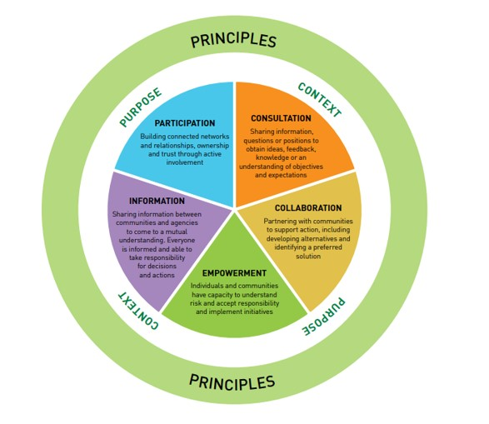
Figure 1. Community engagement principles (Tasmanian Government, 2023).
- Standards
The National Standards for Community Engagement are a set of guidelines that describe the main elements of effective community engagement. These standards are designed to facilitate the development of policies relating to participation, engagement, and community empowerment (National Standards for Community Engagement, 2016). I had no idea how beneficial they would be for community engagement when I revised them. A combination of these seven standards will benefit the public sector, community groups, and independent sector. These include: Impact, Communication, Methods, Working Together, Planning, Support, and Inclusion. Support standards aim to remove or reduce any barriers that prevent people from participating in engagement activities. These barriers include transportation, personal care, convenient times, or interpreter access. Another standard, planning, requires detailed research, revision of the information, and an understanding of community needs and ambitions. During this process, the primary objective of the engagement that will be carried out by the partners is identified and defined. Each participant knows the outcome of the engagement process, the tools that will be used to measure the outcome, the time scale, and resources they have available. Enfield Council, for example, wishes to learn about residents' experiences and needs regarding health and social care. I am confident that the independent community and other members of the community with an interest in the topic will plan together on the questions, methods of engagement, who should be involved, and the time scale for the process. It is my belief that planning is an excellent opportunity to prepare everything before moving forward with implementation.
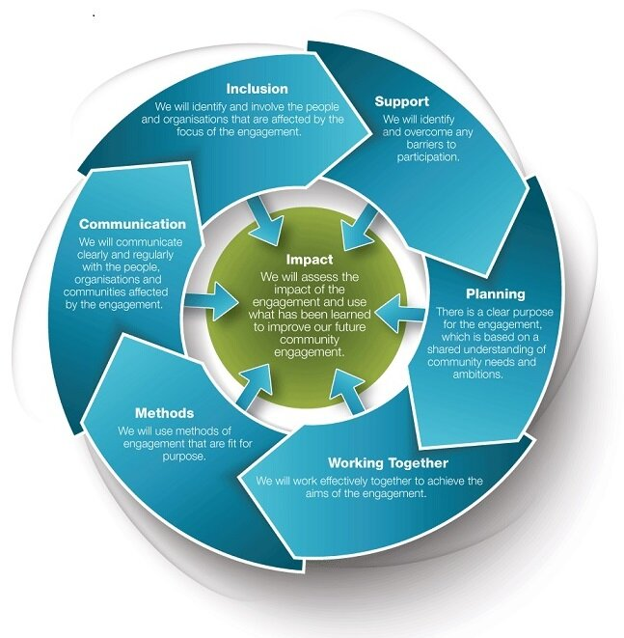
Figure 2. Community engagement standards (The National Standards, 2016).

- Consultation methods
For me, the significant aspect when researching Enfield Council operations was to find out that this council use several consultation approaches. Various methods have been employed, including telephone surveys, website questionnaires, forums, and focus groups, seminars, workshops, public meetings, and interviews. Every individual in a community has different abilities, health situations, and even diverse ways to work and relax. This makes it difficult for all stakeholders to be reached at the same time. However, it should be noted, that we live in a technologically advanced world in which people's preferences are constantly changing. In this case, Enfield Council should carefully consider some methods, such as whether this approach is still accepted or there are alternative options to consult stakeholders. When it comes to face-to-face interviews or meetings with focus groups, why not plan everything online, using Teams or Zoom? Throughout my experience, I have found that online consultations are easy, fast, and more productive than traditional ones. Moreover, the use of paper by Enfield Council to communicate with community members, such as leaflets and letters, is not acceptable to me. According to my view, Enfield Council should revise its methods and operations to ensure sustainability. The situation makes me feel concerned about the future of all trees and the environment as a whole due to human demands.

- Stakeholders' participation
The participation of stakeholders is an essential part of the community's decision-making process. These individuals and groups may be affected by or interested in the Council's work and projects. First, stakeholder participation and collaboration are necessary to ensure their input into different projects. Previously, I was unaware that the number of stakeholders was so large, and they have been divided into two groups, internal and external. In terms of the internal structure, there are several groups: senior officers and councillors, frontline staff, service specialists, IT department, Web team, and communication team. External stakeholders include suppliers, contractors, community and government agencies, voluntary sector organisations such as Citizens Advice, and the private sector. Furthermore, I was impressed by the importance of stakeholder involvement in Enfield Council in such a significant manner, such as the provision of skills, knowledge, and resources for accelerating community development. By involving stakeholders, Council can uncover potential risks and address and resolve grievances more rapidly. Collaboration would also include supporting sustainable development, such as zero-waste living, green roofs, community gardens, and e-waste recycling projects. Diversity of ideas, goals, and talents can also increase participation, facilitate understanding, and enhance contributions. The involvement of stakeholders brings many benefits to the Enfield Council, however, in my opinion it also poses some challenges. This can be illustrated by noting that everyone is unique, that each has their own views, preferences, and different responsibilities and requirements within the community. Therefore, if one person shares a point of view during a meeting, others may disagree or suggest something else, creating tension in the meeting. This is why it is imperative to maintain a balance between diplomacy and democracy when bringing all these individuals together.

- Communication approaches
People can become closer and connect with each other through communication, which is an integral part of social life (Thompson, 2018). Enfield Council communicates with its audience to engage them rather than inform them of its issues and services. In addition, effective communication will assist residents in becoming informed and satisfied, as well as assist Council in building a positive reputation, fostering trust, and providing effective services. The lesson I have learned is that communication is not only about external stakeholders, but also involves internal communications within an organisation. Considering that council staff prepare all written communications and provide all types of customer service, they require a clearly detailed message so that further accurate information can be supplied externally. Furthermore, these details lead me to the conclusion that Enfield Council's approach to communications is timely, open, reliable, and focused on issues. Through a variety of channels, the Enfield Borough Council communicates and engages with residents, councillors, and employees:
- Council's website is the main communication channel, providing large page options including housing, parking, rubbish, recycling, cost of living support, education, and others.
- Several social media channels, including Facebook, Twitter, Instagram, Nextdoor, and LinkedIn.
- Residents email
- Business newsletter
- Print and broadcast media
- Adverts and public notices in the local press
- Public events
- Public noticeboards
- Business masterclasses
- Communication within the organisation is handled through various means, including the Empact app, Teams app, the staff newsletter, and staff forums.

- Conclusion
It has been an immense pleasure for me to revise community engagement based on the model of Enfield Council. As I reflected on Enfield Council's operations, I became more aware of how complex and challenging this process is. All of this is about the community, about the residents, their concerns, and their needs. Enfield Council is making efforts to improve the services offered to its customers, and every received feedback is valuable. Different forms of consultation are being utilised in order to achieve this goal. Additionally, they use principles and standards when engaging all Council stakeholders.
Despite their efforts, I have observed that there is still room for improvement in the technology field. Therefore, revising the impact of COVID-19 on attitudes towards remote and flexible work environments has increased expectations that organisations should be able to rapidly adapt to offer their clients a greater range of connectivity and services. Based on this, specifically, I recommend that Enfield Council implements a digital service strategy. In a newly established department, traditional IT hardware and software support is combined with data analysis. In the future, Digital Services will develop into a mature digital and data service that understands fully the organisation and community it serves, leveraging this insight to achieve the Council's priorities.
Every interaction, product, and solution should be revolved around the customer. Moreover, as indicated by Gilchrist (2009), networking at the workplace will contribute to the development of the community and the delivery of services. Throughout the course of the project, they will acquire, retain, and deploy knowledge that is unparalleled. Also, these changes will allow Council to ensure maximum productivity while minimising waste in terms of effort, resources, and council funds. This will reduce people costs and will deliver savings for approximatively three years. Moreover, developing a comprehensive talent management program, including career paths, succession planning, and training and development from childhood to retirement will be the key to success for the community.

- References:
ATSDR (2015) Principles of Community Engagement. Available at: ttps://www.atsdr.cdc.gov/communityengagement/index.html (Accessed: 12th April 2023).
Day, G. (2006) Community and Everyday Life. London: Taylor & Francis Group.
Enfield Council (2023) About equality and diversity in Enfield. Available at: (Accessed: 27th April 2023).
Gibbs, G. (1988) Learning by doing: A guide to teaching and learning methods. Oxford: Oxford Further Education Unit.
Gilchrist, A. (2009) The well-connected community: a networking approach to community development [online]. 2nd Ed. Bristol: Policy Press. Available at: https://doi.org/10.1332/policypress/9781847420565.001.0001 (Accessed: 25th April 2023).

Government (2015) Equality Act 2010: guidance. Available at: https://www.gov.uk/guidance/equality-act-2010-guidance (Accessed: 27th March 2023).

National Standards for Community Engagement (2016) Available at: https://static1.squarespace.com/static/60b74b3ad7fb3972cfe271b0/t/612ce339dff85a247d7864fd/1630331714162/NSfCE+online_October.pdf (Accessed: 1st May 2023).
Tasmanian Government (2023) Community Engagement [Figure 1]. Available at: https://www.ses.tas.gov.au/emergency-management-2/tasemt/community-resilience-engagement/community-engagement/ (Accessed:15th April 2023).
Thompson, N. (2018) Effective communication: a guide for the people professions. 3rd Ed. England: Palgrave Macmillan.

- Appendix


