

AN INVESTIGATION IN TO THE RISE OF DOMESTIC ABUSE CASES POLICE ARE RESPONDING TO IN THE SWANSEA & NEATH PORT TALBOT AREA IN THE LAST 18 MONTHS

James Rees

Student number – 1816144

Degree Title - BSc Professional Policing Practice

Acknowledgements

I would first off like to acknowledge my friends, family and work colleagues for their immense help and patience whilst I completed this dissertation. Without their help and support I would not have been able to complete this project. Without the support and patience of my colleagues I would not have been able to conduct the research that enabled me to write this project. I would also like to say thank you to my supervisor who without his guidance and his help in time management half of the project would not be completed.

Declaration

Declaration - This work has not previously been accepted in substance for any degree and is not being concurrently submitted in candidature for any degree. Signed: James Rees Date: 29/11/21

Statement 1 - This dissertation is being submitted in partial fulfilment of the requirements for the degree of BSc. Signed: James Rees Date: 29/11/2021

Statement 2 - This dissertation is the result of my own independent work/investigation, except where otherwise stated. Other sources are acknowledged by footnotes giving explicit references. A bibliography is appended. Signed: James Rees Date: 29/11/2021

Statement 3 - I hereby give consent for my dissertation, if accepted, to be available for photocopying and for interlibrary loan, and for the title and summary to be made available to outside organisations. Signed: James Rees Date: 29/11/2021

Statement 4 - I hereby give consent for my dissertation, if accepted, to be available on the university’s IT system to those who have consent to use the system. Signed: James Rees Date: 29/11/2021

Abstract

Domestic violence is a problem that has been prevalent in society for ever, it is a problem that not only exists as people believe, between two partners but Domestic Violence can also be between family members, this is described by Victim Support, 2021 as
‘any incident or pattern of incidents of controlling, coercive, threatening behaviour, violence or abuse between those aged 16 or over who are, or have been, intimate partners or family members regardless of gender or sexuality.
With the Covid-19 lockdown taking place within the last 18 months, this problem has been exacerbated with families and couples being confined together for long periods of time when there would normally be methods of escaping the boredom or company of another. Domestic violence is a country wide issue which has been narrowed down for the purposes of this project to highlight a specific area. This is specifically in the Neath Port Talbot and Swansea area, the purpose is to discover whether or not there has been an increase in domestic violence incidents over the last 18 months which coincides with the national lockdowns for Covid-19.

Table of Contents
- Acknowledgements – Page 1
- Abstract – page 3
- Table of contents – Page 4
- Chapter 1 – 1.1 Introduction – Page 6
- 1.2 Objectives & 1.3 Research methodology - Page 6
- 1.4 Conclusion – Page 7
- Chapter 2 Literature review & 2.1 Introduction – Page 9
- 2.2 The Topic – Page 10
- 2.3 the Conclusion – Page 13
- Chapter 3 & 3.0 Introduction – Page 14
- 3.1 Methods – Page 15
- 3.2 Evaluation – Page 16
- Chapter 4 & 4.0 Analysis of results – Page 17
- 4.1 Survey – Page 18
- 4.2- Summary – Page 21
- Chapter 5 & 5.0 Introduction – Page 22
- 5.1 Survey Results – Page 23
- 5.2 Conclusion – Page 24
- 5.3 Recommendations – Page 25
- Chapter 6 – References – Page 26
- Appendix – Page 30

Chapter 1

1.1 Introduction – Research background

There has been a stark increase in the amount of domestic abuse cases reported to the Police and during the coronavirus pandemic there has been an increase in the number of domestic incidents reported, including assaults and harassments as shown below. However there are some domestic incidents go unreported therefore the true figure would never be known.

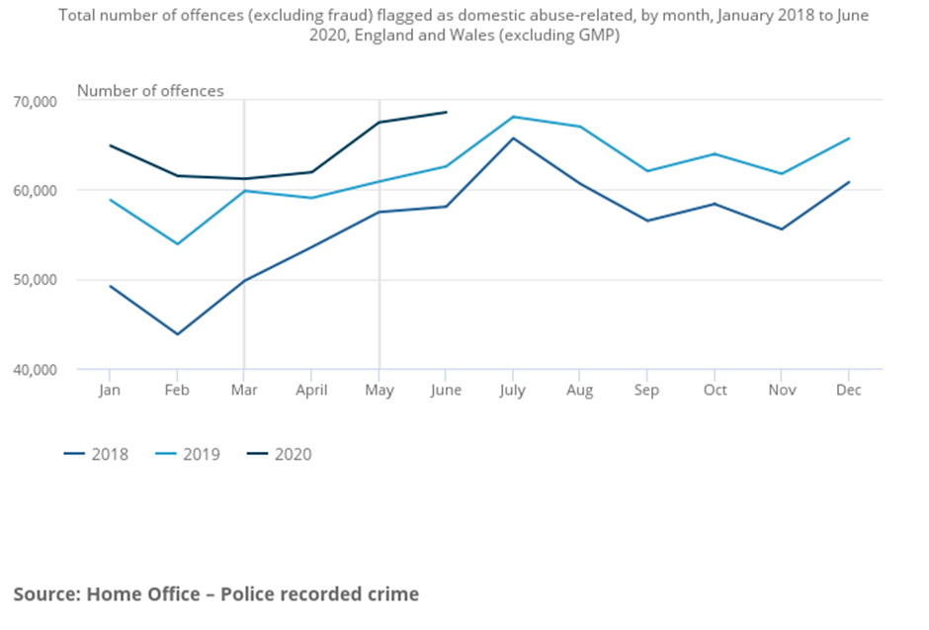

Statistics show that from 2018 there has been an 18% increase in the reported cases to police which are domestic related and a 7% increase in cases from 2019, whether this is due to a case of more crimes are recorded by Police or whether there is an increase in Domestic cases co-in siding with the Coronavirus pandemic. (ONS, 2021)
Domestic violence is a crime that has major impact on lives, not only just the primary persons involved but also those not directly involved such as the secondary/tertiary family members which Betterhelp, 2021 goes into detail on. It is not a victimless crime and it is believed that it goes vastly unreported by the media until a serious matter such as the death of a victim/aggressor as shown in The Crown Prosecution Service, 2021 whereby a domestic abuser ended up taking the life of their partner. The work that the Police do around protecting victims and taking appropriate action is also underreported a study into the rise and the social implications around this is a valid effort. (Whatworks.college.police.uk. 2021) (Justiceinspectorates.gov.uk. 2021)

In the police domestic issues are the primary concern for most forces (Foundation, 2021) and the actions needed to be taken leave no room for discretion, this is a stark contrast to previous years where discretion may have elongated the abuse suffered by the victim or there have been failings by officers to understand the seriousness of the allegations (Maria Stubbings, 2021) (BBC News. 2021. These victims rely on the Police and despite sometimes them not wanting to engage, Police take appropriate action in every circumstance.
By looking into this and by formulating the best conclusion it might have some effect at reducing the number of victims of domestic violence or boost the numbers of persons reporting domestic violence, as it is not just women that experience domestic violence. There is also the added positive that senior Police management such as NPCC (About, 2021) may pay heed to the rises in DV, whilst proactive Policing is something that cannot combat it, perhaps a change in legislation to recognise it as an individual offence could be implemented (Improving police response to domestic abuse, 2021) (Domestic Abuse Briefing, 2021)
The aim of this research is to investigate why there is such a rise in the amount of domestic abuse cases reported and whether there is a key point to learn from this rise, or any potential factors that would be influencing the rise.
The main objectives that to be answered however are –
Why is domestic violence on the rise?
1.2 Objectives
The objectives of this research will be:
- Has there been an increase in domestic violence over the past 18 months in the Swansea and NPT area?
- Has COVID 19 caused a rise in domestic abuse, if so why?
- Survey operational Police officers of varying service in the above areas in relation to the above questions
These objectives have been set out for the study to be conducted locally due to the complexity of conducting such research on a wider scale.

1.3 Research methodology
Exploratory Research (Exploratory research: Definition, Types and Methodologies | QuestionPro, 2021) (Exploratory Research - Research-Methodology, 2021) this is the chosen research methodology as this is the best option with the above question, it is intended to allow effective research into the matter. This method allows focus on the nature of the problem and any factors around it, it also allows flexibility and if necessary the aim of the research to be adjusted allowing different ideas to be formulated. This in turn gives the ability to come at the above question from different angles giving me flexibility.
Using Observational aspect methods (Market Research Strategies | Observational Research Methods, 2021), in which notes will be made of domestic abuse incidents occurring, with no personal information gathered just that the incident has occurred to protect privacy. On a secondary basis, surveys will be utilised with front line officers to gather their views on the question, this will enable me to gather first-hand information, whilst not from official sources it will add to the overall answer. With the surveys this would be collecting real time information. These will be the primary research methods, with the secondary research method being the use of online research, this would be the quickest way to obtain a lot of the information about the subject and allow research to be conducted more effectively.

There are disadvantages with exploratory research, one being that there is sometimes no end result as a result of the constant changings in the findings discovered, this is not necessarily a massive disadvantage in this instance because the subject of Domestic abuse is one is that is ever changing and this will unfortunately always be present In our society. Whilst the conclusion may show an increase or may show there has been no increase, the conclusion will always change as this is an ongoing issue. With exploratory research the interpretation of the research is left up to the author and this could lead to Bias from the author as the information is interpreted by the author rather than an actual conclusion of the information.

1.4 Conclusion
The justification for this research is the fact that figures have been released which appear to show a rise in the number of domestic violence cases over the last three years and an in depth analysis into this may form some answers to the above question. This in turn would help to formulate a response to the issue, compared to the reactive response currently undertaken by the Police.
With the findings in this dissertation that there might be awareness raised that domestic violence is a big issue that is not going away but in fact has increased, in doing this the goal is answering the above question and not just pointing out that it is. That information whilst still essential does nothing to improve the situation for those who need it, however this could force a change in the social norms and remove Domestic abuse as a Taboo subject not to be mentioned to one where victims actually feel that they can freely talk about it, thus ensuring support and potential prosecution of those who wish to inflict this upon others. During my research and looking at the answer to the above question, there will be examination into types of domestic violence reported, such as harassment, physical violence or as another example breaching of restraining orders. If available looking into what the gender gap is in terms of the victims of Domestic violence would be beneficial.
It is believed that the aim is achievable as there is a lot of source material in relation to domestic abuse.
The research itself would consist of looking into the reasons that domestic violence occur, this would include aspects such as social norms, the upbringing of the offender (ACEs) (ACE’s, 2021) and the influence of intoxicants. It would also look into the figures reporting on the rise in Domestic Violence (DV), this would be to look into the figures provided by the Police and the reporting methods.

In relation to the study commenced, it has been decided that whilst Domestic Violence is a Country Wide subject, the range is going to be limited to the Swansea/Neath Port Talbot (NPT) area. It will however still incorporate statistics from country wide organisations such as the Home office and domestic abuse charities as this will show the that the issue is not localised, but to narrow the field down it will be focused on the local area as this will also tie in with the primary research conducted.

Chapter 2

Literature review

2.1 Introduction
The purpose of this chapter is to review available literature into the chosen topic. As shown in the previous chapter, this will consist of a review into the rise of Domestic abuse in the Neath Port Talbot and Swansea area that Police are responding to in the last 18 months. Past researches will be examined and the conclusions of these to facilitate the further research into the subject.
A variety of sources will be looked into such as Government generated information, information obtained from charities and surveys conducted. When this was gathered a variety of relevant sources, these will then be evaluated for their worth and whether they tally with the same narrative that on this dissertation.
These sources will be reviewed for their worth and the content, such as whether they contain the information that is needed or whether the content is suitable for the objectives. The Literature review will delve into the wide range of research and figures that have been released in relation to the above question, whilst there may not be a huge amount of information that can cover the highlighted geographical area, there is a wide range of information and sources that are available which cover around the main topic of domestic abuse with the addition of information that ties in with the subject in relation to the timescale of eighteen months.
Figures have been viewed from the ONS,2021 which as above show that there has been an increase and from Wales Online, 2021 which are both national and local, and show that there has been an increase of domestic violence cases since the Covid- 19 lockdown, with the Wales Online, 2021 quoting Neath Port Talbot council as describing the rise they have reported on as,
The nature of the violence being experienced was more severe and escalating far more quickly than what is ‘typically’ seen
This subject is one of sensitivity as Domestic Violence is a subject of violence that is extremely personal being between family members or those who have been intimate partners, during the Covid-19 Pandemic these persons were kept in close proximity to each other due to restrictions aimed at reducing transmission of the virus. This was quoted in GOV.WALES 2021 as
Enforced isolation can be used as a tool for coercive control or as an excuse to inflict violence on victims.

This topic is aimed at exploring whether this has had an impact on the amount of cases reported and whether Covid-19 was the cause of the rise, if there even was one.
There will also be a review into what the eventual conclusion of these sources were and be analysed for their usefulness to this project. There might also be subtopics that sources will be found for, such as the effect of the pandemic on Domestic Abuse and malicious reporting of domestic abuse. The scope of the review will consist of information that is gathered from within the parameters of the locality and there will also be information which is pertinent to the wider area but this is just to give context to the topic.
To keep the project on track, Objectives were established which provided an aim and gave the project direction. These objectives being

- Has there been an increase in domestic violence over the past 18 months in the Swansea and NPT area?
- Has COVID 19 caused a rise in domestic abuse, if so why?
- Survey operational Police officers of varying service in the above areas in relation to the above questions

2.2 The topic
This topic has come to light as there have been figures released by the Office for national statistics ( ONS, 2021) showing that there has been a 7% increase in the reporting of domestic violence across the UK during the period of lockdown. These figures form the basis of the work as it shows the increase the only issue being that these figures show the whole of the UK. The ONS, 2021 give an overall UK picture of the issue of Domestic Violence, the literature review will consider the local statistics by considering sources from local sources and other secondary research outlets.
Jones, 2020 also identifies the problem and increase of Domestic Violence during the Covid Pandemic Lockdown. In this article Jones, 2021 highlights an article from the BBC which states that in the Lockdown there was a 150% increase in the amount of visits to the domestic abuse charity REFUGE’s website. JONES, 2020 also goes on to discuss about the restrictive methods of the Covid -19 Lockdown stating
‘Restrictive measures are also likely to play into the hands of people who abuse through tactics of control, surveillance and coercion’
In response to the evident rise of domestic violence, the Welsh government conducted a progress report on how they were tackling the rise of domestic abuse during the Covid lockdowns entitled This Is Not Love GOV.WALES, 2021 this was developed to increase awareness of DV. This ties into the above with persons not having access to certain services or even people like neighbours who could see a difference in personality or behaviours. This not only helps to highlight the fact there has been an evident rise but also makes efforts to combat the rise by increasing awareness and means of reporting. This is much closer to the intended locality as there have been efforts made in the Neath Port Talbot area, (NPT domestic violence, 2021)

This is evident in the above source article where it shows that there has been a ‘SPIKE’ in the number of cases reported and the violence used is worse than usually reported on. This included sexual violence against partners which is a worrying type of domestic abuse. BBC,2021 has exerts from interviews from victims of domestic violence, with one victim saying:
It's been bad… I didn't care if I didn't wake up like from the night before... I just knew what was going to happen the next day, I just wanted the days to go past.
This gives another aspect into the rise of domestic violence. Expanding on the above reports by giving the victim’s point of view in relation to the effect that lockdown had on them as a domestic abuse victim. This article also goes into the realms of coercive control and that type of domestic abuse.

Gibson, 2021 is another additional source located which gives context to one of the objectives which is has Covid 19 caused a rise in Domestic violence. One quote from this article states
demand has spiked again significantly — calls and contacts to the Helpline have risen to a weekly average increase of 66% and visits to our website ... have seen a phenomenal 950% rise compared to pre Covid-19
This is relevant to the above objective as it provides information in relation to REFUGE and the increase of demand that they have received compared to Pre-covid. CAFCASS report (CAFCASS, 2021) which delves into the effect that domestic violence has on the children of the victim and aggressor which goes into the development of (ACE's, 2021) in children which is a consequence of the aggressor’s actions. This also gives an insight into the issues that not only the victim suffers but the offspring or close relatives. This shows that the actions involved in a rise of domestic violence are not just directed toward the victim as ACES can lead to developmental issues and lead to issues such as anti-social behaviour and self-harm.

In relation to the question being has Covid 19 caused a rise in domestic violence, (SCIE, 2021) this makes some comments in relation to the lockdown and the restriction of access to support services, this mentions that access to the emergency services was restricted at times, it makes mention to the fact that the emergency services were stretched thin trying to tackle the pandemic and were unable to devote the attention needed to support victims. This also links into the impact that COVID 19 had on the emergency services with them being stretched thin due to not having the ability to work from home and being constantly on the front line, (University of Portsmouth, 2021). Whilst this is slightly off topic of domestic violence it gives a deeper insight into those who are responding to the calls for help and that they can suffer burn out. It was not only the emergency services that suffered and struggled to provide adequate service during the lockdown, (Womens Aid, 2021) , due to the large increase of domestic violence reported most charities like women’s aid struggled to cope with the demand from those victims that needed help.

Whilst there are multiple reasons behind domestic abuse, (Mainwood, 2021) have highlighted some interesting insights such as the lockdown methods giving more control to the perpetrator of domestic abuse as the victim was stuck for all intents and purposes with them and unable to escape for just a few moments of time. There is also the reasoning that due to the virus causing a number of persons to go on furlough or to lose their jobs entirely, this placed a lot of stress on families that could have already been at breaking point, whilst this is not making excuses for the perpetrator, it does provide a look into the reasons why they might have done what they did. As this rise was picked up however there was an exemption to the lockdown rules as evidence by Lipscombe, 2021 which would allow someone fleeing domestic violence to be able to leave their address to another, this could have led to a rise in reporting as they had the ability to tell someone what was happening.
Another interesting point made is that during the pandemic, the justice system appeared to relax, whether this was due to understaffing or other matters is unknown, but the centre for women’s justice appears to try and highlight a point that because of this perpetrators appeared to have come off lightly whether by Police/court or CPS decision, Mainwood N, 2021 states that courts were less likely to remand those awaiting trial and the CPS were happier to take guilty pleas for less srious charges to avoid trials.
Mainwood N, 2021 report into the impact that covid 19 had on the justice system, this report highlights that during the pandemic there was a considerable backlog of cases that needed to be seen in court, in the report it states a number of impacts that victims were less likely to be seen by Police stating that
Police have been reported to have relaxed investigative work

All these would add up that it would be less likely for the perpetrator to be given bail conditions to protect the victim and when sent to the CPS the investigation was less likely to be prioritised by the CPS. These are all worrying factors which could have led to serious harm against a victim or

Domestic violence during lockdown and Covid 19 times between ex partners fell considerably statistically, Ivandic, 2021 states that domestic incidents between ex partners fell by around 9.4% . this would tie into the lockdown methods enforced by the government and the inability to mix households which would have prompted a Police response which is shown in Shaw, 2021 highlights the amount of enforcement fines given by Police.
Attention is also drawn to Police figures, whilst these are figures from Metropolitan police and not South Wales Police, they help to provide information around the topic at hand from a major metropolitan Police force. The figures released show that there has been a 11.4% increase of calls of domestic abuse to the Police since the initial lockdown, these figures do not show an increase of calls to Police from domestic violence victims but are from third parties reporting incidents on their behalf, this could be tied in to the fact that more persons were at home during the lockdown either working from home or on furlough schemes so could have been more likely able to hear any disturbances or goings on from neighbour as they may have worked late and been away from their home during working hours, which would have given the perpetrator a golden opportunity against the victim. This article also states the increase could be due to campaigns that encouraged reporting of any domestic based incidents or victim awareness on the neighbour’s part. This article gives a good overview and statistics that whilst helpful mainly relate to the greater London area.

2.3 Conclusion
- Has there been an increase in domestic violence over the past 18 months in the Swansea and NPT area?
- Has COVID 19 caused a rise in domestic abuse, if so why?
- Survey operational Police officers of varying service in the above areas in relation to the above questions

In conclusion it has been established that there is source material that is available which supports the objectives that have been set. The objective asking whether Covid-19 had caused a rise in Domestic abuse has been answered partly by the ONS,2021 statistics which shows a 7% rise, which is significant in itself that nationally there has been this much of a rise. Jones,2021 also shows that there have been an increase of calls to REFUGE and the impacts that covid-19 has had with the victims being stuck with the aggressors. NPT Domestic violence,2021 answers the question whether there has been an increase in the chosen subject areas, showing a 40% increase in the demand for support services.
The main weakness in this review is lack of specific information pertaining to the locality chosen, this was known on starting this review but it is something that had to be managed and rectified with the primary research survey to be conducted. This should alleviate and provide a more in depth answer to the objectives.

Chapter 3
Research Methodology

3.0 Introduction
Using the above question, the aim was to explore the objectives of

- Has there been an increase in domestic violence over the past 18 months in the Swansea and NPT area?
- Has COVID 19 caused a rise in domestic abuse, if so why?
- Survey operational Police officers of varying service in the above areas in relation to the above questions

This is an under researched topic that has a large significance, this consisted of statistical analysis using quantitative data (Quantitative Research | QuestionPro, 2021) with examples from the office of national statistics. Qualitative data was used, (Mcleod, 2021) which utilised information freely available such as journals and websites. This aim is very specific and this in turn limited the information that could be accessed, this information which was available via online journals and websites, was secondary data. Collection of primary data was ensured to not be reliant on other individual’s data, this was done via the use of a questionnaire/survey which as described previously would be sent to officers in the relevant areas with the intention of providing first hand data on the question which would also enable the basis of an answer.

The approach taken was the best with the options available, this is mainly due to the sensitive nature of the subject and the data protection/ safeguarding around it. This meant only being able to utilise published and sanitised information from certain sources and had to carefully vet the sources to avoid potential bias, using information that could have been misleading or which could have caused offence.

With the nature of my question, there was always a consideration for the ethics behind it, in this circumstance this would be the confidentiality behind the information, with domestic abuse victims, reporting these incidents is a huge risk and is an extraordinary step in itself, for them to then give information and someone to use it against them or not have consideration as to the uses of it, then this would have been a breach of confidentiality. Confidentiality is a must as victims of domestic might only come forward if they can be given that added anonymity with things such as their new location. If this were to be breached then it could adversely affect any ongoing investigations and any victim trust in the Police.

3.1Methods
The methods of data collection consisted of the primary research (Primary Research QuestionPro, 2021) (primary research, 2021) which was the survey and my secondary research (secondary research, 2021) which consisted of some official figures.
With the chosen topic being quite niche and due to data protection and ethical considerations (David B. Resnik, J.D., Ph.D., 2021), there was an inability to utilise real time information and speak to victims of domestic abuse, another way of gathering information was needed. It would be only information as none of the received would be official figures or vetted in any way, but this could give some more information about the problem. This is why a survey was chosen, this would not be a survey for the public but is aimed at frontline serving Police officers who work on the response teams.
This survey would be sent to those officers with the intention of gauging their views on the topic and as they are the frontline against domestic violence, their opinion would be one of realism and not sanitised. The officers would vary from new in service to those who have served upwards of twenty plus years, this gave variation in the responses as some of these officers may have seen the demand placed on officers change over the length of their service and the newer in service officers might have noticed a change in demand pre covid to post covid.
Consideration was given to the data protection aspect and it has been reiterated to adhere to this and not divulge personal information, but only to give an opinion based on the generality of the subject and not to go in depth. Police officers know the severity of data protection breaches in a corporate aspect and the impact that any breach may have on a victim.
The survey in its self was using an online survey maker, this allowed the utilisation of email to reach the officers needed. The questions themselves were a mix of multiple choice questions based on the title and with added questions in which a worded personal reply would be required. This was found to be the right way forward for the topic as the multiple choice questions lead on to the further questions. These further questions consisted of follow on answers from the multiple choice questions, this gave the recipient an opportunity to respond in any which way they would like, using this method, it set the question up and would allow for answers with substance, these may not be lengthy or detailed but would give the answers that were being sought. This is partly due to data protection issues and officers not wanting to go into specifics with incidents due to the aforementioned. Officers may not wish to provide much detail as they may be distrustful of the process or simply that they feel that they could not answer effectively.
Data from existing sources was which was secondary research (Blog, 2021) , these sources were mainly located via the internet and utilising search engines and journals, whilst this was not my primary research, it was found that research could be bolstered utilising these sources. Whilst they were not all from official sources and some were from independent persons or websites, the information provided from these helped me as a base in which to work from. The issue was that the research parameters were quite local and this in turn made the acquisition of official figures quite difficult as it is likely that these would not have been generated or would not exist. Due to this officla figures were needed from places such as the Office of National Statistics which released figures which were United kingdom wide, as above they could be used as a base as these figures showed there to have been an increase across the country which would tie in with the own local research as it would be unlikely that the figures would drop in the chosen locality when the figures showed an increase across the country. The other research which was not statistical or figure based was located via the internet and these were picked as they showed the human and real side of the rise in Domestic Abuse, such as journals from General practitioners or Women’s aid charities, this gave a real life emotive angle as opposed to a strictly cold and statistical analysis, this would also tie in with my primary search surveys from front line Policing staff.

3.2 Evaluation
The evident weaknesses in the research was known before the choice to go local with the issue at hand, It was understood prior to doing this that there would have been limitations to what could be gathered and how it would have an impact to the effectiveness in the answering of the objectives. It was therefore decided to best limit this weakness in information availability and it was decided to proceed with the research as planned. To limit the weakness, surveys were developed to give a basis to proceed on and as a method of information gathering that whilst not shown as official figures, they do come from legitimate sources who are faced with the very questions asked. The reason It was decided to proceed despite the limitations is because It was felt that there was a lack of research into the question at hand and that there was a potential to plug a gap in information, this information coming from a person who is often at the front line and the first response to these incidents. Therefore the belief was that this research is justified and worth the exploration into this subject.

Chapter 4

4.0 Analysis of results

During this investigation, the primary aim is to establish whether or not there has been a rise of Domestic violence in the chosen localities. There had not been any research or collection of information about this and this to some people is a major part of their life and to Police officers and support services this is the day to day norm for them dealing with these matters.

The decision to do this was made with the full knowledge that the information available would be narrowed down in the public domain and the information that had been acquired from the primary research would be subjected to data protection and privacy issues as it would not be in the public domain. This primary research being a unique and tailor made survey which would be sent to serving Police officers in the Neath Port Talbot and Swansea area. This consisted of surveying not only constables but also those of sergeant and inspector ranks. These officers ranged from newer in service officers to those with twenty plus years’ service with the Police so would be able to provide a wide variety of information. This research was conducted with the full knowledge that this information would come entirely from a policing perspective but secondary research that came from a variety of sources such as online information and journals would provide additional information.
The is intention to form graphs based on the answers given in the survey, this will collate all the relevant information provided in the survey questions and make it easier for the reader to digest and for quick reference. These graphs will be in a pie chart format as this is believed to be the most relevant as answers given will make it easier to view the answer as to whether there has been a rise, By putting this into pie chart format it will also show how much difference there is in the answer such as if there has been significant rise in officers opinion then this would show, but if the question does not show an increase of much or not at all then this would be shown.

The research has been conducted in relation to a concern about the lack of information about this subject, the results of the research conducted as said above have been conducted via the survey, this research whilst opinion based gives a good grounding as primary research, this will then be joined with secondary research sources. The primary research stands out as it gives a clear indication of the results.

The survey conducted was intended for officers who are currently front line based or had been in the past, they range from constables to inspectors. This range of ranks was chosen as some of the officers surveyed, have recently returned to operational public facing policing following promotions or moving from departments, this has provided a varied pool of both experience and frontline knowledge.

4.1 Survey
The results from the most important questions are going to be displayed in pie charts below, the first question being :

Do you think there has been a rise in domestic abuse since becoming a Police officer?

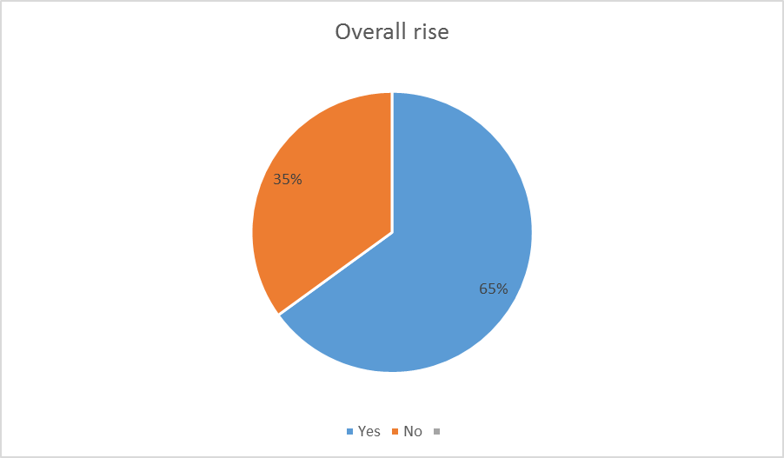

The above chart is from 20 responses out of 68 who had been sent the survey. The question asked whilst not pertinent to the original question, was included to help provide some background in relation to Police officers views on Domestic Violence, whilst quite vague it helps to provide a basis from which to start with. As you can see in the graph that 65 % of the 20 surveyed believe that there has been an overall rise in the amount of Domestic abuse since they started as a Police officer, to sample but a few answers on the survey in relation to the service of officers they range from 2 years of service up to 29 years of service. This question was included as it was believed to give a good grounding to the investigation in that Police officers think that there has been a rise in the amount of domestic abuse. This was shown in the literature review section with figures from the Office of National Statistics,2021 These figures showed a 7% increase in reports of domestic abuse.

This was also followed up with an additional question in relation to any reason for the rise?
Officers have responded with answers such as:
People are more aware
More focus and publicity so victim are more confident in reporting these matters. More support for victims
Whilst still under reported, DV is more likely to be reported now as the issue is becoming more highlighted in the media and awareness is increasing.

This follow up question is in the survey to give more depth into the officers belief behind the rise of domestic abuse, whist this is just a snapshot of the 20 answers given, the general belief from officers surveyed is that the rise of domestic abuse is due to the whole issue of Domestic violence is now more publicised compared to previously when it was seen as a taboo subject and one that is kept indoors. (The Silent Abuse-, 2021)

The next chart is a on the question
Since the Covid-19 lockdown, Do you feel that there has been a rise in the amount of domestic violence calls/reports?

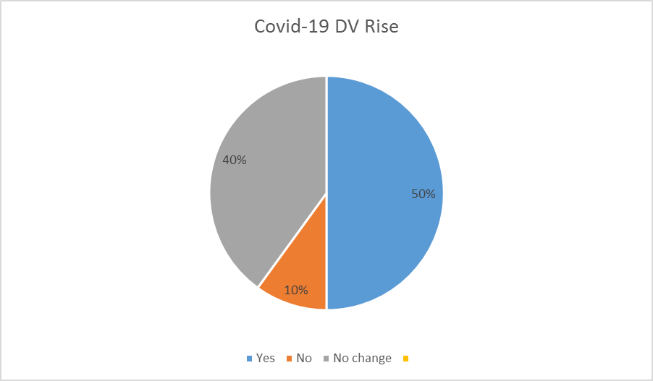

This question was again answered by 20 recipients, the answers given to this question were surprising as the opinion was that there had been a significant rise but the data collected shows that whilst the majority believe that there has been a rise, this is not an overwhelming majority. This answers the main investigation question somewhat with the majority believing that there has been a rise of domestic abuse incidents with others not believing this in the case followed by a small number who do not think there has been any change in the amount reported or responded to. IVANDIC, 2021 reports that incidents between ex partners fell by around 9.4%, this could be an impacting factor to the results as officers could have seen a reduction of calls to the same addresses and victims.
This question was again proceeded by a follow up question asking for a brief explanation of the answer given. Officers responded by saying:
People have been locked up with each other with nowhere to go which has escalated the situation
Due to person being in lockdown together which can adversely impact relationships
I feel that the usual domestic incidents arise from alcohol and drugs and are usually at a property, during lockdown people were still able to drink and get hold of drugs at home so the domestic incidents remained the same level.
Survivors not having an ‘escape’ route from their partners have encouraged earlier reporting

These answers provide an insight into the different opinions provided when using a survey as a research tool.
The final question to officers was
Since the removal of restrictions, have there been an increase in calls relating to domestic abuse?

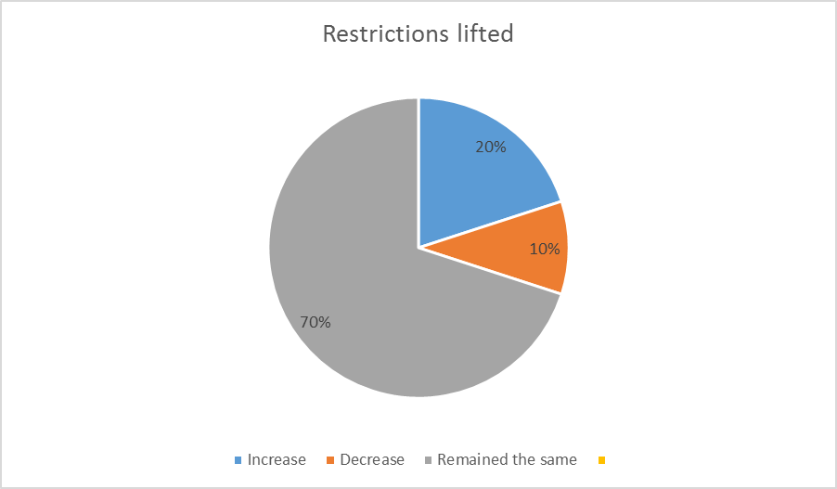

This was the final question in which a pie chart had been produced listing the results, These results also were a surprise with a major majority believing that since the lifting of Covid-19 restrictions, there has been no increase in the officers opinion. This clearly shows that 70% of the 20 officers do not believe that there has been any sort of increase in domestic violence incidents since the ceasing of lockdown measures. NPT Domestic Violence, 2021 in the literature review does state that there has been a reported increase of domestic abuse in relation saying in the article that ‘seen over the last year has been "more severe and escalating far more quickly" than usual’, in the article it also states that Neath Port Talbot Council have seen a 40% increase in demand for domestic violence support. This is at odds with the above survey results but could mean that there may have been no Police involvement in the cases.

A follow up question was also asked of the officers for them to explain their answer given to add further depth to the answer and officers replied with the following:
Since the removal of restrictions there has been an increase in violent crime but not necessarily domestic abuse
People have been locked up with each other and with nowhere to go this has escalated the issue
Due the relaxation of freedom of movement after lockdown
I have not noticed any change, it has returned to how it was before.

4.2 Summary
All the answers given by officers provide a look into individual opinions on the matter as that is what the survey shows, it is just opinion and based on perceptions and experiences, the data collected is not from official data sources but human beings on the front line of policing. It shows the difference in opinion and experiences by the officers surveyed and whilst more participation would have been preferable to give the collected information more depth and potential to provide different answers, only the information provided can be used.
The answers provided give enough grounding to move toward the findings and conclusions stage.

Chapter 5

Findings and Conclusions

5.0 Introduction
Domestic Violence has massive effects on the lives of the victims, it also has effects on the families such as the children involved. This can cause children to suffer from Adverse Childhood Experiences and make them more likely to be involved in criminality or themselves be perpetrators of domestic violence. In domestic violence situations injuries can and do happen these range from serious injuries to those who have minor injuries, despite the level of injury, domestic violence is something that needs to be stopped.
The aim when conducting this research was brought about due to the belief that the amount of calls of service for domestic violence had risen and the belief that were responding to more and more calls within the last 18 months, coinciding with the covid-19 lockdown.
When looking into the potential rise of domestic abuse in the Swansea and Neath Port Talbot multiple secondary research articles were found which looked at domestic violence and the impact on the victims.
- Has there been an increase in domestic violence over the past 18 months in the Swansea and NPT area?
- Has COVID 19 caused a rise in domestic abuse, if so why?
- Survey operational Police officers of varying service in the above areas in relation to the above questions

The primary research in itself was a major step to answering my objectives, It was decided that by surveying officers that are working on frontline or had recently worked frontline of varying ranks then this would provide the topic with not only personal knowledge but also multiple officers knowledge about policing during the last 18 months and the calls they responded to. This research would give an in depth aspect that was not available in the public domain, not in such that it breached data protection or violated any privacy issues but this was an untapped resource that contained a wealth of knowledge.

Following the research conducted and the results produced from the surveys, the above question can be answered and that yes domestic abuse has increased since the covid-19 lockdown.

5.1 Survey Results
Survey operational Police officers of varying service in the above areas in relation to the above questions
The results from primary research of frontline police officers has shown on the research section, that ten of the twenty officers surveyed believe that there has been an increase during the covid-19 lockdown, this can be seen in the Analysis of Results by James, 2021. This has answered the question in which was set out, showing that despite a lack of supporting secondary research due to the parameters, the officers who are dealing with these issues are in majority agreement that cases of Domestic abuse have risen. Explanations have been given and all go along the same track of people being locked up with another as one of the main causes of Domestic abuse having risen.

Whilst this shows that the majority are in agreement with this answer, the belief is that recommendations can be drawn from this conclusion in that further research needs to be conducted with other agencies to solidify the final answer, agencies such as Women’s Aid and other domestic violence charities as only then would there would be a final answer with a bigger picture.
The research and questions were intentionally narrow as to avoid overwhelming the objectives and the final question, if wales in its entirety had been chosen for example instead of just the narrowed down chosen areas then this would have diluted the project and could have left with the topic with no answer and no way forward. This way by keeping the field narrow has come up with a research based answer, which has shown that the objectives that was set out to prove is correct, in terms of this project.

As said above, the primary research had not been conducted in this manner before and has presented the topic with the answer to the question. In the literature review it had been identified there were gaps in local figures relating to the chosen subject which have now been answered in the majority by the primary research survey.

5.2 Conclusion
The overall conclusion of this project is that Domestic abuse has risen during the covid 19 lockdown in the Neath Port Talbot and Swansea area, this has been supported by evidence from secondary sources and corroborated by the primary research survey conducted by James, 2021. In which it is shown that from the survey conducted that 50% of 20 officers surveyed formed the belief that there had been an increase.

As a result of this, this research can show that due to the covid-19 lockdowns which took place in the last 18 months, there has been an increase of Domestic violence, this whilst answering the initial project question, throws out there a lot of further research questions and a further need to look into the reasons why this has happened, whilst the research has provided some answers due to the survey, this is from responding police officers and not from the victims themselves which would provide a greater input and the hope is that it would promote greater awareness of the issues that the victims are going through and what they have had to endure as a result of this.

This being the first project ever conducted by this author, it was approached a level of ignorance, naivety and inexperience about how much information and how much work was involved in relation to a project such as this. With all of these factors there were bound to be limitations in this project with the evident lack of resources to refer to that are within the defined parameters however even with these limitations and lack of experience an answer to the project question was achieved which was not an unambiguous answer but one that was presented with certainty and answers a question that many would not know needed answering but was a topic that was unexplored and a gap in research/information was identified.

5.3 Recommendations
This is why it has been suggested that further research into this matter is conducted, the project set out to prove that there had been an increase during the last 18 months and this is what has been achieved, and therefore further research could possibly be made into the above issues to further generate answers about domestic abuse.
The recommendations being that further research is conducted into –
- Causation behind the rise over the last 18 months
- Who are the victims

This research is needed to ensure that there are facts and figures about domestic violence which would bring about greater awareness of the issues that the victims face and this could help to influence the wider public into helping prevent Domestic Violence before it rises again, as the belief is that the public would be shocked to know that when the country was isolated to protect themselves that there were those who could not protect themselves from harm not caused from covid-19 but from domestic abuse aggressors who seek to cause them harm.

This topic is something that needed further investigation into, there was simply enough information about the rise of Domestic Violence in these areas during the time frame and no one else had chosen this specific topic. This topic was an unexplored area that could have a potential to draw further attention to the plight of those suffering under domestic abusers and those who have suffered from domestic violence during covid-19 lockdown.
One further issue encountered was a lack of responses to the survey which had given a smaller sample pot to pick from and to use for the results than the author would have liked, this is mainly down to timescales, in which a learning point has been made to extend further if the project or another was to be undertaken again. Even with this lessened sample pot, if there were enough responses to be able to formulate the answer to the question and the other research results.

Chapter 6

Reference List

2021. New research reveals the true impact of Covid-19 on police wellbeing. [online] Available at: <https://www.port.ac.uk/news-events-and-blogs/news/new-research-reveals-the-true-impact-of-covid-19-on-police-wellbeing> [Accessed 25 July 2021].

BBC News. 2021. Coronavirus: Domestic abuse calls up 25% since lockdown, charity says. [online] Available at: <https://www.bbc.co.uk/news/uk-52157620> [Accessed 25 July 2021].

BBC News. 2021. Joanna Michael: 'Sorry isn't good enough' - mother. [online] Available at: <https://www.bbc.co.uk/news/uk-wales-31489000#:~:text=Joanna%20Michael%2C%2025%2C%20from%20St%20Mellons%2C%20Cardiff%2C%20rang,law%20which%20protects%20police%20forces%20from%20negligence%20claims.> [Accessed 11 July 2021].

Blog, F., 2021. What is Secondary Research? + [Methods & Examples]. [online] Formpl.us. Available at: <https://www.formpl.us/blog/secondary-research#:~:text=%20Advantages%20of%20Secondary%20Research%20%201%20Easily,for%20field%20investigations.%20When%20carrying%20out...%20More%20> [Accessed 27 August 2021].

Betterhelp.com. 2021. What Are The Effects Of Domestic Violence On The Family And Children? | Betterhelp. [online] Available at: <https://www.betterhelp.com/advice/domestic-violence/what-are-the-effects-of-domestic-violence-on-the-family-children/> [Accessed 12 July 2021].

Bps.org.uk. 2021. ACE's. [online] Available at: <https://www.bps.org.uk/sites/www.bps.org.uk/files/Policy/Policy%20-%20Files/Briefing%20Paper%20-%20Adverse%20Childhood%20Experiences.pdf> [Accessed 26 October 2021].

Cps.gov.uk. 2021. Domestic abuse murderer sentenced to life imprisonment | The Crown Prosecution Service. [online] Available at: <https://www.cps.gov.uk/cymruwales/news/domestic-abuse-murderer-sentenced-life-imprisonment-0> [Accessed 10 July 2021].

Gibson, J., 2021. Domestic violence during COVID-19 - the GP role. [online] British Journal Of General Practice. Available at: <https://bjgp.org/content/70/696/340> [Accessed 25 July 2021].

Global Gender Justice. 2021. The Silent Abuse- Domestic violence: the taboo with disastrous consequences. [online] Available at: <https://globalgenderjustice.wordpress.com/2018/05/30/the-silent-abuse-domestic-violence-the-taboo-with-disastrous-consequences/> [Accessed 4 October 2021].

GOV.WALES. 2021. Support for victims of domestic abuse | GOV.WALES. [online] Available at: <https://gov.wales/support-victims-domestic-abuse> [Accessed 27 November 2021].

Gov.wales. 2021. CAFCASS. [online] Available at: <https://gov.wales/sites/default/files/publications/2019-08/cafcass-cymru-impact-on%20children-experiencing-domestic-abuse.pdf> [Accessed 25 July 2021].

GOV.WALES. 2021. Violence against women, domestic abuse and sexual violence: progress report 2019 to 2020 [HTML] | GOV.WALES. [online]
Available at: < https://gov.wales/violence-against-women-domestic-abuse-and-sexual-violence-progress-report-2019-2020-html > [Accessed 25 July 2021].

Ivandic, R., 2021. Domestic abuse in times of quarantine. [online] Cep.lse.ac.uk. Available at: <https://cep.lse.ac.uk/pubs/download/cp578.pdf> [Accessed 25 July 2021].

Jones, C., 2021. The pandemic paradox - Consequences of covid-19 on domestic violence. https://www.ncbi.nlm.nih.gov/pmc/articles/PMC7262164/.

Justiceinspectorates.gov.uk. 2021. Police response to domestic abuse an updated report. [online] Available at: <https://www.justiceinspectorates.gov.uk/hmicfrs/wp-content/uploads/the-police-response-to-domestic-abuse-an-update-report.pdf> [Accessed 10 July 2021].

Justiceinspectorates.gov.uk. 2021. [online] Available at: <https://www.justiceinspectorates.gov.uk/cjji/wp-content/uploads/sites/2/2021/01/2021-01-13-State-of-nation.pdf> [Accessed 25 July 2021].

Justiceinspectorates.gov.uk. 2021. Improving police response to domestic abuse. [online] Available at: <https://www.justiceinspectorates.gov.uk/hmicfrs/wp-content/uploads/2014/04/improving-the-police-response-to-domestic-abuse.pdf> [Accessed 10 July 2021].

Foundation, T., 2021. Rethinking the police approach to domestic abuse. [online] The Police Foundation. Available at: <https://www.police-foundation.org.uk/2018/09/rethinking-the-police-approach-to-domestic-abuse/> [Accessed 10 July 2021].

Fuel Cycle. 2021. Market Research Strategies | Observational Research Methods. [online] Available at: <https://fuelcycle.com/blog/the-3-most-common-observation-research-methods/> [Accessed 16 May 2021].

Lipscombe, S., 2021. Coronavirus: Domestic abuse. [online] House of Commons Library. Available at: <https://commonslibrary.parliament.uk/coronavirus-domestic-abuse/> [Accessed 26 October 2021].

Mainwood, N., 2021. Covid-19 and the Surge in Domestic Abuse in the UK — Centre for Women's Justice. [online] Centre for Women's Justice. Available at: <https://www.centreforwomensjustice.org.uk/new-blog-1/2020/11/10/covid-19-and-surge-in-domestic-abuse-in-uk> [Accessed 25 July 2021].

Mcleod, S., 2021. Qualitative vs Quantitative Research | Simply Psychology. [online] Simplypsychology.org. Available at: <https://www.simplypsychology.org/qualitative-quantitative.html> [Accessed 27 August 2021].

National Institute of Environmental Health Sciences. 2021. What Is Ethics in Research & Why Is It Important? - by David B. Resnik, J.D., Ph.D.. [online] Available at: <https://www.niehs.nih.gov/research/resources/bioethics/whatis/index.cfm> [Accessed 27 August 2021].

Npcc.police.uk. 2021. About. [online] Available at: <https://www.npcc.police.uk/About/AboutNPCC.aspx> [Accessed 16 May 2021].

Ons.gov.uk. 2021. Domestic abuse during the coronavirus (COVID-19) pandemic, England and Wales - Office for National Statistics. [online] Available at: <https://www.ons.gov.uk/peoplepopulationandcommunity/crimeandjustice/articles/domesticabuseduringthecoronaviruscovid19pandemicenglandandwales/november2020> [Accessed 16 May 2021].

Oxford Reference. 2021. primary research. [online] Available at: <https://www.oxfordreference.com/view/10.1093/oi/authority.20110803100345447> [Accessed 27 August 2021].

Oxford Reference. 2021. secondary research. [online] Available at: <https://www.oxfordreference.com/view/10.1093/oi/authority.20110803100451291> [Accessed 27 August 2021].

Police-foundation.org.uk. 2021. Domestic Abuse Briefing. [online] Available at: <https://www.police-foundation.org.uk/2017/wp-content/uploads/2017/08/domestic_abuse_briefing_final.pdf> [Accessed 11 July 2021].

QuestionPro. 2021. Exploratory research: Definition, Types and Methodologies | QuestionPro. [online] Available at: <https://www.questionpro.com/blog/exploratory-research/> [Accessed 16 May 2021].

QuestionPro. 2021. Primary Research: Definition, Examples, Methods and Purpose | QuestionPro. [online] Available at: <https://www.questionpro.com/blog/primary-research/> [Accessed 27 August 2021].

QuestionPro. 2021. Quantitative Research: Definition, Methods, Types and Examples | QuestionPro. [online] Available at: <https://www.questionpro.com/blog/quantitative-research/> [Accessed 27 August 2021].

Research-Methodology. 2021. Exploratory Research - Research-Methodology. [online] Available at: <https://research-methodology.net/research-methodology/research-design/exploratory-research/> [Accessed 16 May 2021].

Refuge.org.uk. 2021. Maria Stubbings. [online] Available at: <http://www.refuge.org.uk/files/Maria-Stubbings-summary.pdf> [Accessed 11 July 2021].

Royal Manchester Children's Hospital. 2021. Adverse Childhood Experiences (ACEs) and Attachment - Royal Manchester Children's Hospital. [online] Available at: <https://mft.nhs.uk/rmch/services/camhs/young-people/adverse-childhood-experiences-aces-and-attachment/> [Accessed 16 May 2021].

Shaw, N., 2021. Police have issued 32,329 fines for breaching lockdown rules. [online] WalesOnline. Available at: <https://www.walesonline.co.uk/news/uk-news/police-issued-32329-fines-breaching-19587538> [Accessed 27 October 2021].

Social Care Institute for Excellence (SCIE). 2021. Domestic violence and abuse: Safeguarding during the COVID-19 crisis. [online] Available at: <https://www.scie.org.uk/care-providers/coronavirus-covid-19/safeguarding/domestic-violence-abuse> [Accessed 25 July 2021].

Victim Support. 2021. Domestic abuse - Victim Support. [online] Available at: <https://www.victimsupport.org.uk/crime-info/types-crime/domestic-abuse/#:~:text=The%20UK%20government%E2%80%99s%20definition%20of%20domestic%20violence%20is,or%20family%20members%20regardless%20of%20gender%20or%20sexuality> [Accessed 27 November 2021].

Wales Online. 2021. NPT domestic violence. [online] Available at: <https://www.walesonline.co.uk/news/wales-news/neath-port-talbot-domestic-violence-20420226> [Accessed 25 July 2021].

Whatworks.college.police.uk. 2021. Police Initial Responses to Domestic Abuse. [online] Available at: <https://whatworks.college.police.uk/Research/Documents/Police_initial_responses_domestic_abuse.pdf> [Accessed 10 July 2021].

Appendix

Questionnaire sent to Serving Police Officers
- How much service do you currently have?
- How long have you worked currently or previously as a response officer?
- Do you think that there has been a rise in Domestic violence since you began as a Police Officer?
- Yes b) No
- Do you think there is any reason for this?
- Since the Covid-19 Lockdown, do you feel that there has been a rise in the amount of domestic violence calls/reports?
- Yes b) No C) Hasn’t changed
- Please explain your answer
- Do you feel that we are responding effectively to these incidents?
- Do you think that there has been a particular reason why there has been an increase?
(If answered yes ) N/A if any other answer
- How has the covid-19 lockdowns impacted overall demand in your opinion?
- In your particular sector (NPT/Swansea) do you think Police are responding to more serious instances of Domestic Violence? (Please state sector)
- In your opinion is this a natural increase or one caused by the lockdown?
- Lockdown b) Natural
- In relation to the above, why?
- Is there anything you think that would better support victims of Domestic Abuse?
- Since the removal of restrictions, have there been an increase in calls relating to domestic abuse?
- Increase B) Decrease c) remained the same
- Please explain your answer
- Please use this box to add any further information you feel is relevant to the survey. thanks for taking part.

