Question 1 The Contemporary Condition: How do contemporary creative practices articulate or intervene in the complex conditions of late modernity, including ecological precarity, social fragmentation, and global uncertainty? What imaginative or critical strategies do they offer for navigating these crisis?

Universality in the art of Cai Guo Qiang: Between Cosmology and Fragmentation
Through the art of Cai Guo-Qiang (蔡国强), the essay examines how the artist’s use of elemental forces articulates a vision of cosmological universality and evaluates the extent to which this vision remains convincing within the fragmented conditions of late modernity. As theorised by Lyotard, the postmodern condition is defined by an “incredulity towards metanarratives,” in which universal frameworks of meaning are no longer widely sustained (Lyotard,1984, pp. xxiv-xxv). Within this context, Cai’s practice presents a critical tension: it proposes a shared cosmological language, but this is a difficult claim in a fragmented world that fundamentally resists such a notion.
Here, “universality” is understood not as a fixed or absolute truth, but it is used as a meaning or affect, that can be shared across cultural and historical differences, even if such sharing remains unstable.
Bhabha’s concept of cultural hybridity offers a further complication. He suggests that meaning emerges through interaction within a “Third Space” of cultural exchange and translation (Bhabha, 2008, pp. 2,3, 53-56). Reading Cai’s work through Lyotard and Bhabha, the main vision of universality does not simply appear unattainable, but it actively weakens the concept. How then is Cai’s message of universality negotiated and shared within a diverse and fragmented global culture?
Furthermore, Debord’s notion of the spectacle suggests that contemporary experience is increasingly mediated through images and global circulation (Debord, 1994, p.12). This raises the possibility that what appears as a shared or universal experience may in fact be produced for a specific audience or as an entertainment.
As a transnational contemporary artist working across both Eastern and Western cultures, Cai’s practice reflects an awareness of historical and modern tensions between East and West. He is therefore working within Bhabha’s hybrid space of cultural intercourse. His work also draws on ancient Chinese mythology, military history, and Daoist cosmology, connecting inherited cultural traditions with contemporary global concerns. Through his use of gunpowder, both as a material and performative force, destruction becomes creation, symbolising transformation and interconnectedness on a cosmic scale. While these explosive events appear to offer a shared human experience that transcends cultural boundaries, the essay will analyse whether the claim to universality resolves the problem or highlights its contradictions.
The argument will be developed through two case studies. Sky Ladder is submitted as an expression of aesthetic universality, symbolising the connectedness between humans and the cosmos. In contrast, Project for Extraterrestrials No. 10: Extending the Great Wall of China, will be analysed as a collective artwork that proposes unity through participation and cross-cultural exchange. Together, these works expose how one contemporary artist negotiates the complex interplay between the aspiration of universality and its reality. The essay ultimately argues that stable universality is not achievable, and that Cai Guo-Qiang’s practice does not resolve this tension but instead exposes and sustains it.

Primarily, Cai Guo-Qiang’s work stages cosmological universality as an aesthetic and affective experience. What emerges here is that this concept remains unstable within the diverse cultural and political conditions of late modernity. Cai’s use of elemental forces, particularly gunpowder, implies an interconnectedness that proposes universal meaning, beyond cultural differences. However, contemporary theorists challenge the possibility that such universal truths can exist, emphasising fragmentation, plurality, and hybridity. As Cai’s practice gestures towards this universality, his message is exposed as unstable, placing his work at the centre of a broader debate.
Within this theoretical context, Lyotard’s scepticism of the metanarrative is very disruptive, rejecting the possibility of the overarching claim of universality. He proposes that there is no longer a shared consensus or an inherent legitimacy to these notions (Lyotard 1984, pp.37-38). Instead, knowledge is fragmented into “petits récits”, localised narratives that focus on experiences rather than universal truths. These petits récits allow for a plurality of perspectives and reflect the complexity and diversity of contemporary knowledge (Best and Kellner, 1991, pp.146–147). Cai’s work perfectly illustrates the tension surrounding universality as it is difficult to sustain the petits récits because of the continual global circulation of Cai’s work. However, rather than signalling the end of a claim for universality, Cai’s work is highlighting the possibility that shared experiences, not necessarily shared meanings, can exist through the mediated form. Lyotard’s theory struggles to account for this potentiality.
Bhabha (2008, pp.55-56) extends this tension by framing the meaning as relational rather than fixed. Through his concept of hybridity and the “Third space.” Bhabha explains that within this new “in-between” space, meanings can be negotiated, translated, and reshaped. Cai’s position as a transnational artist does not produce universality but shows it as something that is continually being adapted through translation across cultural boundaries. Therefore, he is navigating complex cultural issues to create a unified experience. Yet this emphasis on continual negotiation risks the possibility that a stable framework is endlessly being deferred. This raises the question: can universality ever be realised within a condition of hybridity?
Kant’s theory introduces a different problem: he proposes that aesthetic judgement, while subjective, carries a claim to universality grounded in shared capacity for feeling. (Kant, 2008, pp.119-120, §38). This implies that within Cai’s practice, universality may be experienced through immediate sensory engagement rather than knowledge. However, within the contemporary context where perceptions are mediated, distributed and culturally altered, even this is unstable since no shared judgement can be assumed. As such Kantian “universality” relies on a unity which is no longer supported in the contemporary world.
Deleuze further adds to the debate of Cai’s vision of universality. For Deleuze, art produces affects and intensities that directly affect our thoughts and disrupt the ways we see and think. (Deleuze, 2005, pp.25 -31). Cai’s use of gunpowder aligns with this, as explosions function not as an image but as an event. Yet can universality be guaranteed through sensation or an effect? A shared exposure to the intensity may uncover momentary feelings, but even these are interpreted differently. It raises the further question of how can ‘intensity’ be shared? While the effects may be powerful, the capacity to function as a basis for universality remains uncertain. They may not translate into a common experience that is easy to communicate.
When these perspectives are drawn together, this does not completely undermine the work but could add to its strength. This capacity of Cai’s work to create the impression of connectedness or universality does highlight the possible existence of common interpretations. His vision is gesturing towards the message of universality while simultaneously sharing the limitations, making the contradiction and tensions central to the work’s meaning.
Taken together, Cai’s work evokes connections that allude to cosmological universality, but there remains a question whether it is a fully stable or achievable. While Lyotard and Bhabha both emphasise that fragmentation and hybridity undermine the claims of universality, Kant and Deleuze offer alternative thoughts about the shared experiences that do not necessarily rely on fixed meanings. Cai’s work sits awkwardly between these positions. In his defence of universality, he uses the aesthetic and material strategies to produce moments that appear universal, while remaining open to different interpretations. The significance of Cai’s work is his practice which holds these tensions rather than reconciling them.
In summary, Cai’s practice functions most effectively as an aesthetic and affective proposition. His use of elemental forces, scale and spectacle creates moments in which the viewer may feel connected to something larger than themselves, whether understood as cosmic, natural, or collective. He succeeds in staging ephemeral moments that are shaped by individual perception and cultural context, but rather than resolving the tension between universality and fragmentation, Cai’s work sustains it and highlights the impossibility of achieving it.
Ultimately, I feel that Cai’s work does not sustain an absolute claim to universality, but the following case studies will demonstrate how he articulates the concept across two distinct pieces of work. While Sky Ladder advocates universality through immediacy and affect, Project for Extraterrestrials No. 10: Extending the Great Wall of China modifies this claim by relocating universality from perception to process, and from experience to production.

Sky Ladder (2015) Cai Guo-Qiang
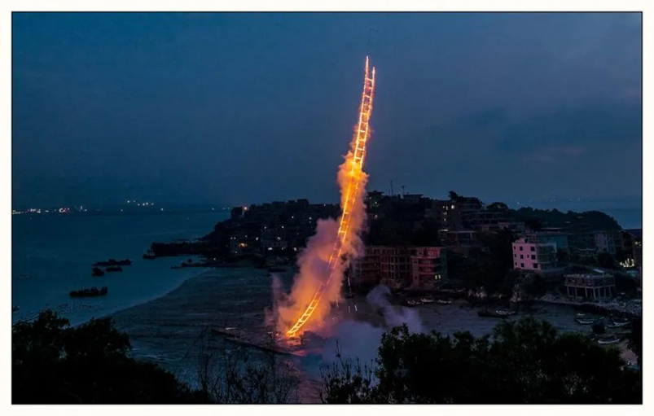
Figure 1: Sky Ladder (gunpowder and fireworks installation), Quanzhou (Cai Guo-Qiang, 2015)

Sky Ladder (Cai Guo-Qiang 2015), located in Quanzhou, China, consists of a 500-metre ladder-shaped structure made of gunpowder, suspended by a helium balloon. On ignition, the ladder burned for approximately 120 seconds, producing a vertical trail of fire that connected the earth to the sky. The work staged a visually striking gesture of a connection to the cosmos, implicitly claiming universality, and it was effectively documented through video footage (Great Big Story, 2016), which captured the movement and sounds of the explosion. In contrast, the image (see Figure 1) shows the ladder as a sculptural form.
My encounter with Sky Ladder occurred not in a museum or gallery, but through a digital interface. What struck me immediately was not only the scale of the work, but the intimacy created through its documentation. This single image captured my attention, embedding itself within an imaginative psyche shaped by dreams and narratives. While studies evidence that gallery visitors spend, on average, seventeen seconds observing a painting (Smith, Smith and Tinio, 2017, pp. 77-85), this 120- second documentation of Sky Ladder has reached millions of viewers, demonstrating not universality itself, but the global scale with which the media can share an aesthetic encounter.
Even though this piece has been chosen because it represents one of Cai Guo-Qiang’s clearest articulations of cosmological universality, it reveals the limits of this claim. The ascending ladder of fire symbolises a movement of energy from earth toward the heavens, inviting spectators to consider a connection between human experience and the wider cosmos. This positions the work between the specific and the universal, drawing on the Daoist cosmology and his personal history. It gestures towards a cosmological connection, which requires no specialist knowledge, but its ephemeral nature questions the stability of universality.
While the scale and ambition of Sky Ladder evoke a sense of universality, its reliance on cultural symbolism complicates the claim. Lyotard’s concepts of petits récits offer a way to understand how the work operates simultaneously within and against universality. The choice of Quanzhou, Cai’s engagement with his family history, and his grounding in Daoist philosophy all situate the work within the petit récits. Cai affirms this when he states that he is interested “in mining the microcosm of my culture for symbols that can universally be understood” (Cai, 2008, cited in Munroe and Krens, 2008, p. 26). Rather than resolving this tension, Sky Ladder supports it, revealing universality as something that is continually negotiated between local specificity and the global context. While Lyotard’s critique explains the instability of universality, it does not fully account for the emotional impact that works like Sky Ladder continue to produce. Despite the claims of fragmentation there persists experiences that may exceed the explanations of his scepticism.
In contrast to Lyotard’s doubt, the aesthetic impact of Sky Ladder resonates with Kant’s notion that universality is accessible through aesthetic judgement. Kant proposes that “the beautiful is that which, apart from a concept, pleases universally.” (Kant, 2008, p.48, §9), suggesting that aesthetic experience requires a shared capacity for feeling. The visual clarity of the burning ladder, its simplicity of form and dramatic ascent, its scale and ephemerality evoke the sublime, in which the limits of sensory perception give way to an awareness of something beyond comprehension (Kant, 2008, p.81, §25). Here, the work suggests that universality is achieved through the shared potential to experience an effective response. However, even shared experience is shaped by culture and technology, which complicates this universal message.
Cai’s use of gunpowder demonstrates the volatile and transformative nature of his medium, in which destruction becomes creation. As Cai writes, “the true nature of gunpowder corresponds to the power and spirit that humans have possessed since the beginnings of evolution… corresponding to characteristics of the universe itself.” (Cai, 2008, cited in Munroe, 2008, p. 31). The material process aligns with cosmological forces, positioning the work as symbolic, an enactment of energy, rather than representation. This resonates with Deleuze’s (2005, p.30) understanding of art as an encounter that produces sensations rather than representing reality. In Sky Ladder, the explosive ignition and the rapid ascent of the fire operate at a preconceptual level, exceeding linguistic description. Cai’s suggestion here is that universality emerges through a mutual experience that affects us.
Sky Ladder is described as an event, but its visual intensity and global circulation also align it with the conditions of a spectacle as critiqued by Debord (Debord, 1994, p. 12). Rather than escaping the idea, a contradiction becomes visible. The event's temporality and uniqueness provide an argument for the passive acceptance of a spectacle. In contrast this notion is resisted because it briefly introduces a sense of loss and reflection, encouraging a contemplative engagement. However, the widespread access to the video and image complicates the idea, indicating it is both an immediate event and a reproduced spectacle. This again exposes the complexity of universality within contemporary conditions. Is the work constructed strategically for a global audience? A cynical proposal is that his vision is not demonstrating universality at all, as it is reliant on media exposure and global interest.
Ultimately, Sky Ladder does not resolve the question of universality but stages its possibility. It offers a more poetic rather than empirical stance to the concept by uncovering the emotional appeal and its instability. It presents universality as a desire, something that can be imagined, felt, and momentarily experienced, rather than fixed truth.
Project for Extraterrestrials No. 10: Project to Extend the Great Wall of China by 10,000 Meters (1993-2008) Cai Guo-Qiang
While Sky Ladder articulates universality through an immediate and affective encounter, the following work implies that universality is constructed through collaboration, negotiation, and cultural interaction. Universality is now interpreted through a process where meaning is constantly changing.
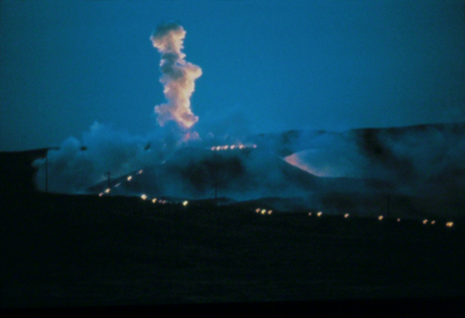
Figure 2: Project for Extraterrestrials Project No. 10: Extending the Great Wall of China (Cai Guo-Qiang, 2015), photograph by Masanobu Moriyama

Two gunpowder and ink drawings made before the event
The following images evolved from pure abstraction to a more representational composition that suggests a charred dragon form. They were created as pre and post-event records.

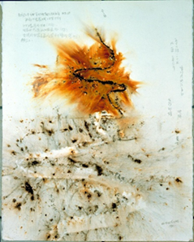
Figure 3: Gunpowder drawing for Sky Ladder (Cai Guo-Qiang, 2015)
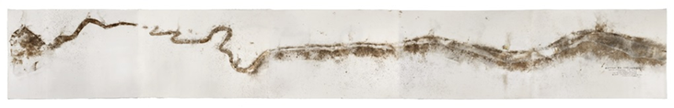
Figure 4: Gunpowder drawing on paper (Cai Guo-Qiang, 2015)

Project for Extraterrestrials No. 10: Project to Extend the Great Wall of China by 10,000 Meters (2008), by Cai Guo-Qiang, was staged on the western edge of the Great Wall, at the boundary of the Gobi Desert. This work consisted of 600 kilograms of gunpowder and two six-mile-long fuse lines, ignited to produce a blazing dragon-like trail across the landscape that lasted for approximately fifteen minutes. The use of gunpowder is not purely technical but central to the conceptual thought process. As a material, it operates through combustion and controlled explosion, transforming stored energy into a visible force. This reflects Cai’s broader interest in material transformation, in which the physical properties of gunpowder become a means of expressing ideas about energy, change and impermanence.
Cai’s practice in this piece extends beyond individual authorship, involving local communities, engineers, technical teams, and artistic assistants, forming a complex network of production. From his early experiments in Japan, through to his later practice in New York, Cai has consistently pursued the possibility that ephemeral explosions of energy might facilitate forms of communication beyond the human. (Munroe 2008, p.132). However, this ambition does not produce universal communication as stable, instead it becomes conjecture. The reference to the Wall’s visibility from space further positions the work within the speculative framework of extraterrestrial communication. This introduces the idea that the work not only addresses human audiences but also gestures to a hypothetical ‘other’ beyond our human perception.
Understanding this piece of work through Bhabha’s concept of hybridity and the ‘Third space,’ implies Cai’s use of gunpowder, historically associated with the Chinese invention, is being reinterpreted within a global artistic framework. The work is emerging through mediation between different cultures, and there is a possibility that a language of universality is continually being produced and understood through a process of translation and exchange. This, however, affects how the work is received; its meaning will alter according to the viewer’s background and familiarity with the concept. Barmé (cited in Schwabsky, 1997, p.118) argues that “Cai is choosing to ‘trade’ on the history of his culture and homeland. This trading takes the form of an exchange to which the viewer brings as much as the artists does, even if it has been orchestrated by Cai himself.” Rather than presenting a fixed interpretation of universality, Cai’s work allows for multiple interpretations to coexist, reinforcing the idea that universality is not a singular concept, but formed through difference and interaction.
The site specificity of Project for Extraterrestrial No. 10 was important, reinforcing the association between local and global communities. The Great Wall is a structure that is embedded in Chinese history, and as such, it anchors the work within the specific cultural narrative. However, its global recognition transforms it into a symbol that operates beyond national boundaries, occupying a space between myth and reality. Cai’s intervention activates this duality, using the Wall as both a physical site and a conceptual bridge between human history and cosmological speculation.
Where Sky Ladder evokes universality through awe and sensory immediacy, Project for Extraterrestrial No.10 challenges this claim. Here, universality is being constructed through collaboration and cultural hybridity, but its understanding differs depending on the context and perspective. The reliance on collaboration further emphasises that universality is not located in a single viewpoint but distributed across multiple understandings and contexts.
In this sense, the work reflects the conditions of late modernity, as meaning is dispersed across networks and through digital media. Universality does not disappear, but it can be reconfigured. It becomes something actively thought about and not passively assumed. The desire to communicate beyond human boundaries remains, but it is no longer grounded in the certainty of a shared cosmological order.
This work again highlights that Cai’s practice does not settle the question of universality but instead uncovers the shifting conditions. While both works articulate a vision of cosmological connection that remains compelling, the two approaches advocate that universality is not a fixed or consistent idea. Universality can change depending on how the work is produced, experienced and interpreted across different contexts.
In conclusion, Cai’s practice suggests that universality persists not as a stable condition, but one that is continually negotiated. It is produced, disrupted, and reconfigured across many different contexts and is never fully resolved. The chosen works do not offer a unified or authoritative universal message; rather, they explain the instability of such a notion within the late-modern global context in which Cai operates. Meaning emerges not as a fixed proposition but as something provisional and dependent upon the spectators’ experience.
The theoretical models applied throughout this essay illuminate aspects of contention around universality, and their limitations become clear when confronted with the complexity of Cai’s methods. Each framework captures a partial truth, but none can fully account for the multiplicity, scale and collaborative processes that define his practice. This partiality is not a failure of theory alone; it reflects the very condition Cai exposes, that universality resists stability through a singular theoretical structure.
In this sense, Cai’s work functions as both proposition and critique. By revealing the contradictions inherent in attempting to articulate universality, he challenges the globalised artistic discourse. Cai’s practice suggests that universality, if it persists at all, does so as an ongoing negotiation process rather than a resolved ideal. It is precisely within this unresolved territory that his work finds its critical force.
As Cai continues to operate across cultural, geographic and disciplinary boundaries, the questions his work raises about universality will remain central to his significance. His practice endures not because it resolves these tensions, but because it sustains them. Universality, in contemporary art, is less a conclusion than a condition continually in motion.
One thing is certain: It is within this instability that his practice finds a critique, and his standing as an international and experiential artist will continue to intrigue.

Book References
Best, S. and Kellner, D. (1991) Postmodern Theory: Critical Interrogations. London: Macmillan
Bhabha, H. (2008) The Location of Culture. London and New York: Routledge
Cai, G-Q. (1993) Project for Extraterrestrials No. 10: Project to Extend the Great Wall of China by 10,000meters. In: Munroe, A. and Krens, T. (2008) I Want to Believe: Cai Guo-Qiang. New York: Solomon R. Guggenheim Museum
Debord, G. (1994) The Society of the Spectacle. Translated by Nicholson-Smith, D. New York : Zone Books
Deleuze, G. (2005) Francis Bacon: The Logic of Sensation. Translated by D.W Smith. London and New York: Continuum
Kant, I. (2008) Critique of the Power of Judgment. Translated by J.C. Meredith. Revised and edited by N. Walker. Oxford: Oxford University
Lyotard, J.-F. (1984) The Postmodern Condition: A Report on Knowledge. Translated by G. Bennington and B. Massumi. Minneapolis: University of Minnesota
Munroe, A. and Krens, T. (2008) I Want to Believe: Cai Guo-Qiang. New York: Solomon R. Guggenheim Museum
Schwabsky, B. (1997) ‘Tao and Physics: The art of Cai Guo-Qiang’, Artforum International, 35(10), pp. 118–121, 155.
Smith, L.F., Smith, J.K. and Tinio, P.P.L. (2017) ‘Time spent viewing art and reading labels’, Psychology of Aesthetics, Creativity, and the Arts, 11(1), pp. 77–85.

Image references
Figure 1: Cai, G.-Q. (2015) Sky Ladder [Firework installation]. Available at:
https://news.artnet.com/app/news-upload/2015/08/DSC_4994edited_ltr-e1439392435391.jpg (Accessed: 21 April 2026).
Figure 2: Cai, G.-Q. (2015) Project for Extraterrestrials Project No. 10: Extending the Great Wall of China. Photograph by Masanobu Moriyama. Available at:
https://caiguoqiang.com/wp-content/uploads/2019/02/1993_GreatWall_pet10_0087_005ltr_cc.jpg
(Accessed: 21 April 2026).
Figure 3: Cai, G.-Q. (2015) Gunpowder drawing on paper. Available at: https://caiguoqiang.com/wp-content/uploads/2019/02/1992_GreatWall_pet10_0089_001ltr-820x1024.jpg
(Accessed: 21 April 2026)
Figures 4: Cai, G.-Q. (2015) Gunpowder drawing on paper. Available at: https://d16kd6gzalkogb.cloudfront.net/__sized__/auction_artwork_images/4303121065-thumbnail_webp-9999x9999.webp (Accessed: 21 April 2026)

Video reference
Great Big Story (2016) This Artist Sets Off Explosions for Art. [YouTube video] Available at: https://www.youtube.com/watch?v=QPyiNzUVb34 (Accessed: 21 April 2026).

