 | SOFTWRE S0LUTONS FOR BUSSINESS  Kristin Hodge (2535909)

Contents
Task 1. e-Commerce Website builders/software solutions 2
Wix 2
Shopify 3
Task 2. Mind-map of contemporary software applications 4
Mind Mapping: Description 4
Creation of Mind Mapping 4
Task 3. Office Applications for creating, storing, presenting, and analysing information/data 6
Microsoft 365 6
Word Processing Applications: MS Word 6
Office Applications for Storing Information: Access 7
Office Applications for Presenting Information: PowerPoints 8
Office Applications for Analysing Data: ME Excel 9
Importance of Office Applications in Modern Business 10
Practical Applications of MS Excel 11
Testing of IF Function 11
Testing of Pivot Table 12
Test of Goa Seek Function 12
Task 4. Communication and Collaboration applications 13
Communication Application: Microsoft Teams 13
Online Collaboration Application: Google Docs 15
Practical Testing and Evidence of Use 17
References 21

Task 1. e-Commerce Website builders/software solutions

E-commerce can be defined as buying and selling of goods and services over the internet. Example can include Amazon and eBay.
Website builders are tools that allow the construction of websites without specialist coding.
They help users (often small businesses):
- Build online stores
- Find customers+
- Create marketing strategies
- Take payment
- Maximize Search Engine Optimization (SEO)
E-commerce can be defined as the buying and selling of goods and services over the internet. Examples of e-commerce businesses include Amazon and eBay. Website builder are software tools that allow users to create websites without needing specialist coding knowledge. These platforms help businesses build online stores, attract customers, process payments, and improve marketing strategies through Search Engine Optimisation (SEO) [1].

Two contemporary e-commerce website builders are Wix and Spotify. Both platforms are widely used by businesses to create professional online stores, but they offer different features and benefits.

Wix

A Wix website is a site created using Wix.com, a popular cloud-based web development platform. It allows individuals and businesses to build professional websites without needing to write any code. It is especially popular among small businesses and beginners because of its drag-and-drop design system. This means user can move text, images, and products around the page without coding experience.
Wix provides a wide range of templates that can be customised for different business types such as clothing stores, restaurants, and beauty businesses. The platform includes important e-commerce features such as shopping carts, secure payments systems, inventory management, and mobile-friendly website designs. Wix also supports several payment methods, including PayPal, debit cards, and credits cards [2].

Another important feature of Wix is its marketing and SEO tools. Businesses can improve their visibility on search engines like Google by using keywords and meta descriptions, and by integrating with social media.

One advantage of Wix its affordability and ease of use. However, it may be less suitable for large businesses because its advance customisation options are limited compared to those of more specialised platforms.



Figure 1WIX E-COMMERCE

Shopify

Shopify is a cloud-based e-commerce platform which allows you to set up an online store and sell your products. It provides the necessary infrastructure like website building tools, payment inventory, and shipping so business owners can sell their products.

Shopify allows businesses to create online stores, manage stock, proceed orders, and organise shipping from one platform. It also provides secure payment gateways and fraud protection to ensure safe online transactions. One of Shopify’s strongest features is its App store, which includes thousands of plugins and tools that add extra functionality such as customer reviews, loyalty programmes, and drop shipping services.

Additionally, Shopify supports multi-channel selling. This means businesses can sell products through websites and social media platforms such as Facebook, Instagram, and TikTok. Shopify also includes SEO and digital marketing tools that help businesses reach more customers online.

A major advantage of Shopify is that it can support businesses as they grow. Small companies can start with basic plans and upgrade to advanced plans as sales increase in the market. However, Shopify can become expensive because many advanced features require paid apps or subscriptions [3].

In conclusion, both Wix and Shopify are effective e-commerce website builders that help businesses create online stores and manage digital sales. Wix is better suited to beginners and small businesses due to its simplicity, while Shopify is deal for businesses that need advanced e-commerce features and growth opportunities.

Task 2. Mind-map of contemporary software applications

Mind Mapping: Description

Mind mapping is a visual technique used to organise information around a central topic. Developed and popularised by Tony Buzan, a mind map starts with a central idea and branches outward into related concepts, allowing users to see connections between different pieces of information. Unlike traditional linear notes, mind maps use keywords, images, colours, and branches to represent relationships and hierarchies [4].

Organisations use mind mapping to support brainstorming, planning, problem-solving, project management, decision-making, and knowledge management. By presenting information visually, mind maps make complex topics easier to understand and communicate.

Benefits of Mind Mapping in Business

- Improves Organisation of Information
- Mind maps help business’s structure large amounts of information into logical categories.
- Managers can quickly identify relationships between departments, processes, and resources.
- Enhances Creativity and Innovation
- The non-linear format encourages brainstorming and idea generation.
- Teams can explore multiple solutions to business challenges without being restricted by traditional note-taking methods.
- Supports Better Decision-Making
- Visual representation of information helps managers evaluate options and identify potential risks and opportunities.
- Complex business processes become easier to analyse.

Creation of Mind Mapping
I created a mind map in Figure 3 for E-commerce. It has the following branches: Types of E-commerce, Payment Methods, Marketing Strategies, Challenges, E-Commerce Platform, Logistics and Fulfilment, Technology and Tooks, Trends.
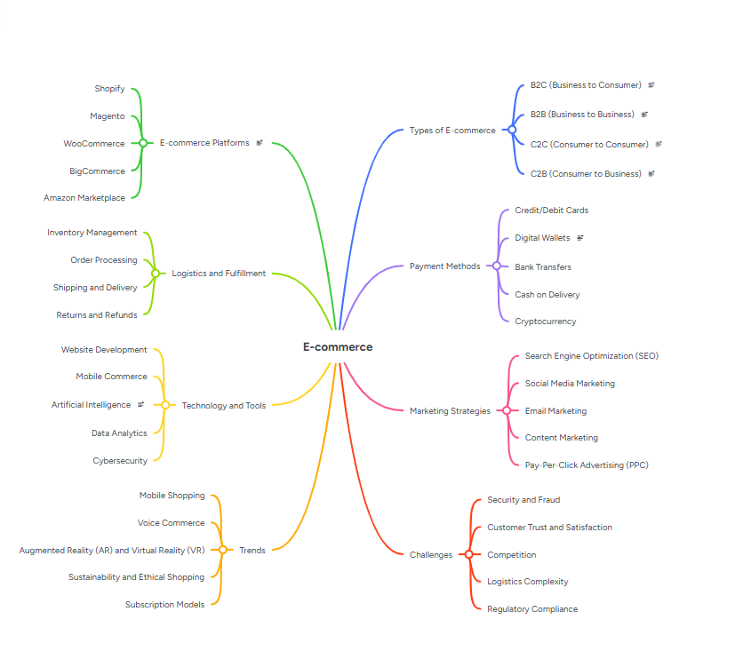
Figure 2 Mind map for contemporary Business.

Task 3. Office Applications for creating, storing, presenting, and analysing information/data

Office applications are essential software tools used by individuals and organisations to create, store, present, and analyse information and data. They support a wide range of business activities, including document creation, communication, record management, financial reporting, data analysis, and presentations. In modern workplaces, office applications improve productivity, collaboration, decision-making, and information management.

The most used office applications are included in suites such as Microsoft 365 and Google Workspace. These suites provide integrated tools that enable users to manage information efficiently while supporting teamwork and remote working environments.
This report examines the main office applications used for creating, storing, presenting, and analysing information and data, their features, benefits, and importance in business operations.

Microsoft 365
Many organizations choose integrated office suites because they provide multiple applications within one environment.

Microsoft 365 combines:
- Word [5]
- Excel
- PowerPoint
- Outlook
- OneDrive
- Teams
- Access

Benefits
- Seamless integration
- Cloud collaboration
- Automatic updates
- Enterprise security

Office Applications for Creating Information

Creating information is one of the primary functions of office software. Organizations produce documents, reports, letters, proposals, manuals, and marketing materials daily. Word processing applications are designed to facilitate the creation and editing of such content.

Word Processing Applications: MS Word
Word processing software allows users to create, edit, format, and print text-based documents.

Common Examples
- Microsoft Word
- Google Docs
- LibreOffice Writer

Features
- Text creation and editing
- Spell and grammar checking
- Templates and styles
- insertion
- Mail merge functions
- Collaboration and commenting tools
- Document sharing and cloud storage

Business Uses

Organizations use word processors to create:
- Business letters
- Reports
- Policies and procedures
- Contracts
- Meeting minutes
- Employee handbooks
- Marketing documents

Benefits
- Improves document quality
- Reduces errors
- Saves time through templates
- Enhances professional presentation
- Supports collaborative working

For example, a Human Resources department may use Microsoft Word to create employment contracts and employee policies, while marketing teams use it to prepare promotional content and business proposals.

Office Applications for Storing Information: Access
Organizations generate large amounts of data and information that must be stored securely and accessed efficiently. Various office applications assist in organizing, storing, and retrieving information.

Database Management Applications
Database software stores large quantities of structured information.

Common Examples
- Microsoft Access [6]
- MySQL
- Oracle Database

Features
- Data storage
- Data retrieval
- Record searching
- Report generation
- Query management
- Data validation

Business Uses

Databases are used to manage:
- Customer records
- Employee information
- Inventory records
- Supplier information
- Sales transactions

Benefits
- Centralized data storage
- Improved accuracy
- Faster retrieval of information
- Better security controls
- Reduced duplication of data

For example, a retail company may maintain a customer database containing purchase histories, contact details, and loyalty programme information.

Office Applications for Presenting Information: PowerPoints

Presenting information effectively is crucial for communication, training, sales, and decision-making. Presentation software enables users to communicate information visually and professionally.

Presentation Applications

Presentation software is used to create slide-based visual presentations.

Common Examples
- Microsoft PowerPoint [7]
- Google Slides
- Prezi

Features
- Slide creation
- Templates and themes
- Charts and graphs
- Images and videos
- Animation effects
- Speaker notes
- Collaboration tools

Business Uses

Presentation applications support:
- Staff training
- Sales presentations
- Business meetings
- Project updates
- Strategic planning sessions
- Investor presentations

Benefits
- Improves audience engagement
- Supports visual communication
- Simplifies complex information
- Enhances professionalism
- Encourages collaboration

For example, managers often use PowerPoint to present quarterly performance reports to senior executives using graphs, charts, and visual summaries.

Office Applications for Analysing Data: ME Excel

Data analysis is one of the most valuable business activities supported by office applications. Organizations rely on data to identify trends, forecast performance, and make informed decisions.

Spreadsheet Applications

Spreadsheet software is the most widely used tool for analysing business data.

Common Examples
- Microsoft Excel [8]
- Google Sheets
- LibreOffice Calc

Features
- Data entry and storage
- Formulas and functions
- Sorting and filtering
- Pivot tables
- Charts and graphs
- Conditional formatting
- What-if analysis

Business Uses
Spreadsheets are commonly used for:
- Budgeting
- Financial analysis
- Sales forecasting
- Payroll calculations
- Inventory tracking
- Project planning

Benefits
- Accurate calculations
- Quick analysis of large datasets
- Improved reporting
- Flexible data management
- Better decision-making

For example, a finance department may use Excel to create annual budgets, calculate expenses, and forecast future revenue.

Importance of Office Applications in Modern Business

Office applications play a critical role in modern organizations because they support nearly every business function.

Improved Productivity

Employees can complete tasks more efficiently through automation, templates, and integrated workflows.

Enhanced Communication

Documents, presentations, and collaborative tools facilitate communication between employees, departments, customers, and suppliers.

Better Decision-Making

Data analysis applications provide insights that help managers make evidence-based decisions.

Increased Accuracy

Automated calculations and validation tools reduce human error.

Cost Efficiency
Digital documents reduce printing, storage, and administrative costs.

Collaboration and Remote Working

Cloud-based applications allow teams to collaborate regardless of location.

Data Security

Modern office applications provide encryption, access controls, backups, and version management to protect business information.

Challenges of Office Applications

Despite their advantages, office applications present several challenges:

Security Risks

Sensitive information may be vulnerable to cyberattacks if security measures are inadequate.

Training Requirements

Employees require training to use advanced features effectively.

Software Costs

Licensing and subscription fees can be significant for large organizations.

Data Management Issues

Poor data governance can result in duplication, inconsistency, and inaccurate reporting.

Dependence on Technology

System failures or internet outages can disrupt business operations.

Organizations must implement appropriate security, training, and support measures to maximize the value of office applications.

Conclusion

Office applications are fundamental tools for creating, storing, presenting, and analysing information and data within modern organizations. Word processing software enables the creation of professional documents, databases and cloud storage systems provide secure information management, presentation applications facilitate effective communication, and spreadsheet and business intelligence tools support data analysis and decision-making. Integrated office suites such as Microsoft 365 and Google Workspace combine these capabilities into unified platforms that improve productivity, collaboration, and operational efficiency.

As businesses increasingly depend on digital information, office applications continue to play a vital role in supporting daily operations, enhancing communication, improving decision-making, and maintaining competitive advantage in a rapidly evolving business environment.

Practical Applications of MS Excel

Testing of IF Function
The IF function in Excel returns different values based on a condition. It is used for decision-making in spreadsheets.
Below is the function is tested in the example below. =IF(H2>=1000, "Good business", "Bad Business")

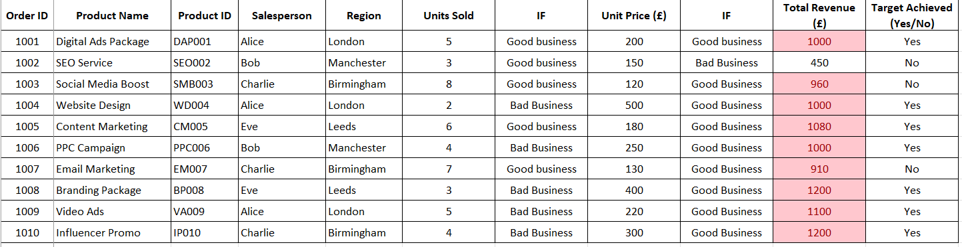
Figure 3 Testing of IF Function

Testing of Pivot Table
A Pivot Table is a powerful tool that summarises large datasets and helps analyse data trends.
Scenario Example (Sales Data)
The sales manager wants to
see total revenue per salesperson without manually calculating it.
Summarise total revenue by region, product, or salesperson.
Quickly generate insights without complex formulas.

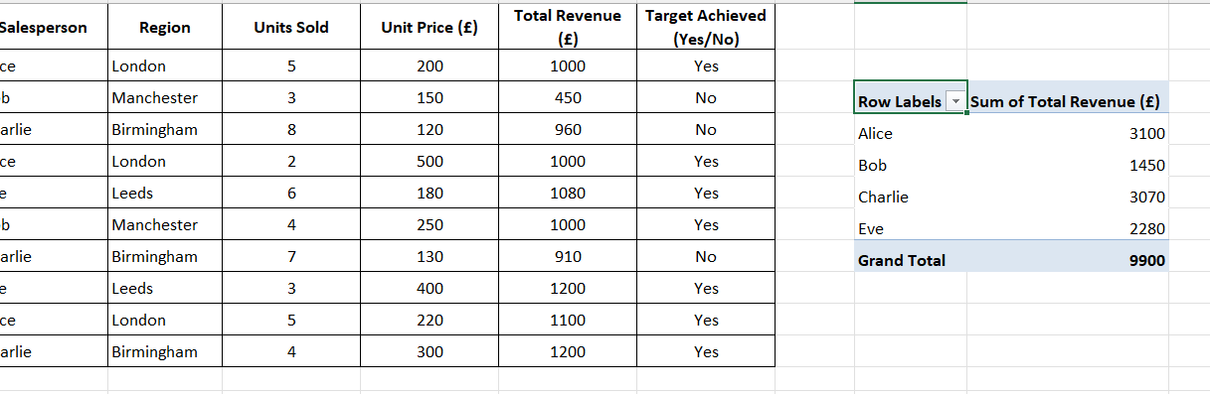
Figure 4 Creating of a Pivot Table

Test of Goa Seek Function
Goal Seek is a What-If Analysis tool in Excel that adjusts input values to achieve a target result.
Scenario Example (Sales Data)
A manager wants to determine how many units must be sold to reach £1,500 revenue.
Given:

Current Revenue Formula: =Units Sold * Unit Price

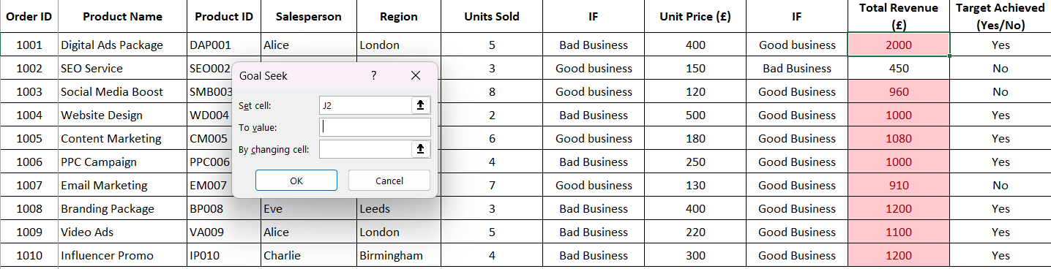

Goal: Adjust Units Sold to reach £2,000.

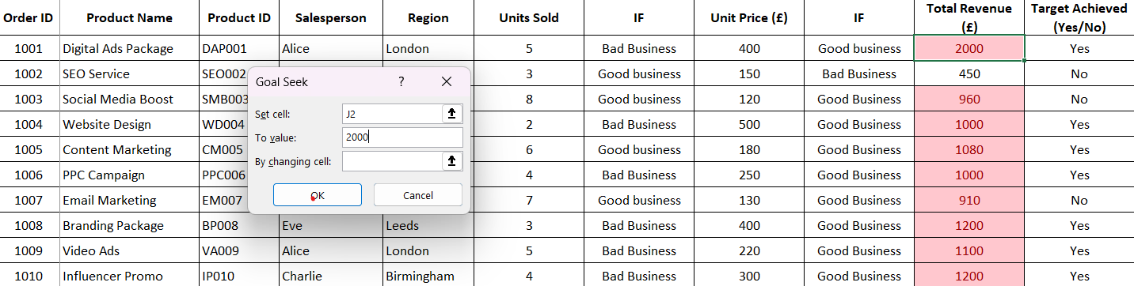
Figure 5 Testin of Goal Seek Function/.

Task 4. Communication and Collaboration applications

Introduction

Communication and collaboration applications have become essential tools in modern organizations. They enable employees, customers, suppliers, and stakeholders to communicate effectively and work together regardless of geographical location. The rise of remote and hybrid working has further increased the importance of these applications. Businesses use communication tools for messaging, voice calls, video meetings, and information sharing, while collaboration tools support teamwork, document sharing, project management, and real-time cooperation.

This report analyses one contemporary communication application, Microsoft Teams, and one online collaboration application, Google Docs, highlighting their key features, benefits, and practical applications in business environments.

Communication Application: Microsoft Teams

Overview

Microsoft Teams is a cloud-based communication platform developed by Microsoft. It is widely used by businesses, educational institutions, and government organizations to support communication and teamwork. Microsoft Teams integrates messaging, video conferencing, voice calls, file sharing, and collaboration tools into a single platform [9].

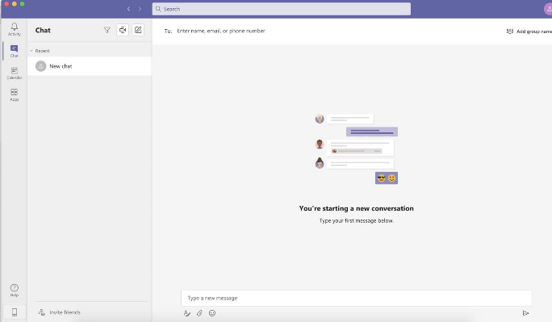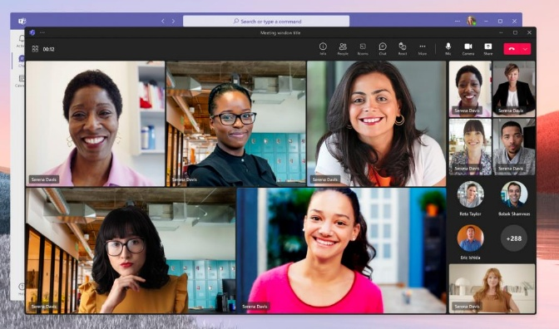
Figure 6 Visual Example.

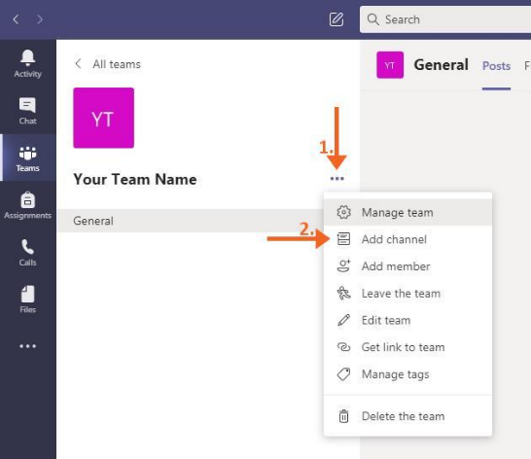
Figure 7 Key Features.

Instant Messaging and Chat—Teams allows users to communicate through one-to-one or group chats. Employees can send text messages, emojis, GIFs, files, and links in real time.

Business Benefit include faster communication compared to email and supports quick decision-making.

Video Conferencing—Users can host virtual meetings with screen sharing, recording, breakout rooms, and live captions.

Business Benefit include, facilitates remote working, reduces travel costs, and supports global collaboration.

Team Channels—Departments and project groups can create dedicated channels for discussions, announcements, and file sharing.

Business Benefit include, organizes communication by project or department, improves information accessibility.

File Sharing and Integration—Teams integrates with Microsoft 365 applications such as Word, Excel, PowerPoint, and OneDrive.

Business Benefit include, centralized document management, easier collaboration on business files.

Security and Compliance—Microsoft Teams provides enterprise-level security including encryption, multi-factor authentication, and compliance management.

Business Benefit include, protects sensitive organizational information, supports regulatory compliance

Microsoft Teams combines multiple communication functions within a single platform. Its integrated environment improves productivity, communication efficiency, and teamwork while supporting remote and hybrid work models.

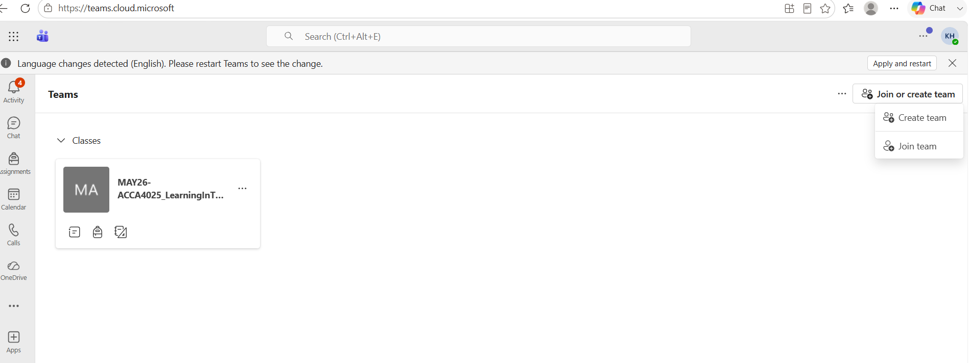

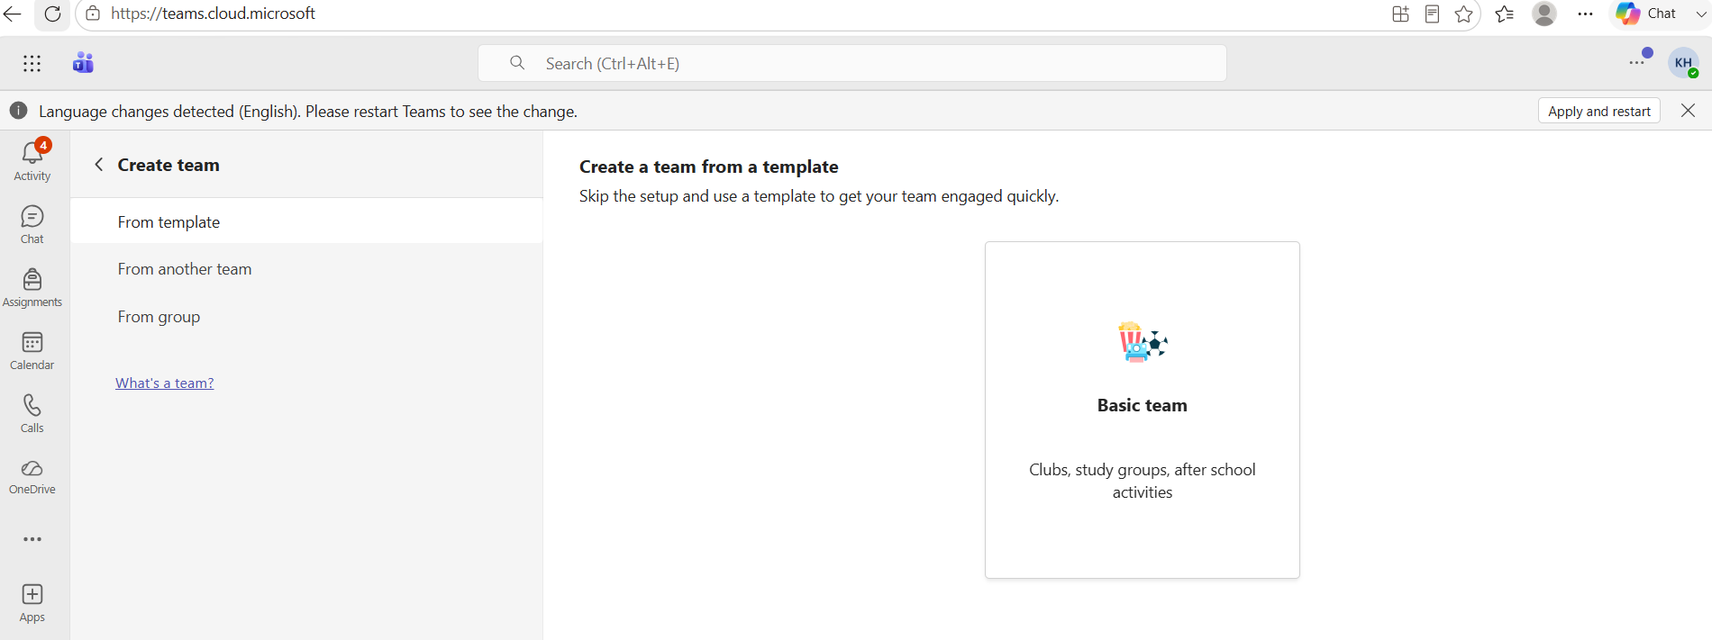

Online Collaboration Application: Google Docs

Overview

Google Docs is a web-based word-processing application that forms part of Google Workspace. It enables multiple users to create, edit, and review documents simultaneously from different locations [10].

Visual Example

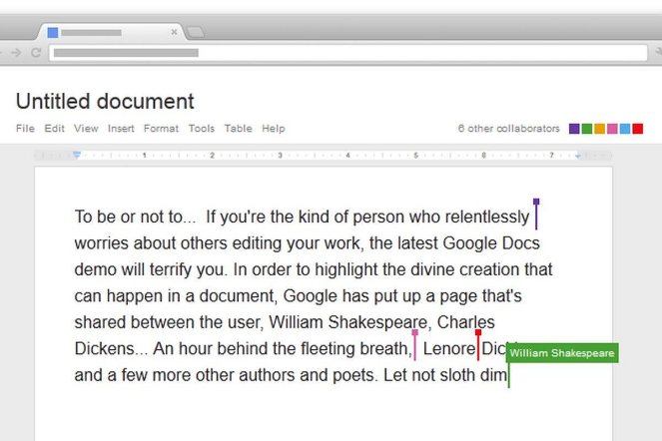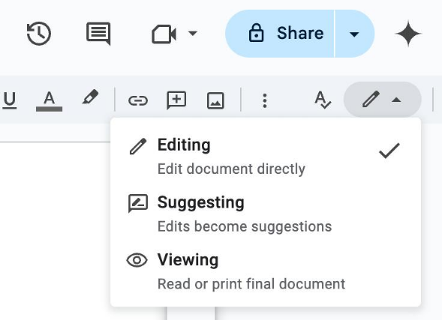

Figure 8 Visual Example.

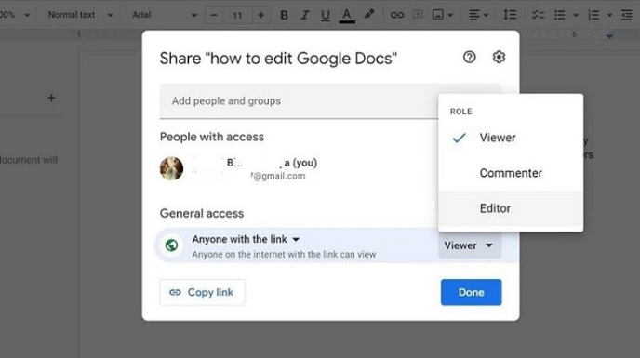
Figure 9 Key Features.

Real-Time Collaborative Editing—Multiple users can work on the same document simultaneously. Changes are displayed instantly to all collaborators.

Business Benefit include, eliminates version-control problems and speeds up document creation.

Commenting and Suggestions—Users can leave comments, feedback, and suggested edits without changing the original content.

Business Benefit include, facilitates peer review and improves document quality.

Cloud Storage Integration—Documents are automatically stored in Google Drive.

Business Benefit include, reduces risk of data loss and enables access from any device.

Sharing and Permissions—Document owners can assign viewer, commenter, or editor permissions.

Business Benefit include, enhances document security and controls access to sensitive information.

Google Docs is a powerful collaboration tool that allows teams to create and edit documents together in real time. Its cloud-based architecture supports flexible working arrangements and improves efficiency through simultaneous collaboration.

Practical Testing and Evidence of Use

Communication Application Test: Microsoft Teams

Tested Feature: Chat Messaging

Objective: Test the instant messaging feature.

Procedure
- Open Microsoft Teams.
- Select "Chat".
- Start a new conversation.
- Type a message.
- Send the message.
- Verify message delivery.

Screenshot Evidence

Screenshot 1: Teams Chat Window



Description:
The chat interface displays available contacts and conversation history.

The user can type messages in the message box at the bottom of the screen.

Screenshot 2: Message Sent Successfully

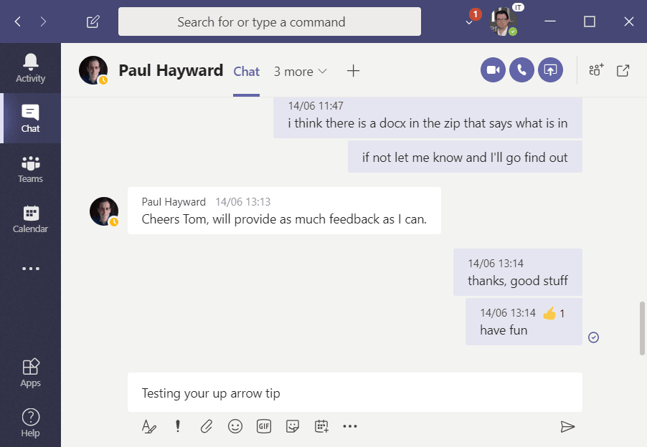

Description:
The screenshot demonstrates successful use of the instant messaging feature. The message appears in the conversation thread and is immediately visible to participants.

Results

The messaging feature worked successfully. Messages were delivered instantly, demonstrating Teams' effectiveness for real-time business communication.

Collaboration Application Test: Google Docs

Tested Feature: Real-Time Collaborative Editing

Objective: Test collaborative document editing.

Procedure

- Create a Google Docs document.
- Share the document with another user.
- Grant editing permissions.
- Both users edit the document simultaneously.
- Observe updates in real time.

Screenshot Evidence

Screenshot 3: Shared Google Document
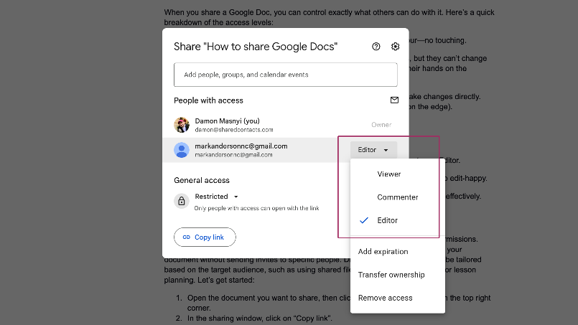

Description:
The screenshot demonstrates that editing permissions were granted to another user, enabling collaboration.

Screenshot 4: Simultaneous Editing
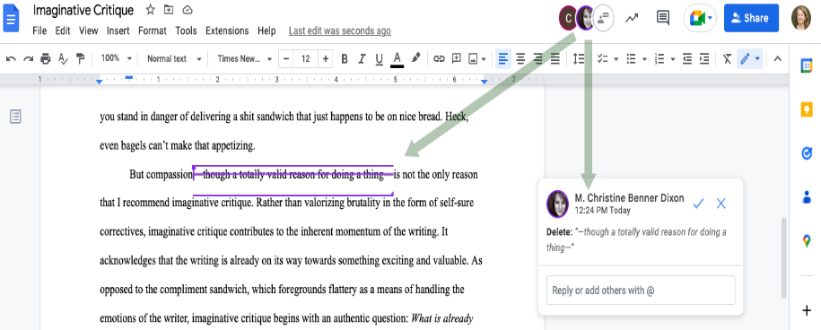

Description:
Google Docs displays edits instantly as collaborators type. Different cursor colours identify individual contributors.

Screenshot 5: Version History
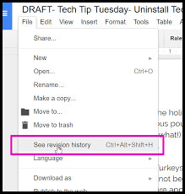

Description:
The version history feature records document changes and allows previous versions to be reviewed or restored.

Results

The collaborative editing feature functioned effectively. Multiple users were able to edit the same document simultaneously, confirming Google Docs' suitability for collaborative business work.

Comparison of the Applications

Feature | Microsoft Teams | Google Docs
Primary Purpose | Communication | Collaboration
Instant Messaging | Yes | No
Video Meetings | Yes | No
Real-Time Document Editing | Limited | Yes
File Sharing | Yes | Yes
Cloud-Based | Yes | Yes
Team Collaboration | Yes | Yes
Version History | Basic | Advanced
Mobile Access | Yes | Yes

Conclusion

Communication and collaboration applications are fundamental to modern business operations. Microsoft Teams provides comprehensive communication capabilities through instant messaging, video conferencing, team channels, and file sharing. Google Docs supports effective collaboration through real-time document editing, cloud storage, commenting, and version control.

Testing demonstrated that Microsoft Teams successfully supports real-time communication through chat messaging, while Google Docs enables efficient collaborative document creation and editing. Together, these applications enhance productivity, support remote working, improve teamwork, and enable organizations to operate more effectively in today's digital business environment.

References
[1] Qin, Zheng, et al. Introduction to E-commerce. Springer Nature, 2025.

[2] Ponce, Jéssica, et al. "Towards a Dashboard for E-Commerce Analytics in a Wix-Based Website." XVIII Multidisciplinary International Congress on Science and Technology. Cham: Springer Nature Switzerland, 2025.

[3] Rich, Jason R. Ultimate Guide to Shopify. Entrepreneur Press, 2022.

[4] Buzan, Tony, and Chris Griffiths. Mind Maps for Business: Using the ultimate thinking tool to revolutionise how you work. Pearson UK, 2013.

[5] Kruse, Otto, and Christian Rapp. "Word processing software: The rise of MS Word." Digital Writing Technologies in Higher Education: Theory, Research, and Practice. Cham: Springer International Publishing, 15-32, 2023.

[6] Eckstein, Jonathan, and Bonnie R. Schultz. Introductory relational database design for business, with Microsoft Access. John Wiley & Sons, 2018.

[7] Foulkes, Linda. Learn Microsoft Office 2019: A Comprehensive Guide to Getting Started with Word, PowerPoint, Excel, Access, and Outlook. Packt Publishing Ltd, 2020.

[8] Winston, Wayne. Microsoft Excel 2010 Data Analysis and Business Modeling. Pearson Education, 2011.

[9] Chaushi, Blerta Abazi, Monika Nastovska, and Teuta Veseli-Kurtishi. "MS Teams for Virtual Collaboration-An Overview." (2024).

[10] Holzner, Steven, and Nancy Conner. Google docs 4 everyone. FT Press, 2009.

