
the bonaliz.com project


University of Wales Trinity Saint David, London Campus
Student Name: Edit Bona
Student Number: 1909474
Course Name: BA (Hons) Leadership and Management Skills for the Workplace Level 5 Term 2
Modul Name: Managing Projects in the Organisation
Lecturer: Dan Hart
Submission Date: 28/03/2021

Table of Content

1. Introduction 2
2. Introduce the BonaLiz.com project tools and techniques 3
2.1 PRINCE2 methodology 3
2.2 Agile methodology 4
2.3 PRINCE2 Agile methodology 5
2.4 Scope 6
2.5 Gantt chart 6
2.6 Work Breakdown Structure /WBS/ 7
2.7 Which methodology the best? 7
3. The BonaLiz.com project 7
3.1 Project background and description 8
3.2 Stakeholders 11
3.3 Budget 13
3.4 Scope planning and execution 15
3.5 Work Breakdown Structure /WBS/ 15
3.6 Roles and responsibilty 16
3.7 Communication Plan 17
3.8 Risk management 17
4. The project SWOT analysis 17
5. Conclusion 19
Bibliography 20

Introduction

This report presents the project of launching a small online web store called bonaliz.com. The idea has long matured, but the COVID19 epidemic, which began in March 2020 and has continued ever since, has only reinforced the creation of a business that is not stationary and can be done flexibly from anywhere. The profile of the company is the distribution of clothing products (women, men and children), bags, hats, masks and art prints that are made in an environmentally conscious way. The target market niche is the people for whom it is important to get quality products (organic cotton, recycled products, plastic-free packaging) and environmentally friendly as possible from production to packaging. For this implementation, the bonaliz.com succeed found a company partner that can perfectly provide these criteria. The Teemill. com is a Print on Demand (POD) company founded in 2009 and manufactures its products in a completely sustainable way (using renewable energy, organic and recycled cotton, low-waste digital printing, etc.). (Teemill.com, n.d.)This project is about launching this webshop and working with Teemill.com. In the webshop, customers will have the opportunity to create their own design for the desired interface, which will make the product unique to them. The project started on February 21, 2021 and is expected to be completed on October 31, 2021.
But what is project and project management? A project is „...a temporary effort to create a unique product, service, or outcome. It has a defined beginning and end in time, and therefore defined scope and resources. And a project is unique in that it is not a routine operation, but a specific set of operations designed to accomplish a singular goal." (PMI.org, n.d.) For a project to work successfully and achieve its goal, proper project management is important. This means professional management to ensure that the project takes place within the right time and budget. „Project management, then, is the application of knowledge, skills, tools, and techniques to project activities to meet the project requirements.” (PMI.org, n.d.)
Different tools and models are needed to complete the project in order to successfully achieve the goal. To do this, the Gantt chart and Milestone chart shows the main tasks in chronological order from start to finish, which is then broken down into smaller subtasks. The Agile methodology is one of the best suited for this business model, providing the flexibility needed in an ever-changing online marketplace, but the more rigid model of PRINCE2 is also suitable partly because of the customer oriented service. The Network Diagram shows each task and its duration, which helps you to identify where there may be gaps. It also helps a lot in risk analysis. The importance of communication and collaboration is also paramount, as it works differently in the online space and a constant relationship with the potential customers needs to be maintained. The SWOT analysis provides a better overview of the project's weaknesses, strengths, opportunities and threats.

Introduce the BonaLiz.com project tools and techniques

This section describes the tools and techniques to help you plan, launch and implement this project. These tools effectively support the project manager work from start to finish. As this is a start-up project for a small business in the online space working with a larger company, the use of different tools will differ somewhat from the traditional business model. After an introduction to the tools and techniques, these differences and the elements that can be used will be analysed.

2.1 PRINCE2 methodology
„PRINCE2 is an acronym for Projects IN Controlled Environments. It’s a process-based method for managing a project. As noted, it’s been mostly used by the government in the United Kingdom, but it’s also prevalent in the private sector in the United Kingdom and other places around the world.” (Malsam, 2018)
PRINCE2 is a customer-oriented project management methodology. It organizes the project into logical steps, maintains this process from start to finish and checks that the different steps are done in an orderly manner. This process consists of 7 parts and covers all the processes of the project:

- Start up the project: This is where it is decided whether the project is feasible. If it is, a project document is drawn up, describing the plan, who is involved, what their role is and how it will be carried out.
- Initiate the project: This is where they set out the specific deliverables, the risks and benefits, and how they will monitor the progress of the project. These strategies are developed.
- Direct the project: This is where the people responsible for managing and implementing the project can be held accountable for the project's progress and they work with other participants.
- Control stages: This is where the specific tasks will be assigned, to check that the project is going according to plan. Identify and resolve any problems and risks that arise.
- Manage product delivery: It oversees the work between the project manager and the team, and is where work processes are implemented.
- Manage stage boundary: Ellenőrzik az elvégzett feladat eredményeit, és megtervezik a következő szakasz lépéseit.
- Close the project: It's about getting the project to the target by the deadline, which can sometimes also mean early closure. It evaluate the results of the project and close it.

PRINCE2 assigns roles and responsibilities to all players at all levels. Several teams can work on the project, and they will be held accountable for the results. (Malsam, 2018)

2.2 Agile methodology
It was developed by engineers in the software industry in the 1990s, when they were trying to find solution constant delays, budget overruns and low quality.
„Agile approaches don’t concern themselves with the wider questions about whether a project is worth it, or whether the benefits can be realized afterwards. They do focus however on delivering value to the customer by delivering products incrementally, in the most efficient manner possible. These products are likely to do what the user/customer needs because the customers have been involved in a constant cycle of defining and prioritizing requirements, developing, testing and providing feedback.” (Buehring, 2020)
There are 4 important values in Agile thinking:
- Continuous communication and ease of response to change is one of the values.
- The aim is to provide high quality products and services.
- Stakeholder involvement in the project. Regular cooperation with them.
- Flexibility to adapt the existing plan to any changes when necessary.

The 12 principles of Agile reformulated to take account of the wider business are:
- Customer satisfaction comes first.
- Agile processes can be changed at any time, giving the customer a competitive advantage.
- Frequent and early delivery of value is very important.
- Communicate with stakeholders on a daily basis.
- The focus is on the team and stakeholders in a supportive environment.
- The emphasis is on personal communication wherever possible.
- A functioning service and product is a sign of progress and success.
- Sustainability is the result of continuous progress.
- The high quality of the finished work is important.
- Keeping things simple.
- The most efficient teams are always self-organised.
- The aim is continuous improvement and efficiency, and to make the necessary changes when require.
(Professionaldevelopment.ie, n.d.)

2.3 PRINCE2 Agile methodology
„In 2015, in recognition that many people were struggling to find a way of applying PRINCE2 on agile projects, AXELOS launched PRINCE2 Agile[2].
PRINCE2 Agile at its core is essentially the same as PRINCE2. They both rely upon the exact same principles, themes and processes. The only real difference is that the PRINCE2 Agile guidance explains in detail how to tailor these elements for agile projects.” (Buehring, 2020)

PRINCE2 Agile explain what needs to be fixed or made flexible during the project. Time and cost are what remain fixed, but scope and quality criteria remain flexible. Changes are always made together with the client. Benefits and risks can be fixed or flexible depending on the client. Combining the advantages of both methods provides both the direction and control the project needs and the flexibility to adapt to changing business conditions. (Buehring, 2020)

2.4 Scope
„Scope is a statement that defines the boundaries of the project. It tells not only
what will be done, but also what will not be done. ... this document is the
foundation for all project work to follow. It is critical that the scope be correct. It is no secret that a project’s scope can change. You do not how or when, but it will change. Detecting that change and deciding how to accommodate it in the project plan are major challenges for the project manager.” (Wysocki, 2014)
The following 5 elements are present in every project and for a project to work well, they must be balanced: scope, quality, cost, time, resources. If one of these changes, another one will change. To restore balance, another must change. When something is out of scope, it means that the client will later request a service that is not available within the scope of the original project. (Wysocki, 2014)

2.5 Gantt chart
Created by American mechanical engineer Henry Gantt in 1910. „A Gantt chart is a project management tool assisting in the planning and scheduling of projects of all sizes, although they are particularly useful for simplifying complex projects. Project management timelines and tasks are converted into a horizontal bar chart, showing start and end dates, as well as dependencies, scheduling and deadlines, including how much of the task is completed per stage and who is the task owner. This is useful to keep tasks on track when there is a large team and multiple stakeholders when the scope changes.” (apm.org.uk, n.d.)

2.6 Work Breakdown Structure /WBS/
„Work Breakdown Structure: A deliverable-oriented collection of project components. Work that isn’t in the WBS isn’t in the project. The point of the WBS is to organize and define the project scope.” (Luijbregts, 2020)
WBS breaks down the various larger tasks into sub-tasks and tries to organise them in order. This helps make the project more transparent and feasible, and avoids missing out on things. The size of the project will determine the level of detail, but an important rule for each is that the plan should be agile enough to keep the workflow moving smoothly. (Luijbregts, 2020)

2.7 Which methodology the best?
As shown above, there are many tools and methods available to start and successfully implement the BonaLiz.com webshop project. Of course, tools alone are worthless if they are not followed by actions. A comparison of the methods will give you a good guide as to which one is the best fit for this project. As the project will mainly sell clothing products, building an online store is a complex task, for which PRINCE2's control and management is a good tool, while the flexible Agile method is also a great tool to deal with changing customer needs or changes caused by any external or internal factor (e.g. COVID19 epidemic).
While PRINCE2 communicates with the customer mostly at the beginning and end of the project, the Agile method continuously asks for feedback and involves them interactively. In the case of an online store, this means continuous communication and information from the partner company, as the range of products can be extended and changed at any time, as can the technical availability of the webshop. Effective market research and marketing, on the other hand, requires more disciplined and accurate work, which is easier to monitor with PRINCE2.
As the 2 methods together are the most efficient, PRINCE2 Agile methodology was chosen to manage the project.

The BonaLiz.com project

In this section, the structure of the concrete project will be presented, using the appropriate tools. The project will be developed from start to finish, although the project itself is still ongoing. Here is the detailed development of the BonaLiz.com webshop project.

Project background and description
The idea of BonaLiz.com is not a new one, the planning for its creation started more than a year ago.The crisis of job losses caused by the COVID19 epidemic only reinforced the need. The aim was to create a business model that could be run from home or from anywhere, that did not require a large financial investment and was accessible to anyone. This business model is known as Print On Demand, or as it will be referred to later POD. The essence of this business is that usually a private company sells products that have a printed design put on them / t-shirt, hat, bedding, pillow, wall art, phone cases, stickers etc/. The private company (who is usually one person) does the design, marketing and promotion of the products and the POD company handles the manufacturing and delivery of the products. The designer receives a royalty fee for each product sold. As this business model is entirely online and is popular among people with average incomes, there are many similar POD companies with different product offerings. But what makes BonaLiz.com different?

Most POD companies use tools and product materials that are not made in an environmentally and human-friendly way, but instead reinforce mass production. In any case, BonaLiz.com was looking for a POD company that has a passion for producing their products in a sustainable and vegan way in a fair trade way. It wasn't easy, but we managed to find a UK based POD partner company in Teemill.com. The company provides the entire ecommerce platform, which can be customised, and as they do the manufacturing and delivery of the products, they also handle the legalities involved.

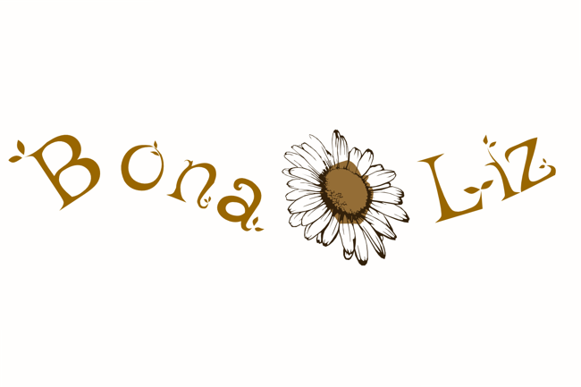

BonaLiz.com aimed to open an online store where these values are important for the target group (vegan people, environmentally conscious people, etc.). The products are mainly outerwear products for women, men and children (t-shirts, hoodies, long sleeves, hats, jumpers) made of 100% organic cotton, recycled cotton.It is possible to return free of charge worn clothes that are recycled, thus reducing our footprint on the Earth. In addition to clothing, tote bags and wall art in various sizes are available. Of course, these are also cotton and made from 100% recycled material. The inks and printers used for printing are also made from eco-friendly materials (water-based inks). The company grows the cotton in Northern India on local organic farms /Fair Trade/ and the products are made in factories there using renewable energy. Teemill.com ships worldwide, making this business a global opportunity.
Customers will have the option to use the webshop's design studio to put their own unique design on the products. This is a very big plus and advantage even compared to other POD companies.

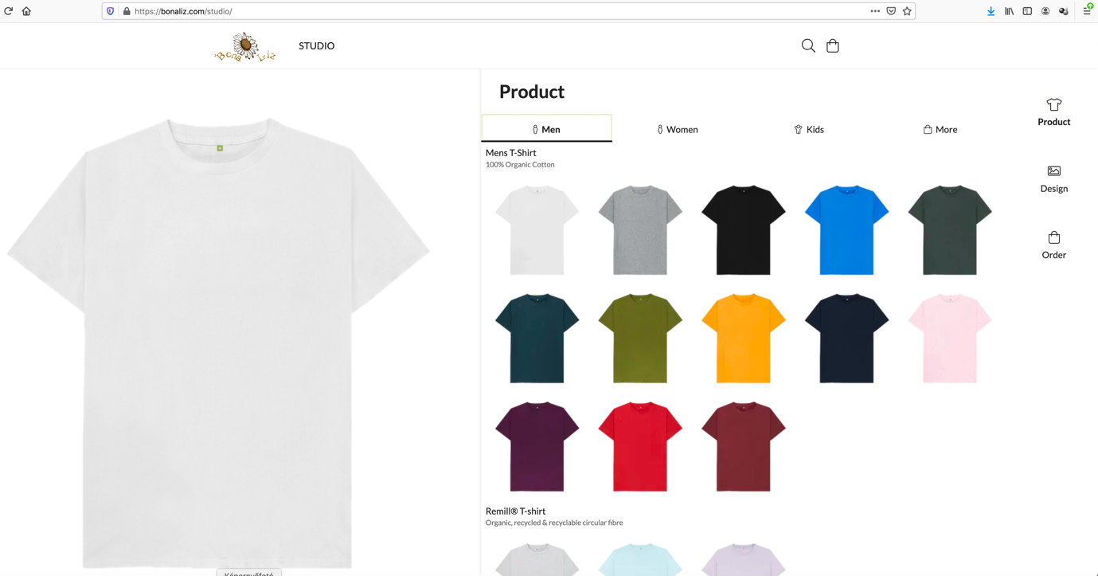
(Teemill.com, n.d.)

BonaLiz.com's goal is to run a profitable business that, in addition to making a profit, also takes care to do so in the most humane way possible for the benefit of the Earth and the life on it.

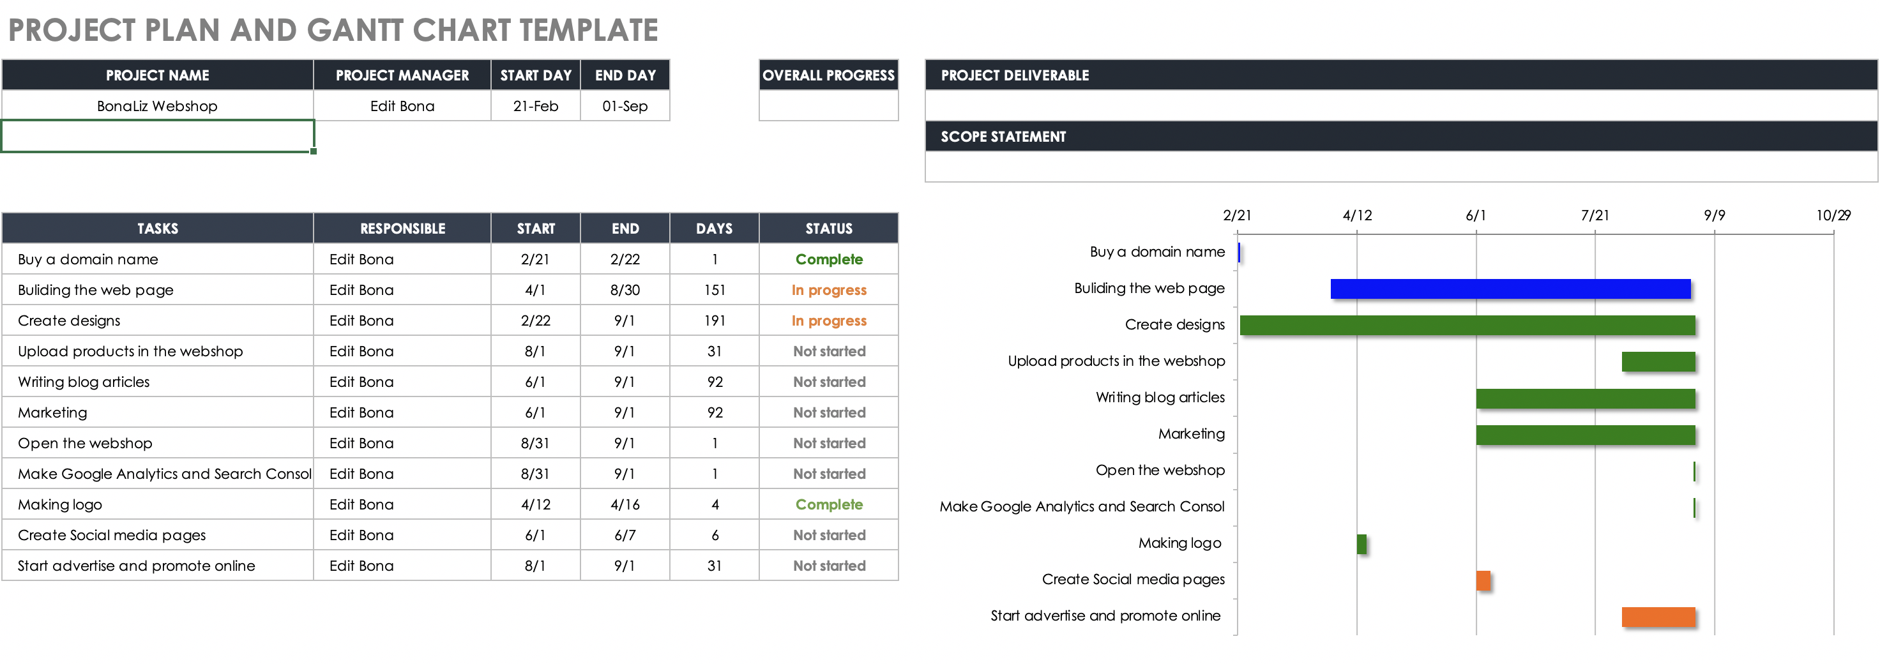

Stakeholders
„...individuals and organizations who are actively involved in the project, or whose interests may be positively or negatively affected as a result of project execution or successful project completion” (Smith, 2000)

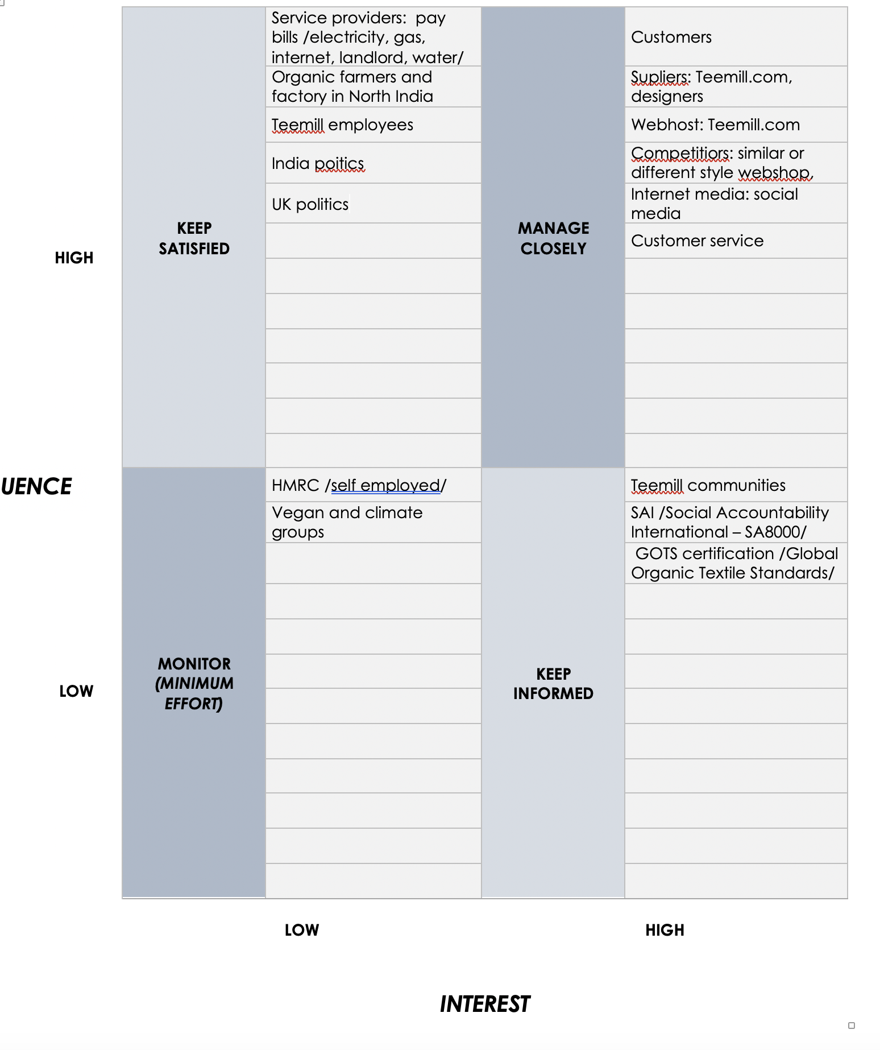
The internal stakeholders in this project are the owner and project manager of the one-man business BonaLiz.com. She does the design, marketing, website building, some administration (revenue, expenses), some customer service. As this is a one-person part-time small business for the time being, these tasks do not require team work for the time being.
The external stakeholders are already more numerous, which is more the partner company. Teemill.com employees are doing the physical part of the sale, so its success is key. They also run the engine of the webshop, which needs to be available at all times to ensure the sale. They also handle part of the customer service, because if there is a problem with the product, they have to fix it. Positive feedback from customers is important. This also includes external designers, who are paid royalties for their work by BonaLiz.com on a collection website. Competition can also affect the site, both negatively and positively.
Teemill also has 2 certificates that prove that its products meet the quality standards detailed above. These are GOTS (which certifies the organic origin of products) and SAI (which is awarded to companies where people work under appropriate conditions). It is important that these organisations continue to find Teemill eligible for this certification. (Globalstandard.org, n.d.) (Saintl.org, n.d.)
Consumer service providers /internet, electricity, water, landlord, gas/ also contribute to getting the job done. Timely payment of these is important. Tax liability to HMRC is also essential. Because if not properly accounted for, it could mean closure of the business.

Budget
An important part of implementing a project is having a budget. This business model does not require any investors, which is why it is so attractive as a home-based business. Of course, this doesn't mean that you don't have to invest anything, especially at the start. The following table details this.
The first table shows how much revenue the business expects to generate over 1 year. Projected by product category, it shows approximately how much product the company would sell and how much royalty fee get. The second table details the compulsory expenditure, also broken down over 1 year. Then, at the top of Table 2, the expected profit after 1 year is calculated. This is broken down on a monthly basis to something like £875, which in the first year as a sideline is not too bad, but definitely double the target or more for the second year.
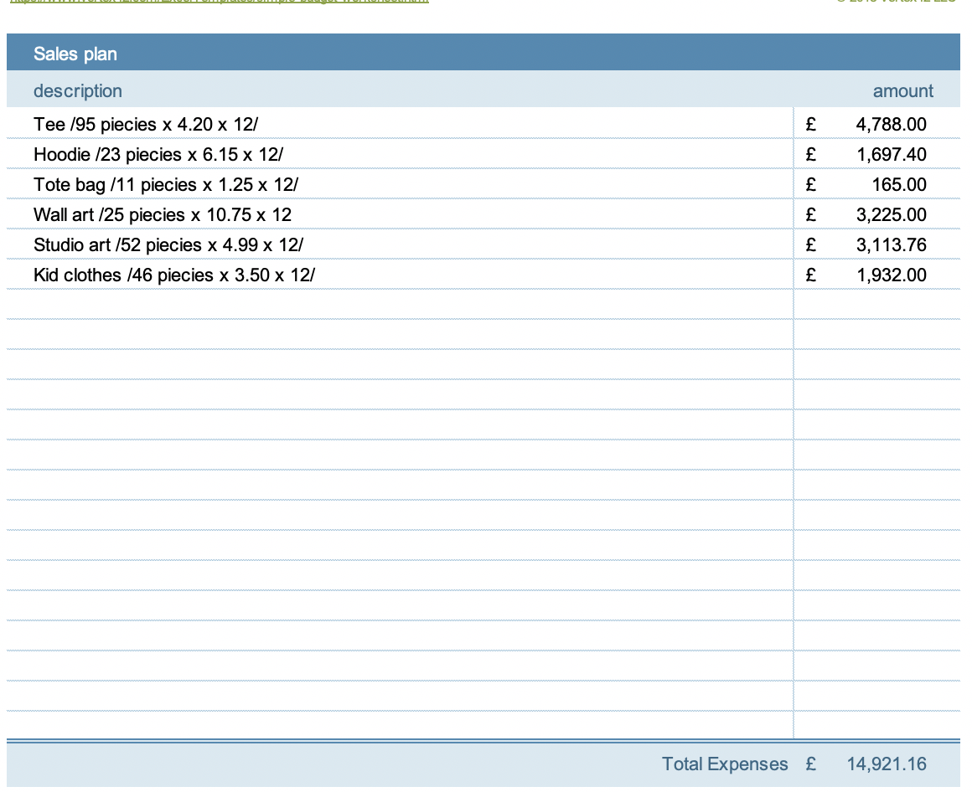
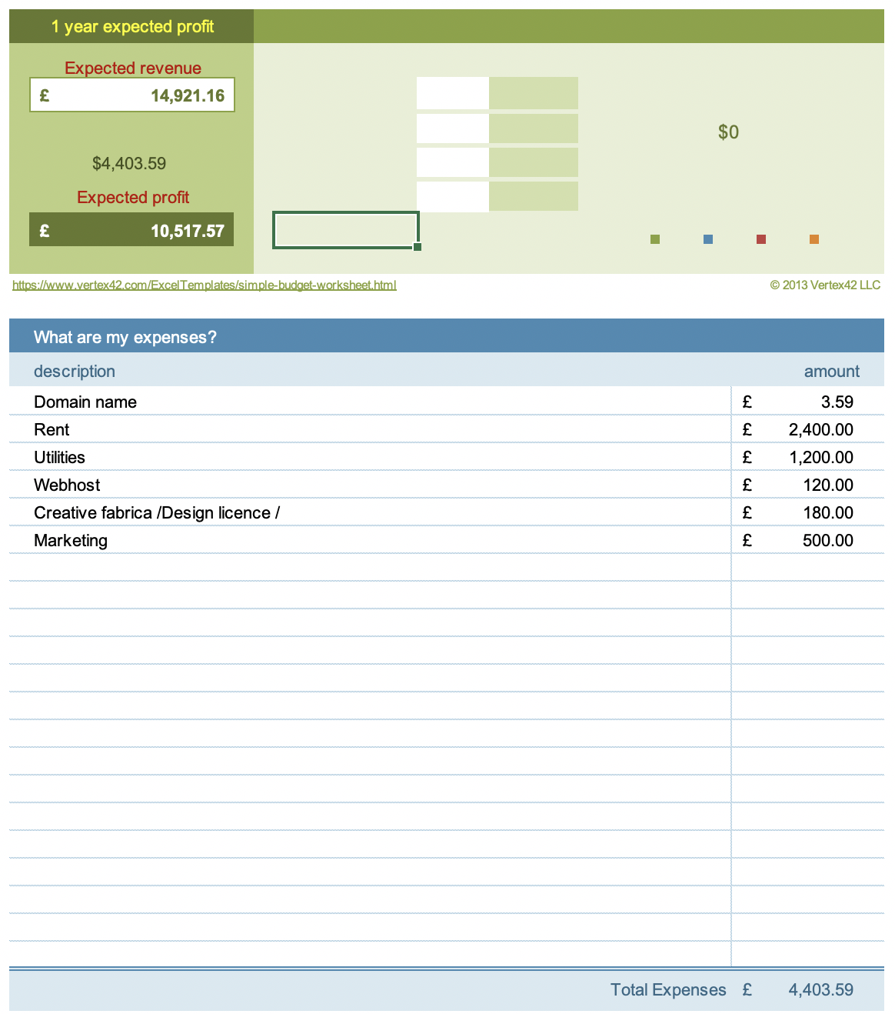

Scope planning and execution
Customers who want to create their own design can choose from a wide range of images and graphics to use on the Studio site. All you have to do is type in the desired term in the search box.
As soon as an order arrives, it determines the fastest possible delivery, depending on where the order came from. Most orders are printed the same day and delivery in the UK is 1-2 days as the company is based in London. They can also guarantee delivery to the rest of the world in around 5 days. The customer pays for the postage.
Circular fashion is provided to buyers: „Our new products are made from our old products, which are designed from the start to be sent back when they are worn out. This is the circular economy for clothing.” (Teemill.com, n.d.)
Quality is guaranteed by GOTS and SAI (SA8000) certifications. The designs created by BonaLiz.com are either self-designed or the work of designers for whom royalties are paid. This can be verified at any time, and certificates are available.

Work Breakdown Structure /WBS/
The main tasks described in the Gantt chart are broken down into subtasks by the Work Breakdown Structure. The table below illustrates this. As you can see, the tasks are sequential, although there are some tasks that need to be done later on to make the business successful. These include ongoing market research, SEO, marketing and design.

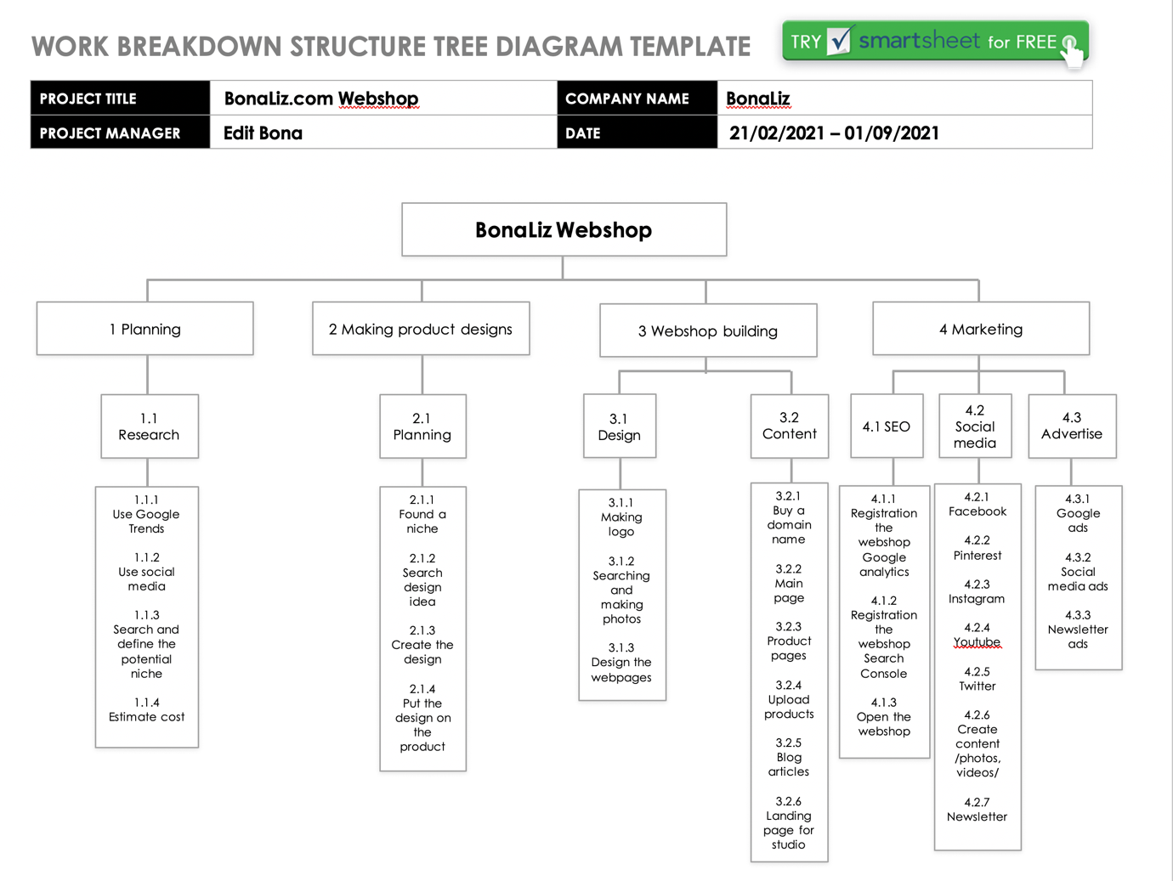

Roles and responsibilty
Head of BonaLiz.com /Edit Bona/ roles and responsibilty: webshop setup, design, marketing, administration, product uploading, advertising. Responsible for the legitimate use of the designer, for the legal operation of the webshop, and for the proper information of customers.

Teemill.com roles and responsibility: To produce the goods ordered to the right quality and deliver them intact and on time. Informing seller of any changes.

Communication Plan
The communication between Bonaliz.com and Teemill.com is, due to the nature of working online, via email. Teemill also provides a forum where you can communicate with other vendors and with each other within a supportive community. We communicate with our customers via social media and email.

Risk management
As most of this project has to be carried out alone on a part-time basis, the biggest risk factor is time. Proper time management is important as it is easy to get behind schedule. Proper market research is also essential because if you define the market wrongly, it will negatively affect sales. Communication to potential customers is also crucial, as this is how we can direct them to the webshop. If it is not done in the right way, on the right platforms and to the right people, it is also a waste of money and time.

The project SWOT analysis

This chapter will focus on the SWOT analysis of the project. This is followed by a self development for the project manager.

Strenghts
- The strength of the project is that it can be launched on a small budget while working full-time.
- flexible working hours
- can be done from anywhere
- all you need is a computer and an internet connection
- small business can become big business
- the partner company /POD/ does the production and delivery

Weaknesses
- bad time management
- dependence on the partner company
- insufficient marketing knowledge /online marketing/
- too many tasks for one person

Opportunities
- opening more shops
- hire a virtual assistant
- do it full time
- working with other businesses

Threats
- Brexit could also cause problems for transport
- COVID19 outbreak could cause problems in transport
- Internet shutdown
- Weather (cotton growing)
- Transport disruption or shutdown

Self develope plan for the project manager
The skills most in need of development during the project are time management and the use of online marketing tools. This means continuous self-training, for which a number of training courses are available. These are in the process of being completed. Design is also an important skill to be practised, for which there are also the appropriate software tools and training materials. It is important that when the opportunity arises, it is essential to hand over to a virtual assistant the administrative tasks that take time away from creative activities. Of course, this requires the business to reach a certain level. The key is continuous lifelong learning, because everything is always changing and you have to keep up with it. Only then can you operate well and efficiently in the long term.

Conclusion

This report presents the project of an online store called BonaLiz.com. Today, in the global online marketplace, the idea of working from home is becoming increasingly popular among people. One way to do this is to team up with one or more POD companies who will ensure the creation and delivery of the products they design to customers. BonaLiz.com has also found the most suitable partner company in Teemill.com. The target group is people who want the products they buy to be made in a sustainable and Fair Trade way. This is what the Teemill.com team can provide through their own webshop system. In this case it is mainly outerwear, bags and wall art. BonaLiz.com is responsible for the design, marketing and webshop development of the project. The project has identified the participants, who are the ones who have more and less influence or impact on the business. The Gantt chart placed the project in a timeline with the main tasks to be done. This was followed by a Work Breakdown Structure, which broke it down into subtasks. A budget was also prepared, as well as a profit forecast for 1 year. The risks were also analysed, followed by a SWOT analysis. Finally, a self-improvement plan was drawn up to identify what could and should be improved in the future to make the business successful.

Bibliography

PMI.org, n.d. Project Management Institute. [Online]
Available at: https://www.pmi.org/about/learn-about-pmi/what-is-project-management
[Accessed 18 04 2021].

Teemill.com, n.d. Teemill.com. [Online]
Available at: https://teemill.com/
[Accessed 24 04 2021].

Wysocki, R. K., 2014. Effective Project Management: Traditional, Agile, Extreme. 7 ed. Indianapolis: John Wiley and Sons.

Buehring, S., 2020. Knowledgetrain.com. [Online]
Available at: https://www.knowledgetrain.co.uk/project-management/prince2-agile/prince2-agile-comparison
[Accessed 19 04 2021].

Petersen, C., 2013. The practical guide to project management. 1 ed. s.l.:bookboon.com.

Malsam, W., 2018. projectmanager.com. [Online]
Available at: https://www.projectmanager.com/blog/prince2-methodology
[Accessed 25 04 2021].

Professionaldevelopment.ie, n.d. professional development. [Online]
Available at: https://www.professionaldevelopment.ie/what-is-agile-project-management
[Accessed 25 04 2021].

apm.org.uk, n.d. Association for project management. [Online]
Available at: https://www.apm.org.uk/resources/find-a-resource/gantt-chart/
[Accessed 26 04 2021].

Westland, J., 2020. Projectmanager.com. [Online]
Available at: https://www.projectmanager.com/blog/milestones-project-management
[Accessed 26 04 2021].

Eby, K., 2018. Smartsheet.com. [Online]
Available at: https://www.smartsheet.com/free-work-breakdown-structure-templates
[Accessed 27 04 2021].

Bonaliz.com, 2021. Bonaliz.com. [Online]
Available at: https://bonaliz.com/design-your-own-t-shirt/
[Accessed 27 04 2021].

Luijbregts, E., 2020. Thedigitalprojectmanager.com. [Online]
Available at: https://thedigitalprojectmanager.com/work-breakdown-structure/
[Accessed 28 04 2021].

Smith, L. W., 2000. Stakeholder analysis: a pivotal practice of successful projects.. [Online]
Available at: https://www.pmi.org/learning/library/stakeholder-analysis-pivotal-practice-projects-8905
[Accessed 28 04 2021].

Globalstandard.org, n.d. Globalstandard.org. [Online]
Available at: https://global-standard.org/
[Accessed 27 04 2021].

Saintl.org, n.d. saintl.org. [Online]
Available at: https://sa-intl.org/programs/sa8000/
[Accessed 27 04 2021].

Teemill.com, n.d. Teemill.com. [Online]
Available at: https://teemill.com/circular-fashion/
[Accessed 28 04 2021].

