DISTRIBUTED WEB APPLICATIONS

Student name: Lingling Liu

Student P Number: 1704859

Module Title: distributed web application

Assignment Title: Failover Cluster Report

Lecturer：TIM BASHFORD

content
Configurations of the Failover Cluster 4
The Storage Area Network 4
Create the targets for Quorum and Storage 6
Try to set up the cluster 9
Investigate hosting a service on this cluster and test the configure of the cluster 11
Configure DHCP to run on the cluster 13
The failover cluster feature itself 16
Functional description 17
Failover Cluster Quorum 17
The heartbeat network and its operation 18
The differences between failover and Network Load Balancing Clusters 19
References 21

Configurations of the Failover Cluster

The Storage Area Network
There were three nodes in the cluster and one of them was the domain controller, while the others were common nodes in cluster. The important thing was that three node were in the same domain.

Storage was required for failover cluster. The setup of Storage Area Network(SAN) can be assessed with iSCSI. In the virtualised environment, having the domain controller host the storage and create the iSCSI targets can be done which was just simulation of the staff in the real word.

In this simulation work, Cardiff was the domain controller, and the storage can be set up in the Disk Management. Figure 1 showed the Disk Management , it was the location to set up the storage required in Cardiff.
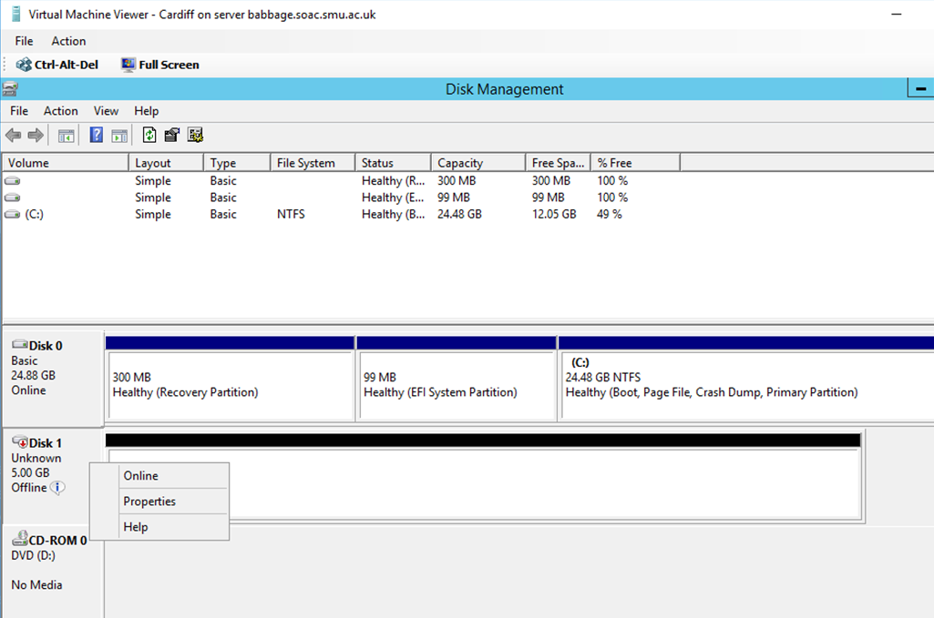
Figure 1 Disk Management
Figure 2 showed the size of one of the storages. The small storage named quorum. The name of storage was set up in Figure 3.

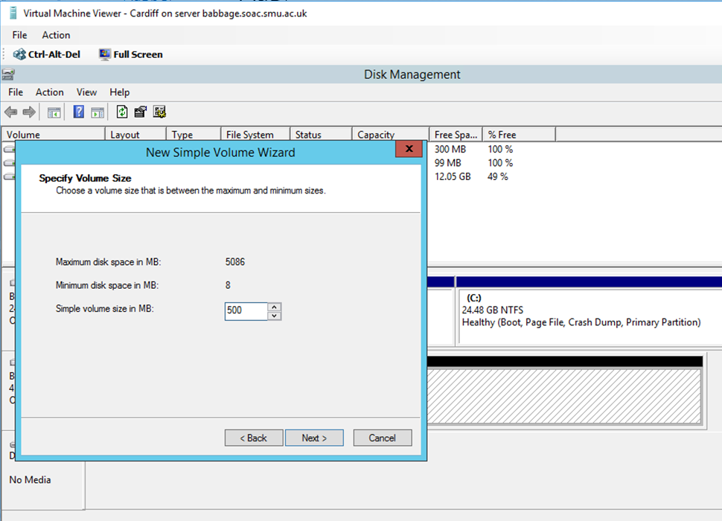
Figure 2 set up the size of small storage
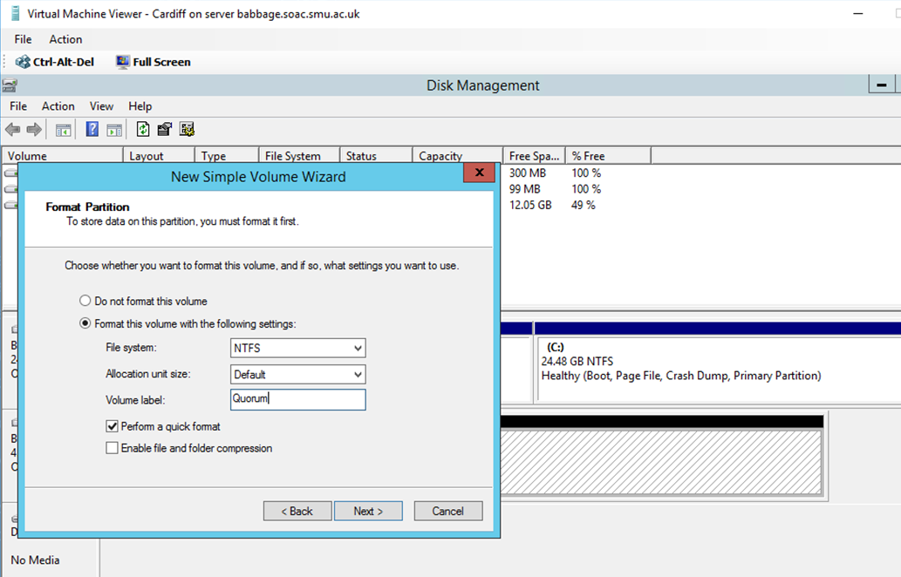
Figure 3 configuration of the name of the small storage

The small storage named Quorum and the size was 500mb, while the other big size storage was also needed to be built up. The big storage named “storage” and the size of the storage was 4.5gb.

The steps of the configurations of the “storage” were similar to that of the small storage named “quorum”.

Then all the storages were created after using the Disk Management.

Create the targets for Quorum and Storage

This work could be done in Sever Manager, first select “File and Storage Services”, and the run the iSCSI virtual disk wizard. A new configuration of one disk could be created first, and then the second could use it again. Just make sure everyone had the appropriate name.

Figure 4, 5, 6 showed the steps of configuration of building the targets
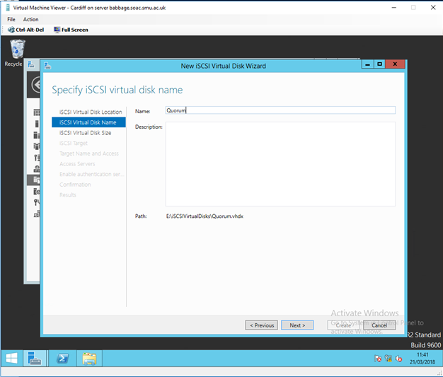
Figure 4 create the target for Quorum
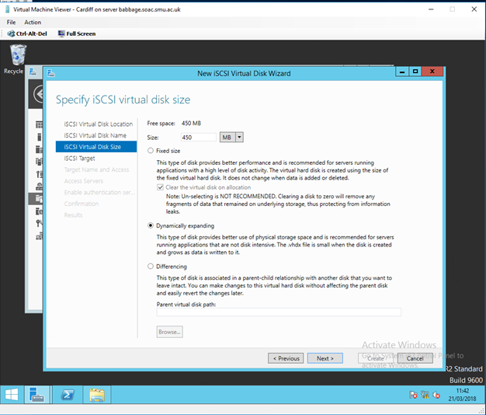
Figure 5 set the size of the disk
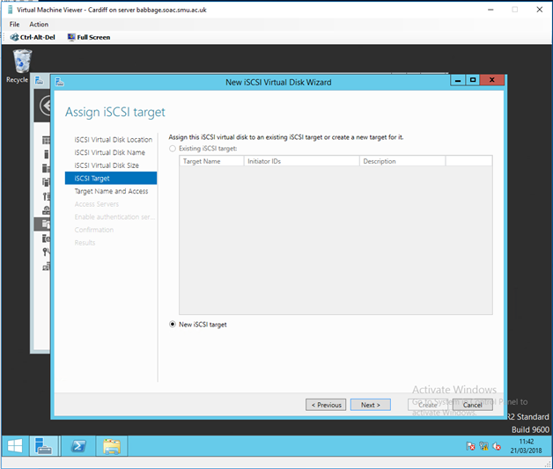
Figure 6 initial work of creating the targets
Adding an access server for the machine was an important work as it could make sure the machine could be accessed through its sever name or IP address.

Connect the iSCISI target through the iSCISI initiator

The “iSCSI” could be searched in the start menu. The work could be done from one or two node servers. Furthermore the service could be enabled in the initiator.
Figure 7 displayed the iSCSI Virtual Disk Wizard. Some work about the iSCSI initiator could start from here.
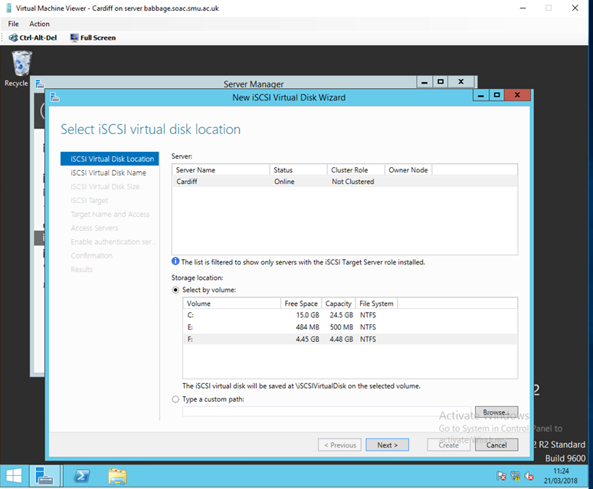
Figure 7 iSCSI Virtual Disk Wizard

The prompt service could be achieved by typing the IP address of the target into the “Target” box, and then hit the button “Quick Connect”. Figure 8 told how to do the connecting work.
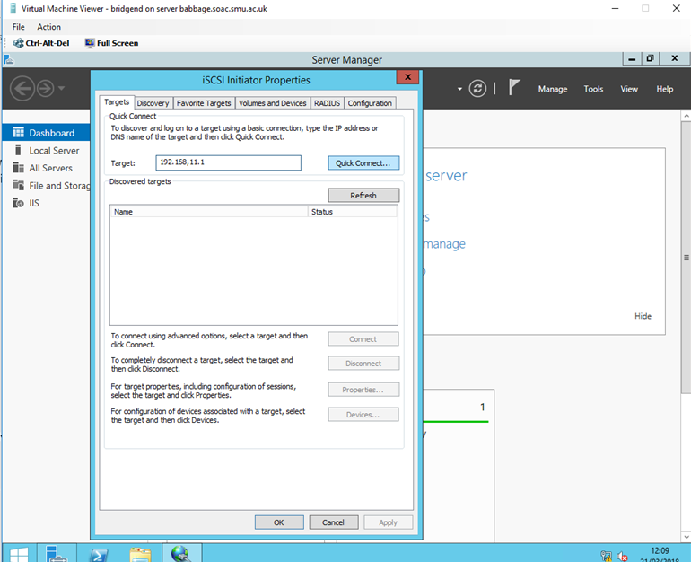
Figure 8 Try to build the “Quick Connect” from Bridgend
Then the disks founded through the iSCSI initiator should be available, and the result could be checked in the Disk Management Tool on Swansea and Bridgend.

Try to set up the cluster

The failover cluster feature needed to be added to the two node severs, further more the configuration should have the proper values. Then the cluster would be created after passing all the warnings.
Figure 9, 10, 11 displayed the steps of creating the cluster.
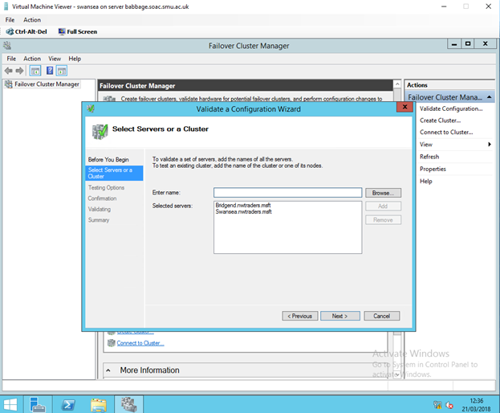
Figure 9 select to create a cluster
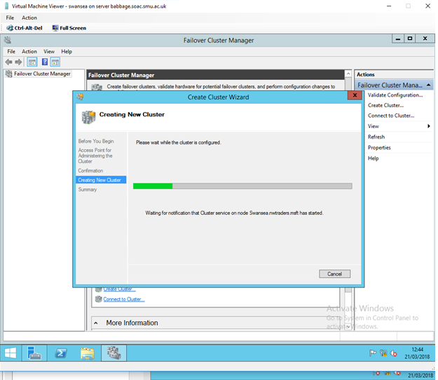
Figure 10 waiting for configuration of creating the cluster

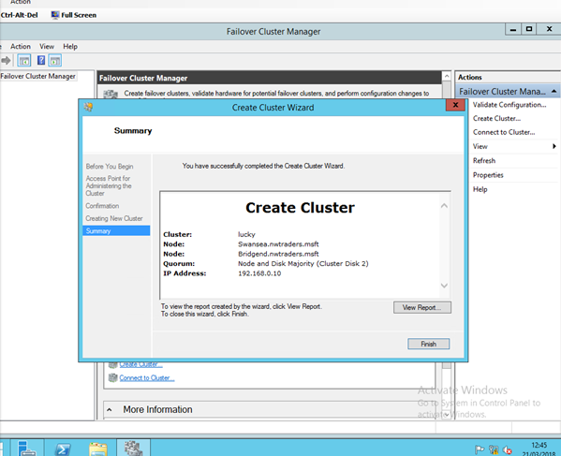
Figure 11 completion of creating the cluster
The name of the cluster was “lucky”, in addition, there were two nodes in the cluster, they were Swansea.nwtraders.msft and Bridgend.nwtraders.msft. Furthermore, the Quorum was Node and Disk Majority. At last, the IP address of the cluster was 192.168.0.10.

Investigate hosting a service on this cluster and test the configure of the cluster

Firstly, ensure the cluster was created successfully. This needed to check if the large disk was assigned to “Available Storage” or the small storage to “Disk Witness in Quorum”.

Figure 12, 13 showed the results of checking if the cluster was created successfully.

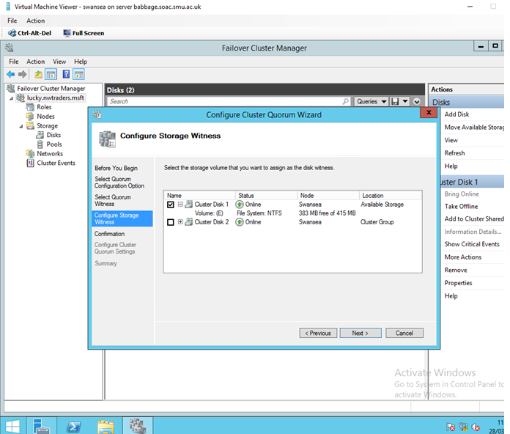
Figure 12 configure storage witness
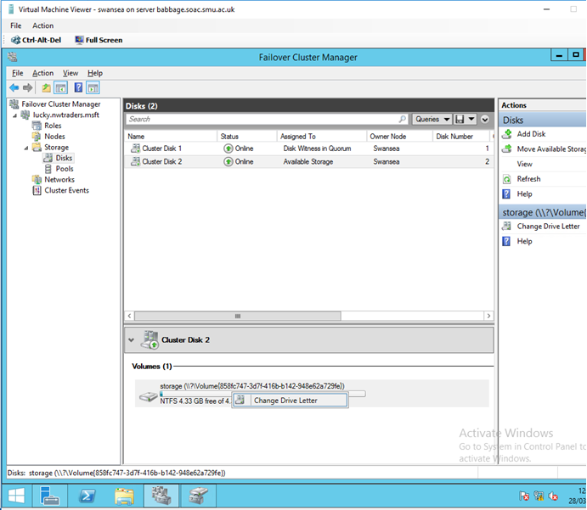
Figure 13 check the two storages

The figure told us that the cluster was created successfully as the two different storages were in the correct situations.

Configure DHCP to run on the cluster

Firstly, proper roles should be installed for all the nodes of the cluster, in this situation that DHCP could be installed on appropriate nodes. That was to mean that DHCP role should be configured on the failover cluster.

The work of configuring the DHCP could be done in the Failover cluster manager.
Figure 14, 15 and 16 showed the steps of installing the DHCP server.

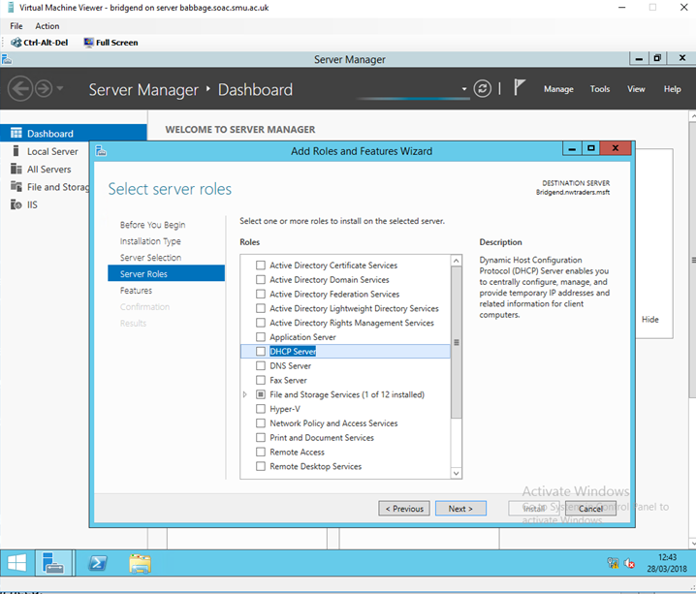
Figure 14 select the DHCP Server

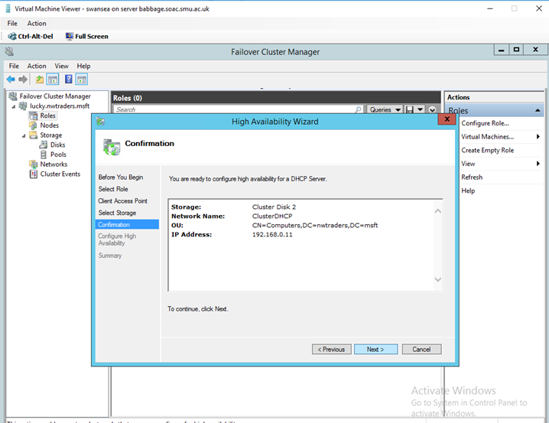
Figure 15 Configuration of DHCP Server
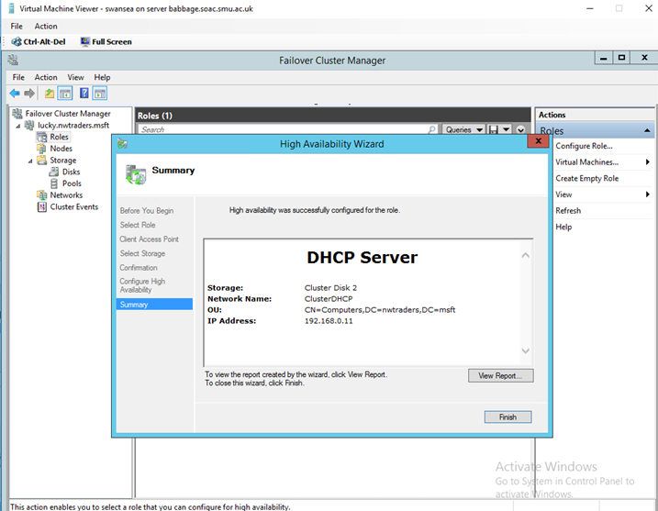
Figure 16 success of installing the DHCP Server

Then the whole Failover cluster could be tested after the completion of DHCP Server.

Firstly turn off the node named Bridgend, figure 17 showed the situation that the Bridgend was turned off.
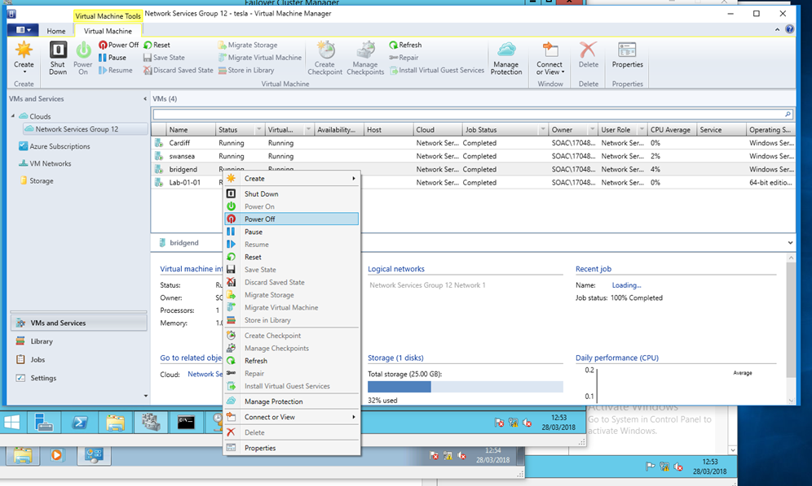
Figure 17 turn off Bridgend
Secondly, go to check status of the nodes, there was no doubt that the Bridgend was down, figure 18 showed the state of the two nodes.
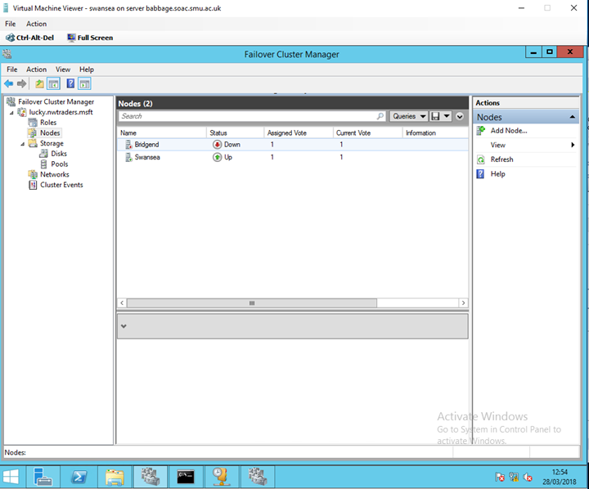
Figure 18 differences between two nodes
Then go to check the status of the cluster DHCP. It would not surprise you that the status of the cluster was “running”.
Figure 19 showed the status of the Cluster DHCP.
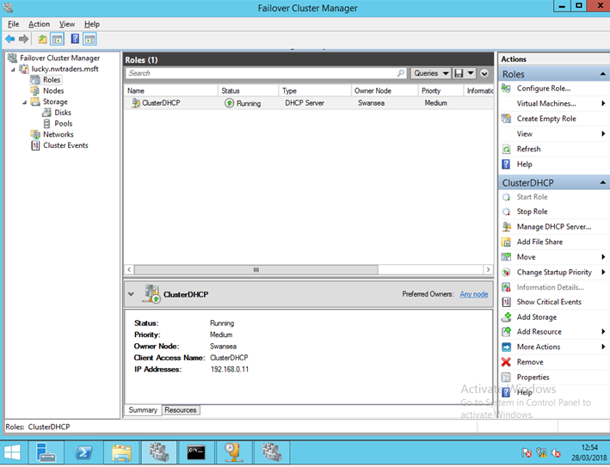
Figure 19 status of the cluster DHCP
In the figure, it was not difficult to find that the cluster could still work when one of the nodes was turned off. In this experiment, Swansea took over the tasks of Bridgend when the Bridgend was powered off.

This was the meaning of Failover Cluster. One of the nodes broke down, as this situation that the other node could take over the tasks to ensure the work of the cluster could still run.
This regulation was very useful in the real word as the physical machine could break down any time, furthermore the time could not be correctly predicted. Therefore, the Failover Cluster would help the real work to stay stable and reliable.

The failover cluster feature itself

Functional description

Numbers of computers can create a failover cluster as long as these computers can work together. As a result, the failover cluster can become very useful in applications and services and can guarantee the availability and the scalability.

Several physical cables and software can connect many cluster severs and these severs can be called nodes. In addition, the failover cluster means that if one or more cluster nodes stop working, then the other nodes can take over the task to provide the services. [1].
Additionally, the clustering roles are checked to ensure that if they are working well or not. If some roles do not work well, then these roles will be started again or moved to other nodes. Failover Clustering also provides the Cluster Shared Volume (CSV) feature, which means that different roles can access storage from all nodes through the consistent distributed namespace. Users would face the minimal disruption in service with the help of failover clustering.

Failover Cluster Quorum
The Windows Server Failover Cluster (WSFC) uses Quorum Voting to determine the health of the cluster or automatically failover or offline of the cluster. When a node in a cluster fails, services are continued to be taken over by other nodes[1]. However, when communication between nodes fails or most nodes fail, the cluster stops serving.

But how many nodes can the cluster tolerate failed? This is determined by the Quorum Configuration. The arbitration configuration uses the principle of majority. As long as the number of healthy nodes in the cluster reaches the number of arbitration requirements which means the most nodes vote, the cluster will continue to provide services. Otherwise, the cluster will stop providing services. During the period when the service is stopped, the normal node continuously monitors whether the failure point has returned to normal. Once the number of normal nodes is restored to the number specified in the arbitration, the cluster returns to normal and continues to provide services.
Some figures help to explain the regulations among different Quorum.
Figure 20 showed the Quorum: 2 Votes, the most number of notes could be tolerated to fail was 1.
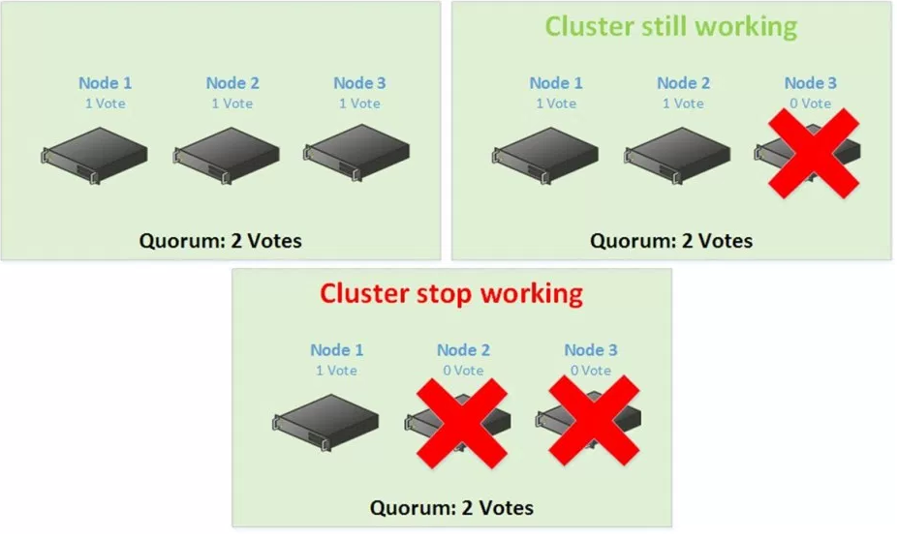
Figure 20 Quorum: 2 Votes
Figure 21 showed the Quorum: 3 Votes, the most number of notes could be tolerated to fail were 2.
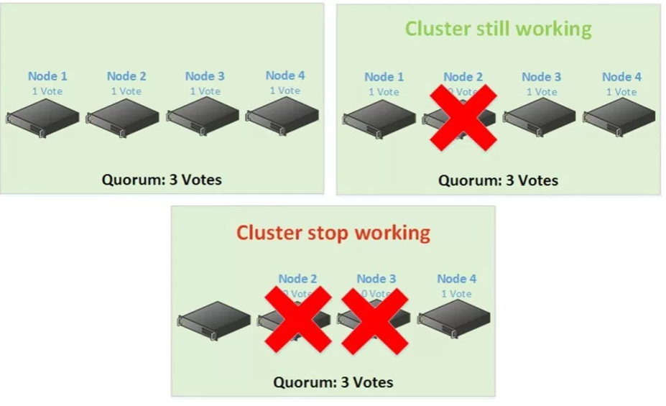
Figure 21 Quorum: 3 Votes

The heartbeat network and its operation

In a C/S structured system using a TCP connection, when one of the communicating parties is normally closed or withdrawn, the other can receive the relative inform of the corresponding connection and then do something proper to salve the problem.

However if any of the so-called "non-elegant disconnection" occurs, such as: accidental crashes, powered off, break down, offline or Router failure, in these situations that the other part cannot know that the TCP connection has failed, unless there are still data been sent over this connection and it will cause an returning error after a long time[2].

However, in many cases, it is hoped that both the server and the client can detect the abnormal disconnection shortly and effectively and then complete some necessary cleaning and report the error to the user.

How to detect the abnormal disconnection timely and effectively is a problem. While the problem can be solved by the method which is that send a heartbeat packet through one or both of the communication parties to tell the other party if the network communication is normal or disconnected.

The differences between failover and Network Load Balancing Clusters

Failover cluster are made up with some computers and these computers are connected in the same network. Each computer can be seen as a redundant node. The whole cluster system allows certain odes to be dropped or damaged without affecting the normal work of the whole cluster system. As a result that the failover means that a normal server can take over of the work of the fail server and make sure the whole system can work well[3].

Then the failover cluster is often used for important online business, because online business must ensure the users can have good experiences and the work of online business should be fine for 24 hours every day.

Additionally, failover clusters are often used for stateful applications such as Hyper-v and DHCP. While they can also run stateless applications.

While the network load balancing cluster can be only used for normal web. Network Load Balancing allows you to spread incoming requests to 32 servers, which means you can use up to 32 servers to share external network requests.

Moreover, the network load balancing clusters can ensure the scalability and reliability of the large and complex applications. In addition, they are often used in stateless applications such as web, FTP, firewall and vpn.

Network load balancing technology ensures that they can respond quickly even under heavy loads. Network Load Balancing requires only one IP address (or domain name) externally[2]. If one or several servers in Network Load Balancing are unavailable, the service will not be interrupted.

The birth of network load balancing technology has a great relationship with the rapid development of the Internet.

With the rapid growth of Internet users, the speed of access to information has become an important factor that restricts the development of the Internet. In particular, with the rapid development of e-commerce, the enterprise information has evolved from a computing factor that focuses on computing and data processing and a network thing that focuses on network and data communications into an integrated data staff that balances the functions of a computing world and a network world. As the basic core of the enterprise e-commerce network, the data will bring together high-performance computing, data communications, voice communications and other processing functions into one, and will become an inevitable platform to support enterprise e-commerce system applications in the future.

Network Load Balancing allows clients to access the cluster with a logical Internet name and virtual IP address (also known as the cluster IP address) while retaining the respective name of each computer.

Load balancing cluster: all nodes in the cluster are active and they share the workload of the system. General web server clusters, database clusters, and application server clusters fall into this category.

Load balancing clusters are generally used for web server and database server for corresponding network requests. Such a cluster can, upon receiving a request, check servers that accept fewer, less busy requests and transfer requests to these servers.

References
[1] “Understand Failover Cluster Quorum.” [Online]. Available: http://www.tech-coffee.net/understand-failover-cluster-quorum/. [Accessed: 04-May-2018].
[2] Y.-W. Ma, J.-L. Chen, and C.-J. Lin, “Automated Network Load Balancing and Capacity Enhancing Mechanism in Future Network,” IEEE Access, vol. 6, pp. 19407–19418, 2018.
[3] “Cluster failover from physical node to virtual node,” Nov. 2003.

