How to engage employees throughout the employee lifecycle

Student name: Musa Farhana Shikder Uddin
Student ID Number: 2109302
Lecturer name: Emma Roberts
Module name: Personnel Resourcing & Development (BMIH5005)

Employee engagement is constantly important and acceptant aspect in Human Resource community for an effective management. Employee engagement combines commitment and values of the organisation, and enthusiasm of how to help the employee. It is above than a job satisfaction and motivation. It is something that employee has to offer to their job, which is not a part of the contract (Beardwell and Thompson, 2017). Therefore, this essay will discuss how Wyndham hotels Group engage their employee throughout their employee life cycle and what is the function of HRM in employee life cycle (Beardwell and Thompson, 2017, p.5).
Employee life cycle is a period of interface among worker and employer, which begin from the moment of attraction of the job and lasts until the employment ends. Within this time frame employer develops and implements appropriate processes for all their employee’s lifecycle which lead them through many employment stages, such as, recruitment, onboarding, development, retention, and separation (Beardwell and Thompson, 2017, p.5). And all of these are categorised by recurring modifications of their engagement. Therefore, Human Resource Management (HRM) is the department who is responsible for this modification and application of this procedures.
Collection of policies which used to coordinate work in the employment relationship is called Human resource management (HRM). Such actions are, how to employ and manage people, develop them in the institute. It works as a centre of the job and management of the people (Beardwell and Thompson, 2017, p.5).
According to Armstrong (2020, p.25) that, HRM reinforce people’s knowledge, abilities, networks and energies, and their physical and emotional health, intellectual capabilities, personalities, and motivations.
There are many hotel chains around the world however Wyndham Hotel Group is one of the largest one. They have approximately 9,200 hotels around the world and more than 15,000 member of team works within them. Wyndham hotel group has been recognised as a best place to work. They received multiple awards and accolades, for example Top 100 Most Loved Workplaces by Newsweek, World’s Best Employers by Forbes, and New Jersey’s Best places to Work by NJBIZ. About us (Wyndham Hotels & Resorts, ND)
HR plays a significant role in employee life cycle. According to chief Human Resource officer of Wyndham Hotels & Resorts, to attract the top talent it is very important for their organisation that they promote flexibility. Their core values of integrity, accountability, inclusivity, caring and fun, which makes their employees proud and excited to be a part of it. (Wyndham Hotels & Resorts, 2022). Flexible work times such as customised work times, designated work hour with a freedom of come and go. Flexibility has many wonderful outcomes including productivity, absenteeism, job satisfaction, schedule satisfaction, and work-to-family conflict (Piszczek, 2021, p.1907).
The most important stage of recruitment process is to attract job applicants and encourage them to submit applications. Because successful attraction and enormous application will allow construct higher and more qualified candidate. At the beginning of the process if they do not attract by a recruiting organization, they basically self-select out of the recruitment process before any official communications (Collins and Martinez-Moreno, 2021).
Wyndham hotels and resorts believe that choosing a wrong candidate can be a expensive mistake for them. Therefore, to avoid hiring a wrong candidate they have their bespoke hiring solution. Which includes enrolment masterclass for HR experts and hiring managers, selection and interview guide, reference checking procedures and forms, entrance to profession posting portal and tracking system for applicant, and general manager recruitment (Wyndham Hotel and Resorts, 2022).
Although modern generation have very short attention limit to catch their notice and involve them. Thus, to interact with them companies need to communicate via the channel what they use. As an example, Hilton utilising social media to advertise the positions and reduced the complications of the job application process (Kurter, 2019). They also change their interview strategy. They use HireVue, which is a digital interview platform. Where without a recruiter being present, they interview multiple candidates at one go. Subsequently they can review the video from the start and decide if the applicant would be suitable or not. Thus, Hilton’s time-to-hire process came down to five days instead of 45-day (Hilton, 2023).
David MacLeod and Nita Clarke’s, in the publication of the UK government-commissioned Engaging for Success report, showed positive correspondence between an engaged workforce and improved performance, and the four common factors such as, strategic narrative (provided by a visible, empowering leadership), engaging managers, employee voice and organisational integrity underpinned effective employee engagement (Warren, 2017). In Wyndham hotels group they welcome new employee with an onboarding programme. Branded induction presentation and speaker notes, HR and line manager new starter checklist, pre-boarding and on-boarding checklist, employee handbook, Buddy Programme & Checklist, Probationary templates, Development Plan templates, Job Chat Template all these are included to the program. (Wyndham Hotel and Resorts, 2022). While Ritz-Carlton referred their employee as Ladies and Gentlemen to empower them, which make them feel inspired, passionate, and driven. Therefore, their employee engaged emotionally and goes above and beyond to their jobs. (Hoffman, 2018)
On the other hand, Marriot has achieved a status of defended type of leader, in the competition with Wyndham and Hilton. They believe when they take care of their employees, it will motivate their employees to take care of customers. Since it is essential to offer productive, consequential opinion to keep them inspired and fulfil their needs (Gibbons, 2020).
Similarly, Banyan Tree hotel and resorts have a magazine called MAD (Make A Difference) for their employees, in the magazine they publish awards to recognise staff. And they also give gratuities and incentives to their employee to encourage (Zolkifi, 2013).
Marriott’s global chief HR officer believes that ability to make sure well-being among employees is the future success of the hotel business. Therefore, they cut the management’s pay to get the company through the covid 19 crisis and giving furlough employees health insurance (Gibbons, 2020).
To develop employee’s career, Wyndham hotels group have leadership development programs, tuition reimbursement and online university programs. Its also includes one-to-one mentoring, learning circles, networking opportunities and other relationship-oriented program (Wyndham Hotel and Resorts, 2022).
Wyndham gives their employee a yearly paid day-off to help their neighbourhoods, and there are many programs like education programs, professional development courses and several affinity businesses groups. Where the employees have access to continuing their education and training (Wyndham Hotel and Resorts, 2022). The company also have many other facilities such as special recognition programs, practical studying hours, celebrations of special occasions, discounts for team member and flexibility in work schedules. And all these activities support to do their best work in the area that works best for them and the company (Wyndham Hotel and Resorts, 2022).
To reduce certain degree of employee attrition there are many things’ hoteliers can do, such as if employer recognise the people who will leave, if they have flexibility work routine, wonderful relationship between staff and employer and finally keep their employee happy (Haussman, 2016). Wyndham have a facility for their employee to threat themselves. They can get a lowest price for the hotels room anywhere in the world and can book a year ahead. Moreover, employees have friends and family discount and same advantage as an employee (Wyndham Hotel and Resorts, 2022).
Wyndham provide flexible working hour to their employee. They can work part time, job share and term time only (Wyndham Hotel and Resorts, 2022). Wyndham have a well being program called Be Well where employees from 516 destinations took participated (Christofis, 2020). Moreover, to meet employee’s expectation and retain them in the work place Marriott gives their female employee a paid maternity leave of 15 weeks, and the fathers and adoptive parents gets 8 weeks leave (Gibbons, 2020).

Separation is the final stage of an employee life cycle, where they can leave the company for any reason. However, it classified into two types, these are voluntary separation and involuntary separation (Human Resource, ND)
Many case studies shows that employee engagement not only important for productivity of a business but also satisfaction of the guest, productivity of the team and retention. There are many advantages of this, such as it will improve to hold talented people, will improve customer satisfaction level, performance of the employee will improve, team performance will be higher, unit productivity and profitability of the business will be enormous, increased enterprise-level financial performance will be increase enterprise-level.
To make employee engagement more tangible employee engagement survey help organisation measure it. It also helps expose employee views, make them perform and apply transformations that transfer the needle (Quantum Workplace, 2022). To collect employee feedback this survey is not the only option. The common varieties of surveys are Annual employee engagement survey, Pulse surveys and Employee lifecycle surveys. It is employee and leaders converse platform. Through this employee can raise their voice, thoughts and feeling about the workplace (Quantum Workplace, 2022).
According to many researchers and organisation there are many employee engagement Models, Gallup is one of these models which discussed employee engagement. There are three types of engagement such as actively disengaged, engaged, and not engaged. Actively disengage employees are very unhappy and unsatisfied, who always spread unhappiness (Mohanty and Choudhury, 2018). They discourage other employees with negative words and make them leave the job so that they can be promoted. On the other hand, engage employees are innovative, they innovate new ideas for the company, they are passionate and committed to do their jobs. Whereas the employee who is not engage are only instruction follower, they only give their time to the company. According to Gallup (2015) research 17.2% of the employee are actively disengaged, 32% engaged and 50.8% are not engaged (Mohanty and Choudhury, 2018).
In Maslow Hierarchy of needs, it described that human lives want to become self-actualising and want to consider human potential. There are five sets of goal in Maslow Hierarchy of needs. They are physiological, safety, love, esteem, and self-actualization. In organisation employees are motivated by the desire to achieve or retain several circumstances and basic satisfactions (Ramlall, 2004). All human has continuous want which are partially satisfied and partially unsatisfied. For a company’s managers and leader, this theory offers many useful visions. It helps the managers to find a way to motivate their employee (Ramlall, 2004). Therefore, organising different program to meet their employee’s needs. Support programs and focus groups can be implemented to help employees. So that their stress can be dealt in challenging times and the needs of respective employees can be understand (Ramlall, 2004). To maximise employee’s potential, managers must create appropriate work environment. However, failure of such conditions will lead to employee’s frustration. As a result, their performance will be poorer, job satisfaction will be very low, and it will increase employee withdrawal (Ramlall, 2004. Pp. 54).
Standard of job quality in the UK is called The CIPD Good Work Index, which has done yearly. This survey report generates the good work and job quality in UK’s employees. In 2022 CIPD conducted a survey using a representative sample of UK workers. Where they measured a wide range of aspects of job quality, including employment essentials, such as pay and contracts, the day-to-day realities of work as experienced by workers themselves, and the impacts on people’s health and wellbeing. Here is a diagram of quality of relationship at work.
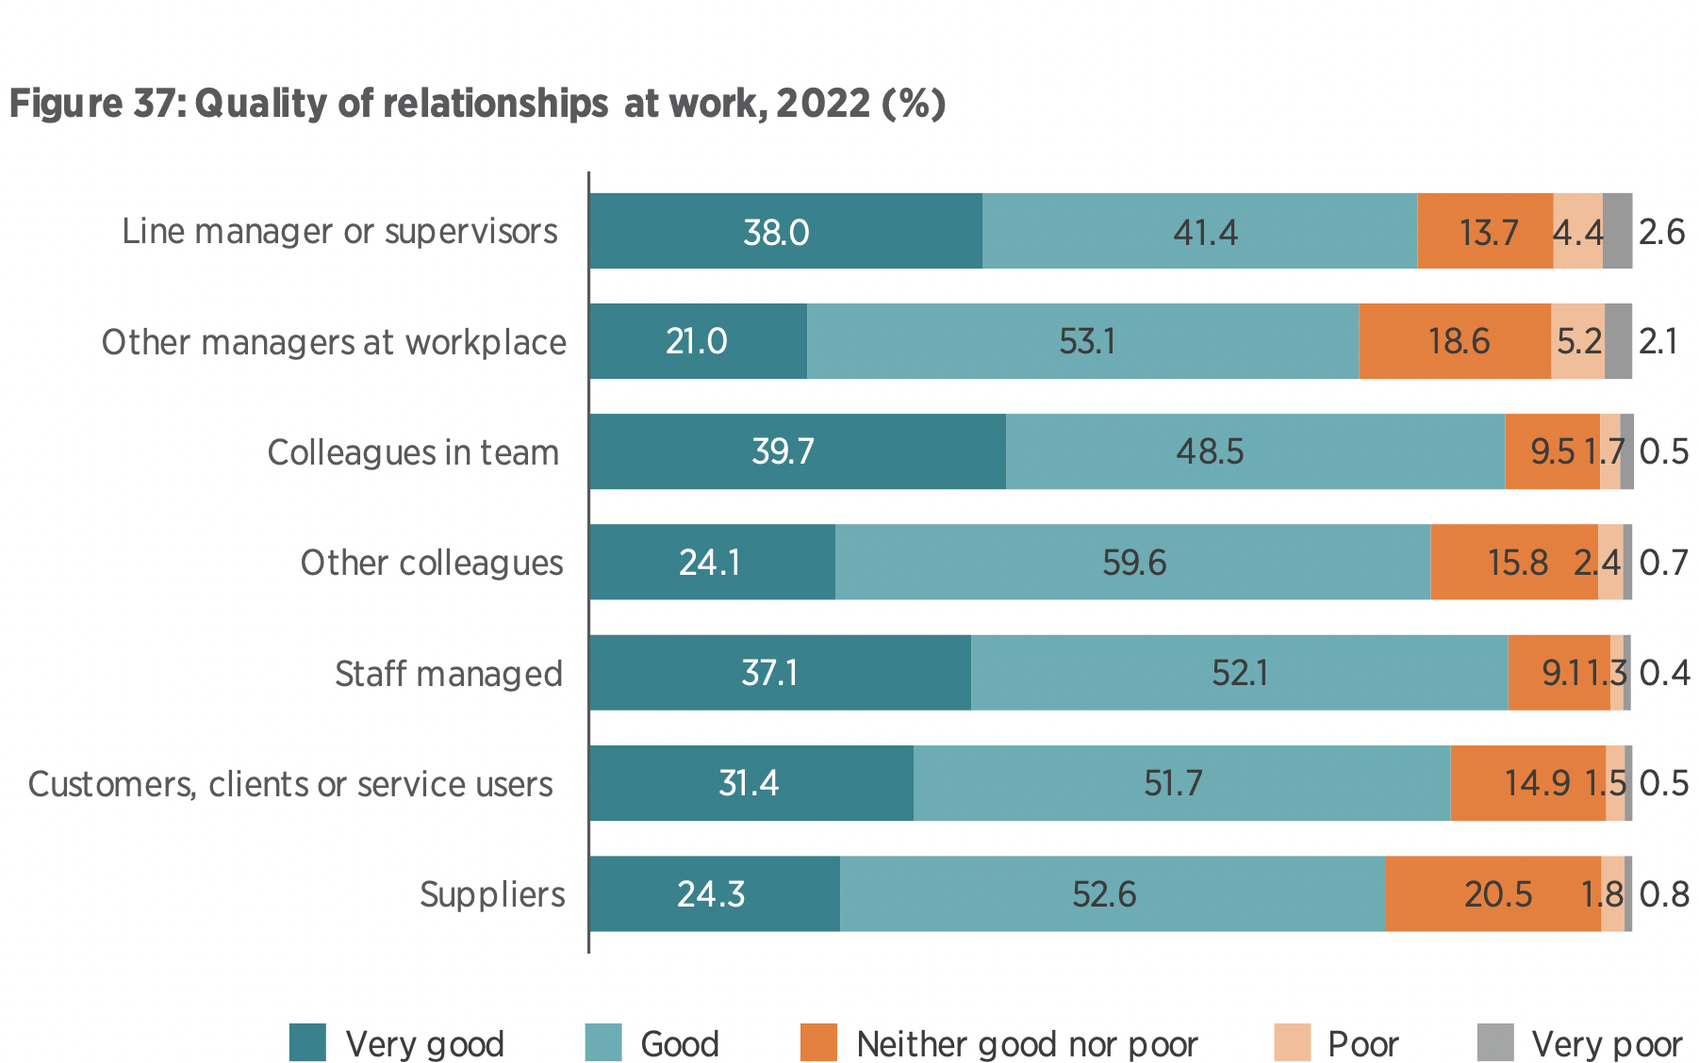
(CIPD, 2022, p. 51)
In conclusion, employee engagement throughout their lifecycle is very important for any organisation. Wyndham and other hospitality industries are doing their best to engage their employee from attracting them for the job to the last day of their job. Companies have many programs and training for engaging in several stage of employee life cycle. It is very important for the productivity and retention. Engage employee are happy employee who will improve customer satisfaction. Human lives want to become self-actualising and want to consider human potential. In organisation employees are motivated by the desire to achieve or retain several circumstances and basic satisfactions. Thus, job satisfaction throughout the employee life cycle has enormous benefits for the company.

Reference:
Armstrong, M. (2020) Armstrong’s handbook of human resource management practice. Available at: https://eu.alma.exlibrisgroup.com/leganto/readinglist/citation/6688767740002421?auth=SAML (Accessed: 14th October 2022)

Beardwell, J. and Thompson, A. (2017) Human Resource Management: A Contemporary Approach. Available at: https://ebookcentral.proquest.com/lib/trinity/reader.action?docID=6108840 (Accessed: 12th October 2022)

Christofis, A. (2020) ‘Focus on Well-Being Keeps Wyndham Destinations Employees Active and Happy’, Reset Trades. Available at: https://resorttrades.com/focus-on-well-being-keeps-wyndham-destinations-employees-active-and-happy/ (Accessed: 22nd February 2023)

CIPD (2022) ‘CIPD Good Work Index 2022’, Survey Report. Pp. 1-70, June. Available at: https://www.cipd.co.uk/Images/good-work-index-survey-report-2022_tcm18-109896.pdf (Accessed: 23rd February 2023)

Collins, C.J. and Martinez-Moreno, J E. (2021) ‘Recruitment brand equity for unknown employers: Examining the effects of recruitment message claim verifiability and credibility on job pursuit intentions’, Human Resource Management, vol 61, issue 5, pp. 585-597. Available at: https://onlinelibrary-wiley-com.ezproxy.uwtsd.ac.uk/doi/full/10.1002/hrm.22089 (Accessed: 20th October 2022)

Gibbon, S (2020) ‘3 Things You Can Learn from Marriott About Taking Care of Employees’, Forbes, 30th April. Available at: https://www.forbes.com/sites/serenitygibbons/2020/04/30/3-things-you-can-learn-from-marriott-about-taking-care-of-employees/?sh=1ea834782bca (Accessed: 20th October 2022)

Haussman, G (2016) ‘4 truths about hotel employee retention’, Hotel Mnagement. 25th Oct. Available at: https://www.hotelmanagement.net/4-truths-about-hotel-worker-employee-retention (Accessed: 22nd February 2023)

Hilton (2023) ‘How We Hire’, Career Path. Available at: https://jobs.hilton.com/latam/en/career-paths (Accessed: 20th February 2023)

Hoffman, J (2018) ‘Employee engagement: Ritz-Carlton’s secret to provide world-class service and increasing customer loyalty’, Leadership and engagement, the Ritz Carlton way. PSA, 14th May. Available at: https://www.psafinancial.com/2018/05/employee-engagement-ritz-carltons-secret-world-class-service-customer-loyalty/ (Accessed: 20th October 2022)
Human Resource (ND) Employee separations - Definitions - Reasons for Separation of employees. Available at: https://www.whatishumanresource.com/employee-separations. (Accessed: 22nd February 2023)

Kurter, H (2019) ‘How Hilton Reduced Their Time to Hire From 43 Days Down To 5’, Forbes, 19th September. Available at: https://www.forbes.com/sites/heidilynnekurter/2019/09/19/how-hilton-reduced-their-time-to-hire-from-43-days-down-to-5/ (Accessed: 20thFebruary 2023)

Mohanty, M and Choudhury, S (2018) ‘A Conceptual Model of Employee Engagement - From the perspective of Manufacturing Industry’, International Journal of Multidisciplinary. 3(07). Available at: https://www.researchgate.net/publication/326572482_A_Conceptual_Model_of_Employee_Engagement_-_From_the_perspective_of_Manufacturing_Industry (Accessed: 23th February 2023)

Piszczek, Matthew M. (2021) ‘Flexible schedules across working lives: Age-specific effects on well-being and work’, Journal of Applied psychology. Vol. 106 no.12, Pp.1907-1920. Available at: https://web-p-ebscohost-com.ezproxy.uwtsd.ac.uk/ehost/pdfviewer/pdfviewer?vid=0&sid=d4f6c66b-89c4-4c11-8f10-cb36fc6fc96c%40redis (Accessed: 21st October 2022)

Quantum Workplace (2022) Employee Engagement Survey Guide (and Research-Backed Survey Questions). 27th July. Available at: https://www.quantumworkplace.com/future-of-work/employee-engagement-survey (Accessed: 21st February 2023)

Ramlall, S. (2004) ‘A Review of Employee Motivation Theories and their Implications for Employee Retention within Organizations’, The Journal of American Academy of Business. Pp 52-63. Available at: https://d1wqtxts1xzle7.cloudfront.net/55461861/Review_of_Employee_Motivation_Theories_-_Journal_of_American_Academy_of_Business-libre.pdf?1515264476=&response-content-disposition=inline%3B+filename%3DA_Review_of_Employee_Motivation_Theories.pdf&Expires=1676943600&Signature=YNarAOciR35FASjArSu1I4~ikRwGscjH1QQgxEYwyOXllxZ~Tg-SO9mEyFzplgFFFmbBaxhwqSW7lFaMpMtdpCv1GDFm9jhvj2~kl-dNmg38d6Q3xpx2-Jc~~P1OwWudrn8hipMbfFTNNsuCNUb2i2aIHI5lLqNvXhmr~6feZFrEj8P~SMP9V3QrTEjpGFCCByTsyxlbO41HkCloTPijmOjZUDE2Z6562GFTVZ6rC4ChRRm-8IYU08CHUaIrxuHZhederUoWEH19chB9grm5hvp-sMoDJoMwairTh3Ra1UEHeIxcKQX77VOpoddNJFkM5bSv5w6HcRbPH1XSUXHpHw__&Key-Pair-Id=APKAJLOHF5GGSLRBV4ZA (Accessed: 14th February 2023)

Warren, C (2017) ‘Is it ‘engagement’ or simply good management practice?’, CIPD, 14th August. Available at: https://www.cipd.co.uk/news-views/changing-work-views/future-work/thought-pieces/engagement-good-management (Accessed: 20th October 2022)

Wyndham Hotels & Resorts (ND) [Linkedin] ND Available at: https://www.linkedin.com/company/wyndhamhotels (Accessed: 14th October 2022)

Wyndham Hotels & Resorts (2022) ‘Once Again Named a Best Place to Work by Newsweek, Forbes and NJBIZ ‘ CISION PR Newswire, 17th oct. Available at: https://www.prnewswire.com/news-releases/wyndham-hotels--resorts-once-again-named-a-best-place-to-work-by-newsweek-forbes-and-njbiz-301650516.html (Accessed: 17th October 2022)

Wyndham Hotel and Resorts (2022) Recruitment & Selection, People Support. Available at: https://whrdevelopmentemea.com/advantage/training/ (Accessed: 19th October 2022)

Harter, J. and Hayes, T. (2002), ‘Business unit level outcomes between employee satisfaction, employee engagement and business outcomes: A meta-analysis’, Journal of Applied Psychology, 87(2). Pp. 268– 79.

Zolkifi, S. (2013) ‘Timothy Cheong, group HR director at Banyan Tree Hotels & Resorts, shares the challenges in providing incentives and recognition in the hospitality industry’. Case study: Banyan Tree hotels and Resorts. Human Resources Online. Available at: https://www.humanresourcesonline.net/case-study-banyan-tree-hotels-resorts (Accessed: 19th February 2022)

