The concept of family has dramatically changed in the 21st century; critically reflect upon this statement.

The Oxford Dictionary of Sociology (Scott, 2014, pp. 238-240) describes the family ‘as an intimate domestic group related to each other by blood, sexual matings, or legal ties.’ This social unit has adapted since 1970 when lone parenting became more common (University of Essex, nd). The Oxford Dictionary of Psychology defines family as a ‘primary social group consisting of parents and their offspring’ and sometimes extended family sharing the same household (Colman, 2015, p. 273). The Office for National Statistics (2024) describe the family structure as complex; this definition of the family is constrained as they must all live at the same address.
This assignment will critically reflect on how the concept of family has dramatically changed in the twenty-first century. First, it defines the six types of family and examines some of their strengths and weaknesses. Next, it focuses on one type of family, loan parenting, and examines the statistics surrounding this phenomenon. Here, the discussion includes how developed countries give support benefits to lone parents, but these benefits still push lone parents and their children into poverty. Likewise, it discusses how parents cannot provide for their children's basic needs and how a lack of education can impact the family, both parent and child. It will then talk about the mental health of lone parents and the impact poverty has. Finally, the essay will discuss employment and how the government tries to get lone parents back into work. This essay concludes that modern families are complex, but this is an accepted part of modern society.
Better Help (2024) describes six different family types, the first being the nuclear family, which consists of married or common-law parents with children (Nickerson, 2024). The concept of a nuclear family arose during the Industrial Revolution (Nickerson, 2024). This family consisted of two parents and immature children and was seen as a fundamental family structure (Nickerson, 2024). The children could be biological or adopted but raised together in their homes (Better Help, 2024). The strength of the nuclear family was stability and consistency; their weakness could be exclusion or isolation from extended family and struggles with conflict resolution (Better Help, 2024). However, Harkonen (2018) wrote that the happiness of the nuclear family ‘is long gone’. Brooks (2020) questioned the nuclear family and thought it was a mistake, believing there were better ways to live together. The UK Government (2024) set a limit for child benefits for families with more than two children. Any families with more than two children would not be able to claim child allowance and would have to be assessed for the benefits (Save the Children, 2024; Child Poverty Action Group, 2024; Gov.UK, 2024).
The second type is the single-parent family with one or more children (Better Help, 2024). They might have been divorced or widowed, but they are more common in the 21st century (Biblarz and Gottainer 2004; Harkness, Gregg, and Fernandez-Salgado, 2019; Better Help, 2024). Their strengths include close bonds and resilience; their weakness is financial difficulty (Better Help, 2024; Gov.UK, 2024). The third is the ‘extended family’ (Scott, 2014, p. 237; Better Help, 2024). An extended family consists of two or more adults related through blood or marriage, including aunts, uncles, or other relatives under the same roof and can also be known as kinship (Bester and Malan-Van Rooyen, 2015; Better Help, 2024). Their strengths are respecting the elderly and helping with childcare; their weaknesses are that there are more members to feed (Talbot, 2024).
The fourth family is the childless family, which consists of two partners who do not want children or cannot have any (Agrillo and Nelini, 2008; Better Help, 2024). The strengths are having more disposable income and no dependents to look after, and a weakness could be isolation from family and friends who start having children (Bachrach, 1980; Better Help, 2024). The fifth is a stepfamily, where two families merge as one, possibly through a divorce or having children outside of marriage (Better Help, 2024). The strengths of stepfamilies are that children benefit from two parents and new siblings, along with an increase in financial income (Golish, 2006; Better Help, 2024). The weaknesses could be families trying to get to know each other and how each parent uses discipline (Better Help, 2024). The sixth family is the grandparent family, where the grandparent raises their grandchild (Better Help, 2024). The strength of this is having a close bond with your grandchild and the children not entering foster homes. The weakness could be financial and health struggles (Dunifon, 2012; Better Help, 2024).

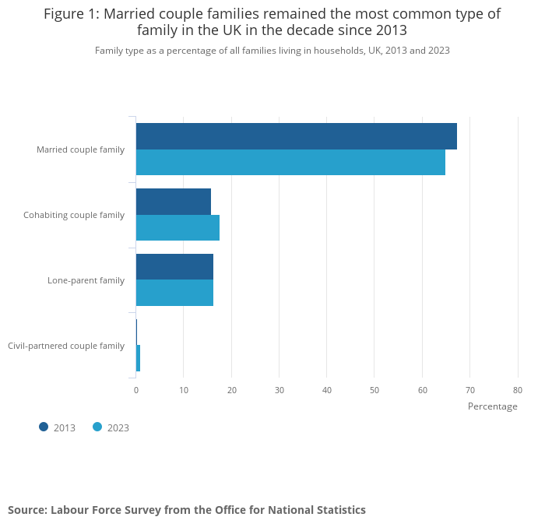
(Office of National Statistics, 2024).

The next section of this assignment focuses on lone parenting. Loan parenting in the mid-1990s came about due to the death of one parent or having children out of wedlock (Letablier and Wall, 2018). Letablier and Wall (2018) wrote that lone parents having children out of wedlock were stigmatised by society due to ‘immoral grounds’, and their children would face the same views (Letablier and Wall, 2018, p. 29; Jun, M. 2019). Being stigmatised places families in outcast groups, devaluing them and affecting human interactions (Scott, 2014, p. 731). With social media being readily available in the 21st Century, it is easier to stigmatise a lone parent and children living in poverty. In developed countries, there is a high risk that most children live in poverty when they are part of a single-parent family (Skinner et al., 2017).
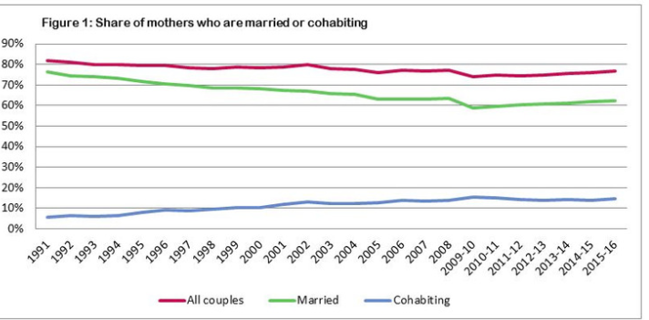
(University of Essex, nd).
The British Household Panel Survey started in 1991, and lone parenting was one in five mothers with children in the United Kingdom (UK) (University of Essex, nd). From 1991 to 2009/2010, lone parenting grew to twenty-six per cent due to the financial crisis; by 2015/2016, the figure was back to twenty-three per cent. In 1991, lone mothers were predominantly divorcees, which accounted for two-thirds of lone mothers. By 2010, the majority were lone mothers who had not married, and in 2021, ‘over half of the children in England and Wales were born to unmarried parents’ (Gibson, 2022, np). This accounted for higher poverty levels and the mother's full parental rights as the father was absent (Children Act 1989; Gibson, 2022). Divorcees had an ex-partner who could help financially; in contrast, unmarried parents had either an ex-partner or the parent was unknown, which meant the mother had no financial provision except from the Government (Gov. UK, 2024).
In Western countries, lone parents receive child maintenance so the parents can support the children (Gov.UK, 2024). However, some countries view child maintenance as a substitute for other benefits, thus reducing the government's costs (Skinner et al., 2017). Due to the high risks of poverty among lone parents in Ireland, the government, between 2012 and 2015, reduced the age of a qualifying child to receiving the one-family parent payment from eighteen to seven years old (Redmond, McGuinness and Keane, 2020, np). This encouraged the lone parent to work and increase family monies, which would help reduce poverty (Redmond, McGuinness and Keane, 2020, np). However, it did not consider childcare because if a family did not have a close extended family living nearby to look after the child or children, the parent would have to pay for childcare (Saraceno, 2011). This could potentially price them out of going to work and place them into poverty due to childcare being expensive (Money Helper, 2024).
In Wales, a devolved country, the rights of the child have not been met (Children’s Commissioner for Wales, 2018; UNCRC, 2024). The United Kingdom is the world’s fifth most prosperous economy, however, in Wales, 185,000 children, approximately 28% of the population, live in poverty, which is estimated to increase to 40% by 2021 to 2022 (Welsh Government, 2018). The Welsh Government and local authorities, along with charities, schools, religious groups, the community and social enterprises, consulted with the Children’s Commissioner for Wales (2018) to achieve answers to help reduce poverty. ‘The children and families (Wales) measure 2010 places a statutory duty on Welsh ministers and authorities to publish a child poverty strategy’. The Well-Being of Future Generations (Wales) Act 2015 set seven indicators for the well-being of its citizens. Its focus was
A prosperous Wales, a resilient Wales, a more equal Wales, a Wales of cohesive communities, a healthier Wales, a globally responsible way, a Wales of vibrant culture and a thriving Welsh language.
Well-Being of Future Generations (Wales) Act (2015).

This Act should improve lives in the long term by involving its citizens in preventing problems in the future and showing other countries the potential of improving poverty.

The Lone Parents Family Act 1992, still in place in the 21st Century, was introduced in Israel, which recognised lone parenting as a social category and lone parents as caregivers. The pillar of this Act was an increase in income support allowance. It recognised a lone parent as being single, divorced, separated, or aguna (meaning a missing partner and not proven dead) (Lea et al., 2014, p. 247; Helman, 2011). Israel amended existing laws that hindered women's equality in the workplace, and this Act also applies to male lone parents (Helman, 2011). In the 20th century, the welfare state helped to reduce inequality in the UK by providing social payments. Still, in the 21st century, the Government has reduced social payments, resulting in more poverty (Atkinson, 2015, pp. 82-109). As loan parents are experiencing poverty, reducing social payments affects this group immensely (Atkinson, 2015, pp. 82-109). The lone parent will struggle to provide basic needs for their child: food, water, shelter, clothing and sleep (Maslow, 2003, np). Moreover, Maslow wrote that lacking basic needs would also affect motivation, keeping them in the lower hierarchy of needs. Talbot (2024, np) wrote, ‘One in two children in single-parent families would live in poverty.’ In comparison, only one in four children in a nuclear family would live in poverty (Talbot, 2024, np).

The United Nations Children’s Fund (UNICEF) (2024) works in countries to protect the rights of every child. Its commitment to children is to deliver timely humanitarian action. It promotes ‘equality, responsibility, transparency and a results-oriented approach’ towards safeguarding and is guided mainly by the United Nations Convention on the Rights of the Child (UNCRC) (UNICEF, np). Western countries are guided by this human rights treaty (Children Act 1989; Children Act 2004; United Nations Children’s Fund, 2024). Also, if the UK Government followed the UNCRC, there would be little poverty in the country; it is also crucial that every child who is in poverty or does not receive a good education will receive that education. UNICEF's (2021) review was about children's rights in education aged nought to six years old, and the UK was involved in this project. It aimed to standardise its review, and it noted that children between the ages of three and six were not developmentally able to understand education and that it was possible to lay the foundations for the child to understand its rights (United Nations Children’s Fund, 2024).
Harkonen (2018) wrote that less educated women tend to be single parents than those who are highly educated, which can lead to inequalities in adult’s and children’s well-being and push the family into poverty (Nieuwenhuis and Maldonado, 2018, p. 31; Harkness, Gregg, and Fernandez-Salgado, 2019). Children would also have a lower level of education like their parents, leading to lower occupational status, which was discussed previously (Adler, 1930; Biblarz and Gottainer, 2004). In Scotland, a devolved country, lone parents can apply for a lone parent grant to encourage lone parents back into higher education (Child Poverty Action Group, 2024; Student Information Scotland, 2024). The same is true for lone parents in the UK, but they could receive less money, depending on other claimed benefits, like universal credit (Gov.UK, 2024). By educating lone parents, they have a chance to stay out of poverty and to have better mental health with better social activities without the stigma (Eitzen et al., 2004; Saraceno, 2011). Galarneau (2005) showed in her graph that lone parents are affected by a lack of education compared to married parents. It shows the importance of education and the chance to work in skilled employment (Eitzen et al., 2004). The UK Government is trying to encourage lone parents to return to education, which might encourage their children through motivation and financial help (Saraceno, 2011). Lone parents can also receive financial assistance for childcare (Saraceno, 2011).

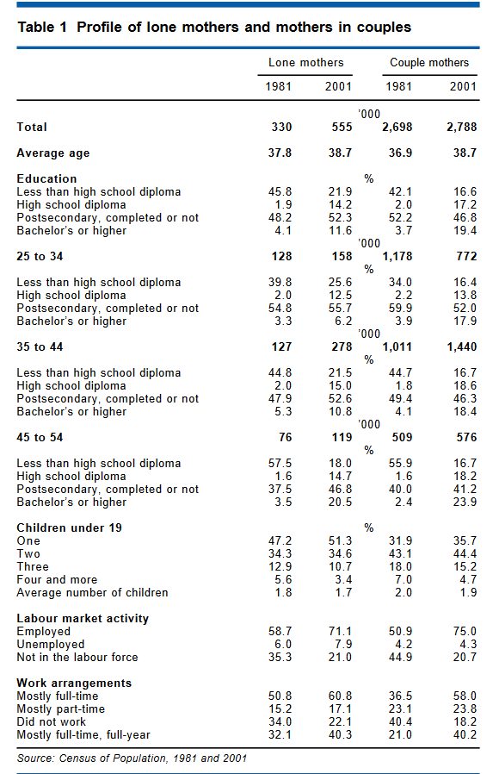
(Galarneau, 2005)

Wajim (2020) noted that in Nigeria, solo parents needed more help from previous partners in childcare and finances. The lack of finance was the central issue for lone parents, who were finding it difficult to provide basic needs like food, clothing, personal needs, and, in some instances, school fees (Maslow, 2003, np). These lone parents came across social and emotional problems, and this resulted in their children showing dangerous behaviours with alcohol and drugs (Young, 1997; Wajim, 2020). Children from single-mother families have lower cognitive outcomes than children with two parents, but coming from a lone-parent family, children will have ‘different socio-economic circumstances’ (Chapple, 2009; Wajim, 2020).

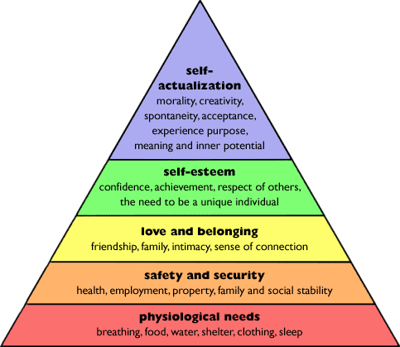
(Maslow, 2003)

Lone-parent families have higher average levels of poor health and social outcomes, impacting their education (Campbell et al., 2016). The lone parent will be more susceptible to turning to alcohol and drugs and attempting suicide (Campbell et al., 2016). Four in 10 single parents in the UK suffer in society, which equates to 41% of single parents (Mental Health Foundation, 2023). Society interferes with day-to-day life, and the cost of living since 2022 has harmed parents' mental health (Mental Health Foundation, 2023). Two-thirds of single parents are anxious about debt and how they will pay their bills, and a third are anxious about their housing situation (Burke, 2001; Mental Health Foundation, 2023). As discussed in this assignment, benefits are insufficient to sustain the family and mental health affects both lone mothers and lone fathers (Choudhry, et al., 2016).

Although most lone parents are mothers, fathers are on the increase (Wade, Veldhuizen and Cairney, 2011). Wade (2011) wrote that lone parents had higher rates for different mood disorders compared to married parents (Wade, Veldhuizen and Cairney, 2011). Mums were shown to have high rates of anxiety disorders, 10.7% compared with 4. 9% of married mums. Compared with fathers, mums had a higher rate of anxiety disorder, which was 19.9%, and 11.1% of fathers were shown to have an anxiety disorder (Wade Veldhuizen and Cairney, 2011). Cooper (2007) argued that rates for lone fathers had never been studied but acknowledged that lone mothers experienced higher rates of psychiatric disorders (Cooper, et al., 2007). Lone mothers with psychiatric disorders were found to be victims of physical and sexual violence (Butterworth, 2018).

The Government was recommended to create more job opportunities and increase wages so lone parents can benefit (Wajim, 2020). The Government promotes employment by making welfare payments conditional, based on how hard the parents look for paid work (Campbell et al., 2016). Welfare-to-work interventions include Government financing and labour policies (Pavoni and Violante, 2007). The purpose of the Welfare Reform Act 2016 was to encourage people who receive benefits to work and for workers to continue working. The new universal credit benefit would replace all other working benefits (Gov.UK, 2016). This could be seen as being more productive and making it easier for payments to be under one benefit, but the downside is the changes. If you are entitled to four different benefits, changing to a single benefit takes time, and mistakes and delays could be made (Citizens Advice, 2024).

Concluding, this assignment described six families but focused on lone parenting. Throughout, it showed how poverty played a crucial part in lone parents' education, mental health, and employment prospects. It emphasised how the benefits systems in Western countries were used to both help or hinder lone parents, and the difficulties that these parents faced to provide the basic needs for the family. The whole family faced stigma from society because they were in poverty or single parents, which again affected their mental health. The Children Act 1989, and the Welfare Reform Act 2016 were developed to help children and families through benefits, as discussed in this assignment (Gov.UK, 2016). The benefits not only helped families to work but also helped families to seek more education, which would better their job prospects and help take the family out of poverty (Campbell et al., 2016; Chapple, 2009; Wajim, 2020).

Reference list:
Adler, A. (1930) The Education of Children. Available at: https://doi.org/10.4324/9781315687933 (Accessed: 18 November 2024).
Agrillo, C. and Nelini, C. (2008) ‘Childfree by Choice: A Review’, Journal of Cultural Geography, 25(3), pp. 347–363. doi: https://doi.org/10.1080/08873630802476292.
Atkinson, A.B. (2015) Inequality What can be done? 6th edn. London: Havard University Press.
Bachrach, C.A. (1980) ‘Childlessness and Social Isolation among the Elderly’, Journal of Marriage and Family, 42 (3), pp. 627-637. doi: https://doi.org/10.2307/351906.
Bester, S. and Malan-Van Rooyen, M. (2015) Emotional Development, Effects of Parenting and Family Structure. 2nd edn. Available at: https://www.sciencedirect.com/topics/social-sciences/extended-family (Accessed: 13 November 2024).
BetterHelp (2024) Six Family Types and their Unique Dynamics. Available at: https://www.betterhelp.com/advice/family/there-are-6-different-family-types-and-each-one-has-a-unique-family-dynamic/(Accessed: 9 November 2024).
Biblarz, T.J. and Gottainer, G. (2004) Family Structure and Children’s Success: A Comparison of Widowed and Divorced Single Mother Families. Available at: Https://www.theatlantic.com/magazine/archive/2020/03/the-nuclear-family-was-a-mistake/605536/ (Accessed: 23 November 2024).
Brooks, D. (2020) The Nuclear was a Mistake. Available at: https://www.theatlantic.com/magazine/archive/2020/03/the-nuclear-family-was-a-mistake/605536/ (Accessed: 13 November 2024).
Burke, T. (2001) Lone Parents, Social Well Being and Housing Assistance. Available at: https://figshare.swinburne.edu.au/articles/report/Lone_parents_social_well_being_and_housing_assistance/26285332?file=47650807 (Accessed: 18 November 2024).
Butterworth, P. (2018) ‘Lone Mothers Experience of Physical and Sexual Violence: Association with Psychiatric Disorders’, British Journal of Psychiatry, 184(1), pp. 21-27. Available at: https://www.cambridge.org/core/journals/the-british-journal-of-psychiatry/article/lone-mothers-experience-of-physical-and-sexual-violence-association-with-psychiatric-disorders/3C32DEDF446D665818C36E5280FC26B7 (Accessed: 18 November 2024).
Campbell, M., Thompson, H., Fenton, C. and Gibson, M (2016) ‘Lone Parents, Health, Well-being and Welfare to Work: A Systematic Review of Qualitative Studies’, BMC Public Health, 16(188), pp. 1-10. doi: https://doi.org/10.1186/s12889-016-2880-9.
Chapple, S. (2009) Child well-being and sole-parent family structure in the OECD. Available at: https://doi.org/10.1787/225407362040 (Accessed: 13 November 2024).
Child Poverty Action Group (2024) Things Will Only Get Worse: Why the Two Child Limit Must Go. Available at: https://cpag.org.uk/news/things-will-only-get-worse-why-two-child-limit-must-go (Accessed: 15 November 2024).
Children Act 1989, c. 41. Available at: https://www.legislation.gov.uk/ukpga/1989/41/section/1 (Accessed: 18 November 2024).
Children Act 2004, c. 31. Available at: https://www.legislation.gov.uk/ukpga/2004/31/contents. (Accessed: 25 November 2024).
Child Poverty Action Group (2024) Things Will Only Get Worse: Why the Two Child Limit Must Go. Available at: Https://cpag.org.uk/news/things-will-only-get-worse-why-two-child-limit-must-go (Accessed: 15 November 2024).
Citizens Advice, (2024) Universal Credit Recipients Unfairly Paying £111m a Year Due to Government Mistakes, Warns Citizens Advice. Available at: https://www.citizensadvice.org.uk/wales/about-us/media-centre/press-releases/universal-credit-recipients-unfairly-paying-gbp111m-a-year-due-to-government/ (Accessed: 27 November 2024).
Colman, A. M. (2015) Oxford Dictionary of Psychology. Oxford: Oxford University Press.
Cooper, C., Bebbington, P.E., Meltzer, H., et al. (2008) ‘Depression and common mental disorders in lone parents: Results of the 2000 National Psychiatric Morbidity Survey’, Psychological Medicine, 38(3), pp.335–342. doi:10.1017/S0033291707001493.
Dunifon, R. (2012) The Influence of Grandparents on the Lives of Children and Adolescents. Available at: https://doi.org/10.1111/cdep.12016 (Accessed: 13 November 2024).
Eitzen, G., Panton, D. and Mills, G. (2004) Multi-Skilled Workforce Optimisation. Available at: https://link.springer.com/article/10.1023/B:ANOR.0000019096.58882.54#Bib1 (Accessed:19 November 2024).
Galarneau, D. (2005) Statistics Canada: Education and Income of Loan Parents. Available at:
https://www150.statcan.gc.ca/n1/en/pub/75-001-x/11205/8981-eng.pdf?st=f0BxtZ-7 (Accessed: 22 November 2024).
Gibson, K. (2022) Over Half of Children in England and Wales Now Born to Unmarried Parents. Available at: https://www.manchester.ac.uk/about/news/over-half-of-children-in-england-and-wales-now-born-to-unmarried-parents/ (Accessed: 18 November 2024).
Golish, T.D. (2006) Stepfamily communication strengths. Available at: https://doi.org/10.1111/j.1468-2958.2003.tb00831.x (Accessed: 13 November 2024).
Gov.UK (2024) Families with More Than Two Children: Claiming Benefits. Available at: https://www.gov.uk/guidance/claiming-benefits-for-2-or-more-children (Accessed: 15 November 2024).
Gov.UK. (2016) Universal Credit. Available at: https://www.gov.uk/universal-credit (Accessed: 20 November 2024).
Harkness, S., Gregg, P. and Fernandez-Salgado, M. (2019) The Rise in Single Mother Families and Children’s Cognitive Development: Evidence from Three British Birth Cohorts. Available at: https://srcd.onlinelibrary.wiley.com/doi/10.1111/cdev.13342 (Accessed: 13 November 2024).
Harkonen, J. (2018) Single-mother poverty: How Much do Educational Differences in Single Motherhood Matter? In the Triple Bind of Single-Parent Families. Bristol: Policy Press.
Helman, S. (2011) ‘Let Us Help Them to Raise Their Children into Good Citizens: The Lone-Parent Families Act and the Wages of Care-Giving in Israel’, Social politics, 18(1), pp. 52–81. Available at: https://academic.oup.com/sp/article/18/1/52/1627923?login=true (Accessed: 12 November 2024).
Jun, M. (2019) ‘Stigma and Shame Attached to Claiming Social Assistance Benefits: Understanding the Detrimental Impact on UK Lone Mothers’ Social Relationships’, Journal of Family Studies, 28(1), pp. 199–215. doi: https://doi.org/10.1080/13229400.2019.1689840.
Lea, D., Bull, V., Webb, S. and Duncan, R. (2014) Oxford Learners Dictionary of Academic English. Oxford: Oxford University Press.
Letablier M.T. And Wall, K. (2018) ‘Changing Lone Parent Patterns: New Challenges for Policy and Research’ in Bernardi L. and Mortelmans D. (eds.) Lone Parenthood in the Life Course: Vol 8. Cham: Springer, pp.1-26.
Maslow, A.H. (2003) The Client Centred Therapy: It’s Current Practice, Implications and Theory: London: Robinson Publishing.Inc.
McLeod, S. (2024) Maslow’s Hierarchy of Needs. Available at: https://www.simplypsychology.org/maslow.html (Accessed: 13 November 2024).

Mental Health Foundation (2023) Single parents are more at risk of anxiety. Available at: https://www.mentalhealth.org.uk/about-us/news/single-parents-are-more-risk-anxiety#:~:text=*%2089%%20of%20single%20parents%20felt%20anxious,financial%20security%20would%20help%20with%20their%20anxiety (Accessed: 18 November 2024).
Money Helper, (2024) Average Childcare Costs. Available at:
https://www.moneyhelper.org.uk/en/family-and-care/becoming-a-parent/childcare-costs (Accessed: 19 November 2024).
Nickerson, C. (2024) Simply Psychology: Nuclear Family Functions in Society. Available at: https://www.simplypsychology.org/nuclear-family.html (Accessed: 10 November 2024).
Nieuwenhuis, R. and Maldonado, L.C. (eds.) (2018) The triple bind of single-parent families: resources, employment and policies to improve wellbeing. Bristol: Policy Press.
Office for National Statistics (2024) Families and Households In the UK: 2022. Available at: https://www.ons.gov.uk/peoplepopulationandcommunity/birthsdeathsandmarriages/families/bulletins/familiesandhouseholds/2022 (Accessed: 12 November 2024).
Office for National Statistics (2024) Families and Households Statistics Explained. Available at: https://www.ons.gov.uk/peoplepopulationandcommunity/birthsdeathsandmarriages/families/articles/familiesandhouseholdsstatisticsexplained/2021-03-02#how-families-are-classified (Accessed: 9 November 2024).
Pavoni, N. and Violante, G. L. (2007) ‘Optimal Welfare-to-Work Programs’, The Review of Economic Studies, 74(1), pp. 283–318. doi: https://doi.org/10.1111/j.1467-937X.2007.00422.x.
Redmond, P., McGuinness, S. and Keane, C. (2020) Impact of One Parent Family Payment Reforms on the Labour Market Outcomes of Lone Parents. Available at: https://www-jstor-org.ezproxy.uwtsd.ac.uk/stable/resrep59752?sid=primo&seq=2. (Accessed: 12 November 2024).
Saraceno, C. (2011) Childcare needs and childcare policies: A multidimensional issue. Journal of Clinical Urology, 59(1). doi: https://doi.org/10.1177/20514158221075405.
Save the Children (2024) Seven Years of the Two Child Limit – A Very Unhappy Birthday. Available at: https://www.savethechildren.org.uk/blogs/2024/seven-years-of-the-two-child-limit (Accessed: 15 November 2024).
Scott, J. (ed.) (2014) Oxford Dictionary of Sociology. Oxford: Oxford University Press.
Skinner, C. Mayer, D.R., Cook, K. and Fletcher, M. (2017) ‘Child Maintenance and Social Security Interactions: The Poverty Reduction Effects in Model Lone Parent Families Across Four Countries’, Journal of Social Policy, 46(3), pp. 495–516. doi: https://doi.org/10.1017/S0047279416000763.
Student Information Scotland (no date) Funding for students who are lone parents. Available at: https://www.studentinformation.gov.scot/students/higher-education/lone-parents (Accessed: 15 November 2024).
Talbot, R. (2024) The Single-Parent Penalty: A Political Choice. Available at:
Children and Families (Wales) Measure 2010 (nawm1). Available at: https://law.gov.wales/children-and-families-wales-measure-2010 (Accessed: 22 November 2024).
United Nations Children’s Fund (2021) Child Rights Education with Children Aged 0-6 Years. Available at: https://www.unicef.org/media/110081/file (Accessed: 12 November 2024).
United Nations Children’s Fund (2024) Core Commitments for Children. Available at: https://www.unicef.org/emergencies/core-commitments-children (Accessed: 14 November 2024).
University of Essex (no date) Changes in Family Structure. Available at: https://www.understandingsociety.ac.uk/wp-content/uploads/briefing-notes/data-note-changes-in-family-structure.pdf (Accessed: 13 November 2024).
Wade, T. J., Veldhuizen, S., Cairney, J. (2011) ‘Prevalence of Psychiatric Disorder in Lone Fathers and Mothers: Examining the Intersection of Gender and Family Structure on Mental Health’, The Canadian Journal of Psychiatry, 56(9). Available at: https://journals.sagepub.com/doi/abs/10.1177/070674371105600908 (Accessed: 19 November 2024).
Wajim, J. (2020) ‘Single Parenting and Its Effects on the Development of Children in Nigeria’, International Journal of Social Sciences and Humanities Invention, 7(4), pp. 891–902. doi: https://doi.org/10.18535/ijsshi/v7i04.02.
Welfare Reform and Work Act 2016 c.7. Available at: https://www.legislation.gov.uk/ukpga/2016/7/contents (Accessed: 19 November 2024).
Well-Being of Future Generations (Wales) Act 2015. Available at: https://www.futuregenerations.wales/about-us/future-generations-act/ (Accessed: 22 November 2024).
Young, N.K. (1997) ‘Effects of Alcohol and Other Drugs on Children’, Journal of Psychoactive Drugs, 29(1), pp. 23–42. doi: https://doi.org/10.1080/02791072.1997.10400168.

