MANAGEMENT ECONOMICS
SILVIA MIHAELA TANACHE
2122649
LECTURER:DR.TAYE OSADIYA

Table of Contents
1. Task 1 2
2. Task 2 4
3. References 9

1. Task 1
A. During the pandemic, industries did face a lot of dark times as it changed the way of business suddenly. Developed economies such as the UK also suffered from demand and supply issues as it was not pre planned. All of a sudden, companies started to follow the Covid-19 rules to keep their business intact. Government officials announced protocols which were unknown and alien to all the businesses. One of the major problems was shortage of supply as transportation and communication was totally blocked.
Due to shortage of supply, the price of products started to increase which made it tough to run a business. Companies started to shut down as they were in debt and their assets started to collapse (Barmuta et al., 2020). Some of the fundamental problems stated in the case are low supply, economic barriers, shortage of demand. The Effects of BREXIT and COVID-19 boosted the economic problems twice as they had no solutions.
Companies in the UK started to panic while buying scarce resources with a huge amount of money. Start-up companies were running in loss and had to close their companies to clear the bank loans. The cost of living was so high that the companies had to apply for huge loans with high interest rates. According to (Davronovich and Kholmirzayevich, 2020), transportation was blocked as the pandemic situation was highly dangerous to lives. Most of the companies in the UK had to go through bankruptcy due to lack of business funds and relied on borrowings. Customers started to shift to services more than raw goods as they tried to cut their expenses. The pandemic brought several pathetic challenges worldwide such as supply chain disruptions, unemployment, income inequality and others. Sectors in the UK faced closures which led to serious job loss and employment (Koberg and Longoni, 2019). Lockdowns turned the transportation system upside down which led to serious disruptions towards the supply chain operations.
Products in the market faced price fluctuations and price shortage due to global supply chain disruptions. Lack of resources and cash flow issues were the reason why the small business of the country faced closure. Covid-19 exacerbated income inequity in marginalised communities. As opined by (Tien et al., 2019), the only option left then was remote working facilities which all the business could not avail. The idea of remote working was so sudden that businesses did not plan to implement it on a positive basis. The Governments of the countries started to provide economic aid to the people which increased their debt and disturbed public finances.
Business in the UK faced high demand for daily products as prices started to increase highly. Fuel demand was increased which stimulated the labour shortage to meet the human requirements of day to day. These issues led UK firms to import raw materials from abroad and export their finished goods in return. According to the Fed Global Supply Chain Barometer, the global market was going through a lot of pressure during the pandemic (Johnson and Haug, 2021). This is the result that customers started to shift from services to goods creating pressure on supply chains.
One of the noticeable economic problems of UK firms was the shortage of drivers which contributed to fuel supply issues. Tons of EU drivers left their jobs which created huge pressures on supply chain management. Due to BREXIT and COVID-19, it was difficult to hire new drivers and replace the older ones. The consumers started to fill their tank rapidly as they received the news of driver shortage from the UK firms. Thus the demand for drivers as well as fuel increased when there was shortage of supply creating a huge mess. This high shortage of fuel reported to 20% during the peak of business which was calculated as 43% generally by the company reports (Min, 2021).
B. There are various ways on how these economic issues could be resolved by the UK firms with good planning and implementation. Pressure on global supply chains is followed by a surge in demand for essential goods in the market. According to Boris Johnsom, several strains and stress in the supply chain surged the demand. Whereas the invasion of the vaccine has led to some confidence within the UK firms. The government acknowledged BREXIT for contributing towards the labour shortage of the country. According to Xu et al., (2020), the post factors of the pandemic recruited EU staff with low wages to stop disruptions. Panic buying of the fuel became worse because of the weaknesses in government communications of the UK. The ministers of the country started calling it a manufactured problem as transportation was highly disrupted (O'Rourke, 2019).
Government did set up structures to monitor the crisis internally which was announced on 14th of September. A National Economic Recovery Taskforce on logistics was created on that day to fasten the coordination within the government departments. It was implemented to address the shortage of HGV drivers and food-chain issues which were expected to draw attention. Former chief executive of Tesco was recruited until the year ending to advise the government bodies on new supply chain programmes (Bisciari, 2019). Two hundred executives of Defra’s Food Resilience Industry Forum coordinated with the government to deal with the economic issues.
The UK government introduced various policy measures to fight the fundamental economic problems of the country. Twenty high-profile government interventions aimed at addressing the shortage of HGV drivers. Additional visas were issued by the sectors to address the shortage leading to serious financial problems. Government changed the procedure to free HGV tests for creating free capacity for testing (Lewis et al., 2021). The car drivers no longer tested the caravan but the checking procedure was shortened by few procedures. This step assured that 50,000 additional drivers can avail the driving test every year. The next step was providing funds to the driver’s licence through the help of the adult education budget.
The Downstream Oil Protocol was activated by the government on a temporary basis which exempted fuel firms and allowed information sharing (Gorton and Ordonez, 2022). Another step was providing temporary visas to the poultry workers under the seasonal working scheme of the UK government. Government applied some distinctive ways to deal with the pandemic learning from their previous records of BREXIT. Whereas the UK firms relaxed some of the tough pandemic rules to run their business. Shortage management was done using teamwork strategy as it was not possible to work individually in this situation.
The firms improved their own supply chain with the help of reducing their waste products and hiring more drivers. Firms had to work with the suppliers to reduce the price of fuel and transportation (Lu et al., 2020). Stakeholders were very serious about investing in any business as all of them were running under loss. Thus the UK firms did their best to keep the stakeholders updated about each and every detail of their company structures. This helped them to seek help from the stakeholders whenever it was needed. Supplier collaborations network could be improved with the help of taking part in collaboration projects and creating dimensions. Supplier relationship management identifies that these collaborations build trust that can help in fighting with the economic crisis over the period.

2. Task 2
2. A. the idea of demand and supply is relevant in this case as it caused price changes due to high demand for fuel. This led to shortage of labour as it is a chain system where the price of fuel is directly proportional to the labour (Hastig and Sodhi, 2020). Pricing strategy that can clearly utilise the law of demand and supply is variable pricing. This is a method where the price of the product is highly dependent on the current supply of the products. Another process is known as demand-based pricing where customers are given their will to pay on products accordingly. Dynamic pricing refers to allowing the business owners to adjust the price of the products depending upon the competitor. Here, in this situation, pricing strategy could help to control the shortage of fuel and labour accordingly by the UK firms.
The firms can depend upon the competition in the market and drive the prices of the fuel accordingly. The price of products increased which disturbed the supply chain of almost all the companies thus the competition could be considered low.
Business expansion procedures such as online platforms and remote working is relevant with the case as it could boost the work. Examples such as Amazon online platform management portrays the shift of online retailing during the pandemic (Acuna et al., 2023). Business expansion was done with the help of online shifts as people were fully dependent on online shopping and services. Marketing strategies shifted from offline campaigns to online posters and promotions. Businesses in the UK tend to use social media as a positive platform for fostering their work. Target market includes geographical areas as people started to rely on seasonal basic needs more than luxury.
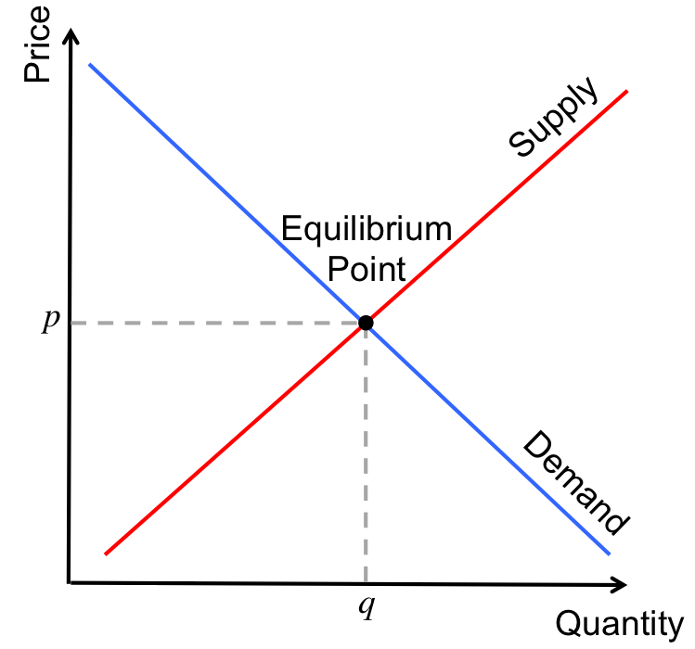
Figure 1: Demand and supply curve
(Source: Kaminski et al., 2021
In commercial business it is prevalent that the demand of a certain product increases and decreases with time. It is vital for the UK firms to record the fluctuations that anticipate the market change. In the above case, fuel deficiency along with workers deficiency was faced by the Uk firms during the pandemic. One of the options is relying on historical data of BREXIT so that the situation could be handled in a better manner. Inventory management strategies include minimum inventory quality in the UK firms. It is one of the crucial techniques in the e-commerce business as it tracks the demand of the product (Kaminski et al., 2021). In the Uk, the demand for fuel increased which led to lesser supply and shortage of drivers. In the pandemic, it was possible for the company to hire new drivers at an average pay. When all the businesses were shutting down, the demand for fuel led to a huge product thus time was needed to cope up.
Initial offerings are relevant with the case as it can help business when hard times come such as pandemic. Initial public offerings include donations, consumer demand, increasing demand and stakeholder’s support. It helped the UK firms to raise capital and create a massive investment area for the country. As opined by Brinkerink et al., (2020)It was difficult during the pandemic to raise salaries as half of the jobs were cut down. But one of the options to balance demand and supply was increasing the salary of workers to get work retention and satisfaction. Increasing employee satisfaction is important for increasing business outcomes. Risk management is one of the crucial aspects of demand and supply for the UK firms during Covid-19.
Firms must calculate the overall debts and income to prioritise risk management during such hard times. Risk managers and leaders are responsible for calculating the increased price of fuel and decreasing drivers. Thus the companies can hire new drivers at an affordable rate and gain the trust of the shareholders. Another aspect which is highlighted includes supply and shortage of market demand which has remained unmatched (Neves et al., 2021). According to the reports it is calculated that the supply and demand of fuel remained unmatched creating the major problem.
B. The difference between elasticity and inelasticity is prominent when it comes to the pandemic situation. Elasticity can be referred to as a measure of shift in quantity demand of a product during the change in the market variables. Examples of elasticity include income, price and salaries of the workers. In the above case, elasticity is linked with the price of fuel and shortage of drivers creating a disruption in supply chain management. The change in an aggregated market which is directly related to price movements can be termed as elasticity. On the other hand, inelasticity refers to the demand when the price of a good goes in an upward direction but the buying habits of the customer is the same. When the price of the goods is same, then also the consumer demand is same which means that it has no effect in the market (Marr, 2019).
Inelastic products are known for necessities when substitutes are not accepted with a common goal. Some of the examples of inelasticity are tobacco and alcohol demand, drugs and prescriptions. Luxury goods and services fall under elastic demand which helps in differentiating both of the demands. Contrasting both of them starts with flexibility of the price and entry barriers (Johnson and Haug (2021). Elasticity demand depends on price flexibility whereas elasticity demand does not focus on such aspects. Elastic goods include advantages as it avoids inflation to some degree whereas the other doesn't. Advantages are it is selected as optimum price, has lower taxes and increases the number of sales. The disadvantages of elasticity of demand includes competitors being continuously monitored by the companies. In elasticity of demand, the UK firms faced revenue boosted due to the increased price of the fuel. One of the disadvantages include an increase in the price where the firms did not have any drivers.
C. The law of supply and demand can be considered as the fundamental principle of economics as it explains the relationship between supply and demand. It influences the price of products and services according to the demand of the market. The law of demand states that as the price of goods decreases, the demand for the same increases (Ardito et al., 2021). Whereas, the law of supply asserts that as the price of goods increases, the demand of the good also increases. Lower price can reduce profitability as thus it supports the concept of increasing both. There are four major laws of demand and supply which deal with market equilibrium when both of them are given the same importance.
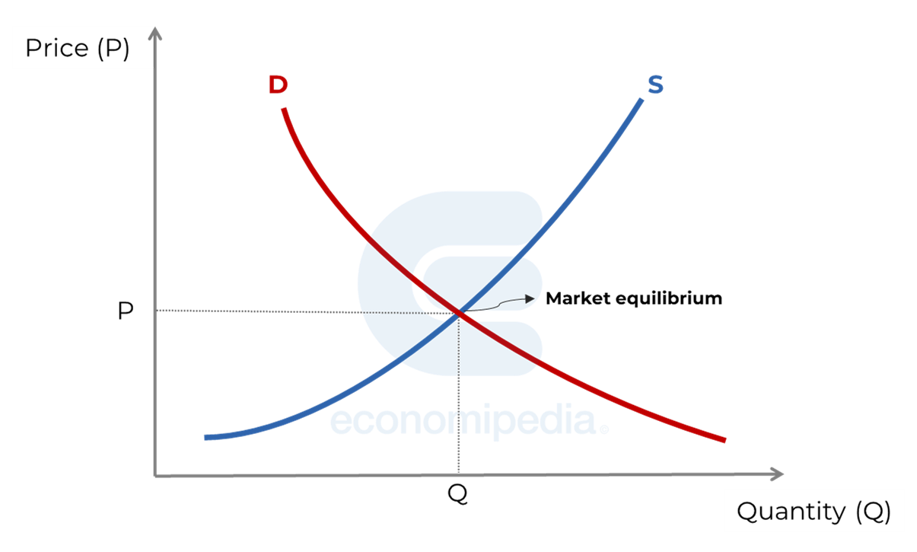
Figure 2: Laws of supply and demand
(Source: Ardito et al., 2021)
Changes in demand include factors such as income changes, population shifts, price preferences for the customers and price alteration (Edmans, 2023). The increase in the product demand raises the price of the market equilibrium for both the quantity and price. Change in supply deals with factors such as technological advancement, changes in input cost and production methods which can affect the supply chain. Decreased demand is the third law of demand and supply stating that demand remains unchanged with lower prices.
It states that if the market price is lower than it will encourage the buyers to buy their luxury items without hesitation. Decreased supply states that demand remains unchanged which leads to lower quantities and high prices. The company will be willing to pay more thus to secure the products which are available to the company (Am et al., 2020). If all the laws of demand and supply are related to the situation of the UK firms during the pandemic, it will state that the shortage of fuel is linked with workers. The companies were facing shortage of workers which was directly linked with the increasing price of the fuel. Companies watched the laws of demand of supply during the pandemic as it was prominent then.

3. References
Acuna-Agost, R., Thomas, E. and Lhéritier, A., 2023. Price elasticity estimation for deep learning-based choice models: an application to air itinerary choices. In Artificial Intelligence and Machine Learning in the Travel Industry: Simplifying Complex Decision Making (pp. 3-16). Cham: Springer Nature Switzerland.
Am, J.B., Furstenthal, L., Jorge, F. and Roth, E., 2020. Innovation in a crisis: Why it is more critical than ever. McKinsey & Company.
Amankwah-Amoah, J., Khan, Z. and Wood, G., 2021. COVID-19 and business failures: The paradoxes of experience, scale, and scope for theory and practice. European Management Journal, 39(2), pp.179-184.
Ardito, L., Coccia, M. and Messeni Petruzzelli, A., 2021. Technological exaptation and crisis management: Evidence from COVID‐19 outbreaks. R&d Management, 51(4), pp.381-392.
Barmuta, K.A., Akhmetshin, E.M., Andryushchenko, I.Y., Tagibova, A.A., Meshkova, G.V. and Zekiy, A.O., 2020. Problems of business processes transformation in the context of building digital economy. Entrepreneurship and Sustainability Issues, 8(1), p.945.
Bisciari, P., 2019. A survey of the long-term impact of Brexit on the UK and the EU27 economies.
Brinkerink, J., Rondi, E., Benedetti, C. and Arzubiaga, U., 2020. Family business or business family? Organizational identity elasticity and strategic responses to disruptive innovation. Journal of Family Business Strategy, 11(4), p.100360.
Davronovich, M.A. and Kholmirzayevich, M.I., 2020. THE DEVELOPMENT OF SMALL BUSINESS AND ITS SOCIO-ECONOMIC AFFECTS. MODERN VIEWS AND RESEARCH, 33.
Edmans, A., 2023. How great companies deliver both purpose and profit. Journal of Chinese Economic and Business Studies, pp.1-5.
Gorton, G. and Ordonez, G., 2022. The supply and demand for safe assets. Journal of Monetary Economics, 125, pp.132-147.
Hastig, G.M. and Sodhi, M.S., 2020. Blockchain for supply chain traceability: Business requirements and critical success factors. Production and Operations Management, 29(4), pp.935-954.
Johnson, J.E. and Haug, P., 2021. Modifications to global supply chain management strategies resulting from recent trade disruptions: an exploratory study. Journal of Global Operations and Strategic Sourcing, 14(4), pp.701-722.
Kaminski, S., Höschle, H. and Delarue, E., 2021. Impact of capacity mechanisms and demand elasticity on generation adequacy with risk-averse generation companies. Electric Power Systems Research, 199, p.107369.
Koberg, E. and Longoni, A., 2019. A systematic review of sustainable supply chain management in global supply chains. Journal of cleaner production, 207, pp.1084-1098.
Lewis, A., Koukoura, A., Tsianos, G.I., Gargavanis, A.A., Nielsen, A.A. and Vassiliadis, E., 2021. Organ donation in the US and Europe: The supply vs demand imbalance. Transplantation Reviews, 35(2), p.100585.
Lu, X., Li, K., Xu, H., Wang, F., Zhou, Z. and Zhang, Y., 2020. Fundamentals and business model for resource aggregator of demand response in electricity markets. Energy, 204, p.117885.
Marr, B., 2019. Artificial intelligence in practice: how 50 successful companies used AI and machine learning to solve problems. John Wiley & Sons.
Min, H., 2021. An inter-organisational decision support system for global supply chain management. International Journal of Logistics Systems and Management, 38(4), pp.475-487.
Neves, E., Oliveira, V., Leite, J. and Henriques, C., 2021. The global business cycle and speculative demand for crude oil. China Finance Review International, 11(4), pp.502-521.
O'Rourke, K., 2019. A short history of Brexit: From Brentry to backstop. Penguin UK.
Tien, N.H., Anh, D.B.H. and Thuc, T.D., 2019. Global supply chain and logistics management.
Xu, Z., Elomri, A., Kerbache, L. and El Omri, A., 2020. Impacts of COVID-19 on global supply chains: Facts and perspectives. IEEE Engineering Management Review, 48(3), pp.153-166.
Yang, Y., Liu, H. and Chen, X., 2020. COVID-19 and restaurant demand: early effects of the pandemic and stay-at-home orders. International Journal of Contemporary Hospitality Management, 32(12), pp.3809-3834.

