WORKSHEET 4 – QUESTION

Build a fruit machine game which represents the 3 reels of symbols using numbers ranging from 1 to 5 (you do not have to use the fruits, just numbers is fine!).

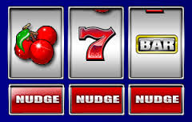

The scoring will be as follows:

- Any three of the same numbers (excluding fives) will pay a bonus of 20 points e.g.
4 4 4
3 3 3
1 1 1, etc.

- Any combination of two fives will pay out 100 points e.g.
5 5 3
5 4 5
5 5 1, etc.

- Three fives pay out the big jackpot of 2000 points.

The points the player has scored after each turn should be displayed and the player should be asked if they wish to make another spin (as shown below).

You could use either a non-cumulative score (score shown each spin) or a cumulative score (score is added to after each spin). It could look something like this:

Non-cumulative score version Cumulative score version


