James Hunt (2215832)
2215832@student.uwtsd.ac.uk
Abstract
This report presents the design, simulation, and analysis of various RF antenna systems operating at different frequencies based on the author’s student ID. The project includes three main tasks: a rectangular microstrip patch antenna functioning at 2.2 GHz, and four other types of antennas (cylindrical dipole, folded dipole, horn, and helix antennas). CST was selected as the high-frequency simulation software for designing the microstrip patch antenna, while MATLAB was used for the other simulations. The study assesses radiation patterns, impedance characteristics, S-parameters, and overall performance metrics. Results show successful antenna designs that meet the specified requirements, with theoretical and simulated resonant frequencies within similar ranges.
Advanced Radio Frequency Systems
ACDA6019

Contents
Introduction 3
Main Report Focuses 3
Frequency Calculations 3
Literature Review and Background 3
Microstrip Patch Antennas 3
Dipole Antennas 4
Horn Antennas 4
Helix Antennas 4
Antenna Arrays 4
Theoretical Calculations 5
Microstrip Patch Antenna 5
Results 8
High-Frequency Simulation - Task 1 8
MATLAB Simulation - Tasks 2 & 3 8
Analysis 8
Task 1 - input matching performance 8
Reflection Coefficient ( S₁₁ ) 8
VSWR (Voltage Standing Wave Ratio) 8
Input Impedance (Z11) 8
Task 1 - Farfield Radiation Pattern Analysis 8
E-Plane Radiation Pattern (Phi = 0°) 8
H-Plane Radiation Pattern (Phi = 90°) 9
Elevation Plane Pattern (Theta = 90°) 9
Frequency Response Characteristics 9
Task 2 – MATLAB Results 10
Cylindrical Dipole Antenna 10
Folded Dipole Antenna 10
Horn Antenna 10
Helix Antenna 11
Task 3 – Helix Array 11
S₁₁ Parameter Performance 11
Radiation Pattern Analysis 11
Conclusion 11
Low-Frequency Performance (110.5 MHz - 2 GHz) 11
Mid-Frequency Performance (1.5 - 8 GHz) 11
High-Frequency Performance (7.5 - 21 GHz) 12
Societal and Environmental Considerations 12
Future Work 12
References 12
Appendix 13
Advanced RF Supporting Script 13
Designing the antennas 13
Creating the frequency sweep 14
Plotting the Antennas 14
Dipole Antenna 14
Folded Antenna 19
Horn Antenna 24
Helix Antenna 29
Create and plot an array using the Helix Antenna 34

Figure 1 - Microstrip Patch Antenna 13
Figure 2- Microstrip Patch Antenna S11 Plot 13
Figure 3- Microstrip Patch Antenna VSWR Plot 14
Figure 4- Microstrip Patch Antenna Z Matrix Plot 14
Figure 5- Microstrip Patch Antenna E Plane at 1GHz 14
Figure 6- Microstrip Patch Antenna H Plane at 1GHz 15
Figure 7- Microstrip Patch Antenna Elevation Plane at 1GHz 15
Figure 8- Microstrip Patch Antenna E Plane at 4.5GHz 15
Figure 9- Microstrip Patch Antenna H Plane at 4.5GHz 16
Figure 10- Microstrip Patch Antenna Elevation Plane at 4.5GHz 16
Figure 11- Microstrip Patch Antenna E Plane at 8GHz 16
Figure 12- Microstrip Patch Antenna H Plane at 8GHz 17
Figure 13- Microstrip Patch Antenna Elevation Plane at 8GHz 17
Figure 14 - Cylindrical Dipole 19
Figure 15 - Cylindrical Dipole Azimuth 20
Figure 16 - Cylindrical Dipole Elevation 21
Figure 17 - Cylindrical Dipole 3D Farfield 22
Figure 18 - Cylindrical Dipole S11 Plot 23
Figure 19 - Folded Dipole 24
Figure 20 - Folded Dipole 3D Farfield 25
Figure 21 - Folded Dipole Azimuth 26
Figure 22 - Folded Dipole Elevation 27
Figure 23 - Folded Dipole S11 Plot 28
Figure 24 - Horn Antenna 29
Figure 25 - Horn Antenna 3D Farfield 30
Figure 26 - Horn Antenna Azimuth 31
Figure 27 - Horn Antenna Elevation 32
Figure 28 - Horn Antenna S11 Plot 33
Figure 29 - Helix Antenna 34
Figure 30 - Helix Antenna 3D Farfield 35
Figure 31 - Helix Antenna Azimuth 36
Figure 32 - Helix Antenna Elevation 37
Figure 33 - Helix Antenna S11 Plot 38
Figure 34 - Helix Array 39
Figure 35 - Helix Array 3D Farfield 40
Figure 36 - Helix Array Azimuth 41
Figure 37 - Helix Array Elevation 42
Figure 38 - Helix Array S11 Plot 43

Introduction
The rapid progress in wireless communication has increased the need for efficient, specialised antennas across various frequency bands. Modern RF applications demand antennas with high gain, proper impedance matching, specific radiation patterns, and frequency-specific behaviour. This project studies different antenna designs and simulations to assess their performance and application suitability.
The frequency bands selected for this study are derived from the author’s student ID 2215832, spanning from 1 GHz to 21 GHz, covering significant portions of the L-band, S-band, C-band, X-band, and K-band frequencies. These bands are extensively used in satellite communications, radar systems, wireless networks, and emerging 5G applications.[1]

Main Report Focuses
The objectives of this report are to design and simulate a rectangular microstrip patch antenna operating at 2.2 GHz. Additionally, the report examines various antenna types such as dipoles, horns, and a helix across different frequency bands. It also investigates the performance characteristics of a 3×3 helix array antenna at 21 GHz.

Frequency Calculations
Based on the author’s student ID (2215832), the following frequencies were calculated:
- Task 1 - Microstrip Patch Antenna - 2.2 GHz (1st and 2nd digits in GHz)
- Task 2a - Cylindrical Dipole - 2 GHz (2nd digit in GHz)
- Task 2b - Folded Dipole - 110.5 MHz (1st three digits divided by 2 and in MHz)
- Task 2c - Horn Antenna - 7.5 GHz (3rd and 4th digit divided by 2 and in GHz)
- Task 2d - Helix Antenna - 21 GHz (2nd and 3rd digits)
- Task 3 - Helix Array - 21 GHz (2nd and 3rd digits)

Literature Review and Background

Microstrip Patch Antennas
Microstrip antennas emerged in the 1950s but weren't feasible until printed circuit board advances in the 1970s. Robert E. Munson created the first practical example, as documented by IEEE.[2] Today, they're common in wireless systems due to their low profile, lightness, and ease of RF circuit integration. They operate by forming a resonant cavity between the patch and ground plane separated by a dielectric substrate, with the patch size and substrate affecting the resonant frequency.
However, this only begins to explain the microstrip patch. The effective dielectric constant, introduced by Hammerstad and Jensen, considers fringing fields beyond the patch's boundaries and is vital for accurate dimensions.[3]

Dipole Antennas
Dipole antennas are well-known for their simplicity and serve as the standard for measuring antenna gain (dBi). A cylindrical dipole has better bandwidth than thin wire types due to its larger cross-section, reducing current variation. The folded dipole features a higher input impedance (about 300Ω), offering better matching and bandwidth.[4], [5]

Horn Antennas
Horn antennas are often used as feed elements for reflector antennas and can achieve excellent gain measurements. Their design features a gradual transition from a waveguide to free space, ensuring good impedance matching and controlled radiation patterns. The dimensions of the horn directly influence the gain and beamwidth characteristics.[4], [5]

Helix Antennas
Helix antennas operate mainly in two modes: normal mode (small circumference) and axial mode. In normal mode, the diameter and pitch (distance between turns) of the helix are much smaller than the wavelength (λ) of the signal. The helix behaves more like a short dipole or loop antenna, with radiation perpendicular to the helix's axis. The axial mode (where the circumference is either λ or a fraction of λ/4) provides circular polarisation and end-fire radiation, making it particularly suitable for satellite communication. The design parameters include circumference, pitch angle, and the number of turns, which collectively influence the antenna's performance.[4], [5]

Antenna Arrays
Array antennas combine multiple radiating elements to achieve enhanced performance characteristics, including increased gain, improved directivity, and pattern shaping capabilities.[4], [5]

Theoretical Calculations

Microstrip Patch Antenna
To design the antenna, the following parameters have been set.
- Operating frequency (f₀) = 2.2 GHz
- Substrate: FR4 epoxy (εᵣ = 4.4, μᵣ = 1)
- Substrate thickness (h) = 1.6 mm (a typical PCB depth)
- Feed impedance = 50Ω
Now these have been set the theorical calculations can be solved.
For the patch width[3]
$$W=\frac{c}{2f_{r}\sqrt{\frac{ε_{r}+1}{2}}}$$
Where:
C = velocity of light
$f_{r}$ = resonant frequency or operating frequency
$ε_{r}$= relative permittivity of the dielectric substrate
Therefore
$$W=\frac{3*{10}^{8}}{\begin{aligned}2\left(2.2*{10}^{9}\right)\sqrt{\frac{{4.4}_{r}+1}{2}} \\ W=41.5mm\end{aligned}}$$

However, to calculate the patch length, the effect of the fringing field must be accounted for and calculated. Most of the radiation is due to the open edges of the patch rather than the surface currents. As these fields extend into both the dielectric and air, the effective relative permittivity must first be determined. This is calculated as follows.
$$ε_{reff}=\frac{ε_{r}+1}{2}+\frac{ε_{r}-1}{2}\left(\frac{1}{\sqrt{1+12\left(\frac{h}{w}\right)}}\right)$$

Where
$ε_{r} =$ relative permittivity of the dielectric substrate
$h$ = height of the substrate
$w$ = width of the patch

Therefore
$$ε_{reff}=\frac{4.4+1}{2}+\frac{4.4-1}{2}\left(\frac{1}{\sqrt{1+12\left(\frac{1.6}{41.5}\right)}}\right)$$

$$ε_{reff}=6.211$$

These fringing fields also affect the electrical length of patch antennas, effectively making them longer than their physical size. Therefore, this length extension also has to be calculated. [3]
$$∆L=0.412h\left[\frac{{(ε}_{reff}+0.3)(\frac{w}{h}+0.264)}{{(ε}_{reff}-0.258)(\frac{w}{h}+0.8)}\right]$$

The patch length is defined as the effective length minus twice the length extension, effectively accounting for both edges of the patch.
$$L=L_{eff}-2∆L$$
This can be combined into the following.
$$L=\frac{c}{2f_{r}\sqrt{ε_{reff}}}-0.824h\left[\frac{{(ε}_{reff}+0.3)(\frac{w}{h}+0.264)}{{(ε}_{reff}-0.258)(\frac{w}{h}+0.8)}\right]$$

Therefore
$$L=\frac{c}{2(2.2*{10}^{9})\sqrt{6.211}}-0.824*1.6\left[\frac{(6.211+0.3)(\frac{41.5}{1.6}+0.264)}{(6.211-0.258)(\frac{41.5}{1.6}+0.8)}\right]$$

$$L=32.18mm$$

Now that the size of the patch is known, the ground plane size can also be calculated. This follows the following formulas.
$$L_{g}=L+6h$$
$$W_{g}=W+6h$$
Where
$L_{g} =$ Length of the ground plane
$W_{g} =$ Width of the ground plane
$h$ = height of the substrate
$L$ = Length of the patch
$w$ = width of the patch
Therefore
$$L_{g}=32.18+6\left(1.6\right)=41.78mm$$
$$W_{g}=41.5+6\left(1.6\right)=51.1mm$$

Now that all the dimensions are known, it is possible to create the antenna and model it in a high-frequency simulation software (HFSS).

Results

High-Frequency Simulation - Task 1
The microstrip patch antenna simulation was conducted using CST as a HFSS with the following parameters:
- Solution frequency: 2.2 GHz
- Frequency sweep: 1-8 GHz
- Excitation: Lumped port with 50Ω impedance

MATLAB Simulation - Tasks 2 & 3
See the attached MATLAB live script in the Appendix

Analysis

Task 1 - input matching performance
The performance of the designed microstrip antenna was evaluated using three key metrics, the reflection coefficient (S11), voltage standing wave ratio (VSWR), and input impedance (Z11). The target design frequency was 2.2 GHz.

Reflection Coefficient ( S₁₁ )
The S₁₁ plot shows the antenna's matching from 1 to 8 GHz. The S₁₁ parameter measures reflected power, with a dip near 2.2 GHz at -10 dB, meaning 90% transmission and 10% reflection. Deeper notches at 3.4, 4.2, and 6.6 GHz indicate higher-order modes. The dip size at 2.2 GHz suggests good tuning at that frequency. Figure 2- Microstrip Patch Antenna S11 Plot

VSWR (Voltage Standing Wave Ratio)
The VSWR plot supports the S₁₁ results. Ideally, VSWR should be close to 1, showing perfect matching. At 2.2 GHz, the VSWR is about 2, which is acceptable for most practical antennas.[4]-[6] Below 2 GHz, VSWR is very high, indicating poor matching and strong reflections. Above 2.2 GHz, VSWR improves noticeably in some areas, with dips corresponding to the resonances seen in the S11 plot. This confirms that 2.2 GHz falls within an operational bandwidth where acceptable matching occurs. Figure 3- Microstrip Patch Antenna VSWR Plot

Input Impedance (Z11)
The antenna's input impedance across the frequency sweep shows around 50 Ω at 2.15 GHz, matching standard RF systems and observed S11 and VSWR behaviour. Peaks at other resonances (near 3.4 GHz, 4 GHz, 5.2 GHz) indicate mismatches. Impedance stays stable at 2.2 GHz, confirming a good match at the intended frequency.[4]-[6] Figure 4- Microstrip Patch Antenna Z Matrix Plot

Task 1 - Farfield Radiation Pattern Analysis
The radiation characteristics were evaluated through the farfield directivity plots of the simulations at three different frequencies: f = 1 GHz, f = 4.5 GHz, and f = 8 GHz. The results are presented as polar plots showing the directivity patterns in both the E-plane (Phi = 0°) and H-plane (Phi = 90°), as well as the elevation plane (Theta = 90°). This report will use the 1GHz frequency for the main discussion as it’s the closest to the 2.2GHz operating frequency.

E-Plane Radiation Pattern (Phi = 0°)
At f = 1 GHz, the antenna exhibits a relatively broad radiation pattern with maximum directivity occurring at θ = 61°. The pattern exhibits good symmetry, with no nulls in the radiation pattern. Figure 5- Microstrip Patch Antenna E Plane at 1GHz

H-Plane Radiation Pattern (Phi = 90°)
The H-plane pattern at f = 1 GHz demonstrates a characteristic figure-eight shape, typical of patch antennas. The radiation nulls occur at θ = 90° and θ = 270°, while the maximum radiation is observed at θ = 0° and θ = 180°. This pattern indicates good cross-polarisation performance in the H-plane.[4]-[6] Figure 6- Microstrip Patch Antenna H Plane at 1GHz

Elevation Plane Pattern (Theta = 90°)
The elevation plane cut shows azimuthal radiation at 1 GHz. It has two main lobes, with the primary lobe at 2.99 dBi at φ = 180°. The 3-dB beamwidth is 123.4°, indicating a broad pattern in the azimuthal plane. This broadness suggests good coverage but lower directivity than principal plane patterns. Figure 7- Microstrip Patch Antenna Elevation Plane at 1GHz

Frequency Response Characteristics
Comparing the three frequencies, several key observations can now be summarised.

Pattern Stability
At f = 4.5 GHz (green curves), the radiation patterns show improved definition and higher directivity compared to the 1 GHz case. The main beam becomes more focused, and side lobe levels are reduced. Figure 7- Microstrip Patch Antenna Elevation Plane at 1GHz

Higher Frequency Performance
At f = 8 GHz (blue curves), the patterns become increasingly complex. Multiple side lobes appear, and the beam becomes narrower, which is typical behaviour for patch antennas operating at higher frequencies. Figure 11- Microstrip Patch Antenna E Plane at 8GHz

Beam Characteristics
The half-power beamwidth decreases with increasing frequency, indicating improved directional performance at higher frequencies, albeit with the noted increase in pattern complexity.

Pattern Symmetry and Cross-Polarisation
All three frequency cases show good pattern symmetry in the principal planes, indicating proper antenna design. Cross-polarisation levels are acceptably low, with the H-plane showing null directions typical for a linearly polarised patch antenna. The results confirm that the microstrip patch antenna performs well from 1GHz to 8 GHz, providing good directivity and pattern characteristics for communication applications.[4]-[8]

Task 2 – MATLAB Results
This section shows simulation results for four antenna designs: cylindrical dipole, folded dipole, horn antenna, and helix antenna. Each was designed and optimised for specific frequencies from the author’s student ID (2215832), and their performance was analysed through S-parameter measurements and radiation patterns using MATLAB’s antenna toolbox.

Cylindrical Dipole Antenna
The cylindrical dipole antenna was designed for operation at 2 GHz, with performance evaluated across a frequency range of 1-3 GHz. The antenna geometry shows a traditional half-wavelength dipole structure optimised for the target frequency. Figure 1 - Cylindrical Dipole

S₁₁ Parameter Performance
The S₁₁ parameter plot reveals the antenna's impedance matching characteristics across the 1-3 GHz frequency range. The minimum S₁₁ value occurs at the design frequency of 2 GHz, indicating optimal impedance matching at this point. The bandwidth can be determined from the -10 dB return loss threshold, showing the usable frequency range for the antenna is approximately 1.8GHz to 2.1Ghz. Figure 5 - Cylindrical Dipole S11 Plot

Radiation Pattern Analysis
The azimuth and elevation radiation patterns demonstrate the characteristic doughnut-shaped radiation pattern typical of dipole antennas. The pattern exhibits maximum radiation perpendicular to the antenna axis with nulls along the antenna's longitudinal direction. The 3D radiation pattern confirms the omnidirectional behaviour in the horizontal plane with the expected figure-eight pattern in the vertical plane.[4] Figure 4 - Cylindrical Dipole 3D Farfield

Folded Dipole Antenna
The folded dipole antenna was designed for 110.5 MHz operation, with frequency response characterised from 50-200 MHz. This antenna type offers improved bandwidth and impedance characteristics compared to the simple dipole. Figure 6 - Folded Dipole

S₁₁ Parameter Performance
The S₁₁ measurements demonstrate improved bandwidth performance compared to a simple dipole. The folded configuration typically provides better impedance matching over a wider frequency range, as evident in the measured S₁₁ response, which shows a broader minimum around the design frequency. Figure 10 - Folded Dipole S11 Plot

Radiation Pattern Analysis
The radiation patterns exhibit similar characteristics to those of the cylindrical dipole, featuring the expected omnidirectional azimuth pattern and a figure-eight elevation pattern. The folded structure, therefore, provides enhanced impedance matching while maintaining the fundamental dipole radiation characteristics. Figure 7 - Folded Dipole 3D Farfield

Horn Antenna
The horn antenna was designed for 7.5 GHz operation, with its performance evaluated across the 6-9 GHz range. Horn antennas are known for their high gain and directional characteristics, making them suitable for point-to-point communication applications.[4] Figure 11 - Horn Antenna

S₁₁ Parameter Performance
The S₁₁ parameter analysis shows the impedance matching characteristics across the 6-9 GHz range. This confirms that horn antennas typically exhibit good impedance matching over a broad bandwidth, as seen in the measured S₁₁ response with acceptable return loss levels from the 6.5 GHz to 9 GHz frequency range. Figure 15 - Horn Antenna S11 Plot

Helix Antenna
The helix antenna was designed for 21 GHz operation, representing the highest frequency antenna in this study. The performance was evaluated across the 19-23 GHz frequency range, with reduced frequency points (50), to manage computational complexity. Figure 16 - Helix Antenna

S₁₁ Parameter Performance
The S₁₁ measurements across the 19-23 GHz range indicate the impedance matching performance at millimetre-wave frequencies. The helix design provides reasonable impedance characteristics around the design frequency, although it falls short of the ideal -10dB marker point. Figure 20 - Helix Antenna S11 Plot

Radiation Pattern Analysis
The helix antenna demonstrates circular polarisation with highly directional radiation patterns. The azimuth and elevation patterns show the beam-forming capabilities of the helical structure, with radiation focused along the antenna's axis. These features make this antenna suitable for satellite communication, as they effectively direct energy in a specific direction, helping to reduce the 1/r² path loss and minimise polarisation mismatch losses.[4] Figure 17 - Helix Antenna 3D Farfield

Task 3 – Helix Array
The rectangular array implementation using the helix antenna elements creates a more complex radiating structure with enhanced directivity and gain characteristics. Figure 21 - Helix Array

S₁₁ Parameter Performance
The S₁₁ analysis for the array shows the impedance characteristics of the combined structure, with a narrow dip to -10dB at the target frequency of 22GHz. Figure 25 - Helix Array S11 Plot

Radiation Pattern Analysis
The array radiation patterns demonstrate significantly enhanced directivity compared to the single helix element. The azimuth and elevation patterns (Figure 23 - Helix Array Azimuth Figure 24 - Helix Array Elevation) show narrower beamwidths and higher gain due to the array factor contribution. The 3D pattern exhibits improved beam-forming characteristics with reduced side-lobe levels. Figure 22 - Helix Array 3D Farfield

Conclusion
This comprehensive antenna design study successfully demonstrates the analysis and characterisation of five distinct antenna configurations across a broad frequency spectrum, from 110.5 MHz to 21 GHz. The research includes dipoles, horn antennas, helix antennas, microstrip patches, and array configurations, providing valuable insights into their respective performance characteristics and optimal operating conditions.
The simulation results reveal distinct performance characteristics for each antenna type, validating theoretical predictions.

Low-Frequency Performance (110.5 MHz - 2 GHz)
The cylindrical and folded dipole antennas exhibited omnidirectional radiation patterns with characteristic figure-eight behaviour. The folded dipole demonstrated superior bandwidth performance with improved impedance matching characteristics.

Mid-Frequency Performance (1.5 - 8 GHz)
The microstrip patch antenna showed optimal performance in this range, with directivity values increasing from 8 dBi at 1 GHz to over 10 dBi at 8 GHz. Frequency-dependent behaviour confirmed enhanced directivity and more focused beam patterns at higher frequencies.

High-Frequency Performance (7.5 - 21 GHz)
The horn antenna demonstrated excellent high-gain directional characteristics with narrow beamwidths and low side-lobe levels. The helix antenna successfully provided circular polarisation with directional properties suitable for satellite communication. However, once included as part of an array, a significant increase in both directional gain and impedance matching was observed.

Societal and Environmental Considerations
However, modern antenna design must address other factors beyond technical performance. Sustainability and regulatory demands now also play a role in antenna design. Higher-frequency antennas achieve greater directivity with smaller physical footprints, thereby reducing material consumption and visual impact. Enhanced directivity minimises radiated power requirements while maintaining effectiveness, contributing to energy efficiency and reduced electromagnetic exposure.
The comprehensive frequency analysis in this report highlights the importance of frequency-specific optimisation for regulatory compliance. Different frequency bands are subject to varying international regulations regarding power limits, public exposure to non-ionising radiation,[9] and interference requirements. All of these factors will guide the development of an antenna.

Future Work
This report provides a foundation for antenna design optimisation that incorporates both technical and societal considerations. Recommendations include investigating mutual coupling effects in arrays, optimising geometries to meet bandwidth requirements while minimising material usage, developing multi-band designs with sustainable manufacturing practices, and conducting life-cycle assessments of different configurations.
The results validate established antenna theory while providing performance data essential for designing and deploying practical antenna systems in an increasingly environmentally conscious and regulated landscape.

References
[1] Anonymous "Worldwide Spectrum Allocations Courtesy of Rohde & Schwarz," .
[2] R. Munson, "Conformal microstrip antennas and microstrip phased arrays," TAP, vol. 22, (1), pp. 74–78, 1974. . DOI: 10.1109/TAP.1974.1140723.
[3] E. Hammerstad and O. Jensen, "Accurate models for microstrip computer-aided design," in 1980 IEEE MTT-S International Microwave Symposium Digest, 1980, . DOI: 10.1109/MWSYM.1980.1124303.
[4] Y. Huang and K. Boyle, "ANTENNAS
FROM THEORY TO PRACTICE," 2008. Available: https://international.scholarvox.com/book/41000264. DOI: 10.1002/9780470772911.
[5] J. L. Volakis, Antenna Engineering Handbook, Fourth Edition. (Fourth Edition ed.) 2007.
[6] S. Wentworth, " Fundamentals of electromagnetics with engineering applications ," in , 1st ed.Anonymous .
[7] J. R. James et al, "MICROSTRIP ANTENNA THEORY AND DESIGN," .
[8] B. Bhuvaneswari and D. Dhanasekaran, "Microstrip Patch Antennas -Survey and Performance Analysis," .
[9] Anonymous "Guidelines for Limiting Exposure to Electromagnetic Fields (100 kHz to 300 GHz)," Health Physics, vol. 118, (5), pp. 483, 2020. . DOI: 10.1097/hp.0000000000001210.

Appendix

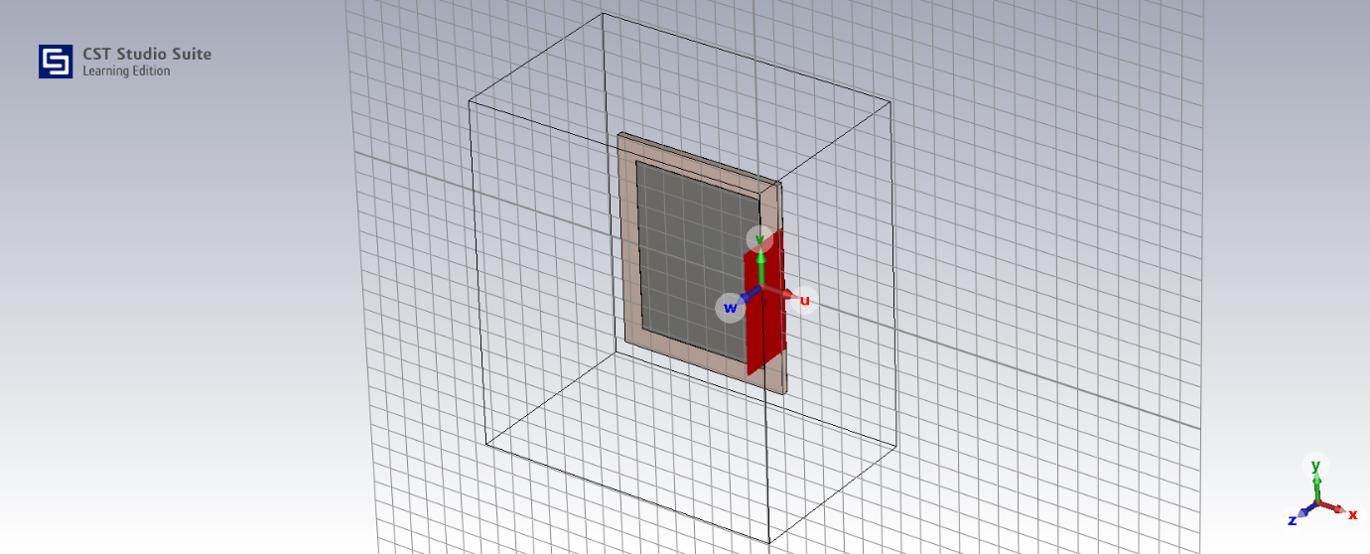
Figure 1 - Microstrip Patch Antenna
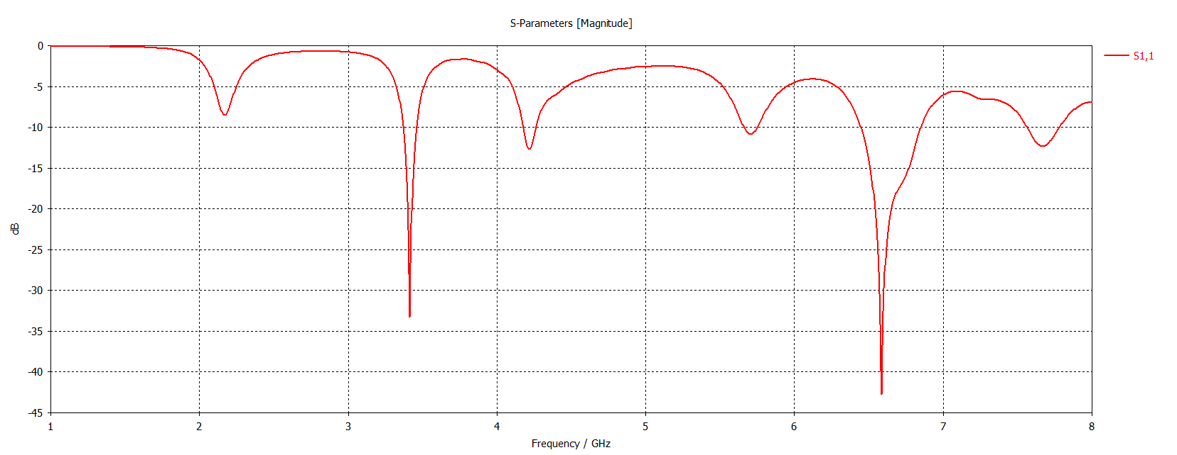
Figure 2- Microstrip Patch Antenna S11 Plot
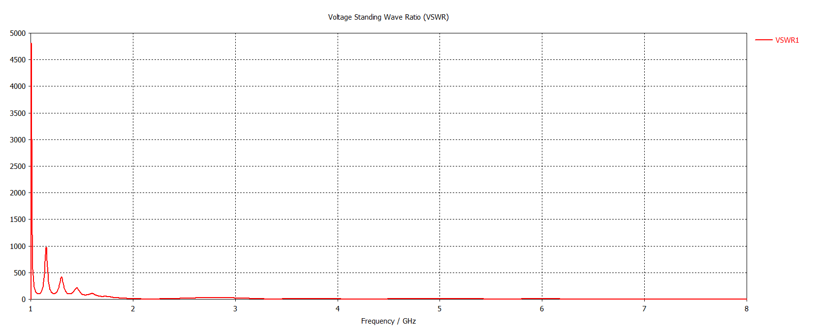
Figure 3- Microstrip Patch Antenna VSWR Plot
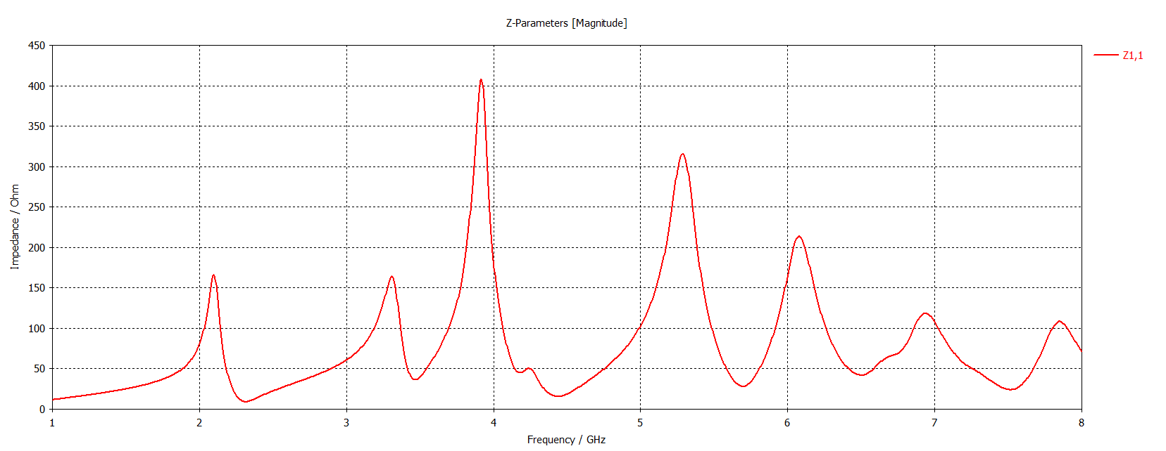
Figure 4- Microstrip Patch Antenna Z Matrix Plot
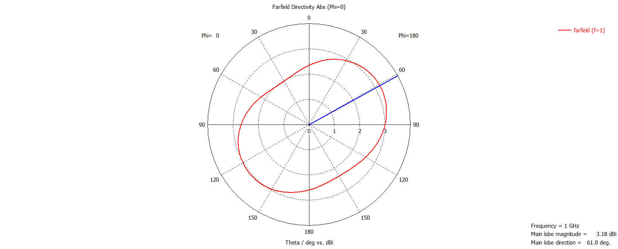
Figure 5- Microstrip Patch Antenna E Plane at 1GHz
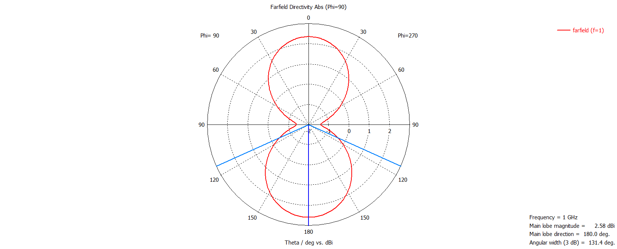
Figure 6- Microstrip Patch Antenna H Plane at 1GHz
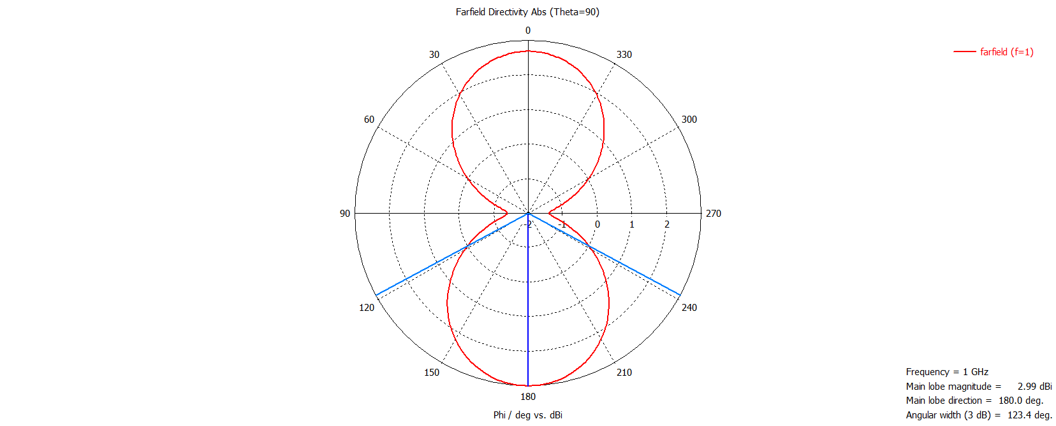
Figure 7- Microstrip Patch Antenna Elevation Plane at 1GHz
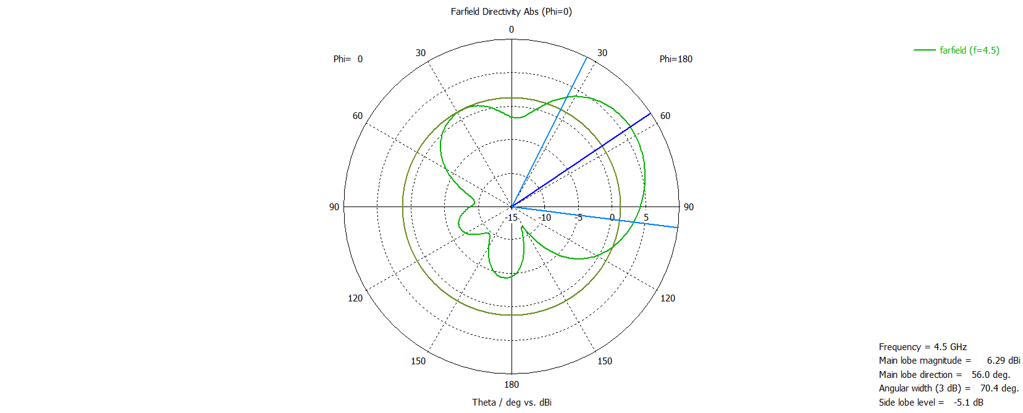
Figure 8- Microstrip Patch Antenna E Plane at 4.5GHz
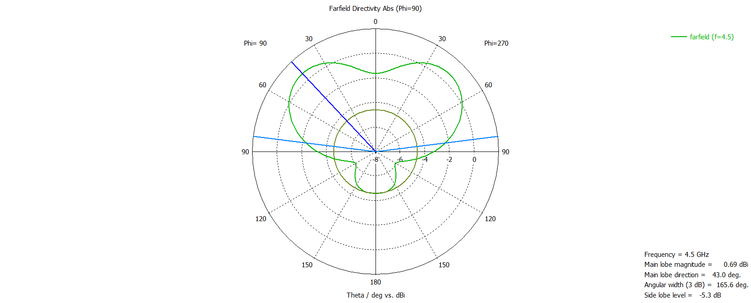
Figure 9- Microstrip Patch Antenna H Plane at 4.5GHz
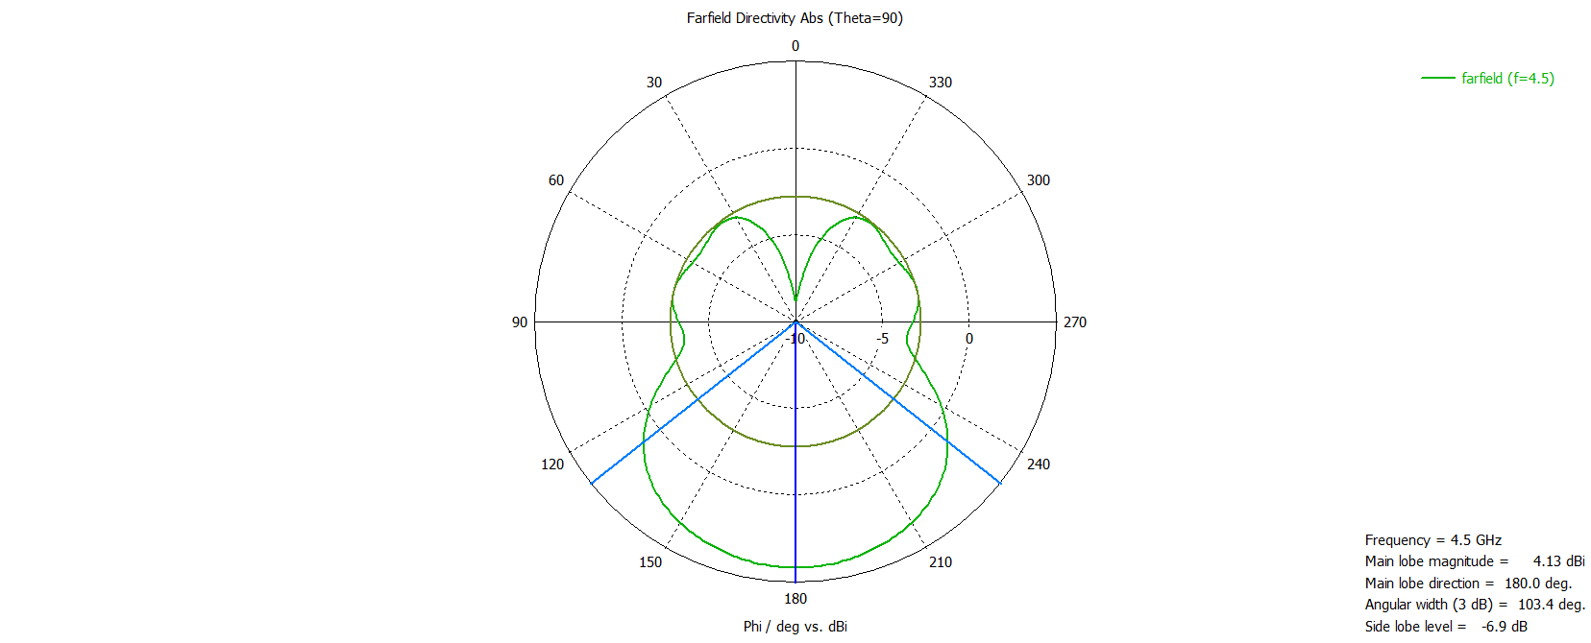
Figure 10- Microstrip Patch Antenna Elevation Plane at 4.5GHz
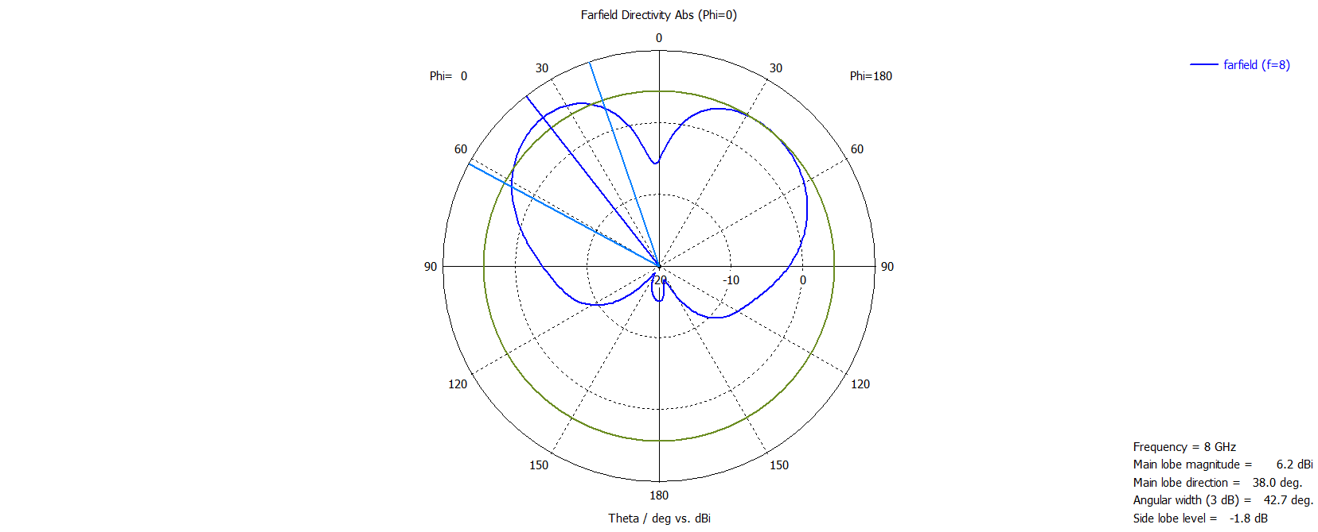
Figure 11- Microstrip Patch Antenna E Plane at 8GHz
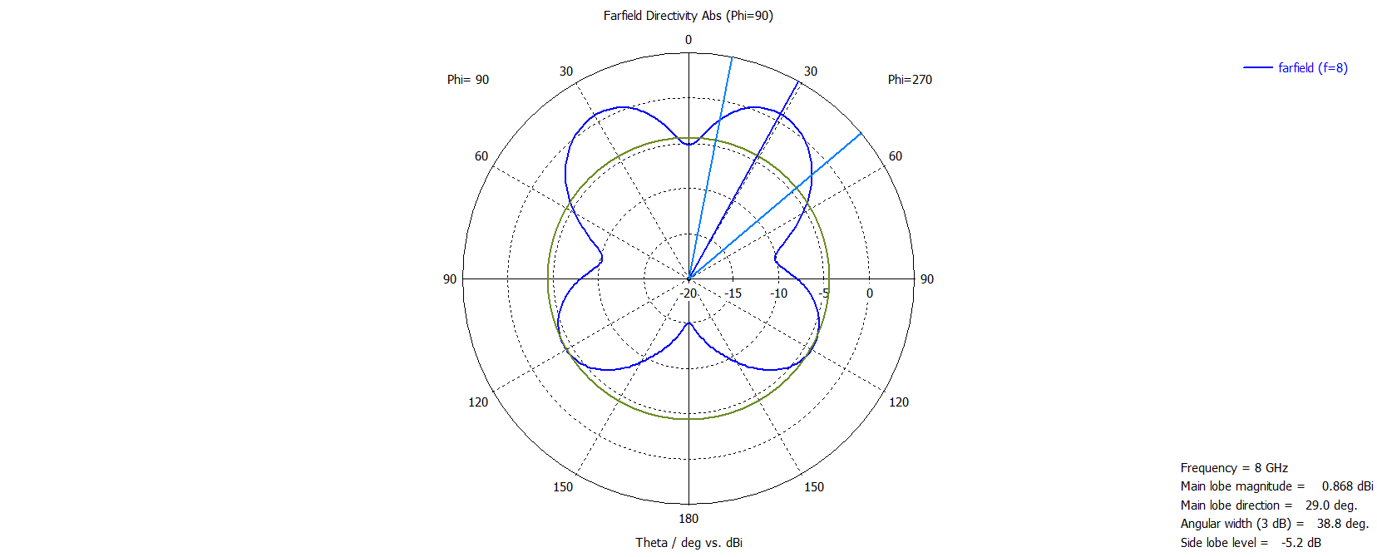
Figure 12- Microstrip Patch Antenna H Plane at 8GHz
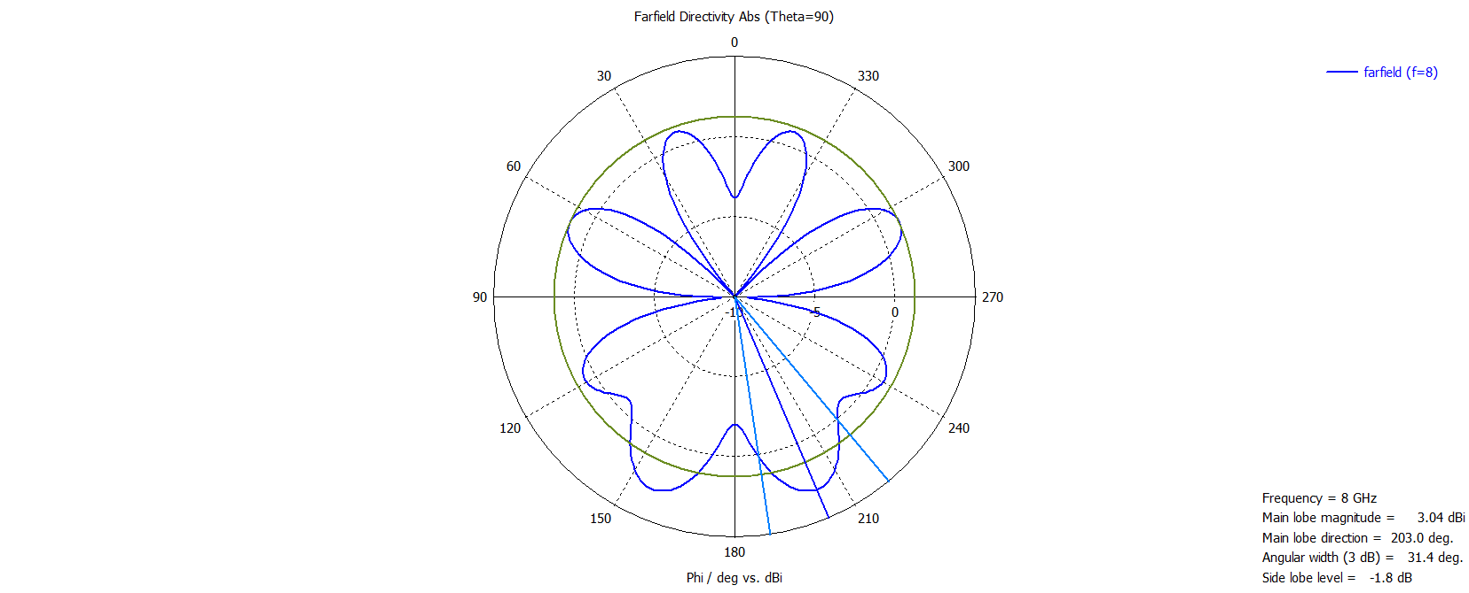
Figure 13- Microstrip Patch Antenna Elevation Plane at 8GHz

Advanced RF Supporting Script
This Matlab script supports the lab report for tasks two and three by designing and simulating the following antennas: Cylindrical Dipole, Folded Dipole, Horn and a 3x3 Helix Array.
The target frequencies for each of the antennas are based on the author's student number.
studentID = '2215832';

% Cyclindircal Dipole Antenna Frequency (GHz) = Second digit
dipole_freq = str2double(studentID(2)) * 1e9;

% Folded Dipole Antenna Frequency (MHz) = first 3 digits / 2
foldedDipoleFreq = (str2double(studentID(1:3)) / 2) * 1e6;

% Horn Antenna Frequency (GHz) = digits 3 and 4 / 2
hornAntennaFreq = (str2double(studentID(3:4)) / 2) * 1e9;

% Helix Antenna Frequency (GHz) = digits 2 and 3
helixAntennaFreq = str2double(studentID(2:3)) * 1e9;

Designing the antennas
This section of the script uses the antenna toolbox to create the antennas optimised for the centre frequency calculated in the section above.
% Design antennas
d1 = design(dipoleCylindrical, dipole_freq);
d2 = design(dipoleFolded, foldedDipoleFreq);
h1 = design(horn, hornAntennaFreq);
hx = design(helix, helixAntennaFreq);

Creating the frequency sweep
In order to create enough data for a meaningful graph plotting the S11 parameters, a frequency sweep range is designed and centred around the centre frequency of each antenna.
As the helix antenna and the later array are operating at 21 GHz, the sweep range is reduced to 50 points to avoid being too computationally heavy
% Dipole: centered around 2 GHz
freq_dipole = linspace(1e9, 3e9, 100);

% Folded Dipole: around 110.5 MHz
freq_folded = linspace(50e6, 200e6, 100);

% Horn: 7.5 GHz
freq_horn = linspace(6e9, 9e9, 100);

% Helix: 21 GHz – memory heavy!
freq_helix = linspace(19e9, 23e9, 50); % reduce points to lower load

Plotting the Antennas
The following sections detail each of the antenna designs in turn displaying a model of the antenna, far field radiation pattern, and S11 plots

Dipole Antenna
figure;
show(d1);
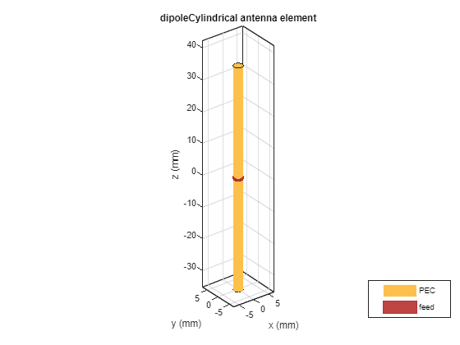
Figure 14 - Cylindrical Dipole
figure;
patternAzimuth(d1,dipole_freq);
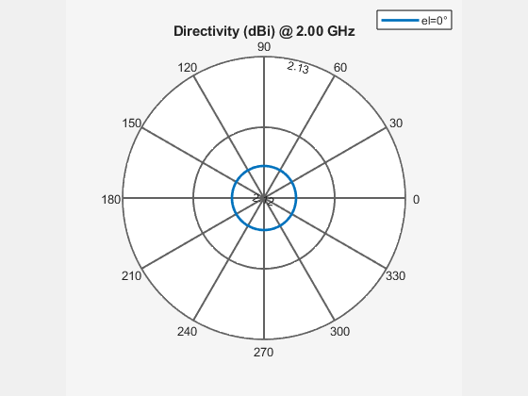
Figure 15 - Cylindrical Dipole Azimuth
figure;
patternElevation(d1,dipole_freq);
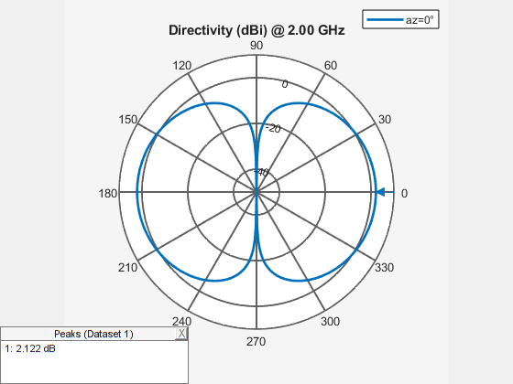
Figure 16 - Cylindrical Dipole Elevation
figure;
pattern(d1, dipole_freq);
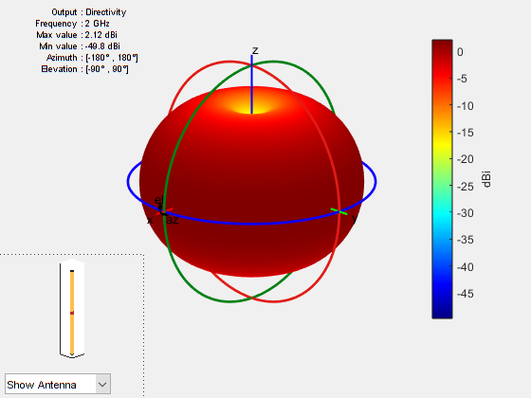
Figure 17 - Cylindrical Dipole 3D Farfield
% Calculate S-parameters
d1s = sparameters(d1, freq_dipole);
% Extract S11 values
d1s11 = rfparam(d1s, 1, 1);
% Plot S11 in dB
figure;
plot(freq_dipole/1e9, 20*log10(abs(d1s11)), 'LineWidth', 2);
grid on;
xlabel('Frequency (GHz)');
ylabel('|S_{11}| (dB)');
title('S_{11} Parameter of Dipole Antenna');
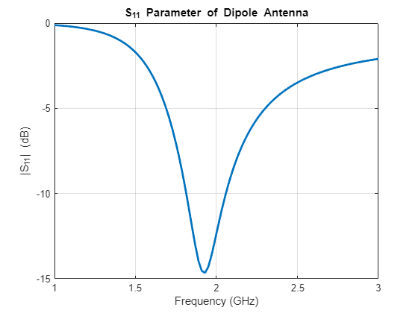
Figure 18 - Cylindrical Dipole S11 Plot
clear d1s d1s11

Folded Antenna
figure;
show(d2);
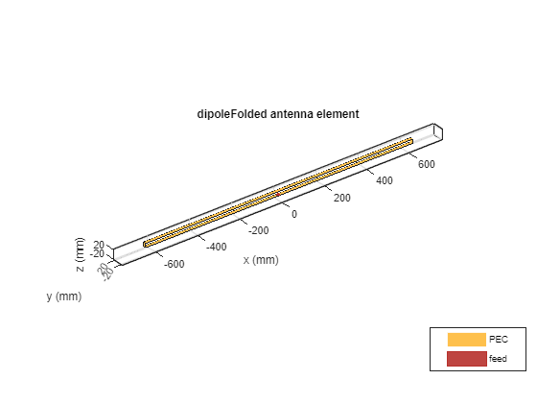
Figure 19 - Folded Dipole

figure;
pattern(d2, foldedDipoleFreq);
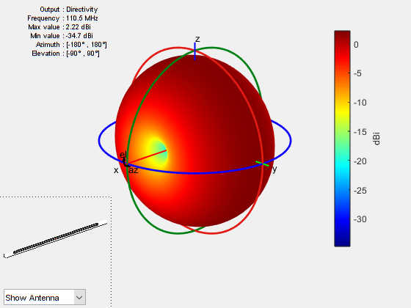
Figure 20 - Folded Dipole 3D Farfield

figure;
patternAzimuth(d2,foldedDipoleFreq);
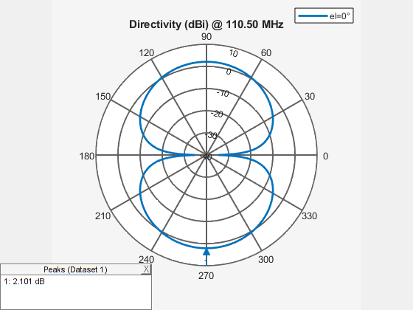
Figure 21 - Folded Dipole Azimuth
figure;
patternElevation(d2,foldedDipoleFreq);
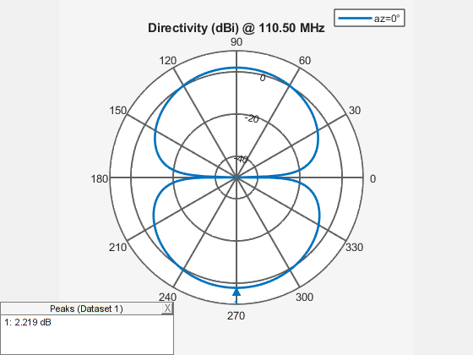
Figure 22 - Folded Dipole Elevation
d2s = sparameters(d2, freq_folded);
d2s11 = rfparam(d2s, 1, 1);
figure;
plot(freq_folded/1e6, 20*log10(abs(d2s11)), 'LineWidth', 2);
grid on;
xlabel('Frequency (MHz)');
ylabel('|S_{11}| (dB)');
title('S_{11} Parameter of Folded Dipole Antenna');
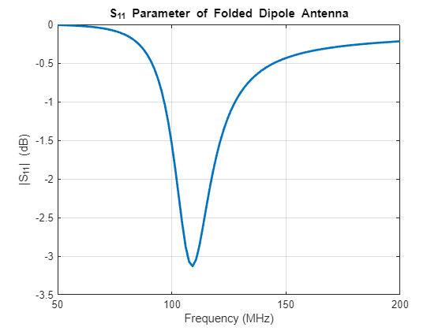
Figure 23 - Folded Dipole S11 Plot
clear d2s11

Horn Antenna
figure;
show(h1);
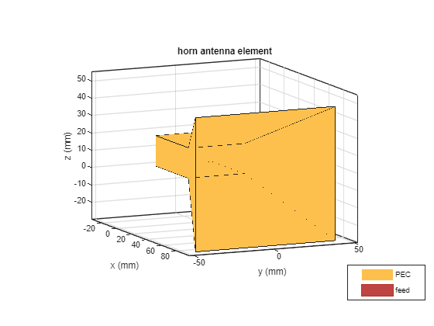
Figure 24 - Horn Antenna

figure;
pattern(h1, hornAntennaFreq);
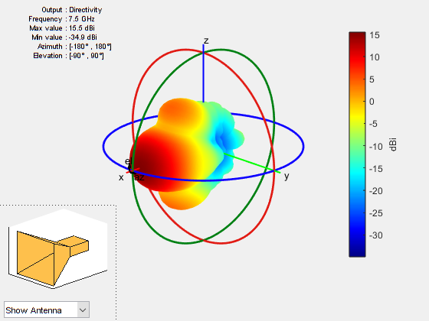
Figure 25 - Horn Antenna 3D Farfield

figure;
patternAzimuth(h1,hornAntennaFreq);
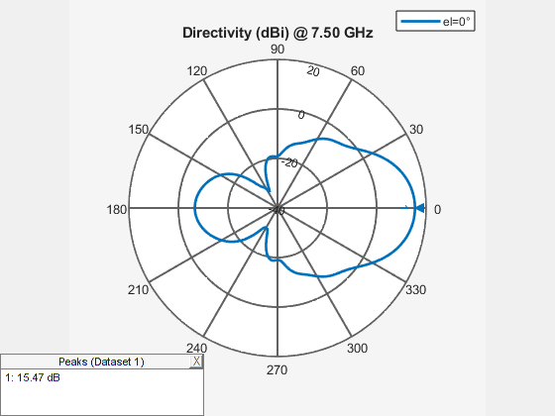
Figure 26 - Horn Antenna Azimuth
figure;
patternElevation(h1,hornAntennaFreq)
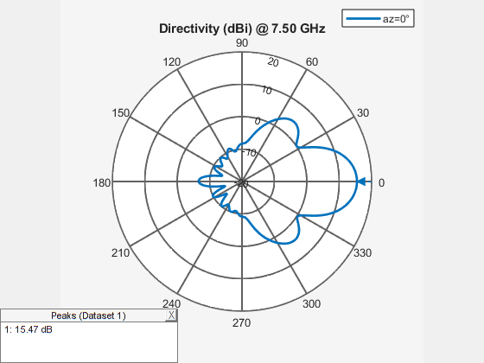
Figure 27 - Horn Antenna Elevation
h1s = sparameters(h1, freq_horn);
h1s11 = rfparam(h1s, 1, 1);
figure;
plot(freq_horn/1e9, 20*log10(abs(h1s11)), 'LineWidth', 2);
grid on;
xlabel('Frequency (GHz)');
ylabel('|S_{11}| (dB)');
title('S_{11} Parameter of Horn Antenna');
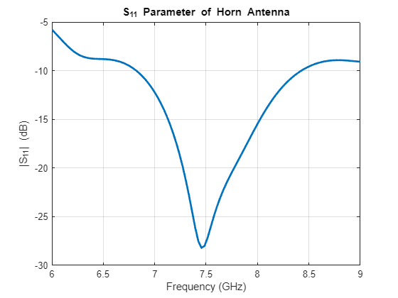
Figure 28 - Horn Antenna S11 Plot
clear h1s11

Helix Antenna
figure;
show(hx);
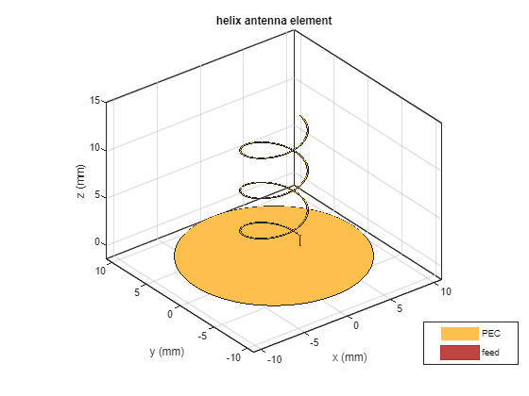
Figure 29 - Helix Antenna
figure;
pattern(hx, helixAntennaFreq);
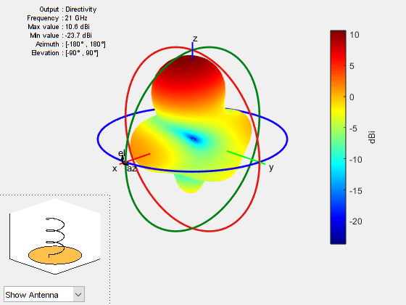
Figure 30 - Helix Antenna 3D Farfield

figure;
patternAzimuth(hx,helixAntennaFreq);
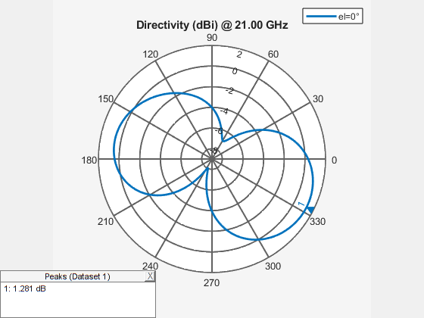
Figure 31 - Helix Antenna Azimuth
figure;
patternElevation(hx,helixAntennaFreq);
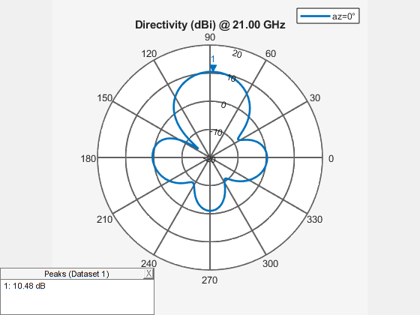
Figure 32 - Helix Antenna Elevation
hxs = sparameters(hx, freq_helix);
hxs11 = rfparam(hxs, 1, 1);

figure;
plot(freq_helix/1e9, 20*log10(abs(hxs11)), 'LineWidth', 2);
grid on;
xlabel('Frequency (GHz)');
ylabel('|S_{11}| (dB)');
title('S_{11} Parameter of Helix Antenna');
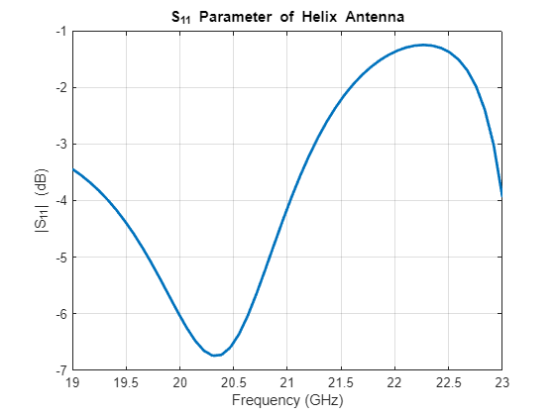
Figure 33 - Helix Antenna S11 Plot
clear hxs11

Create and plot an array using the Helix Antenna
In this section we take the designed helix antenna and use it to create a 3x3 array. This is still focused on a centre frequency of 21GHz.
% Helix Array
helix_array = rectangularArray;
helix_array.Element = hx;
helix_array.Size = [3 3]
helix_array =
rectangularArray with properties:

Element: [1×1 helix]
Size: [3 3]
RowSpacing: 2
ColumnSpacing: 2
Lattice: 'Rectangular'
AmplitudeTaper: 1
PhaseShift: 0
Tilt: 0
TiltAxis: [1 0 0]
show(helix_array)
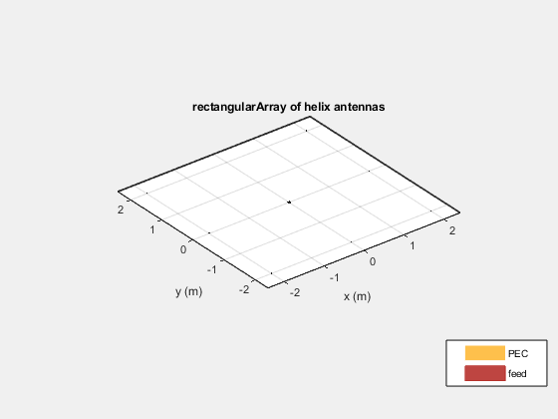
Figure 34 - Helix Array
figure;
pattern(helix_array, helixAntennaFreq);
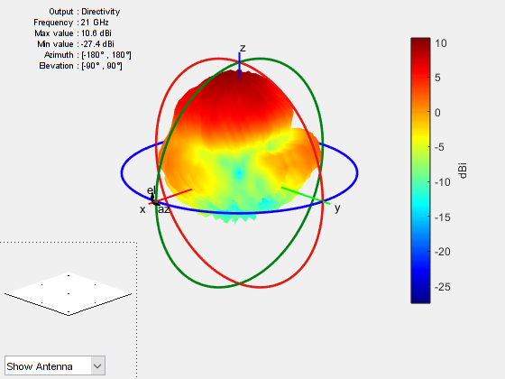
Figure 35 - Helix Array 3D Farfield

figure;
patternAzimuth(helix_array,helixAntennaFreq);
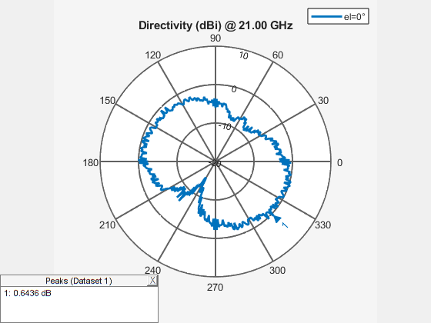
Figure 36 - Helix Array Azimuth

figure;
patternElevation(helix_array,helixAntennaFreq)
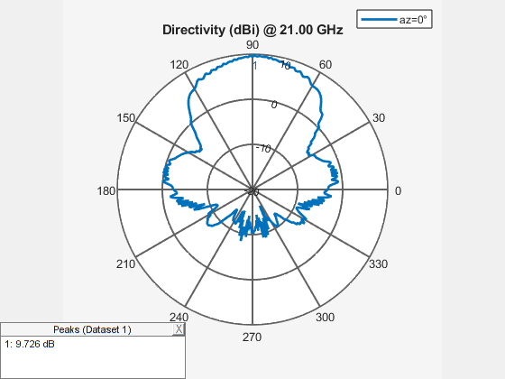
Figure 37 - Helix Array Elevation

hxArrays = sparameters(helix_array, freq_helix);
hxArrays11 = rfparam(hxArrays, 1, 1);

figure;
plot(freq_helix/1e9, 20*log10(abs(hxArrays11)), 'LineWidth', 2);
grid on;
xlabel('Frequency (GHz)');
ylabel('|S_{11}| (dB)');
title('S_{11} Parameter of Helix Array Antenna');
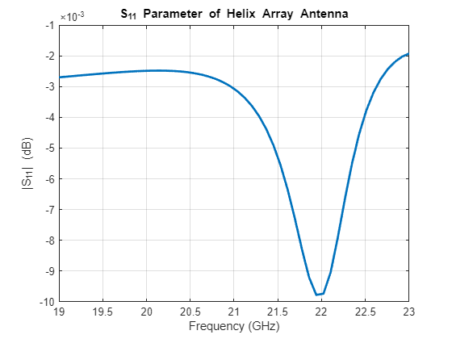
Figure 38 - Helix Array S11 Plot

