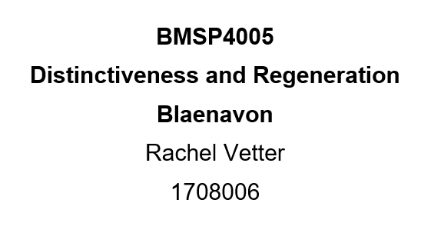

Blaenavon

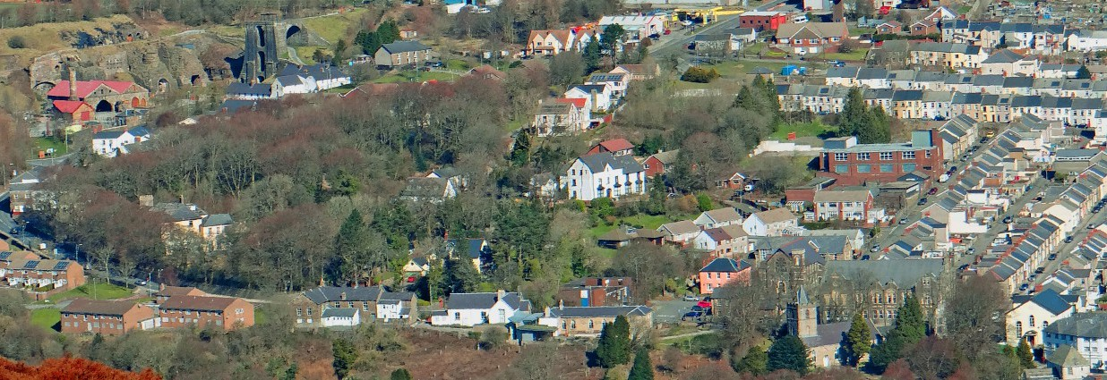
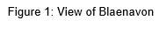
This report will review Carmarthen Business School’s excursion to Blaenavon in February. It will contain analysis of the information gained from my interactions with our guide, Ruth Taylor-Davies, along with observations and interactions with the people we met (Report Writing, 2000).
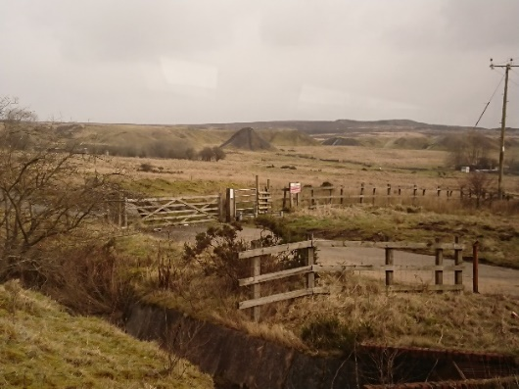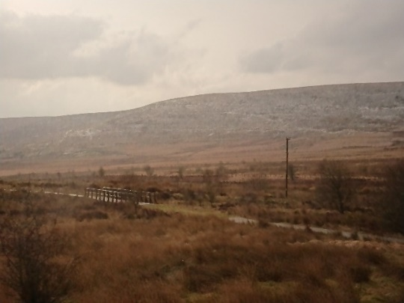
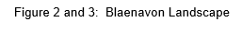
Entering the outskirts of this National Heritage town, the landscape shows a visual reminder of both the town’s productive but environmentally destructive past (Knight, 2011). Scars from years of mining are evident along with the spoil tips used to discard waste, all have left behind a pot marked landscape (Haigh, 1979). Blaenavon’s 8100-acre site contains the ruins of disused mines, railways, canals and quarries, all a testament to their industrial past 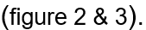
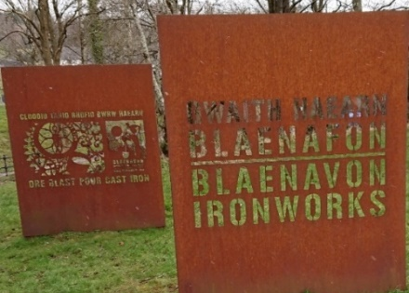
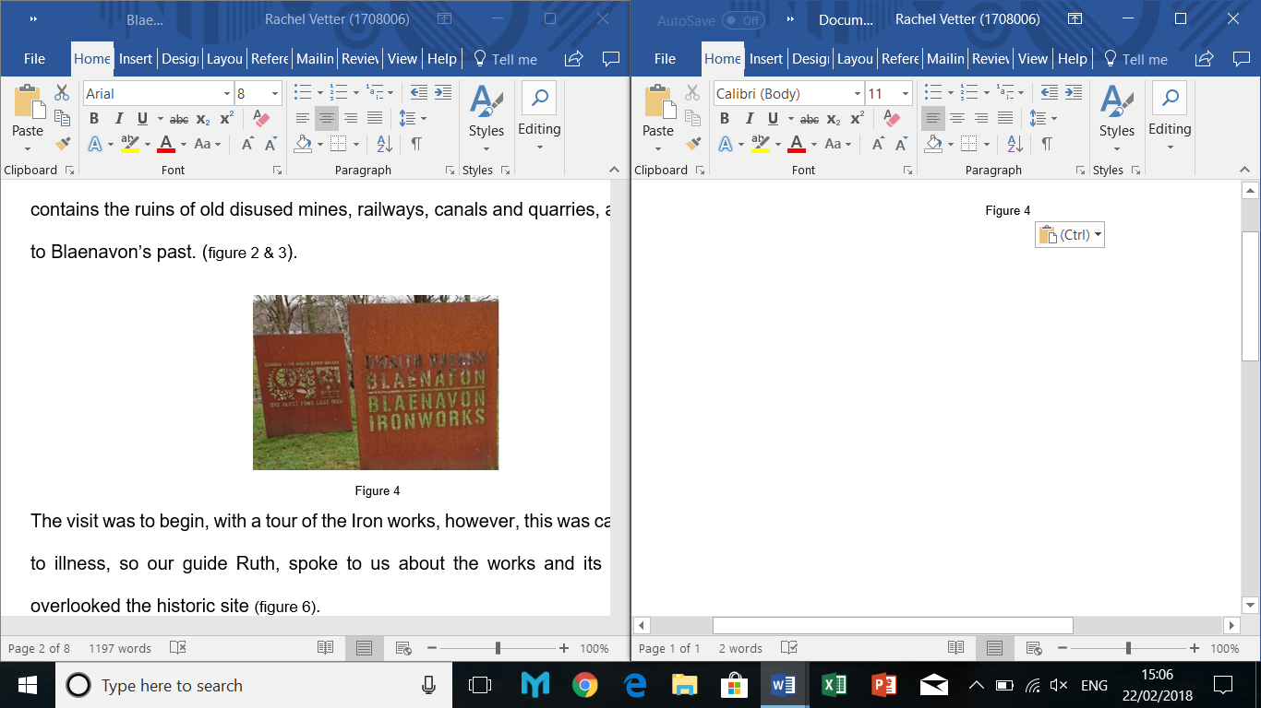
The visit was to begin, with a tour of the Iron works, however, this was cancelled owing to illness, so our guide Ruth, spoke to us about the works and its history as we overlooked the historic site 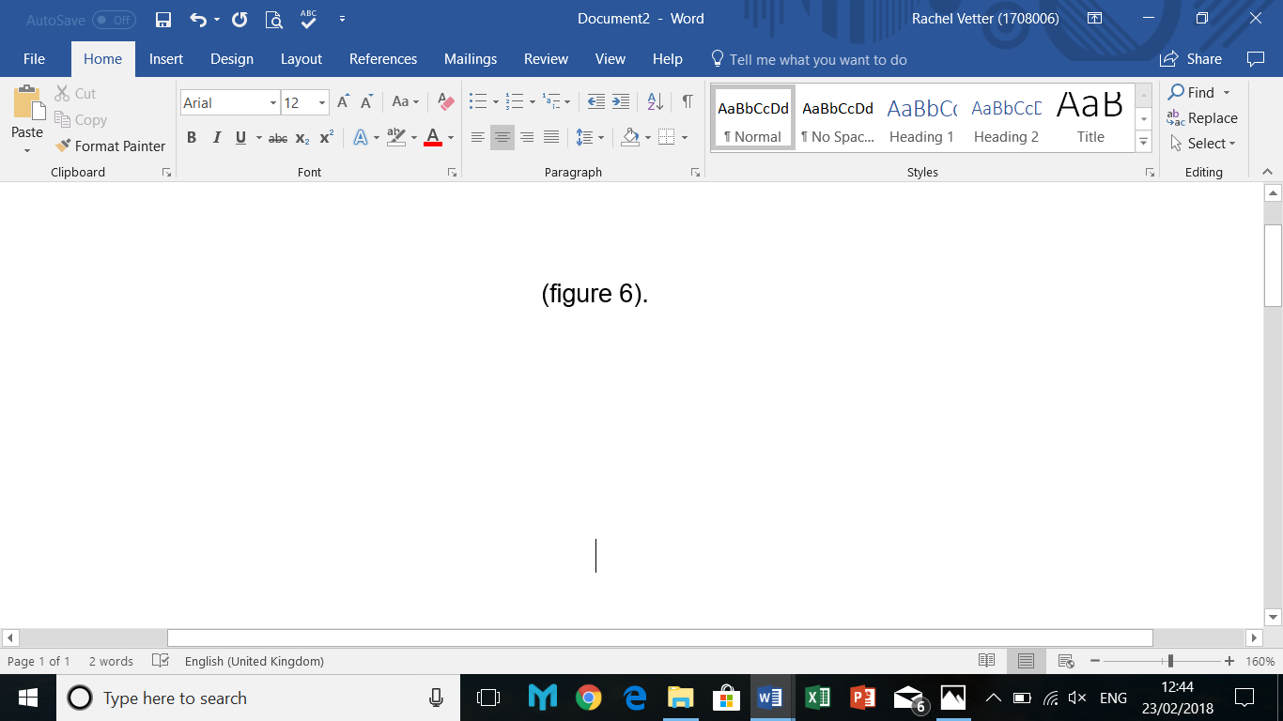
Founded in 1788 on barren, farm land, the iron works grew quickly becoming the second largest Iron Works in the World after the inclusion of a third furnace. The ruins contain many original structures, including cottages built for the workers 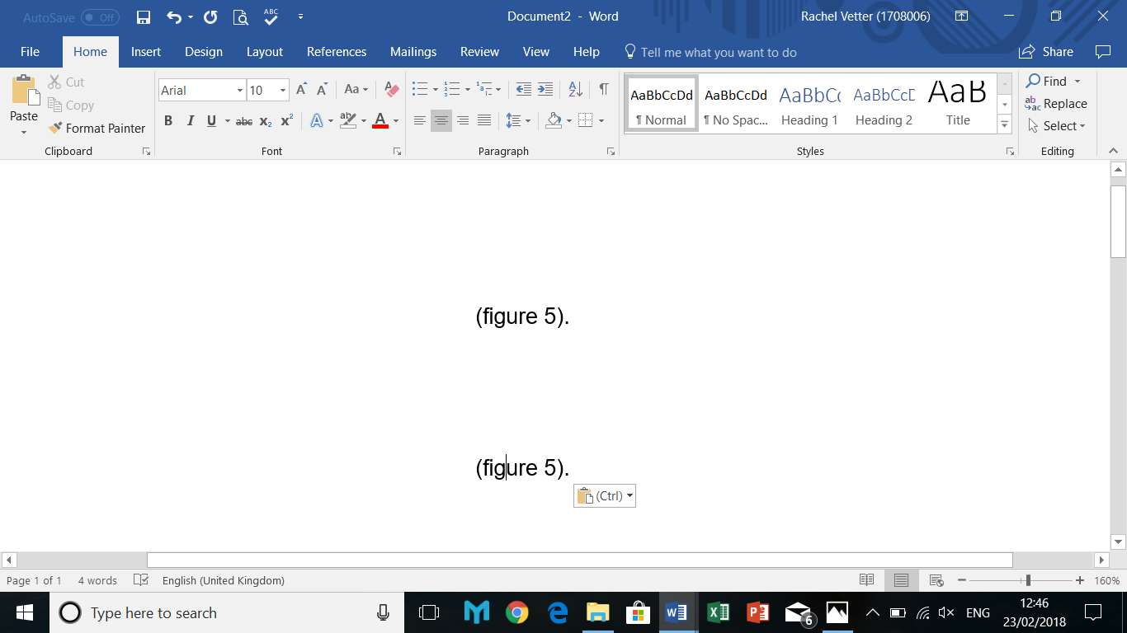These were initially constructed to entice skilled workers to the works, they were considered luxurious when first built because they included a parlour and bedroom downstairs and two bedrooms upstairs. However, within 6 years they had become homes for the lowest of the low, often housing two families within this basic 2 up 2 down setting. The construction of a giant Stack chimney next to the homes further effected the living conditions, causing an increase in noise and emitting dangerous fumes, because of this the street was renamed Stack square (Birch, 2013), (Blaenavon Visit, 2018), (Ellis, 2014).
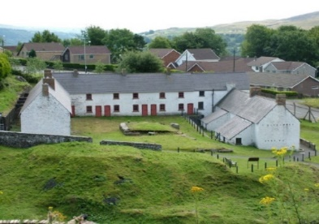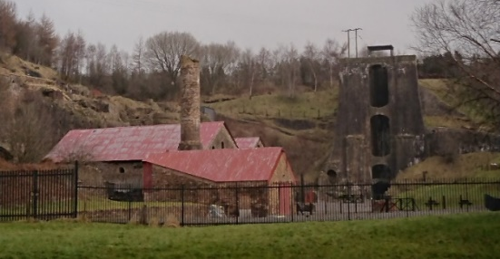
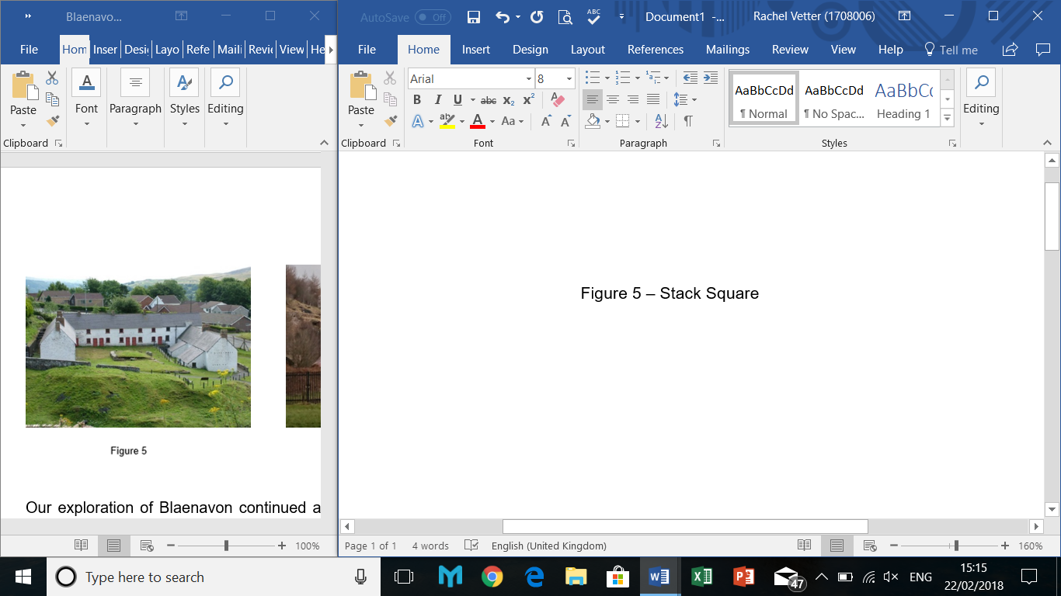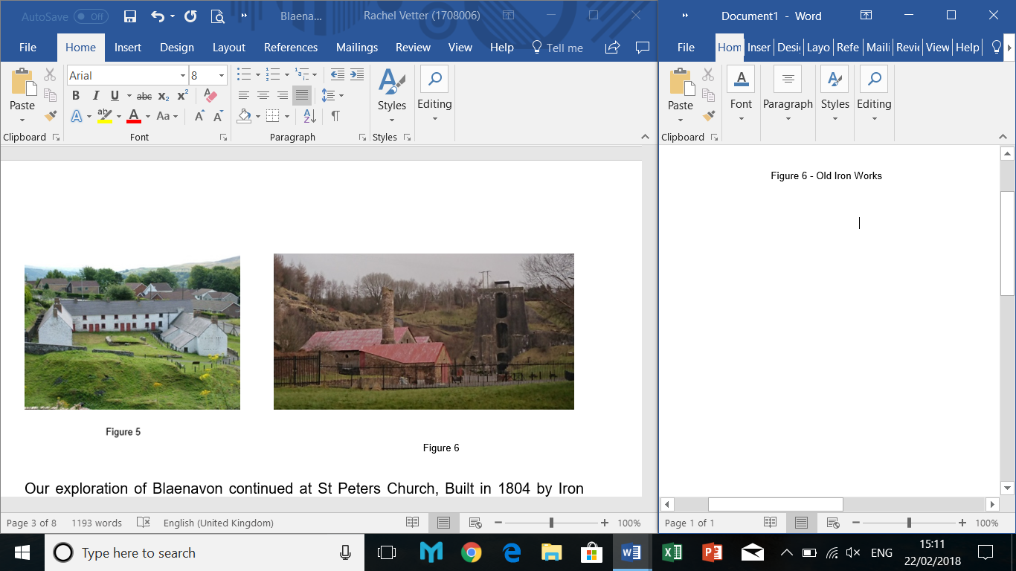
Our exploration of Blaenavon continued at St Peters Church, Built in 1804 by Iron Master Samuel Hopkins. The church and its surrounding graveyard interestingly contain some unique features including several iron topped graves 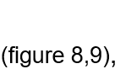cast iron pillars, iron window sills 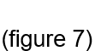 and a unique cast iron baptismal font. The church was specifically built for the workers of the Iron Works; however, unhappy at being told where to worship, they built their own churches. At its peak there were 18 Churches within Blaenavon in contrast there were also 41 pubs. (Blaenavon Visit, 2018)
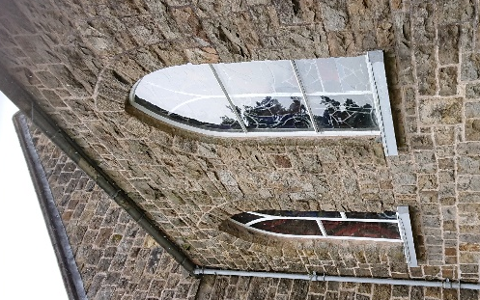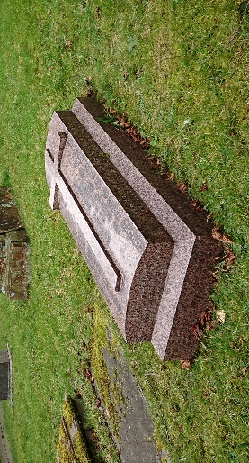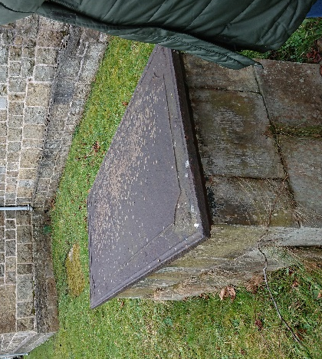
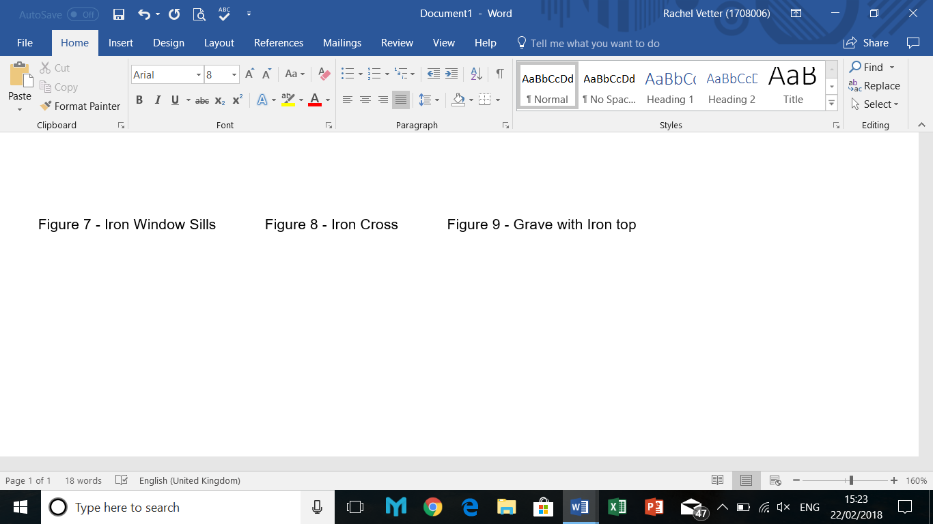
From St peters we made our way to through the town, many areas seamed run down, empty shops lined the centre of the town. However, standing proudly within the town is the beautiful structure of ‘The Community and Cordell Museum’ (figure 10). Originally built in 1894 this working man’s hall was funded with contributions from the local iron and coal workers while predominantly being used as a social and educational centre for these workers. (Ellis, 2014).
In 2002, The Blaenavon Heritage group took over the running of the building. Most of the men working at the museum were ex miners, they talked with passion about their time in the mines. Glyn Probert, one of the museums original founders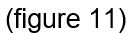 was our guide. We queried how hard life had become after the closure of the mine, Glyn exclaimed that, “the people of the valleys were fighters and you can’t keep them down.” (Probert, 2018)
Carl, another Volunteer, talked about the disappearance of many surrounding villages.
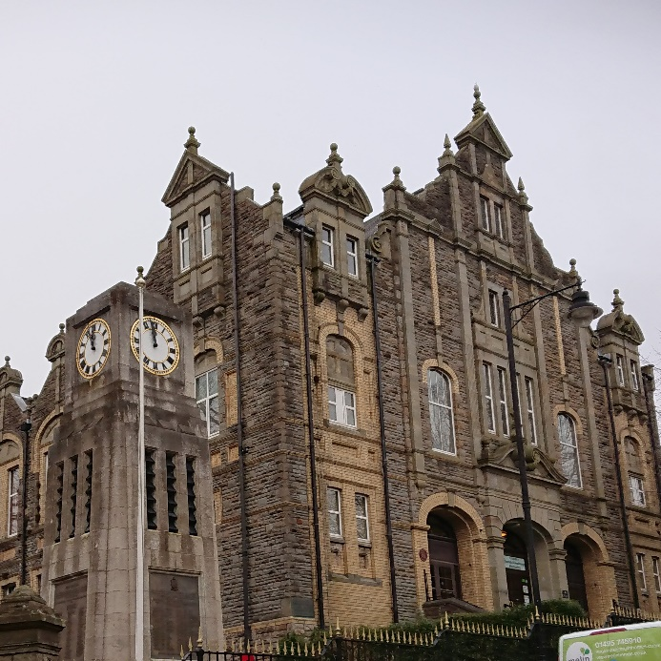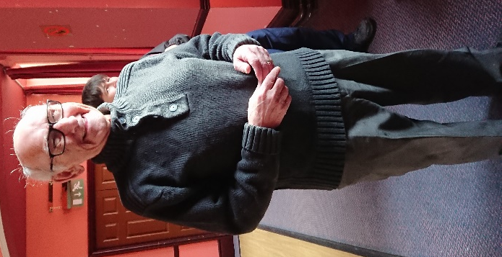
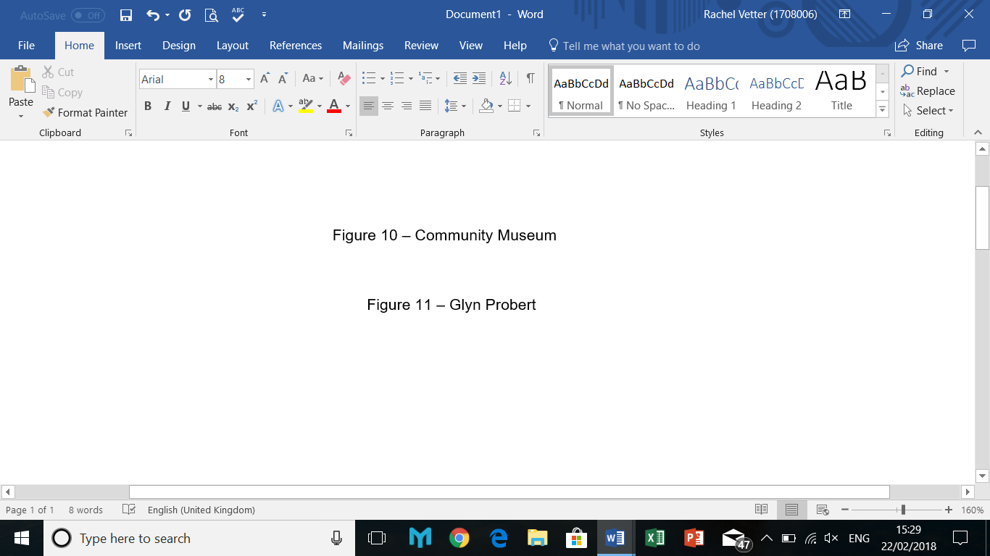

He had come from a village called Pwll Du (Black Pool) less than two miles away, this village was declared a slum by the government and demolished in 1963. The only remaining signs from the village he was born in, is a lone pub ‘The Lamb and Fox’ (PWLL- DU, 2018).
Evidence of the town’s past links with the Iron works were visible around the building including beautiful iron work on the staircases (figure 12,13). The museum also carried mementos of the town’s history, with many items donated by residents and families connected to its historic past 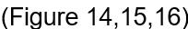.

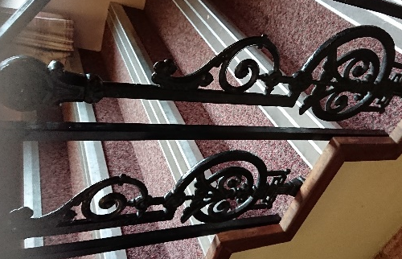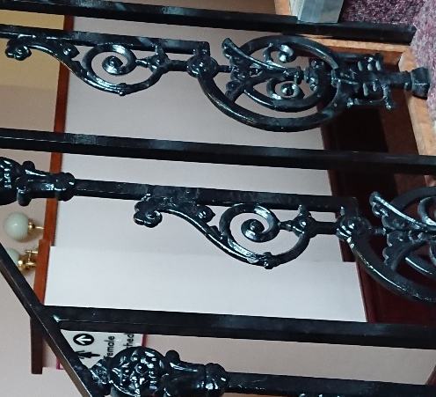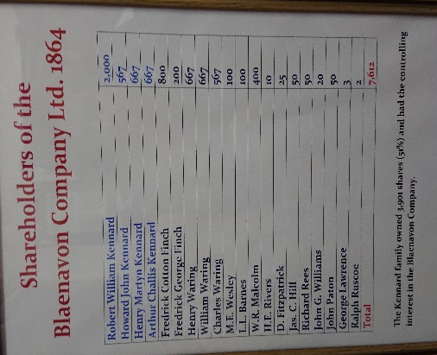
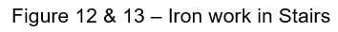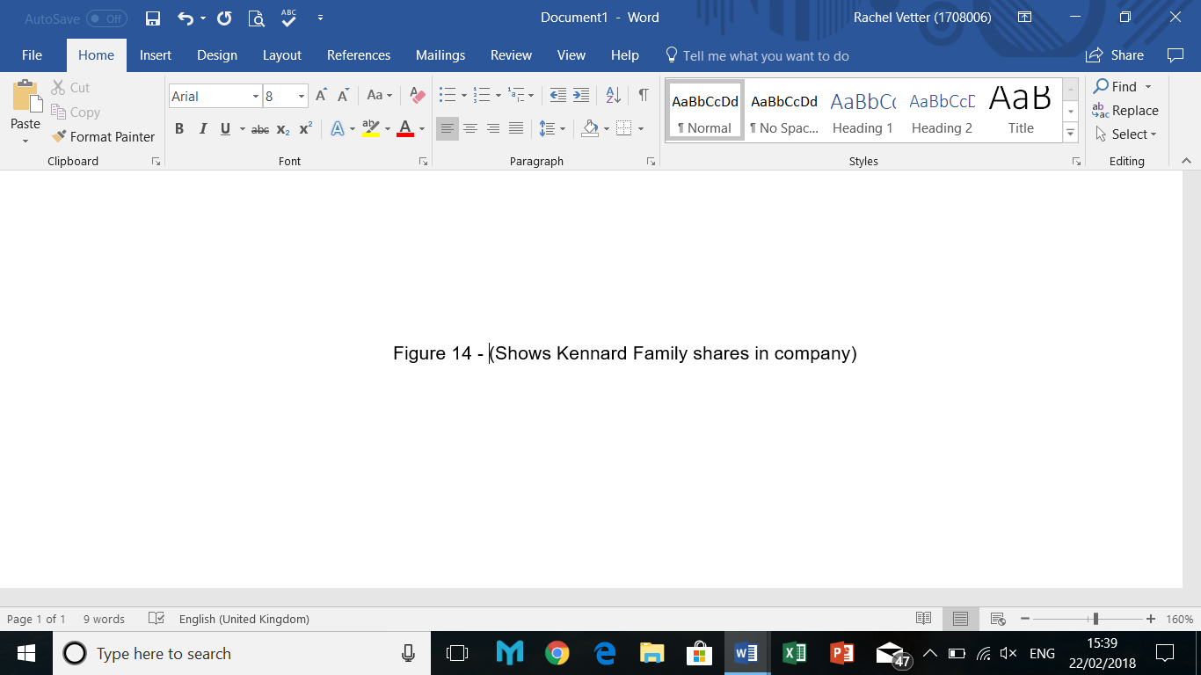

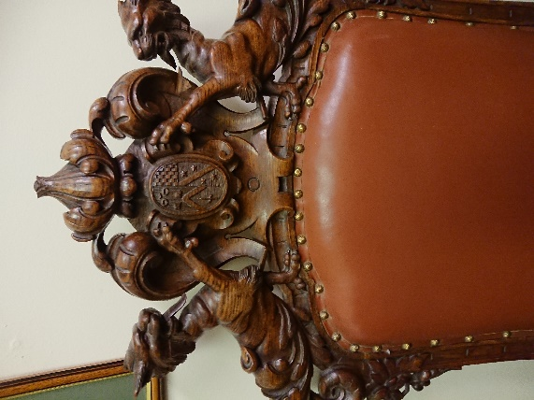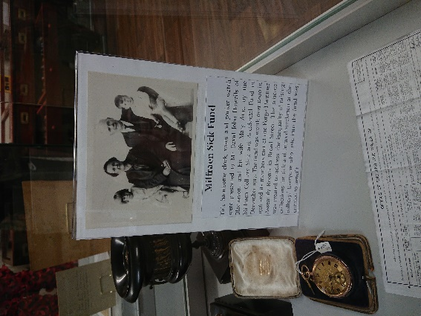
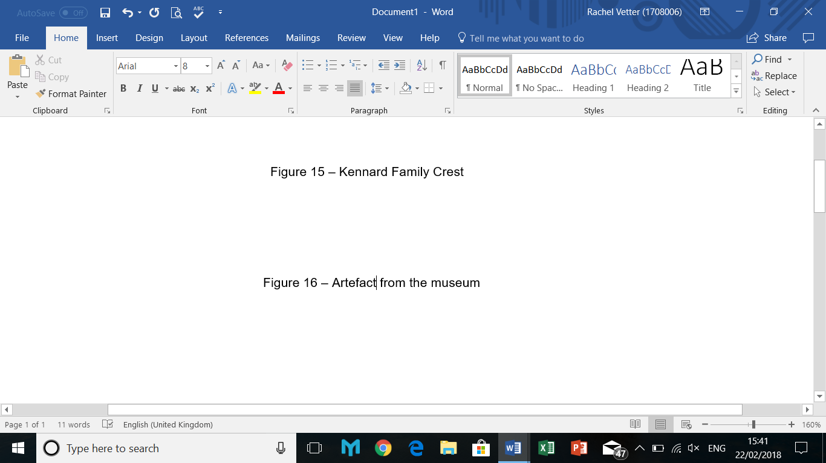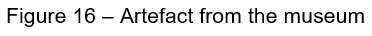

As well as the old, there were also signs of how the building is being utilised today for the local community. The main hall and stage are still used for shows and concerts, another room was converted into a games room containing pool tables and table tennis for use by local clubs. Most striking for me, was the fully digital, 88 seat cinema, which shows both new releases and screens events via satellite, ballets, operas, West end shows and concerts. Like the museum the cinema is also run only by volunteers 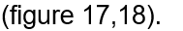
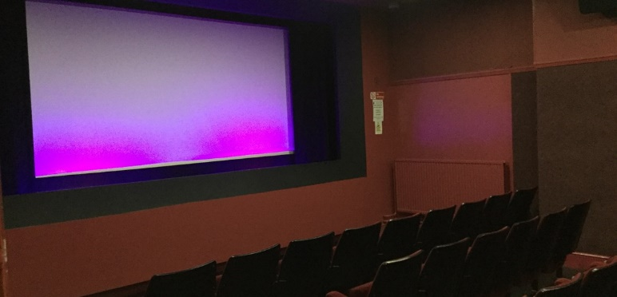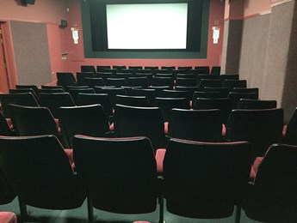
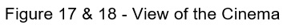
After a short stop at the world Heritage museum, we travelled by bus to the Big Pit. This well-preserved coal mine closed in 1980 but was reopened as a tourist attraction in 1983. Unfortunately, the fates were against us once again and the Cage that transports you into the mine had broken 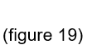. Disappointed, myself and several students chatted to the miners about their experiences as miners and about the Big Pit’s past.
Miner, Robert Farr 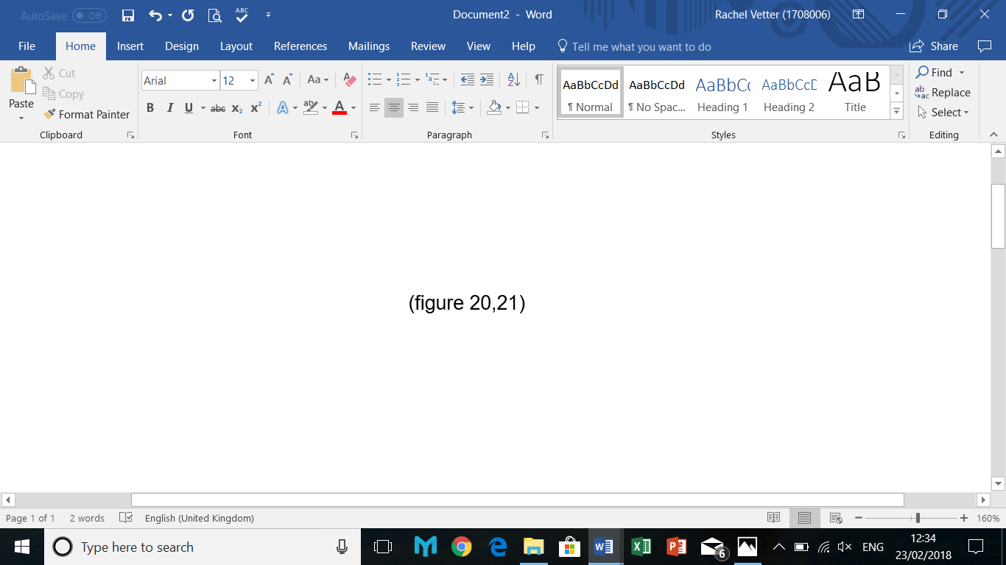 pointed out the table of lights used by visitors to go into the mine. He talked about how lighting in the mines had changed over time and described the work carried out by children as young as 6 in the mines, who often had little or no light at all. Children who worked as ‘Trappers’ would sit often in complete darkness next to the ‘Air Door, with a rope tied around their wrist, whenever they heard one of the trams approach, they pulled the open the door open using the rope.  These children were often left alone in complete darkness for many hours (Chala & Korybut, 2014).

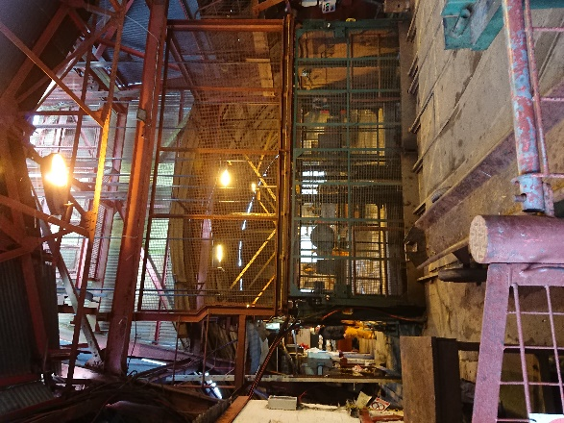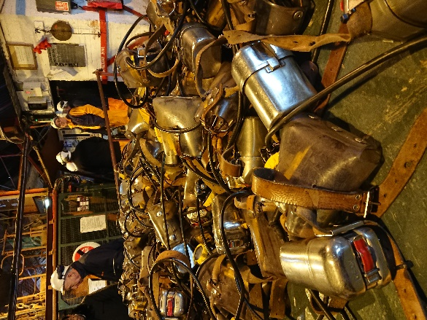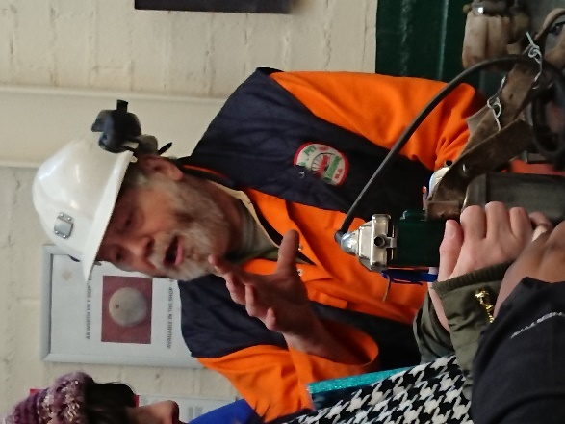
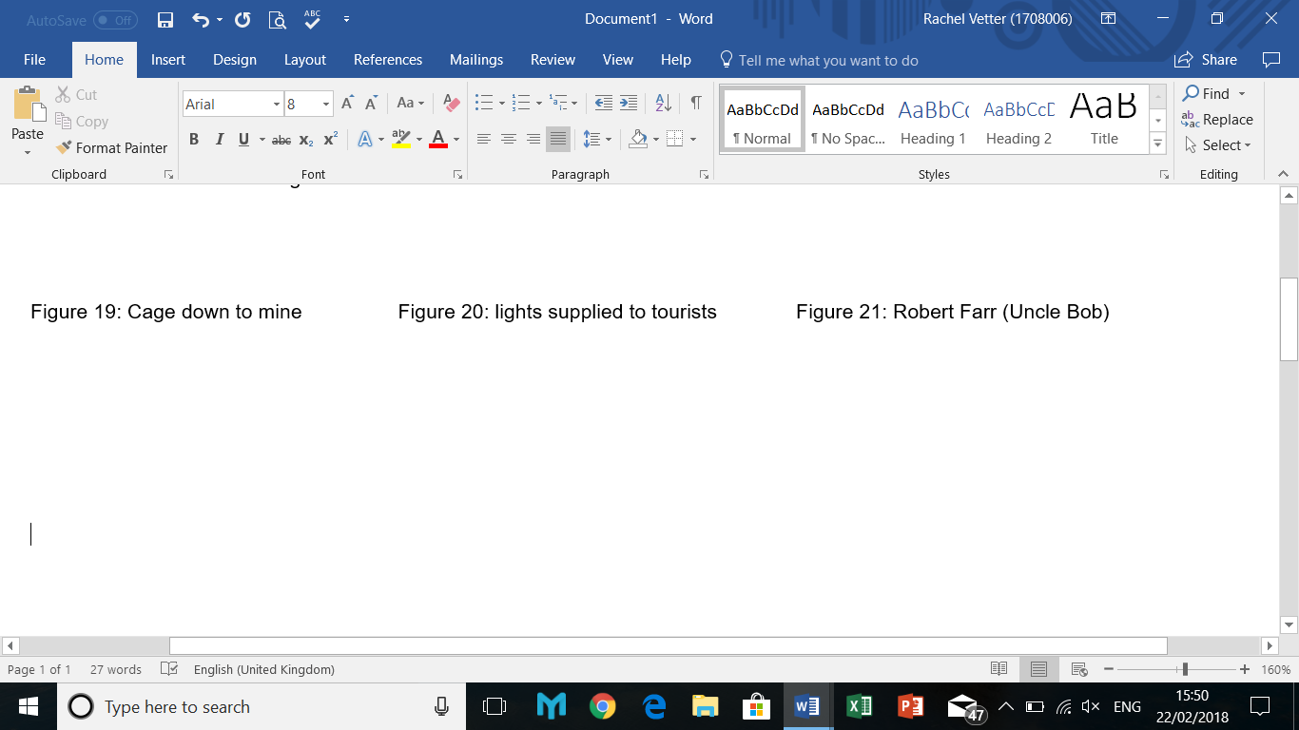
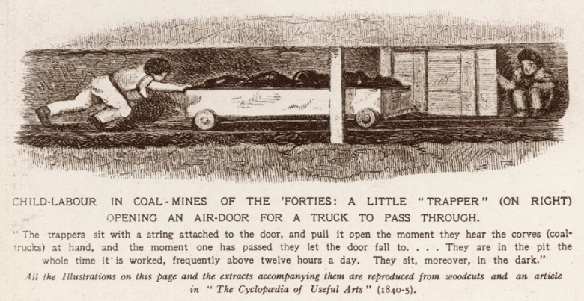

The Bath house, situated at the top of the museum, housed an array of Mining memorabilia. On entering the building there were exhibits revealing the harshness of the mines and the families’ daily lives, their links with trade unions and the strikes of the 1980s. . There was also evidence of humour in much of the signage around the mines, including those used within health and safety 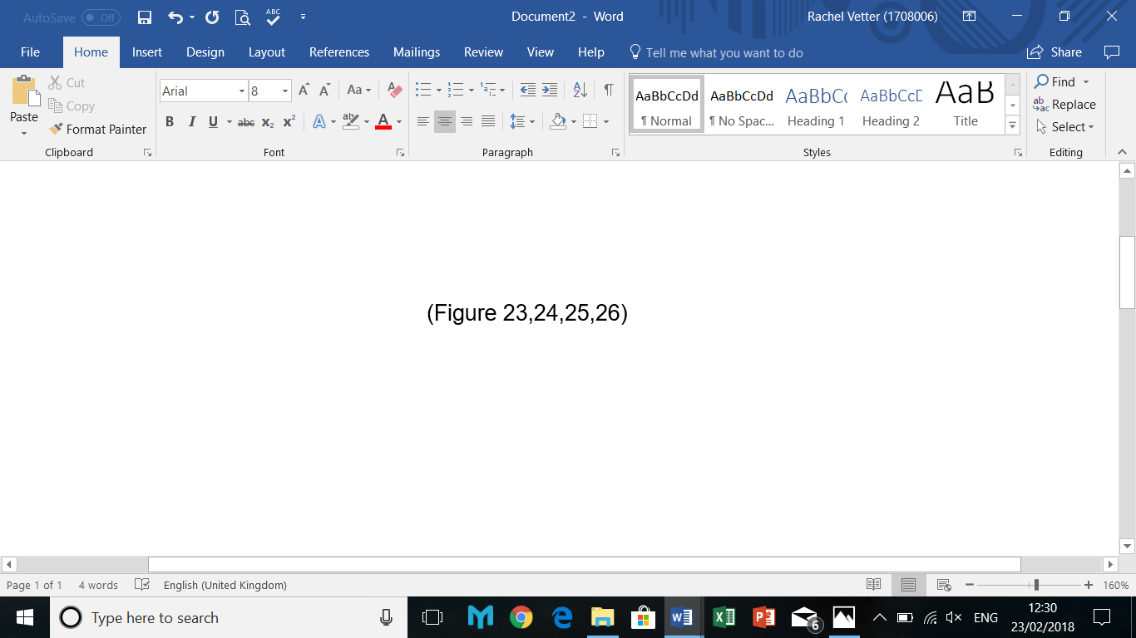.
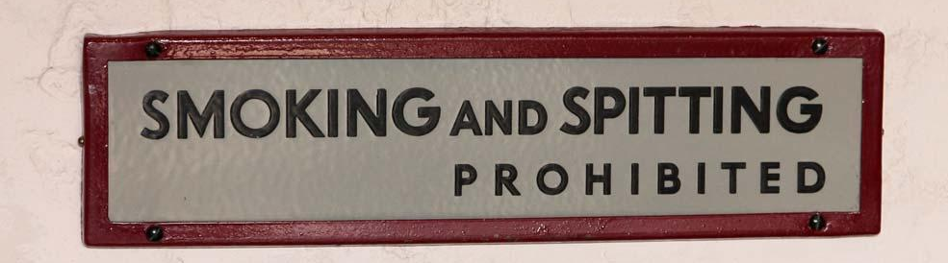
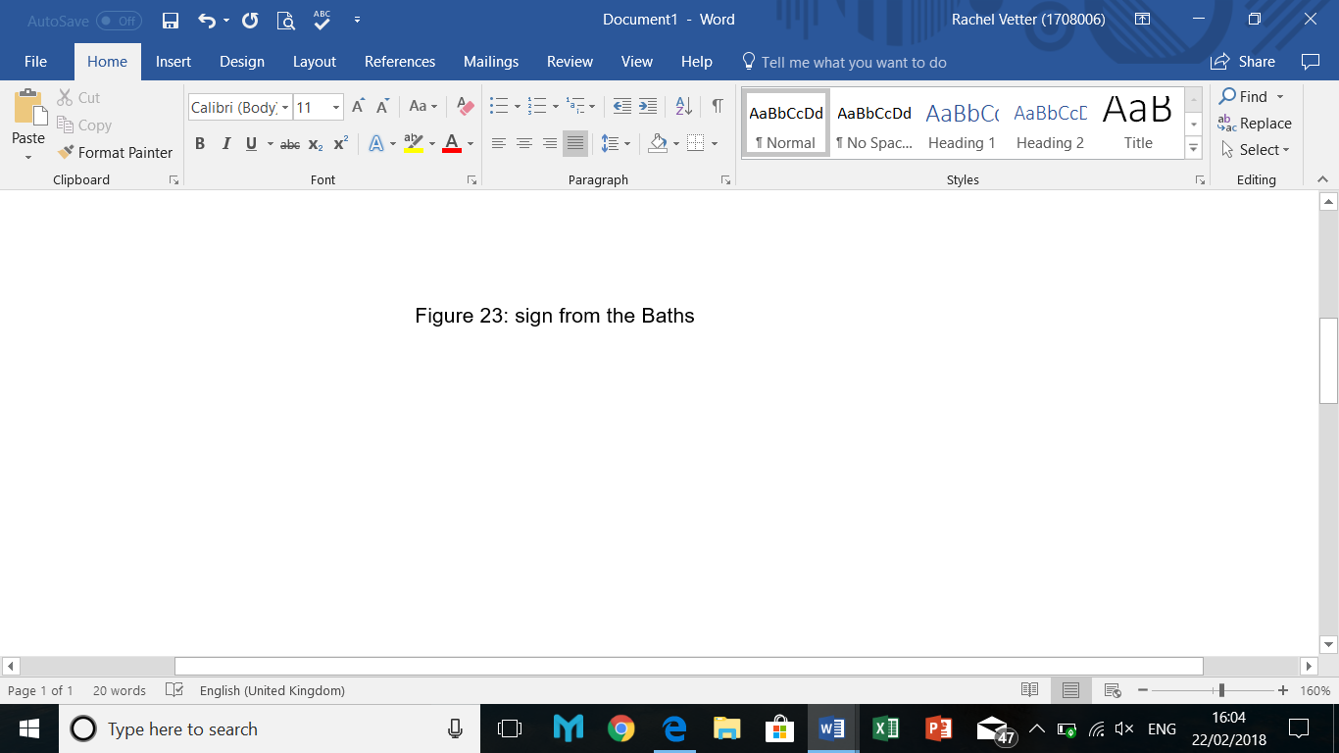
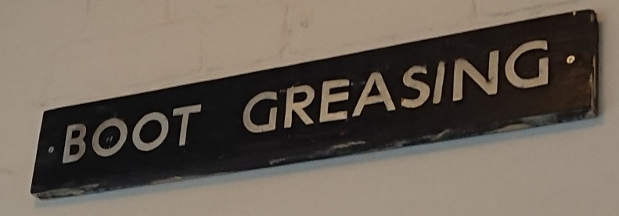

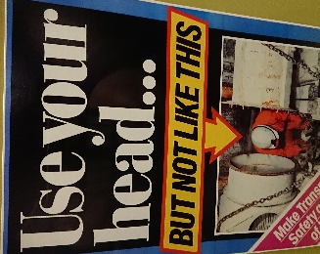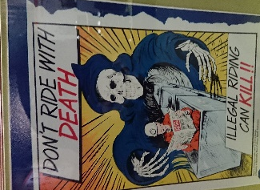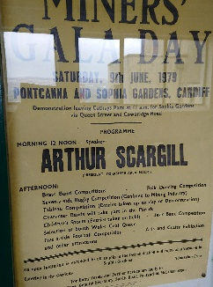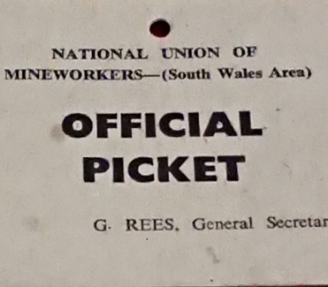
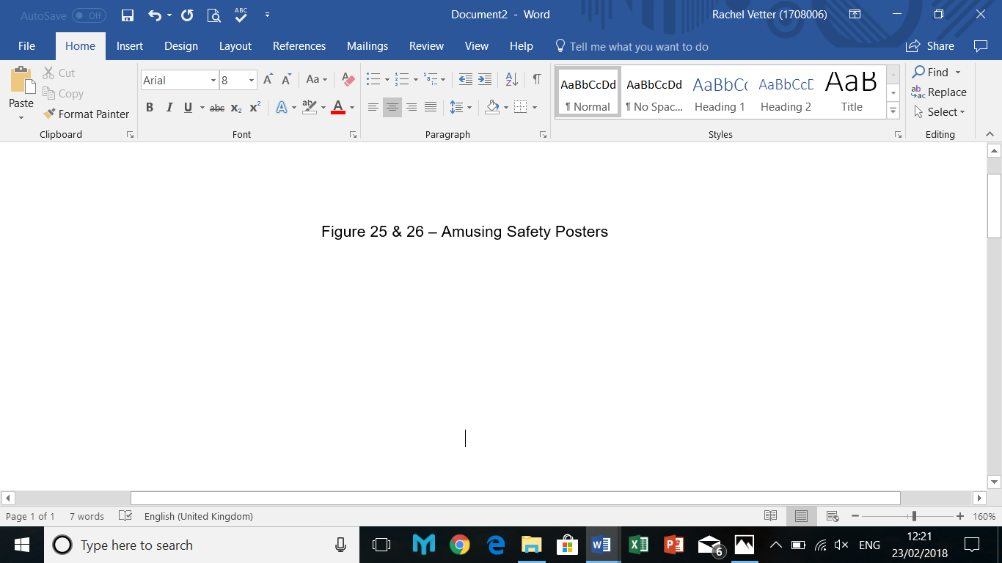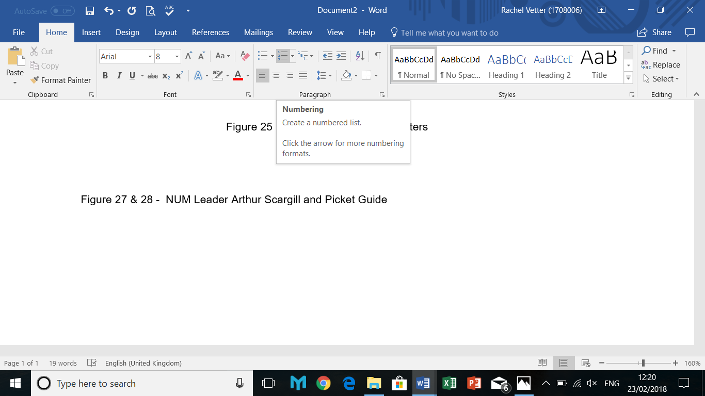
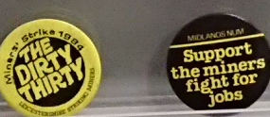
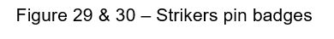

Blaenavon is much more that an old mining town, it is a place full of character, with proud residents eager to share the town’s interesting heritage. It is undoubtable that the town’s world heritage status has brought much to the town, however, it was clearly visible when walking around the town that a lot needs to happen for this town to survive. The local people are looking at the future, with their community projects and cinema. But will the passion, the history and the tourists be enough to regenerate the town on Blaenavon.

References
bbc news. (1986). coal mine canaries made redundant. Retrieved from http://news.bbc.co.uk/onthisday/hi/dates/stories/december/30/newsid_2547000/2547587.stm.
Birch, A. (2013). The Economic History of the British Iron and Steel Industry 1784-1879. London: Routledge.
Blaenavon. (2018). Retrieved from www.visitblaenavon.co.uk.
(2018, Febuary 6th). Blaenavon Visit. (R. Taylor-Davies, Interviewer)
Chala, K., & Korybut, D. (2014). Coal mines in the industrial revolution . Doctoral Dissertation.
Ellis, S. (2014). Ironmasters of Wales . British Heritage, 34-39.
Glesne, C., & Peshkin, A. (1992). Becoming Qualitative Researchers. New York: Longman.
Haigh, M. (1979). Ground Retreat and Slope Evolution on Plateau-Type Colliery Spoil Mounds at Blaenavon, Gwent. . Transactions of the Institute of British Geographers , 321-328 .
Knight, E. (2011). The @forgotten Landscapes' conservation heritage management and lifelong learning in the community. tourism and Management, special issue, Vol 1 p106-113.
Probert, G. (2018).
PWLL- DU. (2018, February ). Retrieved from www.visitblaenavon.co.uk/.../Pwll-Du-Adventure.
Report Writing. (2000). Retrieved from https://unilearning.uow.edu.au/report/5a.html.



