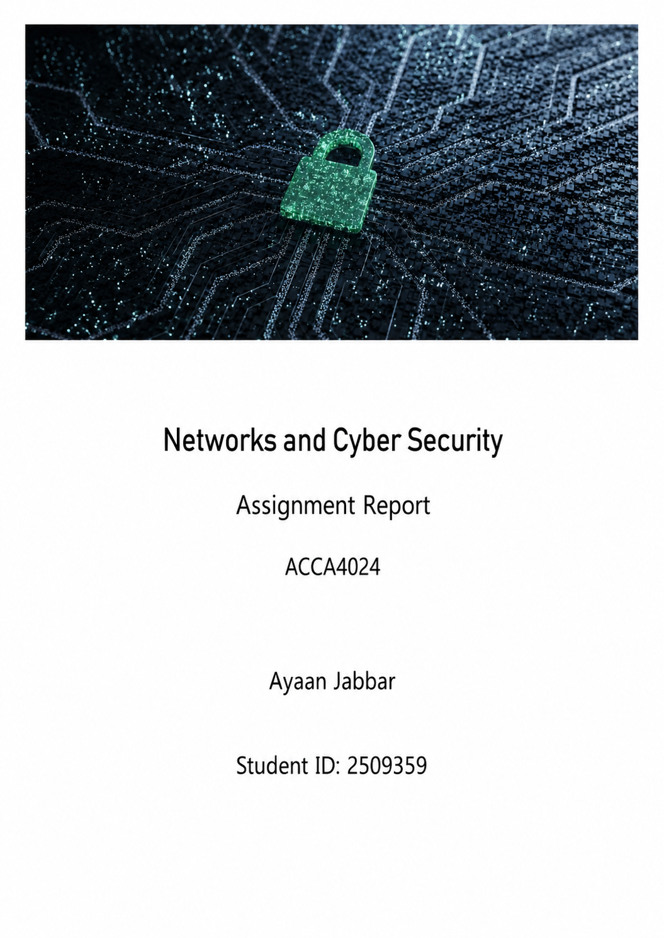

Table of Contents
Abstract 2
Introduction 3
Figure 1 4
2.1 Identification of modern threats 4
External Threats 4
2.2 Modern security policies 5
2.4 Proactive Monitoring and Incident Response 7
2.5 Continuous Training and Awareness 8
Conclusion 9
References 9
Appendix PowerPoint Slides 10
Slide 1 11
Slide 2 11
Slide 3 11
Slide 4 12
Slide 5 12
Slide 6 13
Slide 7 13

Abstract
Cybersecurity is an issue of great importance for any company utilising digital technology in its daily operations. SFM has embraced smart manufacturing systems, such as IoT gadgets, automated machines and cloud-based manufacturing management, all of which have helped the company increase efficiency and become exposed to various cyber threats. In this report, the internal and external security threats that affect the company will be analysed. Those include malware, phishing, unauthorised access, ransomware and insider threats. Moreover, security policies will be developed based on different frameworks, including NIST Cybersecurity Framework, ISO 27001 and Zero Trust security framework. Practical ways of mitigating those risks will be discussed along with a plan for incident detection and response. That will include a plan to utilise modern cybersecurity tools and technologies. A plan for continuous staff education and awareness regarding cybersecurity will also be suggested.

Introduction
Modern organisations face a number of challenges in relation to cybersecurity due to the growing dependence on IT infrastructure, cloud computing and other devices and services used for running daily business operations. As technology progresses, cyber criminals become more innovative in their approach to exploiting vulnerabilities and thus cause loss of money, disruption of operations and harm the reputation of the organisation. The manufacturing company is especially vulnerable due to its reliance on automated systems of production, IoT devices and cloud technologies.
The increasing amount of cyberattacks such as ransomware, phishing, data breach and supply chain attacks has recently hit numerous organisations. Such incidents disrupt business operations, make confidential information vulnerable and lead to serious financial consequences. Protecting information systems and OT systems is extremely important in order to guarantee continued work and customer trust.
This paper provides analysis of cyber security challenges for SteelForm Manufacturing Ltd and offers solutions to the problem.
This report analyses the cyber security challenges of SteelForm Manufacturing Ltd by outlining the modern internal and external threats and developing security policies using the best practices from NIST Cybersecurity Framework (NIST CSF), ISO/IEC 27001, Zero Trust security model. ISO/IEC 27001 establishes internationally recognised requirements for managing information security.[1]

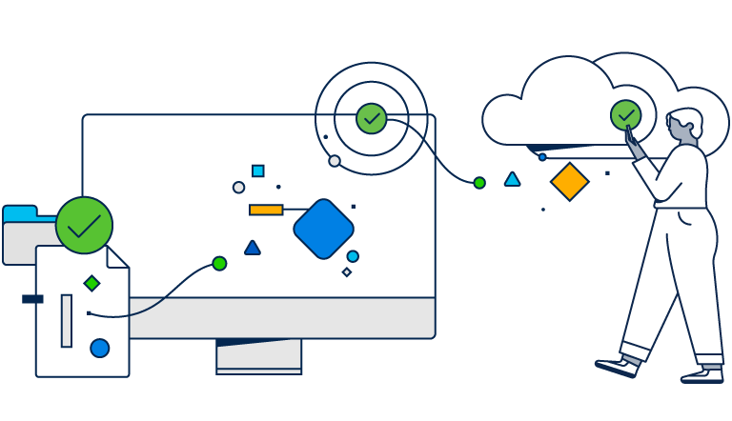
Figure 1: Cyber Security Challenges in Modern Organisations [2]

2.1 Identification of modern threats
Cyber threats faced by SteelForm Manufacturing Ltd (SFM) include both internal and external challenges as a result of the implementation of Internet of Things, automation of manufacturing machinery and cloud based systems within the business. With increasing digital connection of the company, the number of possible ways to hack increases as well. The identification of cyber threats is a prerequisite for the CIA of company data and production system protection.

External Threats
Ransomware-as-a-Service (RaaS):
Modern businesses face the problem of ransomware attacks which is the most dangerous threat for companies in today's world. The selling of ransomware software via RaaS platforms makes possible for hackers without any special knowledge to encrypt company data and blackmail it.

Social Engineering with the usage of Artificial Intelligence (Phishing and Vishing):
More attacks on employees from procurement and finance departments become AI powered by creating phishing emails and making voice phishing calls.
Supply Chain Attacks:
SFM collaborates very much with suppliers, customers, and software vendors. An attack on such partner organizations can help intruders get access to SFM’s infrastructure via trusted software updates or common network access.
Cloud Security Threats:
The company uses cloud technology for production management system. Poor password management, inadequate access control, or cloud misconfiguration may lead to exposure of business-critical data to intruders or unauthorized access to company resources.

2.2 Modern security policies
To boost the cyber security position of SteelForm Manufacturing Ltd (SFM), the company should use a collection of security policies that include NIST Cybersecurity Framework (NIST CSF), ISO/IEC 27001 and the Zero Trust security policy among others. The security policies help a lot in managing cyber risks, asset protection, security detection, attack response and recovery of disruption respectively. Moreover, the security policies adopted by the company should reflect the ideas of CIA triad as well, which include confidentiality, integrity and availability of information.The Cybersecurity Framework is a guide for organizations to better manage and reduce cybersecurity risk. [3]

Zero Trust Security Policy:
The company should embrace Zero Trust security policy, where no user or device gets an automatic access right to any data even if it is connected to the internal network. Each access request should be authenticated before any kind of access is given to users or devices.

Access Control Policy:
The organisation must adhere to the least privilege principle, ensuring that employee’s access to computer systems and sensitive information is limited solely to their job responsibilities. The policy on role-based access control should be adopted by the company, and privileged accounts must be secured via multi-factor authentication to minimise risks related to compromised credentials.
Password and Authentication Policy:
Employees are responsible for creating complex passwords meeting specific requirements, and they must update their passwords immediately after any suspicion of them being compromised. All cloud computing, remote access, and administrator accounts must require multi-factor authentication to minimise the chances of an account take-over.
Data Protection Policy:
All confidential corporate information, customer data, and production data must be protected through encryption when stored or transferred through communication channels. Regular backups of data must be conducted to restore the data in case of ransomware attacks or system malfunctions.
Patch Management Policy:
Security patches must always be applied on all operating systems, software, IoT devices, and network devices. The critical vulnerabilities that are detected by reputable sources such as the CISA Known Exploited Vulnerability (KEV) list must always be given top priority to minimize the cyber risks that arise due to the exploitation of these known vulnerabilities.
Implementation of these security policies will allow SteelForm Manufacturing Ltd to build a more solid security structure for its organization.

2.3 Technical Mitigation Measures
In order to decrease the cyber security risks described above, it is necessary for SteelForm Manufacturing Ltd (SFM) to introduce a number of practical and cost-efficient technical and administrative controls. The following control measures should be implemented in a manner that would be relevant to a manufacturing environment where business continuity and system availability are essential.
Multi-Factor Authentication (MFA):
multi-factor authentication must be implemented for all administrators' accounts, cloud services and remote access connections. Using a second layer of authentication when verifying one's identity (mobile authenticator application or security tokens), one significantly reduces the risk of unauthorized access because of password theft.
Security Information and Event Management (SIEM):
SFM needs to deploy SIEM solution which allows collecting and analysing security events generated by the company's servers, workstations, firewalls, and Internet of Things (IoT) devices. In addition, SIEM system provides real-time identification of the suspicious activity, creation of security alerts and quick investigation of cyber incidents.
Cloud Security Posture Management (CSPM):
Due to the use of a cloud-based production management system, CSPM solution should be implemented to continuously analyse the state of the company's cloud environments to discover security misconfigurations, unnecessary permissions of users and non-compliance of the system with the industry regulations. In this way, one can minimize the probability of data breaches via the cloud.
Patch Management and Vulnerability Assessment:
Any software, operating system or network hardware must be continuously patched to the latest versions to ensure their security. Vulnerability assessments must be automated to detect any potential problems; however, all the known vulnerabilities must be prioritised according to the KEV catalogue.
Backup Security and Disaster Recovery Planning:
The company must conduct backups of critical business data and production systems on a regular basis. These backups must be stored either off-line or in immutable storages to prevent encryption by ransomware. Also, disaster recovery planning tests need to be carried out on a regular basis.
Network Segmentation:
Production network, office network and guest network should be segmented using firewalls and virtual local area networks (VLANs). As a result, it is harder for an attacker to move across the network segments in case some segment becomes vulnerable. Network segmentation helps to protect critical OT systems of SFM.

2.4 Proactive Monitoring and Incident Response
To ensure that its infrastructure is protected against any cyber threats in the modern era, SFM needs to establish proactive monitoring and incident response processes. Proactive monitoring helps the organisation to detect any suspicious actions and avoid any cyberattack as well as minimise disruptions to the business operations.
Security, information and event management (SIEM) is needed to collect and analyse all the security log files from the server, firewalls, workstations, clouds and IoT devices. In real-time monitoring, the SIEM system helps to detect any unusual activities, raise automatic alarms and help the IT security team investigate possible threats. To make the incident response process even faster, the use of a Security, orchestration, Automation and Response (SOAR) solution is necessary. The SOAR tool will automate all routine security procedures like quarantine of infected systems, blocking of malicious IP addresses and notification of the security team.
Whereas when an incident occurs in the network, it is important that the company should follow the right process for incident response. First, the preparation phase should occur. It entails the establishment of security policies, surveillance mechanisms, and response processes. Second, the detection and analysis phase should occur. In this phase, suspicious behaviours are monitored and analysed to determine the nature and level of threat associated with the incident. Where there is any threat detected in the system, it is important that the affected system be isolated to prevent the threat from spreading to other systems.

Figure 2: Incident Report Chart
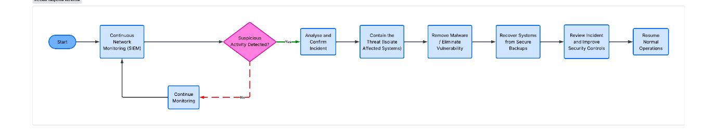
Figure 2 point out the incident response process used by SteelForm Manufacturing Ltd to detect, contain and recover from cyber security incidents.

2.5 Continuous Training and Awareness
The technology by itself is not enough in preventing cyberattacks since human error is among the most common reasons for breaches. In order to lower the risks caused by it, SFM must develop an ongoing cyber security training and awareness program, which will inform the employees about the present threats and foster a security-oriented culture at the company.
The cyber security training should be given to all new employees during their induction so that they could learn more about company security policies and password policies. All other employees should undergo mandatory cyber security training twice per year to stay updated about the threats.
Additionally, SFM needs to perform regular phishing and vishing tests to measure the awareness level of the employees concerning fraudulent attempts to acquire information. Those who pass those tests badly should be subject to further training. Different departments should have different kinds of training depending on the cyber risks they might face. For instance, finance department staff should undergo BEC training, while IT administrators should be provided with technical training regarding incidents responses, access controls, and system monitoring.
To ensure that there is continuous involvement, the firm should issue monthly cybersecurity newsletters, conduct brief online courses and security messages displayed all over the office. The employees should be encouraged to bring their concerns about any emails that might seem suspicious or any other anomalies in system activities without the fear of facing repercussions.
Continuous training and cultivation of a security-focused culture will minimise the chances of any mistake by human error at SteelForm Manufacturing Ltd.

Conclusion
SFM Ltd. is faced with a variety of emerging cyber threats that might potentially affect the firm. The aim of this report is to identify those threats and outline effective security policies, controls, monitoring and training to increase the organisation’s cyber resilience. It is recommended for SFM Ltd. to use the NIST Cybersecurity Framework, ISO/IEC 27001 standard and Zero Trust security approach, updating security controls on a regular basis. In the future, SFM must continue working on integrating advanced security solutions and threat intelligence.

References
[1] International Organization for Standardization, "ISO/IEC 27001:2022 Information security, cybersecurity and privacy protection — Information security management systems — Requirements." [Online]. Available: https://www.iso.org/standard/27001. [Accessed: 23-Jul-2026].

[2] Cisco, "What is Cybersecurity?", Available: https://www.cisco.com/c/en/us/products/security/what-is-cybersecurity.html. [Accessed: 23-Jul-2026].

[3] National Institute of Standards and Technology, *The NIST Cybersecurity Framework (CSF) 2.0*, 2024. [Online]. Available: https://nvlpubs.nist.gov/nistpubs/CSWP/NIST.CSWP.29.pdf. [Accessed: 23-Jul-2026].

Appendix PowerPoint Slides

Slide 1
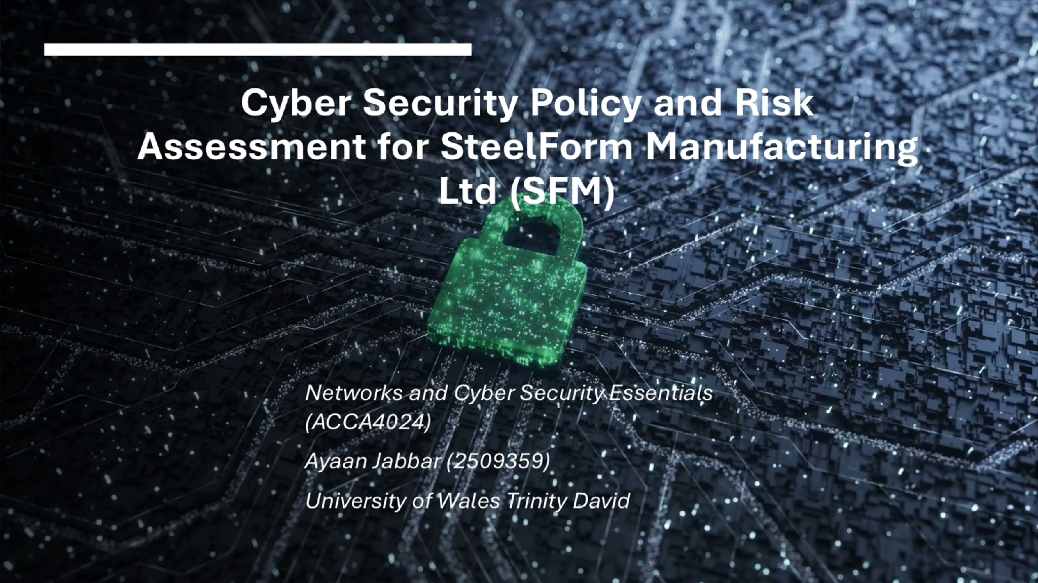

Slide 2

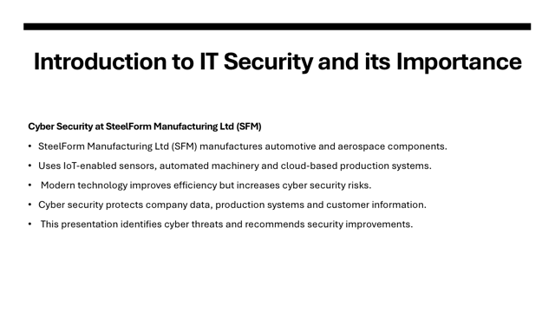

Slide 3
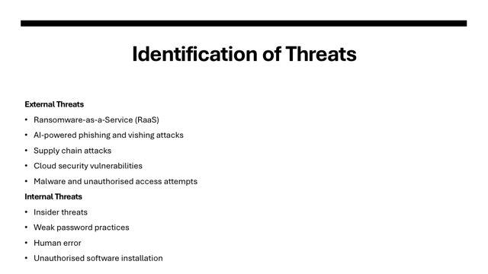

Slide 4
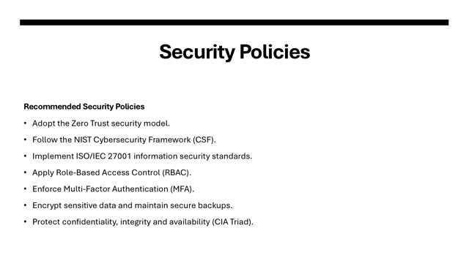

Slide 5
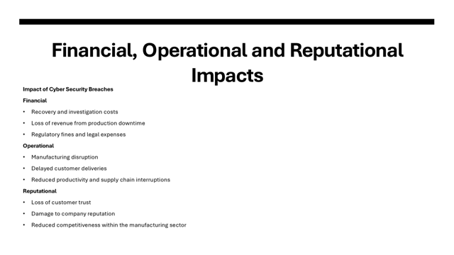

Slide 6
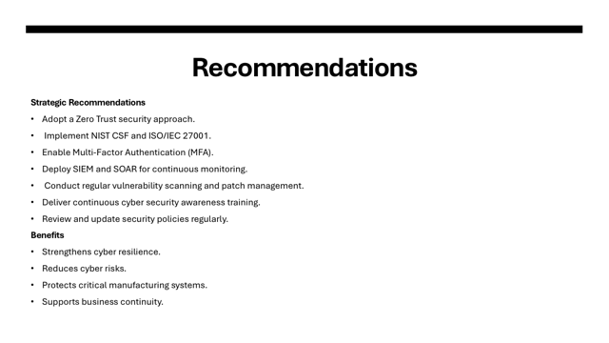

Slide 7


