Digital Skills and Research Methods.
Component 2 - Research Report
Research Topic: Digital tool mostly used by students at UWTSD to collaborate together
BMSW4003_BIRM
Student Name: Elena Mihaela Radu
Student Number: 2126383
Lecturer Name: Dr. Seyed Navid Nasirpourosgoei

Table of Contents
1. Introduction 1
2. Research Design 2
2.1 Research Questions 2
2.2 Method 2
2.3 Ethical Consideration 3
3. Results 4
4. Discussion 8
5. Conclusion 9
6. References 10
7. Appendix A- A Blank Copy Of Questionnaire 12

1. Introduction
In the modern age, the use of digital technology for communication has facilitated different aspects of life to a significant extent. The use of digital communication technology has also influenced the field of education and facilitated the learning of students (Murphy and Cifuentes, 2016). Digital communication tools can enhance the convenience of learning by providing a better environment and facility for learning. In the technologically advanced world, the use of digital technology in education can be highly timely. The digital and internet-based tools can provide the student with access to a massive amount of information necessary for learning (Parrish, 2016). Aside from that, the student can also collaborate with each other using online-based tools for collective learning. The use of the internet can also accelerate the process of information sharing which facilitates the learning process.
Within the busy schedule of people in modern times, people need fast and collaborative learning which is enabled by the use of digital communication technology. Aside from that, the use of online-based tools for learning can provide the students with the flexibility to achieve a balance between academic and other lives (Steenkamp and Rudman, 2016). Thus, different digital tools are used for learning purposes in modern times. The exploration of the use of these tools and the frequency of their use is necessary which will be the main focus of this study.

2. Research Design

2.1 Research Questions
the research would be conducted to explore the use of different digital tools by the student of UWTSD for collaborative learning. As there are different tools in use for facilitating education and enabling collaborative learning, different students use different tools with different degrees of frequency. The different tools also have different degrees of effectiveness, resulting in the different preferences of the students. The aim of the study would be to identify the tool that is most used by the student at UWTSD for collaboration. Thus, the following question would be answered from the findings and analysis of the research data.
- Which digital tool is used mostly by the students of UWTSD for collaboration?

2.2 Method
The research has been conducted within a specific framework incorporating a certain set of research activities. The framework has been developed for enhancing the efficiency of conducting the different activities within the research study. The framework has been developed by incorporating the elements from Saunders’ research onion.
For defining the definite beliefs and values related to the certain way of conducting the research study, a specific philosophy from Saunders’ research onion has been employed while conducting the research (Saunders, Lewis and Thornhill, 2019). The research has been conducted with the positivism philosophy. Within this philosophy, only the factual data within the observable reality have been considered, minimising the scope for misinterpretation.
A certain approach from Saunders’ research onion has also been employed for defining the exact way to reach an outcome of the research from the analysed data. Particularly the deductive approach has been employed for the research (Saunders, Lewis and Thornhill, 2019). With this approach, the collected data have been evaluated based on priorly developed hypotheses to identify the most likely one.
The research has been conducted with the quantitative method. With the quantitative method, the researcher has mainly collected numeric or quantitative data for the research. While the numeric data does not provide elaborative information, it can provide definite information directly related to the concerned topic. The quantitative data are also easier to analyse with lesser scope for error.
For collecting the necessary data for conducting the study, only the primary research has been conducted. Within the primary research, the author has collected the required data from direct participants according to the exact need of the researcher.
As the research has been conducted using the quantitative method and primary data, the researcher used a certain strategy for collecting the data. The strategy used for collecting the data was conducting a survey (Saunders, Lewis and Thornhill, 2019). With the survey, quantitative data were collected with a number of questions. The participants were asked to respond to the questions with numeric ratings or closed responses.
The main tool that facilitated in conducting of the research was the questionnaire used for the survey. The questions in the questionnaire were developed with a strategic approach to maintaining relevance with the research topic.
The participants for the research were students from UWTSD. As the number of students is considerably large, the whole population could not be considered a participant in the research. Yet no restriction was imposed on anyone regarding their participation in the research. Everyone was invited to join and the participation of the students was left to their will.

2.3 Ethical Consideration
Ethical consideration can be defined as using some principles and practices to make moral choices within a research study (Saunders, Lewis and Thornhill, 2019). Strict and clear ethical grounds have been maintained while conducting the research. No discriminatory practices have been conducted against the participants of the research and everyone had the liberty to participate in the research. Proper consent was obtained from all the participants regarding their participation in the research and everyone had the liberty to withdraw consent at any time. All the participants were informed about the purpose, aim and use of the research. To maintain confidentiality regarding the identity of the participants, no personally identifiable information has been collected. The data collected from the participants have been stored in secure digital storage and all the data would be erased after the end of the academic year.

3. Results
As the survey has been conducted, the responses of the participants have been collected and stored. A total of 12 students participated in the research. the responses of the participants have been compiled together and put into Microsoft excel. The data have been presented in the form of charts for easy understanding.
Q-1: I consent to take part in this questionnaire voluntarily.
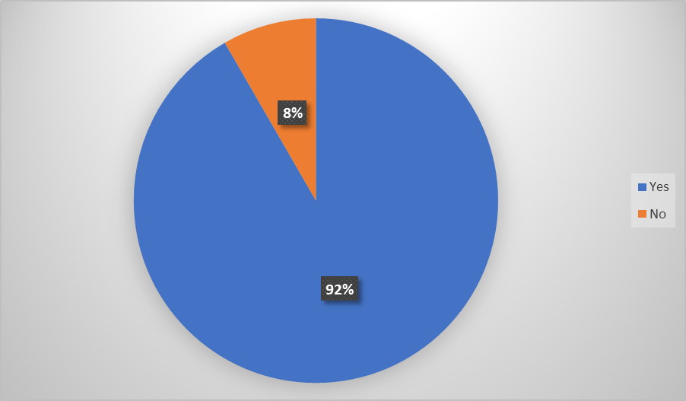
Q-2: Gender
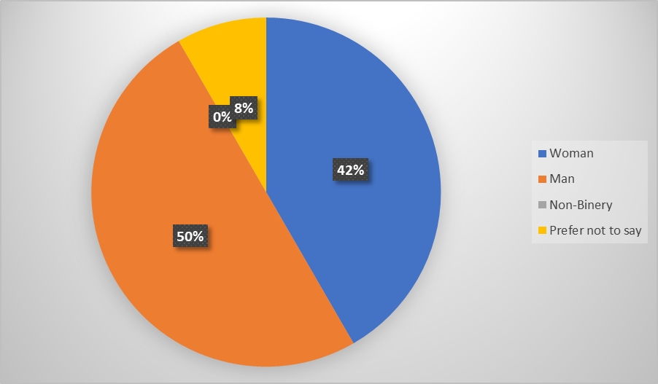

Q-4: When collaborating with your peers do you use any digital tools?
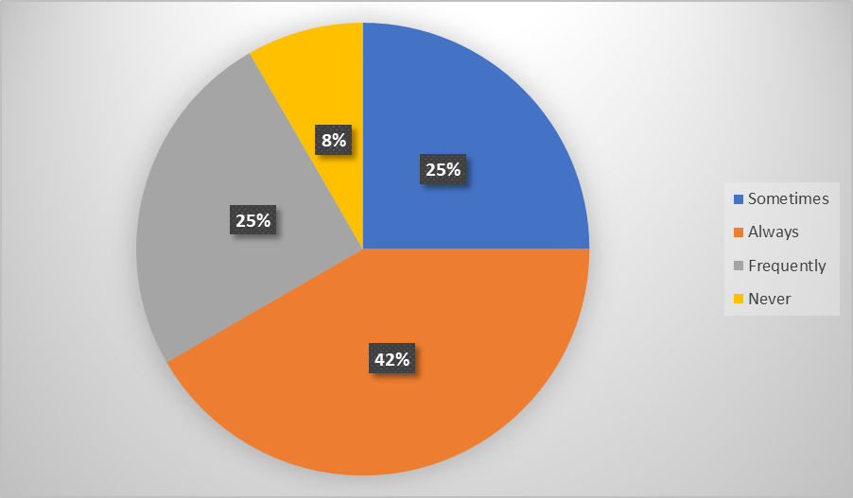
As found from the responses, a significant 42% of students always use digital tools while collaborating with their peers. 25% of the students responded that they sometimes use digital tools for collaborating with peers while another 25% use the tools frequently. 8% of the participants responded that they do not use digital tools for collaborating with peers.
Q-5: When collaborating with peers do you use one digital tool more than others?
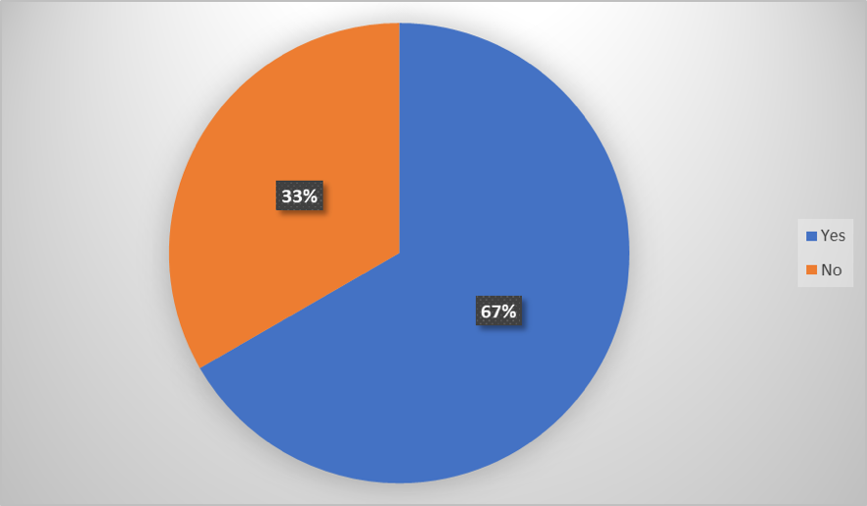
Two-thirds of the participants have agreed that they use one particular tool more than the others while collaborating with the peer. On the other hand, 33% of students responded that they use different tools equally.

Q-6: Rank these applications in order according to how frequently you use them to collaborate with others. (Most frequent at the top)
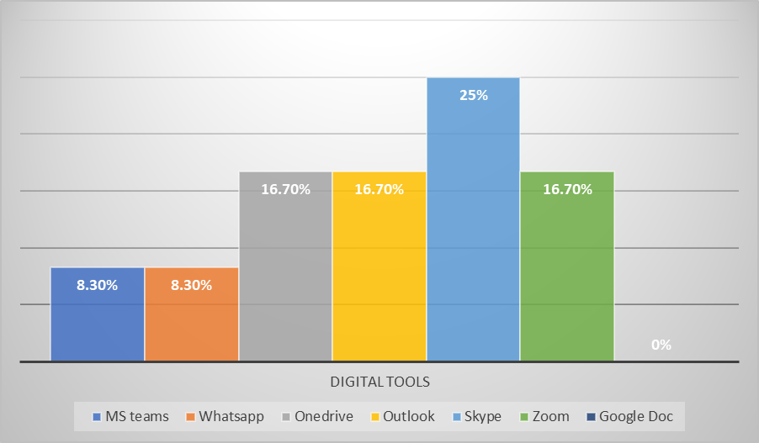
As found from the responses of the participants, 25% of the students most frequently use skype for collaborating with others. Zoom, outlook and OneDrive are also used frequently by 16.7% of students.
Q-7: Rank these applications according to how frequently you use them to collaborate with others on the OneDrive (Most frequent at the top)
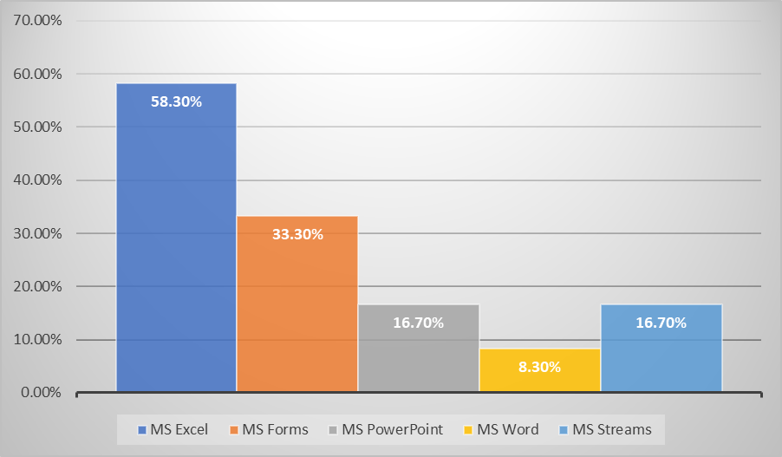

Q-9: In your opinion, is using online tools to collaborate with your peers more efficient than face-to-face collaboration?
As the responses of the participants have been collected, it was found that a significant 67% of the participants find it more efficient to collaborate using online tools. Though 33% of the participant thinks collaborating face-to-face is more convenient. The number of people disagreeing cannot be disregarded.
Q-10: In your opinion, is using online tools to collaborate with your peers more efficient than face to face collaborating?
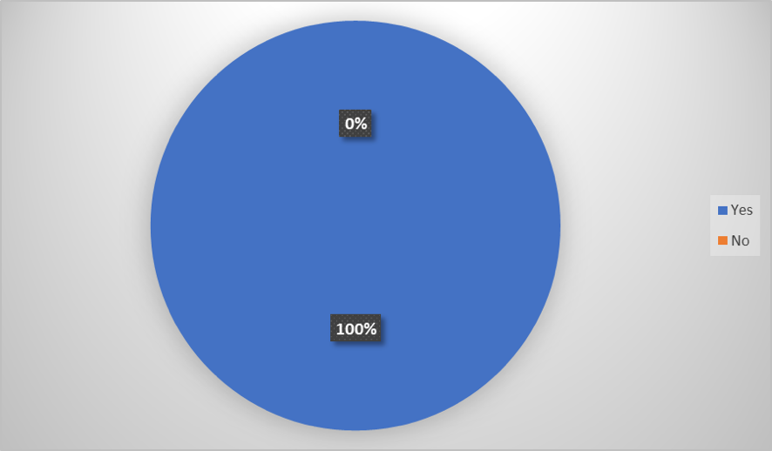

4. Discussion
As the data collected from the research participants have been collected and presented in the prior section, they have been analysed to develop a better understanding relating to the topic. As the world has advanced, the use of digital tools in learning is necessary as they can increase the convenience of learning (Neo, 2017). As found from the collected data majority of the students are using digital tools in their learning process. As a collaboration with peers is highly necessary for effective learning, the students use online-based tools for efficient collaboration (Adam and Perumal, 2020). Even other students use the tools occasionally or relatively more frequently. Only a marginal percentage of students are still not using digital tools. This suggests that the use of digital tools for collaborating with peers is widely accepted among students. The students use a wide range of different tools often in this regard.
The findings also suggest that a number of different tools are in use and each has a different degree of effectiveness. Different students have different preferences regarding the different digital tools (Karakostas and Demetriadis, 2020). In this regard, the majority of the students prefer using a particular digital tool while others do not have specific preferences. This means the majority of the students use one specific digital tool more than the others.
As the different digital online tools have different features and can offer different conveniences, it is very usual for students to have specific preferences. But the preferences of the students are usually developed based on the effectiveness, efficiency and convenience offered by any particular tool (Schönbrodt, Wohak and Frank, 2022). Thus, the identification of the most frequently used or most preferred tool is supposed to be the most appropriate and effective one. As the findings suggest, Skype is preferred by the majority of the students for collaborating with others. Other used digital tools include Zoom, OneDrive, Outlook, MS teams, WhatsApp etc. Zoom, Outlook and OneDrive are also preferred by a large percentage of the students. But among these tools, the students mostly use Skype for collaborating with others. The students also use other digital tools related to data processing and sharing that are also required for collaborating with their peers. These digital tools are mainly incorporated within the OneDrive. These tools include MS Excel, MS Forms, MS PowerPoint, MS Word and MS Stream.
The students also have preferences related to these tools. As the findings suggest, the students of UWTSD mostly use MS Excel for collaborating within OneDrive.
As the use of the different digital tools has become very frequent and widely accepted among the students, a comparison between the efficiency of using the digital tool for collaboration and collaborating face-to-face arises (Suksakorn and Tubtiang, 2020). Digital online tools are usually highly efficient offering various features that can add convenience in collaborating with peers. It also enables the students to collaborate with peers from remote locations (Looi and Ang, 2018). Thus, the majority of the students prefer collaborating with peers using online tools. On the other hand, a great many students find it less efficient. As using the online tools require possessing compatible devices and access to the internet it can become inconvenient to some (Mhouti and Erradi, 2015). Many students may not have access to the required devices or the internet which shifts their preferences toward face-to-face collaboration.
The effectiveness of using digital tools for facilitating education is evident from the appreciation of people. As the findings suggest, all the students think that online collaboration can be the most used learning method at UWTSD. The majority of the students have already adopted this method for effective learning. Though the use of online tools is still not available to everyone now, the situation would improve (McNamee and Moscheta, 2017). While different students are yet to have proper access to the resources required for online collaboration, these barriers can be overcome. Upon overcoming these barriers, the learning process can be more convenient and flexible for all the students at UWRSD using online collaboration and digital tools.

5. Conclusion
The modern world is highly integrated with advanced technology and these technologies significantly influence the different aspects of life. Education is a significant aspect of human life which can be facilitated by the use of technology. As digital communication technologies have advanced significantly, it has added a new dimension to collaborative learning (Pozzi, 2011). With the use of different digital online tools, students can collaborate with peers from remote locations with flexible time schedules. These tools enable the students to balance, their academic, professional and personal life (Stahl and Hesse, 2017). The students at UWTSD are also using different digital tools for collaborating with their peers to enhance the learning process. The majority of the students have access to resources for effective use of the tools. A number of different tools are used by the students but different preferences are existent. Skype is the most used tool by the students at UWTSD. Aside from it the students mostly use MS Excel for collaborating within OneDrive.

6. References
Adam, I. and Perumal, V. (2020). Collaborative Learning Tools for Constructive Learning. Special Issue No.1, 1(1), pp.1–13.
Karakostas, A. and Demetriadis, S. (2020). Enhancing collaborative learning through the use of digital tools. Journal of Computer Assisted Learning, 27(3), pp.243–258.
Looi, C. and Ang, D. (2018). A multimedia-enhanced collaborative learning environment. Journal of Computer Assisted Learning, 16(1), pp.2–14.
McNamee, S. and Moscheta, M. (2017). Relational Intelligence and Collaborative Learning. New Directions for Teaching and Learning, 2015(143), pp.25–40.
Mhouti, A. and Erradi, M. (2015). Collaborative Learning in E-learning Environments. Journal of Education and Vocational Research, 6(4), pp.15–23.
Murphy, K. and Cifuentes, L. (2016). Using Web tools, collaborating, and learning online. Distance Education, 22(2), pp.285–305.
Neo, M. (2017). Developing a collaborative learning environment using a web-based design. Journal of Computer Assisted Learning, 19(4), pp.462–473.
Parrish, M. (2016). Toward transformation: Digital tools for online eduation. Arts Education Policy Review, 117(3), pp.168–182.
Pozzi, F. (2011). Adopting online collaborative learning processes. International Journal of Computer-Supported Collaborative Learning, 6(3), pp.471–484.
Saunders, M., Lewis, P. and Thornhill, A. (2019). Research Methods for Business Students. 8th ed. New York: Pearson.
Schönbrodt, S., Wohak, K. and Frank, M. (2022). Digital Tools to Enable Collaborative Learning Online. Modelling in Science Education and Learning, 15(1), pp.151–174.
Stahl, G. and Hesse, F. (2017). Social practices of computer-supported collaborative learning. International Journal of Computer-Supported Collaborative Learning, 1(4), pp.409–412.
Steenkamp, L. and Rudman, R. (2016). Incorporating Online Tools In Modern Education. Contemporary Issues in Education Research (CIER), 6(4), p.365.
Suksakorn, A. and Tubtiang, A. (2020). The acceptance and effectiveness of interactive online learning in virtual face-to-face learning technology. International Journal of Innovation and Learning, 27(2), p.135.

7. Appendix A- A Blank Copy Of Questionnaire


