Dummy Report for Strategic Management Assignment 1 2018 – Adidas – Europe’s leading manufacturer of Sportswear



OCTOBER 2018

MODULE NAME: Strategic Management & Sustainability (M3X9111)
Name: QIN LU
Student Number: 1804592

Table of Contents

1. eXECUTIVE sUMMARY 1
2. Introduction 2
2.1 Report Remit 2
2.2 Background of the organisation 2
2.3 Definitions of Major Concepts 2
3. Main Body 4
3.1 IMplementation of the strategy 4
3.2 Advantages & Disadvantages of the strategy 5
4. Conclusion 6
4.1 Recommendations 6
5. References 7

List of Figures
Figure 3-1 Proportion of factories' worker (adidas, 2018) 5
Figure 3-2 Supply chain of Adidas (Adidas, 2018) 5
Figure 3-3 Drivers of buyer power in the global footwear market, 2017 (Industry Profile, 2018) 7

LIST OF TABLES
Table 2-1 Three Generic Strategies (Porter, 1998) 3

APPENDICES
APPENDICES ARE ANYTHING THAT IS INFORMATIVE TO THE REPORT, BUT IS NOT REQUIRED IN THE MAIN BODY OF THE REPORT. FOR EXAMPLE, IF YOU HAD COMPLETED QUESTIONNAIRES, YOU MIGHT INCLUDE THEM IN THE APPENDICES

APPENDIX A –
APPENDIX B –

jUST LIST OUT YOUR APPENDICES, THERE IS NO NEED TO INCLUDE PAGE NUMBERS FOR YOUR APPENDICES

eXECUTIVE sUMMARY

Introduction

Report Remit
Strategy is a long term direction of an organisation. Firms usually put their strategy on different ways to achieve their goals. Porter’s Generic Strategies is a model to analyse a company’s strategy through two dimensions-- competitive advantage and competitive scope. Adidas is Europe’s largest manufacturer of Sportswear and there is no doubt that Adidas have both advantages and drawbacks on its strategy. The purpose of this study is to analyse the strategy of Adidas by using Porter’s Generic Strategies.

Background of the organisation
Adidas, established in Germany, is an international company with 56,270 employees and it is also the second place in sportswear manufacturer in the world (The Plus Awards, 2017). With ‘Creating the New’ this strategy, Adidas pushes the boundaries of products, experiences and services to drive brand desire and capitalize on the growth opportunities in sport as well as in sports-inspired casual and activewear (adidas, n.d.). Adidas has Adidas and Reebok brands. What’s more, the major footwear franchises of the company include NMD, Stan Smith, Gazelle, UltraBOOST, PureBOOST X, Superstar, EQT and Alphabounce. It sells products through retail stores, franchisees, department stores and online retailers (MarketLine, 2018). In 2017, Adidas sells its golf brands TaylorMade, Adams Golf and Ashworth (James, 2017).

Definitions of Major Concepts
- Strategy
A strategy is the set of actions through which organisation, by accident or design, develops resources and uses them to deliver services or products in a way which its users find valuable, while meeting the financial and other objectives and constraints imposed by key stakeholders. Most successful strategies give an organisation: some property that is unique, or at least rare; the means or renewing its competitive advantage as the environment changes (Haberberg & Rieple, 2001)
- Business level strategy
Business-level Strategy refers to the plan of action that strategic managers adopt to use a company’s resources and distinctive competencies to gain a competitive advantage over its rivals in a market or industry (Hill& Jones, 1998).
- Competitive advantage
Anything a firm does especially well, compared to rival firms. For example, when a firm can do something that rival firms cannot do, or owns something that rival firms desire, that can represent a competitive advantage (David, 2017).
- Corporate divestiture
The term divestiture (or divestment) represents a number of breaks up operations by which firms adjust their ownership structures and reduce their business portfolio scope through sell-offs, spin-offs, and equity carve-outs( Flickinger & Zschoche, 2018).
- Sportswear
From Oxford University Press (2004), sportswear includes running shoes, training shoes and exercise wear.
- Porter’s Generic Strategies
In the book Competitive Advantage: Creating and Sustaining Superior Performance (1985), Michael Porter introduced the concept of three mutually exclusive generic strategies, cost leadership, differentiation and focus that can be leveraged by an organization to establish and maintain a competitive advantage. Porter asserts that competitive advantage rests upon how well the executed strategy generates value.
Competitive advantage grows out of value a firm is able to create for its buyers that exceeds the firm's cost of creating it. Value is what buyers are willing to pay, and superior value stems from offering lower prices than competitors for equivalent benefits or providing unique benefits that more than offset a higher price. There are two basic types of competitive advantage: cost leadership and differentiation (Porter, 1985, p. 3).
Table 2-1 Three Generic Strategies (Porter, 1998)
Competitive Scope | Competitive Advantage
Competitive Scope |  | Lower Cost | Differentiation
Competitive Scope | Broad Target | 1.Cost leadership | 2.Differentiation
Competitive Scope | Narrow Target | 3A.Cost Focus | 3B.Differentiation Focus

Main Body
Adidas uses a hybrid strategy. For different view, it can be concluded that Adidas has a different strategy. Adidas uses cost leadership strategy, differentiation strategy.
From Porter (1985), the cost leadership strategy is the firm wants to provide the low-cost products in its industry and company need to control costs tightly. The product can be priced at a competitive parity and profit per product is lower if it is compared with differentiation generic strategy (Viltard. 2017). Differentiation strategy requires the development of goods or unique services from unmatched by relying on customer loyalty to the brand (Valipour et al, 2012). A company can be offered higher quality, performance or unique features that each of them can justify the higher prices. Miller (1987) argued that product differentiation firms tend to invest heavily in research and development activities in order to increase their innovative capability and enhance their ability to keep up with their competitors‟ innovations (Jermias, 2008).
Adidas put the new strategy in 2015 with’ Creating the New’ to accomplish their mission. To get closer to our consumers than ever before, their plan is based on three strategic choices: Speed, Cities and Open Source.
Speed – How they deliver: As fast as possible. Putting consumers at the heart of everything and help them always find fresh and desirable products .We will become the first true fast sports company.
Cities – Where they deliver: Urbanization is a global trend. Most of the global population lives in cities. To target that, adidas focus on six key cities: London, Los Angeles, New York, Shanghai, Paris and Tokyo.
Open Source – How they create: This is about collaboration and innovation, about learning and sharing. Adidas invite athletes, consumers and partners to join and create the future with them of sports and sports culture.

IMplementation of the strategy
When using the cost leadership strategy, Adidas takes different approaches. First, adidas has outsourced most of its production with 55 countries around the world (adidas, n.d.). According to adidas (2018), there are 777 independent factories that mainly come from Vietnam with 30.71% workers, China with 18.27% workers and Indonesia with 16.32% workers. By using the data from adidas, it can be printed Figure 3-1 Proportion of factories' worker (adidas, 2018). Based on the data, the conclusion can be drawn that most of the workers come from developing country, which has a lower average income than developed country. Adidas can use local cheap labour and raw materials, and decreases its cost and produces efficiently. Second, adidas has advanced supply chain system. From its website, it can be seen that adidas has different souring relationships with different types of suppliers. The Figure 3-2 Supply chain of Adidas (Adidas, 2018) shows that adidas uses complex supply chain to have not only the best but also cheaper raw materials. Third, adidas has outsourced logistics with an effective logistic network (Ong, 2018).The logistic outsourcing can lower down the cost and give a huge advantage for the online selling. Company News (2018) said that ‘Adidas e-commerce sales boom 76%’, which affect by the logistic. If adidas doesn’t have a strong logistic, it cannot keep up with the online increasing.

Figure 3-1 Proportion of factories' worker (adidas, 2018)
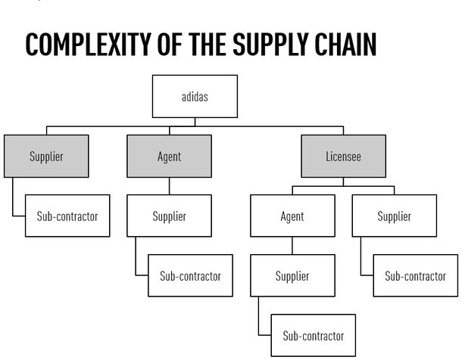
Figure 3-2 Supply chain of Adidas (Adidas, 2018)

From the following steps, adidas uses differentiation strategy. Adidas has adidas special original, adidas performance, adidas Y-3 and Adicolor these brands to Niche market. The classic series (the Original), name the clover classic series and blue white clover logo. The original gathers with vintage fashion concept, mainly sell classic vintage products, which is also a very good series of sales in recent years. Performance series, are now widespread by its black, white and three stripes, mainly sales of professional sports products. The leisure life series (adidas style) has fluorescent green on the whole, shop sign for fluorescent green ball inside three similar white paw, mainly selling leisure products. Fashion series is nearly two years popular Y - 3, cooperating with Japanese designer. Y represents the name of the Japanese designer and 3 on behalf of adidas. These are high-end products and mainly sales in fashion and luxury. With these different series, adidas can focus on different markets and consumers. Especially when some products are not fashion or have a good sales volume, the other one can still get improve on the markets so that adidas can collect the data to keep their whole selling.
From Q1 2017, adias increased up 53% from a year earlier on online part. In the second quarter, that figure to 66%, the north American market increased by 80%, greater China is doubled, transferred to the line more and more consumers. However, this does not mean that adidas entities sales by the huge impact. Adidas provides two kinds of ways to sell their products. One is using the on-line website with other retails to sell the products. This way of selling targets in the consumer who are very sensitive on the price. The other one is selling in stores. Those stores are focusing on the people who don’t pay too much attention on the price and also provide personalized customization. Those stores fit with people’s caution and help build relationship with the consumer. By using these two different types of selling products, adidas distinguishes price insensitive and sensitive consumer, expanding the scope of its sales.
Last but not least, adidas has great amount of innovation and high tech products. Adidas first was well known by football boots. It was in the 1954 World Cup final, the German national football team won so much more than just a trophy and then adidas became popular among the world. Even now, the football shoes of adidas are still the most well-known products. What’s more, adidas spend a lot of money to innovate the sportswear, from the brand of adidas to the high tech equipment, which makes consumers have a deep mind of the brand of adidas and the suitable equipment on the sports area.

Advantages & Disadvantages of the strategy
There are different advantage and disadvantage of the cost leadership strategy and differentiation strategy.
The cost leadership strategy reduces cost and makes products more pricy. Because the world is in a weak economic growth, consumers care about the price of the products. From Figure 3-3 Drivers of buyer power in the global footwear market, 2017 (Industry Profile, 2018), the low-cost switching and price sensitivity are on the first and the third places. The advanced supply chain system and the effective logistic network is the ability for adidas to outperform rivals. Compared with other sportswear manufacture, adidas has a huge advantage on these so that it is easy to buy and the raw materials are easy to get.
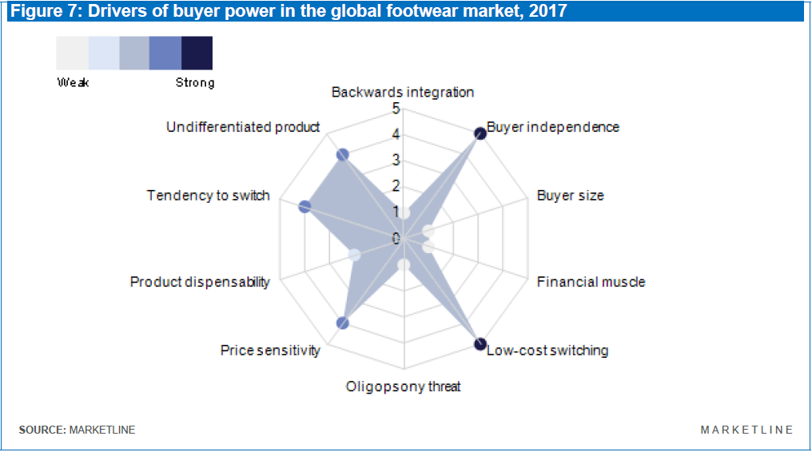
Figure 3-3 Drivers of buyer power in the global footwear market, 2017 (Industry Profile, 2018)
The differentiation strategy also gives adidas a lot of advantages. The brand of adidas is a strong power compared with other brand no matter the blue white clover logo or three stripes with black and white. The brand of adidas has been penetrated deeply into the hearts of the people, which makes a long distancing from others in the market place. What’s more, because of the diversity of brand, adidas can be more flexible when one of brand is descending. The innovation of adidas is a strong power which creates a major competitive advantage.
The cost leadership strategy and the differentiation strategy provide the disadvantages at the same times.
For cost leadership, adidas has outsourced its products to other factories which made their products have different quality. Adidas checked by the city's market watchdog failed quality tests (Top brands Dunlop, 2018). This was not the first news that talked about the quality of adidas. Since adidas have factories around 55 countries with 778 factories, the quality of different countries are different. What’s more, there was some bad news for the industries. From Chen (2014), two of the factories -- Shen Zhou (Cambodia) factory and Daqian Textiles (Cambodia) factory -- manufacture clothing for German sports labels Adidas, about 260 workers collapsed. The Ministry of Labour, some workers felt unwell and they started to faint. According to the ministry, 823 workers fainted in 2013, a sharp decrease from 2012's more than 1,600 workers. But adidas could not be reached for comments. Those news have decreased the positive company culture among the consumer.
The differentiation strategy costs too much and not all of the new products can be successful. Adidas America has dropped out of the wearables race having recently announced it is discontinuing its digital sports division which previously made GPS running watches, fitness trackers, smart apparel and footwear (fashionnetwork, 2017). Just before this, Adidas sold the its hockey brand CCM and its golf brands TaylorMade, Adams Golf and Ashworth. From those news, the differentiation strategy of adidas is not always success. TaylorMade, Adams Golf and Ashworth were a very long products for adidas but finally adidas still sold it out. What’s more, digital sports division is new area but adidas also gave it up. There is a question whether is good to invent new products or not since there is a high failure rate.
Moreover, it is difficult to achieve true and meaningful differentiation. Although there are a lot of brands to fit with different consumer, people who don’t know about it usually confused by the original and performance.

Conclusion
In this article, it is first briefly discussed about some background of adidas and some definition, such as strategy, business level strategy, competitive advantage, corporate divestiture, sportswear and three generic strategies. When making strategic analysis, it is concluded that: adidas has taken cost leadership strategy and differentiation strategy to implement the channels complement each other, mutual utilization of resources, complementary advantages, reduce the production cost of sales and enhance the core competitiveness of strategic objectives.
What’s more, the article analysed impact, the advantages and disadvantages in detail that adidas takes these two strategies by giving some examples and some logical reasoning.

Recommendations

References
Adidas. (n.d.). HISTORY. [online] Available at: https://www.adidas-group.com/en/group/history/ [Accessed 23 Nov. 2018].
adidas (2018). Global Factory List: Primary suppliers and subcontractors. GLOBAL FACTORY LISTS. [online] adidas. Available at: https://www.adidas-group.com/media/filer_public/a8/87/a8873c87-9232-46fb-a78a-08f232086723/2018_july_adidas_licensees.xlsx [Accessed 25 Nov. 2018].
Anonymous. (2017). The Plus Awards. Footwear Plus, 27(3), 22-24,26,28-30,32,34-37.
COMPANY NEWS. (2018). Adidas e-commerce sales boom 76%. [online] Available at: http://advantage.marketline.com.ezproxy.uwtsd.ac.uk/Extract/Pdf?productId=17C75A5F-F1AE-451C-AFD4-E8A2F5F8A515&viewId=overview&itemId= [Accessed 26 Nov. 2018].
Chen, D. (2014). Mass Faintings At Cambodian Factories. WWD, 207(68), 2.
David, F. (2017). Strategic management : Concepts ; a competitive advantage approach (Sixteenth edition, global ed.).
Flickinger, & Zschoche. (2018). Corporate divestiture and performance: An institutional view. Journal of Management & Governance, 22(1), 111-131.
fashionnetwork. (2017). Adidas drops wearables in favor of apps. [online] Available at: http://uk.fashionnetwork.com/news/Adidas-drops-wearables-in-favor-of-apps,903615.html [Accessed 26 Nov. 2018].
GOSWAMI, S. & HA-BROOKSHIRE, J., 2015. From compliance to a growth strategy. Journal of Global Responsibility, 6(2), pp. 246-261.
Haberberg, A., & Rieple, A. (2001). The strategic management of organisations. Harlow: Financial Times/Prentice Hall.
Hill, C., & Jones, G. (1998). Strategic management : An integrated approach (4th ed.). Boston: Houghton Mifflin.
Industry Profile. (2018). Global - Footwear. [online] Available at: http://advantage.marketline.com.ezproxy.uwtsd.ac.uk/Product?ptype=Industries&pid=MLIP2825-0009 [Accessed 26 Nov. 2018].
Jermias, J., (2008) “The relative influence of competitive intensity and business strategy on the relationship between financial leverage and performance”, The British Accounting Review, Vol. 40, pp. 71–86.
MarketLine (2018). adidas AG. COMPANY PROFILE. MarketLine.
Modigliani, F., Miller, M. H. (1958) “The cost of capital, corporate finance, and the theory of investment”, American Economic Review, Vol. 53, pp. 433–43.
Ong, G. (2018). Logistics Adidas. [online] Academia.edu. Available at: http://www.academia.edu/7484819/Logistics_Adidas [Accessed 26 Nov. 2018].
Porter, M. (1998). Competitive advantage : Creating and sustaining superior performance. New York ; London: Free Press.
Q1 2017 adidas AG Earnings Call - Final. (2017). Fair Disclosure Wire, Fair Disclosure Wire, May 4, 2017.
Shotter, J. (2017). Adidas sells TaylorMade and other golf brands for $425m. [online] FINANCIAL TIMES. Available at: https://www.ft.com/content/47d14dd9-43e7-30c7-a06d-ee47576fc874 [Accessed 25 Nov. 2018].
Sportswear. (2004). Visual English Dictionary, Visual English Dictionary.
Top brands Dunlop, adidas fail quality tests. (2018). Shanghai Daily, pp. Shanghai Daily, 2018-01-10.
Valipour, H., Birjandi, H., & Honarbakhsh, S. (2012). The Effects of Cost Leadership Strategy and Product Differentiation Strategy on the Performance of Firms. Journal of Asian Business Strategy, 2(1), 14.
Viltard, L. (2017). STRATEGIC MISTAKES (AVOIDABLE): THE TOPICALITY OF MICHEL PORTER’S GENERIC STRATEGIES. Independent Journal of Management & Production, 8(2), 474-497.

