Portfolio Commentary III
Ground plan of Tintern Abbey

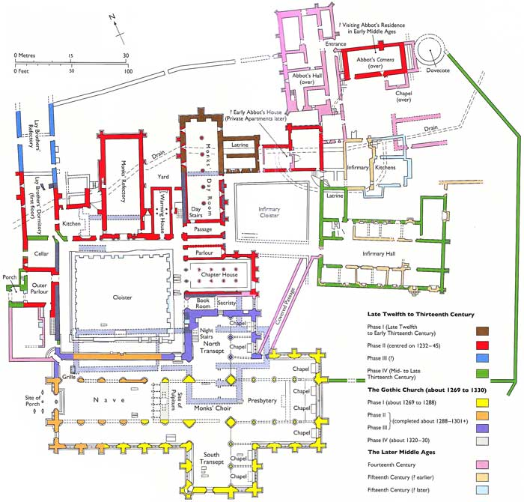

Tintern Abbey was founded in 1131 under the auspices of the Anglo-Norman Walter fitz Richard de Clare, lord of Chepstow, at the beginning of the great Cistercian expansion, only three years after the foundation of the first Cistercian house in England at Waverley. Monks were sent from L’Aumône, known as le Petit Cîteaux, that monastery’s seventh daughter house and called ‘the springhead of Cistercian expansion in England…’ The plan shows remains dating from the twelfth until the fifteenth centuries, almost the eve of the suppression. The original church lay partly below the more recent building. Building work must have been a constant background to abbey life, each new or renovated structure taking many years to complete. Burton and Kerr mention estimates of up to twenty years to construct a church and forty for a claustral complex.

The abbey is set on a small flat area to the south of the River Wye which must, when the monks arrived, have been boggy and is still prone to flooding. Looking around the site it is easy to imagine a wild, wooded area and the Cadw guidebook tells us that the area was then unpopulated. Gerald of Wales, writing in the 1180s, says of the Cistercians: ‘give them a wilderness or forest, and in a few years, you will find a dignified abbey in the midst of smiling plenty.’ When looking at an aerial view the church’s site seems the only one possible. In a very brief survey of the fifteen religious houses whose plans are shown in Burton and Stöber’s Abbeys and Priories of Medieval Wales, all but Tintern have cloisters south of the nave of the church and those showing chapter houses show them adjoining the south transept of their churches. This book tells us that the position of the claustral complex was ‘so that the waters of the Wye could be utilised on the site’. The double broken lines on the plan show the location of the drain which carried water diverted from the nearby Angidy spring to serve the kitchens and latrines, taking waste away from the monks housing and into the river. The topography and hydrology of the site also takes the church out of a strict east-west orientation, and so the concept of Liturgical East is used and the chancel end of the church, although the alignment is almost North West to South East, is known as the east end. Tintern is not the only Cistercian abbey to do this: Rievaulx, in Yorkshire, for one, has its church oriented further to the south because of the site’s topography. This ability to adapt to a site demonstrates the pragmatism which was to become clearer in the later Cistercian project. As Burton says of Cistercian architecture: ‘They accommodated change while preserving the Cistercian spirit.’

Another example of the realism and practicality of the Cistercian order is shown in the area marked ‘site of porch. This is probably the area known as the Galilee which housed a miraculous image of Mary and was a pilgrimage site. The image and the indulgence granted by Pope John XXII for visits to it would be a source of much-needed income for the abbey, despite the statement in Summae Carta Caritatis that income from altar revenues are prohibited. Surely this should include donations from pilgrims.

On first reading the Rule of St Benedict, Exordium Parva, Exordium Cistercii, and Summae Carta Caritatis, although none mention buildings, their tone is such that one would assume that Cistercian architecture should be as plain and unassuming as possible. Chapter 26 of Summae Carta Caritatis reads: ‘We may not have sculptures anywhere; we may have paintings, but only on crosses; and we may have crosses made only of wood.’
However, after the first phase of building this austerity does not appear to continue, although there is little superfluous ornament remaining. While the early Cistercian texts do not explicitly prohibit large churches, the splendour of the new church at Tintern seems to go against the ideal. Bernard of Clairvaux writing his Apologia to Abbot William in 1125 says of church buildings: the soaring heights and extravagant lengths and unnecessary widths of the churches…’ which distract from prayer. However, presumably the church needed to be enlarged during the thirteenth century to accommodate a greater number of monks and conversi. Since the architecture of Cistercian abbeys had evolved, it is hardly surprising that the original buildings should seem plain in comparison with later ones which used more modern building techniques. The earlier church is described as more modest in scale and style, perhaps more appropriate to the ethos of the Carta Caritatis.

Although later medieval Cistercian art and architecture have been considered evidence of decadence, as Michael Carter has shown it is, in fact, a demonstration of Cistercian evolution. We have seen that the Cistercian order was founded on high ideals and realism and, as a result, change and growth were possible, as demonstrated in the evolution of the buildings of this monastery. Tintern is an interesting example of this and what remains there shows that the Cistercians appreciated beauty and elegance in church building and were a growing and evolving order. From Tintern’s foundation, the monks had to adapt by moving the claustral range to the north of the church. Cistercianism is often portrayed as rigid and decaying and becoming decadent in the later medieval period. A site such as Tintern contradicts this negative view of an order which changed without betraying its ideals.

BIBLIOGRAPHY
Aston, Mick, Monasteries in the Landscape (Stroud: Tempus Publishing Ltd., 2002)
Coomans, Thomas, ‘Cistercian architecture or architecture of the Cistercians?’ in Bruun, Mette Birkedal ed., The Cistercian Order (Cambridge: Cambridge University Press, 2013) Pp. 151- 169.
Burton, Janet, Monastic and Religious Orders in Britain, 1000-1300 (Cambridge: Cambridge University Press, 1994)

Burton, Janet & Kerr, Julie, The Cistercians in the Middle Ages (Woodbridge: The Boydell Press, 2011)

Burton, Janet & Stöber, Karen, Abbeys and Priories of Medieval Wales (Cardiff: University of Wales Press, 2015)
Carter, Michael, The Art and Architecture of the Cistercians in Northern England, c. 1300-1540 (Turnhout: Brepols, 2019)
Lawrence, C H, Medieval Monasticism: Forms of religious life in Western Europe in the Middle Ages (Harlow: Longman, 1984) Chapter 9: The Cistercian model.

Williams, David Henry, The Welsh Cistercians (Tenby: Caldey Island Tenby, 1984)
Williams, Diane M, Tintern Abbey (Cardiff: Cadw, 2002)

Internet sources:
Monastic Wales: http://www.monasticwales.org/site/34

Janet Burton & Karen Stöber, Abbeys and Priories of Medieval Wales (Cardiff: University of Wales Press, 2015) p. 204.
Mick Aston, Monasteries in the Landscape (Stroud: Tempus Publishing Ltd., 2002) p. 79.
Janet Burton & Julie Kerr, The Cistercians in the Middle Ages (Woodbridge: The Boydell Press, 2011) p. 37.
Janet Burton & Karen Stöber, Abbeys and Priories of Medieval Wales (Cardiff: University of Wales Press, 2015) p. 208.
Janet Burton & Julie Kerr, The Cistercians in the Middle Ages (Woodbridge: The Boydell Press, 2011) p. 78.
Diane M Williams, Tintern Abbey (Cardiff: Cadw, 2002) p. 11.
Mick Aston, Monasteries in the Landscape (Stroud: Tempus Publishing Ltd., 2002) p. 135.
Janet Burton & Karen Stöber, Abbeys and Priories of Medieval Wales (Cardiff: University of Wales Press, 2015).
Janet Burton & Karen Stöber, Abbeys and Priories of Medieval Wales (Cardiff: University of Wales Press, 2015) p. 207.
David Henry Williams, The Welsh Cistercians (Tenby: Caldey Island Tenby, 1984) p. 118.
Janet Burton & Julie Kerr The Cistercians in the Middle Ages (Woodbridge: The Boydell Press, 2011) p. 81.
Janet Burton & Julie Kerr, The Cistercians in the Middle Ages (Woodbridge: The Boydell Press, 2011) p. 135.
Diane M Williams, Tintern Abbey (Cardiff: Cadw, 2002) p. 17.
Summae Carta Caritatis included in course notes, chapter XXVI.
Bernard of Clairvaux included in course notes p. 63.
Carta Caritatis, included in course notes.
Michael Carter The Art and Architecture of the Cistercians in Northern England, 1300-1540 (Turnhout: Brepols, 2019).

