

Jordan Bailey (HND Web Development)

Module: Programming II (ACCA4006)

Assignment: Programming II

Lecturers: Mike Dacey & Tim Bashford

March 2018

Problem Solving Techniques

Problem solving is the core of programming. Programs are made mainly for that purpose – to solve a problem. The below consists of a few problem solving techniques I use when problem solving.

When programming, I tend to take a step by step approach and identify the task as being one big problem. Once the problem has been identified, it can then be divided into smaller problems. Functions in C++ are extremely helpful with this and can keep your program organised. They are reusable and can be called an infinite amount of times within a program. They can also be used in other programs, and it offers a more efficient method of writing clean code. Once the problems have been identified, code can then start to be written. It’s important to take notes and declare any possible variables you may use in each solution and what arguments to give the function. I would then solve the individual problems. I find it necessary to aim to focus on one problem at a time, as I find trying to solve one big problem in one go can lead to complications in the code and you are more prone to human error.

The use of comments can also be used for problem solving and is good practice when writing any program. Comments offer a programmer organisation within their code and can be extremely efficient. Using clear and concise comments can help enable other programmers to work with your code as they should always give a clear indication as to which part of code does what.

Another problem solving technique is writing pseudocode. After I split the problem into smaller problems, I tend to write pseudocode line by line (either on paper or with a text editor). Pseudocode has no specific structure so a programmer can choose whether they adopt syntax from another language or write in detail.

Debugging is extremely important when solving a problem and should be adopted throughout the process of creating programs. It will help you spot any syntax errors and the source of any bugs can be found and rectified. This is also enhanced by making use of your IDE and debugger. Most debuggers used today will even provide the line of code which consists of the error.

Testing

In this section, a program will be tested and analysed and any errors/bugs will be recorded. A brief overview of the programs errors will be explained and fixed.

- Text input
After selecting an option from the menu, inputting text instead of numeric values triggers the program to display the number -4. Other variations of text were inputted and the negative number did vary.

- Quitting program
Option 3 in the menu display allows the user to quit the program. Once selected, the program asks the user whether they are sure they want to quit. However, the program will only quit if the user inputs the word ‘YES’ strictly in uppercase. It’s important that the program works when yes is entered, and letter case should be no issue. An If statement is used for the variable ‘response’ in function IsQuitting(). The program checks the if statement and will only proceed to close if response equals ‘YES’. Furthermore, it soon became clear that using OR in an if statement declaring all possible letter case scenarios would be inefficient and impractical. However, in C++ there are functions available that allow strings to be compared (strcmp).

- Hash lines
Once 5 values are entered, the program will proceed to add them up and display the total within a boxed display consisting of the hash key (see below)

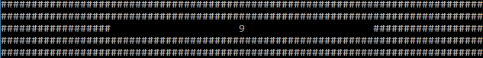

However, when 5 numbers are entered that exceed the total of 9 (anything consisting of 2 digits or more), the display breaks as the extra values interfere with the middle space between the hash keys. (see below)

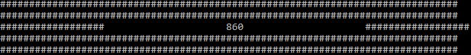

At the time of testing, the hash lines are hard coded and for each extra digit, there should be one less space.

Bug testing

In this section, a wide range of tests will be carried out to test the programs functionality and analyse and bugs and errors within the code. The tests will also include relevant images showcasing the necessary steps taken in the program whilst recordings the results.

#01 | User enters valid choice
Description |  | User enters a valid option (1-3)
 |  | Test Steps :
1 | Menu display asks user to choose from 3 options
2 | The number 1 is entered

Response |  | The menu should proceed and prompt the user to enter 5 numeric values.  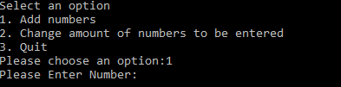
Status |  |  | Date |  |  | Description
Pass |  |  | 27/03/2018 12:02pm |  |  | Pass

#02 | User enters invalid choice
Description |  | User enters a letter instead of a numeric value (1-3)
 |  | Test Steps:
1 | Menu display asks user to choose from 3 options
2 | The letter j is interred

 |  |  |  | 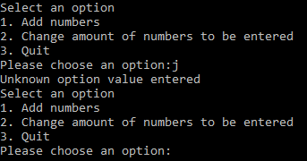
Response |  | An error message should display informing the user that the value entered is not correct. The display option should also be displayed again allowing the user to choose from the option again.
Status |  |  | Date |  |  | Description
Pass |  |  | 27/03/2018 12:12pm |  |  | Pass

#03 | User enters a number above 3
Description |  | The user enters a number outside of the chosen options (1-3)
 |  | Test Steps:
1 | Display menu prompts user to choose an option
2 | User enters 4

Response |  | The program should instruct the user that the value is invalid and display the menu options again.  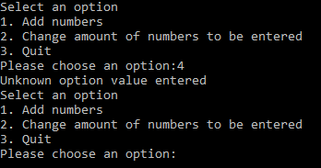
Status |  |  | Date |  |  | Description
Pass |  |  | 27/03/2018 12:20pm |  |  | Pass

#04 | Invalid values inputted
Description |  | When choosing option 1, the program asks for 5 numbers to later add up and display. When the user enters 5 letters instead, it reads back -4.
 |  | Test Steps:
1 | User enters 1 in display menu prompting program to request 5 numbers.
2 | User enters 5 letters
3 | Result displayed is -4

 |  |  |  | 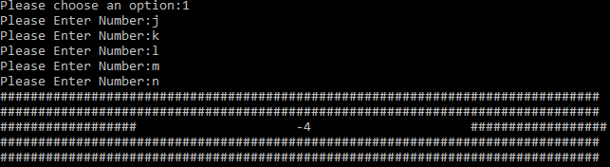
Response |  | The program should remind the user to enter numbers and prompt the user to enter the values again.
Status |  |  | Date |  |  | Description
Fail |  |  | 27/03/2018 12:20pm |  |  | Program inaccurately displayed the result as -4 instead of instructing the user to enter numeric values.

#05 | Total value display
Description |  | When entering 5 values that total more than one digit, the hash line display adds a space per extra digit.
 |  | Test Steps:
1 | User chooses option 1 from display menu
2 | User enters 5 values (that exceeds one digit total)
3 | Displays total

Response |  | The program should provide a total of the 5 values, and display the total precisely centred in the box.  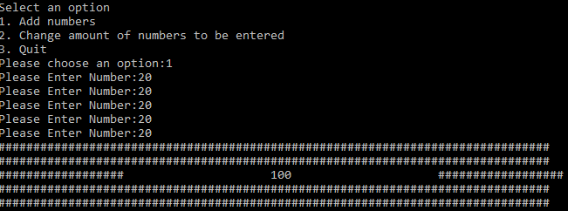
Status |  |  | Date |  |  | Description
Fail |  |  | 27/03/2018 12:26pm |  |  | The program does not centre the total sum accurately in the box. The program adds a space for each extra digit.

#06 | Changing the amount of values entered
Description |  | User selects option 2 from the display menu. The program asks the user to choose how many numbers they want to calculate. Once entered, program should ask for the declared number of values.
 |  | Test Steps:
1 | User enters 2 in display menu
2 | Program asks user to declare how many numbers to calculate
3 | Program runs display menu again, and prompts the user to enter the correct numbers declared previously

Response |  | The program should proceed in allowing the user to enter the correct amount of numbers previously declared, calculate and then display the result.  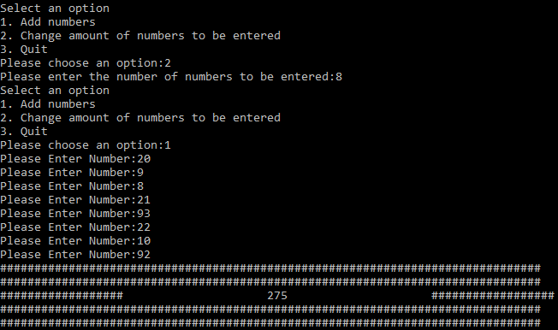
Status |  |  | Date |  |  | Description
Pass |  |  | 27/03/2018 12:34pm |  |  | Pass

#07 | Quitting the Program
Description |  | When choosing option 3 of the display menu, the program should proceed and quit.
 |  | Test Steps:
1 | User enters 3 from the display menu
2 | Program asks if the user is sure they would like to quit.
3 | After confirming with ‘yes’ the program runs the display menu again

 |  |  |  | 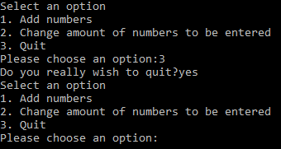
Response |  | The program should close instantaneously when user confirms with ‘yes’.
Status |  |  | Date |  |  | Description
Fail |  |  | 27/03/2018 1.24pm |  |  | Program does not close after confirming with the word ‘yes’.

#08 | Quitting the Program #2
Description |  | When choosing option 3 of the display menu, the program should proceed and quit.
 |  | Test Steps :
1 | User enters 3 from the display menu
2 | Program asks if the user is sure they would like to quit.
3 | After confirming with ‘Yes’ the program runs the display menu again

 |  |  |  | 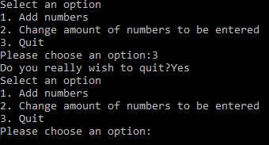
Response |  | The program should close instantaneously when user confirms with ‘Yes’.
Status |  |  | Date |  |  | Description
Fail |  |  | 27/03/2018 1.28pm |  |  | Program does not close after confirming with the word ‘Yes.

#09 | Quitting Program
Description |  | When choosing option 3 of the display menu, the program should proceed and quit.
 |  | Test Steps:
1 | User enters 3 from the display menu
2 | Program asks if the user is sure they would like to quit.
3 | After confirming with ‘YES’ the program begins to quit.

 |  |  |  | 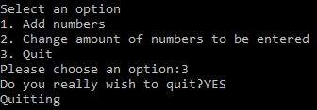
Response |  | The program should close instantaneously when user confirms with ‘YES’.
Status |  |  | Date |  |  | Description
Pass |  |  | 27/03/2018 1.42pm |  |  | Program only closes once the user confirms with ‘YES’ in uppercase. Letter case should not interfere with the programs functionality.

The bugs have been fixed (see Appendix).

The bug within the quit function is case sensitive related. As the variable response must be equal to ‘Yes’. After debating whether or not to use the OR operators and declaring every possible variation of the word Yes in letter case form, I found an interesting function called (_stricmp()). This function allows you to compare the string in the if statement without case sensitivity.

The display error fix was a little more complex. The hash lines are a width of 79 hashes per line. There are also 21 spaces on either side of the result, so I subtracted 42 from 79 and declared the variables rightHashesWidth and leftHashesWidth which were both equal to the number of hashes divided by 2. If the result displays an odd whole number, the program will then use mod to find the remainder to add on one side.

Identifying Problems

In this section, a proposal for a number guessing game has been made. The aim of the game involves the user guessing a number between -20 and +20 within 5 guesses. The user will get a new hint each time they fail to guess the correct number. This section will aim to identify the problems to be solved, and arrange them by complexity.

Using the srand function in the time.h library to automatically generate a number.

Using if statements to determine whether the number hits one of the following ranges:
- +/- 10 of the number
- +/- 5 of the number
- +/- 2 of the number

If the number fits any of the above ranges, print out a clue informing the user whether or not it is a negative or positive number, and which range it meets.

Creating a function that checks if the users guess was correct and use a for loop with the counter set to the variable that contains the number of guesses remaining.

Ask the user to enter a number (using an integer variable).

If user guesses correctly, display an end of game message using a printf statement informing the user that they guessed the random number.

If the user exceeds 5 guesses, inform the user they have lost the game using a printf statement.

APPENDIX

Application.h
#pragma once
#include "Console.h"

class Application
{
// Attributes
private:
Console * _console;
int _chosenOption;
int _numNumbersReqd;

// Constructors
public:
Application(Console* console);

// Properties
// NONE

// Methods
public:
void DisplayMenu();
bool ChooseOption();
bool ProcessOption();
private:
bool ReadNumber(string prompt, int* numberReturn);
bool GetTotal(int *totalReturn);
void DisplayResult(int result);
bool IsQuitting();
void DisplayHashesNTimes(int n);

};

Console.h
#pragma once
#pragma warning(disable:4996)
#include <conio.h>
#include <string>

using namespace std;

class Console
{
// Attributes
// NONE

// Constructors
// NONE

// Properties
// NONE

// Methods
public:
string ReadString();
bool ReadInteger(int* integerReturn);
double ReadDouble();
void Print(string text);
void PrintLine(string line);
void Pause(void);

private:
void ClearInputBuffer();
};

Application.cpp
#include "stdafx.h"
#include "Application.h"

Application::Application(Console * console)
{
_console = console;
_chosenOption = 0;
_numNumbersReqd = 5;
}

void Application::DisplayMenu()
{
_console->PrintLine("Select an option");
_console->PrintLine("1. Add numbers");
_console->PrintLine("2. Change amount of numbers to be entered");
_console->PrintLine("3. Quit");
}

bool Application::ChooseOption()
{
return ReadNumber("Please choose an option:", &_chosenOption);
}

bool Application::ReadNumber(string prompt, int* numberReturn)
{
_console->Print(prompt);
return _console->ReadInteger(numberReturn);
}

bool Application::ProcessOption()
{
bool quit = false;

switch (_chosenOption)
{
case 1:
int total;
if (GetTotal(&total) == true)
{
DisplayResult(total);

}
else
{
printf("Incorrect values entered. Please enter numeric values. \n");
}
break;
case 2:
if (ReadNumber("Please enter the number of numbers to be entered:", &_numNumbersReqd) == false)
{
_console->PrintLine("A number must be entered. Please try option 2 again. \n");
}
break;
case 3:
quit = IsQuitting();
break;
default:
_console->PrintLine("Unknown option value entered");
break;
}

return quit;
}

bool Application::GetTotal(int *totalReturn)
{
int total = 0;
int index;
int number;

*totalReturn = 0;

for (index = 0; index < _numNumbersReqd; index++)
{
if (ReadNumber("Please Enter Number:", &number))
{
total = total + number;
}
else
{
return false;
}
}

*totalReturn = total;

return true;
}

void Application::DisplayHashesNTimes(int n)
{
string hashes(n, '#');
_console->Print(hashes);
}

void Application::DisplayResult(int result)
{
int resultWidth;
int numberOfHashesNeeded;
int leftHashesWidth;
int rightHashesWidth;

_console->PrintLine("###############################################################################");
_console->PrintLine("###############################################################################");

resultWidth = to_string(result).length(); // the width of the number using length

numberOfHashesNeeded = 79 - 42 - resultWidth; // 79 display width - subtract 21 spaces on either side of the number = 42

leftHashesWidth = numberOfHashesNeeded / 2;

rightHashesWidth = leftHashesWidth + (numberOfHashesNeeded % 2); // how many hashes on both sides, if an odd number use mod for remainder as it rounds down.

DisplayHashesNTimes(leftHashesWidth);
_console->Print(" " + to_string(result) + " ");
DisplayHashesNTimes(rightHashesWidth);
_console->PrintLine("");

_console->PrintLine("###############################################################################");
_console->PrintLine("###############################################################################");
}

bool Application::IsQuitting()
{
string response;
bool quit = false;

_console->Print("Do you really wish to quit?");

response = _console->ReadString();

if (0 == stricmp(response.c_str(), "yes") || 0 == stricmp(response.c_str(), "y"))
{
_console->PrintLine("Quitting");
quit = true;
}

return quit;
}

Console.cpp
#include "stdafx.h"
#include "Console.h"

string Console::ReadString()
{
char text[100];

scanf("%99[^\n]s", text);
ClearInputBuffer();

return (string)text;
}

bool Console::ReadInteger(int* integerReturn)
{
int number;
int scanfReturn;

scanfReturn = scanf("%i", &number);
ClearInputBuffer();

if (scanfReturn == 0) {
return false;
}

*integerReturn = number;

return true;
}

double Console::ReadDouble()
{
double number;

scanf("%lf", &number);
ClearInputBuffer();

return number;
}

void Console::ClearInputBuffer()
{
char ch;
while ((ch = getchar()) != '\n' && ch != EOF);
}

void Console::Print(string text)
{
printf("%s", text.c_str());
}

void Console::PrintLine(string line)
{
Print(line + "\r\n");
}

void Console::Pause(void)
{
while (1) { if (_kbhit()) break; } // Pause
_getch();
}

Appendix.cpp
#define _CRT_SECURE_NO_WARNINGS
#pragma warning(disable:4996)

#include "stdafx.h"
#include <string>

#include "Console.h"
#include "Application.h"

using namespace std;

int main(int args, char* argv[])
{
Console* console = new Console();
Application* application = new Application(console);
bool quit = false;

console->PrintLine("*****************************************************************************");
console->PrintLine("* This application is designed to allow you to select the number of numbers *");
console->PrintLine("* you wish to enter, and sum the numbers that you provide. *");
console->PrintLine("*****************************************************************************");

while (quit == false)
{
application->DisplayMenu();
application->ChooseOption();
quit = application->ProcessOption();
}

console->Pause();

delete application;
delete console;
return 0;
}

