11/15/2023
Mohammad Shahidul Islam Chowdhury
Student Id 2026960
Title: Analyses and audits of Accor Hotel Group's business strategies
Lecturer: Dale Clarke
Abstract

An analysis of the Accor Hotel Group is presented in this report, which examines its organisational structure, corporate culture, goals, and recent change initiatives. Accor's position in the dynamic hospitality industry can be nuancedly understood through the analysis, which incorporates relevant theories and empirical evidence. The report identifies potential challenges associated with Accor's matrix structure. Using digital transformation and sustainability initiatives, it explores the company's progressive shift from customer-centricity to innovation and social responsibility. An analysis of recent change initiatives in Accor's internal processes, customer satisfaction, and financial performance is included in the report, which contributes to a holistic view of the company's strategy alignment with sustainable growth.

Table of Contents:
Page
1. Introduction……………………………………………………………………………… 1
Brief Overview of Accor Hotel Group
2. Organisational Structure, Culture, and Goals……………………………………..1-4
3. Recent Change Initiatives and Management………………………………………4-5
3.1 Overview of Recent Change Initiatives
3.2 Impact of Recent Changes
3.3 Management of Change Initiatives
4. Strategic Direction and Current Business Performance………………………..5-6
4.1 Strategic Direction
4.2 Business Performance
5. Two studies by AccorHotels demonstrate the importance of CSR for guest satisfaction and business growth……………………………………..……………….6-7
5.1 CSR Positively Impacts Guest Satisfaction
5.2 CSR Positively Impacts Hotel Profitability
6. Recommendations……………………………………………………………………..7-8
7. Conclusion………………………………………………………………………………8-9
8. References……………………………………………………………………………10-12
Introduction:
Managing various hotel brands, Accor Hotel Group spans more than 110 countries in the global hospitality landscape. As part of this report, Accor's organisational intricacies are examined judiciously to provide an in-depth analysis of its structure, culture, objectives, recent initiatives, and results (Robbins et al., D.A. (2020).; ‌Hitt et al., R.E. (2019).). In addition to analysing Accor's intricate facets, the report also examines its current operational efficiency and strategic direction.
To gain valuable insight into Accor's internal dynamics, we need to examine its multinational presence, which underscores its importance in the hospitality industry. This report attempts to unravel the intricacies of Accor's operations by considering its organisational structure, cultural underpinnings, established goals, and tangible consequences. A strategic orientation analysis accompanies Analysing Accor's real-time performance with this evaluative exploration. A comprehensive investigation of Accor's position within the dynamic and competitive hospitality industry will provide nuanced insights.
2. Organisational Structure, Culture, and Goals:
Structure:
Accor Hotel Group's organisational structure is characterised by a matrix design, which makes it exceptionally adaptable and flexible in managing a diverse portfolio of global hotel brands. (Robbins, S.P. and Judge, T. (2017)). This matrix effectively combines functional and divisional structures to respond dynamically and effectively to market demands.
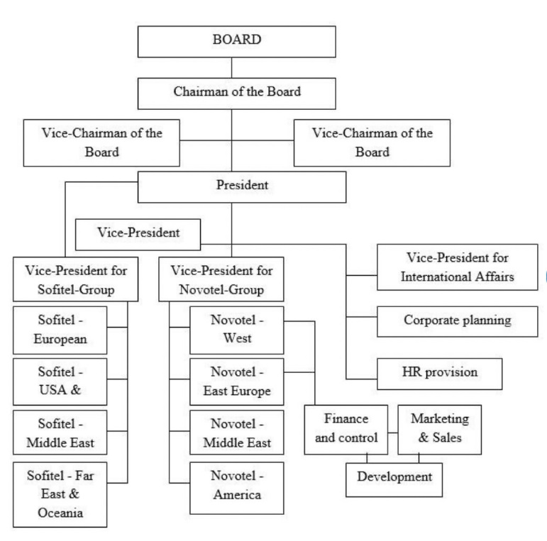
Figure 1: Fragment of the organisational structure of the Accor company as of 1991 (source: developed by authors)

This report examines Accor's matrix structure to identify potential challenges and explore how the company navigates these obstacles. An effective organisational structure ensures seamless service delivery across diverse hotel brands by streamlining operations and fostering collaboration. Efficiency can be improved by analysing this data.
Culture:
Accor Company has historically handled many customers around the world. Customer expectations must be satisfied by Accor Company's management and service delivery. The company will continue to enjoy profits and retain customers if it maintains customer satisfaction. In its history, Accor has been steadfastly committed to customer-centricity. This longstanding cultural trait has made providing personalised and memorable guest experiences possible (Schein, 2017).

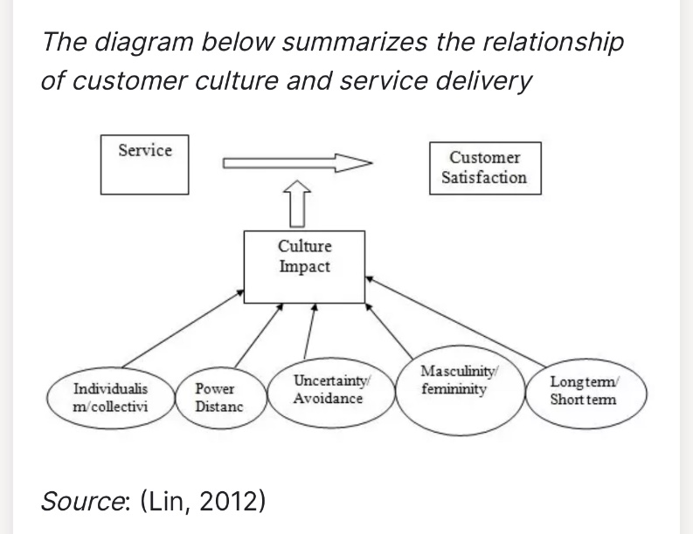

Figure 2: The diagram below summarises the relationship between customer culture and service delivery.
In an investigation of how Accor embeds innovation and social responsibility throughout its daily operations, the organisation explores how innovation and social responsibility are embedded throughout its organisational culture. To serve our guests better, Steven Daines (Chief Talent and Culture Officer) cultivates a multicultural, inclusive environment where creativity and innovation flourish.
Accor's cultural adaptation becomes increasingly crucial as customer preferences change and sustainability becomes a key focus in the hospitality industry. Accor aims to remain relevant and responsive to its diverse customer base by aligning its culture with emerging trends.
Goals:
A commitment to sustainability is at the core of what Accor Hotels does. Hence, through unlocking lifestyle experiences, we hope to positively impact the lives of everyone involved - Heartists®, owners, partners, guests, and communities. Accor's strategic goals are crucial, unveiling the organisation's overarching direction. Rooted in sustainable growth and innovation (Kotler & Keller, 2016), these multifaceted objectives mirror the company's dedication to establishing a formidable presence across diverse markets via international expansion. An in-depth exploration of Accor's digital landscape reveals a steadfast commitment to technological relevance in the fiercely competitive hospitality industry.
Each pillar of Accor's strategy is underscored by specific objectives, strategically addressing global environmental and social challenges intrinsic to the hospitality sector. Notably, the study elucidates Accor's conscientious approach in aligning these objectives with stakeholder concerns, creating a dynamic interplay between corporate strategy and societal expectations. The prioritisation process, integral to this analysis, is viewed through the lens of the United Nations Sustainable Development Goals (SDGs), underscoring Accor's active contribution to global sustainability through its Planet 21 initiative.
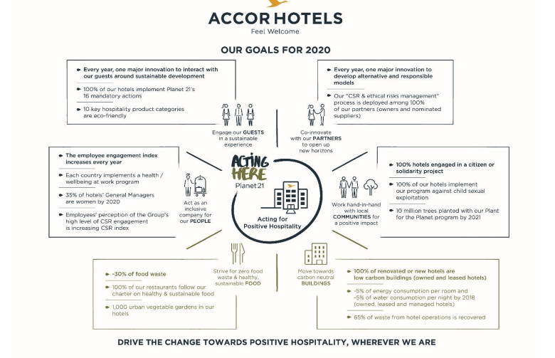
Figure 3: Drive the change towards positive hospitality wherever we are
This comprehensive examination unveils the intricate tapestry of Accor's strategic pursuits, weaving together market expansion, technological resilience, and environmental stewardship while harmonising with the broader canvas of global sustainable development goals.
In addition to achieving Net Zero CO2 emissions by 2050, we plan to reduce greenhouse gas emissions by 90% per the Paris Agreement. As part of our philosophy, we strive to protect and use natural resources responsibly to contribute to a "Nature Positive" world. Our hotels will be tied to their local ecosystems, and we will preserve natural ecosystems and biodiversity by the Kunming-Montreal Agreement of December 2022.
3. Recent Change Initiatives and Impact:
3.1 Change Initiatives:
A significant focus of Accor Hotel Group is aligning with new industry trends through digital transformation, lifestyle brands, and sustainability initiatives (Kaplan & Norton, 1996). Accor's digital transformation is discussed thoroughly, emphasising its role in enhancing guest experiences, optimising operations, and maintaining a competitive edge (Kaplan & Norton, 2016). Accor Hotel Group has undertaken substantial transformations in response to dynamic industry trends, focusing on digital transformation, the introduction of lifestyle brands, and sustainability programs. These initiatives are integral to Accor's strategic evolution, positioning the organisation to thrive in an ever-evolving hospitality landscape.
Digital transformation is a cornerstone of Accor's response to the evolving technological landscape. The report delves into the specific digital initiatives implemented by Accor, exploring how technology is leveraged to enhance guest experiences, streamline operations, and stay ahead in a digitally driven market. Introducing lifestyle brands is another noteworthy shift, reflecting Accor's commitment to catering to diverse consumer preferences. Understanding the rationale behind these lifestyle brand introductions provides insights into Accor's market responsiveness and innovation strategies. Additionally, sustainability programs underscore Accor's commitment to environmental stewardship, aligning with the industry's growing emphasis on responsible business practices.
3.2 Impact and Change Management:
The impact of these change initiatives is comprehensively evaluated across internal processes, customer satisfaction, and financial performance. Internal functions are scrutinised for their influence on organisational efficiency, communication, and employee engagement (Kaplan & Norton, 1996). Customer satisfaction metrics are examined in determining whether turn-around initiatives, such as digital transformations and lifestyle brands, are successful in enhancing guest experiences.
Accor's strategic evolution results from recent changes in revenue growth, profitability, and return on investment (Kaplan & Norton, 1996). Aside from evaluating the program's impact, the report examines Accor's change management strategies, including communication and implementation of these changes, overcoming potential resistance, and cultivating an adaptability culture (Hitt et al., 2019).
4. Strategic Direction and Business Performance:
4.1 Strategic Direction:
Accor's strategic direction includes decisions about brand development, partnerships, and geographic expansion and is a crucial aspect of its organisation. The report scrutinises these strategic choices to unveil the organisation's long-term vision within the complex market forces.
The Accor brand portfolio includes hotels tailored to different market segments (Kaplan & Norton, 1996). Based on consumer preferences, market trends, and competitive landscape analysis, we examine how these brand choices align with market trends and consumer preferences. Insights into Accor's adaptability and responsiveness to evolving market trends can be gained by assessing the rationale behind these brand development strategies.
Accor's strategic landscape depends on partnerships, which enable the organisation to leverage synergies and expand its reach (Dyer et al., 2004). This report examines Accor's strategic partnerships' nature, significance, and impact. It is essential to understand how Accor navigates industry challenges through its collaborative initiatives.
Accor's growth strategy is based on geographic expansion (Hitt et al., 2019). The report examines the criteria for making expansion decisions, the challenges of entering new markets, and the regions targeted for expansion. Analyses like this provide a comprehensive view of Accor's global ambitions and ability to tailor strategies based on various regional contexts.
4.2 Business Performance:
Business-to-business, traveller, and consumer services are the pillars upon which Accor Hotels operates under the visionary leadership of CEO Sebastien Bazin. Both locals and guests will benefit from an enhanced customer experience and comprehensive enhancements of services. Travellers and non-travellers can benefit from Accor's offerings, which go beyond traditional traveller-centric services. Accor has acquired a 50 per cent stake in Next-door to engage the broader community, a social networking site that facilitates local connections, enables babysitter searches and informs users of local events. By investing in this strategic initiative, Accor is enhancing its customer experience and expanding its service footprint. Considering financial and non-financial factors, we adopt a dual-lens approach to measure Accor's effectiveness. A company's commitment goes beyond its financial performance by focusing on non-financial metrics like customer satisfaction and employee engagement. The evaluation of Accor's performance is informed by financial metrics such as revenue growth, profitability, and return on investment.
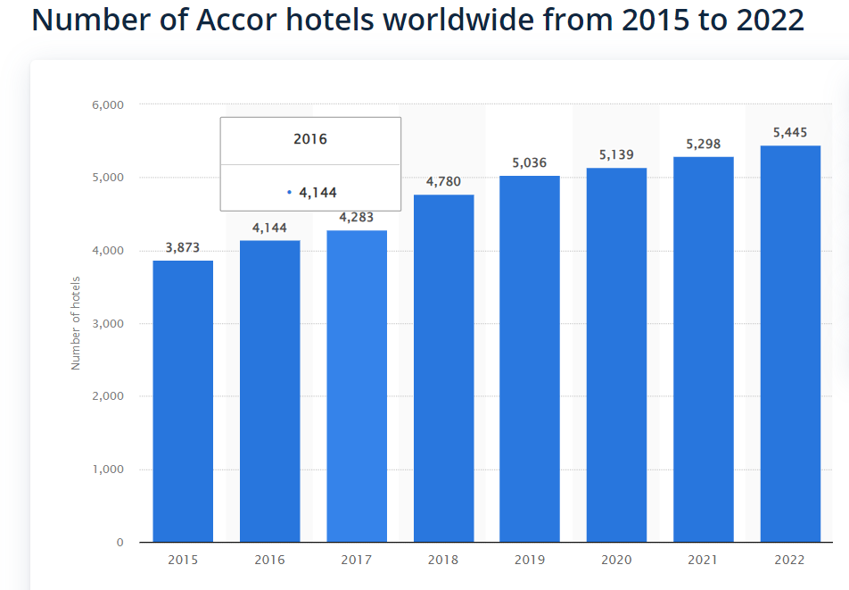
The evaluation extends beyond internal metrics based on Porter's seminal work on industry benchmarks (Porter, 1985). Accor's competitive position within the market can be better understood by comparing its performance with its key competitors. Accor's strengths are highlighted, and avenues for improvement are identified through this comparative analysis. It is in the section on business performance that the insights from earlier areas on organisational structure, culture, and goals are synthesised. A comprehensive overview of Accor's strategic choices is provided in this section, allowing stakeholders to gauge its success. Taking a retrospective view, the findings provide a roadmap for refining and stabilising operations in the dynamic hospitality landscape and sustaining a competitive edge. Accor's commitment to excellence and strategic foresight in the ever-evolving hospitality sector position the company as a leader ready to navigate challenges and capitalise on emerging opportunities.
5. Two studies by AccorHotels demonstrate the importance of CSR for guest satisfaction and business growth:
5.1 CSR Positively Impacts Guest Satisfaction:
According to a survey conducted by Accenture, sustainable development initiatives are closely linked to guest satisfaction. In a study conducted by the PLANET 21 Program, the results have indicated that obtaining ISO 14001 certification and sticking to PLANET 21 objectives will result in greater guest satisfaction.
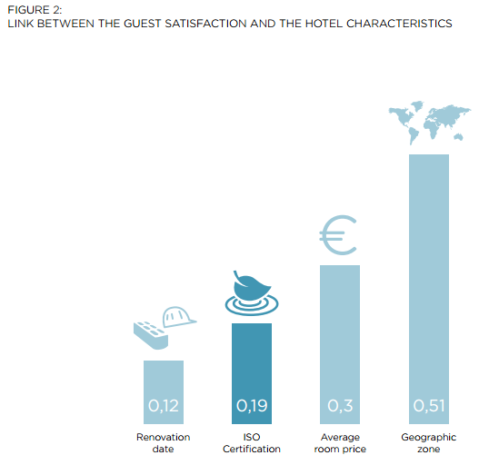 | 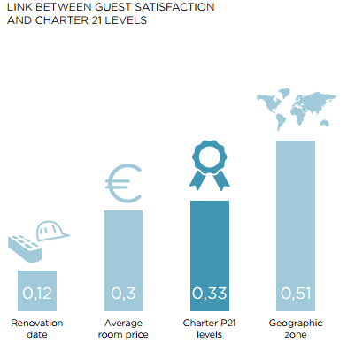

Figure 4: (charts from Accenture's survey conducted in May 2015, pages 14 and 18)
The ISO 14001 certification of a hotel is more correlated with guest satisfaction than the renovation date. PLANET 21 levels and customer satisfaction correlate more strongly than average room rates.
5.2 CSR positively impacts hotel profitability:
PLANET 21 certification also boosts profitability in hotels, which in turn improves guest satisfaction. To reduce hotels' environmental footprint, PLANET 21 recommends 65 actions through a system of internal groups (Bronze, Silver, Gold, Platinum). In addition to reducing costs (water, energy, waste), these actions also increase revenue (EBIT).
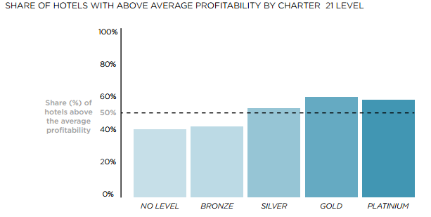
Figure 5: (Charts from May 2015 Accenture survey, page 19)
6. Recommendations:
Accor Hotel Group's competitive positioning and long-term success can be enhanced by the following strategic recommendations based on extensive analysis.
Enhance Communication Channels:
Address potential challenges posed by its adaptability by implementing streamlined communication processes.
Establish clear decision-making frameworks to optimise coordination across diverse hotel brands.
Cultural Adaptation:
Stay in tune with consumer preferences and industry trends by fostering a culture of continuous adaptation.
Enhance innovation and social responsibility in Accor while maintaining the company's historical commitment to customer-centricity.
Invest in Technology and Talent:
For effective implementation of digital transformation initiatives, allocate resources for technology investments.
Maintain a competitive edge in the technologically dynamic hospitality industry by utilising cutting-edge technologies to improve guest experiences.
To navigate the digital landscape successfully, organisations must invest in talent development.
Evaluate Sustainability Initiatives:
Ensure sustainability initiatives are aligned with environmental goals by thoroughly evaluating them.
Strive to resonate with the increasing eco-consciousness of consumers, contributing to societal expectations and enhancing long-term business resilience.
In the global hospitality market, Accor Hotel Group's implementation of these recommendations would position it to navigate industry complexities adeptly, foster an innovation culture, and bolster its overall competitiveness.
6. Conclusion:
Accor Hotel Group's performance was analysed and audited through this comprehensive report, which examines critical aspects such as organisational structure, cultural dynamics, strategic goals, recent transformations, and current business effectiveness. Based on the analysis, stakeholders will have an invaluable understanding of Accor's operations, which will help them navigate the complex and ever-evolving terrain of the hotel industry.
Exploring Accor's organisational structure revealed its adaptability and emphasised its potential challenges, which paved the way for a more nuanced evaluation of communication and decision-making. A historical commitment to customer-centricity was evident in organisational culture, accompanied by a shift towards innovation and social responsibility driven by digital technology and sustainability.
A company's strategic goals are aligned with global expansion, digital advances, and environmental responsibility to ensure sustainable growth and innovation. Accor's recent change initiatives were also discussed in the report, emphasising their pivotal role in the company's strategic evolution and assessing their impact on internal processes, customer satisfaction, and financial performance.
As an industry marked by rapid change, stakeholders will gain comprehensive insights from this synthesis of findings. In an environment characterised by dynamic consumer preferences, technological advances, and elevated environmental awareness, Accor relies on this report as a strategic compass as it navigates the complexities of the global hospitality market.

Reference:
Accor (2022). About Accor. [online] group.accor.com. Available at: https://group.accor.com/en/group/who-we-are/about-us.
Anon, (n.d.). Available at: https://group.accor.com/en/careers/our-culture-of-inclusion/our-commitment.
Anon, (n.d.). Available at: https://group.accor.com/en/commitment/approach/milestones.
Accor Planet 21 Background. (n.d.). Available at: https://accorhotelscomms.com/newsletter/luxe/2019/issue_02/spotlight-pdfs/Accor-Planet21.pdf.
accorregion _ nac (2018). AccorHotels Shares Two Studies on Corporate Social Responsibility (CSR) and its Effect on Guest Satisfaction and Business Performance. [online] Accor – Newsroom | North, Central America & Caribbean. Available at: https://press.accor.com/americas/5710-2/?lang=en.
Anon, (n.d.). Available at: https://group.accor.com/en/commitment/approach/sustainability-strategy.
Barney, J. B., & Hesterly, W. S. (2018). Strategic Management and Competitive Advantage: Concepts and Cases. Pearson.
Barney, J.B. & Hesterly, W.S. (2019). Strategic management and competitive advantage: concepts and cases. New York: Pearson.

Christensen, C. M., & Raynor, M. E. (2003). The Innovator's Solution: Creating and Sustaining Successful Growth. Harvard Business Review Press.

Digital Innovation and Transformation. (n.d.). Accor Hotels: The Transition of a Hotel Brand to a Hospitality Platform or ‘Augmented Hospitality’. [online] Available at: https://d3.harvard.edu/platform-digit/submission/accor-hotels-the-transition-of-a-hotel-brand-to-a-hospitality-platform-or-augmented-hospitality/#:~:text=Accor.
Dyer, J.H., Kale, P. & Singh, H. (2004). When to Ally and When to Acquire.
Free Essays. (n.d.). Accor Hotels’ Marketing Strategy - 1563 Words | Essay Example. [online] Available at: https://ivypanda.com/essays/accor-hotels-marketing-strategy-essay/.

Free Essays. (n.d.). Organisational Change Plan for Accor Company - 6439 Words | Essay Example. [online] Available at: https://ivypanda.com/essays/organizational-change-plan-for-accor-company-essay/.
Grant, R. M. (2019). Contemporary Strategy Analysis: Text and Cases Edition. Wiley.
Hitt, M.A., Ireland, R.D. & Hoskisson, R.E. (2019). Strategic Management Concepts and Cases: Competitiveness and Globalization. Mason, Oh: Cengage.
Hitt, M.A., Foster, J.B., Robbins, D., R. Duane Ireland & Hoskisson, R.E. (2013). Strategic Management: Concepts and Cases. Southwestern Educational Publishing.

Kaplan, R.S. & Norton, D.P. (2021). The strategy-focused organisation: how balanced scorecard companies thrive in the new business environment. Boston, Mass.: Harvard Business School Press.
‌Kaplan, R.S. & Norton, D.P. (1996). The Balanced Scorecard Translating Strategy into Action. Boston Harvard Business Review Press.
Kotler, P., and Keller, K.L. (2016). Marketing management. 15th ed. Harlow, England; London; New York; Boston; San Francisco; Toronto; Sydney [U.A.] Pearson.
Lin, S (2012). Hofstede Analysis and Customer Satisfaction in Hospitality Industries.Web.
Mariette, M. (2022). Accor continues transforming and simplifying its structure by leveraging its leadership positions in the most buoyant hospitality markets and segments. [online] Accor – Newsroom. Available at: https://press.accor.com/accor-continues-to-transform-and-simplify-its-structure-by-leveraging-its-leadership-positions-in-the-most-buoyant-hospitality-markets-and-segments/?lang=en.
‌Prahalad, C. K., & Hamel, G. (1990). The Core Competence of the Corporation. Harvard Business Review.
Porter, M.E. (1985). Competitive Advantage: Creating and Sustaining Superior Performance. Riverside: Free Press, pp.11–15.

Porter, M. E. (2008). The Five Competitive Forces That Shape Strategy. Harvard Business Review, 86(1), 78-93.

Robbins, S.P., Coulter, M.K. & Decenzo, D.A. (2020). Fundamentals of management. 11th ed. New York, NY: Pearson.

Robbins, S.P. & Judge, T. (2017). Organisational behaviour. 17th ed. Boston: Pearson.

‌ Schein, E.H. (2017). Organisational Culture and Leadership. 5th ed. Hoboken, New Jersey Wiley.

Staff, L. (2023). Accor Implements New Organizational Structure — LODGING. [online] LODGING Magazine. Available at: https://lodgingmagazine.com/accor-implements-new-organizational-structure/#.

Whittington, R., Regner, P., Angwin, D., Johnson, G. and Scholes, K. (2020). I am exploring Strategy. 12th ed. Hoboken: Pearson.
Daft, R.L., Murphy, J. and Willmott, H. (2014). Organisation theory and design: an international perspective. Andover: Cengage Learning.
Statista. (n.d.). Number of Accor hotels worldwide in 2019. [online] Available at: https://www.statista.com/statistics/247288/number-of-accor-hotels-worldwide/.
Schein, E.H. (2010). Organisational Culture and Leadership. Somerset: Wiley.
Barney, J.B. & Hesterly, W.S. (2019). Strategic management and competitive advantage: concepts and cases. New York: Pearson.
Kaplan, R.S. & Norton, D.P. (1996). The Balanced Scorecard Translating Strategy into Action. Boston Harvard Business Review Press.

‌

‌

