****DRAFT ONLY****
An Analysis in to the viability of Increasing the Oxford Tibial Tray Capacity at Zimmer Biomet Bridgend.

Student: Andrew Chick 1909134
Supervisor: Andrew Thorn
University: Trinity Saint David Wales



Declaration of Authenticity

‘This thesis is the result of the author’s original research. It has been composed by the author and has not been previously submitted for examination which has led to the award of a degree.’

Signed: Date:

Abstract

This project is aimed to increase the outputs of the Tibial Trays at the Bridgend Facility in order to meet a projected 600-unit, per week, increase in demand for Tibial trays in from September 2023. The project followed the DMAIC process and identified surface roughness of the Tibial Tray as a major factor affecting the Intec Robot's cycle time. By improving the surface roughness at the CNC Mill, the cycle time of the Intec Robot was reduced by 8 minutes, achieving the project goal without the need for additional equipment. However, this improvement came with both annual cost increases, and savings. The research and study highlights the importance of analysing existing processes before investing in new equipment and demonstrates how small changes in one area of the manufacturing process can have a significant impact on overall production capacity.
The paper also examines the obstacles encountered when implementing Lean manufacturing practices. Key challenges include management resistance, employee resistance, insufficient training, and cultural barriers. Authors such as Womack, Jones, Liker, George, Lawrence Jr., and Imai offer insights on overcoming these hurdles.
Furthermore, the paper highlights how Zimmer Biomet Bridgend promote Engagement and employee input.

Acknowledgements
I would like to take this opportunity to thank Zimmer Biomet for giving me the invaluable opportunity to work on this dissertation and complete my degree with honours in advanced manufacturing Operations. I am extremely thankful of the company's support, which has greatly influenced both my academic and professional paths.
The University of Wales Trinity Saint David (UWTSD), which has always supported me throughout my academic career, also has sincere thanks. The institution and Lecturers showed great resilience and commitment to ensure that I obtained the best education possible despite the unprecedented challenges provided by the COVID-19 pandemic. I am especially grateful to Andrew Thorn, my project supervisor, for his unrelenting support, guidance, and mentorship.
Finally, I would like to express my gratitude to my family and friends, who have been a constant source of motivation and support throughout my four-year academic journey. I would like to give special thanks to my wife, Lesley, whose unwavering support and encouragement have been instrumental in keeping me focused and motivated, even during the most challenging times, and also my two sons, Thomas and Ben. Throughout my academic journey, I have missed countless football games and training sessions, and I am grateful for their understanding. I am looking forward to spending quality time with them and focusing on family activities, now that I have completed this significant milestone in my academic and professional journey. I am truly blessed to have such a remarkable support system, and I cannot thank them all enough for their love, encouragement, and understanding.

Contents
Declaration of Authenticity 2
Abstract 3
Acknowledgements 4
Figures and Tables 7
Chapter 1. Literature Review 9
1.1 Six Sigma and Lean 9
1.2 Benefits of Lean 10
1.3 Challenges around the Implementation of Lean 11
1.4 Towers Watson Surveys 12
1.5 Lean and Industry 4.0 14
1.6 How Zimmer Biomet Bridgend Contribute to Employee engagement 16
Chapter 2. Introduction 17
2.1 Company Background 18
2.2 Zimmer Biomet Facility, Bridgend, South Wales 18
2.3 The Oxford Partial Knee System 19
2.4 Aims and Objectives 19
Chapter 3. Define Phase 21
3.1 The purpose of the Define Phase 21
3.2 The Problem Statement 21
3.3 The Project Team 21
3.4 The project objectives 22
3.5 The project plan 22
3.6 Value Stream Map (VSM) 22
3.7 Goal Statement 23
3.8 Project Charter 24
Chapter 4. Measure Phase 25
4.1 Purpose of the Measure Phase 25
4.2 Process Evaluation 25
4.3 Data Collection Plan 27
4.4 Measuring Strategy 27
4.5 Process Capability 30
4.6 FMEA 30
4.7 CNC Mill Measure Phase 33
4.8 Intec Robot 35
4.9 Linish Polish 38
Chapter 5. Analyse Phase 40
5.1 Purpose of the Analyse Phase 40
5.2 CNC Mill Analysis 41
5.3 Intec Robot Analysis 44
5.4 Analysis of rejects 46
Chapter 6. Improve Phase 50
6.1 What is the Purpose of the Improve Phase? 50
6.2 CNC Mill Improvements 51
6.3 Intec Robot Improvements 55
Chapter 7. Conclusion 58
Chapter 8. Further work 61
References 63

Figures and Tables

Table 1 - Resource Team 21
Table 2 - Intec Robot Capacity Detail 23
Table 3 - Intec Robot Cycle Time reduction to meet Demand 23
Table 4 - Advantages of Mirror Finish in Medical Devices 25
Table 5 - Data Collection Plan (Chambers, 2023) 27
Table 6 - Intec Robot OEE 36
Table 7 - Intec Robot Breakdown History 37
Table 8 - Intec Robot energy usage 38
Table 9 - Intec Robot burn mark trial belts 2 - 6 50
Table 10 - Results of Surface finish trial on CNC 51

Figure 1 - Towers Watson Survey Results (Watson, 2012) 13
Figure 2 - Results of Human-Machine Collaboration (H. James Wilson, 2018) 16
Figure 3 - WorkHuman Reward Example 17
Figure 4 - G7 Shells (Biomet, 2023)……………………………………………………………………….18 Figure 5 - Taperloc Stems (Biomet, 2023) 18
Figure 6 - Vanguard Knees (Biomet, 2023) 18
Figure 7 - Oxford Partial Knee System (Biomet, 2023)………………………………………………….18 Figure 8 - Oxford Partial Knee System Implanted (Biomet, 2023) 19
Figure 9 – Intec Robot 20
Figure 10 - Oxford Tray 2023 Forecast 20
Figure 11 - Gantt Chart 22
Figure 12 - Tibial Tray (Alpha) Value Stream Map 22
Figure 13 - Project Charter Part A 24
Figure 14 - Drawing specification of surface roughness (Biomet, 2015) 26
Figure 15 - Tibial Tray Process Flow 26
Figure 16 - Data gathered for Gauge R & R study (Headington, 2023) 28
Figure 17 - Mitutoyo Surftest SJ-310 29
Figure 18 - Mitutoyo Surftest SJ-310 gauge R&R results 29
Figure 19 - FMEA Scoring Criteria 30
Figure 20 – Intec Robot FMEA 31
Figure 21 – CNC Mill FMEA (Watkins, 2022) 32
Figure 22 - Face Mill Tooling……………………………………………………………………………….33 Figure 23 - Insert used in Face Mill (Iscar, 2023) 33
Figure 24 - Clamping Fixtures 33
Figure 25 - Surface Roughness results post CNC Mill 34
Figure 26 - Post Intec Robot Surface Roughness 36
Figure 27 - Post Intec Robot roughness reduction Graph 36
Figure 28 -Intec Robot Timings 37
Figure 29 - Intec Robot Breakdown run Chart 38
Figure 30 - Linish/Polish Work Centre 39
Figure 31 - Surface finish results post Linish/Polish 39
Figure 32 - Kaizen Event 40
Figure 33 - Study on Cutting Time V Surface Roughness (Amlana Panda, 2016) 42
Figure 34 - Runsom Surface Roughness chart 43
Figure 35 - Energy Cost Breakdown 45
Figure 36 - Energy Costs on Intec Robot 2400 45
Figure 37 - Energy Costs on Intec Robot 3000 per week 45
Figure 38 -Linish Polish scrap reason codes 46
Figure 39 - Pareto of Linish polish scrap 46
Figure 40 - Isikawa Diagram for Porosity at Linish Polish 47
Figure 41 - 1 weeks Scrap Download for Intec Scrap 47
Figure 42 - Run Chart of Intec Robot Scrap 48
Figure 43 - Ishikawa Diagram for Burn Mark scrap on Intec robot 48
Figure 44 - Run Chart for the effect of belt changes on Burn Marks 49
Figure 45 - Results of Spindle Speed V Surface Roughness trials 1 - 3 on CNC 51
Figure 46 - Tool Wear Trial 1 - 3 on CNC 52
Figure 47 - Results of Spindle Speed V Surface Roughness trials 3 - 6 on CNC 53
Figure 48 - Tool Wear Trial 3 - 6 on CNC 53
Figure 49 - Surface Finish Improvement 54
Figure 50 - Surface Roughness on CNC trial 55
Figure 51 - Run Chart of surface Roughness trial on CNC 55
Figure 52 - Run Chart of Surface Roughness post Intec Robot 56
Figure 53 - Belt reduction from belt 3 - 6 56
Figure 54 - Results of energy consumption post improvement 3000 per week 57
Figure 55 - Results of energy consumption post improvement 2400 per week 57
Figure 56 - Belt 1 & 2 cost /usage 2022 (Francis, 2022) 58
Figure 57 - Future State Value Stream Map 58
Figure 58 - Project Cost impact 2400 Per Week 60
Figure 59 - Project Cost impact 3000 Per Week 60
Figure 60 - Output from Brainstorming session 62

Chapter 1. Literature Review

1.1 Six Sigma and Lean
In order to improve operations, many sectors have adopted the Six Sigma and Lean techniques. Lean focuses on reducing waste and enhancing workflow, while Six Sigma is a data-driven strategy aimed at reducing inconsistencies and defects within processes. Within the manufacturing and service industries, both approaches have grown in popularity.
A key component of the Six Sigma technique for identifying and resolving issues is the DMAIC process, which consists of five steps. The significance of data and statistical analysis in the decision-making process is emphasised by this method. "The Six Sigma Handbook: A Complete Guide for Green Belts, Black Belts, and Managers at All Levels" (2002) provides a thorough overview of implementing Six Sigma methodology. It emphasises the importance of leadership support, project management, and teamwork in achieving successful execution.
Lean methodology uses a particular set of guidelines and techniques to reduce waste in order to maximise workflow efficiency. The strategy makes use of the value stream, flow, pull, and perfection principles to find and get eliminate waste in processes. Lean methodology's guiding principles and techniques are described in the book "The Toyota Way: 14 Management Principles from the World's Greatest Manufacturer". The book emphasises the importance of continual development and everyone's involvement in the process of improvement in order to obtain the best results. (Liker, 2004)
Numerous studies have shown the significant benefits of using Six Sigma and Lean techniques to raise organisational efficiency and process performance. According to Shah and Ward's study, applying lean techniques resulted in an important 50% decrease in lead time and an average gain in productivity of 33%. A similar study, conducted by an Indian manufacturing firm revealed that the application of Six Sigma successfully decreased the rejection rate for iron casting from 53.8 per heat to 0.66 per heat, resulting in an expected cost savings of up to 90,000 USD. (Rachna Shah, 2007) (Mishra Nandkumar, 2018)
Moreover, it has been demonstrated that combining Six Sigma and Lean techniques produces more significant benefits than using either methodology alone. According to a research study, the application of a combined Six Sigma-Lean methodology improved process performance by an average of 56%. Michael L. George (2005) offers a thorough guide on combining Six Sigma and Lean techniques in his book "Lean Six Sigma: Combining Six Sigma with Lean Speed" from 2002. The book highlights how the two approaches complement one another and emphasises how important it is to select the right tools and procedures in order to achieve the best process improvement. (George, 2002)
However, a number of researchers have also highlighted potential barriers to Six Sigma and Lean implementation. The effectiveness of these approaches is dependent on elements including executive leadership acceptance, staff involvement, and cultural fit, according to Heizer and Render's (2014) research. The Machine That Changed the World's authors have also criticised the introduction of Lean and Six Sigma to other industries. They claim that the shared relationship of these approaches with a particular emphasis on efficiency and cost reduction might lead to a lack of creativity and excessive reliance on standardised procedures. (Jay Heizer, 2017) (James P. Womack, 2007)

1.2 Benefits of Lean
Lean manufacturing, also known as just "Lean," is a production methodology that was developed in the 1980s and has since been widely adopted by companies all over the world. James P. Womack, Daniel T. Jones, and Daniel Roos, the authors of the book "The Machine That Changed the World," (2007) initially used the word "Lean" to describe the creative production techniques used by Japanese automakers like Toyota. Since then, an extensive amount of research has appeared that explores the advantages of Lean for companies across various industries and sectors. Some of the most significant findings from this body of research will be discussed in this literature review.
One of the primary benefits of lean manufacturing is increased efficiency. This is accomplished by removing waste from every stage of the production process, from the procurement of raw materials to the delivery of the finished product. According to James P. Womack and Daniel T. Jones' book "Lean Thinking: Banish Waste and Create Wealth in Your Corporation, lean manufacturing is the only sustainable way to create and maintain high levels of efficiency. They point out that adopting Lean practises frequently leads to significant reductions in lead times, inventory levels, and defect rates, which in turn results in cheaper costs and more production.
Improved quality is one of the main advantages of lean manufacturing. Businesses can find and address the underlying causes of quality concerns by concentrating on waste reduction and continual improvement. This is achieved by putting numerous Lean methods into practise, such as the 5S methodology, which involves sorting, simplification, sweeping, standardisation, and maintenance of a workplace. According to Jeffrey Liker's argument in their book "The Toyota Way: 14 Management Principles from the World's Greatest Manufacturer," lean manufacturing is an essential element in building a culture of continuous improvement and quality. He points out that Toyota's unwavering focus on waste reduction and continuous improvement has allowed them to consistently manufacture high-quality goods at a low cost.
Increased customer satisfaction is a third benefit of lean production. Businesses are better able to satisfy the demands and expectations of their customers by reducing waste and increasing quality. This is achieved through a number of Lean techniques, such as value stream mapping, which entails locating and removing non-value-added manufacturing process activity. According to Michael George and Robert Lawrence Jr. in their book "Lean Six Sigma for Service: How to Use Lean Speed and Six Sigma Quality to Improve Services and Transactions, lean manufacturing is a powerful tool for improving customer satisfaction and loyalty. They point out that companies can produce higher-quality goods and services that match or surpass consumer expectations by concentrating on the customer and reducing waste.
Lean manufacturing's fourth benefit is enhanced employee engagement. Businesses can foster a culture of continuous innovation and improvement by empowering employees to identify and resolve problems through employee involvement in the Lean process. This is accomplished through a variety of Lean techniques, including Kaizen events, which entail cross-functional teams cooperating to improve a particular process. Masaaki Imai argues in his book, "Gemba Kaizen: A Common Sense Approach to a Continuous Improvement Strategy," that lean manufacturing is a way of life that incorporates respect for people and continuous improvement. He points out that companies may tap into the creativity and knowledge of their employees to increase performance and production by engaging workers in the Lean process and establishing a culture of continuous improvement. (Imai, 2012)

1.3 Challenges around the Implementation of Lean
Lean manufacturing has many advantages to offer companies, but putting it into practise can be challenging. The obstacles of implementing Lean will be looked at in this literature review, including management resistance, staff resistance, insufficient training, and cultural barriers.
The resistance of the management is one of the major obstacles to implementing Lean. James P. Womack and Daniel T. Jones emphasise in their book, "Lean Thinking: Banish Waste and Create Wealth in Your Corporation," that a fundamental change in culture needs to occur in an organisation before lean can be implemented. This change can be met with resistance from management since it could put their authority and established procedures in question. The Lean methodology, which aims to cut costs and eliminate waste, may also make managers feel threatened because it could affect their staffing levels and budgets. The authors advise managers to get involved in the Lean process early on and understand its advantages for the company in order to overcome management opposition.
Another key obstacle to the implementation of lean is employee resistance. Employees may be reluctant to change, especially if they believe Lean poses a risk to their employment or method of doing things. Jeffrey Liker makes the case in his book, "The Toyota Way: 14 Management Principles from the World's Greatest Manufacturer," that resistance from employees can be overcome by including them in the Lean process and giving them the responsibility to recognise and resolve issues. The author stresses that the Lean methodology values employee input and motivates them to make ongoing adjustments to the production process.
Another issue that obstructs the application of lean is inadequate training. According to Michael George and Robert Lawrence Jr. in their book "Lean Six Sigma for Service: How to Use Lean Speed and Six Sigma Quality to Improve Services and Transactions," training at all levels of an organisation is necessary for successful Lean implementation. The authors stress that personnel should be given the tools and methods required to successfully apply Lean, and that training should be ongoing. Lack of understanding of the Lean strategy and difficulties implementing it can result from inadequate training.
Another obstacle to the implementation of lean includes cultural barriers. The adoption of Lean may be impacted by the differing views that various cultures have towards change and problem-solving. Masaaki Imai makes the case in their book, "Kaizen: The Key to Japan's Competitive Success," that cultural obstacles can be removed by implementing Kaizen, a Japanese strategy for continual development. The author highlights that Kaizen tries to build a culture of continuous improvement and recognises the contributions of all employees, which can help to get beyond cultural obstacles to implementing lean.
The organisational environment, which includes elements like plant size, unionisation, and age, affects how lean practises are used in organisational settings and can also have an impact on how they are applied. (Rachna Shah, 2003)
In conclusion, this literature analysis has identified some of the major obstacles that must be overcome in order to successfully implement Lean, including management resistance, employee resistance, a lack of proper training, and cultural barriers. Companies have to involve managers and workers into the Lean process, offer sufficient training, and create a culture of continuous improvement that values the input of all employees if they are to effectively solve these issues. The writers of the books under consideration highlight that in order for Lean to be successfully implemented, there must be a considerable cultural shift and a firm commitment on the part of enterprises.

1.4 Towers Watson Surveys
Towers Watson is a well-known, international provider of professional services with a focus on consulting in the areas of risk management, human resources, and employee benefits. To better understand the elements that affect worker satisfaction and retention, the organisation regularly conducts surveys on employee engagement.
One such survey, carried out by Towers Watson in 2012, evaluated the findings of an international study of employee engagement including more than 32,000 employees in 29 different countries. According to the study, there is a positive correlation between organisational performance and employee engagement, and motivated workers are more likely to stay with their employers over the long term, Figure 1 illustrates the correlation found with employee engagement and operating margins over 50 companies. (Watson, 2012)
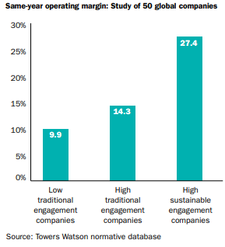
Figure 1 - Towers Watson Survey Results (Watson, 2012)

In addition, the survey highlighted a number of important factors that influence employee engagement, including leadership, professional development opportunities, communication, and rewards and recognition. According to the poll, strong leadership is crucial for increasing employee engagement since motivated individuals are more likely to have confidence in their managers.
According to the report, communication is a key element in fostering employee engagement because informed and connected employees are more likely to be involved. Higher levels of engagement and greater organisational performance are to be expected from companies that communicate with their staff on a regular basis.
According to the survey, employees are more likely to be engaged when there are opportunities for career progression and they feel that their organisations care about their growth and development. Higher levels of engagement among employees are something that organisations that provide clear career routes, skill development programmes, and training opportunities may anticipate.
According to the report, rewards and recognition are crucial factors in determining employee engagement since motivated workers are more likely to feel valued and appreciated. Employers should anticipate seeing higher levels of involvement from their workforce if they provide competitive pay and benefits packages as well as recognition programmes that reward good performance. (Watson, 2012)

1.5 Lean and Industry 4.0
The manufacturing sector is changing thanks to Industry 4.0, often known as the fourth industrial revolution, which integrates innovative digital technologies like robotics, big data analytics, artificial intelligence (AI), and the internet of things (IoT). A more effective and productive manufacturing process is being created by the technology revolution, which is bringing in a new era when machines can communicate with one another and make decisions in real time without human intervention. Lean manufacturing practises, which attempt to reduce waste in the production process, are also being adopted as Industry 4.0 gains traction.
A key component of Industry 4.0 is robotics. Although the use of robots in manufacturing is not new, Industry 4.0 has led to an increase in robot intelligence and their ability to carry out previously human-required jobs. Robots are now able to collaborate with people and other machines thanks to the integration of AI and machine learning, which has accelerated up and improved production processes.
Robots can perform dangerous and repetitive operations, freeing up human workers to concentrate on more difficult and value-added tasks. This is one of the key advantages of applying robots in production. This may lead to more productivity, reduced costs, and higher levels of quality. Robots can work continuously without getting tired, helping businesses to boost production and better satisfy consumer demand.
Robotics can improve how effective lean manufacturing principles are. The use of real-time data from sensors and analytical tools by manufacturers allows them to detect waste areas in the system and optimise their manufacturing processes. For instance, sensors can detect long periods of inactivity of a machine and send out a maintenance request, preventing failures and reducing downtime. Robots can assist in reducing unpredictability in the production process by automating routine operations, allowing companies to reliably deliver high-quality products.
Furthermore, just-in-time (JIT) production can be used thanks to robots that can be taught to do tasks in a particular order. JIT production minimises waste and inventory costs by producing products only when they are required. Robots can also make continuous flow production possible, which minimises lead times and wait times by having materials and components move continually through the production process.
Robotics and Industry 4.0 can help manufacturers in making significant improvements to productivity, quality, and customisation, which is one argument in its favour. Industry 4.0 can result in a 30% gain in productivity, a 50% drop in time-to-market, and a 20% decrease in production costs, suggest Kagermann et al. (2013). Furthermore, robotics can carry out jobs with more accuracy and precision, producing goods of superior quality. (Henning Kagermann, 2013)
There are concerns that the use of robotics in the manufacturing sector could result in job losses and a rise in economic inequality. Some claim that the use of robotics and Industry 4.0 could widen the skills gap because workers will need to acquire new skills in order to work with these cutting-edge technologies. Additionally, as noted by Berman (2012), 3D printing may allow businesses to move manufacturing back to developed nations, which would reduce the need for offshore outsourcing but would result in job losses in nations that rely on low-cost manufacturing. (Berman, 2012)
Combining Industry 4.0, robotics, and lean manufacturing methods provides both advantages and disadvantages. On the one hand, the Toyota Production System, which is founded on lean principles, has proven extremely effective in enhancing efficiency and minimising waste in the manufacturing process, as Liker (2004) explains. Lean manufacturing can aid businesses in increasing productivity, cutting costs, and enhancing quality. On the other hand, others contend that lean manufacturing can also result in increased pressure on employees to perform well, which may cause burnout and adverse health effects. (Liker, 2004)
It is important to point out that human engagement is frequently necessary for proper implementation and use of robotics in industry. While robots can complete jobs quickly and accurately, they are sometimes unable to make decisions and adjust to new circumstances in the same way that humans can. As a result, human personnel are often needed to manage operations, programme and maintain the robots, and make judgement and common sense based judgements. (H. James Wilson, 2018)
According to studies, using humans and robots in collaboration can produce even bigger advantages than relying simply on automation. For instance, a 2018 study in the Harvard Business Review claimed that productivity rose by up to 85% when people and robots collaborated in a production context as opposed to when only humans were involved. The International Federation of Robotics (IFR) also discovered that the employment of robots has resulted in the creation of new jobs, including those in management, maintenance, and programming, in sectors like the automotive manufacturing industry. (Robotics, 2017)
As a result of the introduction of robotics into industry, considerable gains have been made, but it is important to recognise the crucial role that people still play in realising the full potential of automation. It has been demonstrated that human-robot collaboration can produce even bigger advantages, such as higher production and the development of new jobs. They can achieve this by adhering to the five principles listed below: reinvent business processes, welcome experimentation and employee involvement, actively direct AI strategy, responsibly collect data, and redesign work to incorporate AI and foster associated staff abilities. In a study of 1,075 companies across 12 industries, it was discovered that those that implemented more of these concepts outperformed other companies in terms of speed, cost-savings, revenue, or other operational metrics. Human-Machine Collaboration's findings are shown in Figure 2. (H. James Wilson, 2018)

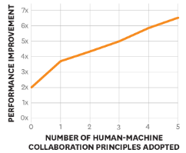
Figure 2 - Results of Human-Machine Collaboration (H. James Wilson, 2018)

Overall, Industry 4.0, robots, and lean manufacturing integration have the potential to change the manufacturing sector and give businesses the ability to adapt quickly to the changing business climate of today. But it's crucial to carefully weigh the possible advantages and disadvantages of new technologies and make sure the advantages are distributed equally throughout society.

1.6 How Zimmer Biomet Bridgend Contribute to Employee engagement
Zimmer Biomet has implemented several noteworthy initiatives to enhance employee engagement within the organisation. One such initiative is the provision of a dedicated kaizen room, where employees can actively participate in continuous improvement activities. Additionally, a specialised continuous improvement team is in place to drive and support these initiatives. However, it is observed that these valuable resources and opportunities for employee engagement are currently underutilised within the company.
Another positive aspect of Zimmer Biomet's employee engagement efforts is the implementation of the "workhuman" reward scheme, this being highlighted as a key component to engagement in the 2012 Towers Watson Survey. An example of such a reward is illustrated in Figure #. This program offers employees the opportunity to earn points that can be redeemed for various gifts. However, there is a need for improvement in terms of effectively utilising this reward scheme. The criteria for awarding points should be made clearer and better communicated to ensure employees fully understand how to earn and redeem their rewards.

Figure 3 - WorkHuman Reward Example
While employees are involved in certain projects directly controlled by the manufacturing department, there is a missed opportunity to fully leverage the extensive knowledge and expertise of the shop floor team. Currently, project teams operate independently, limiting the exchange of insights and valuable contributions from the shop floor. To maximise the potential benefits of employee involvement, it is essential to establish mechanisms that encourage collaboration and knowledge sharing between project teams and the broader workforce.
Whilst Zimmer Biomet has implemented commendable initiatives to promote employee engagement, there is room for improvement in their utilisation. Enhancing the effectiveness of the kaizen room, the workhuman reward scheme, and fostering collaboration between project teams and the shop floor workforce can lead to a more robust and engaged workforce, ultimately benefiting the company as a whole.

Chapter 2. Introduction

2.1 Company Background
Zimmer Biomet, founded in Warsaw in 1927, operates in over 25 countries, selling products in over 100 countries worldwide. The global team designs, manufactures, and markets innovative musculoskeletal technologies that assist orthopaedic surgeons and clinicians in improving patient mobility, pain relief, and overall quality of life. Zimmer Biomet aims to enhance its value to healthcare providers and patients by maintaining world-class scientific facilities and collaborating with leading clinicians and researchers worldwide to find the best technologies, treatments, and solutions for patients. (Biomet, 2023)

2.2 Zimmer Biomet Facility, Bridgend, South Wales
The Bridgend Facility produces a range of products that supply the musculoskeletal market around the globe. Backed by the Welsh Government as an anchor company, the Facility is an integral part of the South Wales community. (Farrell, 2016). The site manufactures 4 core brands for Zimmer Biomet, which are illustrated in figures 4 to 7; G7 shells, Taperloc stems, Vanguard Knee and Oxford Partial Knee. (Biomet, 2023)
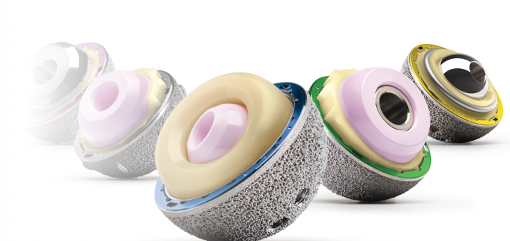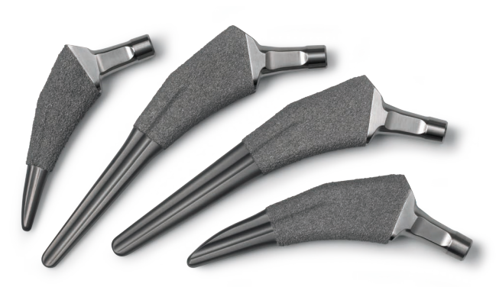
Figure 4 - G7 Shells (Biomet, 2023) Figure 5 - Taperloc Stems (Biomet, 2023)

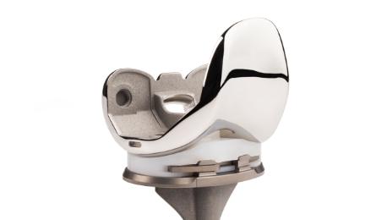
Figure 6 - Vanguard Knees (Biomet, 2023)

2.3 The Oxford Partial Knee System
The Oxford Partial Knee System, as illustrated in Figure 7, is the focus of this project. It boasts clinical legacy of 45 years and is widely acknowledged as the most extensively used and clinically validated partial knee system in the world, with a 94% survivorship at 15 years. In comparison to total knee replacement, the Oxford Partial Knee presents a minimally invasive option for surgical treatment that has been associated with lower morbidity and pain scores. (Biomet, 2023) As a consequence of the products popularity, demand has surged, particularly during the Covid-19 pandemic, and the management team at Zimmer Biomet Bridgend is faced with the challenge of increasing the capacity. (Network, 2023)
As illustrated in Figure 7, the Oxford Knee System comprises a femoral component, a tibial component, and a mobile meniscal bearing. The Tibial and femoral components are made from cobalt chromium, the bearing is made of high molecular weight polyethylene. The system is distinguished by the anatomical configuration of the tibial component, which ensures optimal bone coverage. Figure 8 portrays the appearance of the system following the implantation procedure. (Biomet, 2023) All of the components in Figure 7 are manufactured at the Bridgend Zimmer Biomet Facility in South Wales, UK.

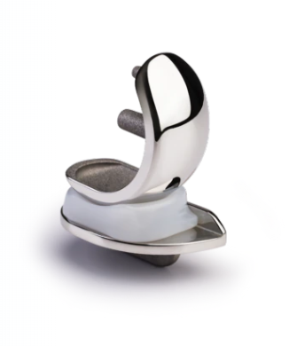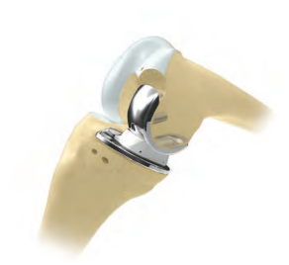
Figure 7 - Oxford Partial Knee System (Biomet, 2023) Figure 8 - Oxford Partial Knee System Implanted (Biomet, 2023)

2.4 Aims and Objectives
The increasing of the production outputs for tibial trays at the Bridgend Facility is a critical task that requires careful consideration of various factors. The facility is currently operating at near-full capacity on the Intec robot, and the demand for tibial trays is projected to increase by 600 per week from September 2023. Therefore, it is essential to analyse the available options and identify the most efficient and cost-effective solution for increasing the production outputs of tibial trays. This project will ensure an in-depth analysis of the current manufacturing process for tibial trays, including the Intec Robot which is a constraint for the Tibial Trays. The project will follow the DMAIC process, however, it will progress up to, and including the Improve Phase. The analysis will aim to identify potential bottlenecks and inefficiencies in the current process that may be limiting the production outputs of the Intec robot. Moreover, various options for increasing the outputs will be explored, such as optimising the current manufacturing process, or investing in additional equipment, which should be the last resort because of the significant cost and resource involved.
Despite an increase in demand for all three components of the Oxford Partial Knee, the Bridgend facility's primary concern is the production of tibial trays. This is due to the fact that tibial trays are manufactured using an automated linishing and polishing robot, namely the "Intec Robot," as depicted in Figure 9. The Intec Robot has an average weekly capacity of 2400 tibial trays, and is running at the maximum capacity. As outlined in Figure 10, the forecast for tibial trays in 2023 is 3000 per week, resulting in a total annual production requirement of 153,000 components, a 600 per week increase on the previous year. This increase is expected in September of 2023.
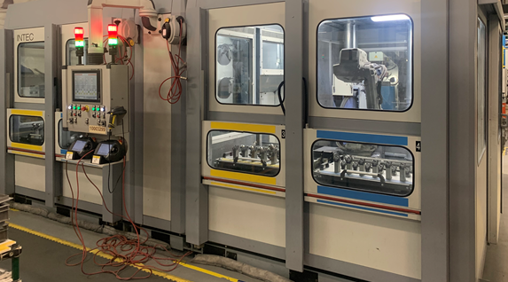
Figure 9 – Intec Robot

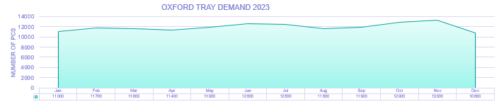
Figure 10 - Oxford Tray 2023 Forecast

Chapter 3. Define Phase

3.1 The purpose of the Define Phase
The Define phase will be the initial step that aims to identify and define the problem, and develop a clear understanding of the project's scope. The Define phase involves gathering relevant data and information, analysing the problem, and defining the project's goals and objectives. This phase is crucial in ensuring that the project team and stakeholders have a shared understanding of the problem, and that the project's objectives align with the organisation's strategic goals.
According to the Six Sigma improvement methodology, the Define phase establishes a clear problem statement, identifies the project's scope and objectives. (Thomas Pyzdek, 2002)

3.2 The Problem Statement
The demand for Oxford tibial trays is projected to increase to 3000 components per week in 2023, which exceeds the current production output of 2400 on the Intec Robot. An analysis of the manufacturing process is required to explore the possibility to increase the output to meet the new demand, or purchase new equipment.

3.3 The Project Team
The resource required for this project is minimal, the goal here is to analyse and put forward a proposal to the senior leaders of Zimmer Biomet Bridgend, following the proposal, the resource requirement for implementation would increase. Highlighted in Table 1 is a breakdown of the resource required to achieve a proposal.
Name | Role | Requirement
Andrew Chick | Manufacturing Leader (Project Leader) | To Champion and Create proposal for the Senior Leadership at Zimmer Biomet Bridgend.
Dean Evans | Manufacturing Support | Support with Information gathering and Trials
Chris Chambers | Manufacturing Support | Support with Information gathering and Trials
Justin Headington | Quality Support | Support with Information gathering and Trials
Gari Bush | Quality Support | Stakeholder
Anthony Harrison | Manufacturing Manager | Stakeholder

Table 1 - Resource Team

3.4 The project objectives
The primary objective of this project is to decrease the cycle time on the Intec Robot by analysing the automatic linishing robot process in the Oxford Area at Zimmer Biomet Bridgend, with a focus on increasing the output and/or making a business case for the purchase of new equipment. However, in order to achieve this objective in a comprehensive manner, a holistic review of all processes will be required. Moreover, research and analysis will be conducted on Lean methodologies and their implementation in a manufacturing setting, specifically at Zimmer Biomet Bridgend.

3.5 The project plan
The project plan will be monitored via a Gantt Chart; Figure 11 illustrates the chart. A Gantt chart is a visual project management tool that displays a project's tasks and their related deadlines. The timetable for the project is shown as a bar chart, with each bar representing a specific task, its duration, and its start and end dates. (Kerzner, 2013)
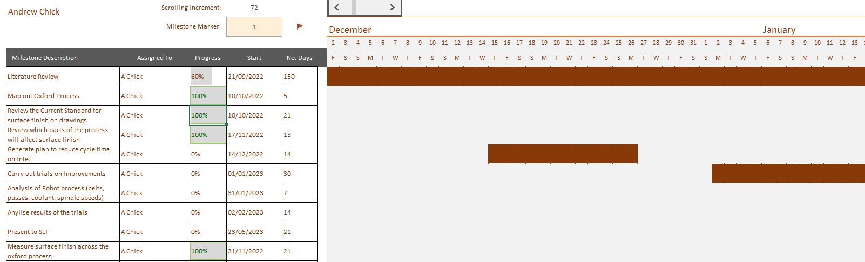
Figure 11 - Gantt Chart

3.6 Value Stream Map (VSM)
The VSM, as depicted in Figure 12, serves to provide a broad and inclusive view of the entire process, with the intention of identifying any factors that may impact the reduction of the Intec cycle time or increase outputs.
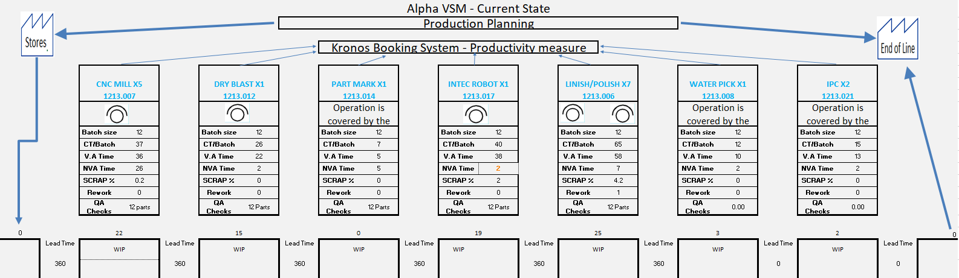
Figure 12 - Tibial Tray (Alpha) Value Stream Map
A value stream map has detailed the Intec Robot Cycle time, which amounts to 40 minutes. The capacity of the Intec robot has been carefully quantified, taking into consideration all necessary break times, Shift Cleans, and Planned Maintenance. Table 2 contains a breakdown of these considerations. Based on this analysis, the current output of the Intec robot is estimated to be 2569 components per week. However, the demonstrated output for 2022 was 2400 per week, this is because of all the small stops that occur, for example; change overs, belt changes. This gives an average productivity of 94%. (Karen Martin, 2014)

Average Cycle Time per batch in minutes on the Intec Robot (12 components) | 40
Average Cycle Time per part in minutes on the Intec Robot | 3.33
Total Minutes available per week on Intec Robot in minutes (minus Breaks, planned maintenance and TPM) | 8556
Total Maximum Weekly output achievable with no stops | 2569
Average demonstrated output 2022 at 94% productivity (all stops included, belt change, Line Clearance) | 2415

Table 2 - Intec Robot Capacity Detail

3.7 Goal Statement
The Goal is to ensure that the Bridgend facility can meet the increasing demand for tibial trays while maintaining high-quality standards and operational efficiency for tibial trays to maintain its competitive position within the orthopaedic manufacturing industry, and also Zimmer Biomet Bridgends position in the global structure. To quantify this;

“Increase the output on the Intec Robot to 3000 per week, enabling the fulfilment of increased customer demand”.

Table 3 shows the reduction in cycle time required. This will effectively allow Bridgend to increase the supply to 3000 per week, which means demand can be met. Should this reduction not be possible, a new machine may be required. The reduction equates to <1minute per part.

Cycle Time per batch on the Intec Robot (12 components) | 40 minutes
Required Cycle Time to ensure demand can be met (12 components) | 32 minutes
Total Reduction in Cycle Time | 8 minutes
Table 3 - Intec Robot Cycle Time reduction to meet Demand

3.8 Project Charter

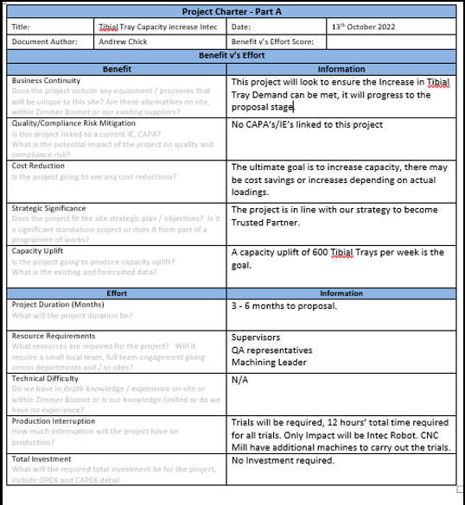
Figure 13 - Project Charter Part A

Chapter 4. Measure Phase

4.1 Purpose of the Measure Phase
The purpose of the Measure phase in the DMAIC improvement methodology is to establish a baseline performance of the process to be improved through the collection and analysis of data (Montgomery, 2009). During this phase, process performance is measured to determine the process's stability and capability (E. V. Gijo, 2011). The data collected during the Measure phase is used to validate the problem statement, confirm the project goals and objectives, and identify the root causes of the problem (Thomas Pyzdek, 2002).
The Measure phase is a critical step in the DMAIC methodology, as it provides the foundation for subsequent improvement efforts (Chase, 2004)The data collected and analysed during this phase serve as a baseline for comparison to evaluate the effectiveness of any changes made during the subsequent Analyse, Improve, and Control phases of the DMAIC process (Thomas Pyzdek, 2002).

4.2 Process Evaluation
The primary purpose of the Intec Robot process is to reduce the average surface roughness of the tibial tray to the drawing tolerance.
Medical devices, such as tibial trays, are manufactured to specific standards to ensure their safety and efficacy. One of the critical factors that impact the performance of medical devices is their surface finish. A mirror finish, characterised by a smooth and polished surface, is often required for medical devices as it has several advantages which can be found in Table 4. (Crisbasan, 2021) Moreover, Figure 14 illustrates the specification, which is 0.05µm (+0.00 µm / -0.05 µm).
Advantages of Mirror Finish in Medical Devices
Reduced Friction | A smooth surface finish reduces friction, which is essential for medical devices that come into contact with tissues, fluids, or other surfaces. Reduced friction minimises the risk of damage or wear to the device and ensures that it functions optimally.
Improved Cleanliness | A mirror finish makes the surface of medical devices easier to clean and disinfect. The absence of microscopic crevices and pits that can harbour bacteria and other pathogens reduces the risk of infection and contamination.
Enhanced Biocompatibility | The surface finish of medical devices can affect their biocompatibility, which is the ability of the device to interact with living tissue without causing an adverse reaction. A mirror finish can improve biocompatibility by reducing the surface area and thereby reducing the amount of material that comes into contact with tissue or bodily fluids.
Table 4 - Advantages of Mirror Finish in Medical Devices
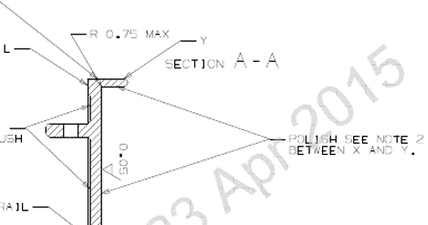
Figure 14 - Drawing specification of surface roughness (Biomet, 2015)

A comprehensive evaluation was carried out to assess the factors influencing the roughness of the Tibial Tray. As depicted in Figure 15, the Process Flow illustrates all the work centres that can impact the surface finish of the Tibial Tray. From the seven work centres, it was observed that only three of them significantly contribute to the surface finish of the tray. Therefore, it can be determined that these three work centres play a vital role in determining the final roughness of the Tibial Tray, furthermore, they could directly impact the cycle time of the Intec Robot.

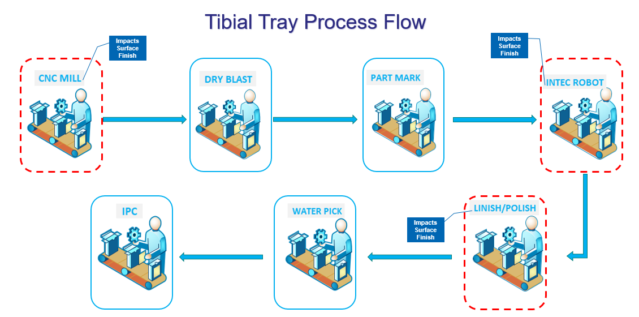
Figure 15 - Tibial Tray Process Flow

4.3 Data Collection Plan
A data collection plan is crucial because it ensures the data is gathered in an organised and systematic manner, that the information is reliable and pertinent to the research question, and that the research is carried out quickly and successfully. A well-crafted data collection plan aids in reducing errors, boosting the validity and dependability of the data gathered. The processes that can affect surface roughness will be the focus of the data collected for this project, as concentrating on these areas will ensure the best use of time. Table 5 Illustrates the Data Collection Plan. The Data plan includes where the data will be gathered, when, by who and what data is required. (Hessing, 2023)

Data Collection Plan
Process | Points of interest | Required Data | Measuring Strategy (How will it be measured) | Start Date | End Date | Owner
1. CNC Mill  At Zimmer Biomet Bridgend | 1.1 Surface Finish  1.2 Cutting Speeds  1.3 Tooling used | 1.1.1 Average Roughness in MM  1.2.1 Feed Rate and Spindle Speed  1.3.1 Tooling Description | 1.1.2 Mitutoyo Surftest SJ - 310  1.2.2 Review of CNC Program  1.3.2 Evaluation of CNC Tooling | 18th Nov 2022 | 12th Jan 2023 | C Chambers
2. Intec Robot  At Zimmer Biomet Bridgend | 2.1 Surface Finish  2.1 Cycle Times | 2.1.1 Surface reduction post belts  2.2.1 Cycle times of each step | 2.1.2 Mitutoyo Surftest SJ – 310  2.2.2 Intec Robot PC | 18th Nov 2022 | 12th Jan 2023 | A. Chick
3. Linish/Polish  At Zimmer Biomet Bridgend | 3.1 Surface Roughness | 3.1.1 Average Roughness Pre and Post Linish/Polish | 3.1.2 Mitutoyo Surftest SJ - 310 | 18th Nov 2022 | 12th Jan 2023 | A. Chick
Table 5 - Data Collection Plan (Chambers, 2023)

4.4 Measuring Strategy
As Table 5 indicates, the only measuring device that is required for the data collection is a surface roughness tester which measures the surface finish of the components.
The tester used in the project was selected following a gauge R&R study on the surface tester used at Zimmer Biomet Bridgend.
Gauge R&R (repeatability and reproducibility) is a statistical method used to assess the measurement system's variation and this study was conducted on both surface testers. An acceptable variance in Gauge R&R depends on the specific application and industry standards. In general, a total variance of 30% or less is often considered acceptable in many industries, and this is the case for this study.
(Saikaew, 2018)
The Quality Department conducted the Gauge R&R study following the data gathering. The study involved three operators, who were tasked with measuring ten parts each, three times. A sample of the data gathered during the study is presented in Figure 16. The Surface tester can be seen in Figure 17.

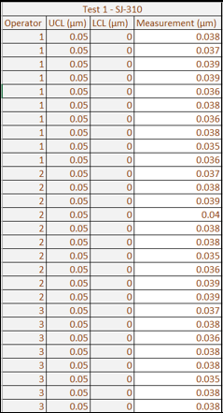
Figure 16 - Data gathered for Gauge R & R study (Headington, 2023)

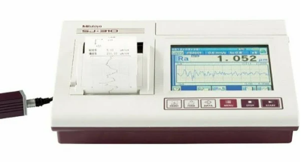
Figure 17 - Mitutoyo Surftest SJ-310

Subsequently, the data collected was exported to Mini tab software for analysis, and the resulting findings were documented. Figure 17 has been provided to depict the results on the Mitutoyo Surftest SJ-310. Upon conducting the analysis, it was observed that the Mitutoyo Surftest SJ-310 had a Total Variance (TV) of 19.1% which is acceptable. The tester confirmed for use on this project.
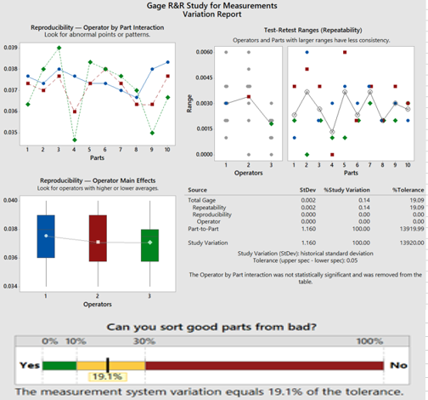
Figure 18 - Mitutoyo Surftest SJ-310 gauge R&R results (Bush, 2022)

4.5 Process Capability
The process capability of the Intec Robot is critical as this is the constraint for an increase in outputs for Tibial Trays. Within the process there is 1 defect opportunity per part which is a burn mark. The burn marks have no tolerance range, if there are any, the component is rejected. The sigma level was determined based on Week 14 data.
In Week 14 there was 63 defects, they were all burn marks. The total number of units produced was 2398. The defects per million opportunities was calculated at 26,272.
The sigma level of the Intec Robot is 3.4, the conversion chart in Figure 19 was used to determine this. (CE, 2023)

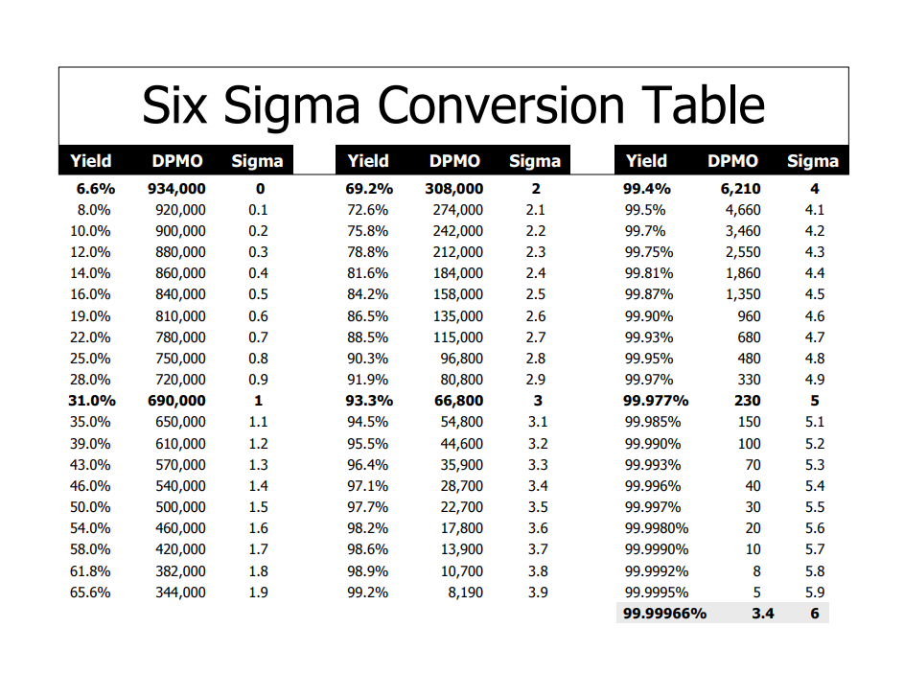
Figure 19 - Sigma level conversion Chart (CE, 2023)

4.6 FMEA
FMEA stands for Failure Mode and Effects Analysis. It is a structured approach to identify and evaluate potential failures in a process or system, and to develop actions that can prevent or mitigate these failures. Here are the general steps to carry out an FMEA on a manufacturing process. Two FMEA’s were created to establish the failure modes on the Intec Robot and the CNC Mill. The CNC FMEA was created in 2022 by the Engineering Department at Zimmer Biomet, the Intec Robot FMEA was created as part of this project. Figure 20 illustrates the scoring criteria for both FMEA’s. (Watkins, 2022)

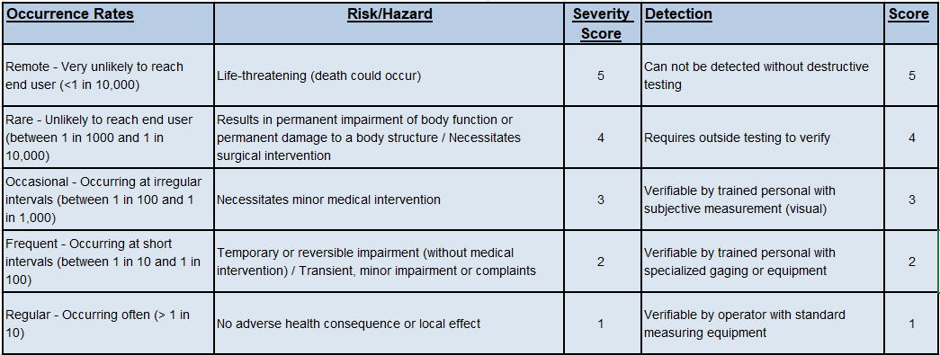
Figure 20 - FMEA Scoring Criteria
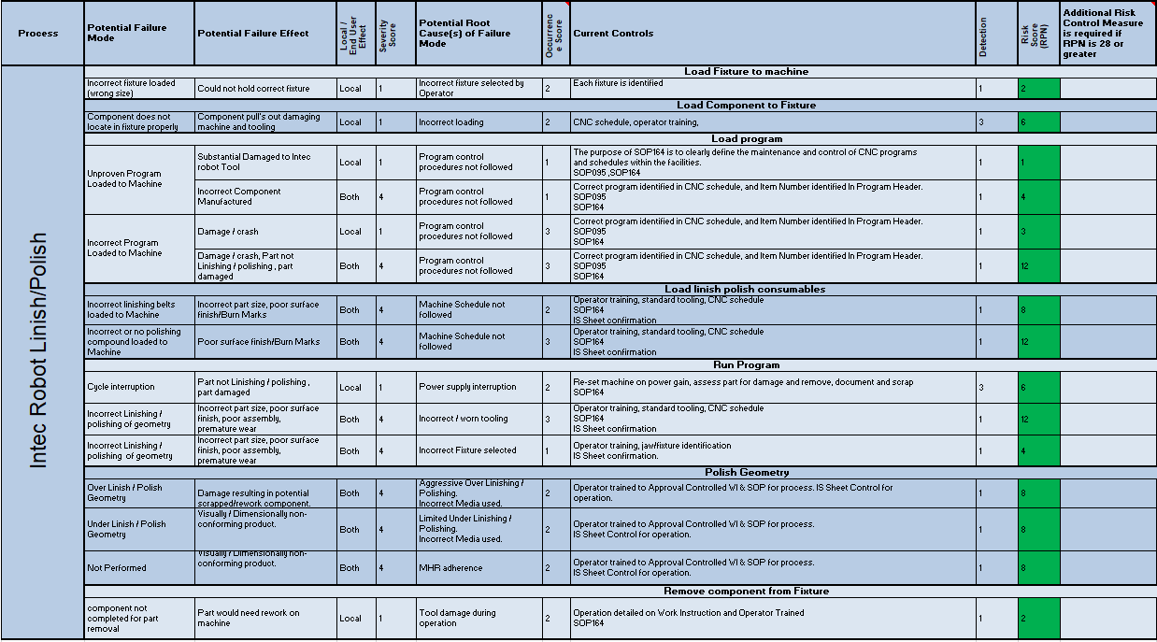
Figure 21 – Intec Robot FMEA

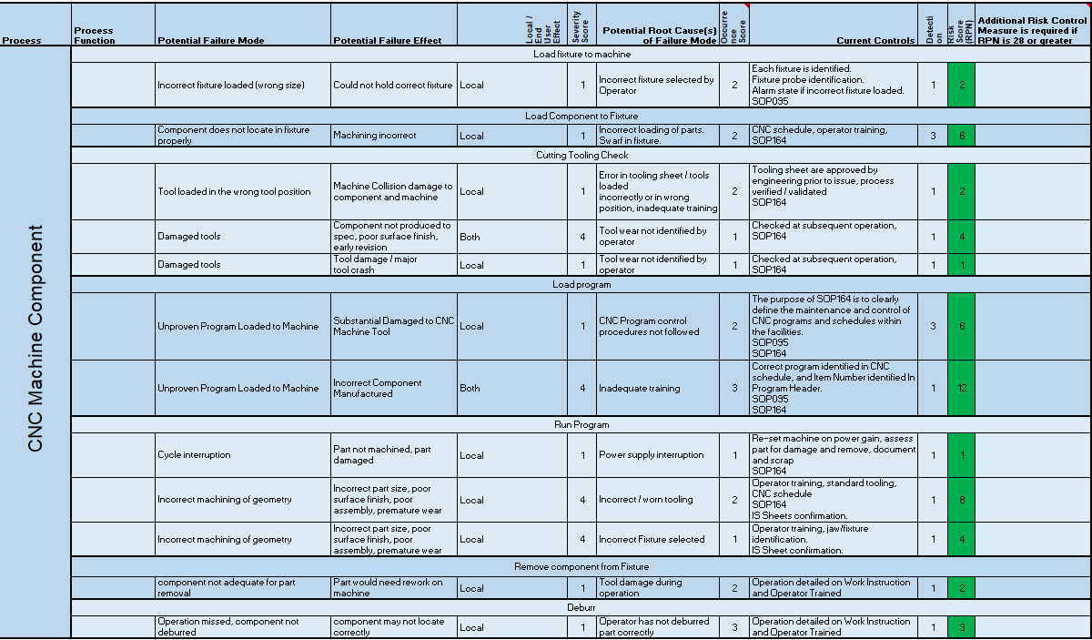
Figure 22 – CNC Mill FMEA (Watkins, 2022)

4.7 CNC Mill Measure Phase
The CNC Mill in question is a three-axis Fanuc Robo drill, specifically designed for precision machining operations. Employing a vertical milling configuration, it utilises a specialised tool known as a face mill, illustrated in Figure 23, to generate a refined finish on the tibial tray. The insert used on the face mill can be found in Figure 24, which is a tangentially clamped inserts with 4 helical cutting edges. (Iscar, 2023) The components in question are secured in place during machining operations by means of clamping fixtures, as demonstrated in Figure 25. This approach serves to ensure that the components remain firmly in position throughout the machining process, thereby minimising the risk of chatter, misalignment or other forms of deviation that could compromise the quality of the final product. The use of clamping fixtures is a common practice in manufacturing, particularly in the field of precision machining, where accuracy and repeatability are paramount considerations. (John R. Walker, 2019)
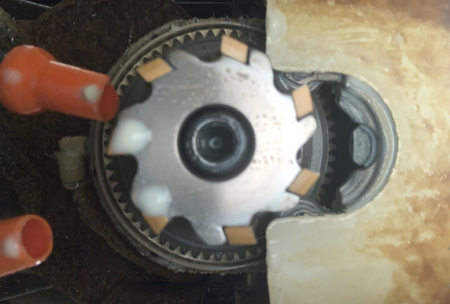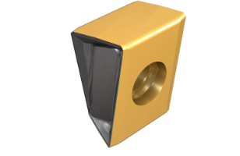
Figure 23 - Face Mill Tooling Figure 24 - Insert used in Face Mill (Iscar, 2023)

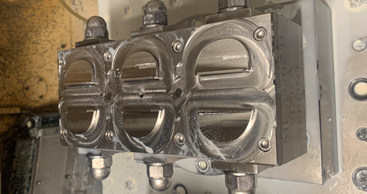
Figure 25 - Clamping Fixtures
Surface Roughness is a measurement of a surface's imperfections. The majority of technicians refer to surface roughness as surface finish since it is the most measurable and quantifiable component of the surface finish.
The roughness of a machined component after CNC machining directly affects the Intec Robot Cycle time. Therefore, the importance of surface roughness is crucial, and special care should be taken when performing CNC machining. During the CNC machining process, the surface roughness value of the machined object is regulated rather than random. A typical value for the industry, ranging from 25 µm to 0.05 µm. (Made, 2023)
To ascertain the quality of the surface finish on the machined components, a surface roughness tester was employed. A total of 12 components were subjected to testing, and they are presented in Figure 26.
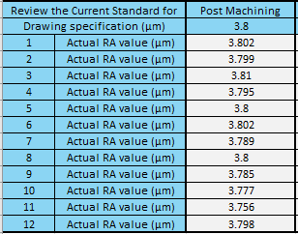
Figure 26 - Surface Roughness results post CNC Mill

According to the findings, the average surface roughness of all 12 components was measured to be 3.79µm. This information is critical to ensure that the final product meets the desired standards of precision and quality, and can be used to inform future machining operations for similar components.
The surface roughness data is used by the operators to determine tip changes, should the roughness increase the operators will initiate a tip change.
The clamping fixtures used are in good order and no concerns raised.
The coolant flow can be regulated, the current flow rate is 10l/min.
The current feed rate is 75mm/min, and the spindle speed is 1500rmp.

4.8 Intec Robot
The INTEC polishing robot, illustrated in Figure 9, is an industrial robot designed for automated polishing, buffing, and deburring of various metal parts and components. It is developed and manufactured by INTEC GmbH, a German company specialised in robotic surface finishing solutions. One of the primary advantages of the INTEC polishing robot is its ability to perform these surface finishing operations quickly and accurately, which can significantly reduce labour costs and improve efficiency in the manufacturing process. Additionally, the use of a robotic system can also minimise the risk of human error and increase workplace safety. (Robotics, 2023).
OEE, or overall equipment effectiveness, is a statistic used to assess how well industrial equipment performs. It calculates a score based on three criteria, availability, performance, and quality, and indicates the proportion of time the machinery is actually turning out high-quality output.
The Japan Institute of Plant Maintenance created the OEE concept in the 1960s, and manufacturing sectors all over the world have since widely embraced it. It is used to pinpoint areas for equipment performance improvement, save downtime, and boost production. (Hansen, 2001)
The OEE formula is:
OEE = Performance X Availability X Quality
Where;
Availability = Operating Time / Planned Production
Performance = (Total Parts / Ideal Cycle Time) / Real Run Time
Quality = Good Pieces Produced / Total Pieces Produced
(Thorn, 2022)
The OEE of the Intec Robot was calculated to ascertain the level of the equipment because the Intec Robot being a critical piece of equipment in this study and the equipment that causes the capacity constraint. Table 6 illustrates the Intec Robot’s OEE taken in Week 14. The table indicates the Intec robot runs at World Class OEE which is 85%.
The Intec Robot OEE is calculated as follows;
Availability – 8536 / 8566 = 0.996
Performance – (2389 X 3.33) / 8536 = 0.936
Quality – 2398 / 2335 = 0.93
OEE - 0.996 X 0.936 X 0.97 = 0.91 or 91%
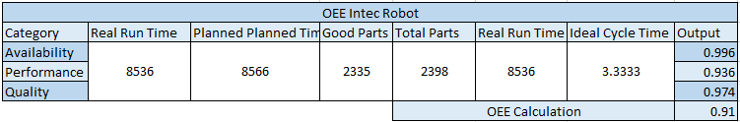
Table 6 - Intec Robot OEE

Figure 27 illustrates the data collection for the roughness reduction for each belt on the Intec robot. The Robot uses six belts to reduce the surface roughness to an acceptable level. The grade of belts is also illustrated within Figure 27. The data is also presented in graphical form in Figure 28.
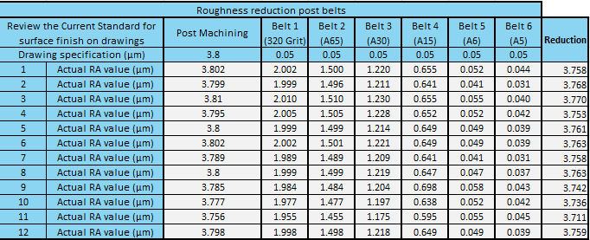
Figure 27 - Post Intec Robot Surface Roughness

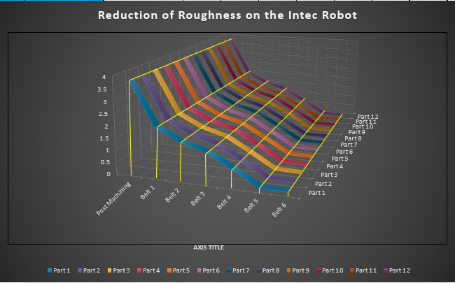
Figure 28 - Post Intec Robot roughness reduction Graph
The Intec Robot employs 6 belts and 1 mop to achieve the desired surface finish. The timings of each belt, as indicated in Figure 29, have been calculated and programmed into the Intec PC. It should be noted that the total time per batch is determined based on the completion of Belts 1-6 on the first component before the cycle is restarted on the belts with the second component. Furthermore, the mop is utilised while the linish robot arm is in operation, and the last component is polished on the mop, with the time required for this last step being added to the total duration.
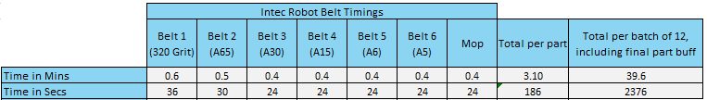
Figure 29 -Intec Robot Timings

Equipment uptime plays a vital role in capacity, below in Table 7 and Figure 30 is the Intec Robot breakdown history from weeks 47 of 2022 to 15 of 2023.
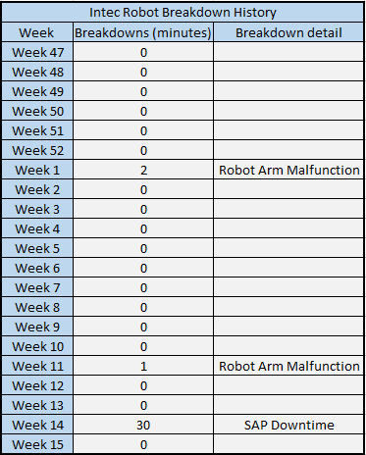
Table 7 - Intec Robot Breakdown History

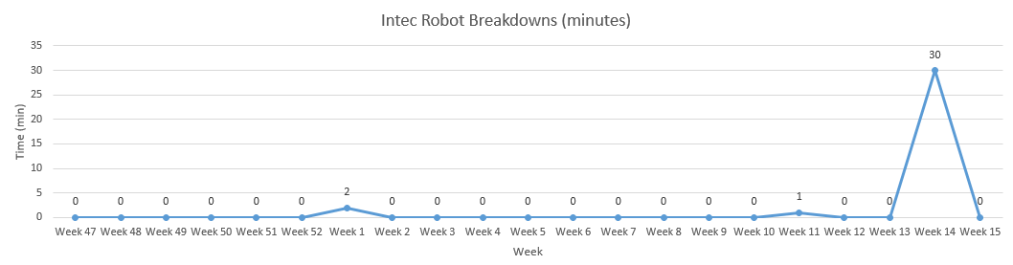
Figure 30 - Intec Robot Breakdown run Chart

The impact of energy increases on manufacturing has been significant, as energy costs can make up a significant portion of a manufacturer's expenses, the Intec Robot uses a total of 9 motors, Table 8 below shows the detail.

Intec Robot Motors
Description | Quantity | Usage
Linishing Motor (5kW) | 6 | To linish parts from Post Machining.
Polishing Motor (5.5kW) | 1 | To polish parts post Linishing.
Robot Arm (11kW) | 2 | To grip and move parts across the linishing and polishing belts.
Table 8 - Intec Robot energy usage

4.9 Linish Polish
The Linish/Polish Work Centre is a robust spindle that imparts rotational motion to linishing belts and buffing mops, operating at variable speeds to generate a smooth surface finish. This work centre, as depicted in Figure 31, serves as the final buffing stage for the components that have completed processing on the Intec Robot. Subsequently, the surface roughness of the components was measured, with the outcomes illustrated in Figure 32.
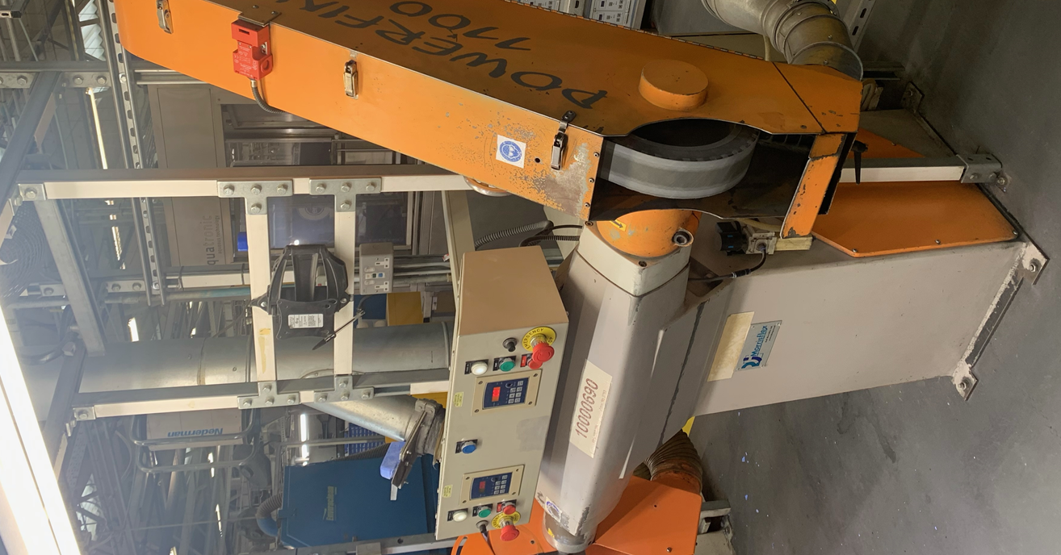
Figure 31 - Linish/Polish Work Centre

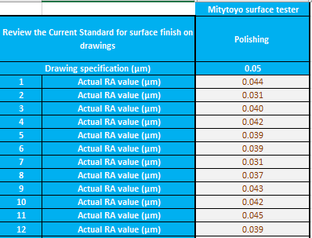
Figure 32 - Surface finish results post Linish/Polish

Chapter 5. Analyse Phase

5.1 Purpose of the Analyse Phase
The Analyse phase is a critical step in the DMAIC (Define, Measure, Analyse, Improve, Control) improvement process, which is widely used in Six Sigma methodology. The primary purpose of this phase is to identify the root causes of problems or inefficiencies that were uncovered during the previous phases of the DMAIC process. The Analyse phase helps to determine the underlying causes of the issues and provides insights into how they can be addressed in the Improvement phase. (Thomas Pyzdek, 2002)
After the completion of data collection in the measure phase, a Kaizen event was organised to put into practice all of the knowledge and insights gained from the shop floor employees. As Masaaki Imai argues, businesses should tap into the knowledge of the employees to increase performance by engaging workers in the Lean process and establishing a culture of continuous improvement. (Imai, 2012)
The purpose of this event was to identify areas of improvement in the production process and develop solutions to increase the Tibial Tray outputs on the Intec Robot, as well as promoting continuous improvement culture through engagement. Figure 33 provides a snapshot of the Kaizen event and showcases the collaborative efforts of the employees and management in achieving the common goal of process improvement. The event involved a brainstorming session where ideas and suggestions were shared and evaluated based on their feasibility and potential impact on the process. The Kaizen event was successful in not only generating ideas but also in fostering a culture of continuous improvement and promoting employee engagement in the production process.

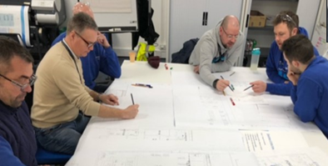
Figure 33 - Kaizen Event

5.2 CNC Mill Analysis
The measure phase indicated the CNC mill as having significant influence over the surface finish of the tibial tray. This analysis will cover the points from that phase.
The CNC Mill FMEA created highlights the importance of effective operator training and compliance with established procedures to mitigate the risks associated with potential failure modes in the CNC machine manufacturing process. There are no risk scores that require any additional measures required but it does highlight throughout the importance of training.
The drawing specification requires a surface finish of 3.8µm typical at CNC machining. The actual RA values range from 3.756µm to 3.81µm, with an average value of 3.79µm, so the values are within the tolerance range specified by the drawing indicating that the CNC milling process is producing surface finishes that meet the requirements. According to the guidelines provided by "Get it Made", the most cost-effective surface roughness value to work towards is 3.2μm in CNC machining. It is likely that this theory has influenced the manufacturing process at Zimmer Biomet Bridgend, where the tibial trays have consistently been machined to achieve this approximate value for it cost effectiveness. (Made, 2023) It must be noted that this may have been implemented without a consideration of the overall process.
There does seem to be some variability in the actual surface roughness values. This may indicate that there is some room for improvement in the CNC milling process to reduce variability and improve consistency of surface finish.
The most viable suggestion during the Kaizen to increase the Intec Robot capacity was to decrease the surface roughness at the CNC Mill which allow the Intec to work less to achieve the specified requirement. The suggestions can be seen in Appendix 1 & 2.
In order to achieve an improved surface finish on a vertical mill, various factors must be considered. One of the most important factors is the choice of cutting tools. Using high-quality cutting tools that are specifically designed for the material being machined can significantly improve surface finish and reduce tool wear. (Suryadiwansa Harun, 2022)
The inserts used are high quality inserts and perfect for this type of operation. (Iscar, 2023)
Another effective method for improving surface finish is by reducing cutting speed, particularly when machining difficult-to-machine materials like Cobalt Chromium, which is the material used to manufacture the Oxford Tibial Trays. This approach helps to reduce the impact of vibrations and chatter, leading to smoother surface finishes. This assertion is supported by a study completed by Panda et al, the results of that study can be found in Figure 31. (Amlana Panda, 2016),
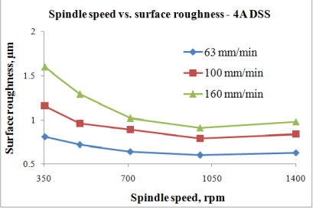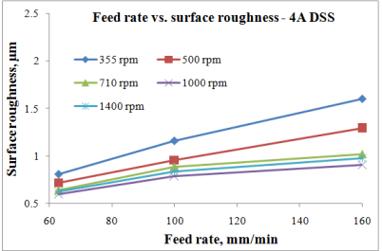
Figure 34 - Study on Cutting Time V Surface Roughness (Dirviyam, 2018)

The study indicates that the quicker you cut material, the higher the surface roughness becomes. Cutting speed is a crucial parameter in Computer Numerical Control (CNC) machining operations, referring to the rate at which the cutting tool moves across the work piece. This speed is often measured in meters per minute (m/min) or feet per minute (ft/min) and can also be referred to as the surface speed or tangential speed. The cutting speed has a significant impact on the efficiency and quality of the machining process, affecting factors such as heat generation during cutting, the rate of tool wear, and the surface finish of the work piece. (Dirviyam, 2018)
In a Fanuc CNC system, which is the same CNC Mill used in this process, the cutting speed is controlled by manipulating the spindle speed and the feed rate. The spindle speed dictates the rate at which the cutting tool rotates, while the feed rate determines the speed at which the cutting tool moves across the work piece. By adjusting these variables, the operator can regulate the cutting speed to achieve the desired level of efficiency and quality. (feature-articles, 2023)
The current feed rate and spindle speed used in the CNC program for manufacturing the Oxford tibial tray are provided below, these parameters produce the 3.8µm currently witnessed.
- Feed Rate – 75 mm/min
- Spindle Speed – 1500 rpm

Optimising feed rate and depth of cut is also essential for achieving a desirable surface finish on a vertical mill. A lower feed rate and shallower depth of cut can reduce tool deflection and vibrations, resulting in a smoother surface finish.
Moreover, the use of a high-quality coolant can significantly improve surface finish by reducing heat build-up and minimising tool wear. (Walker, 2004) The coolant currently used is Hocut 3380 and is built on the newest Houghton technology and provides outstanding surface finish and tooling performance. Zimmer Biomet use it at a concentration of 5% to 10%, which is perfect for the machining carried out. (shop, 2023) The concentration is measured and controlled daily by the operators.
Runsom Precision suggest a standard machined surface roughness for a vertical mill is 3.2μm, however, other cutting techniques can be used to reduce surface roughness, we can control this roughness down to level of 1.6μm,0.8μm or 0.4μm. Figure 35 below illustrates this surface roughness achievable on a Vertical Mill, with the current roughness also highlighted. (Runsom, 2023)

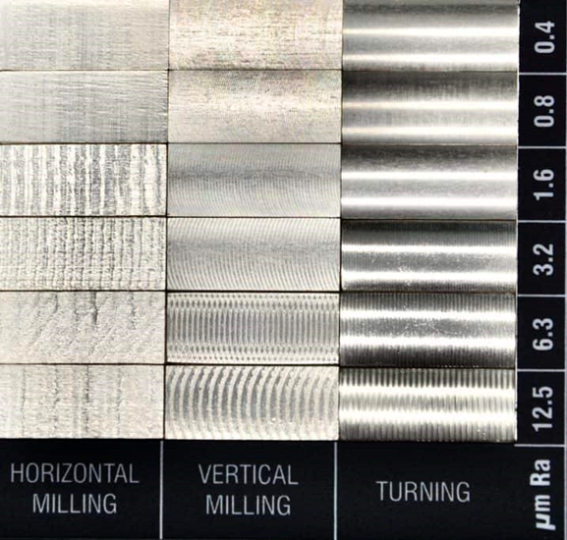
Current Ra
Figure 35 - Runsom Surface Roughness chart

5.3 Intec Robot Analysis
Figure 28 illustrates the accuracy of the Intec Robot robot, the data shows a consistent reduction of the surface roughness in the process, with the total reduction on each component being between 3.711µm and 3.770µm.
The results indicate that the INTEC polishing robot is a highly accurate and effective solution for achieving a smooth and consistent surface finish on metal components. The consistent reduction of surface roughness during the polishing process is indicative of the robot's ability to apply a uniform and controlled amount of pressure and movement to the work piece. This capability can significantly improve the efficiency and quality of the manufacturing process, as it reduces the need for manual labour and ensures a high degree of consistency in the surface finish across multiple components.
Figure 27 of the report presents the findings of the roughness reduction process for each component manufactured using the Intec Robot. The results indicate that Belt 1 yields the greatest reduction in the overall roughness reduction. It is noteworthy that the belt employed for this process is a 320 Grit, which is known for its aggressive surface abrasion characteristics. Subsequent belts employed for the process become progressively finer, as reflected in the table where the reduction values decline with each successive belt.
Figure 28 portrays the reduction of individual components as depicted in Figure 27. The findings demonstrate a highly replicable and robust process, where all units undergo a reduction in a uniform and consistent manner.
Figure 27, shows a table of results for surface roughness measurements on machined parts before and after the Intec Robot Operation with six different abrasive belts (Belt 1 to Belt 6). The aim of the Intec Robot process is to reduce the surface roughness to meet the drawing specification of 0.5 µm following the CNC operation.
The Intec OEE is 91%, which is world class.
Performance is impacted by the reject rate, all of which are burn marks.
The energy usage per part was calculated based on the timings in Figure 29. Zimmer Biomet are charged two rates, a day rate, and a night rate which can be seen in Figure 36. These rates average out at 15.47p per kWh as Zimmer Biomet Bridgend is a 24/7 site.
Figure 36 - Energy Cost Breakdown
In the current state, tibial trays cost 12.84p each in energy to manufacture on the Intec Robot. On an annual basis this equates to £15,716 based on producing 2400 parts per week. With the projection of 3000 per week, the energy cost would increase to £19,645, Figure 37 shows the cost per belt at 2400 per week, Figure 38 shows the same detail at 3000 per week. It must be noted that the difference in cost between the belts and mop is because the mop is driven by a 5.5kW motor and the belts are driven by a 5kW motor, as illustrated in Table 8.
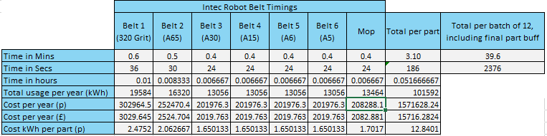
Figure 37 - Energy Costs on Intec Robot 2400
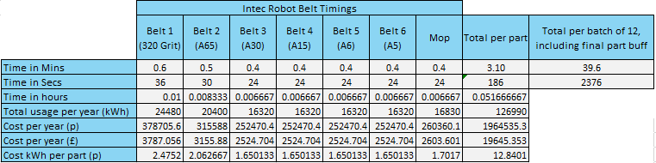
Figure 38 - Energy Costs on Intec Robot 3000 per week

5.4 Analysis of rejects
The value stream map, represented by Figure 12, provides insight into the reject rates associated with various components of the manufacturing process. Notably, the analysis reveals that two critical areas, namely, Linish/Polish and Intec Robot, exhibit the highest reject rate.
The value stream map illustrates that the Linish/Polish process generates a scrap rate of approximately 4.2%. Figure 39 presents the reason codes associated with rejects at the Linish/Polish process that contribute to the high scrap rate. A pareto chart was then created, which is illustrated in Figure 40.
To analyse this issue, a Quality circle was organised to utilise the extensive knowledge of the equipment operators. During the event, the team members completed a cause and effect analysis for both processes, and offered up their opinions based on process knowledge.

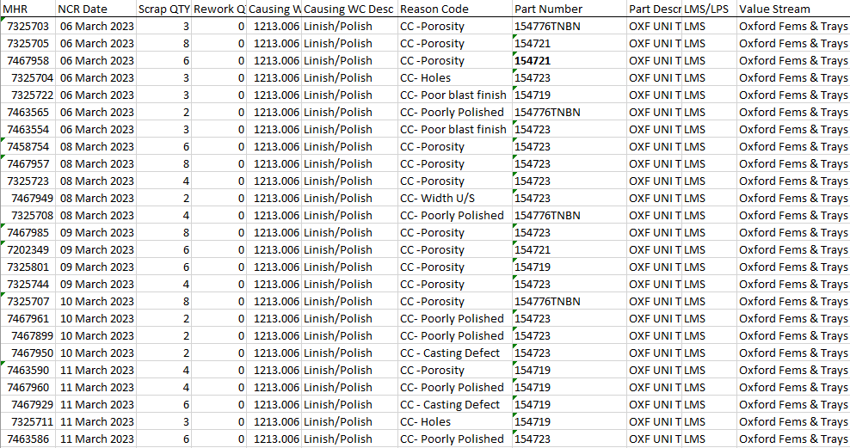
Figure 39 -Linish Polish scrap reason codes

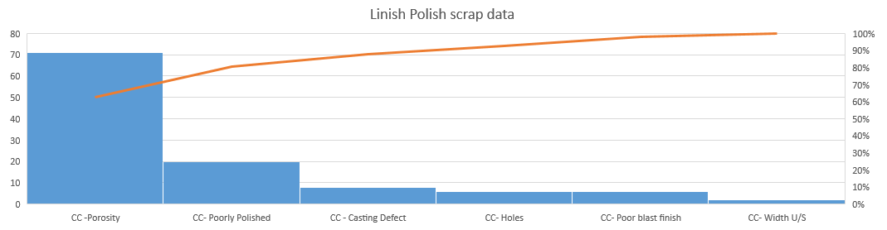
Figure 40 - Pareto of Linish polish scrap

Using Pareto analysis principle, Porosity is the cause of nearly 80% of the rejects at Linish/Polish.
Porosity can be described as voids or holes within the material, it can be caused by several factors, including the use of improper abrasives, excessive pressure, or incorrect speed settings. Porosity formation in a linishing process can be attributed to the breakdown of abrasive grains during the process, which leads to heat generation. This, in turn, causes the material to soften and become more susceptible to porosity formation. Additionally, improper abrasive selection or the use of worn-out abrasive belts can contribute to porosity formation in a linishing process. (Smaith W.F, 2006)
The cause and effect diagram completed during the Quality Circle in figure 41 highlights many variables that could cause porosity within the process, however, it could be caused at either of the operations, Linish polish or Intec Robot. Further analysis will be required outside of this project.

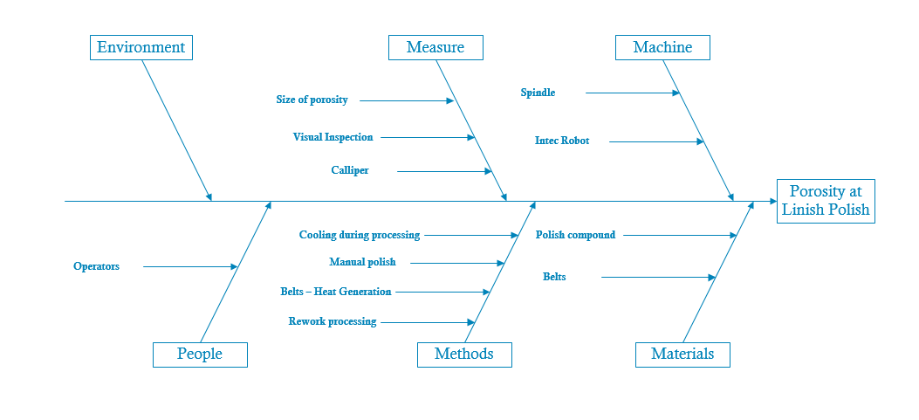
Figure 41 - Isikawa Diagram for Porosity at Linish Polish
The Value Stream Map in Figure 12 shows around a 2% scrap rate on the Intec Robot. All of these rejects are because of burn marks.
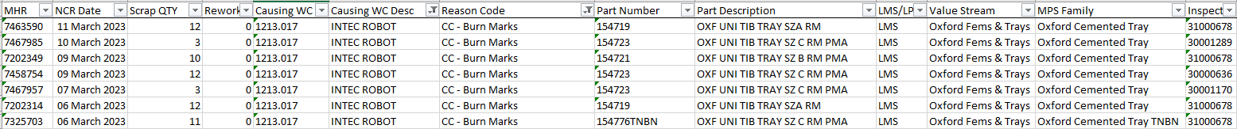
Figure 42 - 1 weeks Scrap Download for Intec Scrap

Figure 43 is a run chart of Intec scrap from Week 1 – 14, all the rejects within the run chart are burn marks, this shows that burn marks are a consistent problem on this machine.
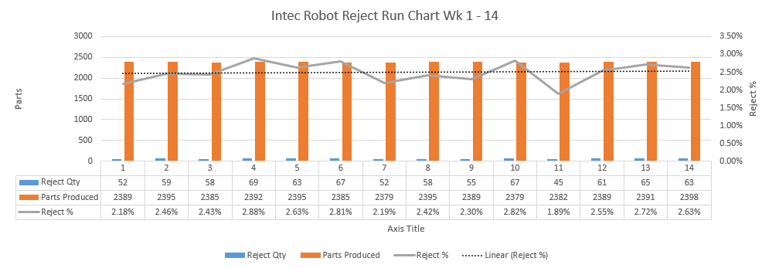
Figure 43 - Run Chart of Intec Robot Scrap

The cause and effect diagram, as depicted in figure 44, identifies several potential factors that could be responsible for the burn marks observed on the Intec Robot. However, after engaging in discussions, the team has unanimously concluded that Belt 1 is the primary contributor to the burn marks, especially during belt changes. Although other factors may be at play, the evidence suggests that Belt 1 is the most likely cause.

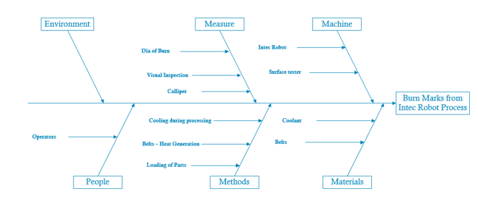
Figure 44 - Ishikawa Diagram for Burn Mark scrap on Intec robot

To substantiate this, a trial was conducted to assess the effect of new belts on the tibial trays being produced on the Intec Robot. Specifically, 30 parts were subjected to linishing on the Intec Robot, with a belt change after every ten parts, normal usage of belts is far lower. The results revealed that 77% of the parts exhibited burn marks, all of which were unacceptable indicating a significant increase in the reject rate. Furthermore, the pattern of failure clearly shows an increase after a belt change, Figure 45 illustrates this pattern. The Operators of this robot suggested the belts require “bedding in” and “some operators”, bed in belt 1 during the scheduled cleaning to try and mitigate the burning.

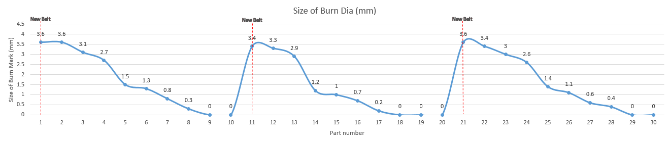
Figure 45 - Run Chart for the effect of belt changes on Burn Marks

This finding serves to validate the claim that Belt 1 is responsible for generating burn marks on the Intec Robot, and supports the team's decision to focus on this component for further investigation and corrective action. Besides, it also validates the “bedding in” theory by the operators as the burn marks decrease with early wear, or “bedding in”.

Following the pattern of burn marks on Belt 1, Belts 2 – 6 were subject to the same testing to ascertain if this was only an issue on Belt 1. 30 components, that did not contain any burn marks, were selected and run through belts 2 – 6 with a belt change every 10 components. No burn marks were witnessed across any of the remaining belts, Table 9 below illustrates the results. This not only confirms belt 1 to be the root cause of the burning on the Intec Robot, but further highlights the knowledge that can be undervalued on the shop floor.

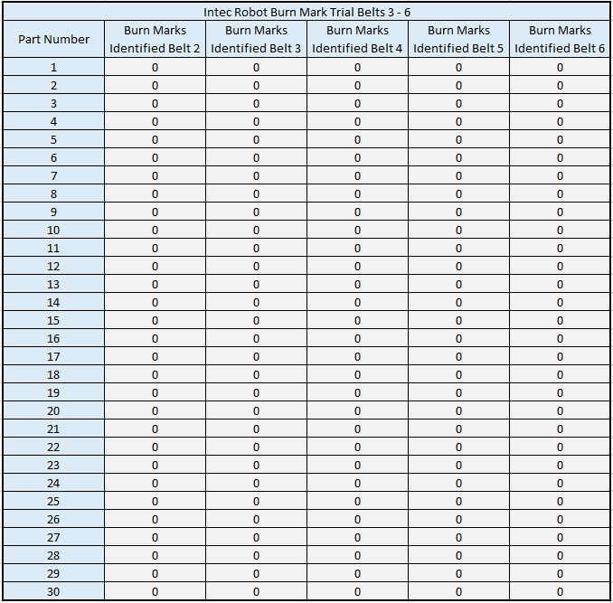
Table 9 - Intec Robot burn mark trial belts 2 - 6

Chapter 6. Improve Phase

6.1 What is the Purpose of the Improve Phase?
The Improve phase of the DMAIC (Define, Measure, Analyse, Improve, Control) methodology is a critical component of the Six Sigma approach to process improvement. The primary aim of this phase is to generate and implement solutions that address the underlying causes of process issues identified during the Analyse phase. The Improve phase involves developing, testing, and implementing a solution that enhances process performance.
During the Improve phase, potential solutions are evaluated based on their effectiveness, feasibility, and impact on the process. Once a solution is selected, a plan is created to implement it in the process. This plan should contain specific details, such as who will be responsible for implementing the solution, the required resources, a timeline for implementation, and a method for measuring the solution's impact on the process.
The implementation of the chosen solution is then executed, and the results are closely monitored to ensure that the desired improvements have been achieved. If necessary, adjustments may be made to the solution to enhance its effectiveness. (Thomas Pyzdek, 2002)
This project will not implement, but put forward a suggestion of improvement to Zimmer Biomet Senior leadership team.

6.2 CNC Mill Improvements
It was determined during the Kaizen event, the first avenue to explore was the cutting speed which can improving the surface finish. As Figure 34 indicates, the cutting speed can have a considerable effect on the finish, with this in mind some trials were carried out. As stated in the CNC Analyse phase “the cutting speed is controlled by manipulating the spindle speed and the feed rate”, a trial was carried out to aim at improving the surface finish whilst not compromising cycle time, this was done by increasing the spindle speed. Table 10 quantifies the results.
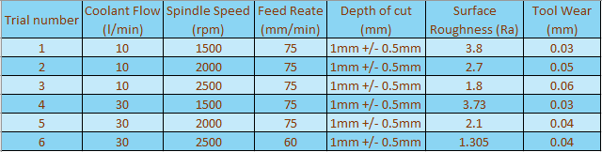
Table 10 - Results of Surface finish trial on CNC

The findings obtained were put into a graphical format, the outcomes were analysed. In particular, it was observed that the increase of spindle speed in experimental trials 1 to 3, with a constant coolant flow rate of 10 litters per minute, resulted in a reduction of surface roughness values (Ra) from 3.8 to 1.8. This suggests that increasing spindle speed had a positive impact on the surface finish quality of the material, figure 46 illustrates this in graphical form.
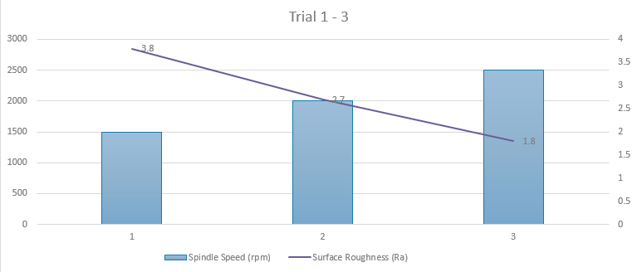
Figure 46 - Results of Spindle Speed V Surface Roughness trials 1 - 3 on CNC

The graphical representation in figure 47 depicts the tool wear observed during the course of experimentation 1 to 3. As apparent from the data, the alteration made had an adverse impact, resulting in an increase in the wear of the cutting inserts. Such an outcome is expected to lead to an increase in the cost incurred by the business for the replacement of these inserts

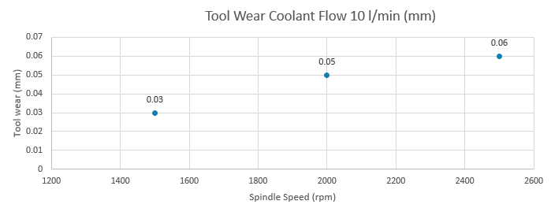
Figure 47 - Tool Wear Trial 1 - 3 on CNC

Trial 3 to 6, as represented in Table 10, exhibits a reduction in surface roughness (Ra) values, with the lowest Ra being recorded as 1.305 µm. It is important to note that this achievement was accomplished by decreasing the feed rate from 70mm/min to 60mm/min, while concurrently increasing the spindle speed during experimental trial 6. Additionally, the trial was conducted with higher coolant pressure, aimed at mitigating the wear of the cutter. Figure 48 also presents the findings in graphical form.
.
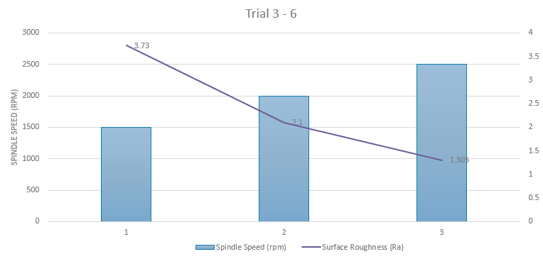
Figure 48 - Results of Spindle Speed V Surface Roughness trials 3 - 6 on CNC

The graphical representation in Figure 49 exhibits the tool wear observed during trials 3 to 6. Despite the favourable reduction in surface roughness values achieved during these trials, there is still a 0.01mm increase in tool wear. Whilst this seems minimal, it translates into a 25% rise in the cost of inserts required for the machining process. As stated previously, tip changes are conducted based on the change in surface roughness, so this would be an accurate increase in cost.
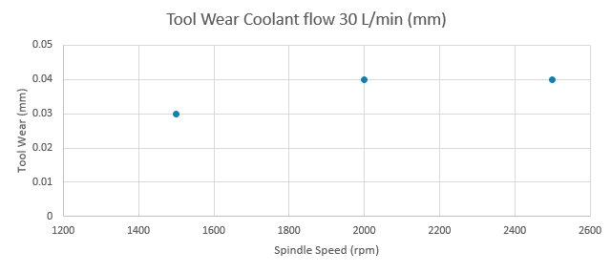
Figure 49 - Tool Wear Trial 3 - 6 on CNC

The trials conducted resulted in a reduction of surface roughness values, as indicated by the Ra measurements. However, there was an adverse effect observed on tool wear, which could lead to a significant increase in the cost incurred by the business for replacing the inserts. According to the guidelines provided by "Get it Made", the most cost-effective surface roughness value to work towards is 3.2μm. It is likely that this theory has influenced the manufacturing process at Zimmer Biomet Bridgend, where the tibial trays have consistently been machined to achieve this particular value whilst not considering the process holistically. (Made, 2023)
The trials were conducted with slower feed rates, higher spindle speeds, and increased coolant pressure aimed to not only achieve a lower Ra, but mitigate these negative impacts. Nevertheless, an increase in tool wear was still observed, signifying a 25% increase in the cost of inserts and an increase in cycle time of 7 minutes.
The inserts used are sold to Zimmer Biomet at £10.67 each, average use is 185 per week (Francis, 2022) when producing 2400 parts, which generates a cost of £1973.95p. Based on the 25% increase in wear, the new cost will be £2467.44p per week. This gives an annual increase of £25,168 on the current loadings of 2400 over a 51-week year.

It is noteworthy that while the CNC Mill does not represent the primary focus or bottleneck in the process, this enhancement facilitates the entry of components into the intec robot operation with a considerably improved surface finish. Consequently, the intec robot would be required to exert less effort to achieve the finished drawing specification, thus yielding a positive outcome for the overall process. Figure 50 illustrates the improvement made to the surface.
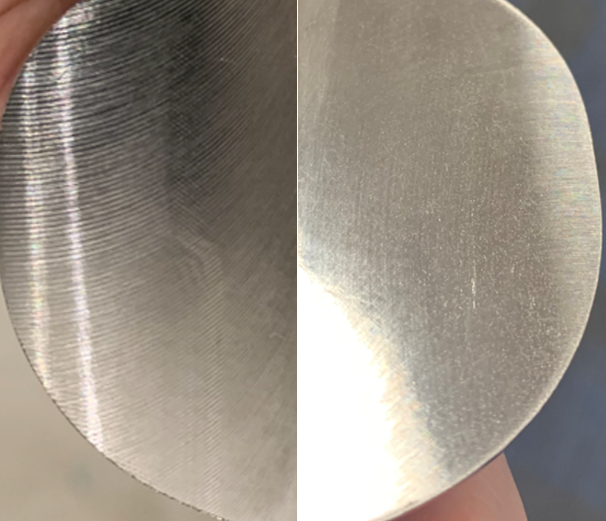
Figure 50 - Surface Finish Improvement

A batch was run under the conditions shown in trial 6, to ascertain if normal production could produce the desired Ra value in the trial. Figure 51 is the output from that trial, as illustrated, all parts produced fall between 1.355 and 1.297. A run chart was created to present this data in Figure 52.
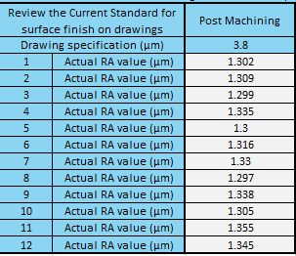
Figure 51 - Surface Roughness on CNC trial

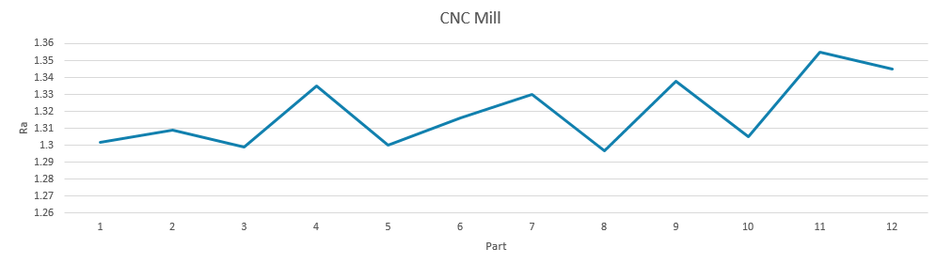
Figure 52 - Run Chart of surface Roughness trial on CNC

6.3 Intec Robot Improvements
The ultimate bottleneck within the process resides in the cycle time of the Intec Robot. Subsequent to the trial conducted on the CNC Mill, the components illustrated in Figure 51 were transferred to the Intec Robot at Belt 3 in order to complete the finishing process. This decision was made based on the data that was collected during the measure phase. To facilitate this approach, the analysis that was performed on the surface roughness of the components once each belt had been completed was used. Figure 27 provides a visual representation of the surface roughness values achieved at each stage of the process. Moreover, the results generated from Figure 51 in the CNC Mill trial demonstrate that the highest RA attained was 1.305. As a result, belt 3 was identified as the optimal starting point for the Intec Robot operation.
The run chart in Figure 53 presents the outcomes of the post-robot trial of the parts. As evident from the data, all parts conform to the surface finish drawing specification, signifying that a reduction in cycle time can be achieved. This reduction is 13.5 minutes per batch of 12, predicated on a pre-improvement total cycle time of 40 minutes per batch of 12 compared to a post-improvement cycle time of 26.5 minutes per batch of 12, the goal here was 32 minutes as shown in Table 2. It is noteworthy that this substantial reduction has been made feasible by the reduction in surface roughness that was attained through the CNC Mill trial, which enabled the parts to begin at Belt 3 on the Intec Robot effectively eliminating the Belt 1 and 2 cycle time.
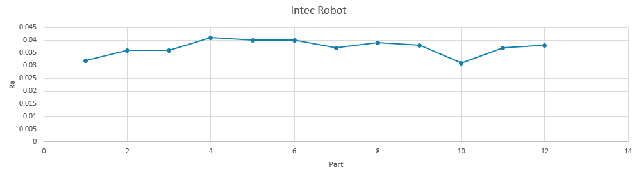
Figure 53 - Run Chart of Surface Roughness post Intec Robot

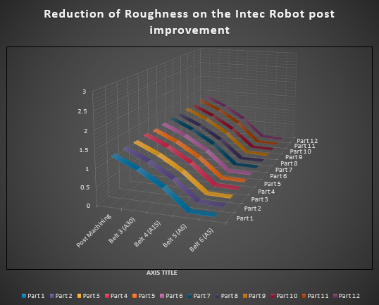
Figure 54 - Belt reduction from belt 3 - 6

The energy savings were calculated based on the removal of belts 1 and 2 on the current state of 2400 components per week. Prior to the improvement the energy cost annually was £15,716, after the removal of the belts the energy usage reduced to £10,161, making an annual saving of £5,555. These savings are based on the average charge per kWh.
In a future state of 3000 components per week, prior to the improvement, the energy cost annually would be £19,645, after the removal of the belts the energy usage reduced to £12,702 making an annual saving of £6,943. These savings are based on the average charge per kWh.
Figure’s 55 and 56 illustrates the energy costs post improvement for both a 2400, and 3000 component week.
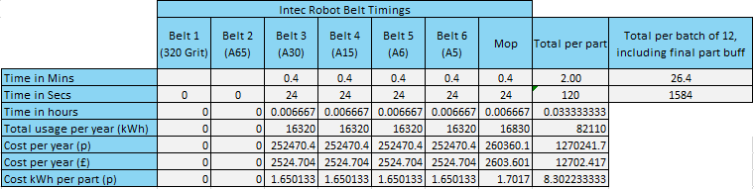
Figure 55 - Results of energy consumption post improvement 3000 per week
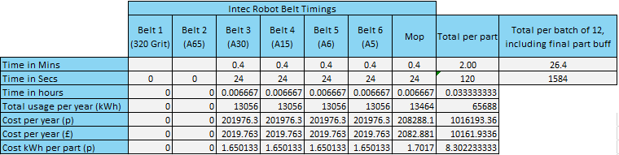
Figure 56 - Results of energy consumption post improvement 2400 per week

Beside the energy reduction on the Intec following the improvement, the belt usage will also reduce. Figure 57 illustrates the usage of belts 1 and 2 in 2022, as well as the cost for each.
Both belts are changed together and the average cost of the 2 belts is £14.10p, this gives an annual saving of £6,564 on a 2400 component week. Should this increase to 3000 per week, the annual saving would increase to £10,222.


Figure 57 - Belt 1 & 2 cost /usage 2022 (Francis, 2022)

A Future State Value Stream Map was created to incorporate the Improvements, the VSM is illustrated in Figure 58. The VSM includes the increase for the cycle time on the CNC Mill, and the reduction on the Intec Robot following the removal of belts 1 & 2.
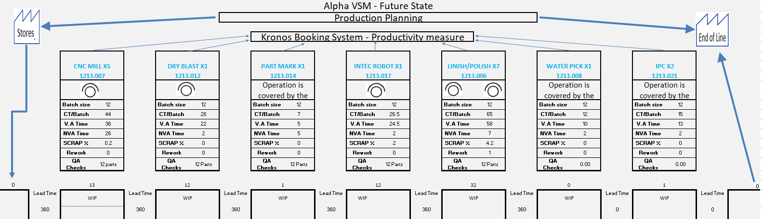
Figure 58 - Future State Value Stream Map

Chapter 7. Conclusion
The primary goal of this project was to increase the production output of the Intec Robot by 600 units per week. This objective was set based on the following problem statement: " The demand for Oxford tibial trays is projected to increase to 3000 units per week from September 2023, which exceeds the current production output of 2400 units on the Intec Robot. An analysis of the manufacturing process is needed to explore the possibility to increase the output to meet the new demand, or purchase new equipment".
A value stream map was created before the manufacturing process was analysed. The Tibial Tray's surface roughness was found to have a substantial impact on the Intec Robot's cycle time because the Robot needed to use six belts to reach the required surface roughness.
Three areas were identified as having an impact on the surface roughness of the Tibial Tray during the evaluation of the process: CNC Mill, Intec Robot, and Linish/Polish. The first area to be measured was the CNC Mill. During the measurement phase, the surface roughness produced was found to be 3.8 µm, which was a highly cost-effective surface roughness for CNC machining (Made, 2023). Whilst 3.8 µm is highly regarded as a cost effective machining roughness, it’s clear this machining strategy was complete without a holistic view of the whole process, if this had been complete with all the process in mind, the data would have shown the process as a whole would be more expensive.
After conducting CNC Mill trials on the cutting speeds and coolant flow, the surface roughness of the Tibial Tray was successfully reduced to 1.305 µm, which was influenced by a study completed by P.S. Dirviyam (Dirviyam, 2018). However, this improvement came with the drawback of a 25% increase in cutter wear and a 7-minute increase in the CNC Mill cycle time on a batch of 12, resulting in an annual cost increase of £25,168 for cutters, and a labour increase on the CNC Mill of £24,514. The quality of the clamping fixtures and cutting inserts were found to be acceptable.
With the surface roughness considerably reduced at CNC Mill, the focus shifted towards the Intec Robot. The surface roughness reduction was measured for each of the six belts used in the robot, and the data in figure 29 indicated that the Intec Robot could consistently reduce the surface roughness from 1.305µm to less than 0.05 µm by starting the process at belt three. A trial was then conducted with the same parts produced on the CNC Mill trial which had a roughness of 1.305 µm, Figure 53 is a run chart of a trial that was conducted, which illustrates that all parts produced from belt three conformed to a surface roughness of <0.05 µm.
The timings for each step of the Intec Robot was measured and Figure 32 illustrates them. By starting the process at belt three on the Intec Robot the cycle time was reduced from 38 minutes to 24.5 which yields >13 minutes’ reduction in cycle time which satisfies the goal. This reduction indicates that purchasing more equipment is not always the answer, it may be the easiest route to take but improvements should be analysed on existing processes first. The cycle time improvement also results in a 46-hour reduction labour requirement for the operation. This reduces headcount by 1 operator which is £45,000.
Additionally, there are hidden savings. A £5,807 saving would be made on energy usage with current loadings of 2400 per week. This would increase to a £7,258 saving on a 3000 component week.
Furthermore, during a Kaizen event, belt one was highlighted as the cause of burning on the Intec Robot, during the analysis it was clear that burning on the tibial trays was a consistent issue, however, only by accident a reduction, or even elimination of this scrap could be realised by removing belt one, this would not have been discovered if it weren’t for the shop floor operator’s engagement. Further trials will be recommended outside of this study to quantify the possible reduction.
Figure 53 below illustrates what these improvements mean for Zimmer Biomet Bridgend for the current state of 2400 components per week, which equates to a total Value of Production of £5,997,600. Should 2400 components remain the target, an increase in operational cost would total £49,867, however, the operational cost savings would total £63,260 giving a total reduction in operational cost of £13,393. The main driver being a reduction in headcount for the cycle time improvement on the Intec Robot.
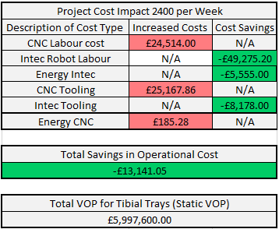
Figure 59 - Project Cost impact 2400 Per Week
Figure 54 below illustrates what these improvements mean for Zimmer Biomet Bridgend for the future state of 3000 components per week, which equates to a total Value of Production of £7,497,000. Should 3000 components become the target, an increase in operational cost would total £62,950, however, the operational cost savings would total £17,480 giving a total increase in operational cost of £45,470. The main driver being increased energy and consumables, which is expected. Whilst the operational cost has increased by £45,470, Zimmer Biomet Bridgend will realise a £1.5M increase in VOP and achieve the customer demand, this increased demand will be achieved whilst not increasing the headcount.
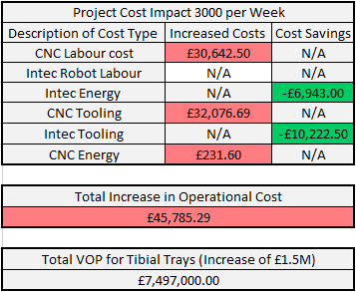
Figure 60 - Project Cost impact 3000 Per Week

Chapter 8. Further work

As depicted in Table 4 titled "Advantages of Mirror Finish in Medical Devices," the surface roughness of the tibial tray holds significant importance in reducing friction and wear. However, the drawing showcased in Figure 12 reflects a surface roughness of equal to or less than 0.05 μm, which may warrant reconsideration. It is suggested that an increase to 0.1 μm could potentially improve the process, resulting in additional capacity and improved productivity. However, the 94% survivorship at 15 years, that the Oxford Partial knee boasts has to be considered. It is noteworthy that the bearing that articulates on the tibial tray is susceptible to wear. While a study on the Prediction of Wear Rates of UHMWPE, which is the material of manufacture for the Oxford bearing, suggests that Ra values greater than 0.05 μm would escalate the wear, the magnitude of the impact is not explicitly established, nor is the effect on the Oxford Product. Therefore, it is imperative for the design authority and engineering to collaborate on this matter. (Rania E. Hammam, 2022)
During the course of the analysis it was discovered that two energy rates are chargeable to Zimmer Biomet Bridgend, it is recommended that a review of all manufacturing areas is conducted to establish if any equipment that consumes high amounts of energy has the capacity to run only at night, this could save the business 5.343p per kWh and have a positive impact on Manufacturing Variance.
During the Brainstorming session with the Team, a recommendation was put forwards to grind the Tibial Trays, Figure # illustrates some of the outputs from th brainstorm, this has potential to totally eliminate the linishing process. A study conducted in 2017 by Krzysztof Przystupa and Grzegorz Litak achieved a surface finish on Titanium of 0.05 μm indicating this is a possibility. (Krzysztof Przystupa, 2017). Should this be a reality it would increase the capacity significantly.
Figure 32 illustrates the possibility of further reducing surface roughness during the CNC Mill, whilst the project goal has been achieved, this doesn’t mean further work can’t be done. To quote one of the ten precepts from the godfather of Lean, Taichi Ohno - “Re-improve what was improved for further improvement” should be the overall goal within Zimmer Biomet Bridgend to achieve results that will ensure we grow as a business. (James P. Womack, 2007)
Figure 29 illustrates the breakdown history on the Intec Robot. The breakdowns are very low, with only 3 hours actually attributed to the Intec Robot in 21 weeks. It is recommended that Maintenance conduct a study to ascertain if the planned maintenance activities could be decrease based on the mean time to failure.
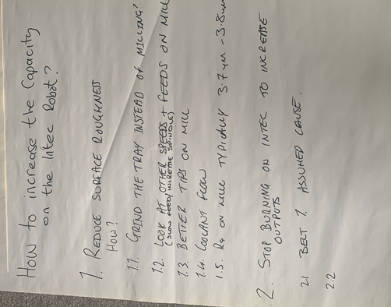
Figure 61 - Output from Brainstorming session

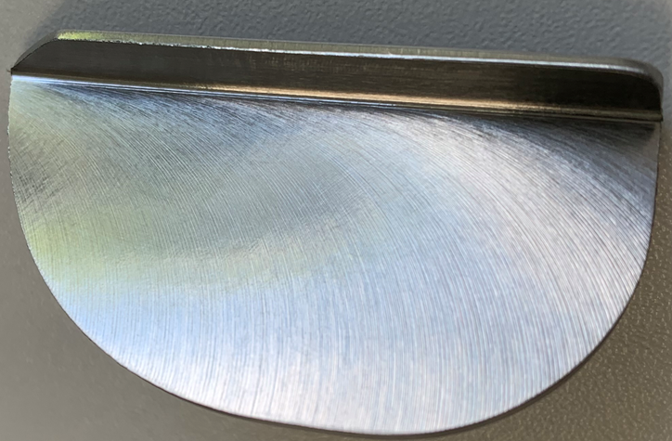

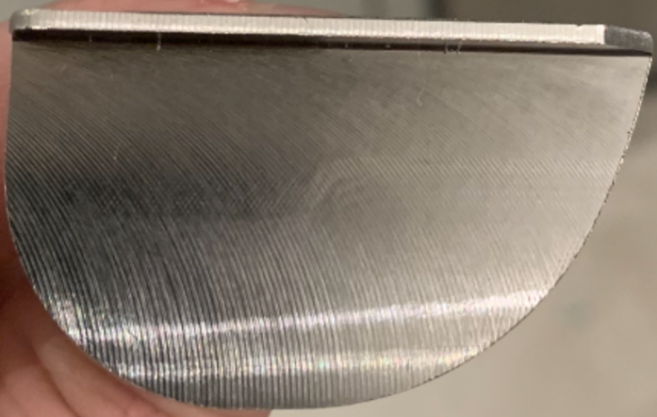

References
Amlana Panda, A. K. S. A. K. R., 2016. Investigations on surface quality characteristics. Alexandria Engineering Journal, 55(2), pp. 1625 - 1633.
Berman, B., 2012. 3-D printing: The new industrial revolution. Business Horozons, 55(2), pp. 155 - 162.
Biomet, Z., 2015. Oxford Tibial Tray Drawing. London: Zimmer Biomet.
Biomet, Z., 2023. https://www.zimmerbiomet.eu/en/products-and-solutions/specialties/knee/oxford-partial-knee-replacement.html#:~:text=The%20most%20widely%20used1,in%20cementless%20and%20cemented%20fixation.. [Online]
Available at: https://www.zimmerbiomet.eu/en/products-and-solutions/specialties/knee/oxford-partial-knee-replacement.html#:~:text=The%20most%20widely%20used1,in%20cementless%20and%20cemented%20fixation
[Accessed 15th December 2022].
Biomet, Z., 2023. Zimmer Biomet. [Online]
Available at: https://www.zimmerbiomet.lat/en/medical-professionals/knee/product/oxford-partial-knee.html#:~:text=The%20Zimmer%20Biomet%20Oxford%20Partial,component%20for%20optimal%20bone%20coverage
[Accessed 12th October 2022].
Biomet, Z., 2023. Zimmer Biomet. [Online]
Available at: https://www.zimmerbiomet.com/content/dam/zb-corporate/en/education-resources/surgical-techniques/specialties/knee/oxford-partial-knee/oxford-partial-knee-microplasty-instrumentation-surgical-technique1.pdf
[Accessed 2nd December 2022].
Biomet, Z., 2023. Zimmer Biomet. [Online]
Available at: https://www.zimmerbiomet.com/anz/corporate/about-zimmer-biomet/about-us.html
[Accessed 15th Jan 2023].
Bush, G., 2022. Gauge R&R for Surface tester, Cardiff: Gari Bush.
Chambers, C., 2023. CNC Mill Data gathering. Cardiff: Chris Chambers.
Chase, R., 2004. Operations Management for Competitive Advantage by Richard Chase. Tenth ed. Boston: McGraw-Hill Companies.
cncci, 2023. cncci. [Online]
Available at: https://www.cncci.com/blog/categories/feature-articles
[Accessed 1st Mar 2023].
Crisbasan, A., 2021. Acton Finishing. [Online]
Available at: https://acton-finishing.co.uk/why-is-surface-finishing-for-medical-implants-and-instruments-so-important/
[Accessed 12th Feb 2023].
Dirviyam, P. S., 2018. EXPERIMENTAL INVESTIGATIONS OF NITROGEN ALLOYED. Journal of Engineering Science and Technology, 13(2), pp. 321 -331.
E. V. Gijo, J. S. J. A., 2011. https://strathprints.strath.ac.uk/32818/1/jiju.pdf. [Online]
Available at: https://strathprints.strath.ac.uk/32818/1/jiju.pdf
[Accessed 20th Feb 2023].
Farrell, S., 2016. Inside Media. [Online]
Available at: https://www.insidermedia.com/news/wales/2.5m-investment-for-medical-device-manufacturer
[Accessed 15th Jan 2023].
Francis, J., 2022. Oxford cutter usage. Cardiff: Jenifer Francis.
George, M. L., 2002. Lean Six Sigma: Combining Six Sigma Quality with Lean Production Speed. 1st ed. New York: McGraw-Hill Education .
Guo, C., 2008. Grinding Technology: Theory and Applications of Machining with Abrasives. Second ed. New York: Industrial Press Inc.
H. James Wilson, P. R. D., 2018. Collaborative Intelligence: Humans and AI Are Joining Forces, New York: Harvard Business Review.
Hansen, R. C., 2001. Overall Equipment Effectiveness: A Powerful Production/maintenance Tool for Increased Profits. 1st ed. New York: Industrial Press, Inc.
Headington, J., 2023. Gauge R & R study. Cardiff: Justin Headington.
Henning Kagermann, W. W. J. H., 2013. Recommendations for implementing the strategic initiative INDUSTRIE 4.0, s.l.: acatech.
Hessing, T., 2023. six sigma study guide. [Online]
Available at: https://sixsigmastudyguide.com/data-collection-plan/
[Accessed 5 March 2023].
Imai, M., 2012. Gemba Kaizen: A Commonsense Approach to a Continuous Improvement Strategy. 2nd ed. New York: McGraw Hill.
Iscar, 2023. Iscar.com. [Online]
Available at: https://www.iscar.com/eCatalog/item.aspx?cat=5607354&fnum=2756&mapp=ML&app=59&GFSTYP=M&isoD=1
[Accessed 2 March 2203].
James P. Womack, D. T. j., 2007. The Machine That Changed the World. 1st ed. London: Simon & Schuster UK.
Jay Heizer, B. R. C. M., 2017. Operations Management: Sustainability and Supply Chain Management. 12th ed. Boston: Pearson .
John R. Walker, B. D., 2019. Machining Fundamentals. Tenth ed. Los Angeles : Goodheart-Willcox.
Karen Martin, M. O., 2014. Value Stream Mapping: How to Visualize Work and Align Leadership for Organizational Transformation. 1st ed. New York: McGraw Hill.
Kerzner, H., 2013. Project Management: A Systems Approach to Planning, Scheduling, and Controlling. 11th ed. New York: John Wiley & Sons.
Krzysztof Przystupa, G. L., 2017. ELECTROCHEMICAL GRINDING OF TITANIUM-CONTAINING MATERIALS. Advances in Science and Technology , 11(4), pp. 183 -188.
Liker, J., 2004. The Toyota Way: 14 Management Principles from the World's Greatest Manufacturer. 1st ed. New York: McGraw-Hill.
Made, G. i., 2023. Get it Made. [Online]
Available at: https://get-it-made.co.uk/resources/surface-roughness-explained
[Accessed 28 April 2023].
Michael L, G., 2005. The Lean Six Sigma Pocket Toolbook: A Quick Reference Guide to 100 Tools for Improving Quality and Speed. 1st ed. New York : McGraw-Hill.
Mishra Nandkumar, R. S. B., 2018. Prediction and improvement of iron casting quality through analytics and Six Sigma approach. International Journal of Lean Six Sigma, 10(1), pp. 189 - 210.
Montgomery, D. C., 2009. Introduction to Statistical Quality Control. Sixth ed. New York: Don Fowley.
Montgomery, D. C., 2019. Introduction to Statistical Quality Control. 8th ed. New York: Wiley.
Network, M. D., 2023. Medical Device Network. [Online]
Available at: https://www.medicaldevice-network.com/comment/medical-devices-market-covid-19/
[Accessed 17th December 2022].
Rachna Shah, P. T. W., 2003. Lean manufacturing: context, practice bundles, and performance. Journal of Operations Management , 21(2), pp. 129 - 149.
Rachna Shah, P. T. W., 2007. Defining and developing measures of lean production. Journal of Operational Management, 25(4), pp. 785 - 805.
Rania E. Hammam, H. A. A. A. H. I. 3. I. V. A. S. P. V. M. R. K. M. A. D., 2022. Prediction of wear rates of UHMWPE bearing in hip joint prosthesis with support vector model and grey wolf optimization, London: Rania E. Hammam.
Robotics, I., 2023. Intec Robotics. [Online]
Available at: https://intecrobotics.com/
[Accessed 26th Feb 2023].
Robotics, I. I. F. o., 2017. The Impact of Robots on Productivity, Employment and Jobs, Frankfurt: IFR International Federation of Robotics.
Runsom, 2023. Runson.com. [Online]
Available at: https://www.runsom.com/technology/surface-finishes-for-cnc-machining/#:~:text=Our%20standard%20machined%20surface%20roughness,0.8%CE%BCm%20or%200.4%CE%BCm.
[Accessed 3 April 2023].
Saikaew, C., 2018. An implementation of measurement system analysis for assessment of machine and part variations in turning operation,. Journal of the International Measurement Confederation , 118(10), pp. 246-252.
shop, L., 2023. Lubri Shop.com. [Online]
Available at: https://www.lubrishop.co.uk/product/houghton-hocut-3380-available-in-20l-205l/
[Accessed 23 March 2023].
Smaith W.F, H. J., 2006. Foundation of Materials Science and Engineering. 4th ed. New York: McGraw-Hill.
Suryadiwansa Harun, Y. B. G. A. I., 2022. The Effect of Cutting Parameters on Surface Roughness and Morphology of Ti-6Al-4V ELI Titanium Alloy during Turning with Actively Driven Rotary Tools. Manufacturing and MAterial Processing, 6(5), p. 17.
Thomas Pyzdek, P. A. K., 2002. The Six Sigma Handbook, A Complete Guide for Green Belts, Black Belts, and Managers at All Levels. Third ed. New York: The McGraw-Hill Companies, Inc.
Thorn, A., 2022. Overall Equipment Effectiveness (OEE). Swansea : Andrew Thorn .
Walker, J. R., 2004. Machining Fundamentals: From Basic to Advanced Techniques. 1st ed. Texas: Goodheart-Willcox Co Inc.,U.S..
Watkins, W., 2022. CNC Mill FMEA. Cardiff: Wayne Watkins.
Watson, T., 2012. Global Workplace Study, London: Towers Watson.
Wheeler, D. J., 1992. Understanding Statistical Process Control. Thrid ed. Knoxville: SPC Press.

