Assignment one

Robert Cook
Student number 2015030

Table of Contents.
Link to E-portfolio
Task1
Task2
Task3
Task4

e-Portfolio.
- A link to the e-portfolio homepage. - https://20150304.wixsite.com/task1submit

2. A screenshot of the e-portfolio homepage

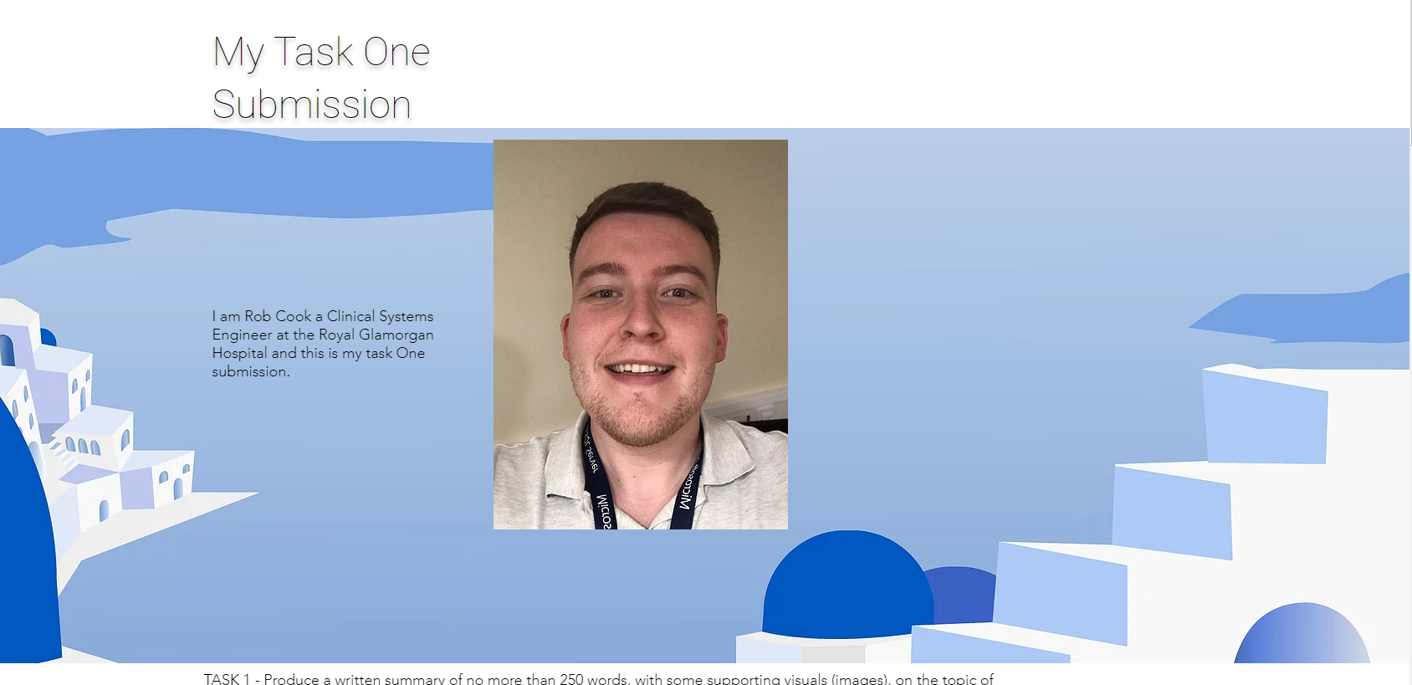

Task 1 – Written summary.
Please see E-portfolio
Task 2 – Mind Map.
Please see E-portfolio or use https://mm.tt/1660038794?t=588cO06UE0

Task 3 – Video presentation.
Please see E-portfolio
Video made via Adobe Spark.

Task 4 – Academic poster.
Please see E-portfolio
Poster made via Adobe Spark.

IMPORTANT LINK TEST REMINDER: to ensure your work is accessible by the module tutors for marking, it is very important to sign out of the online applications used to create your work (e-portfolio and task answer Applications) and to try accessing them with the links you are providing in this document. For the work to be marked, it must be available to the module tutors for marking.

