Title of report: Marks and Spencer Report
Name of the author: Tariqul Islam
Name of the host Organisation: University of Wales Trinity Saint David
Date of Report publication: 20th July 2018

Executive summary:
The report made on the recent strategic analysis of Marks and Spencer is one of the UK’s leading retailers. The company facing a to survive in the high street retail business since last ten years as decided to close100 shops around the UK as so many competitor brought new trends and fashionable design of cloths in the market, new trends with online shopping for the new generation has also impacted of M&S turnover and portfolio. Other retailer offers fashionable and quality of product in bargain price whereas M&S product are high price in the market.
Researcher has analyses of M&S‘s recent problem with clothing business, reviewed on the SWOT and Pestle analysis in consideration of present situation, the strategies of management, stakeholders influences to resolve the issues by adopting the new trends, challenges of the recent market situation where they are affected by economic crisis also, online trading and new concept such as, to implement Plan A 2025 by the new management strategies.

Content of page:
Content Page No.
  - Terms of reference 1
- Procedure 1
- Findings 2
- Conclusion 10
- Options 12
- Appendices 13
- Acknowledgement 13
- Reference List 14
- Bibliography 15

1.0 Terms of Reference
The lecturer Maria Heffernan has requested on 18th June2018 to compile a report to analysis the problem of Marks and Spencer. The author Tariqul Islam researched about the current problems of M&S as decided closing 100 retails in the UK high streets. The submission date of this report is 20th July 2018.
2.0 Procedure
2.1 Books, Web sites and article

Page 1

3.0 Findings
3.1 Introduction of Marks and Spencer (M&S)
Marks and Spencer brand started as a market stall in Leeds in 1884 now a well recognised brand on the high street of the United Kingdom over the period of 130 years. The company was founded by partnership between Michael Marks and Thomas Spencer to sell quality clothing in a reasonable price. In 1953 their approach towards customer relationship was précised by ‘Customer is always and completely right’. After 1963-72 they expand their business globally. Marks and Spencer made its reputation in the early 20th century only selling British made goods; it entered a long term relationship with British manufacturers and sold clothes and food under St. Michael brand. Which was introduced 1928. In 1989 M& S had revolution of selling in undergarments and in 20th century they did double marketing of underwear product.
The brand had become house hold name recognised for quality product and service within the largest retail sector in the UK and particularly those opening on high street. It is also an international retailer and operating stores over the 20 countries.
The statistic presents the number of Marks and Spencer stores in the world wide from 2010 to 2018, by region where in the UK has increased from 690 to 1035 in 2018 and internationally since 2015 to 2018 a total number of 428 stores.
Retail and Trade, (2018)
After a huge success and boasted profit of more than £1 billion a decade ago. Marks and Spencer ( M&S ) currently face the strategic challenges of reviving two core business food and clothing, which is currently suffering bigger competition from fashionable and fresh high street and online competitors.
UKessays, (2017)
Page 2

3.2 Problems and attempts to resolve:
The Sales of M& S in its general merchandise division which includes clothing and home wares and has been a long-term problem and fail to set along with its food business. High street stalwarts such as M & S have been struggling for years with an expensive and oversize store estate along with rising costs including wages, the apprenticeship levy and business rates. Retailers have been squeezed by online competition and a shift in customer’s habit towards shopping over the internet.
Ralph, (2018)
Marks and Spencer was ranked as the 102nd biggest public company by value in the FTSE 350, with a market capitalisation of £4.7 billion according to Thomson Reuter’s data.
The M&S Chief executive, Steve Rowe is shutting 100 of its large clothing and food shops by 2022 amid falling sales and profit. It already closed 20. The trends, new competitors for the fashionable cloths by Zara, Gap, the habits online marketing of customers and fight against the growth of value chains for food and cloths such as Primark, Aldi and Lidl has also influenced.
The chief executive Rowe will flag price cuts recent in the food and clothing aisles as M&S attempts to fight back against the growth value chains.
Wood, (2018)
M&S has recently started increased the range of product offers to their loyal customers, they approach to delivering plan A to their creating long term sustainable business value. According to that their approaches to the retail operations they aim to excite and inspire their customers at every turn with the product, service and experience that are desirable and sustainable. They aim to communicate the customers about sustainability issues in a straight forward and easy to understand manner and a practical way.

Page 3

Stakeholders are well listen and valued carefully, M&S aim to adopt responsible approach in depicting social and ethical diversity and avoid images or campaigns which are inappropriate and cause offences.
M&S commitments and targets to approach to manage the sustainability of their food, cloth and house products such as to new product development and investment decision, sourcing of key material and commodities, to promote and reward sustainable behaviour within supply base and to look for the customers a product with more healthy and sustainable lifestyle, helping to build sustainable on well being for the communities and for the planate.
3.3 Nature, Scope and Impact:
During the last 10 years;
M&S clothing prices are too high and too promotional for the shoppers as they wait to buying anything until special offer made by the company. Middle class has gone in different direction, customers has a habit to buy online and fashionable competitors such as Gap, Zara , Primark, Lidl, Aldi Waitrose and Tesco has also impacted the market share of M&S.
‘A key part of our recovery plan for clothing and home is lowering prices and reducing promotions’ said Rowe as an example he pointed to women’s leggings with a number of pairs has sold increasing 149% after the price cut from £19.50 to £15.
The post Brexit collapse in terms of pound was also bad news for the turnover of M&S as in common with other clothing retailers, import are based on dollars as from £770m-1.16bn worth of imported goods a total 65% is clothing which has also impacted on the net profit.
Wood and Farrell, (2018)

Page 4

Apart from the nature of the problem M&S has management strategies which have also impacted the turnover of the company as few size shops was not suitable, had to close and pricing of M&S product are too high. Ordinary and middle class people has a choice, new trends, the expensive product of M&S and financial abilities has also impacted for the M&S turnover and people had choice to shop around online and offline with other retailer like Waitrose and other fashionable brands. Overhead cost and estate rent has also impacted on M&S turnover.
3.4 Analysis of Marks and Spencer
3.4.1 SWOT of M&S
‘In the dynamic word of marketing, an effective solution to satisfying customer needs does not have longevity’ Gibbs
Base on the market research and a successful analysis of customers the SWOT of M&S reviewed as follows:
Strength:
Introducing of New products and designed by George Davies a famous designer at present.
Focus on UK retail market and concentrated on home such as excellent food product through carefully expansion of the simply food special stores.
Customers have a strong faith on M&S underwear. 40% of female population currently wears M&S knickers.
An extend growth of product and quality and technological innovation, simple food stores and NCR and Fujitsu self check out tills.

Page 5

Weakness:
St. Michael brand failed to attract teenagers.
Loss of customer focus.
Poor decision making, overstocking causes to led cut price clothing.
Cut cost by outsourcing to the cheaper foreign suppliers.
Less attractive clothing other than Debenhams, Matalan and H&M.
Opportunities:
M&S is the biggest retailer in the Europe.
UK customers have faith on M&S as well as in international market. To lead a leading retailer must have an international dimension.
M&S hope to explore in home improvement boom and focused on selling food in smaller shops.
Railways encourage developments of present opportunities and M&S exploit of customers’ needs. At present in 650m passengers a year uses in UK’s 14 major railway stations.
Introducing of new loyalty credit card.
Threats:
New trends and teenagers choice, as they have different opinion for M&S product.
Fashionable shops such as Zara, Gap, Primark, Waitrose and Tesco.
Expensive product, bargaining power of buyer and seller.
Economical environment is also a big issue, Brexit issue has also impacted on greater economical affect on UK’s retail market.
High pricing and promotional offer retain the customers to visit M&S shops.
Page 6

3.4.2 Pestle analysis for M&S:
Political:
M&S has been considered by EC’s free trade agreement which led to decrease sourcing cost. Higher cost has a disadvantage of international market. M&S known as Plan A CSR initiative but there is lack of support by UK government for energy efficiency scheme what affect the negative impact of M&S.
Economical:
M&S is affected for the discounted prices by the competitors. M&S focus on high quality but also affected with the customers to on short term loss. Financial crisis has also lead more price sensitive for the customers as M&S needs to lead market flow to sustained sale. Customers are often looking for value sale or promotional sale of M&S product to purchase through online or from the shop. Falling the oil price negatively and other reason like pre Brexit issues impacted the economical crises.
Technological Factors:
Although M&S has a strong social media and online presence and well placed on the avenue, the consumers are now more technology focused and their habits changes to do online shopping. Considering the mobile commerce and online retailing M&S should build a strong presence of digital marketing facilities to take its full advantage.
Kasi, (2017)
3.4.3 Stakeholders of M&S
There are two types of stakeholders of Marks and Spencer
Internal stakeholders: such as Management, Owners, Employee and staff and Shareholders.
External stakeholders are such as Suppliers, Customers, General public, Communities, Media, Reporters and Commentators.
Page 7

For example Management stakeholders of M&S has full of power and they can influence very much.
3.4.4 Stakeholders analysis diagram
Please see Appendices
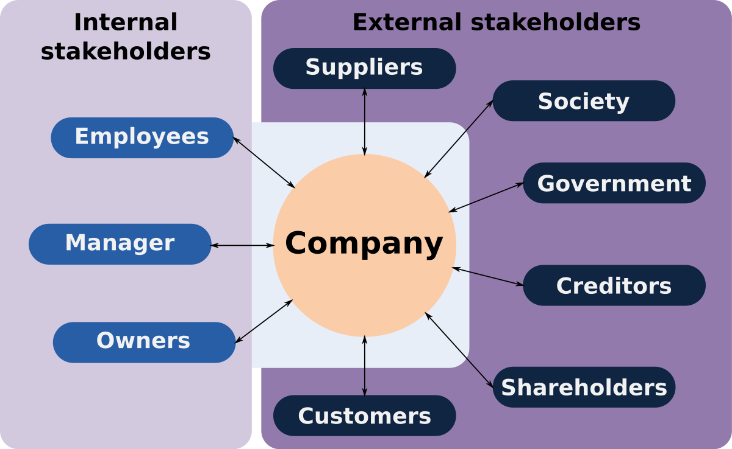

The Internal stakeholders like Owner and Managers has high power and high interest and Employees has high interest and low power.
The external stakeholders like customer, creditor, Government, society has high power and low interest for M&S and other way the Supplier and Shareholders has low power and high interest for company.

Page 8

3.4.5 Stakeholders influence of resolving problem
The internal Stakeholders of M&S can influence for the company and to establish the new strategies to implement or to resolve any issues arise as they have high power and high interest. They can associate risk areas and help to decide better strategies and making decision. Such as M&S stakeholders place in the organization, priorities and importance recognised by a good relationship with the company. On the other side the external shareholders they have low power and high interest for M&S and stakeholders are feeling insecure for the future as share prices falling down. M&S should undertake various steps to maintain the market share and retain the stakeholder in the business for the future growth of the company.
UKESSAYS, (2017)

Page 9
4.0 Conclusion:
4.1
The researcher has acknowledged, indentified the issues of Marks and Spencer their last ten year operational strategies and portfolio as they failed to meet the turnover and looking for to close 100 shops in the UK, although they are a leading largest retailer in the UK and operating internationally as well. M&S failed to meet the new generation choice as the new generation are different for new trends and fashionable clothing, middle class has gone in different direction, the recent economy is not stable and prices of M&S product too high. Despite this management failed, had poor strategies and didn’t consider the new trends, pricing, the strategies such as online retailing and customer’s affordability to recent financial crisis.
4.2
Many other fashionable products available and competitor such offering bargain fashionable products as overseas supplier, supply cheap and quicker, whereas M&S has local product and local supplier and customer doesn’t want to pay high price for the British manufacturer, customers retain to visit the shop till any promotional offers to begin in M&S. M&S should consider the current trend, quality and customers affordability to buy the M&S product. Many customers have changed their habits for Online retailing and looking for any promotional offers offered by other retailer. This also a bad impact for the M&S customers rather than a sustainable price the valued customer. Overhead cost has gone up for M&S and estate rents and size of the shops has also impacted their turnover and should pay in consideration of M&S management.

Page 10

4.3
They management could changed their strategies to recover their business which mainly their clothing range with segmentation, product appeal by implementing sustainable Plan A 2025 which enable to meet the future demands of M&S customers. This will sets bold social and environmental goals, crucially complemented by a desire to engage of all M&S customers, colleagues, suppliers, and business partners in sustainable journey. A future plan is to truly sustainable M&S in partnership with customers and other stakeholders have positive impact in all that it does.
Rowe, (2015)

Page 11

5.0 Options
Based on the review and many other issues created by the previous management strategies as to resolve the problems the stakeholders such as the share holders, the management board has full power to decide on the new strategies to implement the plan A 2025 to make a sustainable product offer for the M&S trusted customers and the supplier in future.
When Customers are valued they come back and make the big difference of turnover. M&S has to focus on customers and bring back their trust. The strategies of considering the quality, price, trends, a sustainable price in related to the current economical situation, should consider online retailing trends, fashionable design and quality to offer to the new generation and other aged customers.
To reduce the overhead cost of M&S should consider about the size of store is going to open and to recruit the right number of staffs, as well as to reward and recognise the employees for their better performance. To build an excellent relationship with local supplier and a new relationship to be made with foreign supplier for a better and wide range of fashionable product to supply. No more stock load to reduce the price cut in future. To look on less promotional offer instead better quality and sustainable price offer to be made.
5.1
Shareholders such as Management should focus on recent trend and habits of online treading. M&S should offer an attractive price offer for the online buyer and rewarding them by earning points of each shopping via online. Complaints and issues should attend carefully and resolve quickly as possible.

Page 12

6.0 Appendices

7.0 Acknowledgements
The report has made with the co-operation of the Lecturer Maria Heffernan and by the help of the students and librarians of University of Wales Trinity Saint David.

Page 13

8.0 Reference List
Retail and Trade, (2018 ), (online), Number of Marks and Spencer stores, www.statista.com/statistices/2686/ marks-und –Spencer-number-of-outlet-by-region, accessed online on 17/07/2018
UKessays, (2017), Marks and Spencer problem, www.ukessays.com, viewed online on 17/07/2018
Ralph, A., (2018), M& S at risk of symbolic relegation, the times, pp53, col2
Wood, Z., (2018), Marks and Spencer to reveal dozens of store closures, www.theguardian.com, accessed on line on 17/07/2018
Wood, Z. and Farrell, S., (2018), Marks and Spencer suffers biggest clothing sales fall in 10 years, www.theguardian.com/business, accessed online on 17/07/2018
Kasi, A., (2017), Pestle analysis of Marks and Spencer (M&S), www.freepestelanalysis.com, accessed online on 17/06/2018
UKESSAYS, (2017), Marks and Spencer: An analysis,www.ukessays.com/essays/marketing/marks-and –Spencer, accessed online on 19/07/2018
Rowe, S., (2017, Plan A/ 2025 M&S, www.corporate.marksandspencer.com/documents/plan, accessed online on 17/07/2018

Page 14

9.0 Bibliography
Online resources and Google.com

Page 15

