Student name: Ana Maria Dobrinoiu
Student number: 2017713
Module: Foreign Languages – Mandarin (BMIH 5003)
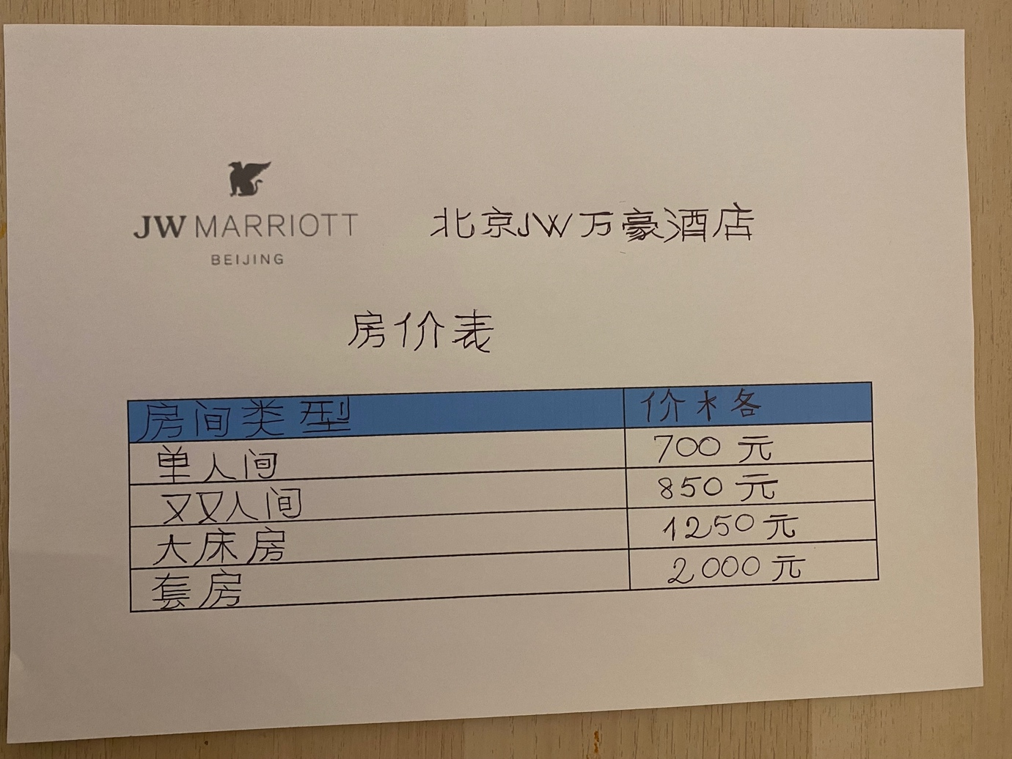
Hotel Display Board for JW Marriott Hotel Beijing

