

Programming

L0 -Introduction to Computer Programming - COMPUTING
Module Code: ACCA4020
BSC4F Computing (Computer Networks and Cyber Security) with Foundation Year

Bethan Moyle (1707952)
1707952@student.uwtsd.ac.uk
Table of Contents
1a. Flowchart Analysis 3
1b. Identified Loops 4
Primary Loop (Outer Loop) 4
Secondary Loop (Nested Loop) 4
2a. Loops and Termination Conditions 4
Impact of early exit 5
2b. Boolean Variable 5
3 Conditional Statements 5
3a. Purpose of Conditional Statements 5
3b. Explanation of Specific Conditional Statements 6
If Num1 > 1 6
If Num1 % Num2 == 0 6
If Is_Correct == True 6
4a. Program 7
4b Test Cases 8
Start: 3 End:16 8
Start: 25, End: 42 8
5. Program Validation 9
a. Test Case 1: 9
b. Test Case 2: 9
c. Test Case 3: 10
d. Test Case 4: 10
e. Test Case 5: 11
6 Optimisation Techniques 11
7 Reflection on Learning Journey 12
Challenges 12
Solutions 12
Application of Concepts 12
8 Conclusion 12
9 References 13

Introduction
This assignment explores a flowchart that outlines an algorithm for identifying prime numbers within a specified range. The analysis focuses on how loops interact with one another, the role of conditional statements, and the implementation of early exits. A Python program will be developed based on the logic and structure of the flowchart, including tests to validate its functionality. A reflection on the learning journey throughout the module is reviewed, highlighting key challenges encountered and proposed strategies for overcoming them.

1a. Flowchart Analysis
The purpose of the flow chart is to identify and collect all prime numbers within a set range defined by the user. The program begins by taking two inputs: a starting number (given to the variable start) and an ending number (given to the variable end). It then checks each number in that range to determine if it is prime. The flowchart includes two nested loops: the outer loop iterates through each number from start to end, and the inner loop checks if the current number has any divisors other than 1 or itself.
The flowchart uses several conditional checks implemented through if statements. The statements control the flow of the program and ensure correct prime numbers are identified. The first loops if conditions are to see if the number has a possibility of being prime before allowing it through to the second loop. If the number passes this initial filter, the program proceeds to check the divisibility of the number, by introducing new variables such as Num2. If the number is determined as prime it is added to the Value[] list and the program will move onto the next number until the value of Num1 is larger than the value of end+1, at which point the program will then exit the loop and display the identified list of prime numbers.
However, a flaw in the flowchart’s algorithm is that it fails to identify 2 as a prime number. When Num1 = 2 and Num2 = 2, the condition Num1 > sqrt(Num1) + 1 evaluates as true, causing the algorithm to incorrectly mark 2 as non-prime. This is problematic because 2 is the only even prime number [1], divisible only by 1 and itself. To fix this, a special condition should be added to explicitly check if Num1 equals 2 and handle it separately before applying the general logic.

1b. Identified Loops
The flowchart contains two nested loops, with one loop operating within the other. The outer loop runs first, and within it, the inner loop is executed. Although flowcharts don’t use a unique symbol for loops, decision diamonds combined with arrows are used to indicate repetition [2]. The arrow will point back to a section of the code that has already been executed, this indicates the presence of a loop [2], where the process will repeat based on the decision made at that point.

Primary Loop (Outer Loop)
The first loop in the flowchart is the outer loop, which runs the program from the range of the start variable to the end variable specified by the user. It begins by checking whether Num1 is less than end+1. Since Num1 is initially set to the start value and increases by 1 with each iteration, this condition determines when the loop should exit and move on to the next block of code. If Num1 exceeds the end value, the loop exits, the Values list is printed, and the program ends. However, If the condition is met, the loop moves on to another if statement that checks whether Num1 is greater than 1, as value of 1 and below are not considered prime numbers[1]. If Num1 is not greater than 1, it is incremented by 1, and the loop restarts. Once this condition finds number that meets the requirements, the program continues with the next steps in the prime checking process.

Secondary Loop (Nested Loop)
This loop checks whether the value of Num2 is less than the square root of Num1+1. It uses the square root of the num1 instead of its whole number for efficiency to check each number up to the number of Num1. This is because any factor greater than the square root of Num1 would require a corresponding smaller factor, which would already have been checked.
If it is less than Num2, the program proceeds to check if is_Correct is set to true. Within the loop, the program checks whether Num1 divided by Num2 leaves a remainder of 0. If this condition is true, it means Num1 is divisible by the value of Num2, so is_Correct is set to False, the loop breaks, and the program moves on to the next value of Num1. If the condition is false, Num2 is incremented by 1, and the loop repeats as long as the condition Num2 < sqrt(Num1) + 1 holds.

2a. Loops and Termination Conditions
The outer loop is responsible for checking whether Num1 could potentially be a prime number, and it also checks whether the numbers in the range defined by the user has all been checked.
The inner loop is responsible for filtering out non-prime numbers by checking whether Num1 is divisible by any number other than 1 and itself. If no such divisor is found, is_Correct remains True, and Num1 is added to the Values[] list, which stores all identified prime numbers. However, if the loop finds a number that divides Num1 evenly (without leaving a remainder), it means Num1 is not prime, is_Correct is then set to False, the loop exits early, and Num1 is not added to the list. This inner loop directly affects the outer loop’s behaviour by deciding whether each Num1 value qualifies as a prime. The early exit condition improves efficiency by avoiding unnecessary checks once a divisor is found.

Impact of early exit
If the outer loop exits early, it means that either the range of numbers from start to end+1 have all been checked or that the start and end range is not able to meet the conditions to continue through to the second loop. This helps to avoid unnecessary computations of numbers that do not meet the criteria to be considered possibly prime or are further than the defined range.
If the inner loop terminates early, it sets is_Correct to False and skips the remaining checks. This allows the outer loop to proceed to the next number. The early exit improves efficiency by avoiding unnecessary calculations and ensuring that non-prime numbers are not added to the Values[] list.

2b. Boolean Variable
The Boolean variable used in the flowchart is is_Correct. Its purpose is to keep track of whether the current value of Num1 is a prime number. It is initially set to true before any divisor checks are performed. This means that after passing the first two conditions, the program assumes Num1 is prime unless a later condition proves otherwise. If a divisor is found (i.e., Num1 % Num2 == 0), is_Correct is set to False.
If the condition Num2>sqrt(Num1)+1 is false, the program checks whether is_Correct is still true before adding Num1 to the Values [] list. If it is, the number is added, otherwise, it is skipped.

3 Conditional Statements

3a. Purpose of Conditional Statements
In programming, the conditional statements are used to make decisions [3]. It allows certain blocks of code to execute only when a specific condition is met [3]. This controls the flow of the program by determining which parts of the code should run based on logic, data, or user input [3]. Conditional statements are especially useful for implementing decision-making logic [3]. For example, they can be used to validate user input by checking whether the user has entered a valid number or character and then respond accordingly by executing different sections of code. They are also essential for error handling, allowing the program to check for potential issues before they cause problems [3]. If statements help prevent programs from crashing or behaving unpredictably [3].

3b. Explanation of Specific Conditional Statements

If Num1 > 1
This conditional statement checks whether the value of Num1 is greater than 1. This is important because, by definition, prime numbers are greater than 1. If Num1 is less than 1, the condition evaluates to false, and the program typically does not check whether the number is prime. The program is structured to skip the prime-checking logic and increment Num1 and continue looping until Num1 > 1 is true. This ensures that the program only starts checking for prime numbers when Num1 is in a valid range (i.e. greater than 1)

If Num1 % Num2 == 0
This conditional statement checks whether the remainder of dividing Num1 by Num2 is equal to 0. This is important for identifying non-prime numbers because prime numbers can only be divisible by 1 and itself. If Num1 is divisible by any number other than 1 and itself leaving a remainder of 0, then Num1 is not prime.

If Is_Correct == True
This condition checks whether the variable Is_Correct is set to True. The program uses this variable to track whether Num1 has been identified as a prime number and has passed all checks. If Is_Correct is True, it means Num1 was not divisible by any number other than itself or 1. When this condition is met the program will then add Num1 to the Values[] list.

4a. Program
Generate_special_numbers
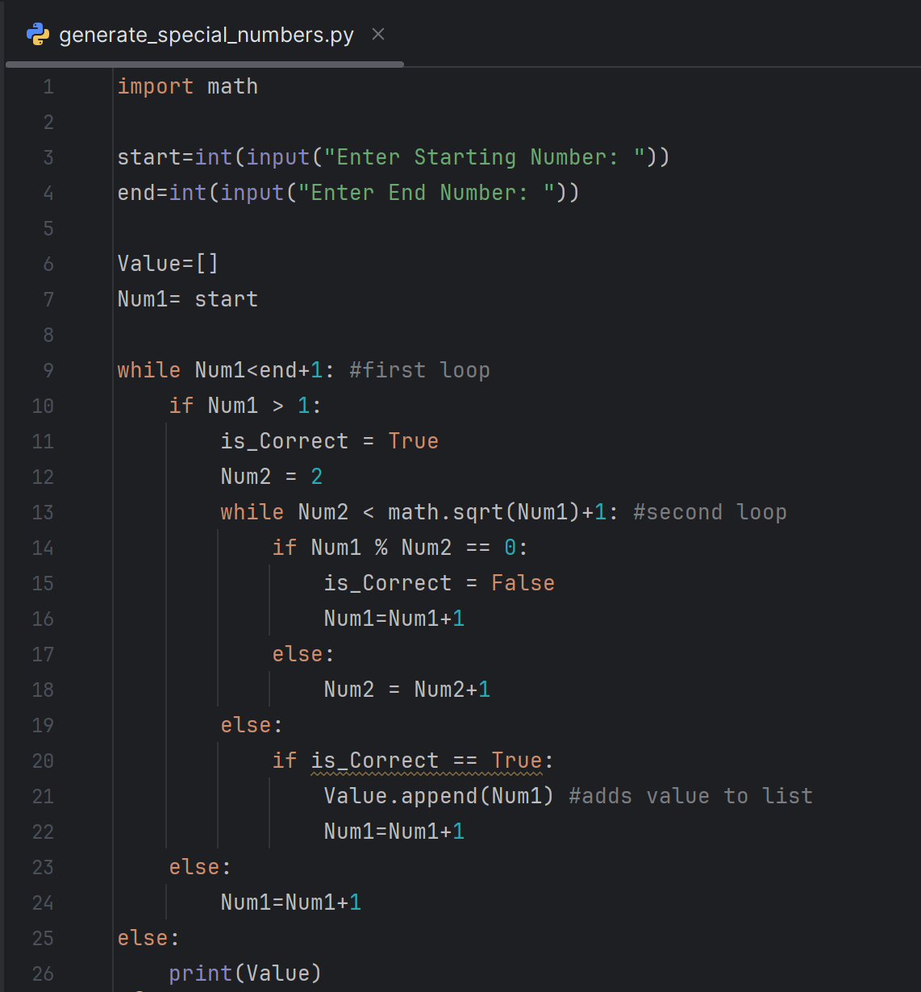

4b Test Cases

Start: 3 End:16
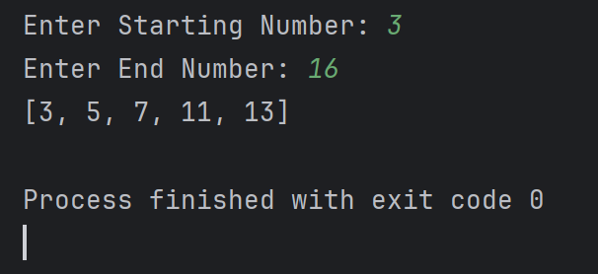

Start: 25, End: 42
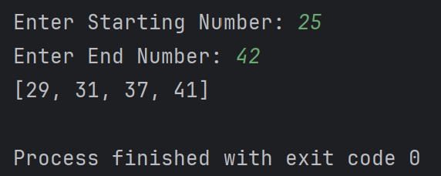

5. Program Validation

a. Test Case 1:
Start = 12, End = 22
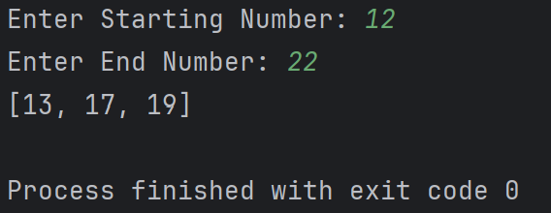
The program was executed for a range of numbers from 12 to 22. It evaluated each number within this range using conditional statements to determine whether it is a prime number. Once all prime numbers were identified, they were stored in a list. Finally, the program printed the list of prime numbers found in the given range, which were: 13, 17, and 19.

b. Test Case 2:
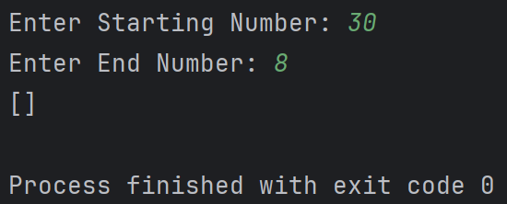
Start = 30, End = 8

When the program checks whether the starting value (30) is less than or equal to the end value plus one (8 + 1 = 9), the loop does not execute. As a result, the loop does not execute, and no numbers are evaluated or added to the Value[] list. Therefore, the program outputs an empty list.

c. Test Case 3:
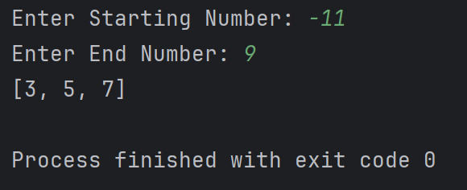
Start = -11, End = 9

In this scenario, the program does not enter the main prime-checking logic until the value of Num1 is greater than 1. It increments Num1 (-11) using Num1 = Num1 + 1 until this condition is satisfied. Once Num1 exceeds 1, the program proceeds to evaluate each number for primality. This continues until Num1 reaches the end value of 10. During this process, the prime numbers identified and added to the list are 3, 5, and 7, which are then printed as the final output.

d. Test Case 4:
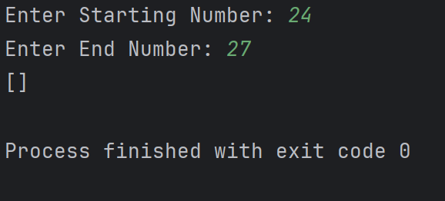
Start = 24, End = 27

Despite running through its validation steps for the given small range, the program does not identify any prime numbers. Since no values satisfy the prime condition, the Values[] list remains empty, and the program prints an empty output.

e. Test Case 5:
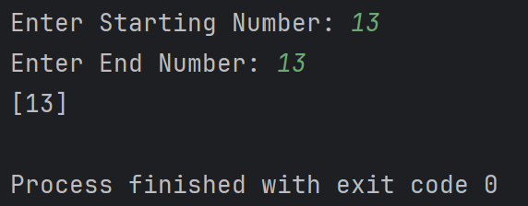
Start = 13, End = 13

The program still performs its checks even though the start and end values of the range are both 13. Since the condition Num1 > end + 1 is not initially met, the loop runs. The number 13 is evaluated and identified as a prime number, then added to the list. After this, Num1 is incremented, causing the loop condition to fail, and the program exits, printing the list containing the single prime number 13.

6 Optimisation Techniques
To optimise the program, the outer loop determines whether execution should continue based on the validity of the range. Loops reduce code repetition by allowing operations to be executed multiple times without duplicating code, improving both time and readability. Additionally, the nested loop allows for early exits during divisor checks. if a number is found to be non-prime, the loop can break immediately, avoiding unnecessary computations. Reusing the variables Num1 and Num2 also helps conserve memory and improve performance by eliminating the need for repeated resetting of the variables to their initial values each time.
Using sqrt(Num1) + 1 further reduces computation time by limiting the number of checks needed to determine if Num1 has any divisors. This is especially beneficial when dealing with large numbers, as it significantly narrows the range of potential factors.

7 Reflection on Learning Journey

Challenges
Loops presented a significant challenge, especially when determining the most appropriate type to use in varying scenarios. Mastery of these concepts tends to develop through consistent practice and experimentation. Beyond selecting the right loop structure, logical errors can also pose difficulties. For instance, in the process of creating the generate_special_numbers program, the initial version was free of syntax errors but contained flawed logic. Resolving these issues required stepping back, re-evaluating the approach, and identifying the root cause of the problem.

Solutions
To address challenges related to loops, a strategic approach involves practicing carious loop types within real-world scenarios, gradually increasing complexity as comprehension strengthens. Revisiting foundational loop concepts and thoroughly understanding each type can provide a solid base before progressing to more advanced topics. When it comes to minimising logical errors, examining problems from multiple perspectives and testing different solutions can offer valuable insights into what works effectively and why certain approaches fall short.

Application of Concepts
In tackling this assignment, nested loops were applied to solve the problem. The initial approach involved using a range loop, attempting to preset the range with start and end numbers provided by the user. However, this method did not yield the expected results, as the program produced no output. To troubleshoot, the code was reviewed line by line, with sections commented out to isolate the issue. Replacing the range loop with a while loop to initiate the program allowed the code to function as intended.

8 Conclusion
The flowchart uses logic, nested loops and conditional statements to determine whether a number is a prime number. It contains identified prime numbers within a list and prints the final result. The program can self correct if the user input range starts from below one or is higher than the end value. Optimisation techniques are used to make the code efficient, short and easy to read.

9 References
[1] Bitesize, “What are Prime Numbers,” BBC. [Online]. Available: https://www.bbc.co.uk/bitesize/articles/z2q26fr#zp38mbk
[2] Unknown, “Flowcharts,” Ada Computer Science. [Online]. Available: https://adacomputerscience.org/concepts/design_flowcharts#:~:text=Some loops check their condition at the,end (these loops are called post-condition loops).&text=To represent a post-condition loop in a,decision symbol%2C as shown in Figure 2.
[3] O. Jeremiah, “How to Use Conditional Statements in Python – Examples of if, else, and elif,” free Code Camp. [Online]. Available: https://www.freecodecamp.org/news/how-to-use-conditional-statements-if-else-elif-in-python/#:~:text=Conditional statements are an essential,to use them in practice.

Reference Page

