Intercultural competence Report

Student name Catalina Gabriela Dumitru
Student ID number 2209716
Foreign Language & Cultural Awareness BMIH5003
Lecturer Lisa-Marie Bassler
21/05/2024
Wordcount 1098

Executive Summary :

This report makes a comparison of intercultural aspects between two countries, England and China with the data from GLOBE Project study (2004). Data analysed for two countries are similarities and differences in context of cultural intelligence and sensitivity, the analyse will help General Manager to understand better the context of business expansion, English hotel will open a new unit in China. Will be relevant also data about leadership, to help General Manager to decide how many expats and how many locals must relocate and respectively hire in the new place.

Content Table

1 Introduction 4
2 Basics 4
3 Context 4
4 GLOBE Project (2004) 5
5 England in GLOBE Project 5
6 China in GLOBE Project 6
7 England and China cultural data 7
8 Management and Leadership 7
9 Conclusion 8
10 Recommendations for General Manager 9
References 10

1. Introduction
Soon, Diversity Hotel & Spa will open a branch in China. Initially, part of the management team will come from England, while the rest of the staff will be hired locally. This arrangement will bring about some differences due to variations in culture, education, perceptions, and conduct rules. To ensure successful operations, managers leading the China branch must study the differences and similarities between English and Chinese cultures. This understanding is crucial for effectively managing the new team. The aim of this analysis is to comparison English and Chinese cultural norms, drawing on findings from the GLOBE Project (2004) on intercultural competencies and leadership. This exploration provides a series of recommendations for the hotel manager, highlighting key elements identified through this case study.
2. Basics
Intercultural competence refers to the ability to interact and to communicate efficiently across various cultural settings. In today’s situation, where different cultures converge, this skill is indispensable. Will allow both persons and institutions to comprehend, to value and to adjust to cultural variances, facilitating effective communication and collaboration. Enhanced cultural understanding fosters connection, eliminates errors, and fortifies relationships within the unified market (Hofstede, 2005). This competence is crucial for fostering cooperation, driving new concepts, and building a crosslink between various mixed values for both institutional and individual achievements. Intercultural competence is that capability to engage completely in same team people from different cultures. Core elements include cultural awareness, communicative sensitivity, and flexibility. Cultural empathy, which involves understanding others' perspectives without judgment, is a fundamental aspect (Garg, 2018) in promoting successful global interrelations between institutions and people.
3. Context
Actual situation brings economies together, swift technological progress and mixes various consumer demographics. It offers vast possibilities, it also casts challenges as governing intricacies or different views about facts. Cultural specificities play a crucial role in many business aspects, influencing how the things develop and shaping communication types, management procedures and tactics to build professional relationships (Hampden-Turner, 2020). Misunderstandings can occur due to differing views on polite norms or perception of time, social hierarchy and interhuman communication practices. Multinational companies understand the significance of cultural intelligence and tailor their methods to fit local values. Successfully nuancing cultural details inspires trust, reduces confusion risk and cultivates productive, lasting relations in the fast changing and intricate global business environment.
4.GLOBE Project (2004)
The project known as GLOBE is a comprehensive statistical analysis and a cross-cultural study about several values in different perceptions and also about leadership in a case study with subjects from many countries. Initiated in 1991, this study gathers answers of employees of different nations with the goal of enhancing understanding of how culture impacts leadership comportment. Initially, GLOBE has centred on six main dimensions of global leader posture. GLOBE project offers significant understandings about how cultural background differences could influence leadership and human perception of values across various cultural contexts (House, 2004). In 2004, the GLOBE (abbreviation for Global Leadership and Organizational Behaviour Effectiveness) Project developed its research to include 61 countries, examining, for this time, nine “cultural dimensions”: “Power Distance, Uncertainty Avoidance, Societal Collectivism, In-Group Collectivism, Gender Egalitarianism, Assertiveness, Future Orientation, Performance Orientation, and Humane Orientation” (House, 2004). By interpretation of data and results, exploring these nine directions, the program provides a inclusive interpretation of cultural patterns on leadership highlighting which kind of leaders could expect from a predefined background.
5. England in GLOBE Project
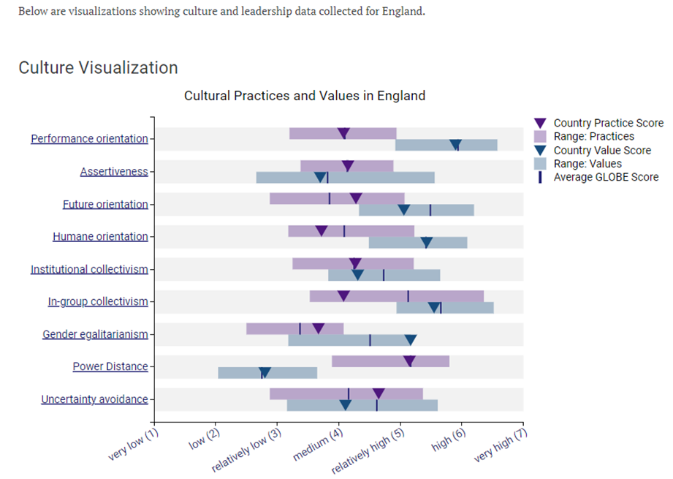
(GLOBE Project, 2004)
England predominantly embodies an individualistic culture, prioritizing personal autonomy and self-expression. Communication is generally direct, valuing clarity and open dialogue. Leadership tends to favour democratic and participative styles. Notable customs include respect for the monarchy and traditions such as cult for sports and bets or to drink tea. Politeness and humour, often self-deprecating, are key aspects of behaviour. While English culture aligns with global norms like recognizing individual rights (Thomas, 2016), its unique approach to social interactions and historical traditions sets it apart. Grasping these cultural aspects is essential for effective cross-cultural interrelations and leadership in England.
6. China in GLOBE Project
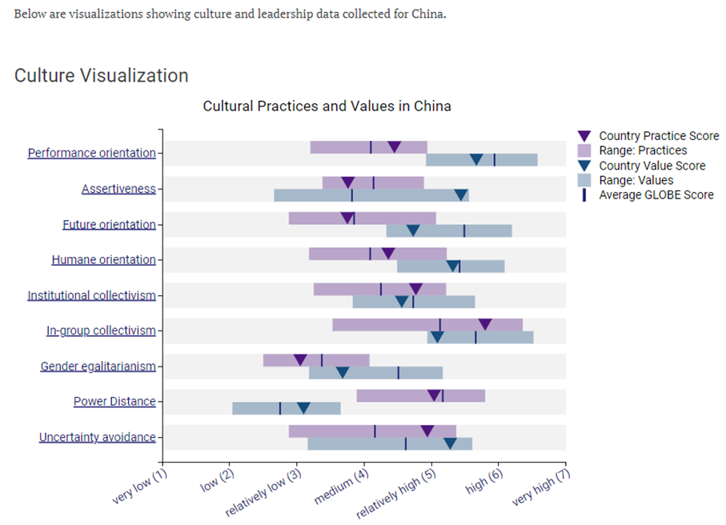
(GLOBE Project, 2004)
China represents a communalist culture, where numerous communities and family connections take precedence to individualistic goals. Direct communication in Chinese society is mostly indirect and reliant on circumstances, many times signals and unsaid massages replacing direct expression of messages. Also leadership is typically hierarchical and paternalistic, with leaders precepted as teachers or mentors (Hofstede, 2005). Cultural values like filial respect, appreciation for elderly people and for teachers are central to many norms and beliefs. Celebrations such as the Dragon New Year, ancestor worship, also the meaning and importance of the colour “red”, symbolizing luck success and fortune, are deeply ingrained in Chinese culture (Christiansen, 2020).. Grasping such cultural aspects could be essential to lead to a successful cross-cultural interaction, fostering effective relations, based on familiar trust and effectively managing leadership roles within the Chinese context.
7. England and China cultural data
England and China have distinct cultural traits shaped by their unique histories and social norms. In England, communication is typically direct and clear, while in China, it often relies on indirect expression and non-verbal cues. English work ethics emphasize individual initiative, whereas Chinese work ethics focus on group consistency and group objectives (House, 2004). English partnership codes are flexible, whereas Chinese practices value are more rigid and based on durable bonds and ancient values. Social practices in England emphasize a manners code, politesse and informality, while Chinese customs are deeply rooted in collectivism and indirect communication, ancestral or deeply ingrained (House, 2013).
In comparison, these cultural features highlights the importance of understanding different cultural perceptions to obtain a solid intercultural cooperation. The GLOBE Project reveal significant differences in cultural dimensions. England promoting individualism, valuing individual independence, meanwhile China accentuates communalism and grouping unity to succeed (House, 2004). In terms of uncertainty avoidance, another difference, while England prefers flexibility and adaptability, whereas China favours rules and structured situations. Assertiveness also differs, England having a better confidence in communication and China been less direct, more intuitive communication and transmitting messages in a suggestive approach.
8. Management and Leadership
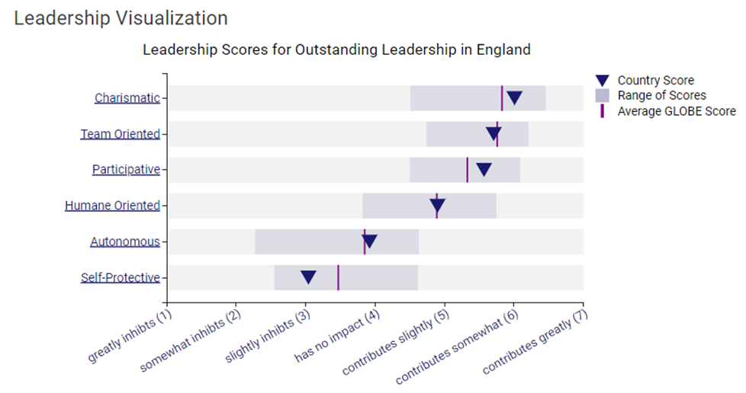
(GLOBE Project, 2004)
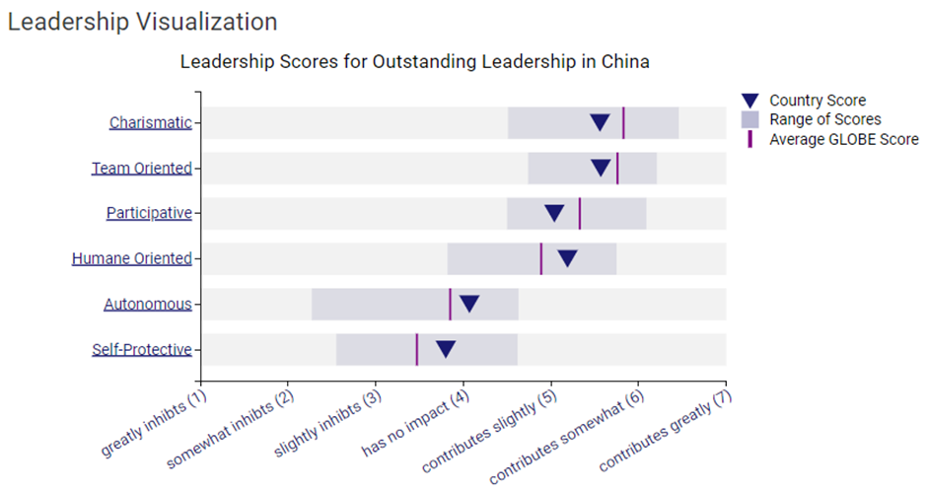
(GLOBE Project, 2004)
These distinctions profoundly impact commercial interactions in England versus China. In England, one-person centred principles nurtures innovative ventures and frequently lead to decentralized decision-making (House, 2013). Leadership in England typically focuses on teamwork and open dialogue. In contrast, China's collectivist ethos shapes cooperative business practices within hierarchical systems that steer decision-making. Chinese leaders often assume a paternal role, stressing guidance and group harmony (Abramson, 2018).
Intercultural competence is vital for managing these differences, enabling leaders to grasp and adjust to diverse communication styles, work ethics, and decision-making methods. Leaders with strong intercultural skills can enhance cooperation, build trust, and design strategies suited to both British and Chinese business environments. This cultural sensitivity is crucial for reaching success for entire organization and less individual .
9 Conclusion
In summary, the comparison underscores the unique cultural traits of these countries, influencing communication methods, work values, and companies rules. Accepting these distinctions is essential for an effective multicultural interaction. Cross-cultural competence is highlighted as a crucial element for an embedded leadership and company resolution achievement (Deardorff, 2023). The international marketplace demands an understanding of cultural nuances and to accept different viewpoints. Managers and businesses that develop intercultural competence could obtain prolific relationships, improve cooperation, and prosper in a connected environment. This skill is vital for attaining success amid the difficulties of the constantly transforming worldwide environment.
10. Recommendations for General Manager
Few directions to improve Cultural Interrelations at Diversity Hotel & Spa in China:
Cross-Cultural Training: Provide comprehensive training on Chinese cultural nuances, including communication styles, preferences, and expectations. Topics should cover salute styles, etiquette customs and usances, rules and local habitudes (Storti, 2022).
Elaboration of Service Rules: Establish standards of staff to meet Chinese cultural expectations. Training staff to offer personalized and attentive service can significantly enhance guest satisfaction (King, 2014).
Linguistic and Communicative Skills: Allocate resources to language training for essential staff members. Having employees proficient in Mandarin can significantly enhance the guest experience and demonstrate a dedication to accommodating Chinese visitors.
Cultural Awareness in Promotion: Tailor marketing content to resonate with Chinese cultural values and aesthetics, to attract Chinese clientele.
Leadership Cultural Awareness Training: Ensure leadership undergoes cultural awareness training to set the tone for valuing diversity and understanding cultural intelligence in operations (Russette, 2008).
Local Partnerships: Establish partnerships with local businesses and cultural organizations to better integrate into the community and understand local customs.
Implementing these recommendations will help the hotel staff to successfully manage cultural distinctions to offer a positive and culturally respectful experience for future local guests.

REFERENCE LIST
Abramson, N.R. and Moran, R. (2018) Managing Cultural Differences: Global Leadership for the 21st Century. 10th Ed. Abingdon: Routledge.
Christiansen, B., Branch, J.D. and Karmowska, J. (2020) Cultural Factors and Performance in 21st Century Businesses. Hershey : IGI Global.
Deardorff, D. K., & Berardo, K. (Eds.). (2023). Building Cultural Competence: Innovative Activities and Models. Taylor & Francis.
Garg, S. (2018). Strategy and leadership practices across cultures world wide. International Journal on Leadership, 6(2), 35.
GLOBE project (2004) Visualizations of 2004 study / China / Culture Visualization and Leadership Visualization available at: https://globeproject.com/results/countries/CHN
GLOBE project (2004) Visualizations of 2004 study / England / Culture Visualization and Leadership Visualization available at: https://globeproject.com/results/countries/GBR
Hampden-Turner, C. and Trompenaars, F. (2020) Riding the Waves of Culture. 4th Ed. London: John Murray Press
Hofstede, G., Hofstede, G. J., & Minkov, M. (2005). Cultures and organizations: Software of the mind (Vol. 2). New York: McGraw-Hill.
House, R. et al. (2004). Culture, leadership, and organizations: The GLOBE study of 62 societies. Sage publications.
House, R. et al. (2013). Strategic leadership across cultures: GLOBE study of CEO leadership behaviour and effectiveness in 24 countries. Sage Publications.
King, P., & Zhang, W. (2014). Chinese and western leadership models: A literature review. Journal of Management Research, 6(2), 1.
Russette, J. W., Scully, R. E., Preziosi, R. (2008). Leadership across cultures: A comparative study. Academy of Strategic Management Journal, 7, 47.
Storti, C. (2022). The art of crossing cultures. Hachette UK.
Thomas, D. C., Peterson, M. F. (2016). Cross-cultural management: Essential concepts. Sage Publications.

