DS 1 My Digital Life

Photo 1
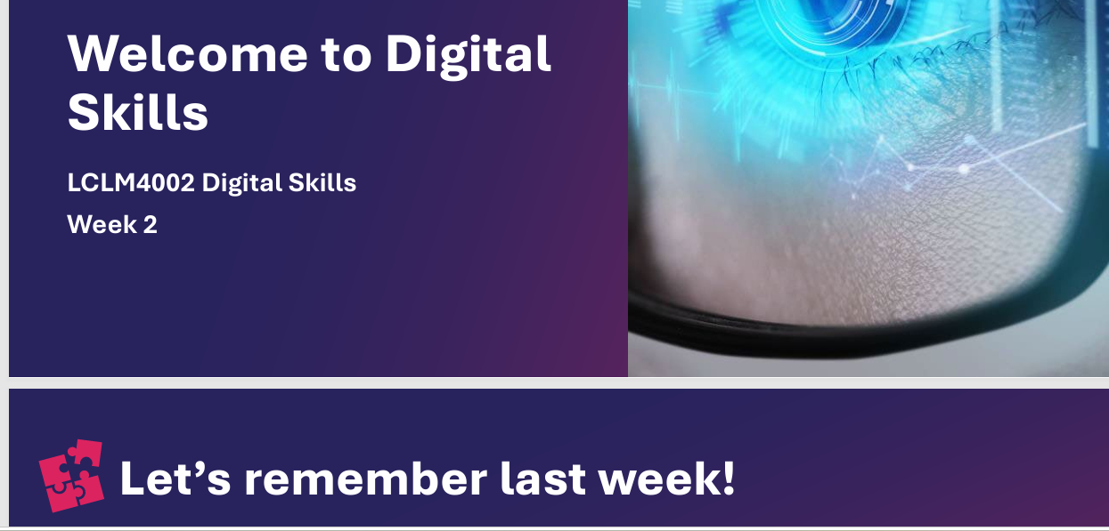
A Welcome to Digital Skills in my new digital life in the University of Wales Trinity Saint David, London.

Photo 2
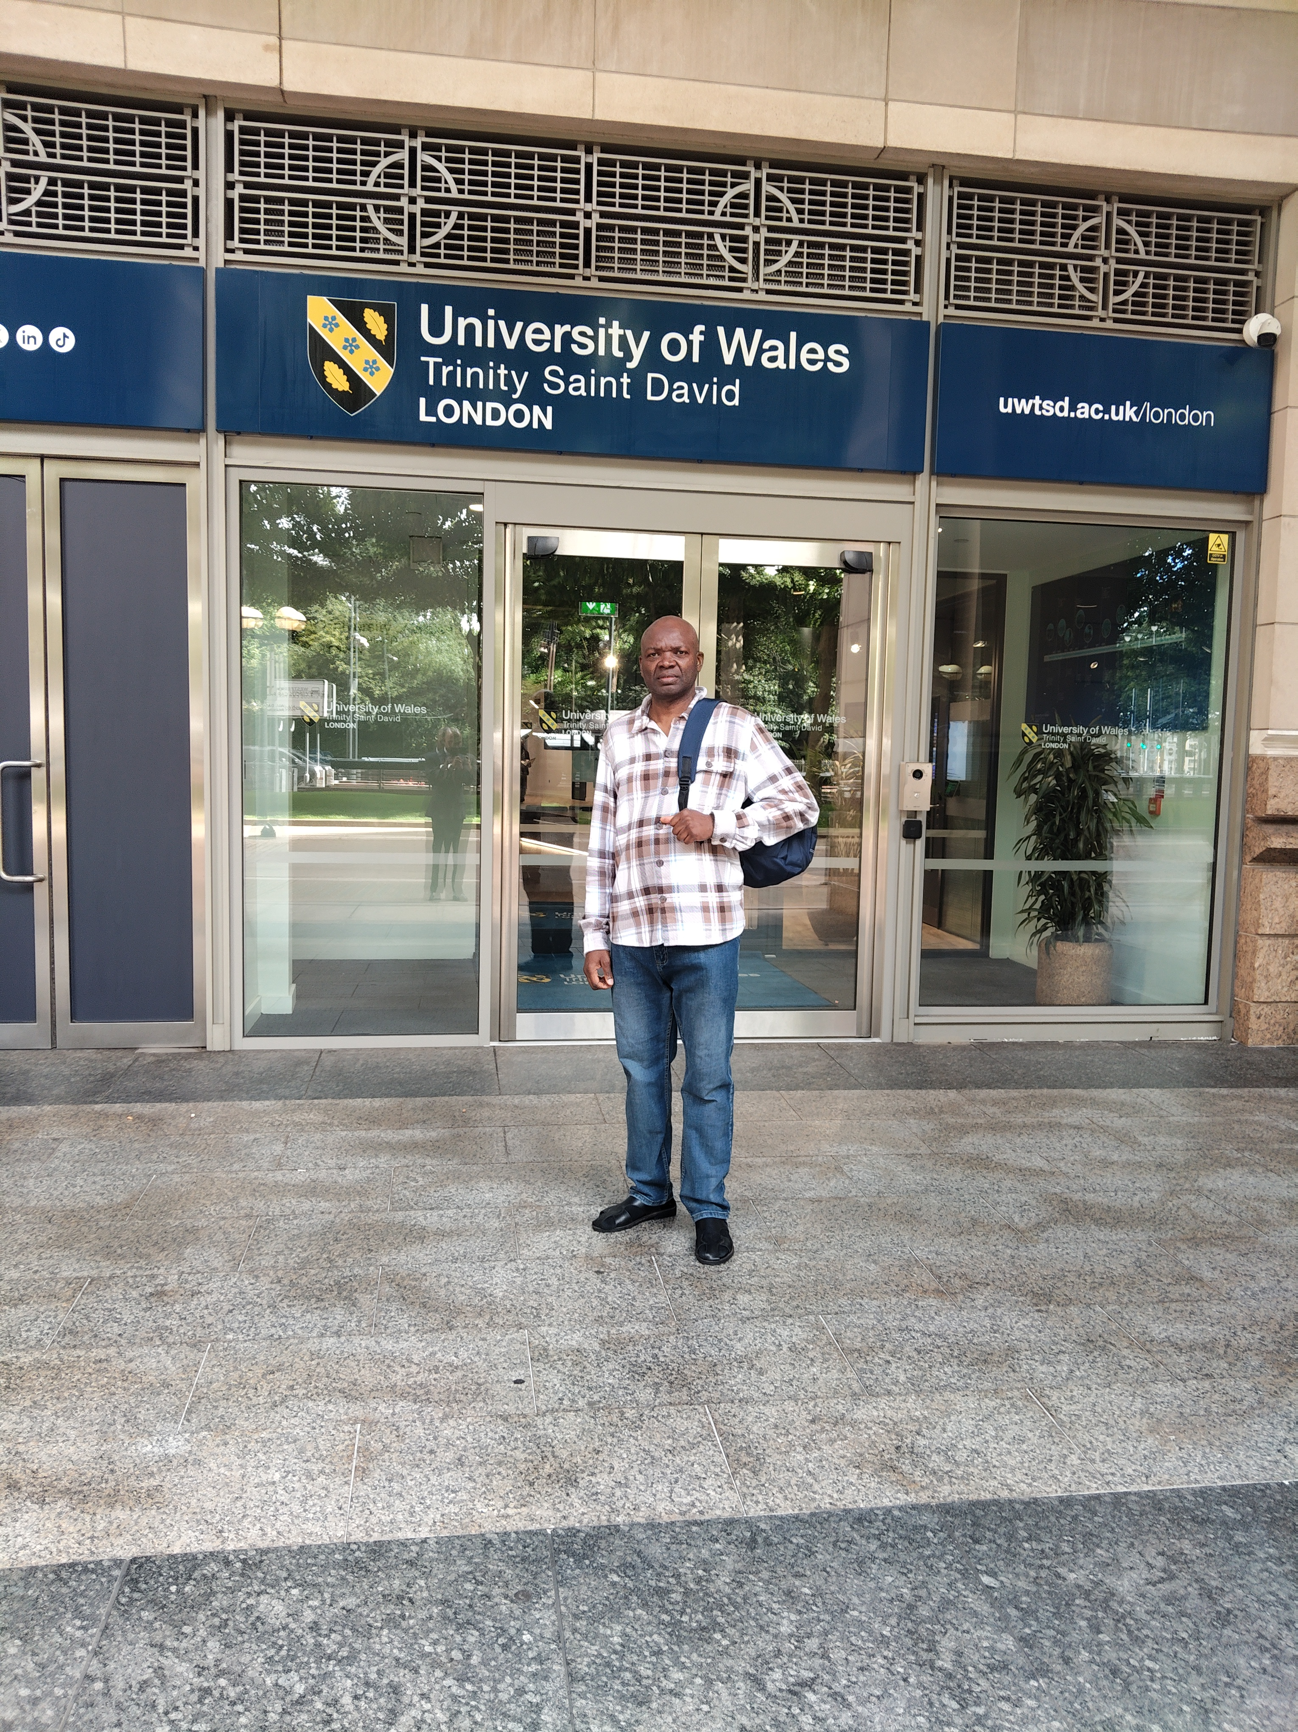
My first digital life picture after the induction at the London Campus entrance of the University of Wales Trinity Saint Davis.

Photo 3
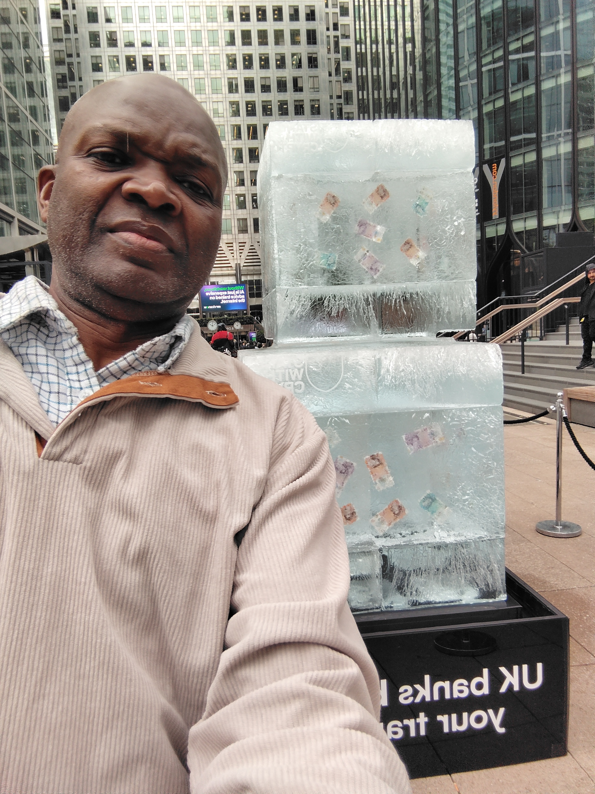
A visit to “Stand with Crypto Uk” open awareness on the bank restrictions on transfers to crypto asset exchange on Uk customers.

Photo 4
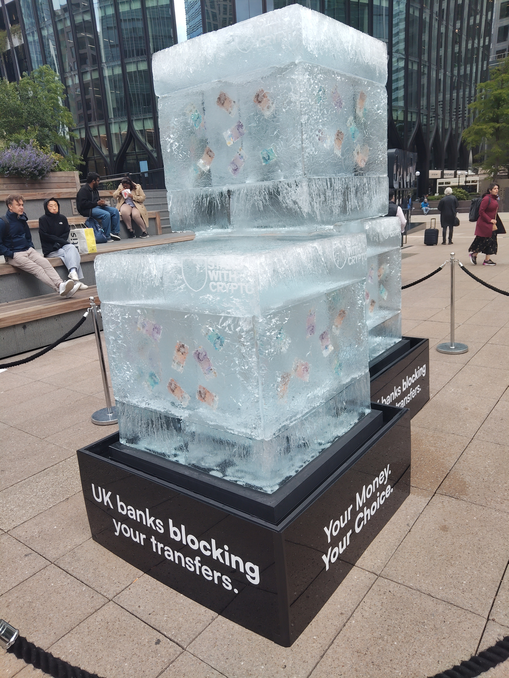
A street display of Uk currency in ice blocks to support the bank customers now complaining on the blanket restrictions placed on crypto transfers.

Photo 5
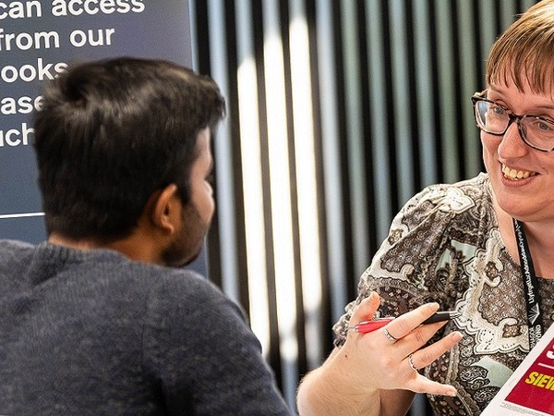
The library staff welcome a customer in the UWSTD Birmingham Campus.

Photo 6
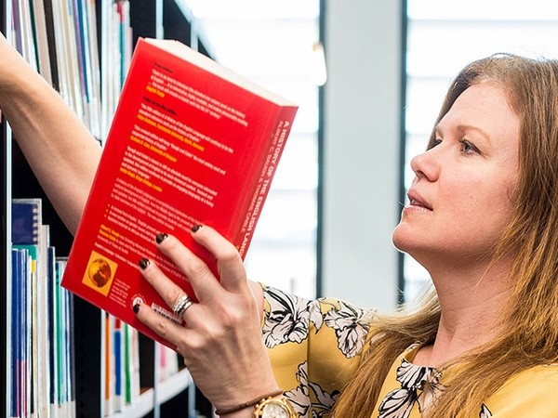
A self-service library digital display of books in Swansea Campus of the University of Wales Trinity Saint David.

My Short Reflection

I fancy digital wristwatch which serve many other health benefits like keeping me always fit. I feel confident when I operate my computer system. I want to improve on my typing speed in the future. I often use these computer tools before however; I have now improved on my skills. I sometimes feel nervous about meeting new people. I hope the module will help me to achieve the business and academic skills. Digital Skills are important for me because is part of my daily life activity.

Sentence starters

Submission Checklist
Before you submit, please check:
​​​ ☒ I added 4–6 screenshots
☒ I wrote short sentences for each screenshot
☒ I wrote my short reflection
☒ My work is my own
☒ My file opens correctly
​​☒ My file opens correctly

