Attachment
Attachment, What is it? and Why is it important?
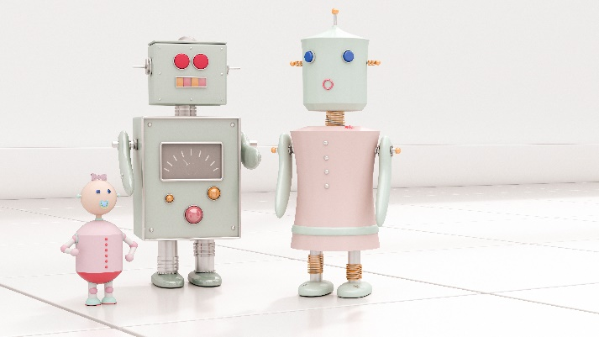  A Brief Introduction to Attachment.  Daryl Jones 13/03/2021  Let us explore what attachment is and what it can mean for you and your children.  Attachment can be defined as ‘attachment noun (FEELING OF LOVE)’ (https://dictionary.cambridge.org).  When we talk about attachment theory, we discuss the love between a caregiver and a child. Early and healthy attachment can have a marked effect on your baby’s development, affecting the rest of their lives. This article will explore how and why attachment is crucial to developing well-rounded children and how it affects them as adults. Strong attachments can give vital skills that children need to succeed and to be emotionally fulfilled.  We will explore the developmental stages of attachment, the importance of attachment, Family Dynamics and the different types of attachment.  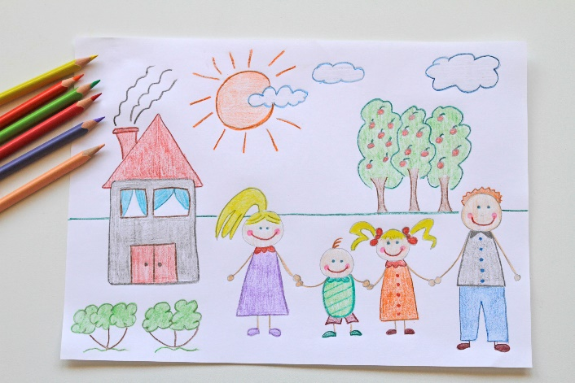 |   The development of Attachment
 | To start, let us first have a brief look at the developmental stages of a child.  John Bowlby (1969) developed four stages of attachment.  Pre-attachment (birth to 6 weeks)  Babies are more interested in faces than objects. They can mimic some facial expressions. Crying is used to get attention from caregivers.  Attachment in the making (6 weeks to 6-8 months)  Babies start to smile at specific individuals. Stranger anxiety develops. | Clear-cut attachment (6-8 months to 18 months – 2 years)  Infants start to distinguish between attachment figures and strangers. Security and comfort are attached to the caregiver.  Goal-corrected partnership (18 months onwards)  Toddlers create a partnership with the mother. Each is having to make an effort to keep the interaction going. Experiences in this stage can affect the child’s life as they use these experiences to gauge the world.  As we can see from the developmental stages, attachment starts really early on and progresses. It is worth noting that although these attachment phases are critical if interrupted for whatever reason, you can still develop a healthy relationship over time.
IN THIS ISSUE
Development | Importance | Types of attachment

Why is Attachment so Important?  Developing life skills |  | World Health Organisation  The benefits for children & society  Many challenges in adult society including; ‘mental health problems, obesity/stunting, heart disease, criminality, competency in literacy and numeracy.’ Have roots in early childhood development (Groh et al. 2016).  Attachment is something that we strive for throughout our entire lives. You can always find stories in the news of elderly people that suffer from loneliness. It is a vital resource that we need to feel safe and secure. This allows us to deal with many of life’s hardships. Individuals that suffer from any sort of mental ill-health are usually strengthened by a strong support system. This includes family and friends, which can help overcome many negative emotions when the relationship is nurtured. In the same regard, stress is a big part of life and can be healthy. However, too much stress can be harmful. Having a strong attachment in your support system will help elevate stress. This, in turn, will have a drastic effect on the persons overall happiness.
Now that we have discussed the developmental stages let us look at why attachment is so important.  Bowlby’s developmental stages show when the attachment is formed; however, there is a lot more behind the scenes. At a very early phase of child development, your babies brain is adapting and changing to its surroundings (Groh et al. 2016). It is within these early years that socioemotional development can be enhanced. The result of which will set the foundation for social development.  Social development has a massive impact on everyone. We are social creatures, and if you think you’re not, then the recent lockdowns have probably changed your mind. As socialisation is a huge part of who we are, children need to develop peer-to-peer relationships within society. They also need to establish the necessary coping mechanisms to deal with stressful situations without resorting to negative coping strategies. |     This Photo by Unknown Author is licensed under CC BY  Research suggests that secure attachments at an early age can decrease psychological problems (Levine 2015) and enhance the ability to make meaningful connections later in life (Simpson et al. 2007).

This Photo by Unknown Author is licensed under CC BY-SA-NC

‘An infant crying at the departure of someone who helps the infant feel secure does not indicate an excessive attachment to that person. It is quite a normal reaction’ (Levine 2015)
  This Photo by Unknown Author is licensed under CC BY-SA-NC |  | Family dynamic  Let’s discuss one essential aspect of attachment. There is a historical perspective in western culture to put a lot of pressure on the mother to raise the child. You are taking the time to read about attachment, so I already know that you care about a child’s development. What I want to stress to you is that you may be the mother, father or a different family member taking care of a child. It is not so important who you are as long as you are a caregiver and all family caregivers have a role to play (Levine 2015). The family dynamic is the most basic socialisation for a child, helping them develop skills that will benefit their entire lives.

Different types of attachment
To fully understand attachment and how it works, we will have to look at the different attachment types. We will also need to understand the implications of these attachments. According to Ainsworth (1979)  There are four different attachment types.  Secure: explores freely with the caregiver and is soothed easily upon return.  Anxious avoidant: explores with or without the caregiver present and does not seek the caregiver upon return.  Anxious ambivalent: Stays close to the caregiver and both seeks out and rejects the caregiver upon return.  Disorganised: may freeze or explore unusually and can show fear of the caregiver upon return.  Ainsworth developed these attachment types by using the strange situation. A basic example of this is babies are observed with the mother. Then the mother leaves, and a stranger enters and | Interacts. The mother then returns.  Ainsworth noted the difference in behaviour in each scenario. Ainsworth also predicted the baby’s reactions to the early mothering received.  Secure: responsive to infants needs  Anxious avoidant: is emotionally unavailable  Anxious Ambivalent: attentive but not to cues or needs  Disorganised: mistreatment or emotionally unavailable.  Secure parenting is the benchmark and is achievable through a secure attachment. It is possible to change a baby’s attachment over time, depending on the attention given.  These attachment types could indicate the type of attachments that will affect the child’s adult life. This could include their relationships and personality. If they struggle to develop social skills. Undue stress could be put on them in social situations. A secure child, |  | 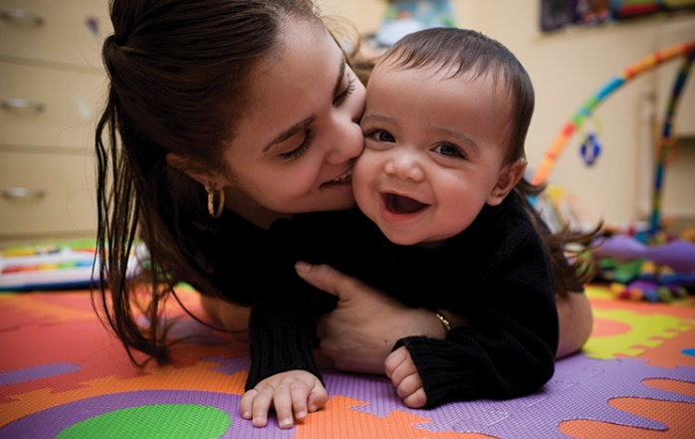  This Photo by Unknown Author is licensed under CC BY-SA-NC  However, should form the correct Social skills. Being confident in various situations will allow them to have a secure support group and to succeed.

What else do we need to know about Attachment?
Attachment is a bi-directional relationship. You form an attachment at the same time that your child does. You do not have to be the perfect caregiver for this attachment to form. If you have attachment issues with your child, do not become disheartened, and please seek professional support. Attachment is what gives us security and is essential for both the parent and the child.  One aspect of attachment that needs to be mentioned that we have not looked at is nature VS nurture. You will find a variety of information online with different opinions on which is more critical. A popular belief in psychology now is that both contribute. However, we cannot control the nature of a child. So, we need to focus on nurture.  Suppose you have problem behaviours with your child. In this case, there could also be other factors contributing to behaviour. Although attachment is essential, it is worth investigating any medical reasons or a recent emotional event that might have occurred. Taking these factors into consideration will help to assess how best to help your child. | Summary  We have explored a variety of information on attachment. I want to emphasise that attachment is essential and should be considered in your parenting method. There have been many different ideas over the years of the best ways to raise a child. Each technique should always be centred around a robust, stable attachment with your child, as the benefits will last throughout their lives. I also want to stress that households currently are different from typical thinking throughout history. Same-sex couples, divorce, adoption and any other family types are all valid support systems. Everyone requires a secure attachment. This should be given by caregivers in early development and life.
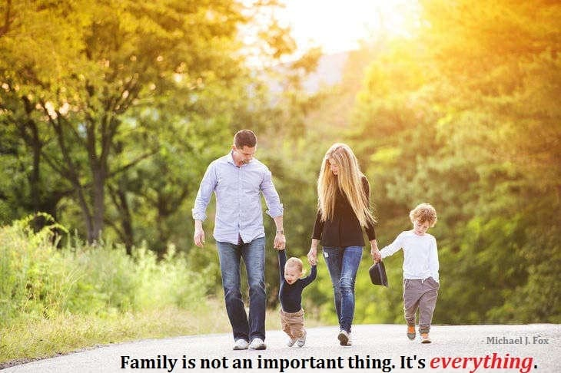
This Photo by Unknown Author is licensed under CC BY-SA

References
Attachment. (2021). Https://Dictionary.Cambridge.Org/. https://dictionary.cambridge.org/dictionary/english/attachment
Bowlby, J. (1979). The Bowlby-Ainsworth attachment theory. Behavioral and Brain Sciences, 2(4), 637–638. https://doi.org/10.1017/s0140525x00064955
Child Development From Infancy to Adolescence: An Active Learning Approach by Laura E. (Ellen) Levine (2015-02-19). (2021). SAGE Publications, Inc; edition (2015-02-19).
Groh, A. M., Fearon, R. M. P., van IJzendoorn, M. H., Bakermans-Kranenburg, M. J., & Roisman, G. I. (2016). Attachment in the Early Life Course: Meta-Analytic Evidence for Its Role in Socioemotional Development. Child Development Perspectives, 11(1), 70–76. https://doi.org/10.1111/cdep.12213
Hayes, N., & Filipović, K. (2017). Nurturing ‘buds of development’: from outcomes to opportunities in early childhood practice. International Journal of Early Years Education, 26(3), 220–232. https://doi.org/10.1080/09669760.2017.1341303
Simpson, J. A., Collins, W. A., Tran, S., & Haydon, K. C. (2007). Attachment and the experience and expression of emotions in romantic relationships: A developmental perspective. Journal of Personality and Social Psychology, 92(2), 355–367. https://doi-org.ezproxy.uwtsd.ac.uk/10.1037/0022-3514.92.2.355

