FROM ONLINE PRESENCE TO BUSINESS PERFORMANCE:
EVALUATING THE REAL IMPACT OF DIGITAL MARKETING ON SMEs

Dissertation
LCBB6000
BA (Hons) Business Management
University of Wales Trinity Saint David (London Campus)

Student Name: Ionut Hrisca
Student ID: 2243953
Supervisor: Konstantina Mari
Date: July 2026

Declaration
I declare that this dissertation is my own work and that all sources used have been acknowledged in accordance with the required Harvard referencing style. The study is based on secondary published evidence and did not involve the collection of personal data from human participants.
Signed: IONUT HRISCA Date: 12/08/2026

Abstract
This dissertation investigates the true effect of digital marketing on the business performance of SMEs. There is a need to resolve this issue in both the industry and academic sphere as many SMEs do have a presence on the internet, but their presence does not necessarily translate to sales and increased performance. The study that will be used for this dissertation is secondary based. Business and management databases will be searched for relevant literature using specific criteria. The literature review and theoretical framework will be based on classical and contemporary literature in the field. However, an analytic sample of ten studies will be used to investigate these themes within SMEs. The theories that will be used for this dissertation are the Resource-Based View and the Technology-Organisation-Environment framework. Digital marketing contributes positively towards the performance of SMEs. While the technology and the capabilities of the SMEs to implement these technologies may be limited, their managerial capabilities have a significant impact on the performance of the SME. Additionally, the resources that are available to the SME and their skills in utilizing these resources have a significant impact on the SMEs’ performance. The findings of the research that will be conducted will determine whether digital marketing for SMEs should be considered a separate area of focus for management and marketing functions or if it is simply another area of focus for these managers. Furthermore, the findings will help to clarify the exact nature of the managerial capabilities and skills that are required to manage these SMEs in the digital world. The research that was conducted establishes a foundation upon which future research can be built and allowed for the identification of future research questions and topics of research for SMEs and their managers.
Keywords: SMEs; digital marketing; business performance; digital capability; social media; Resource-Based View; TOE framework.

Contents
Declaration 2
Abstract 3
Chapter 1: Introduction 6
1.1 Introduction 6
1.2 Background of the Study 6
1.3 Problem Statement 8
1.4 Research Aim and Objectives 8
1.5 Research Questions 9
1.6 Significance of Research 9
1.7 Scope of the Study 9
1.8 Rationale of the Study 10
1.9 Structure of the Dissertation 10
Chapter 2: Literature Review 11
2.1 Introduction 11
2.2 Understanding SME Business Performance 11
2.3 Digital Marketing Practices and Customer Value 12
2.3.1 Channel Integration and the Customer Journey 13
2.4 Digital Marketing Capability 14
2.5 Managerial Capability and Strategic Alignment 15
2.5.1 Measurement, Learning and Return on Investment 16
2.6 Barriers and Unequal Digital Returns 16
2.7 Theoretical Framework 17
2.9 Identified Research Gap 19
Chapter 3: Research Methods and Methodology 21
3.1 Introduction 21
3.2 Research Philosophy 22
3.3 Approach to Theory Development 22
3.4 Methodological Choice and Strategy 22
3.5 Search Strategy 23
3.6 Inclusion and Exclusion Criteria 23
3.7 Study Selection and PRISMA 24
3.8 Thematic Analysis 25
3.9 Ethical Considerations 26
Chapter 4: Analysis and Discussion 27
4.1 Introduction 27
4.2 Theme 1: Digital Marketing Improves SME Performance 27
4.3 Theme 2: Digital Marketing Capability is More Important than Presence 28
4.4 Theme 3: Managerial and Complementary Capabilities 29
4.5 Theme 4: Barriers and Boundary Conditions 30
4.6 Integrated Discussion of Findings 31
4.6.1 Cross-study Comparison and Strength of Evidence 32
4.7 Implications of the Findings 33
Chapter 5: Conclusions, Limitations and Recommendations 34
5.1 Introduction 34
5.2 Summary of Findings and Achievement of Objectives 34
5.3 Conclusions 34
5.4 Practical Recommendations 35
5.5 Limitations 36
5.6 Future Research 36
References 37
Appendix 1- Analytical matrix of the ten core empirical studies 43

Chapter 1: Introduction

1.1 Introduction
SMEs today rely on various digital marketing methods to attract customers and to stay competitive in today’s markets. From search engines to social media platforms, websites, email to online marketplaces and digital advertising, SMEs have the same digital presence as large companies that have considerable marketing budgets. However, SMEs might have an active digital presence and a growing number of followers on social media accounts without generating any demands from customers. Alternatively, their less frequent digital presence might result in a major pay-off if related to the customers’ requirements and their business objectives.
A review of the literature on digital marketing and SME business performance will separate the concept of an organic digital presence from digital marketing prowess. Digital marketing prowess encompasses the skills, processes, and practices that SMEs utilize to effectively market their products and services online. The objectives of this dissertation are to provide a review of the current literature on digital marketing and its relationship to SME business performance. This chapter provides background information, the problem statement, aims, objectives, research questions, significance, and scope of the proposed research.

1.2 Background of the Study
The SME sector is of economic importance to the UK due to the number of companies that are owned by SMEs. As of the beginning of 2025, the number of private-sector companies in the UK was 5.7 million, of which 99.85 per cent were SMEs. These SMEs accounted for 60 per cent of private-sector jobs (approximately 16.9 million employees) and for 51 per cent of the private-sector turnover of the UK economy (around £2.8 trillion) (Page, 2025). Thus, the productivity and success of SMEs is not just an issue for those companies’ owners but has implications for the nation’s economy as well.
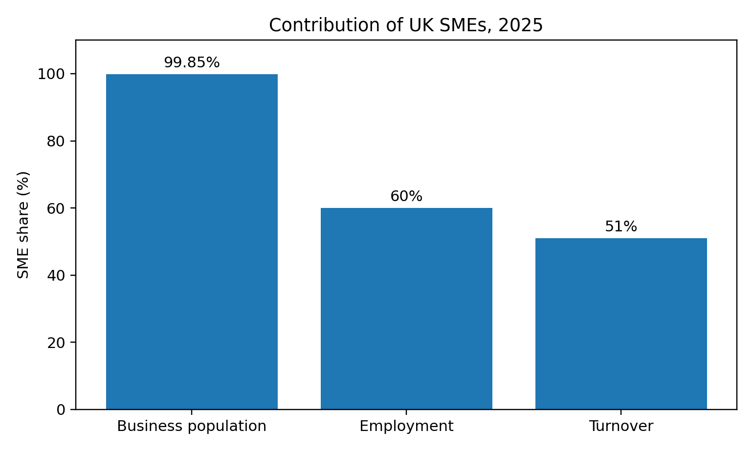
Figure 1. Contribution of UK SMEs to business population, employment and turnover, 2025. Source: Department for Business and Trade (2025).
Digitalisation has altered the competitive landscape that these organisations face. Companies no longer rely on traditional media to reach out to their customers. They have media that they own and control through their websites, search marketing to improve their discoverability, social media to foster interaction, community and e-word-of-mouth communication, email to retain their customers, marketplaces to facilitate transactions and analytics to understand their customers’ behaviour. While digital channels offer organisations the opportunity to target their communications to reduce the cost of communication, they also make it more competitive, forcing them to rely on third party platforms and to keep up with the changes in these platforms’ algorithms and policies.
The literature discusses digital marketing as a capability. Capabilities are developed by market-driven organisations as a means of bridging the firm to its customers and competitors (Day, 1994). Dynamic capabilities focus on identifying changes in the environment, taking advantage of these changes and the firm’s ability to shape its resources (Teece et al, 1997). For small and medium sized enterprises, the incorporation of technology into small business operations only has value when it is incorporated into the daily operations of the company. For instance, small businesses can use specific types of social media to enhance their market-sensing and brand management capabilities, which directly impact their market and financial performance (Ancillai et al., 2023).

1.3 Problem Statement
The disconnect between digital presence to quantifiable business outcome. Although the SMEs may boast adoption and platform activity statistics, these are vanity metrics that fail to show whether they have created profitable customers for the business, whether they have experienced revenue growth or enhanced profit margins, customer loyalty, or digital marketing resilience. For these resource-constrained firms, it is essential to know whether they are investing their time and money into activities that bring in valuable returns on their investment.
First off, the dissertation itself is the most urgent need that the SMEs have right now. Despite the pressure that they are under to digitise their businesses, they are also faced with rising costs to operate these businesses, the market itself being unpredictable, and competition from her online competitors. Furthermore, the digital world is constantly evolving and changing due to developments in paid media, algorithms, artificial intelligence, and online privacy. Finally, recent studies into the subject matter have moved beyond the adoption of digital marketing software towards evaluating the capacity to utilise digital marketing tools effectively and the outcomes of such efforts. Therefore, conducting such a research study at this time is timely and allows for the discernment of the evidence that truly demonstrates the success of digital marketing for these firms in their specific context of operations.
Prior studies into digital marketing have mostly focussed upon national, sectoral, channel and performance definition specific contexts, and have reported more favourable associations. These studies have focussed upon social media adoption and use, digital transformation, analytics, e-commerce and digital marketing more generally. Furthermore, as the majority of these studies are based upon cross-sectional analyses of digital marketing contexts, it is possible that the analyses reflect the reverse causality phenomenon of firms that are succeeding with their commercial activities investing more significantly in digital marketing than do firms that are less successful with their commercial goals. Thus, this study seeks to make this problem apparent through a review of the recent empirical studies on digital marketing and the literature on the topic more generally.

1.4 Research Aim and Objectives
The aim of this study is to evaluate the real impact of digital marketing on the business performance of SMEs.

The objectives are:
- to examine the role of digital marketing in shaping SME business performance;
- to identify the key digital marketing practices that influence SME growth and competitiveness;
- to explore the relationship between digital marketing capabilities and SME performance outcomes; and
- to evaluate the challenges that affect SMEs’ ability to convert online presence into measurable business results.

1.5 Research Questions
- The study asks: How does digital marketing affect the business performance of SMEs?
- Which digital marketing practices contribute most to growth and competitiveness?
- What is the relationship between digital marketing capabilities and SME performance?
- What challenges prevent SMEs from converting online presence into business results?

1.6 Significance of Research
Academically, the separation of digital adoption, digital marketing activity and digital marketing capability is unique to this study. Get involved and engaged with the various players in the landscape and it will measure the outcomes in relation to finance, the market and the relationships between the organisations involved rather than treating their engagement with digital marketing as equivalent to the performance of that digital marketing. The model explains the use of digital marketing in both the Technology–Organisation–Environment (TOE) and Resource-Based View (RBV) models as a means of demonstrating the reasons for the effects identified within the model. Practically, the study provides information to the owners and advisers of these companies regarding where to allocate their limited resources and which indicators to monitor.

1.7 Scope of the Study
This research investigates small and medium sized businesses and their customer facing digital marketing activities such as social media marketing, website marketing, search marketing, online advertising, email marketing, content marketing, e-commerce, customer analytics and digital relationship marketing. The outcomes of these activities impact the small and medium sized business in relation to their sales, profitability, share of the market, customer acquisition, customer retention, competitive advantage and innovation. This is a secondary research study and does not gather any data from the owners of these businesses or from their customers. The sample for this research consists of an overview of ten empirical studies on the topic, as well as literature and theory that relates to and supports these studies.

1.8 Rationale of the Study
The reasoning behind this claim is that SMEs generally require some proof of the commercial value of being online as compared to the general encouragement to become online. While it may be cheap to begin to go online, it can be expensive to maintain such a presence online in consideration of the costs of planning and hosting websites, content creation, online advertising, and software and other external online experts and services. Thus, the synthesis that explains the various factors that contribute to (or act as barriers to) the commercial value of being online is more informative than a synthesis that only indicates that there is a positive association between the two concepts.

1.9 Structure of the Dissertation
Beyond the ten analysis studies covered in chapter 2, there is also a literature review and discussion of the theories behind the study. Chapter 3 covers the research onion, search strategy, eligibility criteria, PRISMA-informed selection, quality appraisal and thematic synthesis. Chapter 4, which also includes and updates the study matrix, presents the thematic analysis of the ten papers and then the integrated discussion and implications. Finally, chapter 5 presents a recap of the research findings, demonstrates how the research aims were fulfilled, draws conclusions from the research, presents recommendations, and also discusses any limitations to or future avenues for the research.

Chapter 2: Literature Review

2.1 Introduction
Within this chapter is an investigation into the literature that creates the framework for the understanding of the topics of SME performance and digital marketing and capability. The ten core research papers were not used for this investigation based upon the supervisory feedback. Instead, the data from established and more influential research studies in the area are explored and compared. Topics explored in this chapter include reviews of the concept of performance and measuring performance, digital marketing, capability, the managerial angle to digital marketing, and the barriers and inconsistent results within digital marketing. The last part of the paper includes the theoretical framework and research gap presented in the literature review (Webster and Watson, 2002; Snyder, 2019).

2.2 Understanding SME Business Performance
Performance is multidimensional - there are financial metrics (such as revenue, profit, cash flow and return on assets), market metrics (such as acquisition, retention, market share and brand equity), and operational and strategic metrics (such as productivity, innovation, resilience and the ability to respond to change). Venkatraman and Ramanujam (1986) differentiate between metrics that indicate financial performance versus those that indicate overall business effectiveness. Furthermore, both Kaplan and Norton (1992) suggest that it is also possible to combine financial and non-financial metrics, arguing that business effectiveness is better measured through indicators of how satisfied customers and how efficient processes are within a company, as those two factors tend to influence the financial success of that company (Venkatraman and Ramanujam, 1986; Kaplan and Norton, 1992; Richard et al., 2009).
This distinction becomes particularly relevant when one talks about digital marketing research. While the digital marketing leading indicators of engagement, reach, and traffic are all useful, these metrics, if measured without any consideration of the commercial behaviour of customers, can become vanity metrics. For instance, a brand may find that their campaigns are engaging others than their target OR they may find that introducing a discount to their products results in an increase in sales, but at the cost of the margin with which they can afford to operate. Furthermore, the benefit derived from the quality of the existing customer relationship and the knowledge of their customers of those digital products is likely to develop over time, and is therefore not immediately measurable in terms of the short-term performance of their business. The conversion rate of digital marketing products is likely to be established through the understanding that exposure to their products can lead to engagement with the brand; engagement with the brand can lead to enquiries regarding their products; enquiries regarding their products can lead to transactions with those brands; and the fulfillment of the customers’ orders will lead to the customers’ continued retention with and advocacy of the brand. Thus, any failure in any phase of the digital marketing process will have an impact upon the strength of the brand’s eventual sales (Peters et al., 2013; Kumar et al., 2013; Malthouse et al., 2013).

2.3 Digital Marketing Practices and Customer Value
Digital marketing is a collection of different marketing practices instead of one singular practice. There are practices for owned assets like websites and e-commerce, demand is captured through search and online advertising, demand is generated through social media, customer retention is performed through email and customer relationship management systems, and all of these efforts are connected by content that performs the essential function of educating, persuading customers, and reducing the risk that they will have to take in establishing a relationship with a company. As the marketing authors note, there is a need for planning, integration, and evaluation in digital marketing (Chaffey & Ellis-Chadwick, 2022). Furthermore, Kannan and Li (2017) also note that digital marketing is an adaptive process that connects the firm to its customers and the platforms they use.
Digital marketing channels are believed to eliminate the geographical and communication barriers that may exist between the customer and the firm. However, while it is true that the entry costs to begin using these channels are low, the disagreement between the marketing authors is that this is not an advantage for the firms that use these channels. It is easy to start using these channels with low-cost and widely available platforms. However, the algorithms that rule these platforms can change, causing paid advertising to be costly in high-competition areas. Thus, having an account and purchasing the software will not be an advantage to the firm. Instead, it is the use of customer insights and the other factors related to the management of the digital marketing channels that will provide the advantage. This conclusion is in line with the Resource-Based View of firms and their competitive advantages. According to the RBV, the common technologies that companies use can be highly valuable to the firms. However, they are hardly ever respected or considered to be inimitable by other firms in the same industry (Barney, 1991; Nambisan, 2017; Li et al., 2018).
Social media also reflects this tug-of-war between encouragement of eWom, community and customer services yet different influences according to the industry and purchase journey of the customer. Consumers are more likely to exhibit immediate buying behaviour on social media platforms to participate in the interaction while business-to-business (B2B) companies must focus on creating value for the customer indirectly. Hence, no literature discusses a universal solution to the question of which social media platform is the best for all industries and products. There are various factors that play into this decision, including the buying behaviour of the customer and the complexity of the product and company capacity to respond (Ainin et al., 2015; Odoom, Anning-Dorson and Acheampong, 2017; Ancillai et al., 2023).

2.3.1 Channel Integration and the Customer Journey
Another of the main lessons from the existing literature is that channels should be considered steps in the customer journey, rather than tools for promotion. Channels such as search can lead a customer to the discovery of the firm, social proof can alleviate the customer of any anxieties about purchasing the product, the website contains the product’s content gold, and email communications help with the retention of customers and following up with those who have purchased from the company’s offerings. Friction within the organization arises when the customer journey experiences issues with relaying information to the customers or uses different messages along each channel. Thus, integration addresses both communication and data. While the software may be expensive and not suited for small organizations, there should be some path from awareness of the organization to enquiry and purchase of their products, followed by contact with the company after the sale of the product (Lemon and Verhoef, 2016; Kannan and Li, 2017).
Channel integration plays a significant role in interpreting the return on investment for marketing channels effectively. The last-click model can only track the value of the last interaction a customer has with a company but does not account for the value of the content and social channels they engaged with before the last click. The inverse shortcoming of - first click models. These models may also be too sophisticated for a company with limited data. A combination of metrics from each campaign to the customer will provide a better understanding of the effectiveness of each channel. This approach will allow companies to make better decisions than solely using the platform dashboards to make marketing decisions (Berman, 2018; Anderl et al., 2016).

2.4 Digital Marketing Capability
Capability is the idea of processes that organisations can repeat to achieve a specific purpose with the resources at their disposal. Authors Amit and Schoemaker (1993) blot out all the contrast between resources and capabilities; for Day (1994a) the capabilities of a company to sense markets and customers are throne on the performance of those markets. The ability to perform digital marketing tasks includes researching the audience for whom a company creates products or services, choosing the channels on which to distribute those products or services, creating the content for those channels, planning the digital marketing campaign, analysing digital marketing campaign results, enhancing the process of converting leads to customers, and gaining knowledge of the campaign as a result. This is not only defined in the ownership of the technological tools required to perform digital marketing tasks, but in the planning, execution, and improvement of the activity that occurs with those technologies (Amit and Schoemaker, 1993; Day, 1994; Morgan, 2012).
That is also a dynamic aspect of the concept. As markets and audiences for digital products and services evolve at a rapid rate, the capabilities of organisations to adapt to these changes are also crucial for success. As defined within this paper, dynamic capabilities relate to a company’s ability to sense opportunities and threats within their market, to develop plans to seize those opportunities or threats, and to reconfigure their resources to reflect these changes (Teece, 2007). Such capabilities relate to determining opportunities in markets through tasks like listening to search engine trends, customer reviews, and social media conversations regarding the products or services that a company offers; seizing these opportunities may relate to tasks like introducing an offering or channel for distributing products, and reconfiguring resources towards these changes may relate to tasks like reallocation of marketing budgets, redesigning customer journeys, or the development of required staff skills. Thus, these digital marketing dynamic capabilities appear to be as much of a managerial and organizational concept as they are technical (Teece et al., 1997; Teece, 2007; Warner and Wäger, 2019).
The two concepts are not substitutable for one another but rather exist in conjunction with one another. Digital marketing capabilities exist hand in hand with traditional marketing skills and knowledge, sales processes, and customer service skills. Authors Homburg & Wielgos (2022) found that digital marketing capabilities are indeed profit extracts in and of themselves, but that the two types of marketing capabilities interact in a way that may require trade-offs between the digital and the traditional marketing skills and knowledge.

2.5 Managerial Capability and Strategic Alignment
SMEs are mostly owned and managed by their seniors; hence, their attitudes will have a very large impact on the SME’s digital marketing strategy. Digital marketing can either be an ad-hoc exercise or have its own separate process that impacts the revenue and value of the product to the customer. Managerial skills include the allocation and management of resources, data analysis, and an attitude towards experimenting with new strategies. This also includes the skill to cease investing in strategies that do not produce the desired results for the company. Route 1 in the study of upper-echelons theory suggests that the decisions made by the managers and owners of these companies are impacted by the experiences of these individuals (Hambrick and Mason, 1984; Taiminen and Karjaluoto, 2015).
Of the two extremes in managerial skills is excessive caution versus uncritical enthusiasm for new digital marketing strategies. Managers that are too cautious may not want to commit the SME’s resources to a digital marketing strategy until they are certain of the returns on investment that the strategy will produce. On the opposite extreme are managers that are too zealous in their desire to try out new digital marketing strategies, regardless of the goals that they may have for these strategies. For digital marketing to be successful, a company will have to have a target market for their product, a value proposition for the product, and a journey for the customer to take while using the product, and in place of a system to measure the success of the digital marketing efforts. In addition to this, the demands of the market may require the company to have marketing and fulfilment departments that work in harmony to meet those demands. If a company cannot meet the demands of its customers, customers will leave bad reviews of the company which will destroy the company’s value. Hence, the performance of the digital marketing strategy is contingent upon the operational readiness of the company (Tiago and Veríssimo, 2014; Quinton et al., 2018).

2.5.1 Measurement, Learning and Return on Investment
Separate consideration should be given to the measurement capability of the platform and how this links the activity to the learning that is desired within the organisation. While the platform provides real-time data for measuring the campaign, this is according to the outcome that the platform has defined for the campaign. In other words, the business may be able to optimize for clicks or engagement but not necessarily for the creation of value for the customers of the business. More useful data can be obtained by defining a business hypothesis for the campaign. This will include information such as the target audience for the product, the pain point that the product will eliminate, the product proposal and action that will be taken and the time frame within which the goal will be achieved. Such information can then be measured on the back end through costs, revenue quality and sales volume. The outcome of such a process will create a feedback loop that will allow the business to determine the allocation of resources for future campaigns based upon the outcomes of past campaigns (Cohen and Levinthal, 1990; Marchand, Hennig-Thurau and Flemming, 2021).
Hidden costs also impact the net present value return on investment. Costs to include time of owner, training of employees, software costs, agency fees, creative costs and discounting. Benefits include not just the revenue that is likely to be earned in the medium term, but also the costs that are avoided, and the improved information about customers that results from the campaign. In considering the success of digital marketing campaigns, therefore, it is also important to consider both financial results and customer results. The scorecard, however, given to agencies widely turned out to be excessively muddled and is hence not utilized by most agencies. Instead, SMEs will require a limited set of measures associated with their objectives (Taiminen and Karjaluoto, 2015; Odoom, Anning-Dorson and Acheampong, 2017).

2.6 Barriers and Unequal Digital Returns
Beyond the three identified, numerous other barriers to entry exist in the literature. For example, companies must face costs related to advertising, software, photography, and the creation of digital content that goes beyond the face value of free access to various digital platforms. Furthermore, small teams must also face the opportunity cost of the time required to create digital content for their organizations. Other technological barriers to entry include the skills deficiencies within organizations to understand and use analytics and optimization tools, as well as the disparities that exist between various technological systems. Finally, companies must also overcome the requirements of enhancing the cybersecurity of their systems, as well as obtaining consent and meeting privacy-related requirements (Berman, 2018; Martin & Murphy, 2017).
The literature on these barriers exhibits a selection bias. For example, firms that have survived into the present day have a higher likelihood of having the necessary capabilities to manage their online presence as compared to firms that have discontinued their digital activities. Furthermore, most digital platform metrics are created by the commercial intermediaries that operate those platforms, meaning that their definitions and algorithms are subject to change over time (Peters et al. 2013; Martin and Murphy 2017). Therefore, although the digital marketing initiatives that have been implemented into various organizations can produce the benefits that are cited in the literature, these benefits are better exhibited in studies that use objective digital metrics rather than relying upon the assessments of the digital organization owners themselves (e.g., Podsakoff et al., 2003; Richard et al., 2009).
Environmental barriers also matter. Being dependent on a platform introduces disadvantages for SMEs, such as changes to the platform’s algorithms, possible suspension of their accounts, higher prices for advertised products, and a lack of transparency around the platform. Market Structure also impacts the outcomes of IT investments. Buying a standardized product online can deliver measurable conversion rates for a company compared to a professional services company that can take months to decide. Greater adoption and benefit from IT systems will be possible in adopting regulations, increasing connectivity in rural areas, and improving digital literacy skills among citizens. The TOE also accepts that the value of IT will always be contingent on the relationship between technology, organization, and the environment.

2.7 Theoretical Framework
According to the Resource-Based View, a firm’s sustainable advantage emerges passively from its resources and capabilities that are valuable, rare, costly to imitate and organised to exploit (Barney, 1991). Although the digital platforms themselves rarely satisfy these criteria (as competitors can always get at them), the various advantages that the firm possesses may be nearly impossible to replicate. Thus, the Resource-Based View can explain how digital marketing’s capabilities lead to performance from organisations (Barney, 1991; Day, 1994; Morgan, 2012), although with some limitations.
The Technology-Organisation-Environment (TOE) framework explains the adoption and implementation of digital marketing technologies within three different contexts (Tornatzky and Fleischer, 1990). The context of technology considers the relative advantage, compatibility, complexity, trialability and observability of the technology to be adopted. The organizational context considers the firm’s available resources, skills, and level of leadership readiness to implement the new technology. Finally, the environmental scenario context considers the impact of competitors, customers, regulation and support upon the successful implementation of digital marketing technologies. The TOE framework explains the reasons behind the different results achieved by SMEs implementing the same digital marketing tools (Tornatzky and Fleischer, 1990; Baker, 2012).
The framework that has been developed and integrated within this dissertation unifies the frameworks by explaining that the factors that impact digital marketing performance are enabled or inhibited by the TOE framework, the presence of digital marketing capabilities, and the impact of business performance. The entire framework is additionally influenced by the capabilities and alignment of the managers with the business strategy. The Resource-Based View can explain the formation of digital marketing capabilities, while the TOE framework explains whether the conditions are created to enable their implementation. Together, these two frameworks stand as a counter-intuitive stance to the viewpoint that the implementation of a specific digital marketing technology within a business is the factor that determines the business’s performance (Teece, 2007; Warner and Wäger, 2019).
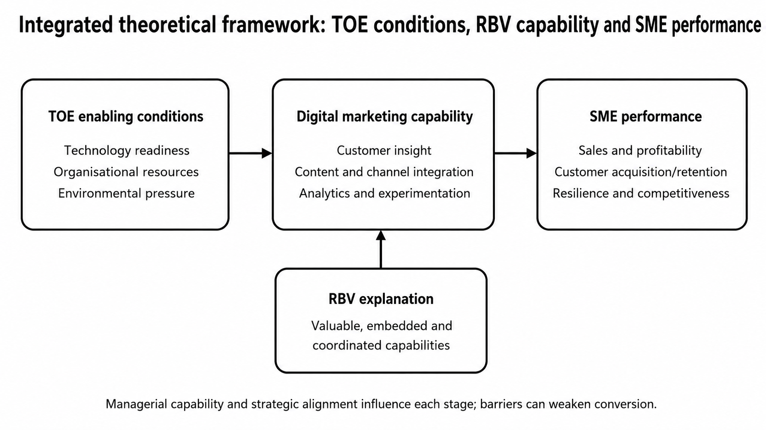
Figure 2. Integrated theoretical framework developed for this study.

2.9 Identified Research Gap
Within the literature on digital marketing for SMEs, there are four interrelated gaps. The first relates to the confusion between the concepts of adoption and usage with good use of those technologies and practices. The second relates to the focus of existing literature on performance metrics that utilize alternative metrics to financial metrics to indicate the success of SMEs that have implemented digital marketing strategies. The third relates to the use of cross-sectional research designs within existing literature that prevents the assertion of any causal relationships between digital marketing strategies and the outcomes of those SMEs. Finally, though there is information within the existing literature that relates to digital marketing capabilities and their outcomes for SMEs, there is a scarcity of empirical evidence within that literature that directly relates the two concepts (Taiminen and Karjaluoto, 2015, Homburg and Wielgos, 2022, Ancillai et al., 2023).
The dissertation contains a synthesis of ten empirical research papers that overcome these gaps in the literature. Instead of only publishing research papers that question whether or not digital marketing is a good practice for SMEs, this dissertation investigates the different practices, skills, and the barriers to implementing those practices and attaining measurable results of those SMEs that have implemented these different digital marketing strategies. Furthermore, the dissertation incorporates an integrative literature review that conceptualizes each of the various digital marketing capabilities for SMEs, combines the different pieces of evidence that support the impact and outcomes of each of these capabilities, and assesses the strengths and shortcomings of each of these published research papers as a result (Snyder, 2019; Tranfield, Denyer and Smart, 2003).

Chapter 3: Research Methods and Methodology

3.1 Introduction
In this chapter, the way the evidence was identified, selected and analysed will be discussed. Design: A systematic review of the literature with thematic synthesis. The methodology adheres to the logic of the research onion to determine the philosophical stance, approach, design, strategy, time horizon and the processes of data collection and analysis. Thus, the dissertation has not reviewed clinical interventions regarding their effectiveness, although the PRISMA 2020 model was used to provide transparency in the preparation of the study selection of literature to review (Saunders, Lewis and Thornhill, 2019; Snyder, 2019; Page et al., 2021).

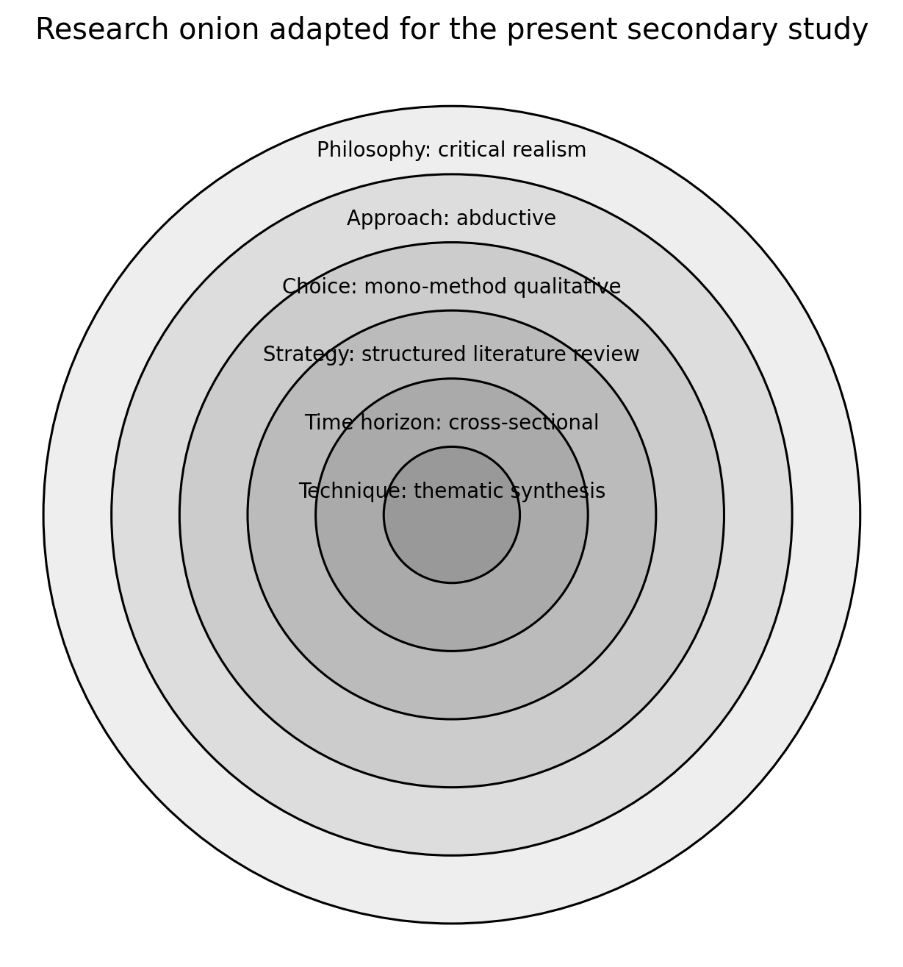
Figure 3. Research onion adapted to the secondary review design.

3.2 Research Philosophy
For the empirical study a critical realist stance will be taken. Critical realism assumes that there is a causal relationship between the variables of both digital marketing and the outcomes of the business but assumes that the knowledge of the effects of digital marketing is mediated by the research study itself. Critical realism is appropriate for this research because it considers both types of evidence in the review of the literature but does so in a way that ensures that one individual measure of a business outcome is not considered to be a proxy for the business’ overall performance. Thus, the dissertation can provide both an understanding of the causal mechanisms between digital marketing and business outcomes, while also making clear the dangers of relying upon self-reported data or outcomes that are dependent upon the specific context of that business’ operations (Bhaskar, 1978; Saunders, Lewis and Thornhill, 2019).

3.3 Approach to Theory Development
It is an abductive review. While the theories existing in the literature provide a high-level explanation for the results of the study, the evidence has also built some themes. Abduction theory alternates between theory and data. This is appropriate because the study neither collects data to test a hypothesis nor does it build theories without considering existing concepts in the literature. Instead, it catalyses insights by juxtaposing data with the proposed hypothesis (Dubois and Gadde, 2002; Saunders, Lewis and Thornhill, 2019).

3.4 Methodological Choice and Strategy
This is a mono-method qualitative synthesis that is based on secondary evidence. This is a style of a structured literature review. The search strategy employed to locate the studies to be reviewed means that this review is more transparent than a narrative review of the literature. The empirical study is the unit of analysis for this review and the data were gathered on each empirical study on aspects like country, sample, research design, measures, results and limitations, and the relevance of each empirical study to the research questions (Tranfield, Denyer and Smart, 2003; Denyer and Tranfield, 2009; Snyder, 2019).

3.5 Search Strategy
This included searches on the population, intervention and outcome. Such searches included the following terms: (“small and medium enterprise” OR SME OR MSME) AND (“digital marketing” OR “social media marketing” OR “online marketing” OR “digital marketing capability” OR “social media analytics”) AND (performance OR growth OR sales OR profitability OR resilience). These searches were conducted on Google Scholar, Scopus-indexed journals' platforms, ScienceDirect, Emerald, Taylor & Francis, and SpringerLink databases. In addition to these databases, manual searches of the reference lists of relevant articles also helped to reveal other empirical literature on the topic (Booth, Sutton and Papaioannou, 2016; Gough, Oliver and Thomas, 2017).
The search was broad in scope when first identifying potential studies for the review, but narrowed when screening the studies for inclusion within the review. The rationale for this search strategy was to minimize the chance of missing studies that may have utilized the term “capability” within their study titles, but who did not utilize the term “digital marketing” within their titles alone. Table entries included fields for each study’s title, year of publication, source of publication, whether it was a duplicated study (yes/no), and the screening decision for the study (with a field to indicate the reason for screening the study for exclusion). The limit of ten studies was established as a means of performing an in-depth review of the studies within the word limit for the dissertation (Webster and Watson, 2002; Tranfield, Denyer and Smart, 2003).

3.6 Inclusion and Exclusion Criteria
Inclusion criteria for studies to be included in the review were the following: studies had to be peer-reviewed, empirical research studies, contain an overview of SMEs or present results specific to SMEs, investigate one of the following topics: digital marketing practice, strategy, strategy, or any customer-facing digital activity, contain an outcome relating to the performance of SMEs, the growth of SMEs, the number of SMEs customers or the resilience of SMEs, be written in English, and focus on the topic within the confines of the time period 2021 2026. Studies to be excluded from inclusion in the review were those that were purely conceptual in nature, review papers in the field, solely focused on large firms, investigated aspects of digitalisation of large firms that did not have a marketing or customer-facing dimension, did not have an outcome measuring the performance of SMEs, were a report that was otherwise repetitive in nature relative to other reports published on the topic, or whose methods were not detailed sufficiently to allow for review (Petticrew and Roberts, 2006; Booth, Sutton, and Papaioannou, 2016).

3.7 Study Selection and PRISMA
The flow diagram that was employed to report the findings of the studies that were included in this review has identified 126 records from the search. One hundred and three records were obtained following the removal of 23 duplicates. Of those records, 71 were removed due to relation to the topic, type of data published in the studies, or because the studies revealed non-empirical results with relation to the performance of SMEs. As a result, thirty-two studies were read in to determine if they would be included in the review in their publication of full-text articles. Twenty-two articles were excluded from the review in whole; eight were not well-suited to the population of SMEs, six did not report on the relevant performance outcome of the SMEs in question, five were review articles, and three lacked sufficient detail within their methods to permit for an understanding of how they performed in relation to the SMEs that were to be evaluated. Ten studies were included in the review for thematic synthesis. While effort was made to utilize the reference lists and citations of the included studies to locate additional studies that would contribute to the review, those citations were logged in the same database as the initial studies, rather than being independently counted within this stage of the study selection. In creating the visual logic of the flow diagram according to the PRISMA 2020 template, the adjusted flow diagram reflects the counts of the screened, included, and excluded studies as they were observed during this dissertation (Page et al., 2021).
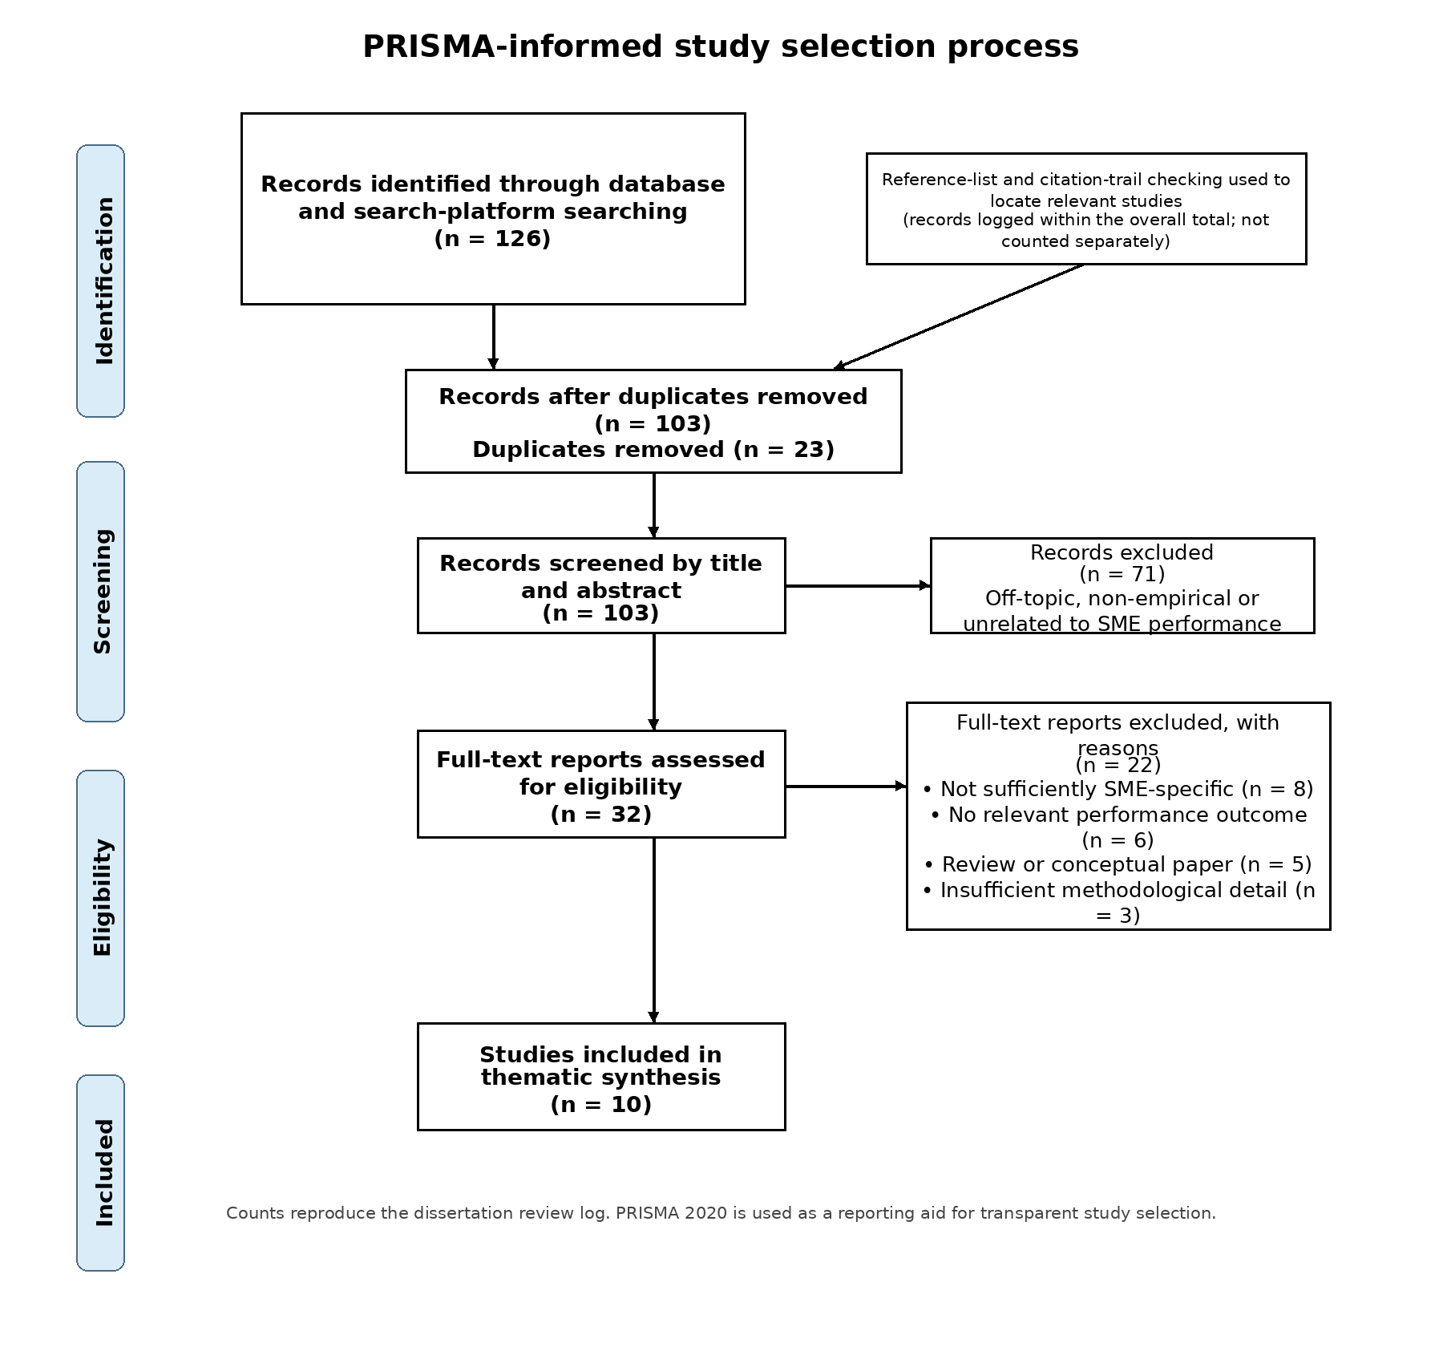
Figure 4. PRISMA-informed flow of study identification and selection.

3.8 Thematic Analysis
Following Braun and Clarke’s (2006) methodology for analysing qualitative data, the analysis that was performed on the data from the interviewed individuals related to sales, coverage, customer experiences, analytics, managerial ability, market orientation, CRM, skills, resources, platform reliance, and sizing/resilience. Four themes emerged from the interview: performance improvement, digital marketing capability, managerial and complementary capability, and barriers and boundary conditions. Unlike Braun and Clarke (2006; 2021) and Nowell et al. (2017), the findings include the contradictory findings from the interviewed individuals, despite their methodological weaknesses.

3.9 Ethical Considerations
As there were no human participants in this research study, there are still aspects of ethics to consider in relation to the study. Such considerations include issues like authenticity, not cherry-picking information, determining how the individuals were selected for the study, citation, and making certain that any information used within the study included information about uncertainty. Minimizing confirmation bias helped to ensure that the decisions made during the search and screening of literature was documented. Finally, no primary data was collected or processed from the individuals within this study (Johnston, 2014; British Educational Research Association, 2018).

Chapter 4: Analysis and Discussion

4.1 Introduction
Chapter 4 presents an analysis of the ten empirical journal articles that remained after the selection process informed by the PRISMA model. Consistent with the supervisor’s recommendations, the evidence that is used in this Chapter 5 is limited to the ten articles that were selected; the remainder of the literature that was discussed in Chapter 2 is not to be used as evidence in this chapter. First, an analysis of the findings of each of the ten articles, as well as the implications or management recommendations that emerged from each of those articles, is performed. Following this presentation of each of the individual articles and their findings, four overarching themes that emerged from the articles are discussed. Finally, a comparison of the ten articles and their findings is presented below in table 1 to provide an overview of the strength, consistency, and implications of such findings.

Study | Context | Where/how data were obtained | Variables/focus | Key findings | Recommendations / managerial implications | Limitations
Sharabati et al. (2024) | Jordan; marketing-sector SMEs | 190 managers; structured questionnaire; PLS-SEM | Digital marketing; digital transformation; SME performance | • Digital marketing had a significant positive relationship with SME performance.  • Digital transformation partially mediated the relationship, showing that marketing activity creates more value when embedded in wider digital change. | • SMEs should strengthen digital-marketing investment together with wider digital-transformation capability.  • Managers should develop staff and organisational readiness so that digital tools are integrated rather than used as isolated promotional activities. | Single-country, cross-sectional design; self-reported measures limit causal inference.
Wu, Botella-Carrubi and Blanco-González-Tejero (2024) | Taiwan; cross-sector SMEs | 148 SMEs; questionnaire; SEM and fsQCA | Innovativeness; proactiveness; managerial capability; digital marketing strategy; performance | • Innovativeness, proactiveness and managerial capability supported adoption of digital-marketing strategy.  • Digital-marketing strategy was positively associated with organisational performance.  • fsQCA showed that more than one capability configuration can support strong outcomes. | • SMEs should build managerial capability alongside innovativeness and proactive market behaviour.  • Managers should configure digital strategy around the firm’s capability mix rather than copy a single universal best practice. | Cross-sectional design and perceived performance; causal direction remains uncertain.
Zahara et al. (2023) | Indonesia; SMEs in post-pandemic recovery | 197 SMEs; owner-manager survey; area/stratified sampling; SmartPLS path analysis | Entrepreneurial marketing; digital-marketing capability; marketing performance | • Entrepreneurial marketing positively affected digital-marketing capability and marketing performance.  • Digital-marketing capability acted as an important pathway through which entrepreneurial marketing improved performance. | • SMEs should convert entrepreneurial orientation into concrete digital-marketing routines and capabilities.  • Post-pandemic recovery strategies should use digital tools to reach customers, support real-time interaction and strengthen satisfaction. | Self-reported data and one-country setting; the design cannot establish temporal causality.
Ancillai et al. (2023) | United Kingdom; B2B SMEs | 143 UK B2B SMEs; survey; structural model | Strategic social-media use; market sensing; CRM; brand management; marketing and financial performance | • Strategic social-media use strengthened market-sensing and brand-management capability.  • The effect on marketing and financial performance was mainly indirect rather than a simple direct social-media effect.  • Brand management was particularly important in transmitting social-media value into performance. | • B2B SMEs should integrate social media into market-sensing rather than treat it as a stand-alone communication channel.  • Managers should connect social-media insight with brand management and customer-relationship processes to improve commercial outcomes. | Moderate UK sample; B2B context limits transferability to consumer SMEs.
Homburg and Wielgos (2022) | Multi-industry firms; not SME-only | 49 managerial interviews plus a multi-industry, multisource quantitative dataset with lagged profitability measures | Digital marketing capabilities; conventional marketing capabilities; profitability; organisational/environmental contingencies | • Digital-marketing capabilities contributed to profitability beyond conventional marketing capabilities.  • The joint value of digital and conventional capabilities depended on customer orientation and environmental dynamism.  • Competitor orientation could weaken the complementarity between capability types. | • Managers should justify investment in digital-marketing capabilities using profitability evidence rather than adoption metrics.  • Firms should integrate digital and conventional capabilities selectively: customer-oriented firms and dynamic markets gain more from simultaneous strength, while stable settings may not justify equally high investment in both. | Not SME-specific; transferability to resource-constrained SMEs must therefore be treated cautiously.
Tatik and Setiawan (2025) | Indonesia; MSMEs | 234 MSME actors; questionnaire survey; SmartPLS SEM | Social-media marketing adoption; MSME performance; adoption factors | • Social-media marketing had a positive effect on MSME performance.  • The study linked adoption to the rapid development and accessibility of digital media for customer connection. | • MSMEs should adopt and use social-media platforms actively to connect customers with products, services and brands.  • The paper highlights the value of digital infrastructure, teaching and public policy that support effective business use of social media. | Single-country survey with subjective responses; adoption and performance measured at one point in time.
Rialti et al. (2024) | Thailand; SMEs | 334 SMEs sampled from an official business register; probability sampling; questionnaire; PLS-SEM | Social-media analytics; entrepreneurial orientation; firm performance | • Social-media analytics practices were positively associated with firm performance.  • Entrepreneurial orientation shaped the performance effect, indicating that analytics creates more value when firms are willing to act entrepreneurially on insight. | • SMEs should develop social-media analytics routines rather than rely only on posting activity.  • Managers should combine analytics with entrepreneurial orientation so that insights are converted into market action and resource decisions. | Cross-sectional survey and possible common-method bias.
García-Morales (2024) | 100 SMEs; multi-sector | Monthly social-media engagement and operating-revenue series, October 2015–October 2023; ARIMA time-series analysis | Customer engagement; social-media management mode; operating revenue | • Customer engagement on social media had predictive value for operating revenue.  • The relationship differed according to whether social networks were managed internally by non-specialists or externally by specialised professionals. | • SMEs should treat social-media engagement as a business forecasting input rather than a vanity metric.  • Professional or specialist management should be considered where internal capability is weak, while commercial outcomes should remain the ultimate performance check. | Observational design; external market, pricing and demand changes may confound the revenue relationship.
Aguirre, Naranjo-Valencia and Restrepo-Morales (2024) | 313 SME managers | Survey of 313 SME managers; mediation and moderation modelling | Digital capability; opportunity capability; entrepreneurial leadership; entrepreneurial performance | • Digital capabilities improved entrepreneurial performance through opportunity capability.  • Entrepreneurial leadership strengthened the relationship between digital fluency, opportunity capability and performance. | • SMEs should invest in digital capability together with opportunity-recognition processes.  • Entrepreneurial leadership should be strengthened so digital knowledge is translated into opportunities and performance rather than remaining a technical resource. | Broad digital capability rather than marketing alone; survey data limit causal certainty.
Mittal and Kumar (2024) | India; e-commerce-based SMEs | Survey data from SME executives; factor analysis and regression | Technological capability; digital marketing; financial and operational performance | • Digital marketing and technological capability significantly supported financial performance.  • The combination also improved operational efficiency, indicating that marketing and technology work jointly rather than independently. | • E-commerce SMEs should strengthen technical competence while using digital advertising, mobile marketing and CRM tools.  • Managers should adapt digital activity to changing customer expectations and competitive pressure, with attention to both cost efficiency and sales outcomes. | E-commerce setting and context-specific measures limit generalisation.
Table 1- Literature Review matrix

4.2 Theme 1: Digital Marketing Improves SME Performance
The first of the themes is that there is a positive relationship between digital marketing and SME performance. However, the concept of each of these terms is understood in different ways in each of the ten papers. For instance, the positive relationship between digital marketing and SME performance is evident in the studies by Wu et al. (2024), Botella-Carrubi and Blanco-González-Tejero (2024), Tatik and Setiawan (2025), and Mittal and Kumar (2024). Garcia-Morales, however, found a positive relationship between digital marketing and SME performance over an eight-year time series study. Thus, while all the studies indicate a positive relationship between digital marketing and SME performance, the quality of such findings is not comparable across the ten studies.
The most powerful analogy within the article is that of the direct and indirect effects of some of these variables. Sharabati et al. (2024) reveal that while digital marketing has a positive influence on small and medium sized enterprises, it is also mediated by digital transformation. Ancillai et al. (2023) expand upon this idea to show that using social media does not necessarily influence financial performance directly; instead, it enhances the small and medium sized enterprise’s market sensing and brand management capabilities, which subsequently impacts the small and medium sized enterprise’s financial results and marketing performance. Zahara et al. (2023) find similar results arguing that entrepreneurial marketing and the performance of marketing for these companies is additionally mediated by their digital-marketing capabilities. Thus, these three studies indicate that the digital presence of a company does not necessarily lead to small and medium sized enterprise growth. However, small and medium sized enterprises must possess the appropriate digital competencies to lead to a positive outcome from their digital presence (Sharabati et al, 2024; Zahara et al., 2023; Ancillai et al., 2023).

4.3 Theme 2: Digital Marketing Capability is More Important than Presence
The second major theme that emerges from this literature is that it is the capability of the organization that is important - not the mere fact that they are present on these digital channels. Zahara et al. (2023) provide evidence for this because the relationship between entrepreneurial marketing and marketing performance is mediated through digital-marketing capability. Homburg and Wielgos (2022) also provided evidence for this through multiple sources of evidence that indicated that digital marketing capabilities for organizations pay off for the organization and often provide additional capabilities beyond those required of traditional marketing capabilities. Furthermore, the findings of Wu, Botella-Carrubi and Blanco-González-Tejero (2024) indicate that the innovativeness, proactiveness and managerial capabilities of an organization’s managers is what underpins its digital marketing strategy, which ultimately determines its marketing performance. Thus, each of these studies utilizes the concept of the availability of an organization to adopt new technologies as the unifying concept.
Rialti et al (2024) published two new reports that focus on social-media analytics. Their study finds that social-media analytics do contribute to the value of the company, but only if the company features specific features regarding entrepreneurial orientation. This finding contrasts with the findings of Tatik and Setiawan (2025) that social-media marketing contributes to the performance of MSMEs. However, it is possible that the authors of the reports on social media and MSMEs discovered that the adoption of social media is the initial step for these companies to increase their performance, but that analytics is the next step that can further differentiate them (Tatik & Setiawan, 2025; Rialti et al., 2024).
In an e-commerce context, Mittal and Kumar (2024) provide support for the argument of complementarity. Their study concludes that both the technological and digital marketing capabilities contribute to the efficiency of e-commerce SMEs. While the findings of this study are like those of Homburg and Wielgos (2022), who discovered the intermediary value of digital technology in conjunction with another marketing capability, the contexts of these studies are different. Mittal and Kumar (2024) studied Indian e-commerce SMEs, while Homburg and Wielgos (2022) used a sample of businesses from various industries. Thus, these findings do not indicate that any marketing capability will lead to efficient outcomes for e-commerce businesses, but rather that incorporating digital marketing into an already well-functioning system of marketing capabilities can create opportunities for those businesses to succeed.

4.4 Theme 3: Managerial and Complementary Capabilities
The third theme of managerial capability is also very evident when comparing authors such as Wu, Botella-Carrubi and Blanco-González-Tejero (2024), Aguirre, Naranjo-Valencia and Restrepo-Morales (2024) and García-Morales (2024). Authors such as Wu et al. discuss how managerial capability is a precursor to the digital-marketing strategy that is to be implemented by the company (Aguirre et al (2024). Furthermore, both Wu et al (2024) indicate that the relationship between digital fluency and the opportunity capability and performance of the company is additionally influenced by authors such as García-Morales (2024) discuss how the level of activity performed with social media platforms by those who are either not specially trained in those platforms (non-specialist staff) or are specially trained professionals additionally has an impact upon the capability and performance of the company. Thus, while each of these authors utilized different constructs to indicate their impact upon the topic of managerial capabilities, each of these authors still discussed how the manager’s judgement plays an important role in the relationship between technology and the performance of the company.
The complementary capabilities that impact whether a digital activity makes it to the bottom line are also evident in the ten studies that were performed. Additionally, Homburg and Wielgos (2022) discovered that digital and traditional marketing capabilities are indeed complementary, but only in certain circumstances. Aguirre et al. (2024) also discovered that opportunity capability can act as a mediating factor in this relationship. These findings are much more specific than those of Sharabati et al. (2024) and Tatik and Setiawan (2025), as they can identify the processes within the organisation that lead to the creation of value from these marketing activities.
From Homburg and Wielgos (2022), arises a particularly conspicuous contradiction. On the one hand, there is evidence of the lack of additional value that arises from having strong digital and conventional capabilities; on the other, customer-orientation creates additional value, while competitor-orientation erodes it - and such value is only realized in dynamic business environments rather than stable ones. These findings support the more expansive recommendations for digital and technological capabilities presented in the work of Sharabati et al. (2024) and Mittal and Kumar (2024).

4.5 Theme 4: Barriers and Boundary Conditions
Despite the predominantly positive findings of the literature discussed in this report, there are some boundaries of the research that prevent you from making a general finding of the idea that more digital is better for SMEs from any of the ten research articles that were read. First, the contexts of the research studies differ. For instance, Ancillai et al (2023) studied B2B SMEs based in the UK, Mittal & Kumar (2024) investigated Indian e-commerce SMEs, and Tatik & Setiawan (2025) surveyed MSMEs in Indonesia. While the nature of the companies was similar within each of these studies, the level of digital adoption within those businesses differed.
Second, the return that is earned from utilizing social media platforms within these companies can depend upon the management of those social media platforms. García-Morales (2024) explains, for instance, that the interaction between the engagement that a business obtains from the users of its social media platforms and the revenue that is earned by those companies is a twofold relationship that is established based upon whether those social media platforms are managed in-house by the business or whether other companies are responsible for managing those social media platforms and platforms. Additionally, other studies have explored how the management of social media and other digital platforms can lead to different results in various marketing spaces for SMEs. Banalieva & Eroglu (2023) discovered that the entrepreneurial orientation of the SME impacted the effect that analytics within social media platforms had upon those companies; in contrast, Homburg & Wielgos (2022) found that the digital and traditional marketing capabilities of SMEs were impacted by the customer and environmental orientations of those companies. Thus, the digital assets of these firms appear to not be easily accessible to the SMEs with which they create businesses, yet the different methods in which the management of those digital platforms for SMEs can significantly transform the returns that those businesses earn.
The third main point of contention in this discussion is that the conviction with which one can state the conclusion drawn from the aggregate of the limitations of the studies is not adequately represented by the limitation of the methods of those studies. Authors like Sharabati et al. (2024), Wu et al. (2024), Zahara et al. (2024), Rajput, MacroBerg (2023), Tatik and Setiawan (2025), Rialti et al. (2024), and Aguirre et al. (24) utilized surveys of data from a specific moment in time to indicate the contribution of SMEs to the economic growth of the countries in which those surveys were conducted. Ancillai et al. 2023) utilized an elaborate specification of the relationship between SMEs and economic growth but only surveyed a small number of firms. Instead, other studies have used time-series data to indicate the prerequisites for economic growth among SMEs (García-Morales, 2024), or interviews with the SMEs and individuals that experienced the economic growth from those SMEs to substantiate their findings (Homburg & Wielgos, 2022).

4.6 Integrated Discussion of Findings
An explanation of the performance of SMEs in the digital marketing industry is presented in four different stages that have been synthesized from the ten research studies that were conducted. The first stage in the life cycle of these SMEs is the adoption or increasing the use of their digital marketing processes (Bauman and Barlow, 2024 Mittal and Kumar, 2024.). However, the second stage indicates that the SME will gain more value from their digital marketing efforts if they also have developed capabilities in digital marketing, analytics, and managerial skills (Zahara et al. (2023), Wu et al. (2024) and Rialti et al. (2024.). At the third stage in the life cycle of these SMEs, their intermediate digital marketing processes are affected by those developed capabilities (Aguirre et al. 2024; Ancillai et al. 2023). Finally, at the fourth and last stage of the life cycle of these SMEs, those middle digital marketing processes begin to have an impact upon the profit and revenue of the company (Homburg and Wielgos, 2022; García-Morales, 2024).
This allows for the specifications to be made regarding the comparisons that can be made between the studies. The answer to this question broadly synchs with the previous proposition by {2024} and (Tatik und Setiawan 2025) also lugging agree with the proposition that digital marketing will enhance the performance of SMEs but to a weaker extent as explained in their articles. Several other scholars have also expressed interest in the topic and provided explanations for the ways in which the performance of SMEs is enhanced using digital marketing (Zahara et al. 2023, Ancillai et al. 2023). For some kinds of digital implementation, for some of these SMEs with specific capabilities and entrepreneurial orientations, there is an opportunity for these firms to experience significant benefit from the use of digital marketing strategies. Furthermore, these propositions of the impact of digital marketing on SMEs have been solidified using objective and multisource metrics of the performance of the SMEs that were studied (García-Morales, 2024; Homburg & Wielgos, 2022). These indicators for performance help to explain the nested nature of the impact of digital marketing on these SMEs, as they can provide ten unified results regarding the relationship between digital marketing and the performance of SMEs rather than ten separate results for each of the separate indicators of digital marketing and its relationship with each aspect of the performance of these SMEs.

4.6.1 Cross-study Comparison and Strength of Evidence
For the ten-study sample, the studies that support the relationship between these capabilities are those reports by Homburg and Wielgos (2022) and García-Morales (2024), though for very different reasons. Homburg and Wielgos (2022) performed their study using interviews with various managers of mines, as well as quantitative data from various sources within the mines, and utilized lagged measures of profitability to mitigate any potential bias from survey responses. The downfall of this methodology, however, was that they did not limit their study to SMEs alone; instead, they used several different profitability measures from 100 SMEs over an 8-year span without the ability to control for external factors that may have impacted their markets and profitability. Thus, while both studies support the relationship between these variables, there is not true evidence of such relationships.
Ancillai et al. offer the second layer of evidence, albeit somewhat loosely with Wu et al. (2024) and Rialti et al. (2024). In each of these studies, it is not just the fact that their sample comprised of UK B2B SMEs microdata that helps to form their conclusions, but also the fact that their model was able to separately identify the effects of their capabilities upon the organization’s performance. Wu et al. such that their residual organizational performance could be explained by each of those different capabilities is consistent with Schilke et al. (2024) performed the same application using Fuzzy-set Qualitative Comparative Analysis (fsQCA) and Structural Equation Modelling (SEM) for the same variables. Rialti et al. (2024) utilized probability sampling techniques from an official Thai business register rather than convenience sampling from questionnaires of the SMEs. Yet in each of these studies, as with the other studies to be reviewed in this paper, the researchers only utilized cross-sectional study designs that did not include data that would allow for an investigation of the temporal causality of the SMEs’ variables in any depth.

4.7 Implications of the Findings
The processes of the business also need to become integrated with the social media channels. Ancillai et al. (2023) found that social media channels only create value for the firm if its processes include market sensing, brand management, and CRM functions. Rialti et al. (2024) also found that firms that have an analytical orientation to their management will gain more benefit from their use of social media analytics. The engagement with social media is also only valuable for the firm if the mode of management is used by that organization (García-Morales, 2024). Therefore, the social media channels need to become aligned with the decisions of the business rather than being the metrics that demonstrate the success of that business.
The third implication regarding digital and social media channels is regarding the idea of the selective integration of those platforms rather than attempting to find digital maximalism for the business. According to the researchers, digital capabilities for the company can enhance the likelihood of the business becoming more profitable; however, the benefits of integrating digital with traditional marketing capabilities for the company are only strong if there is the potential forth customer orientation within the business or within the dynamism of the company itself (Homburg & Wielgos, 2022). For MSMEs that have limited resources to invest in their business, it is not necessary for them to be strong in all aspects of their business. Instead, they should invest in aspects of their business only to the extent that their digital and traditional marketing capabilities are integrated with each other or reflect some economic benefit to their customers or their business environment. In Tatik and Setiawan’s (2025) study of MSMEs that have not started to implement any digital capabilities or internal structures to engage with their customers, the implementation of social media platforms was found to be the basic first step in the digitalization of that MSME.

Chapter 5: Conclusions, Limitations and Recommendations

5.1 Introduction
This chapter summarizes the findings, explains how the objectives were achieved, presents conclusions and practical recommendations, and identifies limitations and future research priorities.

5.2 Summary of Findings and Achievement of Objectives
In order to do this, one of the first goals of the paper was to integrate the research that demonstrates the role of digital marketing for market and business performance - though this is performed through the capabilities that are implemented by the business and the processes that are experienced by the customer. Furthermore, it is also important to recognize that while many of the digital channels for marketing for a business have a bearing upon the company’s effectiveness in its marketing efforts, there is no single channel that is the best in every scenario for a company. Thus, objective two was attained. The third objective was to demonstrate that the digital marketing capabilities that a company has implemented, the managerial capabilities of that company, and the conventional marketing processes that are implemented by that company are the factors that explain the differences in the marketing performance of that company. Lastly, another objective of the paper was to perform an assessment of the obstacles that may prevent a company from implementing such digital marketing capabilities and effectively integrating those digital marketing efforts into the company’s available resources, skills, integration with other business processes, means of measuring performance, digital marketing platform, and marketing and business environment.

5.3 Conclusions
Conclusion 1 indicates that digital marketing does have a positive impact upon SMEs, but only conditional impacts. The data regarding the reach, engagement, performance, and revenue of SMEs indicate that digital marketing is positively impacting these companies. However, the relationship between SMEs and digital marketing indicates that there is no direct relationship between either the ownership or activity of SMEs and the use of digital marketing strategies.
Conclusion 2 indicates that the main determining factor for SMEs is their level of capability. SMEs that implement digital marketing strategies beyond simply implementing digital marketing into their company find that they can achieve significantly higher values from the implementation of these strategies. This factor is more readily justified than factor of the use of technology by SMEs and relating to the RBV.
Conclusion 3 reiterates that the capability of the managers within the SME will have an impact upon the digital marketing and its use. The leadership within the company will have an impact upon the objectives of the digital marketing efforts, the resources that are required to implement those digital marketing efforts, and how the company determines the success of those implemented digital marketing efforts. Digital marketing is most successful if incorporated into the existing programs of the company relating to branding, customer relations, sales, and services rather than implementing digital marketing as an isolated marketing effort.

5.4 Practical Recommendations
SMEs should adopt goals for their commercial activities, as well as establish a limited number of KPIs that indicate the level of success of their conversion efforts. The goals should focus upon qualified leads, conversion rate, customer acquisition cost, repeat purchase, revenue and margin, as well as other KPIs that indicate the level of success of those goals.
Another suggestion for improving digital marketing efforts of SMEs is to focus upon building the capabilities of their managers rather than training their employees. The agency can accomplish this through the establishment of processes or experiments to test various aspects of their business operations each month. Furthermore, the agency will report back into the SME regarding their efforts, as they will spend some of their time within the SME’s office.
Another suggestion for improving the digital marketing efforts of SMEs is to integrate their digital channels with their customer relationship management (CRM) software, as well as with their sales and customer service departments. Establishing standards and sales lead ownership will ensure that every customer is followed up with. Furthermore, their marketing demands should be ensured to align with their sales and customer service departments to avoid creating a negative experience for their customers.
Beyond providing SMEs with the tools to begin implementing digital marketing into their commercial activities, a good support system will implement training into their efforts to build the management skills of SMEs. Such training could include topics like management, analytics, cybersecurity, and management programs specific to their industry. Furthermore, these programs should utilize indicators of success beyond the initial implementation of digital marketing strategies for SMEs.

5.5 Limitations
The limitations of this study are the fact that it is a secondary study looking at the quality of the research that has been done until now. Furthermore, the sample of ten was only used to support the study but is not sufficient for comprehensive research. Additionally, the prohibition of accessing research databases and limiting research to English may have squeezed and avoided some evidence. The heterogeneity of the studies also prevented the performance of a meta-analysis. Most of the studies that were used were based on self-reported data and cross-sectional studies, as well as studies outside of the UK. Furthermore, it is also important to keep a log of the counts of the studies at each step of the PRISMA diagram, as well as any decisions regarding data extraction.

5.6 Future Research
Future work in this area can utilize longitudinal data designs that utilize objective measures of the long-term impacts associated with revenue and margins. Further studies will be conducted in the UK based upon the studies that have been performed in relation to other sectors of B2B, retail, hospitality and services industries. Future studies will investigate which combinations of analytics, content, CRM and managerial capabilities lead to the maximum return of these firms. Additionally, it will be interesting to investigate the effects of subcontracting upon the internal capabilities of these firms. Finally, future studies can investigate how changes to marketing, privacy and dependencies upon certain platforms enable or hinder those organizations from performing well in the future.

References
Aguirre, M., Naranjo-Valencia, J.C. and Restrepo-Morales, J.A. (2024) ‘Impact of digital capabilities on entrepreneurial performance in SMEs’, Journal of Innovation & Knowledge, 9(4), 100609.
Ainin, S., Parveen, F., Moghavvemi, S., Jaafar, N.I. and Shuib, N.L.M. (2015) ‘Factors influencing the use of social media by SMEs and its performance outcomes’, Industrial Management & Data Systems, 115(3), pp. 570–588.
Amit, R. and Schoemaker, P.J.H. (1993) ‘Strategic assets and organizational rent’, Strategic Management Journal, 14(1), pp. 33–46.
Ancillai, C., Terho, H., Cardinali, S. and Pascucci, F. (2023) ‘Strategic use of social media in marketing and financial performance: The B2B SME context’, Industrial Marketing Management, 111, pp. 41–54.
Anderl, E., Becker, I., von Wangenheim, F. and Schumann, J.H. (2016) ‘Mapping the customer journey: Lessons learned from graph-based online attribution modelling’, International Journal of Research in Marketing, 33(3), pp. 457–474.
Baker, J. (2012) ‘The Technology–Organization–Environment framework’, in Dwivedi, Y.K., Wade, M.R. and Schneberger, S.L. (eds.) Information Systems Theory. New York: Springer, pp. 231–245.
Barney, J. (1991) ‘Firm resources and sustained competitive advantage’, Journal of Management, 17(1), pp. 99–120.
Bell, E., Bryman, A. and Harley, B. (2022) Business Research Methods. 6th edn. Oxford: Oxford University Press.
Berman, R. (2018) ‘Beyond the last touch: Attribution in online advertising’, Marketing Science, 37(5), pp. 771–792.
Bhaskar, R. (1978) A Realist Theory of Science. 2nd edn. Hassocks: Harvester Press.
Booth, A., Sutton, A. and Papaioannou, D. (2016) Systematic Approaches to a Successful Literature Review. 2nd edn. London: Sage.
Braun, V. and Clarke, V. (2006) ‘Using thematic analysis in psychology’, Qualitative Research in Psychology, 3(2), pp. 77–101.
Braun, V. and Clarke, V. (2021) Thematic Analysis: A Practical Guide. London: Sage.
British Educational Research Association (2018) Ethical Guidelines for Educational Research. 4th edn. London: BERA.
Chaffey, D. and Ellis-Chadwick, F. (2022) Digital Marketing. 8th edn. Harlow: Pearson.
Cohen, W.M. and Levinthal, D.A. (1990) ‘Absorptive capacity: A new perspective on learning and innovation’, Administrative Science Quarterly, 35(1), pp. 128–152.
Day, G.S. (1994) ‘The capabilities of market-driven organizations’, Journal of Marketing, 58(4), pp. 37–52.
Denyer, D. and Tranfield, D. (2009) ‘Producing a systematic review’, in Buchanan, D.A. and Bryman, A. (eds.) The Sage Handbook of Organizational Research Methods. London: Sage, pp. 671–689.
Denzin, N.K. (1978) The Research Act: A Theoretical Introduction to Sociological Methods. 2nd edn. New York: McGraw-Hill.
Department for Business and Trade (2025) Business Population Estimates for the UK and Regions 2025. London: DBT.
Dubois, A. and Gadde, L.-E. (2002) ‘Systematic combining: An abductive approach to case research’, Journal of Business Research, 55(7), pp. 553–560.
García-Morales, V.J. (2024) ‘Can customer engagement in social media be used as a predictor of operating revenue in SMEs?’, Journal of Open Innovation: Technology, Market, and Complexity, 10(4), 100380.
Gough, D., Oliver, S. and Thomas, J. (2017) An Introduction to Systematic Reviews. 2nd edn. London: Sage.
Hambrick, D.C. and Mason, P.A. (1984) ‘Upper echelons: The organization as a reflection of its top managers’, Academy of Management Review, 9(2), pp. 193–206.
Homburg, C. and Wielgos, D.M. (2022) ‘The value relevance of digital marketing capabilities to firm performance’, Journal of the Academy of Marketing Science, 50, pp. 666–688.
Hong, Q.N., Pluye, P., Fàbregues, S., Bartlett, G., Boardman, F., Cargo, M., Dagenais, P., Gagnon, M.-P., Griffiths, F., Nicolau, B., O’Cathain, A., Rousseau, M.-C. and Vedel, I. (2018) Mixed Methods Appraisal Tool (MMAT), Version 2018. Montreal: McGill University.
Johnston, M.P. (2014) ‘Secondary data analysis: A method of which the time has come’, Qualitative and Quantitative Methods in Libraries, 3(3), pp. 619–626.
Kannan, P.K. and Li, H.A. (2017) ‘Digital marketing: A framework, review and research agenda’, International Journal of Research in Marketing, 34(1), pp. 22–45.
Kaplan, R.S. and Norton, D.P. (1992) ‘The balanced scorecard: Measures that drive performance’, Harvard Business Review, 70(1), pp. 71–79.
Kumar, V., Bhaskaran, V., Mirchandani, R. and Shah, M. (2013) ‘Practice prize winner—Creating a measurable social media marketing strategy: Increasing the value and ROI of intangibles and tangibles for Hokey Pokey’, Marketing Science, 32(2), pp. 194–212.
Lemon, K.N. and Verhoef, P.C. (2016) ‘Understanding customer experience throughout the customer journey’, Journal of Marketing, 80(6), pp. 69–96.
Li, L., Su, F., Zhang, W. and Mao, J.-Y. (2018) ‘Digital transformation by SME entrepreneurs: A capability perspective’, Information Systems Journal, 28(6), pp. 1129–1157.
Malthouse, E.C., Haenlein, M., Skiera, B., Wege, E. and Zhang, M. (2013) ‘Managing customer relationships in the social media era: Introducing the social CRM house’, Journal of Interactive Marketing, 27(4), pp. 270–280.
Marchand, A., Hennig-Thurau, T. and Flemming, J. (2021) ‘Social media resources and capabilities as strategic determinants of social media performance’, International Journal of Research in Marketing, 38(3), pp. 549–571.
Martin, K.D. and Murphy, P.E. (2017) ‘The role of data privacy in marketing’, Journal of the Academy of Marketing Science, 45, pp. 135–155.
Morgan, N.A. (2012) ‘Marketing and business performance’, Journal of the Academy of Marketing Science, 40, pp. 102–119.
Nowell, L.S., Norris, J.M., White, D.E. and Moules, N.J. (2017) ‘Thematic analysis: Striving to meet the trustworthiness criteria’, International Journal of Qualitative Methods, 16, pp. 1–13.
Odoom, R., Anning-Dorson, T. and Acheampong, G. (2017) ‘Antecedents of social media usage and performance benefits in small- and medium-sized enterprises’, Journal of Enterprise Information Management, 30(3), pp. 383–399.
Page, M.J. et al. (2021) ‘The PRISMA 2020 statement: An updated guideline for reporting systematic reviews’, BMJ, 372, n71.
Peters, K., Chen, Y., Kaplan, A.M., Ognibeni, B. and Pauwels, K. (2013) ‘Social media metrics—A framework and guidelines for managing social media’, Journal of Interactive Marketing, 27(4), pp. 281–298.
Petticrew, M. and Roberts, H. (2006) Systematic Reviews in the Social Sciences: A Practical Guide. Oxford: Blackwell.
Podsakoff, P.M., MacKenzie, S.B., Lee, J.-Y. and Podsakoff, N.P. (2003) ‘Common method biases in behavioral research: A critical review of the literature and recommended remedies’, Journal of Applied Psychology, 88(5), pp. 879–903.
Quinton, S., Canhoto, A., Molinillo, S., Pera, R. and Budhathoki, T. (2018) ‘Conceptualising a digital orientation: Antecedents of supporting SME performance in the digital economy’, Journal of Strategic Marketing, 26(5), pp. 427–439.
Rialti, R., Zollo, L., Pellegrini, M.M. and Ciappei, C. (2024) ‘Effect of social media analytics on firm performance: The moderating role of entrepreneurial orientation’, Journal of Asia Business Studies, 18(4), pp. 911–929.
Richard, P.J., Devinney, T.M., Yip, G.S. and Johnson, G. (2009) ‘Measuring organizational performance: Towards methodological best practice’, Journal of Management, 35(3), pp. 718–804.
Saunders, M., Lewis, P. and Thornhill, A. (2019) Research Methods for Business Students. 8th edn. Harlow: Pearson.
Sharabati, A.-A.A., Ali, A.A.A., Allahham, M.I., Hussein, A.A., Alheet, A.F. and Mohammad, A.S. (2024) ‘The impact of digital marketing on the performance of SMEs: An analytical study in light of modern digital transformations’, Sustainability, 16(19), 8667.
Snyder, H. (2019) ‘Literature review as a research methodology: An overview and guidelines’, Journal of Business Research, 104, pp. 333–339.
Taiminen, H.M. and Karjaluoto, H. (2015) ‘The usage of digital marketing channels in SMEs’, Journal of Small Business and Enterprise Development, 22(4), pp. 633–651.
Tatik, T. and Setiawan, D. (2025) ‘Does social media marketing important for MSMEs performance in Indonesia?’, Asia Pacific Journal of Marketing and Logistics, 37(1), pp. 99–114.
Teece, D.J. (2007) ‘Explicating dynamic capabilities: The nature and microfoundations of sustainable enterprise performance’, Strategic Management Journal, 28(13), pp. 1319–1350.
Teece, D.J., Pisano, G. and Shuen, A. (1997) ‘Dynamic capabilities and strategic management’, Strategic Management Journal, 18(7), pp. 509–533.
Tiago, M.T.P.M.B. and Veríssimo, J.M.C. (2014) ‘Digital marketing and social media: Why bother?’, Business Horizons, 57(6), pp. 703–708.
Tornatzky, L.G. and Fleischer, M. (1990) The Processes of Technological Innovation. Lexington, MA: Lexington Books.
Trainor, K.J., Andzulis, J.M., Rapp, A. and Agnihotri, R. (2014) ‘Social media technology usage and customer relationship performance: A capabilities-based examination of social CRM’, Journal of Business Research, 67(6), pp. 1201–1208.
Tranfield, D., Denyer, D. and Smart, P. (2003) ‘Towards a methodology for developing evidence-informed management knowledge by means of systematic review’, British Journal of Management, 14(3), pp. 207–222.
Venkatraman, N. and Ramanujam, V. (1986) ‘Measurement of business performance in strategy research: A comparison of approaches’, Academy of Management Review, 11(4), pp. 801–814.
Verhoef, P.C., Broekhuizen, T., Bart, Y., Bhattacharya, A., Dong, J.Q., Fabian, N. and Haenlein, M. (2021) ‘Digital transformation: A multidisciplinary reflection and research agenda’, Journal of Business Research, 122, pp. 889–901.
Warner, K.S.R. and Wäger, M. (2019) ‘Building dynamic capabilities for digital transformation: An ongoing process of strategic renewal’, Long Range Planning, 52(3), pp. 326–349.
Webster, J. and Watson, R.T. (2002) ‘Analyzing the past to prepare for the future: Writing a literature review’, MIS Quarterly, 26(2), pp. xiii–xxiii.
Wu, C.-W., Botella-Carrubi, D. and Blanco-González-Tejero, C. (2024) ‘The empirical study of digital marketing strategy and performance in small and medium-sized enterprises (SMEs)’, Technological Forecasting and Social Change, 200, 123142.
Zahara, Z., Ikhsan, Santi, I.N. and Farid (2023) ‘Entrepreneurial marketing and marketing performance through digital marketing capabilities of SMEs in post-pandemic recovery’, Cogent Business & Management, 10(2), 22

