BREXIT- the impact on talent and knowledge management
Introduction
What is knowledge management:

Knowledge management is a system, which helps people in organisations to share, access and update business knowledge and information. For example. Customer information, scripts and many more. This tool is a support for businesses, its department and its employees.

“Strategies and processes designed to identify, capture, structure, value, leverage, and share an organization's intellectual assets to enhance its performance and competitiveness.
(BD Dictionary)
"Over the years, I’ve used more knowledge base software than I would like to remember. Help juice is far and away the best solution I’ve encountered. It’s robust and full-featured, yet intuitive, fast and easy-to-use. Oh, and their customer support team is world class. "
(Peter Hedlund)

SWOT analysis for Knowledge management:
Management have many tools, SWOT analysis is one of its major tools. The technique to identify any risks which is involved is the element of SWOT analysis. An example below indicates the idea of SWOT analysis which is used by organisation:

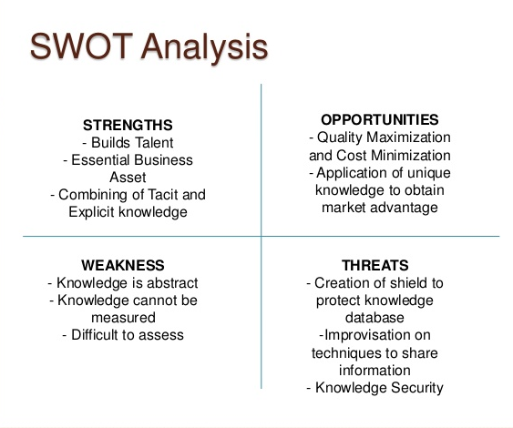

(image share)

What is a value chain:
“The value chain is a concept from business management that was coined and popularised by
Porter (1985). A value chain is a chain of production activities in a firm, starting from the inputs
up to the final customer delivery. Products or services pass through all activities of the chain in
order and, at each activity; the product or service gains some value. A value chain is a
decomposition of the activity of the firm into value-processing activities. These processing
components and activities are the building blocks by which a corporation creates a product or
provides service valuable to its customers. The chain of activities gives the products or services
more added value than the sum of added values of all activities.”
(Jean-Louis Ermine)

“The disruption from the closure of neighbouring airspace and cessation of carrier services to Qatar has ensured the shockwaves of the sanctions are being felt immediately,”
(Francis Churchill, 2017)

The value chain for Qatar Airways can offer different types of benefits. Qatar Airways conducts their value chain during processes and planning. There are possible source and competitive advantages can be identified. There are various activities that can be shared to a certain extent. The value chain can approach suggestions that the organisation can consider activities as an economic source. The activities can also become a barricade to new competitions and can be cost effective. The use of value chain can analyse the finance, the products and offer information flow. Qatar Airways identifies internal and external links with their activities through their value chain. The internal or inter-relation links are activities with-in the same organisations but different departments. For example. Schedule department, HR and help desks. The external links are activities outside the organisations. For example. other airports, travel agents and hotels.
Qatar Airways advertise 5 star flights. Which means customers who fly with Qatar Airways will be expecting the 5 star service that they promised in every aspect, such as Queue jumping, on time schedules and airport lounge facilities.

“During the 2003/2004 financial year, Qatar Airways carried 3.3m passengers, up 35% on the previous 12month period. During the 2004/2005 financial year, passenger numbers rose sharply to 4.6m, while the figure topped 6 million in the 12-month 2005/06 financial period. The figure surpassed the 8 million passenger mark for the 2006/07 financial year and hit around 10 million passengers for the 2007/08 financial period.
(Skytrax Airline Global Industry Audit)

Presently airline industry growing very well and world top level profitability industry where from we can earn profit .On the other hand political and some other economic factors are affected on this industry, after 11th September there was a great change in the trend of abroad journey for visit, studying and business purposes etc. Another big factor is rapidly rising in oil prices over the world specially in middle east as well, due to this cost increased of airline industry and in this way profit has been decreased and these losses has been reached round $ 6 billion in 2009 (IATA) 6 billion in 2009 (IATA).

The new entrants in any industry face some threats from existing companies because new company offer more attractive product with low cost etc. In airline industry threats are low as comparatively barriers are high. Some challenges under below due to new entrants..
Capital Requirements. We need huge capital for this industry for purchasing new crafts and also for starting new projects and also need for attractive to customers.
Brand name & Customer loyalty: Airlines companies with excellent goodwill and strong image in market will easily compete with new threats at the time of entry

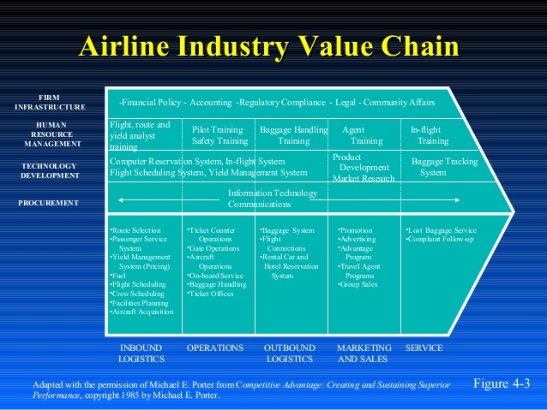

(airline analysis)
Emirates Airlines has a good and effective business model which is very helpful to gain company objectives and help to company become leader in the airline Industry .following are strategies of the emirates airlines strategies.
Emirate has its threshold resources which include its flights, office equipment, head quarter, finance resources and employees. Emirate also has core resources in the form of management team, Ahmed Bin Saeed Maktoum (CEO/Chairman).Same as resources Emirate has threshold competences which includes online booking, operations of on time delivery and point to point routing. While in its core competences includes IT development, no frill strategy and route policy strategy.

Conclusion and Recommendation

At the time of strong competition which refers to maturity stage of Airline Industry so each company should approach offensive and use the offensive strategy after in detail review its internal and external environment and all related factors which directly affect the company position. The following recommendations are for Emirates airlines.
Operational cost of Emirates is very high only due to huge investments on technologies, aircrafts and best quality services. Emirates should control its cost and should decrease its cost through improvement and development of operations activities .Emirates should improve maintenance process, effective and efficient flight schedule of the company and better utilization of the company resources like aircrafts etc. Another way for reduction of cost is advancement in its technologies by investment in technologies and in this way cut of labour cost. For example, it is strongly recommended to new installation of self-check service system on all airports.
In reply to the threat of low cost airlines in UAE market. Emirates should offer advance level services and control cost and this way no need to reduce the prices and in this order it should introduce its new brand as subsidiary which should be based on low cost. a subsidiary
Extension in routes strongly recommended and should be special growth in tourism UAE. In this order to it should extend its route worldwide most attractive areas and Canada one of them. Joining with global alliance will help to increase its worldwide destinations in this way should offer more impressive and effective strategy for competing low cost airlines.
Advancement in Information Technology is most important for progress of emirates airlines and in this order it should make contracts with E-Business Company for improving its services and increase the customer’s satisfactions. E-CRM is the latest technology and adopted by Emirates this strategy since increasing in numbers of the internet users and this way out for keep long term relation with customers. (Jiang, 2003).
Eventually, Emirate’s Airlines make comprehensive analysis and review of company internal and external factors and its competitors and should develop new strategies for staying and keep good position in airline industry at this maturity time.

References

- BD Dictionary, 2019,kowledgw management. (online) available at: http://www.businessdictionary.com/definition/knowledge-management.html accessed on 08/07/2019

- Peter Hedlund, director of marketing, at www.drop.com. (online) available at: https://www.knowledge-management-tools.net/knowledge-management.html accessed on 08/07/2019

- Swot analysis (online) available at: https://image.slidesharecdn.com/knowledgemanagementasasupporttoenterprisesolution1-/131125065738-phpapp02/95/knowledge-ma/nagement-as-a-support-to-enterprise-solution-eps-17-638.jpg?cb=1385362745 accessed on 08/07/2019

- Jean-Louis Ermine, 2013,a Knowledge Value Chain for Knowledge Management. (online) available at: https://www.researchgate.net/publication/272731129_A_Knowledge_Value_Chain_for_Knowledge_Management accessed on 08/07/2019

- Francis Churchill, 06 June 2017, Supply Chain, Supply Management. (online) available at: https://www.cips.org/supply-management/news/2017/june/qatars-supply-chains-instantly-disrupted-/ accessed on 08/07/2019

- Skytrax Airline Global Industry Audit, 2017, the Qatar airways story, charting the rise of one of the fastest growing airline in the world. (online) available at: https://www.qatarairways.com/content/dam/documents/press-kit/The%20Story%20of%20Qatar%20Airways%20-%20English.pdf accessed on 10/07/2019

- Airline analysis. www.bing.com. (online) available at: https://www.bing.com/images/search?view=detailV2&id=DF5B3F1B98EF005A924492D4196BA4FD78A4A15E&thid=OIP.XMEmo5eC2raDUnqqSd4DWAHaFj&mediaurl=https%3A%2F%2Fimage.slidesharecdn.com%2Fairlinesanalysis-140201001514-phpapp01%2F95%2Fairlines-analysis-9-638.jpg%3Fcb%3D1391213814&exph=479&expw=638&q=porter%27s+value+chain+for+qatar+airways&selectedindex=14&ajaxhist=0&vt=0&eim=1,2,6&ccid=XMEmo5eC&simid=608029353549169068 accessed on 11/07/2019

