Planning and Delivering an International Meeting/Event.
Report

Module name: International Meetings Management BMIH6007
Student Name: Elena-Petronela Ciubotariu
Student ID: 2219782
Lecturer’s name: Kathryn Flynn

I confirm that I have not used any Al tools in the research and creation or this assignment. I confirm that I have not presented any Al generated materials as my own work. I confirm I have copies of my drafts, notes, and other resources I used, which may be asked to provide in evidence.

Table of Contents
1 Introduction 3
2 The Event Cycle 3
3 Event Concept 4
4 Aim and Objectives of the Event 4
5 Event Management 5
6 Event Management 5
6.1 Operational Activities 5
6.2 Planning Activities 5
6.3 Marketing Activities 6
7 Event Budget 6
7.1 Budget BreakdownIncome Sources 6
7.2 Expenditure Sources 7
7.3 Revenue Breakdown 8
8 Industry Trends / Issues / Impacts 9
8.1 Industry Trends 9
8.2 Issues 9
8.3 Impacts 10
9 Situational and Cultural Considerations 10
9.1 PESTLE Analysis 10
9.1.1 Political 10
9.1.2 Economic 10
9.1.3 Social 11
9.1.4 Technological 12
9.1.5 Legal 12
9.1.6 Environmental 13
9.2 SWOT Analysis 13
10 Conclusion 14
11 References 15

Introduction
The report outlines a comprehensive plan for the Diverse Leaders Conference 2025, a sector specific conference that is geared towards promoting equity, diversity, and inclusion (EDI) in the hospitality industry. The conference has been selected in light of the increasing demand for EDI somewhere deep within leadership. It will be held in London, the venue for hospitality business, and will include industry practitioners, politicians, and scholars to debate the growth EDI issues. The report will provide details on the event cycle, concept, event objectives, management strategies, budget, industry innovation, and cultural aspects to structure the event and execute it appropriately.
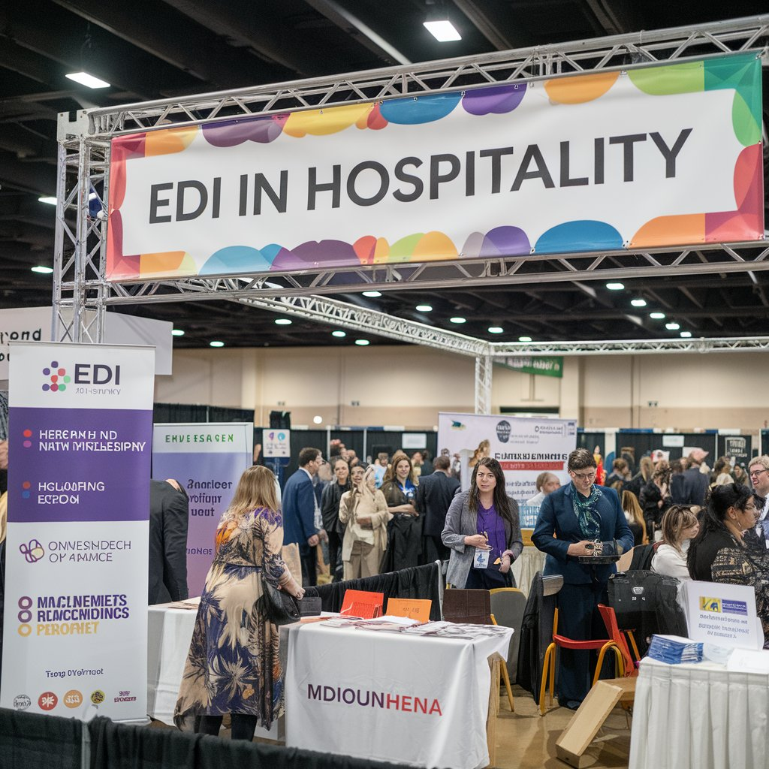
Figure 1. EDI Expo
(Source: Author)

The Event Cycle
The event cycle is mainly using Kolb’s cycle. Hence, it consists of four stages of the Event Cycle, including planning, promotion, at event and post event (Lamb, 2015).
The Planning stage of this event includes extensive market research to establish the state of EDI practice in the sector. Market research focuses on identifying current EDI trends, challenges, and opportunities within the industry (Kamasaak et al., 2023). Suppliers and vendors who espouse EDI values will be prioritized in London, and the event itself will reflect the values that it aims to promote.
Market research also put emphasizes to uncover the latest trends, challenges, and opportunities related to EDI in the industry. For this program, suppliers and vendors that align with EDI principles will be given priority in London, and the event will embody the values it seeks to advance.
The promotion will be in regard to the multi-channel process in regard to social media, influencer and email marketing. With this, SEO, paid advertisements and word of mouth will be the main strategy for this event.
The during event stage, the organizers will do their best to create a stimulating and dynamic experience for the participants. Real-time planning success will guarantee smooth changeovers during the course of the event from the opening ceremony to main speeches, debate forums, and workshops in this course of program, which shall be held. Real time coordination will ensure seamless transitions between sessions, from the opening ceremony through keynote presentations, panel discussions, and workshops.
The Post event stage is a critical role in measuring the event's success and ongoing improvement including emails, reviews, surveys to ask about the event and viewing the KPIs was attained.

Event Concept
The purpose of Equity, Diversity, and Inclusion (EDI) Expo is to offer an educational experience for participants by promoting practical discussion in the hospitality sector (Santos et al., 2024). The event organizers will implement comprehensive planning to deliver outstanding networking opportunities alongside educational sessions and interactive activities. The day will feature interesting workshops and motivational keynote presentations and panel discussions as well as networking opportunities for attendees. The event starts with registration followed by a welcome session which provides participants with materials and opportunities to socialize.
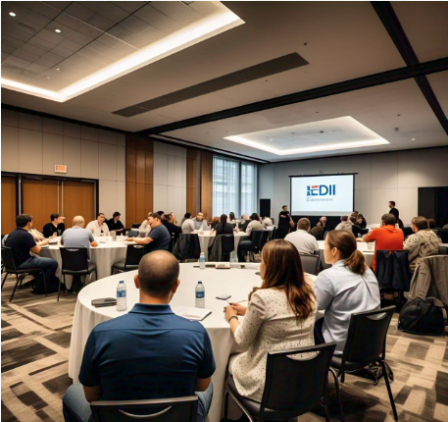
Figure 2: People in EDI Conference
The program will feature experienced panelists who will provide valuable visions on best practice EDI. There are will be interactive training sessions as well as workshop seminars in the afternoon. These training sessions focused on using the business practices that are inclusive in the hospitality industry (Wickham et al., 2021). The organizations centered on diversity that will offer the chance to participants to build the strong professional networks. This lunch will help participants in forming the partnerships while strengthening their connections (Aktepe and Demirci, 2024). This event will conclude with panel discussions that demonstrates the real case studies. There will be concluding comments at the end of the event that recap key takeaways to facilitate upcoming partnerships (Rogers and Wynn-Moylan, 2022).

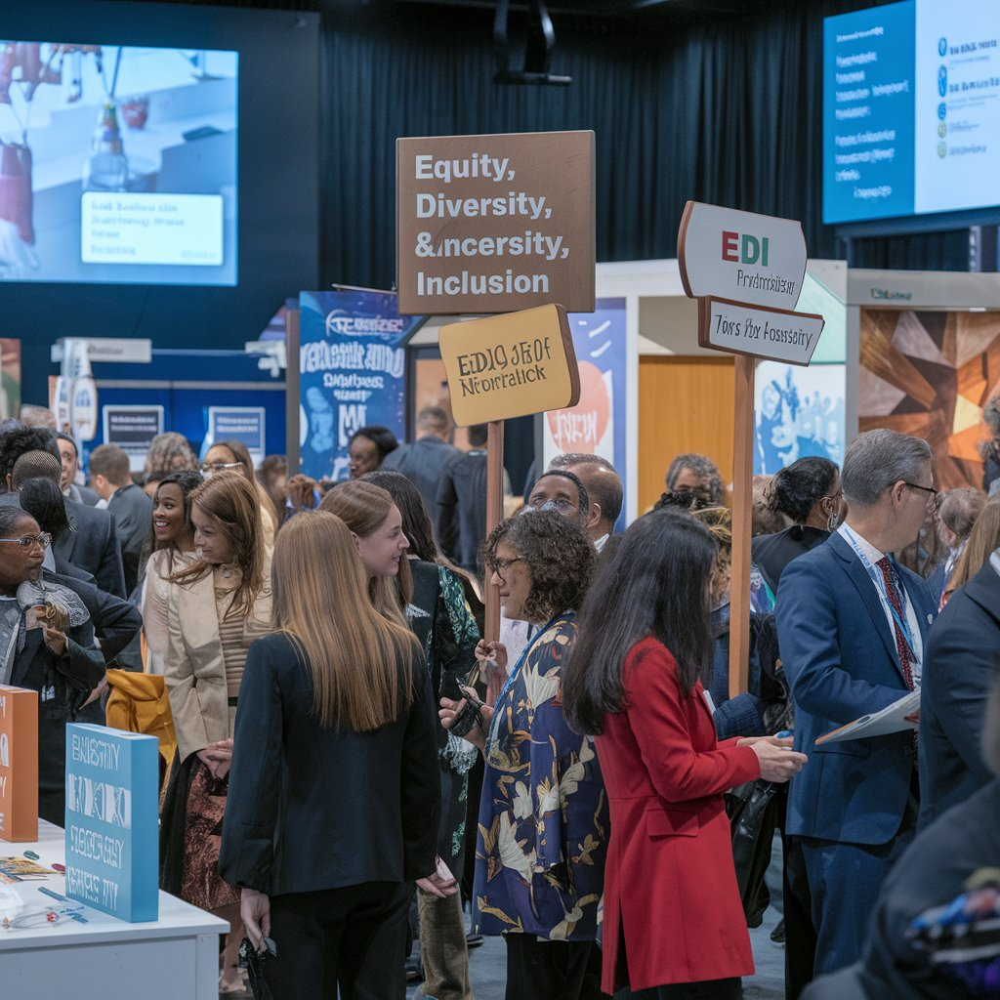
Figure 3. Event concept
(Source: Author)

Aim and Objectives of the Event
By having an expo that raises awareness and promotes equity, diversity, and inclusion (EDI) in hospitality industry.
Objectives:
- By having an expo that raises awareness and promotes equity, diversity, and inclusion (EDI) in hospitality industry.
- By having an expo that raises awareness and promotes equity, diversity, and inclusion (EDI) in hospitality industry.
- By having an expo that raises awareness and promotes equity, diversity, and inclusion (EDI) in hospitality industry.

Event Management

Event Management

Operational Activities
The appropriate handling of logistics is important in order to make sure that event’s operations runs smoothly. These operational activities are scheduling, venue management, catering, and security preparations. A committed technical team will oversee digital interaction platforms, IT infrastructure and audiovisual equipment (Getz and Page, 2019). The accessibility services like support for mobility and sign language interpreters need to be offered to cater to a variety of attendees. Furthermore, a risk management plan needs to be established to tackle unexpected issues which incorporate technical malfunctions and safety hazards. The effective management of suppliers and vendors will be vital for the seamless operation of every facet of the event (Bladen et al., 2022).

Planning Activities
A clearly defined planning procedure is required for establishing explicit objectives and designating responsibilities to make sure that all aspects of the event align with the main aim of advancing EDI in the hospitality sector. This requires creating a comprehensive schedule, organizing guest speakers, completing the event program and obtaining sponsorships. In addition, a contingency strategy should be created to address risks linked to abrupt cancellations, financial limitations and attendance variations (Getz, 2024).

Marketing Activities
A robust marketing strategy is essential for drawing in attendees, key industry stakeholders and sponsors. A multifaceted approach will be utilized to optimize event visibility which incorporate email marketing, social media initiatives, conventional outreach methods and digital advertising. The collaborations with industry influencers, educational institutions and hospitality groups will be strategically employed to effectively promote the event (Zim.pcz.pl, 2025). The creation of compelling content marketing materials which include promotional videos, blog articles and participant testimonials will boost event awareness in a significant way. Furthermore, post-event marketing activities which include participant feedback and sharing event highlights will sustain engagement to foster interest in future events (Gamble, 2019).
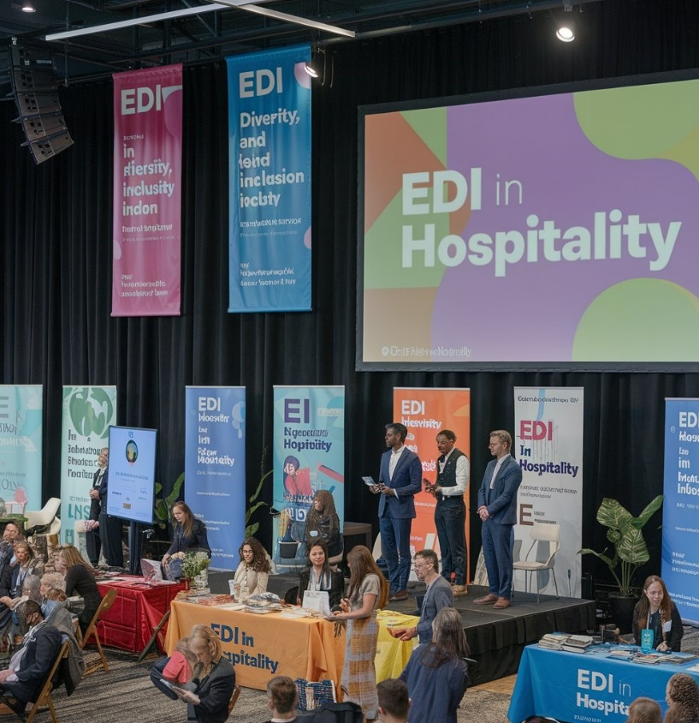
Figure 4. Event management
(Source: Author)

Event Budget

Budget Breakdown Income Sources
Category | Details | Estimated Cost (£)
Income Sources
Ticket Sales | 500 tickets @ £50 each | 25,000
Sponsorships | Corporate sponsors (5 x £5,000) | 15,000
Government Grants | Diversity and inclusion initiatives | 8,000
Exhibitor Fees | 5 booths @ £1,000 each | 5,000
Merchandise Sales | Branded event merchandise | 3,000
Total Income |  | £56,000

Expenditure Sources
Category | Details | Estimated Cost (£)
Venue Hire | Conference hall + facilities | 8,000
Catering | Lunch, refreshments (500 attendees) | 3,000
Speaker Fees | Honorariums for keynote speakers | 5,000
Marketing & Promotion | Digital, print, and social media campaigns | 2,000
Staff & Logistics | Event coordinators, security, logistics | 2,500
AV Equipment | Sound, screens, and live streaming | 2,000
Miscellaneous | Printing, signage, contingency fund | 1.200
Total Expenditure |  | £23,700

Revenue Breakdown
Revenue Source | Details | Estimated Revenue (£)
Ticket Sales | 500 tickets @ £50 each | 25,000
Sponsorships | 5 corporate sponsors @ £5,000 each | 15,000
Government Grants | Funding for diversity & inclusion initiatives | 8,000
Exhibitor Fees | 10 exhibition booths @ £1,000 each | 5,000
Merchandise Sales | Branded event items (Tshirts, mugs, etc.) | 3,000
Total Revenue |  | £56,000
With enough money to cover the budgeted cost of £23,700, this breakdown is in line with the total budget, leaving a net surplus of £32,300 that may be used for further improvements or future events.

Industry Trends / Issues / Impacts

Industry Trends
A significant trend is the combination of hybrid and virtual events which enhances accessibility by extending audience reach. The digital platforms currently allow for real-time interaction that permit participants to engage via interactive networking events. This change promotes inclusivity for making events easier to access for a varied audience (Wickham et al., 2021). A key trend is the focus on sustainability within event planning. The event planners are embracing eco-friendly methods as awareness of environmental responsibility grows. Several venues are pursuing eco-friendly certifications, thus advancing sustainability within the sector. The EDI Expo adheres to this trend by minimizing environmental impact via choice of eco-friendly venues and digital resources. The diversity and inclusion are key factors in event management. Organizations are emphasizing accessible locations, fair representation and diverse speaker panels at every level of involvement (Glenn et al., 2023).

Issues
The events sector encounters various obstacles that affect the planning of events even with favorable developments. The budget limitations present major challenges as increasing expenses for venue hire, logistics compel organizers and catering to obtain sponsorships for refining budget distribution (Getz and Page, 2019). An important concern is the experience of attendees. The incorporation of real-time engagement tools with interactive workshops at the EDI Expo will improve the attendee experience by promoting significant involvement. Furthermore, regulatory and legal aspects continue to pose a challenge in event organization. It is essential to adhere to accessibility guidelines, health and safety standards and data protection regulations is crucial to guarantee a legally compliant event (Bladen et al., 2022). The EDI Expo is required to comply with these legal regulations to ensure a secure culture for every attendee.

Impacts
The changing trends presents various obstacles in the events sector that significantly affect the ways events are planned and carried out. The implementation of virtual and hybrid event solutions gives everyone worldwide access to participate in such events without travel restrictions (Santos et al., 2024). The businesses apply sustainable practices for event planning because it protects both environmental health and reduces the organizational impact on the planet. The EDI Expo achieves both long-term success and increased corporate reputation due to these environmentally beneficial actions. The implementation of diversity and inclusion programs has expanded events throughout every individual segment of society (Aktepe and Demirci, 2024).

Figure 5. Industry trends
(Source: Author)

Situational and Cultural Considerations

PESTLE Analysis

Political
The London hospitality sector is seriously affected by a myriad of political issues in profitability and operation. Some of the new policies, for instance, removal of tax-free shopping for tourists, have had significant economic impacts. For instance, West End retailers lost £220 million in potential revenues in only the first half of 2024 due to the policy (The Times, 2024). Reversal of the business rates relief is another controversial topic. The news indicates that more than 50% of pubs, breweries, and hospitality firms will reduce staff and stop investment if the relief is taken away as scheduled (The Times, 2024a). West End retailers, for instance, lost £220 million of potential revenues in the first half of 2024 alone as a result of the policy (The Times, 2024). The business rates is considered to be a contentious issue.
Industry accounts have showed that more than 50% of the pubs, breweries, and hospitality businesses will reduce staff and abandon investment plans if the relief is phased out as scheduled (The Times, 2024a).

Economic
In 2024, the UK hotel sector experienced an unprecedented surge in deal-making with the total deals amounting to £6.6 billion, a 182% increase from 2023 and a new high, beating the previous high of 2019. London was the epicenter, with 50% of the total deal volume being of luxury hotels (The Times, 2024b).
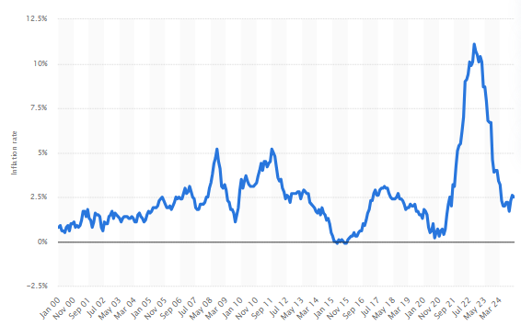
Figure 6: Inflation rate for the Consumer Price Index (CPI) in the United Kingdom from January 2000 to December 2024
Statista, 2024a
In regard to the economic result, shops in London's West End lost £220 million worth of sales opportunity in the first half of the year as a result of this policy shift. While international tourists increased by 3%, expenditure fell by 12%, compared to a 36% rise in foreign spending in the EU (The Times, 2024c). The UK inflation rate was 2.5% in December 2024 (Statista, 2024a)

Social
London’s hospitality industry is deeply influenced by its diverse population. Approximately 40% of hospitality workers in the UK come from non-native backgrounds (High-End Hospitality, 2025).
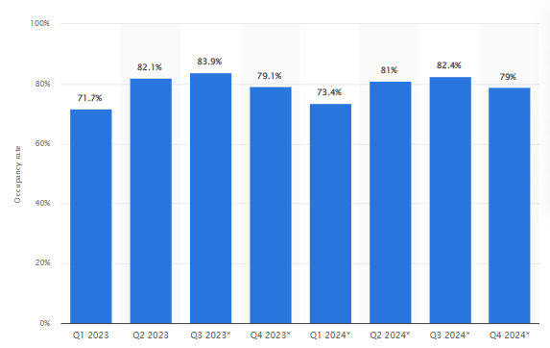
Figure 7: Hotel occupancy rate in London, United Kingdom in 1st quarter and 2nd quarter 2023, with a forecast until 4th quarter 2024
Statista, 2024
The occupancy rate of hotels in the United Kingdom's capital, London, stood at 82.1% (Statista, 2024). There is an increasing expectation for equity, diversity, and inclusion (EDI) in both the workforce and customer experiences. Vegan and plant-based options have surged in popularity among Londoners for a flexitarian diet (London.gov.uk, 2024).

Technological
Small and medium enterprises (SMEs) in the hospitality sector are also adopting these technologies in a bid to catch up with industry leaders. Security risks in regard to data, cost, and productivity hinder SMEs' for adoption of technology (The Times, 2024d).

Legal
The law, in 2024, requires employees to be paid all tips and service charges. There are establishments that have put in place cover charges, not paid to employees, which could face legal proceedings (Butler, 2024). For instance, the staff in luxurious restaurants in London, such as Harrods, the Savoy Grill, and the Ivy, are considering legal proceedings against these restaurants. Employers charged for violations are to be fined and required to pay the employees (Butler, 2024). The Working Time Regulations Act therefore safeguards the rights of the staff members, including: staff not to exceed 48 hours of work per week on average. According to CIPD (2025) report, at least 5.6 weeks of paid holiday a year to employees (CIPD, 2025).

Environmental
In regard to environment, hotels and restaurants use energy for heating, cooling, lighting, and appliances in the hotel in the UK. Hence, the adoption of energy-efficient equipment and renewable energy will mitigate this impact. High water consumption is prevalent in hospitality industry (Khatter, 2023).

SWOT Analysis
Table 1: SWOT ANALYSIS
Strengths | Weaknesses | Opportunities | Threats
The event to focus on Equity, Diversity, and Inclusion (EDI) in the UK. | It will cost (£29,500), however, the costs can exceed. | This industry increases and creates demand for such events (Allen, 2010). | There is competition in EDI or hospitality events (Allen, 2010).
The event provides structure event planning (keynotes, workshops, exhibitions). | There can be logistical challenges to coordinate with multiple sessions and vendors. | Many new sponsorships from businesses focused on social responsibility can be enagaged in this (Cornwell, 2020). | The hospitality industry can face downturns, which can limit these events and sponsorhips.
This event will provide networking opportunities with professionals in the hospitality sector. | There can be attendee turnover. | If this event is successful then this can come to the same company or vendor. | There can be potential challenges in the event such as mic, logistics, food, seating arrangement and finances.
Hence, industry trends towards inclusivity and corporate social responsibility to be discussed. | There will be external speakers and panelists may affect program quality if cancellations occur. | Hence, if this event is successful then partnerships with diverse can broaden the event's scope. | Attendances can give negative feedback to this as well.

SOAR analysis
Table 2: SOAR ANALYSIS
Strengths | Opportunities | Aspirations | Results
Proper sessions and mentorship to be provided in this event. | All gender, backgrounds and ethnicities to be gathered for this. | This event will tell about the EDI practices in the hospitality industry. | There will be 500 attendees in the event.
The show will be full of mentorship, sessions, opportunities and question answer session to get their experience in the UK’s industry. | The ongoing trends and leads to be discussed and further be explained. | There will be directed to inspire upcoming employees for standard of inclusivity. | EDI knowledge and practices to be also discussed.
There will a space for parking, little entrance fees and food while also taking sessions. | There will be potential for growth in future editions of the event. | The hospitality industry to be discussed openly with sharing the challenges and potential solutions. | In the end of the event, feedback and ongoing industry engagement topics to be touched upon.

Conclusion
In regard to conclusion, this event to play a key role to promote EDI industry in the UK. Hence, in regard to the hospitality industry, formal event cycle is structured in order to showcase the whole plan for this event. Also, industry trends and analysis are done in regard to see the EDI industry of the UK using relevant eveidence. This event will include debate, exchange inclusive practices, and offer networking opportunities among hospitality leaders, policymakers, and researchers. Therefore, proper budgeting will be effective for this event.

References
Aktepe, B. and Demirci, B. (2024). Emerging technologies in the event industry. Worldwide Hospitality and Tourism Themes, 16(4), pp.498-518. doi: https://doi.org/10.1108//WHATT.
Allen, J. (2010). The business of event planning: behind-the-scenes secrets of successful special events. John Wiley & Sons, pp. 35–40. Doi: https://books.google.com/books?hl=en&lr=&id=LlSmkUtkN40C&oi=fnd&pg=PR11&dq=Allen,+J.+(2010).+The+business+of+event+planning:+behind-the-scenes+secrets+of+successful+special+events.+John+Wiley+%26+Sons.&ots=RIq86av8Qq&sig=Ng9dOr6LOC_PVxGr83HcDJDazyo
Bladen, C., Wilde, N., Kennell, J. and Abson, E. (2022). Events Management. [online] doi:https://doi.org/10.4324/9781003102878.
Butler. S., (2024). Staff at top London restaurants consider legal action over cover charges. [Online]. Available at: https://www.theguardian.com/business/2024/dec/22/workers-london-restaurants-harrods-cover-charges-legal-action [Accessed 12 Feb. 2025].
CIPD. (2025) Working time regulations. [Online] Available at: https://www.cipd.org/uk/knowledge/employment-law/working-time/ [Accessed 12 Feb. 2025].
Cornwell, T.B., 2020. Sponsorship in marketing: Effective partnerships in sports, arts and events. Routledge.
Gamble, T.R. (2019). Event management education and the meeting and business event competency standards: the perspective from alumni. [online] K-state.edu. Available at: https://krex.k-state.edu/items/11c8fb01-ab92-4c11-adaa-d645e74b8e4d [Accessed 12 Feb. 2025].
Getz, D. (2024). Festival and Event Tourism. [online] pp.391–395. doi:https://doi.org/10.1007/978-3-030-74923-1_84.
‌Getz, D. and Page, S.J. (2019). Event Studies. [online] Routledge eBooks. Informa. doi:https://doi.org/10.4324/9780429023002.
Glenn, McDonnell, I., Harris, R., O’Toole, W., Allen, J. and Jago, L. (2023). Events Management. [online] doi:https://doi.org/10.4324/9781003044963.
High end hospitality. (2025). Diversity in hospitality: how cultural inclusivity defines the industry. [Online]. Available at: https://highendhospitality.co.uk/2025/01/13/diversity-in-hospitality-how-cultural-inclusivity-defines-the-industry [Accessed 12 Feb. 2025].
Kamasak, R., Alkan, D. P., and Yalcinkaya, B. (2023). Emerging Trends of Industry 4.0 in Equality, Diversity, and Inclusion Implementations. Contemporary approaches in equality, diversity and inclusion: Strategic and technological perspectives, pp. 129-148.
Khatter, A. (2023). Challenges and solutions for environmental sustainability in the hospitality sector. Sustainability, 15(15), p. 11491.
Lamb, D. (2015). Learning about events through involvement and participation: The use of experiential and authentic learning experiences. International Journal of Event and Festival Management, 6(1), pp. 73-91.
London.gov.uk. (2024). New data shows London’s world-leading hospitality industry and livemusic events defied all expectations in 2023. [Online]. Available at: www.london.gov.uk/new-data-shows-londons-world-leading-hospitality-industry-and-livemusic-events-defied-all [Accessed 12 Feb. 2025].
Rogers, T. and Wynn-Moylan, P. (2022). Conferences and Conventions. [online] doi:https://doi.org/10.4324/9781003298953.
Santos, Fernández-Gámez, M.A., Puig-Cabrera, M. and Santos, M.C. (2024). Sustainability in Business Events: How Hybrid Formats Shape Attendee Decision-Making. Journal of Tourism and Services, [online] 15(29), pp.320–348. doi:https://doi.org/10.29036/jots.v15i29.1006.
Statista. (2024). Hotel occupancy rate in London, United Kingdom in 1st quarter and 2nd quarter 2023, with a forecast until 4th quarter 2024. [Online]. Available at: https://www.statista.com/statistics/323719/annual-hotel-occupancy-rate-in-london-uk/ [Accessed 12 Feb. 2025].
Statista. (2024). Inflation rate for the Consumer Price Index (CPI) in the United Kingdom from January 2000 to December 2024. [Online]. Available at: https://www.statista.com/statistics/306648/inflation-rate-consumer-price-index-cpi-united-kingdom-uk/#:~:text=Inflation%20rate%20in%20the%20UK%202000%2D2024&text=The%20UK%20inflation%20rate%20was,11.1%20percent%20in%20October%202022. [Accessed 12 Feb. 2025].
The Times. (2024). Retailers lose £220 million due to end of tax-free shopping scheme. [Online]. Available at: https://www.thetimes.co.uk/article/15taxfreeshopping-tffgp38f2 [Accessed 12 Feb. 2025].
The Times. (2024a). Scrapping rates relief will put hospitality jobs at risk, bosses warn. [Online]. Available at: https://www.thetimes.co.uk/article/scrapping-rates-relief-will-put-hospitality-jobs-at-risk-bosses-warn-jxrw26v8x [Accessed 12 Feb. 2025].
The Times. (2024b). Why UK hotels suddenly seem more expensive. [Online]. Available at: https://www.thetimes.com/uk/society/article/250-a-night-how-labour-tax-rises-will-hit-your-staycation-plans-this-year-sm0hjp6ml?utm_source=chatgpt.com&region=global [Accessed 12 Feb. 2025].
The Times. (2024c). London’s stores count cost of ‘tourist tax’. [Online]. Available at: https://www.thetimes.com/business-money/economics/article/15taxfreeshopping-tffgp38f2 [Accessed 12 Feb. 2025].
The Times. (2024d). How AI helps small newcomers compete with the giants. [Online]. Available at: https://www.thetimes.com/business-money/entrepreneurs/article/how-ai-helps-small-newcomers-compete-with-the-giants-enterprise-network-mqbgvwbqt?utm_source=chatgpt.com&region=global [Accessed 12 Feb. 2025].
Wickham, M., Donnelly, T. and French, L. (2021). Strategic Sustainability Management in the Event Sector. Event Management, [online] 25(3), pp.279–296. doi:https://doi.org/10.3727/152599519x15506259856318.
‌Zim.pcz.pl. (2025). Publishers Panel. [online] Available at: https://pjms.zim.pcz.pl/article/143015/en [Accessed 12 Feb. 2025].

