
remote work APPRAISALS
The Role of Technology in Modern Performance Management

May 3, 2024
UNIVERSITY OF WALES TRINITY ST DAVIS
Student: Mihai Tilea
Lecturer: Nishi Ramsurrun
Module: LCBB5004_LON


Table of Contents
1. Introduction 2
1.1. Brief overview of the shift to remote work 2
1.2. Importance of performance appraisal in a remote setting 2
2. The Role of Technology in Appraising the Performance of Remote Workers 2
2.1. Overview of technology's impact on performance management 2
3. Performance Measurement Techniques for Remote Workers 5
3.1. Technique 1: Continuous Feedback Systems 5
3.2. Technique 2: Objective and Key Results (OKRs) 5
3.3. Technique 3: Self-Assessment 5
3.4. Technique 4: 360-Degree Feedback 5
4. Performance Appraisal Tools for Remote Workers 7
4.1. Tool 1: Project Management Software 7
4.2. Tool 2: Time Tracking Tools 7
4.3. Tool 3: Performance Management Software 7
4.4. Tool 4: Employee Monitoring Software 8
5. Conclusion 9
5.1. Summary of key points 9
5.2. Future implications for remote work performance management 9
6. References 10

1. Introduction
The rise of remote work represents a significant shift in the development of workplace practices, a movement that was greatly hastened by the global health crisis. This shift, while challenging traditional office dynamics, has underscored the necessity for agility and resilience within the workforce and organizations (Eurofound, 2020).

1.1. Brief overview of the shift to remote work
As a response to the pandemic, businesses rapidly embraced remote work, with many employees finding themselves operating from home almost overnight. This transformation was not merely a stop-gap measure but has persisted, indicating a potential long-term change in how and where work can be effectively conducted (Kniffin et al., 2021).

1.2. Importance of performance appraisal in a remote setting
In such a decentralized work environment, performance appraisals have become a pivotal tool for maintaining employee focus and productivity. They serve as a critical link between remote employees and organizational goals, helping to align and motivate dispersed teams (Pulakos et al., 2019).

2. The Role of Technology in Appraising the Performance of Remote Workers
The recent surge in remote work has necessitated a parallel evolution in performance management, significantly shaping the mechanisms by which organizations appraise and develop their workforce. The integration of technology in these processes has become central, offering both opportunities and challenges in the pursuit of effective performance management practices.

2.1. Overview of technology's impact on performance management
Technology's role in performance appraisal has become critically pronounced, particularly as organizations navigate the complexities of remote work. The use of digital tools and platforms has become the norm, allowing managers to maintain oversight and provide timely feedback, despite the lack of traditional face-to-face interactions.
The use of sophisticated performance management systems (PMS) is one of the most notable tech-driven changes. These systems can track an employee's progress against pre-defined objectives and competencies, allowing for an objective assessment of performance that is not constrained by geographical barriers. PMS often comes with dashboards that provide at-a-glance views of performance data, which can include metrics such as project delivery times, sales figures, and customer service ratings, making the appraisal process more data-driven and less subjective (Stone, Deadrick, Lukaszewski, & Johnson, 2015).
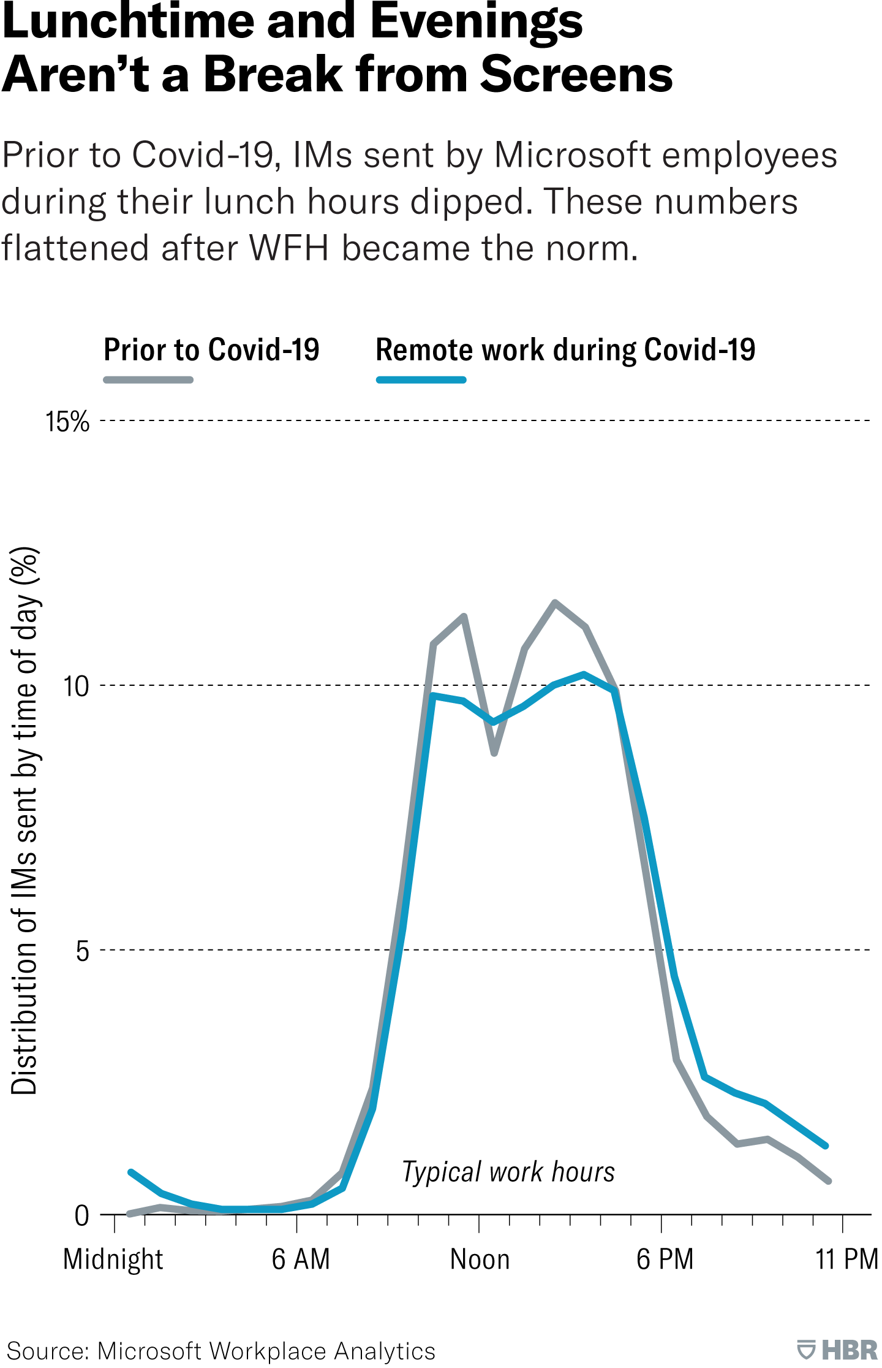
Moreover, technology has enabled the implementation of continuous performance management (CPM) processes. CPM shifts the focus from annual reviews to an ongoing conversation about performance, which can be especially beneficial for remote workers who require more frequent engagement to feel connected and aligned with their teams. Platforms enabling CPM foster real-time communication, provide instant recognition for achievements, and facilitate the setting and tracking of short-term goals, which aligns with modern theories of motivation and employee engagement (Pulakos, 2004; Buckingham & Goodall, 2015).
Collaboration tools, such as Slack and Microsoft Teams, have also redefined how remote teams communicate and collaborate. These tools allow for instant messaging, file sharing, and real-time document collaboration, which can be beneficial for tracking project milestones and individual contributions, a vital component of performance appraisal (Buckingham & Goodall, 2015).
While technology facilitates a more streamlined and continuous appraisal process, it also raises concerns about employee privacy and the potential for over-monitoring. Digital monitoring tools and time-tracking software can create a 'Big Brother' atmosphere, which may hinder trust between employees and management. This underscores the importance of creating clear policies and maintaining an ethical approach to using performance data (Alge et al., 2006).
Despite these challenges, technology remains a cornerstone in facilitating effective performance appraisals for remote workers. It offers scalability for performance management processes, enabling organizations to manage large remote teams efficiently. The ability to collect and analyse large volumes of performance data can also lead to more informed decisions regarding training needs, promotion paths, and other HR-related decisions.
In the realm of learning and development, technology has enabled personalized learning paths through e-learning platforms, which can be directly tied to performance appraisals. Employees can engage in self-directed learning, allowing them to close skill gaps identified during the appraisal process, further demonstrating the symbiotic relationship between technology and performance management (Noe, Clarke, & Klein, 2014).
As organizations continue to navigate the intricacies of remote work, the role of technology in performance appraisal will only grow in importance. It provides a comprehensive, flexible, and data-driven approach to performance management that, when used ethically and effectively, can enhance the employee experience, and drive organizational success.

3. Performance Measurement Techniques for Remote Workers
The shift to remote work has propelled the development and adoption of various performance measurement techniques that cater to the nuances of virtual environments. Such techniques aim to ensure that remote workers are evaluated fairly and accurately, contributing to their professional growth, and aligning their performance with the company’s strategic goals.

3.1. Technique 1: Continuous Feedback Systems
Continuous Feedback Systems have become integral to remote work settings, providing employees with timely insights into their performance. Unlike annual reviews, continuous feedback is characterized by regular, informal check-ins between managers and employees. This approach allows for immediate recognition of accomplishments and swift correction of any missteps, fostering a dynamic and responsive work culture (Buckingham & Goodall, 2015). Implementing continuous feedback can be facilitated by platforms like 15Five or Trello, which encourage ongoing dialogue and reflection on work progress.

3.2. Technique 2: Objective and Key Results (OKRs)
Objective and Key Results (OKRs) provide a framework for setting and communicating clear and measurable goals. This technique helps in translating organizational objectives into specific tasks that employees can work towards (Doerr, 2018). For remote workers, OKRs can be particularly beneficial as they offer a transparent and straightforward way to measure outcomes and contribute to a sense of purpose and direction in their work. Tools like Asana and Monday.com integrate OKR tracking to keep remote teams focused and aligned with organizational priorities.

3.3. Technique 3: Self-Assessment
Self-assessment empowers employees to reflect on their performance, accomplishments, and areas for improvement. This participatory approach encourages personal accountability and professional development. For remote workers, self-assessment can provide insights into their work habits and productivity in a home setting, which might be overlooked by managers or traditional evaluation methods (Pulakos et al., 2019). Self-assessment can be facilitated through digital surveys and reflection tools that allow employees to document and share their progress and challenges.

3.4. Technique 4: 360-Degree Feedback
360-Degree Feedback involves collecting performance-related feedback from all directions - supervisors, peers, subordinates, and sometimes, customers. This comprehensive approach provides a well-rounded view of an employee’s performance, encompassing multiple perspectives. For remote workers, 360-degree feedback can offset the lack of physical presence and ensure a more balanced appraisal by incorporating insights from those who interact with them in various capacities (London & Smither, 2002). Platforms like SurveyMonkey and Google Forms can be utilized to conduct 360-degree feedback sessions efficiently.
Each of these techniques, while distinct, can be integrated into a coherent system that supports the unique needs of remote work arrangements. Continuous feedback systems ensure that communication channels remain open, OKRs tie individual efforts to the company's success, self-assessments provide individual insights, and 360-degree feedback offers a balanced view of an employee's performance.
For these techniques to be effectively implemented, the right technological tools must be in place, alongside a culture that values transparency, continuous improvement, and constructive feedback. Moreover, training for both managers and employees on effectively using these techniques is critical, as is ensuring that the selected methods align with the company’s values and objectives (Aguinis, Joo, & Gottfredson, 2011).
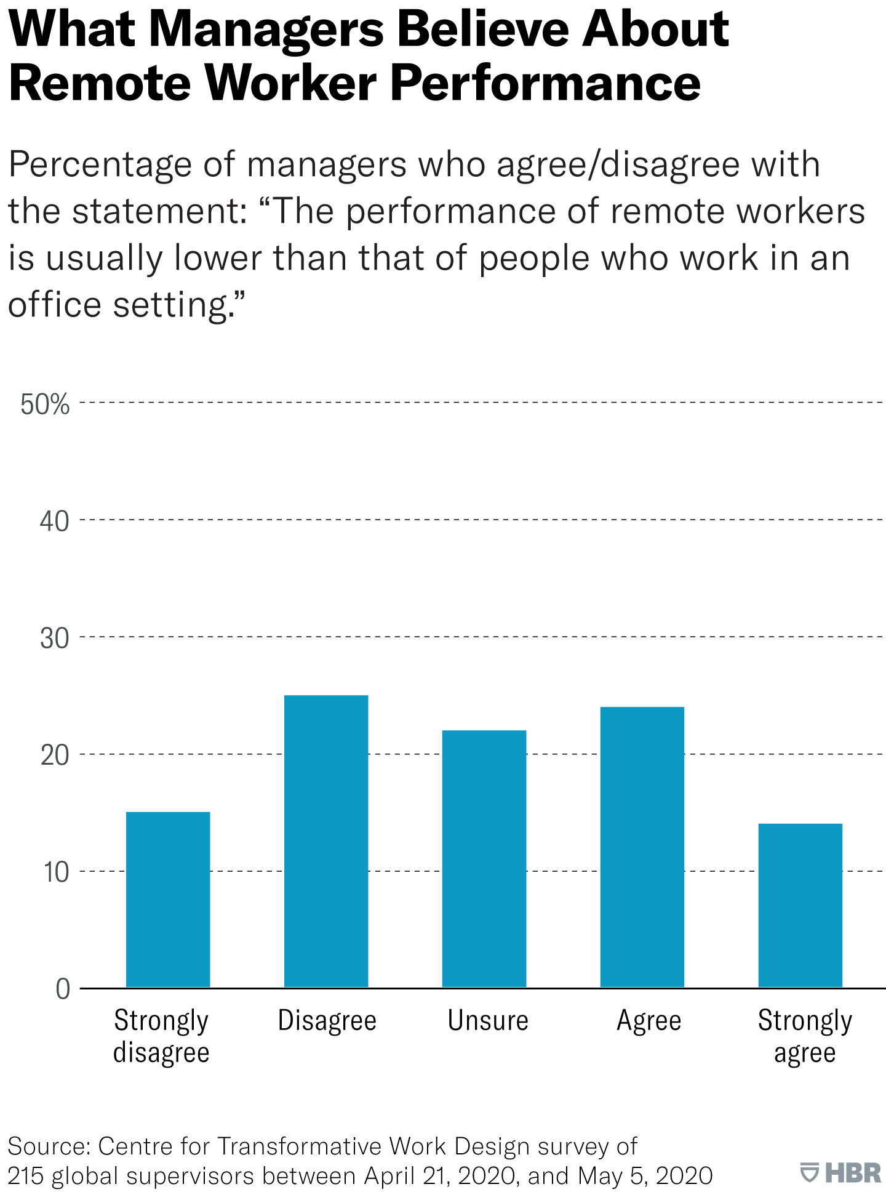
The performance of remote workers can be measured through various techniques that leverage continuous communication, goal setting, self-reflection, and multi-source feedback. By employing these methods consistently, organizations can foster a culture of continuous development and maintain a high level of performance among their remote workforce.

4. Performance Appraisal Tools for Remote Workers
The right tools are crucial for effectively appraising remote worker performance. As organizations increasingly adopt remote work, the demand for digital tools that can replicate and even improve upon in-office appraisal mechanisms has surged. These tools not only facilitate the evaluation of performance but also aid in managing projects, tracking time, enhancing productivity, and monitoring work activities, all while supporting the unique aspects of remote work.

4.1. Tool 1: Project Management Software
Project Management Software like Asana, Trello, and JIRA has become invaluable for remote teams. These tools offer platforms for organizing tasks, setting deadlines, and tracking progress on projects. Managers can view real-time updates, making it easier to assess how individuals and teams are progressing against objectives. These platforms support a range of methodologies, from Kanban boards to Scrum frameworks, accommodating various working styles and preferences (Highsmith, 2009). Additionally, such software often includes features for resource allocation and budget tracking, which further inform performance appraisals by providing a comprehensive view of an employee's project management skills and efficiency.

4.2. Tool 2: Time Tracking Tools
For roles where output is closely correlated with time invested, Time Tracking Tools such as Toggl and Harvest play a vital role. They allow for precise recording of the time spent on different tasks, offering insights into productivity and time management skills. These tools can provide data for performance appraisals, especially in roles where billable hours are a key metric. However, it is important for organizations to use these tools judiciously to maintain trust and avoid micromanagement, which can be counterproductive (Morgeson, Campion, & Maertz, 2005).

4.3. Tool 3: Performance Management Software
Performance Management Software like BambooHR and Lattice integrates various aspects of performance appraisal into a single platform. These systems enable goal setting, feedback collection, and performance reviews, facilitating a structured appraisal process. Such software often incorporates analytics to highlight trends and patterns in performance, aiding managers in making data-driven decisions. These tools also support CPM, where managers and employees can engage in ongoing dialogue about objectives, achievements, and developmental needs, leading to a more dynamic and personalized appraisal process (Aguinis et al., 2011).

4.4. Tool 4: Employee Monitoring Software
Employee Monitoring Software, such as Teramind and Time Doctor, provides functionalities to monitor employee activity levels during work hours. These systems can record keystrokes, track application usage, and sometimes take screenshots, offering a detailed log of an employee's workday. While this can provide clear data for performance appraisals, it is critical to balance monitoring with respecting privacy and autonomy. The use of such software should be guided by clear policies, and employees should be made aware of monitoring practices to ensure ethical use (Stanton & Stam, 2006).
While these tools offer various benefits for appraising remote worker performance, they also require consideration of the ethical implications related to privacy and the potential for misuse. Organizations must be transparent about their use, ensure they are used ethically, and provide clear communication to employees about how they contribute to appraisal processes.
The deployment of these tools can significantly enhance the appraisal process for remote workers, offering a level of detail and insight that might not be achievable through traditional methods. These digital solutions support the performance appraisal process by providing objective data, facilitating communication, and fostering a culture of continuous improvement and accountability. When used effectively, they can help remote teams stay aligned with organizational goals and maintain high productivity levels.

5. Conclusion

5.1. Summary of key points
The appraisal of remote workers has been significantly influenced by technological advancements, with a range of tools and techniques now at the disposal of organizations to ensure effective performance management. Continuous feedback systems, OKRs, self-assessments, and 360-degree feedback have each presented methods to align remote workers with organizational goals, offering varied perspectives and fostering a culture of ongoing development. Similarly, the use of project management software, time tracking tools, performance management systems, and employee monitoring software has allowed for a more nuanced and comprehensive approach to performance appraisal.

5.2. Future implications for remote work performance management
Looking ahead, the trajectory for remote work performance management is poised to further integrate technology, balancing efficiency and data richness with ethical considerations and employee well-being. The ongoing evolution in this domain suggests that organizations will continue to refine these tools and techniques, fostering a performance management ecosystem that is robust, fair, and conducive to remote work's dynamic nature. As this integration deepens, the challenge will be to harness the full potential of technology while maintaining the human touch that is essential to effective management and employee engagement.

6. References
Aguinis, H., Joo, H., & Gottfredson, R. K. (2011). Why we hate performance management—And why we should love it. Business Horizons, 54(6), 503-507.
Alge, B. J., Ballinger, G. A., Tangirala, S., & Oakley, J. L. (2006). Information privacy in organizations: Empowering creative and extrarole performance. Journal of Applied Psychology, 91(1), 221-232.
Amico, L. (2021) The Realities of Remote Work, Harvard Business Review. Available at: https://hbr.org/2021/10/the-realities-of-remote-work. (Accessed on: 14.04.2024)
Armstrong, M. (2014) Armstrong’s Handbook of Human Resource Management Practice. London: Kogan Page.
Buckingham, M., & Goodall, A. (2015). Reinventing performance management. Harvard Business Review, 93(4), 40-50.
Buckingham, M., & Goodall, A. (2015). Reinventing performance management. Harvard Business Review, 93(4), 40-50.
Doerr, J. (2018). Measure What Matters: Online Tools for Understanding Customers, Social Media, Engagement, and Key Relationships. Wiley.
Eurofound (2020). Telework and ICT-based mobile work: Flexible working in the digital age. Luxembourg: Publications Office of the European Union.
Highsmith, J. (2009). Agile Project Management: Creating Innovative Products. Addison-Wesley Professional.
Kniffin, K. M., et al. (2021). COVID-19 and the workplace: Implications, issues, and insights for future research and action. American Psychologist, 76(1), 63-77.
London, M., & Smither, J. W. (2002). Feedback orientation, feedback culture, and the longitudinal performance management process. Human Resource Management Review, 12(1), 81-100.
Morgeson, F. P., Campion, M. A., & Maertz, C. P. (2005). The impact of time flexibility on direct and indirect job performance measures. European Journal of Work and Organizational Psychology, 14(2), 121-145.
Noe, R. A., Clarke, A. D. M., & Klein, H. J. (2014). Learning in the twenty-first-century workplace. Annual Review of Organizational Psychology and Organizational Behavior, 1, 245-275.
Pulakos, E. D. (2004). Performance management: A roadmap for developing, implementing, and evaluating performance management systems. SHRM Foundation's Effective Practice Guideline Series.
Pulakos, E. D., et al. (2019). Performance management can be fixed: An on-the-job experiential learning approach for complex behavior change. Industrial and Organizational Psychology, 12(1), 31-51.
Pulakos, E. D., et al. (2019). Performance management can be fixed: An on-the-job experiential learning approach for complex behavior change. Industrial and Organizational Psychology, 12(1), 31-51.
Torrington, D., Hall, L. and Taylor, S. (2017) Human resource management. 10th edn. Harlow: Pearson.
Stanton, J. M., & Stam, K. R. (2006). The visible employee: Using workplace monitoring and surveillance to protect information assets—without compromising employee privacy or trust. Information Today, Inc.
Stone, D. L., Deadrick, D. L., Lukaszewski, K. M., & Johnson, R. (2015). The influence of technology on the future of human resource management. Human Resource Management Review, 25(2), 216-231.

