  Global Leadership Excellence Program: Empowering Visionary Leaders for a Borderless Future AT HSBC  Leaders in a Global Business | Elena Alexandra Moise 1908804  UWTSD/ 26 July 2023

Executive Summary

The Global Leadership Excellence Program: Empowering Visionary Leaders for a Borderless Future intends to provide HSBC's leaders with the necessary skills and mindset to succeed in the intricate global business environment of today. The primary objective of this all-encompassing programme is to effectively tackle the obstacles associated with managing diverse teams in various cultural environments, while also equipping leaders with the necessary skills to take advantage of the prospects offered by the worldwide financial services sector (Paine, 2016).
The following report introduces the Global Leadership Excellence Programme: Empowering Visionary Leaders for a Borderless Future at HSBC. The report describes the program's goals, organisation, and predicted results. It details how this transformative programme will provide HSBC leaders the skills and mentality to succeed in a dynamic global banking and financial services environment. The report covers the creation and execution of HSBC's Global Leadership Excellence Programme for leaders in diverse geographies and business areas. Effective leadership in global banking and financial services highlights the industry's problems and possibilities in an increasingly linked world. The study emphasises the program's compatibility with HSBC's strategic strategy and ongoing dedication to success. Leadership training sessions, engaging experiences, and online learning modules promote visionary leadership, cross-cultural competency, inclusive practises, and digital collaboration. The study also emphasises HSBC's global operations' ethical choices and corporate social responsibility. It also emphasises building a strong leadership pipeline, cultivating talent, and training future leaders for varied and changing markets. The study discusses the planned Global Leadership Excellence Programme, its budget and resources and provide recommendations for implementing the leadership development for HSBC's long-term success.

Table of Contents
Executive Summary 1
1. Introduction 3
1.0 Overview of HSBC 3
2. Findings 4
2.1 Hofstede's Cultural Dimension Theory 4
2.2 Leadership theories relevant for developing a new leadership programme. 5
2.3 The value of effective leadership in a global banking and financial services context. 6
2.4 Rationale for Developing a New Global Leadership Development Program at HSBC 6
Leadership Styles 7
2.5 Leadership Program Objectives 7
2.6 Leadership Program Structure 7
2.7 Leadership Program Outcome 8
2.8 Gaps in current leadership capabilities in the banking sector 8
2.9 Challenges and opportunities of managing diverse teams. 9
Challenges 9
Opportunities 9
2.10 Strategies 9
2.11 Delivery and Implementation 10
Phase 1 - Program Development and Design 10
Phase 2 - Program Delivery 10
Phase 3- Program Evaluation and Continuous Improvement 11
Duration 11
Target Audience 11
3. Budget 12
4. Resources 14
5. Conclusion 15
6. Recommendations 16
References 17

1. Introduction

1.0 Overview of HSBC
The Hongkong and Shanghai Banking Corporation (HSBC) is a globally recognised banking and financial services institution that features a long-standing history and a wide-ranging global presence Established in 1865 in Hong Kong, HSBC has experienced significant expansion and has emerged as a prominent global financial institution, catering to a vast customer base covering various markets. HSBC, a multinational banking institution, is based in London, United Kingdom, and maintains a global presence across sixty-four countries and territories. This extensive reach places HSBC as one of the foremost international banks, with a notable foothold in crucial financial markets. The financial institution provides an extensive array of financial services encompassing retail and commercial banking, wealth management, asset management, global banking, and insurance services (HSBC, 2023).
HSBC possesses a comprehensive worldwide network that encompasses Europe, Asia, North America, the Middle East, and Africa, thereby enabling the provision of services to a wide-ranging clientele and facilitating international financial transactions The bank's financial robustness is apparent through its consistent placement among the world's foremost financial institutions in relation to aggregate assets, revenue, and market capitalization. HSBC, aside from its notable financial capabilities, demonstrates a strong dedication to sustainability by actively engaging in endeavours that promote environmental, social, and governance objectives. The bank's commitment to prioritising customer satisfaction is evident through its focus on delivering innovative solutions and personalised services that cater to a wide range of customer requirements (Mallick, et al. 2022).
HSBC aspires to be the world's top international bank, helping people, companies, and communities succeed. Its purpose is to provide long-term value and sustainable growth via responsible banking HSBC's basic principles include being transparent, dependable, and engaged with customers, employees, shareholders, and society. Its worldwide financial success depends on its openness and interconnectedness (HSBC, 2023).

2. Findings

2.1 Hofstede's Cultural Dimension Theory
Geert Hofstede's Cultural Dimension Theory highlights how cultural variations affect leadership development and effectiveness. The theory highlights six cultural characteristics that can impact leadership styles, behaviours, and methods in diverse national and organisational contexts. Understanding these factors can help leaders acquire cross-cultural competences by shaping leadership development programmes (Hofstede, 2001).(See Fig. 1)
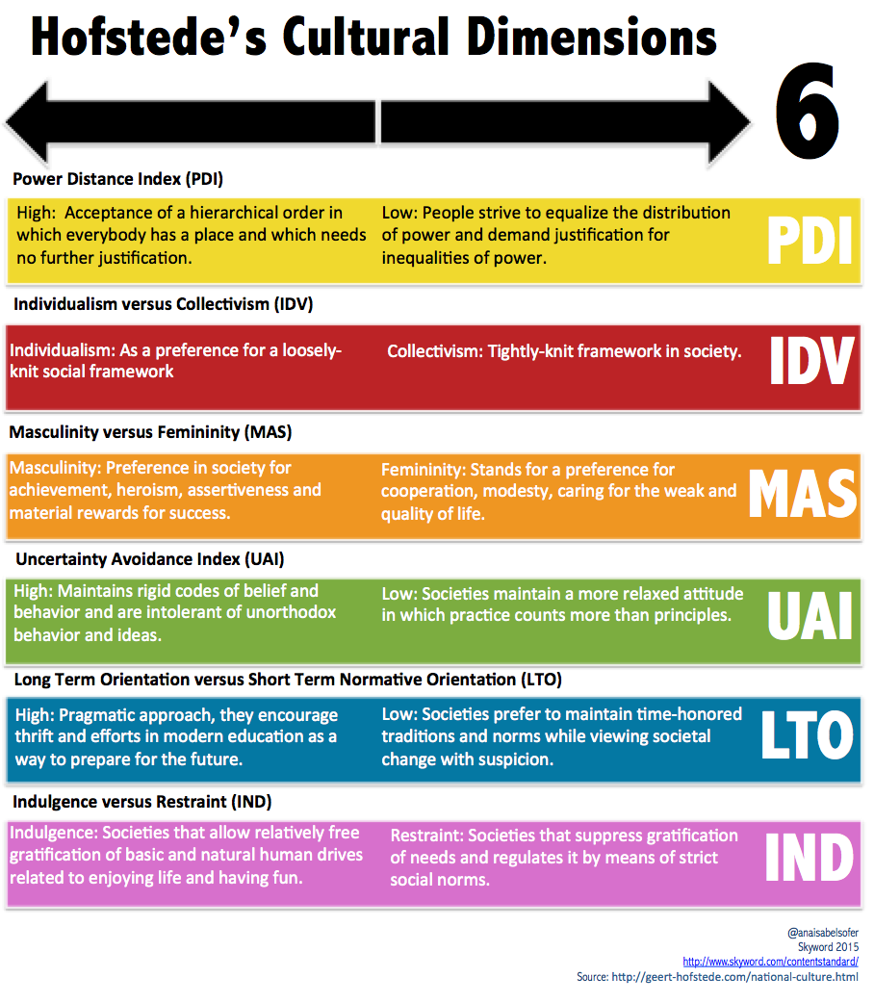(Fig. 1)

2.2 Leadership theories relevant for developing a new leadership programme.
The process of developing leadership programmes entails the utilisation of diverse models and theories to create initiatives that are both effective and impactful. By using the following models and theories, HSBC’s leadership development programme has the potential to offer a comprehensive and all-encompassing strategy for cultivating proficient leaders who possess the ability to adjust to various circumstances, motivate their teams, and propel organisational achievements. Every model and theory provide distinct perspectives on the dynamics of leadership and can be customised to align with the specific requirements and circumstances of an organisation.
1. Cultural Intelligence Theory- refers to intercultural adaptability and communication. The theory improves cross-cultural communication and collaboration in global leadership programmes (Ang and Dyne, 2015).
2. Global Leadership Competencies Model- defines global leadership qualities and competences such as cultural awareness, global thinking, cross-cultural communication, and flexibility (Hassanzadeh, et al. 2015).
3. GLOBE Leadership Dimensions- The Global Leadership and Organisational Behaviour Effectiveness highlights global leadership cultural factors helping global leadership programmes build culturally sensitive and successful leaders (Gupta, 2004).
4. Global Leadership Ethics and Corporate Social Responsibility- Global leadership programmes highlight ethical decision-making and corporate social responsibility in varied cultural contexts to guarantee responsible and long-lasting leadership (Stahl, et al. 2020).
2.3 The value of effective leadership in a global banking and financial services context.
Effective leadership is crucial in the global banking and financial services sector due to the distinct challenges and opportunities arising from its global nature. Global banks operate in a wide range of markets that have different legal structures, social standards, and monetary circumstances. Effective leaders require a comprehensive understanding of these intricacies to make well-informed decisions and foster expansion in diverse geographical areas. Effective leadership is crucial for cultivating an inclusive work environment, encouraging collaboration, and harnessing the various points of view and knowledge of colleagues. It enables organisations to navigate intricate markets, oversee diverse teams, adopt technology, mitigate risks, and foster innovation. Leaders who possess an international outlook, cultural awareness, and solid tactical competence can effectively navigate global challenges and take advantage of opportunities in an increasingly interconnected world (Ullah, 2017).

2.4 Rationale for Developing a New Global Leadership Development Program at HSBC
The rationale for developing the Global Leadership Excellence Program: Empowering Visionary Leaders for a Borderless Future at HSBC is founded on the acknowledgement of causes that highlight the requirement for a wide-ranging leadership development initiative (Day, 2000):
Succeeding in a globalized world- a multinational banking and financial services corporation, HSBC conducts operations in a wide range of markets characterised by distinct cultural, regulatory, and economic contexts. The programme has the objective of providing leaders with the essential skills and cultural intelligence required to thrive in a globalised society (Cook, 2006).
Developing visionary leadership- As financial services sector is undergoing rapid evolution, primarily propelled by advancements in technology, customer expectations, and changing market aspects, the objective of the programme is to cultivate visionary leadership capabilities among participants, by equipping future leaders with skills to anticipate forthcoming trends, foster innovation, and spearhead strategic initiatives that establish HSBC as an industry leader (Kruckeberg and Amann, 2017).
Managing global teams: HSBC’s staff exhibits a notable degree of diversity, encompassing employees hailing from diverse backgrounds and regions. The programme places emphasis on fostering inclusive leadership practises that encompass diversity and foster a climate of collaboration and respect (Zander, et al. 2012).
Developing a strong leadership channel- the leadership development programme fosters talent and builds a leadership pipeline. The programme creates high-potential leaders and promotes continual learning (Charan, et al 2011).
HSBC vision and mission: The programme supports HSBC's objective to be the world's top multinational bank and offer value and profitable development. HSBC empowers executives to navigate a borderless future to serve customers, employees, and stakeholders (DuBrin, 2013).

Leadership Styles
To train future leaders for future challenges, specific leadership styles are sought. These leadership styles emphasise adaptation, teamwork, emotional intelligence, and inspiration and motivation.
Transformational Leadership- has been linked to team job satisfaction, dedication, and performance (Bass, 1985).
Servant Leadership- this style to leadership underlines empathy, listening skills, and a commitment to ethical decision-making (Greenleaf, 2002).
Adaptive Leadership- encourage teams to welcome change and adapt to new occurrences immediately (Heifetz and Linsky, 2017).
Emotional Intelligence- leaders with high emotional intelligence can control their emotions and empathise with others, improving leadership and organisational outcomes (Goleman, 2019).

2.5 Leadership Program Objectives
The key objectives of developing Global Leadership Excellence Program: Empowering Visionary Leaders for a Borderless Future at HSBC are to improve cross-cultural experience, to empower future leaders in leadership positions with the capacity to conceptualise and propel strategic actions, to foster inclusive leadership, enhance virtual partnerships and develop principled decision making (Moldoveanu and Narayadas, 2019).

2.6 Leadership Program Structure
Paine (2016) describes leadership development as a process, not an event, multifaceted and continuous, that requires time. The author suggested the following structure for a leadership program:
Leadership Development Seminars:
- Boosting cross-cultural knowledge in varied business situations.
- Promotion of tactical thinking and visionary leadership
- Promoting diversity and inclusion within teams and the organisation.
Immersive Experiences:
- Leaders will be exposed to different business cultures and practices;
- Leaders will be provided with individualised mentoring by senior executives at HSBC;
Online Learning Modules:
- Leaders will enhance their cultural awareness;
- Leaders will focus on principles of ethical leadership and corporate social responsibility.

2.7 Leadership Program Outcome
The HSBC global leadership development programme aims to provide leaders with the necessary tools and mindset to effectively navigate global complexities. The programme aims to enhance HSBC's leadership capabilities and promote long-term organisational success through the development of cultural intelligence, strategic thinking, teamwork, and inclusive leadership (Hannum, et al. 2007).
The Global Leadership Excellence Program plays a crucial role in developing visionary leaders capable of leading HSBC towards a global future, fostering innovation, embracing diversity, and effectively managing the complexities of the global financial services industry, as well to the organisation's ongoing success in a constantly changing world (Whitaker and Reeves, 2021).

2.8 Gaps in current leadership capabilities in the banking sector
According to the Financial Services Skills Commission (2022), technological change and customer behaviour are the two reasons for financial services skills change, which influence almost 25% of enterprises. Liu (2021), stated that banking CEOs struggle to lead and react to rapid technology developments, affecting the bank's competitiveness. Garvey, et al.(2020) indicated that banking sector leaders struggle to create a culture of innovation and agility, hindering the bank's capacity to adapt to new market trends and consumer needs. OECD (2014) indicated that banking leaders need risk management skills to oversee regulatory requirements, comply with changing financial standards, and address threats to the bank's viability. Furthermore, Amin, et al. (2023), indicated that bank leaders may need to increase their abilities to foster diversity and inclusion inside their organisations, creating an egalitarian work environment and leveraging varied viewpoints. Mohsin, (2021) stated that developing leaders’ abilities, they encourage talent development, recruit, and retain top personnel and build a strong pipeline of future leaders, expand cross-cultural skills to traverse varied foreign markets, and finally to uphold ethical standards and promote corporate social responsibility.

2.9 Challenges and opportunities of managing diverse teams.
In today's globalised society, leaders must manage multicultural teams. It involves cultural awareness, efficient communication, and inclusive leadership. By incorporating strategies as cultural intelligence, conflict resolution, or diversity training, leaders can collaborate, innovate, and produce in diverse teams across cultures (Neely, 2021). Managing varied teams across diverse cultural contexts displays both challenges and opportunities for organisations.

Challenges
- Language disparities, communication styles, and cultural conventions can lead to confusion and misinterpretation, impeding teamwork (Meyer, 2014).
- Team problem-solving, decision-making, and handling conflicts may differ according to cultural differences (Neuliep, 2016).
- Coordinating meetings and duties across time zones can impede team productivity (Sheridan, 2012).
- Unconscious biases and stereotypes, extended periods of time to build trust and team culture (Meyer, 2014).

Opportunities
- Diverse teams may provide a variety of viewpoints and experiences to problem-solving and innovation.
- Multicultural teams assist organisations customise goods and services to varying client demands by providing insights into foreign markets.
- Diverse teams learn to overcome problems and use their strengths.
- In a globalised society, managing various teams develops multicultural leadership skills.
- Diverse workplaces empower and reward employees (Livermore, 2010).

2.10 Strategies
The Global Leadership Excellence Program: Empowering Visionary Leaders for a Borderless Future will use these methods to manage multicultural teams:
- Promote cultural knowledge and respect via training and awareness programmes;
- Recognise and use each team member's abilities;
- Overcome time zone and distance barriers with digital collaboration tools;
- Offer conflict resolution and mediation training to resolve cultural differences;
- Celebrate cultural diversity to promote a sense of belonging and an inclusive workplace;
- Hold team-building events to improve teamwork;
Addressing problems and harnessing opportunities may maximise the potential of diverse teams and create a collaborative and inventive work environment that benefits individuals and the organisation (Szkudlarek, et al. 2020).

2.11 Delivery and Implementation
The Global Leadership Excellence Programme: Empowering Visionary Leaders for a Borderless Future at HSBC requires a thorough framework for programme creation, delivery, and assessment. Programme implementation is outlined below:

Phase 1 - Program Development and Design
- Determine HSBC's leadership development requirements and gaps, based on the input from senior leadership, HR, and programme participants;
- The leadership programme must define and connect with HSBC's long-term strategic strategy, covering leadership skills needed in a global financial services environment;
- A curriculum must be design that encompasses leadership abilities, cultural competency, technological change, creativity, multicultural leadership, responsible choices, based on case studies and experiential learning;
- Programme content must blend live seminars, virtual meetings, webinars, and self-paced learning modules, conducted by leadership and industry professionals with worldwide leadership development experience (Kouzes and Posner, 2017).

Phase 2 - Program Delivery
- Selection of high-potential leaders from HSBC's areas for the programme, considering diversity and inclusiveness in selection;
- Programme launch event to inspire senior leadership;
- The programme will make use of digital collaboration technologies to enable real-time engagement and group operations for in-person and virtual workshops to accommodate multiple time zones;
- One-on-one coaching and mentoring;
- Use of international meetings or overseas assignments to expose participants to diverse markets and cultures (Centre for Creative Leadership, 2023).
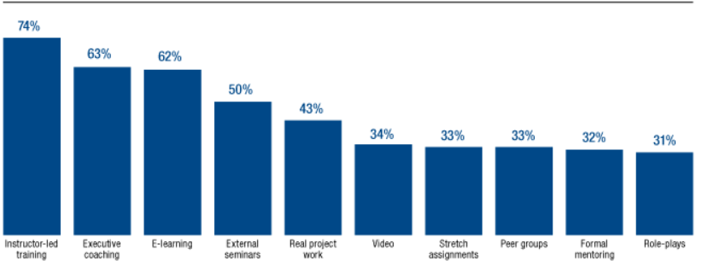
(Prokopeak, 2018)

Phase 3- Program Evaluation and Continuous Improvement
- The programme will be evaluated based on feedback from programme participants, leadership competence improvements, and organisational indicators;
- Based on feedback and leadership development trends, the initiative's material and presentation methods will be re-examined, adapting the programme to address current issues;
- Incorporation of the programme into HSBC's leadership development and succession planning.
- Honour programme alumni and HSBC's achievement (Thorpe, 2016).
Duration
- In person workshops – between one and three days, throughout the programme
- Online – between thirty minutes to two hours each, once a week, for new online modules.
The program's duration and frequency should be adjustable to accommodate participant feedback, availability, and changing learning requirements.

Target Audience
Participants with:
- high leadership potential,
- directing HSBC’s worldwide teams or business segments.
- employees who aim to lead HSBC's long-term strategy.
- culturally diverse participants
- top leaders and HR.

3. Budget
According to Prokopeak (2018) 94% of learning organisations aim to spend in leadership development. Additionally, he asserted, that according to a data from the Chief Learning Officer Business Intelligence Board, eight percent of organisations spend above ten thousand dollars per person on leadership development, six percent spend between seven thousand and ten thousand dollars, while sixty-eight percent of companies spend less than four thousand dollars on leadership development programmes (See Fig. 2 and 3).
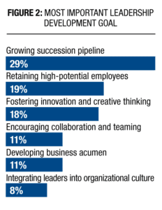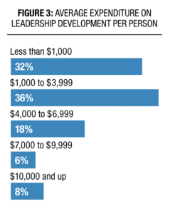
The Global Leadership Excellence Program's budget estimate depends on programme duration, number of participants, written material, delivery techniques, and instructor’s fees. The Global Leadership Excellence Program's scope and needs must be considered when creating a budget estimate with HSBC's finance and HR divisions. Leadership development can also be justified by the program's ROI and long-term impact.
- Programme Development- Evaluations, interviews, data research to determine leadership development gaps, employing skilled leadership specialists and facilitators.
- In-Person Workshops: Venue rental, food, travel, and facilitator accommodations.
- Virtual Sessions: Online platform and collaboration tool.
- One-on-one coaching and mentoring costs.
- Costs for building and maintaining a Learning Management System for online modules and tracking participant progress.
- Online course, video, and learning resource development
- Participant immersion or international exchange
- Programme planning, participant communications, and registration staffing.
- Programme brochures, banners, and other promotional materials: printing
- Internal HSBC advertising and promotion
- Data analysis and assessment
- Independent assessment.
- Unexpected costs or programme changes (Paine, 2016).
The cost of a leadership program for a global bank can vary significantly based on factors such as the program's scope, duration, content, location, and the number of participants. In general, leadership development programs for a global bank as HSBC, can range from two thousand pounds per participant for shorter and more basic programs to thirty thousand pounds or more for more extensive and high-level programs.

4. Resources

Global Leadership Excellence Programmes succeed when important resources are available and used well. These tools include global leadership facilitators and trainers, technology for virtual collaboration and online learning, extensive curriculum materials, and immersive experiences to foster cross-cultural awareness. Programme management professionals also plan, coordinate, and execute smoothly. The Global Leadership Excellence Programme equips visionary leaders to succeed in a borderless environment by promoting creativity and embracing diversity to design a prosperous future for global organisations (International Monetary, et al. 2022).
The necessary resources for The Global Leadership Excellence Program:
- qualified leadership development facilitators and mentors with knowledge in global leadership
- virtual collaboration tools
- programme development materials
- staff for program planning, logistics, communications, and registration.

5. Conclusion
HSBC's leadership programme, The Global Leadership Excellence Programme: Empowering Visionary Leaders for a Borderless Future, is essential, as the programme will develop executives with the cross-cultural skills, global attitude, and imaginative thinking to traverse the global banking and financial services business. Furthermore, HSBC's Global Leadership Excellence Programme will promote ongoing development, employee involvement, and a broad group of innovative leaders to lead the company into a borderless future.
The programme is aligned with HSBC's strategic goals by identifying leadership development gaps during the development phase, and it will be taught by worldwide leadership experts. To accommodate varied learning styles and overcome geographical limitations, the programme combines in-person workshops and virtual sessions with a Learning Management System, which will track participant progress and promotes continual learning.
As HSBC embarks on this transformative journey, it is optimistic that The Global Leadership Excellence Programme will motivate leaders to promote change, inventiveness, and diversity, revealing the full potential of a diverse, global workforce and promoting HSBC's international success. These visionary visionaries will redefine banking and financial services for an interconnected globe of sustainable development and prosperity.
The transformative programme presents HSBC with the prospect of fostering a novel generation of visionary leaders equipped with the essential skills and competencies to effectively navigate the complexities of an increasingly interconnected global landscape. The programme enhances participants' leadership capabilities through a comprehensive training approach that focuses on global leadership, cross-cultural adaptability, and strategic thinking. This equips individuals with the necessary skills to effectively lead diverse teams, make well-informed decisions, and foster innovation. As these individuals with forward-thinking qualities ascend in their professional positions, they will introduce a novel outlook and influential style of leadership to the organisation, cultivating an environment characterised by exceptional performance and facilitating progress. The programme places emphasis on personal development, coaching, and immersive experiences, which contribute to the enhancement of participants' sense of purpose and belonging within HSBC.
Finally, it can be argued that the implementation of the Global Leadership Excellence Programme has the capacity to initiate substantial and favourable transformations within HSBC. By fostering the growth of forward-thinking individuals in leadership positions, promoting active involvement and commitment from employees, and striving for overall organisational achievement, this programme aims to facilitate HSBC's ability to flourish in an interconnected global environment. Consequently, it is expected to have a profound and enduring influence on the future trajectory of the company and the broader landscape of the global financial sector.

6. Recommendations
HSBC's leadership should examine the following recommendations before adopting The Global Leadership Excellence Programme:
1. The programme must prioritise leadership skills for global business.
2. HSBC must engage top leaders to advocate the programme.
3. HSBC must assess the program's ROI and influence on leadership, employee engagement, and organisational performance. Leadership abilities, employee happiness, talent retention, and business success should be measured.
4. Adapt programme content and delivery to HSBC's worldwide cultural and commercial settings
5. Provide course flexibility to address each region's leadership issues.
6. Stress diversity and inclusion in leadership development.
7. Continue supporting programme participants after training.
These recommendations can help HSBC's leadership decide whether to adopt The Global Leadership Excellence Programme and position the company for long-term success in a borderless, fast changing global marketplace (Lacerenza, et al. 2017).

References
Amin, S., Yasin, I. and Rutkowska-Ziarko, A. (2023). Diversity-Inclusion Nexus: Assessing the Role of Ethnic and Religious Diversity in Financial Inclusion; A Global Perspective. Economic Research. Taylor and Francis Online. 36(1), pp:1205-1225. https://doi.org/10.1080/1331677X.2022.2083648.
Ang, S. and Dyne, L. V. (2015). Handbook of Cultural Intelligence: Theory, Measurement, and Applications. United Kingdom: Taylor and Francis.
Bass, B. M. (1985). Leadership and Performance Beyond Expectations. New York: Free Press.
Centre for Creative Leadership (2023). Incorporating and Scaling a Leadership Development Curriculum. Available at: https://www.ccl.org/articles/leading-effectively-articles/incorporating-scaling-leadership-development-curriculum-into-your-executive-education-program/. (Accessed: 19 July 2023).
Charan, R., Drotter, S. and Noel, J. L. (2011). The Leadership Pipeline: How to Build the Leadership Powered Company. United Kingdom: Wiley.
Cook, M. (2006). Thrive: Standing on Your Own Two Feet in a Borderless World. United States: St. Lynn's Press.
Day, D. V. (2000). Leadership Development: A Review in Context. The Leadership Quarterly. 11(4), pp: 581-613. https://doi.org/10.1016/S1048-9843(00)00061-8. Elsevier.
DuBrin, A. J. (2013). Principles of Leadership. United Kingdom: South-Western Cengage Learning.
Financial Services Skills Commission (2022). Mind the gaps – Skills for the Future of Financial Services 2022. Available at: https://wp.financialservicesskills.org/wp-content/uploads/2022/03/FSSC-Future-Skills-Interactive-V12.pdf. (Accessed: 19 July 2023).
Garvey, J. et al. (2020). Retail Banking 2020: Evolution or Revolution? Price Waterhouse Coopers LLP.
Goleman, D. (2019). The Emotionally Intelligent Leader. United States: Harvard Business Review Press.
Greenleaf, R. K. (2002). Servant Leadership: A Journey into the Nature of Legitimate Power and Greatness. United States: Paulist Press.
Gupta, V. (2004). Transformative Organizations: A Global Perspective. India: SAGE Publications.
Hannum, K., Martineau, J., Reinelt, C. (2007). The Handbook of Leadership Development Evaluation. United Kingdom: Wiley.
Hassanzadeh, M. et al (2015). Global Leadership Competencies. Journal of Educational and Social Research. 5(2), pp: 137. DOI: 10.5901/jesr.2015.v5n2p137.
Heifetz, R. A. and Linsky, M. (2017). Leadership on the Line: Staying Alive Through the Dangers of Change. United States: Harvard Business Review Press.
Hofstede, G. (2001). Culture's Consequences: Comparing Values, Behaviours, Institutions and Organisations Across Nations. India: SAGE Publications.
HSBC (2023). Opening a World of Opportunity. Available at: https://www.hsbc.com/who-we-are/purpose-values-and-strategy. (Accessed: 18 July 2023)
HSBC (2023). Who We Are: Opening a World of Opportunity. Available at: https://www.hsbc.com/who-we-are. (Accessed: 18 July 2023).
International Monetary, International Monetary Fund, Monetary and Capital Markets Department (2022). United Kingdom: Financial Sector Assessment Program-Banking Supervision and Issues in Financial Stability. United States: International Monetary Fund.
Kouzes, J. M. and Posner, B. Z. (2017). The Leadership Challenge: How to Make Extraordinary Things Happen in Organizations. Germany: Wiley.
Kruckeberg, K. and Amann, W. (2017). Advanced Leadership Insights: How to Lead People and Organisations to Ultimate Success. United States: Information Age Publishing, Incorporated.
Lacerenza, C., N., et al. (2017). Leadership Training Design, Delivery, and Implementation: A Meta-Analysis. Journal of Applied Psychology: American Psychological Association. 102(12), pp: 1686-1718. http://dx.doi.org/10.1037/apl0000241.
Liu, E. X. (2021). Stay Competitive in the Digital Age: The Future of Banks. United States: International Monetary Fund.
Livermore, D. A. (2010). Leading with Cultural Intelligence: The New Secret to Success. United Kingdom: American Management Association.
Mallick, H. et al. (2022). Proceedings of the 2022 4th International Conference on Economic Management and Cultural Industry. Germany: Atlantis Press International BV.
Meyer, E. (2014). The Culture Map: Breaking Through the Invisible Boundaries of Global Business. United States: Public Affairs.
Mohsin, M. et al. (2021). The Empirical Investigation Between Ethical Leadership and Knowledge-Hiding Behaviour in Financial Service Sector: A Moderated-Mediated Model. Frontiers in Psychology. 12, p:798631. https://doi.org/10.3389/fpsyg.2021.798631.
Moldoveanu, M. and Narayandas, D. (2019). The Future of Leadership Development. Harvard Business Review. 97(2), pp: 40-48.
Neeley, T. (2021). Remote Work Revolution: Succeeding from Anywhere. United States: HarperCollins.
Neuliep, P. J. W. (2016). Intercultural Communication: A Contextual Approach. United States: SAGE Publications.
OECD (2014). Risk Management and Corporate Governance. United States: OECD.
Paine, N. (2016). Building Leadership Development Programmes: Zero-Cost to High-Investment Programmes that Work. United Kingdom: Kogan Page.
Prokopeak, M. (2018). Follow the Leader(ship) Spending. Available at: https://www.chieflearningofficer.com/2018/03/21/follow-the-leadership-spending. (Accessed: 20 July 2023).
Sheridan, K. (2012). The Virtual Manager: Cutting-Edge Solutions for Hiring, Managing, Motivating, and Engaging Mobile Employees. United States: Red Wheel Weiser.
Stahl, G. H., et al. (2020). Responsible Global Leadership: Dilemmas, Paradoxes, and Opportunities. United States: Taylor and Francis.
Szkudlarek, B., Caprar, D.V., Osland, J.S. and Romani, L. (2020). The SAGE Handbook of Contemporary Cross-Cultural Management. SAGE Publications
Thorpe, R. (2016). Gower Handbook of Leadership and Management Development. United Kingdom: Taylor and Francis.
Ullah, P. (2017). Collaborative Leadership in Financial Services. United Kingdom: Taylor and Francis.
Whitaker, K. and Reeves, M. (2021). Winning the ’20s: A Leadership Agenda for the Next Decade. Germany: De Gruyter.
Zander, L., Mockaitis, A.I. and Butler, C.L. (2012). Leading Global Teams. Journal of World Business. 47(4), pp:592-603. https://doi.org/10.1016/j.jwb.2012.01.012.

