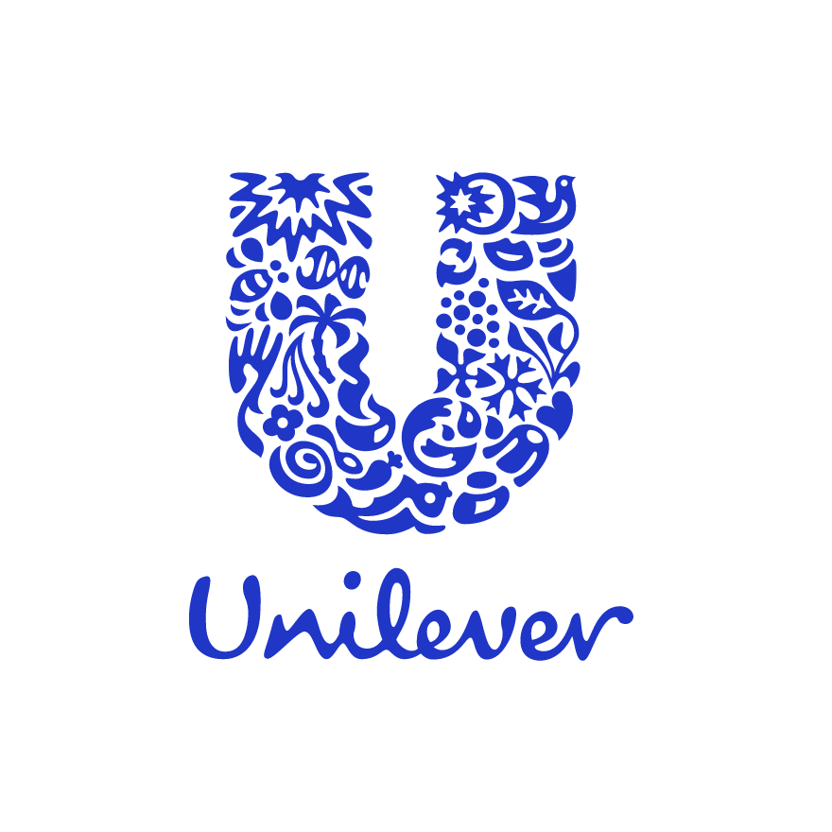
Brief introduction of the impact of pandemic directly towards Unilever
Unilever is a global consumer goods company which provides and produces at the highest rate and equality daily essential products such as soap and snacks. This company can be classified as one of the oldest multinational companies which specialize in distributing its products to more than 190 countries. But when Covid-19 pandemic begin an existential negative impact has occurred towards Unilever such as: the demand for products and services has decreased.

However according to media, Unilever instant food products decreased due to the consumers/costumer’s main idea of purchasing household products. The status of Unilever however in year 2020 will be the following. Unilever is practically the largest and best-established global company selling fast-moving day-to-day consumer goods. Just to put in consideration the importance of this existing company to produce and too continue to be a fast-moving company, there are two billion people which are consuming the products as Unilever gives their customers an opportunity and sustainability . Unilever objectives mainly aim to be able to help every individual make sustainable living in commonplace. Unilever is considered a high-ranked FMCG company representing and sustaining successfully for approximately 400 brands all over the world with various product segments and demands.

Background reference and how Unilever was established

Unilever was first practically founded in 1930 and of course has become without a doubt one of the oldest companies producing consumer goods in the whole world.

The company has first started to produce and provide its products from the collaboration between the Margarine Unit and Lever Brothers, a British soap maker, in order to then form a multinational company which was chosen to be named Unilever as they started to gradually succeed in producing numerous daily products. The company has succeeded to create numerous product brands, suitable for multiple areas and containing a wide product range such as: food and beverages, beauty and personal care, home care, cleaning agents, personal care, refreshments, and more. This not only includes the wide product range but also the successful outcome of profitability and sustainability, as this includes $15 billion worth top brands include Rexona, Knor, Lipton, Sunsilk, and Dove, which expand and produce their products at a higher rate of 50% faster and have around 60% share of the company's worth total growth. Unilever has been engaged and has tried to promote itself by participating in several Corporate Social Responsibility (CSR) events, such as: an impressive total of 35 initiatives by Unilever Home Brands to clean 2,000 mosques in 13 cities during Ramadan in Indonesia, and Ben & Jerry's efforts to improve criminal justice and address racial bias in the United States. Besides, it is fiendishly difficult to penetrate the farthest corner of the world in places like India. But Unilever has tried to made this action possible and provide easy access and sustainability to any individual, no matter where they are located around the globe through its involvement in the network of distributors which is practically the most successful and easy method to distribute its products at a fast rate and in multiple locations at the time and need.
Information of the product line of Unilever

The product line of the company is very diverse and can be suitable for both luxurious or affordable products. Whereby this company has additionally made several strategic and successful investments which have initially not made a big change, but have gradually made a major change in terms of the overall profits, and revenue. These investments will be the following: Breyers from Kraft, the biggest ice cream maker in the United States. Unilever's power and practically its predominant factor being supply chain network. But when the coronavirus occurred, the market worldwide has struggled and has tried multiple initiatives to keep their market on-going and keep being able to afford producing and distributing its products while pandemic were giving an adverse supply chain effects on the economy and business which was mainly due to the pandemic rules and regulations which had to be applied to any business .
Political Factors Affecting Unilever’s Business
The political landscape affects Unilever’s performance. This section of the PESTLE analysis specifically refers to and identifies the impact of governments on firms’ remote or macro-environment. The following political external factors are significant in Unilever’s consumer goods business: Political stability of most countries (opportunity), Political issues in the European Union (threat),Growing free trade relations (opportunity)
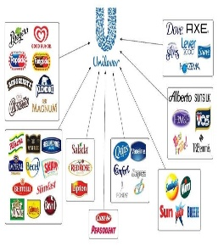
This factor, such as political stability can present either an opportunity or a threat for Unilever to distribute its products and promote itself in these markets and make the aim of expansion to be achievable and sustainable .But the political stability of the United States helps minimize challenges in the company’s strategic implementations and other regulations in the country. However the political issues in the European Union are a likely potential threat against Unilever’s operations in the region’s consumer goods market. This leads to the company potential opportunity for global growth based on expanding free trade relations, especially those involving developing countries. This has been applicable measure to be taken by Unilever mainly as a result of the covid-19 pandemic which has caused a few complications in this case for this company is standing up to Base on the political external and internal factors in this section of the PESTLE analysis, there are opportunities available in the market but also complications as the regulations of covid-19 do not correlate or are not necessarily suitable for the activity of Unilever of distributing its products worldwide due to the prevention and measures necessary to avoid the unavoidable of spreading the virus.
Economic Factors Important to Unilever
Unilever’s either success or failure such as losses are defined or partly affected by the economy of each country in which its products are being distributed. This section is focusing on the impact of the economic conditions on the company. The following economic factors are resulting in the successful or no, of the Unilever economic performance: Increasing wages in developing countries (opportunity & threat, High growth of developing countries (opportunity),Economic stability of developed countries (opportunity)
The increasing wages in developing countries have resulted to an opportunity for Unilever to profit more from higher potential sales, as consumers gain higher disposable incomes. However, the same external factors but also external factors which are without a doubt a threat in terms of increasing costs, considering that the company has many manufacturing facilities located in developing regions and not to mention covid-19 which have caused a significant decreasing domino effect towards the economy of any country and less profitability for any country and distribution and exportation has been majorly affected .But on the other hand, regardless of this negative impacts taken on businesses,Unilever can still aim to business growth, as these countries grow due to the following factors : consumer goods, market size and value. For example, such as China presents huge and significant growth opportunity towards Unilever.Whereby the economic stability of developed countries represents the likelihood of business success and growth or expansion as well as distinguishing and protection from other markets, while facilitating gradual but steady growth.

Social/Sociocultural Factors Influencing Unilever’s Business Environment
Sociocultural trends are an important factor which affects the likelihood of the business to succeed and to avoid making future losses. The This section mentions in detail sociocultural external factors which are relevant and applicable to Unilever. These factors will be the following: Raising health consciousness (opportunity), Rising environmentalist behaviors (opportunity), Gradual dismantling of the gender divide (opportunity)
Unilever can potentially aim to grow by making to sure to provide as its target market demands ,assuring sustainability and costumer satisfaction. Dressing directly to its costumers ,collecting data directly from the source is a very effective method of providing its costumers with products they need and this can include social media platforms which are available at all time ,and as pandemic occurred ,this lead to more likelihood of individuals choosing online shopping as an alternative ,therefore by bringing this facilities for costumers ,maintaining sustainability and providing accessible ways for costumers to access Unilever products, leading to maintaining profit at a constant level ,and assuring sales at a high rate ,despite the on-going discomfort of the pandemic regulations. Another factor which might be advantageous for Unilever might be considering environmentalist behaviors, as it presents an its audience that the producing process and distribution does not negatively affect the environment and as a result it attracts more consumers by improving its environmental impact’s measure of environmentalist behavior might be minimizing the energy used within a time frame and by adopting new and more renewable and efficient technology based equipment or machines, as technology is an on-going developing area which provides more accessible points for both costumers and the more internal individuals within company which affect the outcomes of Unilever directly.

Technological Factors in Unilever’s Business
This section of the PESTLE analysis is focusing on the impact of technological trends. In Unilever’s case, there are the following technological external factors: Rising business automation (opportunity & threat) Rising R&D investments (threat), Decreasing cost of transportation based on technological efficiencies (opportunity & threat)
By playing an initiative of improving technology for Unilever could possibly lead to production and distribution efficiency. For example, a more advanced technologically wise, processing equipment can enhance inventory monitoring and stock management in order to support supply chain. However, this technological external factors do not fully lead to a positive outcome because it increases the competitiveness as well as the costs of handling and maintaining more advanced equipment or machinery ,and may also cause hiring more individuals to handle this and due to pandemic, this may cause difficulty or loss for Unilever or imbalance between the inflows and outflows of the business. Also, other factors which may contribute or led by these changes might be the decreasing cost of transportation which may gradually cause lower operating costs which are major elements that affect and contributes to business growth.

Environmental Factors Affecting Unilever
The effects of the natural environment and related issues are considered in this section of the PESTLE analysis including somel external factors which are without a doubt affecting Unilever. These factors are the following: Rising interest in business environmentalism (opportunity), Increasing business efforts on sustainability (opportunity), Increasing complexity of environmental programs (opportunity)
The rising interest in business environmentalism is an opportunity for Unilever to attract more consumers which might be also concerned about the environment, therefore might considers how much impact of the production process of the products provided and by this making a judgement whether they will like to buy products from a particular company. AS a result of this action being taken the company can keep constant its sustainability programs to strengthen its competitiveness against other companies manufacturing in the same or similar markets. Therefore, this leading to Unilever’s corporate social responsibility strategy which must effectively implement these programs throughout the organization and moreover be able to promote it ,,therefore creating a particular advantageous image towards its audience. For example, this strategy must consider such measures as product innovation and internal business processes to further on be able to generate and maintaining to reducing Unilever environmental impact. These lead to Unilever’s capacity/ rate to satisfy environmental programs.

Legal Factors Facing Unilever
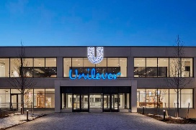
Unilever must satisfy regulations to minimize barriers to its consumer goods business. This section of the PESTEL/PESTLE analysis determines the impact of legal systems on firms’ remote or macro-environment. Unilever must satisfy the issues based on the following legal external factors:
Increasing complexity of environmental regulations (opportunity)
Strengthening international patent laws (opportunity), Strengthening consumer rights laws (opportunity)
Unilever should consider improving its corporate image by matching the organization’s corporate social responsibility strategy with environmental regulations. Therefore, strengthening international patent laws can facilitate the company’s growth. Moreover stronger consumer rights laws create an opportunity for the company to improve its customer-service quality, along with product quality standards the attractiveness of consumer goods market and overall brand image.
Information reference:
https://www.researchgate.net/publication/348905003_The_Impacts_of_Covid-19_on_Unilever
image references: https://www.unilever.com/
https://www.researchgate.net/figure/Unilever-Multi-brand-Strategy_fig5_342145600
https://www.bakingbusiness.com/articles/54240-inflation-undermines-unilevers-first-half-performance

